UNITED STATES
SECURITIES AND EXCHANGE COMMISSION
Washington, D.C. 20549

FORM 8-K

CURRENT REPORT
Pursuant to Section 13 or 15(d)
of the Securities Exchange Act of 1934

Date of report (Date of earliest event reported): July 30, 2026

Commission File Number: 001-41430

Pagaya Technologies Ltd.
(Exact name of registrant as specified in its charter)
Israel |  |  |  |  |  |  |  |  |  |  |  |  |  |  |  |  |  |  |  |  |  |  |  |  |  |  | 98-1704718
(State or other jurisdiction of incorporation or organization) |  |  |  |  |  |  |  |  |  |  |  |  |  |  |  |  |  |  |  |  |  |  |  |  |  |  | (I.R.S. Employer Identification No.)
335 Madison Ave, 16th Floor
New York, New York |  |  |  |  |  |  |  |  |  |  |  |  |  |  |  |  |  |  |  |  |  |  |  |  |  |  | 10017
(Address of principal executive offices) |  |  |  |  |  |  |  |  |  |  |  |  |  |  |  |  |  |  |  |  |  |  |  |  |  |  | (Zip Code)
(646) 710-7714
(Registrant's telephone number, including area code)

Check the appropriate box below if the Form 8-K filing is intended to simultaneously satisfy the filing obligation of the registrant under any of the following provisions (see General Instruction A.2. below):

☐ Written communication pursuant to Rule 425 under the Securities Act (17 CFR 230.425)

☐ Soliciting material pursuant to Rule 14a-12 under the Exchange Act (17 CFR 240.14a-12)

☐ Pre-commencement communication pursuant to Rule 14d-2(b) under the Exchange Act (17 CFR 240.14d-2(b))

☐ Pre-commencement communication pursuant to Rule 13e-4(c) under the Exchange Act (17 CFR 240.13e-4(c))

Securities registered pursuant to Section 12(b) of the Act:
Title of each class |  |  |  |  |  | Trading Symbol(s) |  |  |  |  |  | Name of each exchange on which registered
Class A Ordinary Shares, no par value |  |  |  |  |  | PGY |  |  |  |  |  | The NASDAQ Stock Market LLC
Warrants to purchase Class A Ordinary Shares |  |  |  |  |  | PGYWW |  |  |  |  |  | The NASDAQ Stock Market LLC

Indicate by check mark whether the registrant is an emerging growth company as defined in Rule 405 of the Securities Act of 1933 (17 CFR §230.405) or Rule 12b-2 of the Securities Exchange Act of 1934 (17 CFR §240.12b-2).

Emerging growth company ☐

If an emerging growth company, indicate by check mark if the registrant has elected not to use the extended transition period for complying with any new or revised financial accounting standards provided pursuant to Section 13(a) of the Exchange Act. ☐

Item 2.02. Results of Operations and Financial Condition.

On July 30, 2026, the registrant issued a press release announcing its financial results for the quarter ended June 30, 2026. A copy of the press release announcing the Company’s quarterly earnings results is attached hereto as Exhibit 99.1.

Item 7.01. Regulation FD Disclosure.

On July 30, 2026, the registrant also released a letter to shareholders relating to its results for the quarter ended June 30, 2026. A copy of the letter is attached as Exhibit 99.2 hereto.

The information contained in Exhibit 99.1 and Exhibit 99.2 shall not be deemed “filed” for purposes of Section 18 of the Securities Exchange Act of 1934, as amended (the “Exchange Act”), or incorporated by reference in any filing under the Securities Act of 1933, as amended, or the Exchange Act.

Item 9.01. Financial Statements and Exhibits.

(d) Exhibits

Exhibit No. |  |  |  |  |  | Description
99.1 |  |  |  |  |  | Press Release Announcing Quarterly Earnings Results, dated July 30, 2026
99.2 |  |  |  |  |  | Shareholder Letter, dated July 30, 2026

SIGNATURES

Pursuant to the requirements of the Securities Exchange Act of 1934, the registrant has duly caused this report to be signed on its behalf by the undersigned hereunto duly authorized.

 |  |  |  |  |  | PAGAYA TECHNOLOGIES LTD.
Date: July 30, 2026 |  |  | By: |  |  | /s/ Gal Krubiner
 |  |  | Name: |  |  | Gal Krubiner
 |  |  | Title: |  |  | Chief Executive Officer

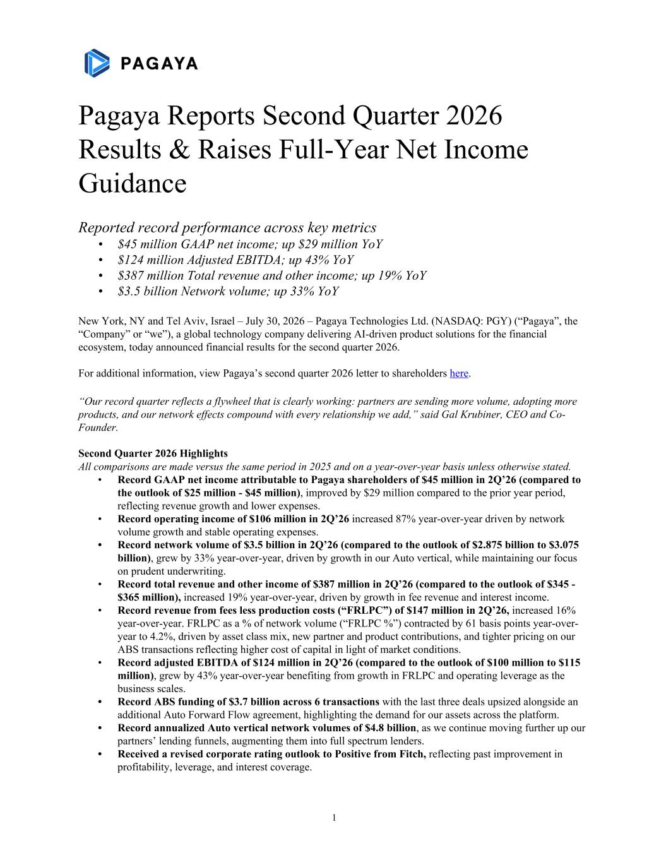

Pagaya Reports Second Quarter 2026 Results & Raises Full-Year Net Income Guidance Reported record performance across key metrics • $45 million GAAP net income; up $29 million YoY • $124 million Adjusted EBITDA; up 43% YoY • $387 million Total revenue and other income; up 19% YoY • $3.5 billion Network volume; up 33% YoY New York, NY and Tel Aviv, Israel – July 30, 2026 – Pagaya Technologies Ltd. (NASDAQ: PGY) (“Pagaya”, the “Company” or “we”), a global technology company delivering AI-driven product solutions for the financial ecosystem, today announced financial results for the second quarter 2026. For additional information, view Pagaya’s second quarter 2026 letter to shareholders here. “Our record quarter reflects a flywheel that is clearly working: partners are sending more volume, adopting more products, and our network effects compound with every relationship we add,” said Gal Krubiner, CEO and Co- Founder. Second Quarter 2026 Highlights All comparisons are made versus the same period in 2025 and on a year-over-year basis unless otherwise stated. • Record GAAP net income attributable to Pagaya shareholders of $45 million in 2Q’26 (compared to the outlook of $25 million - $45 million), improved by $29 million compared to the prior year period, reflecting revenue growth and lower expenses. • Record operating income of $106 million in 2Q’26 increased 87% year-over-year driven by network volume growth and stable operating expenses. • Record network volume of $3.5 billion in 2Q’26 (compared to the outlook of $2.875 billion to $3.075 billion), grew by 33% year-over-year, driven by growth in our Auto vertical, while maintaining our focus on prudent underwriting. • Record total revenue and other income of $387 million in 2Q’26 (compared to the outlook of $345 - $365 million), increased 19% year-over-year, driven by growth in fee revenue and interest income. • Record revenue from fees less production costs (“FRLPC”) of $147 million in 2Q’26, increased 16% year-over-year. FRLPC as a % of network volume (“FRLPC %”) contracted by 61 basis points year-over- year to 4.2%, driven by asset class mix, new partner and product contributions, and tighter pricing on our ABS transactions reflecting higher cost of capital in light of market conditions. • Record adjusted EBITDA of $124 million in 2Q’26 (compared to the outlook of $100 million to $115 million), grew by 43% year-over-year benefiting from growth in FRLPC and operating leverage as the business scales. • Record ABS funding of $3.7 billion across 6 transactions with the last three deals upsized alongside an additional Auto Forward Flow agreement, highlighting the demand for our assets across the platform. • Record annualized Auto vertical network volumes of $4.8 billion, as we continue moving further up our partners’ lending funnels, augmenting them into full spectrum lenders. • Received a revised corporate rating outlook to Positive from Fitch, reflecting past improvement in profitability, leverage, and interest coverage. 1

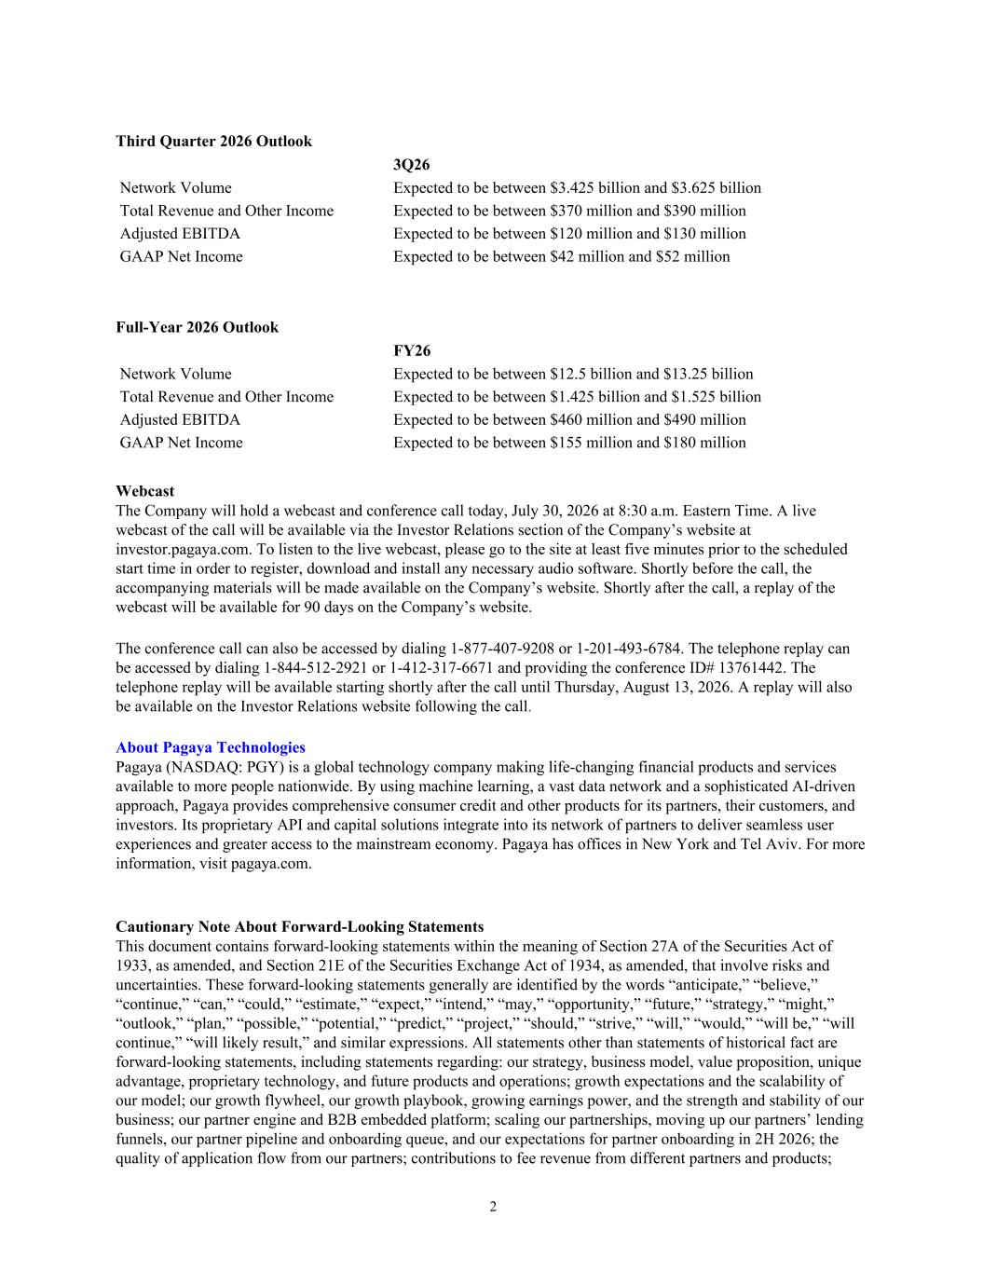
Third Quarter 2026 Outlook 3Q26 Network Volume Expected to be between $3.425 billion and $3.625 billion Total Revenue and Other Income Expected to be between $370 million and $390 million Adjusted EBITDA Expected to be between $120 million and $130 million GAAP Net Income Expected to be between $42 million and $52 million Full-Year 2026 Outlook FY26 Network Volume Expected to be between $12.5 billion and $13.25 billion Total Revenue and Other Income Expected to be between $1.425 billion and $1.525 billion Adjusted EBITDA Expected to be between $460 million and $490 million GAAP Net Income Expected to be between $155 million and $180 million Webcast The Company will hold a webcast and conference call today, July 30, 2026 at 8:30 a.m. Eastern Time. A live webcast of the call will be available via the Investor Relations section of the Company’s website at investor.pagaya.com. To listen to the live webcast, please go to the site at least five minutes prior to the scheduled start time in order to register, download and install any necessary audio software. Shortly before the call, the accompanying materials will be made available on the Company’s website. Shortly after the call, a replay of the webcast will be available for 90 days on the Company’s website. The conference call can also be accessed by dialing 1-877-407-9208 or 1-201-493-6784. The telephone replay can be accessed by dialing 1-844-512-2921 or 1-412-317-6671 and providing the conference ID# 13761442. The telephone replay will be available starting shortly after the call until Thursday, August 13, 2026. A replay will also be available on the Investor Relations website following the call. About Pagaya Technologies Pagaya (NASDAQ: PGY) is a global technology company making life-changing financial products and services available to more people nationwide. By using machine learning, a vast data network and a sophisticated AI-driven approach, Pagaya provides comprehensive consumer credit and other products for its partners, their customers, and investors. Its proprietary API and capital solutions integrate into its network of partners to deliver seamless user experiences and greater access to the mainstream economy. Pagaya has offices in New York and Tel Aviv. For more information, visit pagaya.com. Cautionary Note About Forward-Looking Statements This document contains forward-looking statements within the meaning of Section 27A of the Securities Act of 1933, as amended, and Section 21E of the Securities Exchange Act of 1934, as amended, that involve risks and uncertainties. These forward-looking statements generally are identified by the words “anticipate,” “believe,” “continue,” “can,” “could,” “estimate,” “expect,” “intend,” “may,” “opportunity,” “future,” “strategy,” “might,” “outlook,” “plan,” “possible,” “potential,” “predict,” “project,” “should,” “strive,” “will,” “would,” “will be,” “will continue,” “will likely result,” and similar expressions. All statements other than statements of historical fact are forward-looking statements, including statements regarding: our strategy, business model, value proposition, unique advantage, proprietary technology, and future products and operations; growth expectations and the scalability of our model; our growth flywheel, our growth playbook, growing earnings power, and the strength and stability of our business; our partner engine and B2B embedded platform; scaling our partnerships, moving up our partners’ lending funnels, our partner pipeline and onboarding queue, and our expectations for partner onboarding in 2H 2026; the quality of application flow from our partners; contributions to fee revenue from different partners and products; 2

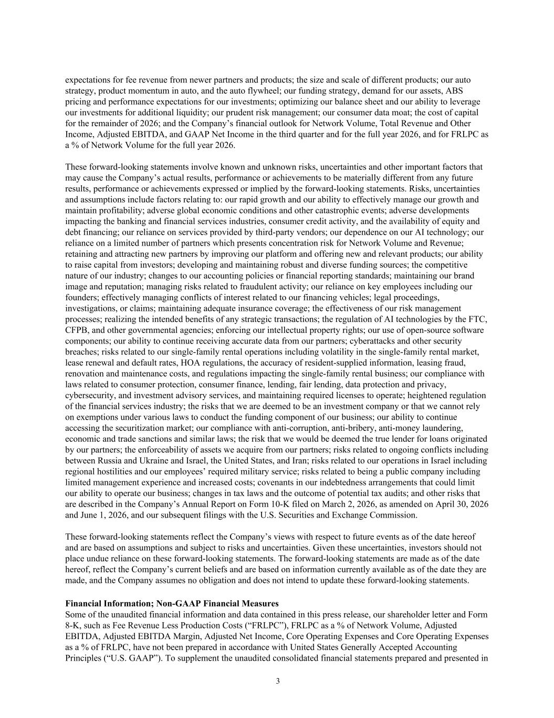
expectations for fee revenue from newer partners and products; the size and scale of different products; our auto strategy, product momentum in auto, and the auto flywheel; our funding strategy, demand for our assets, ABS pricing and performance expectations for our investments; optimizing our balance sheet and our ability to leverage our investments for additional liquidity; our prudent risk management; our consumer data moat; the cost of capital for the remainder of 2026; and the Company’s financial outlook for Network Volume, Total Revenue and Other Income, Adjusted EBITDA, and GAAP Net Income in the third quarter and for the full year 2026, and for FRLPC as a % of Network Volume for the full year 2026. These forward-looking statements involve known and unknown risks, uncertainties and other important factors that may cause the Company’s actual results, performance or achievements to be materially different from any future results, performance or achievements expressed or implied by the forward-looking statements. Risks, uncertainties and assumptions include factors relating to: our rapid growth and our ability to effectively manage our growth and maintain profitability; adverse global economic conditions and other catastrophic events; adverse developments impacting the banking and financial services industries, consumer credit activity, and the availability of equity and debt financing; our reliance on services provided by third-party vendors; our dependence on our AI technology; our reliance on a limited number of partners which presents concentration risk for Network Volume and Revenue; retaining and attracting new partners by improving our platform and offering new and relevant products; our ability to raise capital from investors; developing and maintaining robust and diverse funding sources; the competitive nature of our industry; changes to our accounting policies or financial reporting standards; maintaining our brand image and reputation; managing risks related to fraudulent activity; our reliance on key employees including our founders; effectively managing conflicts of interest related to our financing vehicles; legal proceedings, investigations, or claims; maintaining adequate insurance coverage; the effectiveness of our risk management processes; realizing the intended benefits of any strategic transactions; the regulation of AI technologies by the FTC, CFPB, and other governmental agencies; enforcing our intellectual property rights; our use of open-source software components; our ability to continue receiving accurate data from our partners; cyberattacks and other security breaches; risks related to our single-family rental operations including volatility in the single-family rental market, lease renewal and default rates, HOA regulations, the accuracy of resident-supplied information, leasing fraud, renovation and maintenance costs, and regulations impacting the single-family rental business; our compliance with laws related to consumer protection, consumer finance, lending, fair lending, data protection and privacy, cybersecurity, and investment advisory services, and maintaining required licenses to operate; heightened regulation of the financial services industry; the risks that we are deemed to be an investment company or that we cannot rely on exemptions under various laws to conduct the funding component of our business; our ability to continue accessing the securitization market; our compliance with anti-corruption, anti-bribery, anti-money laundering, economic and trade sanctions and similar laws; the risk that we would be deemed the true lender for loans originated by our partners; the enforceability of assets we acquire from our partners; risks related to ongoing conflicts including between Russia and Ukraine and Israel, the United States, and Iran; risks related to our operations in Israel including regional hostilities and our employees’ required military service; risks related to being a public company including limited management experience and increased costs; covenants in our indebtedness arrangements that could limit our ability to operate our business; changes in tax laws and the outcome of potential tax audits; and other risks that are described in the Company’s Annual Report on Form 10-K filed on March 2, 2026, as amended on April 30, 2026 and June 1, 2026, and our subsequent filings with the U.S. Securities and Exchange Commission. These forward-looking statements reflect the Company’s views with respect to future events as of the date hereof and are based on assumptions and subject to risks and uncertainties. Given these uncertainties, investors should not place undue reliance on these forward-looking statements. The forward-looking statements are made as of the date hereof, reflect the Company’s current beliefs and are based on information currently available as of the date they are made, and the Company assumes no obligation and does not intend to update these forward-looking statements. Financial Information; Non-GAAP Financial Measures Some of the unaudited financial information and data contained in this press release, our shareholder letter and Form 8-K, such as Fee Revenue Less Production Costs (“FRLPC”), FRLPC as a % of Network Volume, Adjusted EBITDA, Adjusted EBITDA Margin, Adjusted Net Income, Core Operating Expenses and Core Operating Expenses as a % of FRLPC, have not been prepared in accordance with United States Generally Accepted Accounting Principles (“U.S. GAAP”). To supplement the unaudited consolidated financial statements prepared and presented in 3

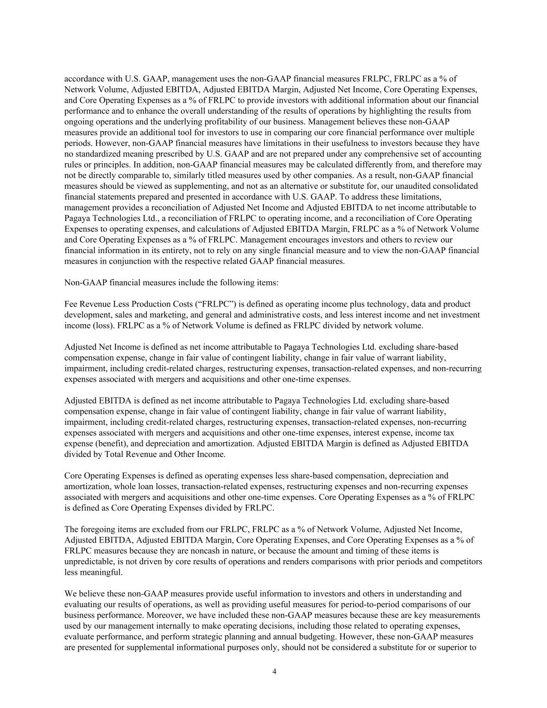
accordance with U.S. GAAP, management uses the non-GAAP financial measures FRLPC, FRLPC as a % of Network Volume, Adjusted EBITDA, Adjusted EBITDA Margin, Adjusted Net Income, Core Operating Expenses, and Core Operating Expenses as a % of FRLPC to provide investors with additional information about our financial performance and to enhance the overall understanding of the results of operations by highlighting the results from ongoing operations and the underlying profitability of our business. Management believes these non-GAAP measures provide an additional tool for investors to use in comparing our core financial performance over multiple periods. However, non-GAAP financial measures have limitations in their usefulness to investors because they have no standardized meaning prescribed by U.S. GAAP and are not prepared under any comprehensive set of accounting rules or principles. In addition, non-GAAP financial measures may be calculated differently from, and therefore may not be directly comparable to, similarly titled measures used by other companies. As a result, non-GAAP financial measures should be viewed as supplementing, and not as an alternative or substitute for, our unaudited consolidated financial statements prepared and presented in accordance with U.S. GAAP. To address these limitations, management provides a reconciliation of Adjusted Net Income and Adjusted EBITDA to net income attributable to Pagaya Technologies Ltd., a reconciliation of FRLPC to operating income, and a reconciliation of Core Operating Expenses to operating expenses, and calculations of Adjusted EBITDA Margin, FRLPC as a % of Network Volume and Core Operating Expenses as a % of FRLPC. Management encourages investors and others to review our financial information in its entirety, not to rely on any single financial measure and to view the non-GAAP financial measures in conjunction with the respective related GAAP financial measures. Non-GAAP financial measures include the following items: Fee Revenue Less Production Costs (“FRLPC”) is defined as operating income plus technology, data and product development, sales and marketing, and general and administrative costs, and less interest income and net investment income (loss). FRLPC as a % of Network Volume is defined as FRLPC divided by network volume. Adjusted Net Income is defined as net income attributable to Pagaya Technologies Ltd. excluding share-based compensation expense, change in fair value of contingent liability, change in fair value of warrant liability, impairment, including credit-related charges, restructuring expenses, transaction-related expenses, and non-recurring expenses associated with mergers and acquisitions and other one-time expenses. Adjusted EBITDA is defined as net income attributable to Pagaya Technologies Ltd. excluding share-based compensation expense, change in fair value of contingent liability, change in fair value of warrant liability, impairment, including credit-related charges, restructuring expenses, transaction-related expenses, non-recurring expenses associated with mergers and acquisitions and other one-time expenses, interest expense, income tax expense (benefit), and depreciation and amortization. Adjusted EBITDA Margin is defined as Adjusted EBITDA divided by Total Revenue and Other Income. Core Operating Expenses is defined as operating expenses less share-based compensation, depreciation and amortization, whole loan losses, transaction-related expenses, restructuring expenses and non-recurring expenses associated with mergers and acquisitions and other one-time expenses. Core Operating Expenses as a % of FRLPC is defined as Core Operating Expenses divided by FRLPC. The foregoing items are excluded from our FRLPC, FRLPC as a % of Network Volume, Adjusted Net Income, Adjusted EBITDA, Adjusted EBITDA Margin, Core Operating Expenses, and Core Operating Expenses as a % of FRLPC measures because they are noncash in nature, or because the amount and timing of these items is unpredictable, is not driven by core results of operations and renders comparisons with prior periods and competitors less meaningful. We believe these non-GAAP measures provide useful information to investors and others in understanding and evaluating our results of operations, as well as providing useful measures for period-to-period comparisons of our business performance. Moreover, we have included these non-GAAP measures because these are key measurements used by our management internally to make operating decisions, including those related to operating expenses, evaluate performance, and perform strategic planning and annual budgeting. However, these non-GAAP measures are presented for supplemental informational purposes only, should not be considered a substitute for or superior to 4

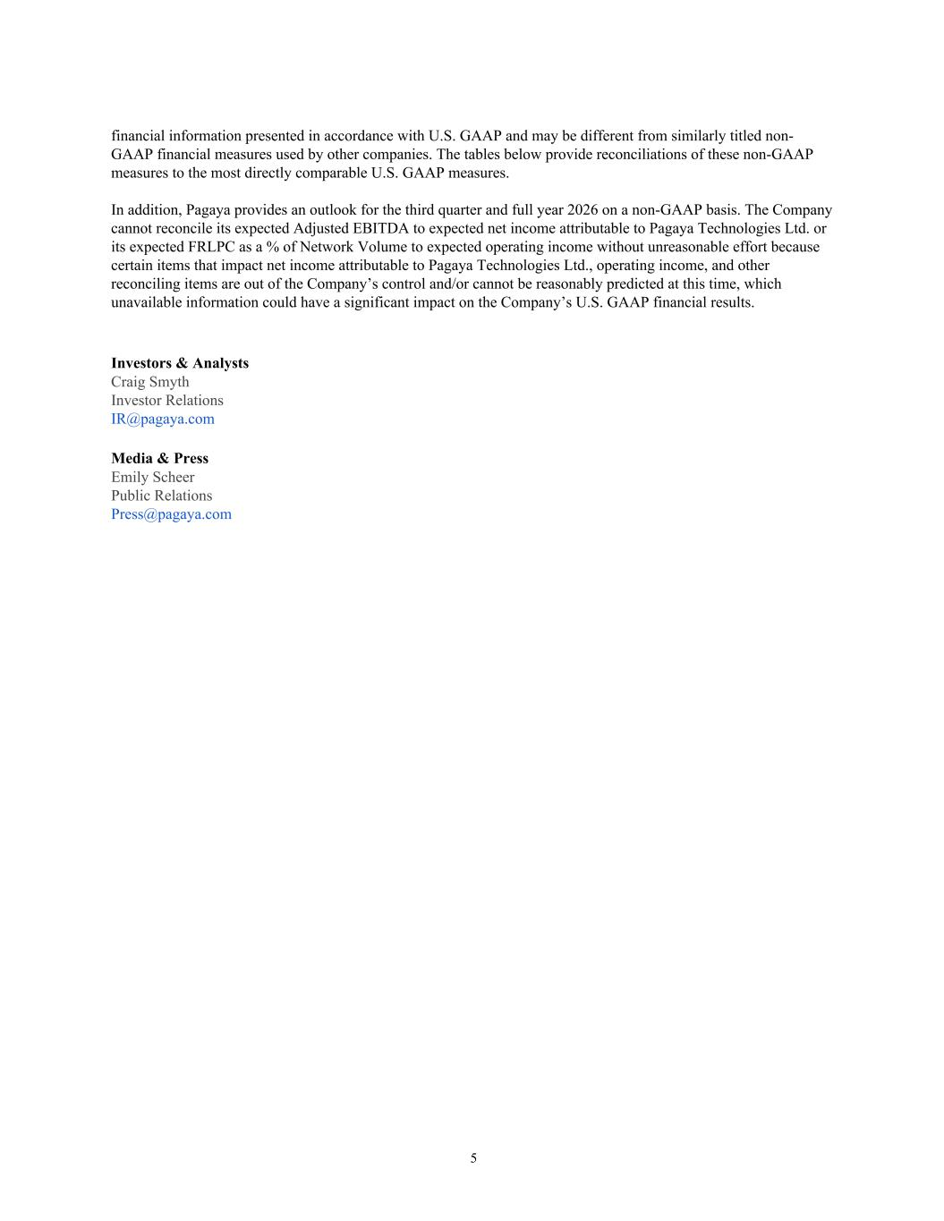
financial information presented in accordance with U.S. GAAP and may be different from similarly titled non- GAAP financial measures used by other companies. The tables below provide reconciliations of these non-GAAP measures to the most directly comparable U.S. GAAP measures. In addition, Pagaya provides an outlook for the third quarter and full year 2026 on a non-GAAP basis. The Company cannot reconcile its expected Adjusted EBITDA to expected net income attributable to Pagaya Technologies Ltd. or its expected FRLPC as a % of Network Volume to expected operating income without unreasonable effort because certain items that impact net income attributable to Pagaya Technologies Ltd., operating income, and other reconciling items are out of the Company’s control and/or cannot be reasonably predicted at this time, which unavailable information could have a significant impact on the Company’s U.S. GAAP financial results. Investors & Analysts Craig Smyth Investor Relations IR@pagaya.com Media & Press Emily Scheer Public Relations Press@pagaya.com 5

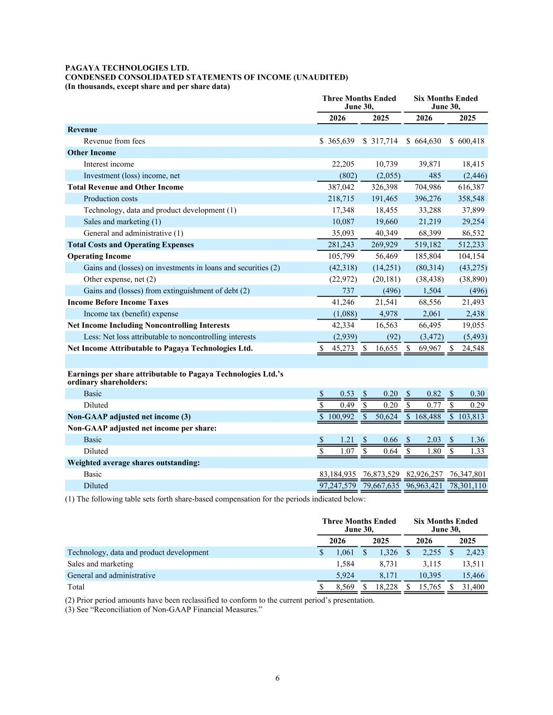
PAGAYA TECHNOLOGIES LTD. CONDENSED CONSOLIDATED STATEMENTS OF INCOME (UNAUDITED) (In thousands, except share and per share data) Three Months Ended June 30, Six Months Ended June 30, 2026 2025 2026 2025 Revenue Revenue from fees $ 365,639 $ 317,714 $ 664,630 $ 600,418 Other Income Interest income 22,205 10,739 39,871 18,415 Investment (loss) income, net (802) (2,055) 485 (2,446) Total Revenue and Other Income 387,042 326,398 704,986 616,387 Production costs 218,715 191,465 396,276 358,548 Technology, data and product development (1) 17,348 18,455 33,288 37,899 Sales and marketing (1) 10,087 19,660 21,219 29,254 General and administrative (1) 35,093 40,349 68,399 86,532 Total Costs and Operating Expenses 281,243 269,929 519,182 512,233 Operating Income 105,799 56,469 185,804 104,154 Gains and (losses) on investments in loans and securities (2) (42,318) (14,251) (80,314) (43,275) Other expense, net (2) (22,972) (20,181) (38,438) (38,890) Gains and (losses) from extinguishment of debt (2) 737 (496) 1,504 (496) Income Before Income Taxes 41,246 21,541 68,556 21,493 Income tax (benefit) expense (1,088) 4,978 2,061 2,438 Net Income Including Noncontrolling Interests 42,334 16,563 66,495 19,055 Less: Net loss attributable to noncontrolling interests (2,939) (92) (3,472) (5,493) Net Income Attributable to Pagaya Technologies Ltd. $ 45,273 $ 16,655 $ 69,967 $ 24,548 Earnings per share attributable to Pagaya Technologies Ltd.’s ordinary shareholders: Basic $ 0.53 $ 0.20 $ 0.82 $ 0.30 Diluted $ 0.49 $ 0.20 $ 0.77 $ 0.29 Non-GAAP adjusted net income (3) $ 100,992 $ 50,624 $ 168,488 $ 103,813 Non-GAAP adjusted net income per share: Basic $ 1.21 $ 0.66 $ 2.03 $ 1.36 Diluted $ 1.07 $ 0.64 $ 1.80 $ 1.33 Weighted average shares outstanding: Basic 83,184,935 76,873,529 82,926,257 76,347,801 Diluted 97,247,579 79,667,635 96,963,421 78,301,110 (1) The following table sets forth share-based compensation for the periods indicated below: Three Months Ended June 30, Six Months Ended June 30, 2026 2025 2026 2025 Technology, data and product development $ 1,061 $ 1,326 $ 2,255 $ 2,423 Sales and marketing 1,584 8,731 3,115 13,511 General and administrative 5,924 8,171 10,395 15,466 Total $ 8,569 $ 18,228 $ 15,765 $ 31,400 (2) Prior period amounts have been reclassified to conform to the current period’s presentation. (3) See “Reconciliation of Non-GAAP Financial Measures.” 6

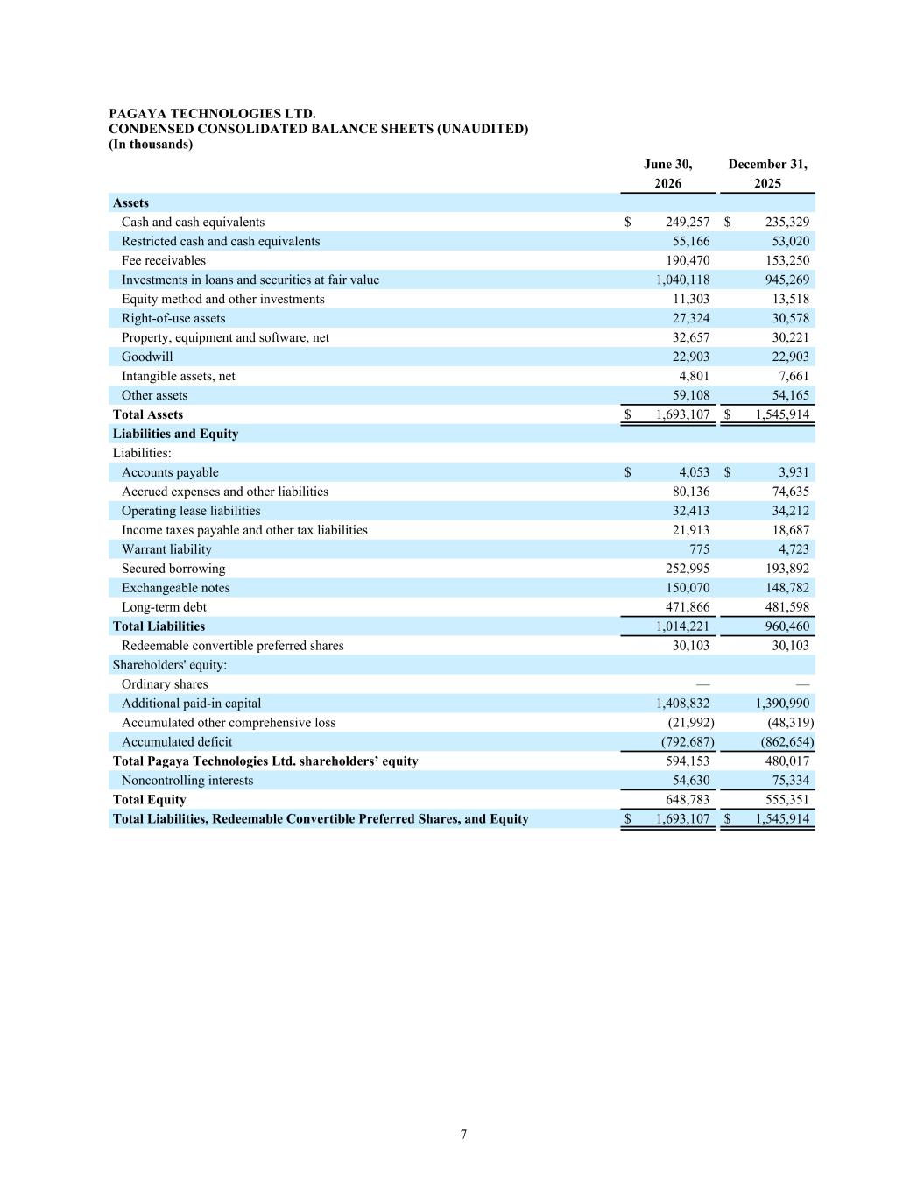
PAGAYA TECHNOLOGIES LTD. CONDENSED CONSOLIDATED BALANCE SHEETS (UNAUDITED) (In thousands) June 30, December 31, 2026 2025 Assets Cash and cash equivalents $ 249,257 $ 235,329 Restricted cash and cash equivalents 55,166 53,020 Fee receivables 190,470 153,250 Investments in loans and securities at fair value 1,040,118 945,269 Equity method and other investments 11,303 13,518 Right-of-use assets 27,324 30,578 Property, equipment and software, net 32,657 30,221 Goodwill 22,903 22,903 Intangible assets, net 4,801 7,661 Other assets 59,108 54,165 Total Assets $ 1,693,107 $ 1,545,914 Liabilities and Equity Liabilities: Accounts payable $ 4,053 $ 3,931 Accrued expenses and other liabilities 80,136 74,635 Operating lease liabilities 32,413 34,212 Income taxes payable and other tax liabilities 21,913 18,687 Warrant liability 775 4,723 Secured borrowing 252,995 193,892 Exchangeable notes 150,070 148,782 Long-term debt 471,866 481,598 Total Liabilities 1,014,221 960,460 Redeemable convertible preferred shares 30,103 30,103 Shareholders' equity: Ordinary shares — — Additional paid-in capital 1,408,832 1,390,990 Accumulated other comprehensive loss (21,992) (48,319) Accumulated deficit (792,687) (862,654) Total Pagaya Technologies Ltd. shareholders’ equity 594,153 480,017 Noncontrolling interests 54,630 75,334 Total Equity 648,783 555,351 Total Liabilities, Redeemable Convertible Preferred Shares, and Equity $ 1,693,107 $ 1,545,914 7

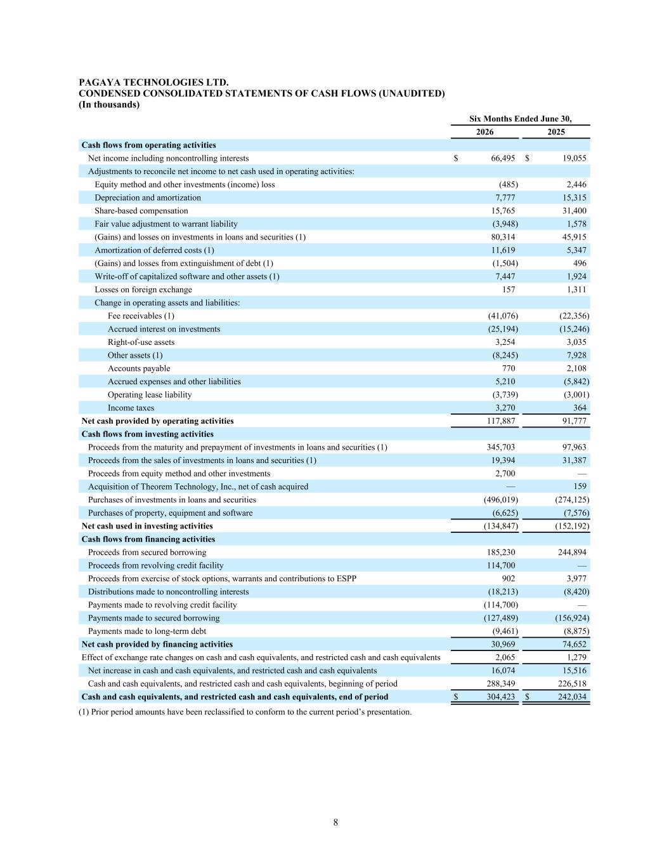
PAGAYA TECHNOLOGIES LTD. CONDENSED CONSOLIDATED STATEMENTS OF CASH FLOWS (UNAUDITED) (In thousands) Six Months Ended June 30, 2026 2025 Cash flows from operating activities Net income including noncontrolling interests $ 66,495 $ 19,055 Adjustments to reconcile net income to net cash used in operating activities: Equity method and other investments (income) loss (485) 2,446 Depreciation and amortization 7,777 15,315 Share-based compensation 15,765 31,400 Fair value adjustment to warrant liability (3,948) 1,578 (Gains) and losses on investments in loans and securities (1) 80,314 45,915 Amortization of deferred costs (1) 11,619 5,347 (Gains) and losses from extinguishment of debt (1) (1,504) 496 Write-off of capitalized software and other assets (1) 7,447 1,924 Losses on foreign exchange 157 1,311 Change in operating assets and liabilities: Fee receivables (1) (41,076) (22,356) Accrued interest on investments (25,194) (15,246) Right-of-use assets 3,254 3,035 Other assets (1) (8,245) 7,928 Accounts payable 770 2,108 Accrued expenses and other liabilities 5,210 (5,842) Operating lease liability (3,739) (3,001) Income taxes 3,270 364 Net cash provided by operating activities 117,887 91,777 Cash flows from investing activities Proceeds from the maturity and prepayment of investments in loans and securities (1) 345,703 97,963 Proceeds from the sales of investments in loans and securities (1) 19,394 31,387 Proceeds from equity method and other investments 2,700 — Acquisition of Theorem Technology, Inc., net of cash acquired — 159 Purchases of investments in loans and securities (496,019) (274,125) Purchases of property, equipment and software (6,625) (7,576) Net cash used in investing activities (134,847) (152,192) Cash flows from financing activities Proceeds from secured borrowing 185,230 244,894 Proceeds from revolving credit facility 114,700 — Proceeds from exercise of stock options, warrants and contributions to ESPP 902 3,977 Distributions made to noncontrolling interests (18,213) (8,420) Payments made to revolving credit facility (114,700) — Payments made to secured borrowing (127,489) (156,924) Payments made to long-term debt (9,461) (8,875) Net cash provided by financing activities 30,969 74,652 Effect of exchange rate changes on cash and cash equivalents, and restricted cash and cash equivalents 2,065 1,279 Net increase in cash and cash equivalents, and restricted cash and cash equivalents 16,074 15,516 Cash and cash equivalents, and restricted cash and cash equivalents, beginning of period 288,349 226,518 Cash and cash equivalents, and restricted cash and cash equivalents, end of period $ 304,423 $ 242,034 (1) Prior period amounts have been reclassified to conform to the current period’s presentation. 8

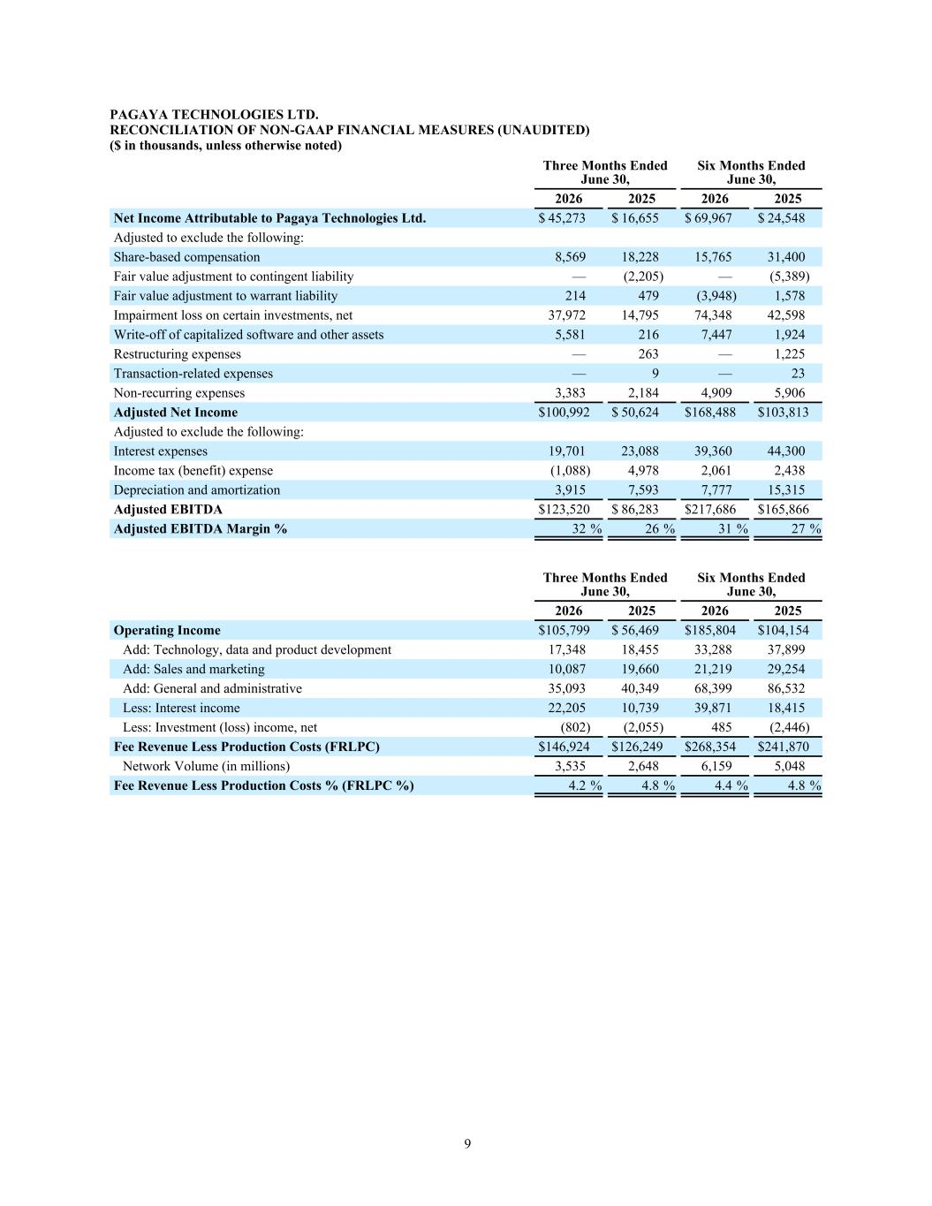
PAGAYA TECHNOLOGIES LTD. RECONCILIATION OF NON-GAAP FINANCIAL MEASURES (UNAUDITED) ($ in thousands, unless otherwise noted) Three Months Ended June 30, Six Months Ended June 30, 2026 2025 2026 2025 Net Income Attributable to Pagaya Technologies Ltd. $ 45,273 $ 16,655 $ 69,967 $ 24,548 Adjusted to exclude the following: Share-based compensation 8,569 18,228 15,765 31,400 Fair value adjustment to contingent liability — (2,205) — (5,389) Fair value adjustment to warrant liability 214 479 (3,948) 1,578 Impairment loss on certain investments, net 37,972 14,795 74,348 42,598 Write-off of capitalized software and other assets 5,581 216 7,447 1,924 Restructuring expenses — 263 — 1,225 Transaction-related expenses — 9 — 23 Non-recurring expenses 3,383 2,184 4,909 5,906 Adjusted Net Income $ 100,992 $ 50,624 $ 168,488 $ 103,813 Adjusted to exclude the following: Interest expenses 19,701 23,088 39,360 44,300 Income tax (benefit) expense (1,088) 4,978 2,061 2,438 Depreciation and amortization 3,915 7,593 7,777 15,315 Adjusted EBITDA $ 123,520 $ 86,283 $ 217,686 $ 165,866 Adjusted EBITDA Margin % 32 % 26 % 31 % 27 % Three Months Ended June 30, Six Months Ended June 30, 2026 2025 2026 2025 Operating Income $ 105,799 $ 56,469 $ 185,804 $ 104,154 Add: Technology, data and product development 17,348 18,455 33,288 37,899 Add: Sales and marketing 10,087 19,660 21,219 29,254 Add: General and administrative 35,093 40,349 68,399 86,532 Less: Interest income 22,205 10,739 39,871 18,415 Less: Investment (loss) income, net (802) (2,055) 485 (2,446) Fee Revenue Less Production Costs (FRLPC) $ 146,924 $ 126,249 $ 268,354 $ 241,870 Network Volume (in millions) 3,535 2,648 6,159 5,048 Fee Revenue Less Production Costs % (FRLPC %) 4.2 % 4.8 % 4.4 % 4.8 % 9

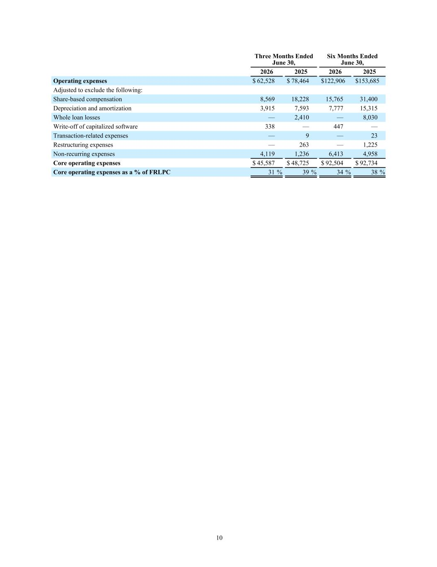
Three Months Ended June 30, Six Months Ended June 30, 2026 2025 2026 2025 Operating expenses $ 62,528 $ 78,464 $ 122,906 $ 153,685 Adjusted to exclude the following: Share-based compensation 8,569 18,228 15,765 31,400 Depreciation and amortization 3,915 7,593 7,777 15,315 Whole loan losses — 2,410 — 8,030 Write-off of capitalized software 338 — 447 — Transaction-related expenses — 9 — 23 Restructuring expenses — 263 — 1,225 Non-recurring expenses 4,119 1,236 6,413 4,958 Core operating expenses $ 45,587 $ 48,725 $ 92,504 $ 92,734 Core operating expenses as a % of FRLPC 31 % 39 % 34 % 38 % 10


Q1 Q2 Q3 Q4 Q2 Letter to Shareholders July 30, 2026

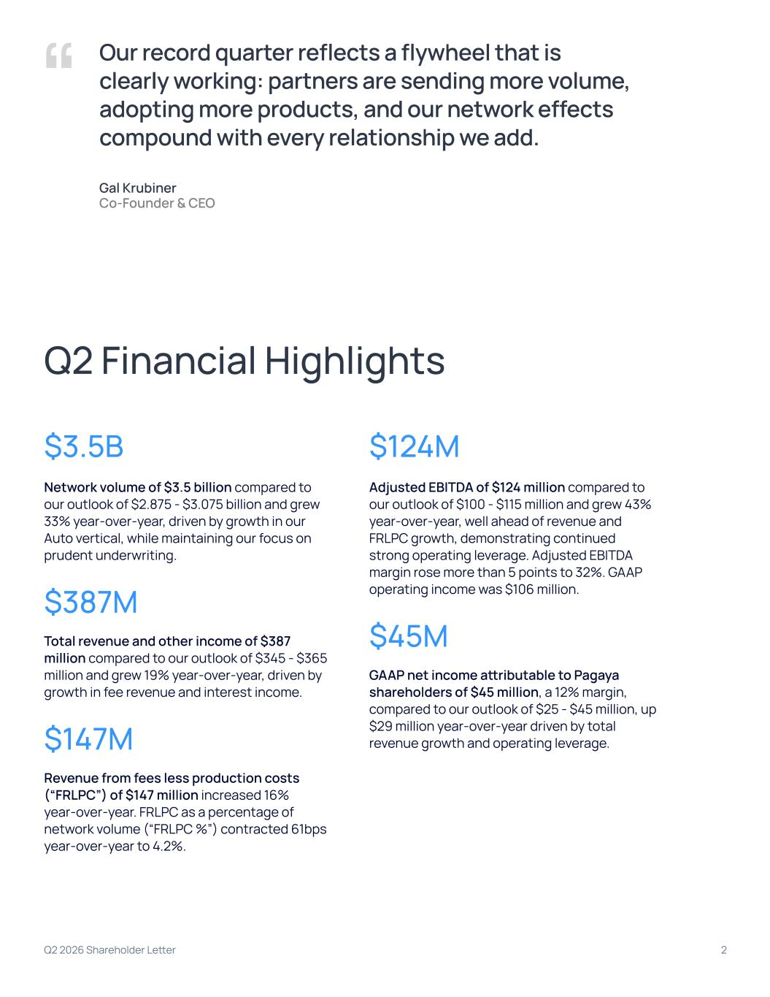
Q2 2026 Shareholder Letter 2 Q2 Financial Highlights $3.5B Network volume of $3.5 billion compared to our outlook of $2.875 - $3.075 billion and grew 33% year-over-year, driven by growth in our Auto vertical, while maintaining our focus on prudent underwriting. $387M Total revenue and other income of $387 million compared to our outlook of $345 - $365 million and grew 19% year-over-year, driven by growth in fee revenue and interest income. $147M Revenue from fees less production costs (“FRLPC”) of $147 million increased 16% year-over-year. FRLPC as a percentage of network volume (“FRLPC %”) contracted 61bps year-over-year to 4.2%. $124M Adjusted EBITDA of $124 million compared to our outlook of $100 - $115 million and grew 43% year-over-year, well ahead of revenue and FRLPC growth, demonstrating continued strong operating leverage. Adjusted EBITDA margin rose more than 5 points to 32%. GAAP operating income was $106 million. $45M GAAP net income attributable to Pagaya shareholders of $45 million, a 12% margin, compared to our outlook of $25 - $45 million, up $29 million year-over-year driven by total revenue growth and operating leverage. “ Our record quarter reflects a flywheel that is clearly working: partners are sending more volume, adopting more products, and our network effects compound with every relationship we add. Gal Krubiner Co-Founder & CEO

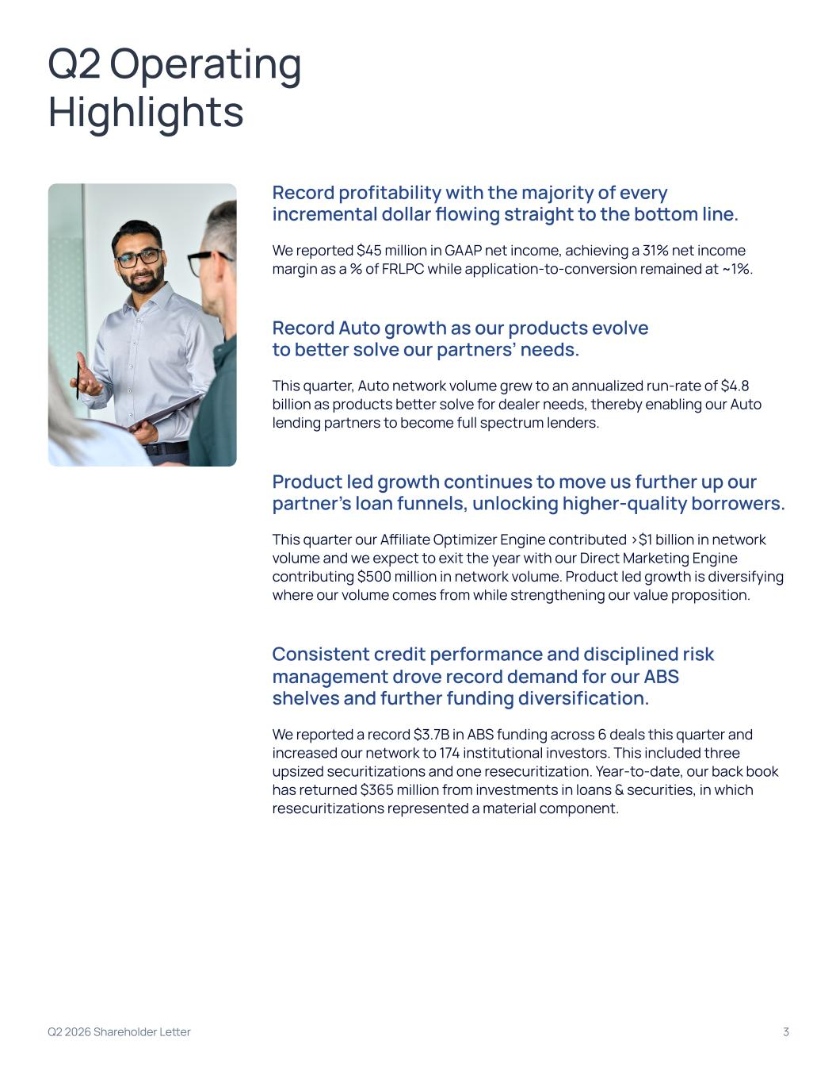
Record profitability with the majority of every incremental dollar flowing straight to the bottom line. We reported $45 million in GAAP net income, achieving a 31% net income margin as a % of FRLPC while application-to-conversion remained at ~1%. Record Auto growth as our products evolve to better solve our partners’ needs. This quarter, Auto network volume grew to an annualized run-rate of $4.8 billion as products better solve for dealer needs, thereby enabling our Auto lending partners to become full spectrum lenders. Product led growth continues to move us further up our partner’s loan funnels, unlocking higher-quality borrowers. This quarter our Affiliate Optimizer Engine contributed >$1 billion in network volume and we expect to exit the year with our Direct Marketing Engine contributing $500 million in network volume. Product led growth is diversifying where our volume comes from while strengthening our value proposition. Consistent credit performance and disciplined risk management drove record demand for our ABS shelves and further funding diversification. We reported a record $3.7B in ABS funding across 6 deals this quarter and increased our network to 174 institutional investors. This included three upsized securitizations and one resecuritization. Year-to-date, our back book has returned $365 million from investments in loans & securities, in which resecuritizations represented a material component. Q2 2026 Shareholder Letter 3 Q2 Operating Highlights

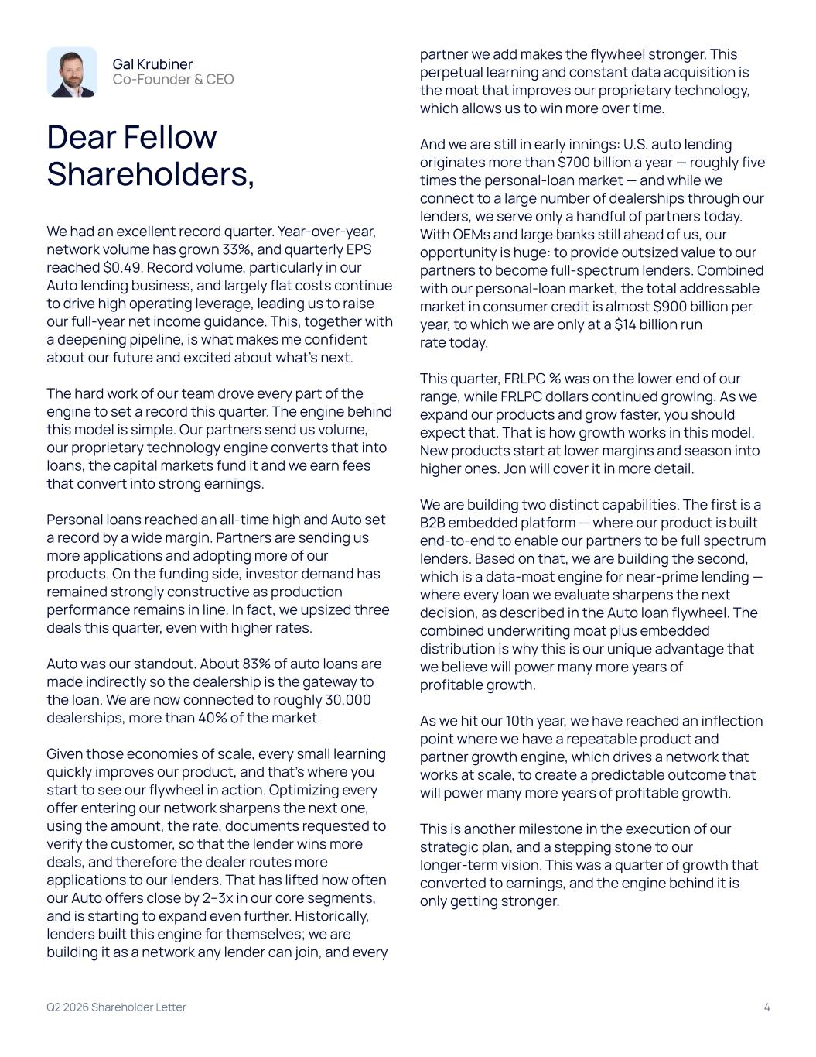
Q2 2026 Shareholder Letter 4 Gal Krubiner Co-Founder & CEO Dear Fellow Shareholders, We had an excellent record quarter. Year-over-year, network volume has grown 33%, and quarterly EPS reached $0.49. Record volume, particularly in our Auto lending business, and largely flat costs continue to drive high operating leverage, leading us to raise our full-year net income guidance. This, together with a deepening pipeline, is what makes me confident about our future and excited about what’s next. The hard work of our team drove every part of the engine to set a record this quarter. The engine behind this model is simple. Our partners send us volume, our proprietary technology engine converts that into loans, the capital markets fund it and we earn fees that convert into strong earnings. Personal loans reached an all-time high and Auto set a record by a wide margin. Partners are sending us more applications and adopting more of our products. On the funding side, investor demand has remained strongly constructive as production performance remains in line. In fact, we upsized three deals this quarter, even with higher rates. Auto was our standout. About 83% of auto loans are made indirectly so the dealership is the gateway to the loan. We are now connected to roughly 30,000 dealerships, more than 40% of the market. Given those economies of scale, every small learning quickly improves our product, and that’s where you start to see our flywheel in action. Optimizing every offer entering our network sharpens the next one, using the amount, the rate, documents requested to verify the customer, so that the lender wins more deals, and therefore the dealer routes more applications to our lenders. That has lifted how often our Auto offers close by 2–3x in our core segments, and is starting to expand even further. Historically, lenders built this engine for themselves; we are building it as a network any lender can join, and every partner we add makes the flywheel stronger. This perpetual learning and constant data acquisition is the moat that improves our proprietary technology, which allows us to win more over time. And we are still in early innings: U.S. auto lending originates more than $700 billion a year — roughly five times the personal-loan market — and while we connect to a large number of dealerships through our lenders, we serve only a handful of partners today. With OEMs and large banks still ahead of us, our opportunity is huge: to provide outsized value to our partners to become full-spectrum lenders. Combined with our personal-loan market, the total addressable market in consumer credit is almost $900 billion per year, to which we are only at a $14 billion run rate today. This quarter, FRLPC % was on the lower end of our range, while FRLPC dollars continued growing. As we expand our products and grow faster, you should expect that. That is how growth works in this model. New products start at lower margins and season into higher ones. Jon will cover it in more detail. We are building two distinct capabilities. The first is a B2B embedded platform — where our product is built end-to-end to enable our partners to be full spectrum lenders. Based on that, we are building the second, which is a data-moat engine for near-prime lending — where every loan we evaluate sharpens the next decision, as described in the Auto loan flywheel. The combined underwriting moat plus embedded distribution is why this is our unique advantage that we believe will power many more years of profitable growth. As we hit our 10th year, we have reached an inflection point where we have a repeatable product and partner growth engine, which drives a network that works at scale, to create a predictable outcome that will power many more years of profitable growth. This is another milestone in the execution of our strategic plan, and a stepping stone to our longer-term vision. This was a quarter of growth that converted to earnings, and the engine behind it is only getting stronger.

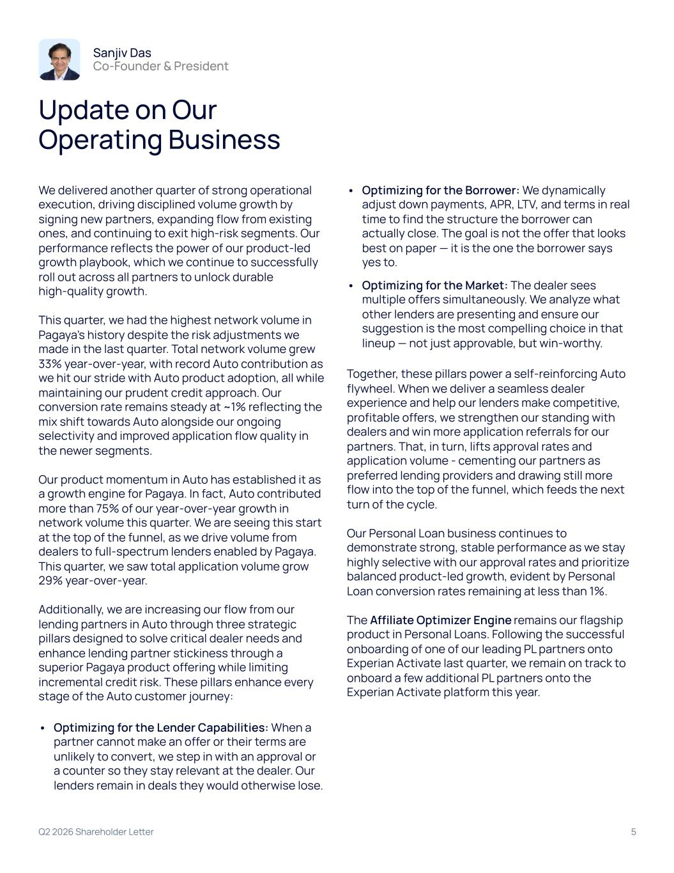
Q2 2026 Shareholder Letter 5 Sanjiv Das Co-Founder & President Update on Our Operating Business We delivered another quarter of strong operational execution, driving disciplined volume growth by signing new partners, expanding flow from existing ones, and continuing to exit high-risk segments. Our performance reflects the power of our product-led growth playbook, which we continue to successfully roll out across all partners to unlock durable high-quality growth. This quarter, we had the highest network volume in Pagaya’s history despite the risk adjustments we made in the last quarter. Total network volume grew 33% year-over-year, with record Auto contribution as we hit our stride with Auto product adoption, all while maintaining our prudent credit approach. Our conversion rate remains steady at ~1% reflecting the mix shift towards Auto alongside our ongoing selectivity and improved application flow quality in the newer segments. Our product momentum in Auto has established it as a growth engine for Pagaya. In fact, Auto contributed more than 75% of our year-over-year growth in network volume this quarter. We are seeing this start at the top of the funnel, as we drive volume from dealers to full-spectrum lenders enabled by Pagaya. This quarter, we saw total application volume grow 29% year-over-year. Additionally, we are increasing our flow from our lending partners in Auto through three strategic pillars designed to solve critical dealer needs and enhance lending partner stickiness through a superior Pagaya product offering while limiting incremental credit risk. These pillars enhance every stage of the Auto customer journey: • Optimizing for the Lender Capabilities: When a partner cannot make an offer or their terms are unlikely to convert, we step in with an approval or a counter so they stay relevant at the dealer. Our lenders remain in deals they would otherwise lose. • Optimizing for the Borrower: We dynamically adjust down payments, APR, LTV, and terms in real time to find the structure the borrower can actually close. The goal is not the offer that looks best on paper — it is the one the borrower says yes to. • Optimizing for the Market: The dealer sees multiple offers simultaneously. We analyze what other lenders are presenting and ensure our suggestion is the most compelling choice in that lineup — not just approvable, but win-worthy. Together, these pillars power a self-reinforcing Auto flywheel. When we deliver a seamless dealer experience and help our lenders make competitive, profitable offers, we strengthen our standing with dealers and win more application referrals for our partners. That, in turn, lifts approval rates and application volume - cementing our partners as preferred lending providers and drawing still more flow into the top of the funnel, which feeds the next turn of the cycle. Our Personal Loan business continues to demonstrate strong, stable performance as we stay highly selective with our approval rates and prioritize balanced product-led growth, evident by Personal Loan conversion rates remaining at less than 1%. The Affiliate Optimizer Engine remains our flagship product in Personal Loans. Following the successful onboarding of one of our leading PL partners onto Experian Activate last quarter, we remain on track to onboard a few additional PL partners onto the Experian Activate platform this year.

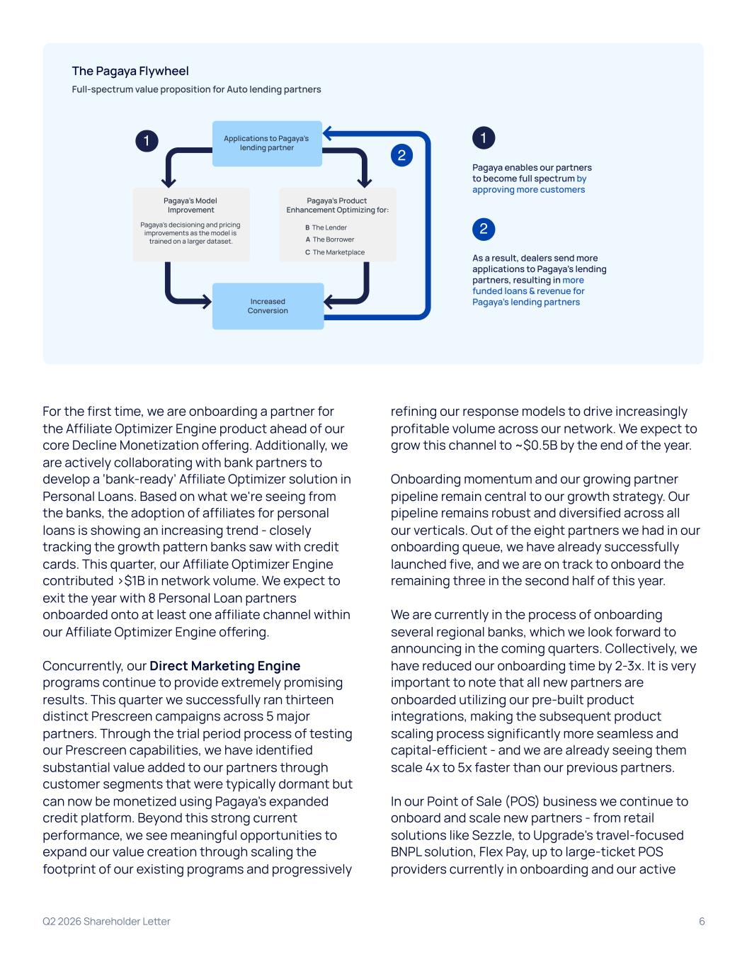
Increased Conversion Pagaya’s Model Improvement Pagaya’s decisioning and pricing improvements as the model is trained on a larger dataset. Pagaya’s Product Enhancement Optimizing for: B The Lender A The Borrower C The Marketplace Applications to Pagaya’s lending partner 1 2 1 Pagaya enables our partners to become full spectrum by approving more customers 2 As a result, dealers send more applications to Pagaya’s lending partners, resulting in more funded loans & revenue for Pagaya’s lending partners Full-spectrum value proposition for Auto lending partners The Pagaya Flywheel For the first time, we are onboarding a partner for the Affiliate Optimizer Engine product ahead of our core Decline Monetization offering. Additionally, we are actively collaborating with bank partners to develop a ‘bank-ready’ Affiliate Optimizer solution in Personal Loans. Based on what we're seeing from the banks, the adoption of affiliates for personal loans is showing an increasing trend - closely tracking the growth pattern banks saw with credit cards. This quarter, our Affiliate Optimizer Engine contributed >$1B in network volume. We expect to exit the year with 8 Personal Loan partners onboarded onto at least one affiliate channel within our Affiliate Optimizer Engine offering. Concurrently, our Direct Marketing Engine programs continue to provide extremely promising results. This quarter we successfully ran thirteen distinct Prescreen campaigns across 5 major partners. Through the trial period process of testing our Prescreen capabilities, we have identified substantial value added to our partners through customer segments that were typically dormant but can now be monetized using Pagaya’s expanded credit platform. Beyond this strong current performance, we see meaningful opportunities to expand our value creation through scaling the footprint of our existing programs and progressively refining our response models to drive increasingly profitable volume across our network. We expect to grow this channel to ~$0.5B by the end of the year. Onboarding momentum and our growing partner pipeline remain central to our growth strategy. Our pipeline remains robust and diversified across all our verticals. Out of the eight partners we had in our onboarding queue, we have already successfully launched five, and we are on track to onboard the remaining three in the second half of this year. We are currently in the process of onboarding several regional banks, which we look forward to announcing in the coming quarters. Collectively, we have reduced our onboarding time by 2-3x. It is very important to note that all new partners are onboarded utilizing our pre-built product integrations, making the subsequent product scaling process significantly more seamless and capital-efficient - and we are already seeing them scale 4x to 5x faster than our previous partners. In our Point of Sale (POS) business we continue to onboard and scale new partners - from retail solutions like Sezzle, to Upgrade's travel-focused BNPL solution, Flex Pay, up to large-ticket POS providers currently in onboarding and our active Q2 2026 Shareholder Letter 6

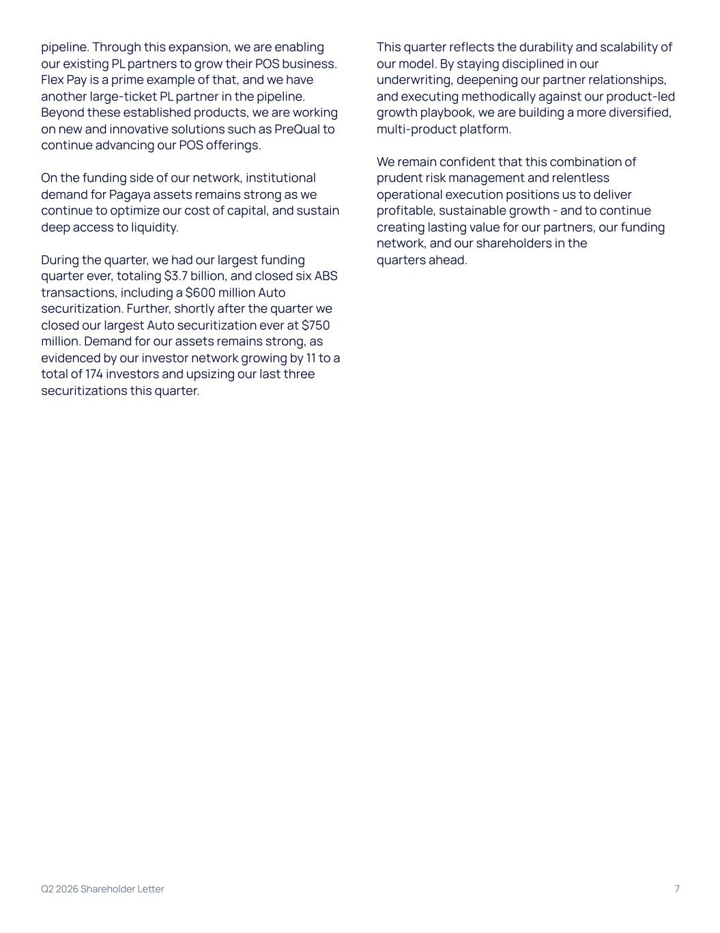
pipeline. Through this expansion, we are enabling our existing PL partners to grow their POS business. Flex Pay is a prime example of that, and we have another large-ticket PL partner in the pipeline. Beyond these established products, we are working on new and innovative solutions such as PreQual to continue advancing our POS offerings. On the funding side of our network, institutional demand for Pagaya assets remains strong as we continue to optimize our cost of capital, and sustain deep access to liquidity. During the quarter, we had our largest funding quarter ever, totaling $3.7 billion, and closed six ABS transactions, including a $600 million Auto securitization. Further, shortly after the quarter we closed our largest Auto securitization ever at $750 million. Demand for our assets remains strong, as evidenced by our investor network growing by 11 to a total of 174 investors and upsizing our last three securitizations this quarter. This quarter reflects the durability and scalability of our model. By staying disciplined in our underwriting, deepening our partner relationships, and executing methodically against our product-led growth playbook, we are building a more diversified, multi-product platform. We remain confident that this combination of prudent risk management and relentless operational execution positions us to deliver profitable, sustainable growth - and to continue creating lasting value for our partners, our funding network, and our shareholders in the quarters ahead. Q2 2026 Shareholder Letter 7

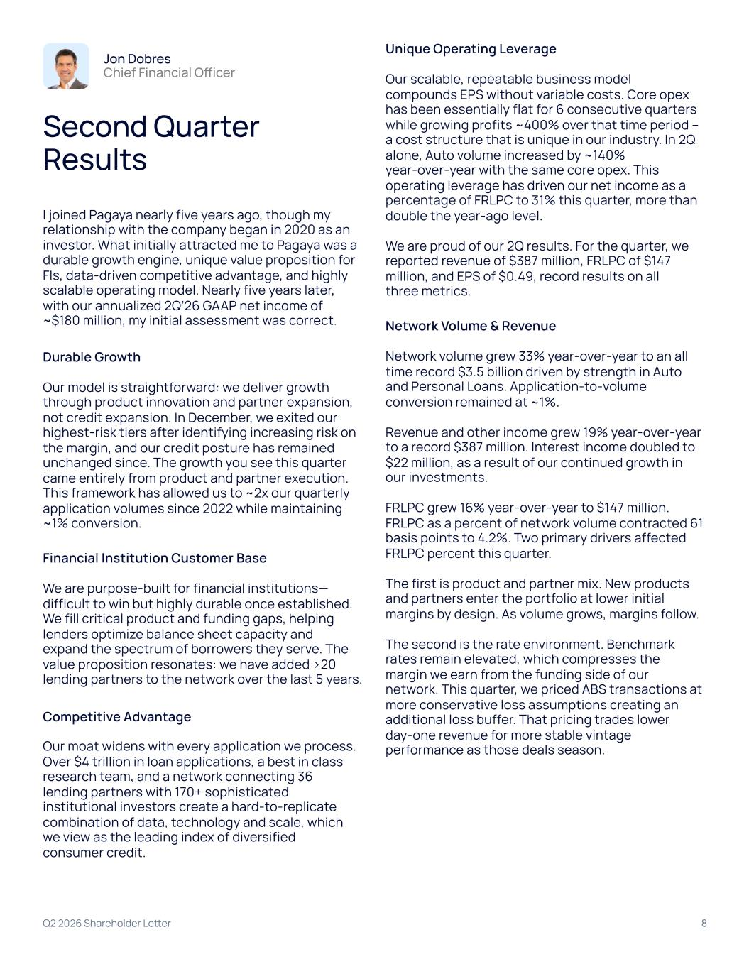
Q2 2026 Shareholder Letter 8 Jon Dobres Chief Financial Officer Second Quarter Results I joined Pagaya nearly five years ago, though my relationship with the company began in 2020 as an investor. What initially attracted me to Pagaya was a durable growth engine, unique value proposition for FIs, data-driven competitive advantage, and highly scalable operating model. Nearly five years later, with our annualized 2Q’26 GAAP net income of ~$180 million, my initial assessment was correct. Durable Growth Our model is straightforward: we deliver growth through product innovation and partner expansion, not credit expansion. In December, we exited our highest-risk tiers after identifying increasing risk on the margin, and our credit posture has remained unchanged since. The growth you see this quarter came entirely from product and partner execution. This framework has allowed us to ~2x our quarterly application volumes since 2022 while maintaining ~1% conversion. Financial Institution Customer Base We are purpose-built for financial institutions— difficult to win but highly durable once established. We fill critical product and funding gaps, helping lenders optimize balance sheet capacity and expand the spectrum of borrowers they serve. The value proposition resonates: we have added >20 lending partners to the network over the last 5 years. Competitive Advantage Our moat widens with every application we process. Over $4 trillion in loan applications, a best in class research team, and a network connecting 36 lending partners with 170+ sophisticated institutional investors create a hard-to-replicate combination of data, technology and scale, which we view as the leading index of diversified consumer credit. Unique Operating Leverage Our scalable, repeatable business model compounds EPS without variable costs. Core opex has been essentially flat for 6 consecutive quarters while growing profits ~400% over that time period – a cost structure that is unique in our industry. In 2Q alone, Auto volume increased by ~140% year-over-year with the same core opex. This operating leverage has driven our net income as a percentage of FRLPC to 31% this quarter, more than double the year-ago level. We are proud of our 2Q results. For the quarter, we reported revenue of $387 million, FRLPC of $147 million, and EPS of $0.49, record results on all three metrics. Network Volume & Revenue Network volume grew 33% year-over-year to an all time record $3.5 billion driven by strength in Auto and Personal Loans. Application-to-volume conversion remained at ~1%. Revenue and other income grew 19% year-over-year to a record $387 million. Interest income doubled to $22 million, as a result of our continued growth in our investments. FRLPC grew 16% year-over-year to $147 million. FRLPC as a percent of network volume contracted 61 basis points to 4.2%. Two primary drivers affected FRLPC percent this quarter. The first is product and partner mix. New products and partners enter the portfolio at lower initial margins by design. As volume grows, margins follow. The second is the rate environment. Benchmark rates remain elevated, which compresses the margin we earn from the funding side of our network. This quarter, we priced ABS transactions at more conservative loss assumptions creating an additional loss buffer. That pricing trades lower day-one revenue for more stable vintage performance as those deals season.

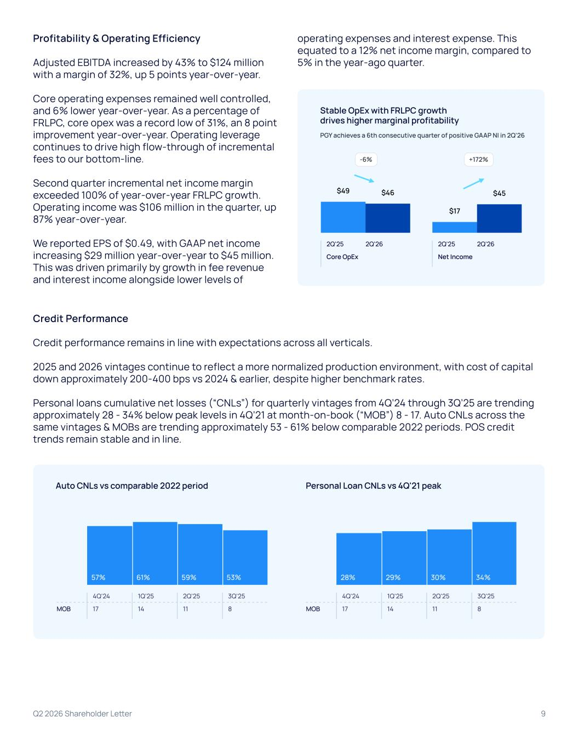
Q2 2026 Shareholder Letter 9 Profitability & Operating Efficiency Adjusted EBITDA increased by 43% to $124 million with a margin of 32%, up 5 points year-over-year. Core operating expenses remained well controlled, and 6% lower year-over-year. As a percentage of FRLPC, core opex was a record low of 31%, an 8 point improvement year-over-year. Operating leverage continues to drive high flow-through of incremental fees to our bottom-line. Second quarter incremental net income margin exceeded 100% of year-over-year FRLPC growth. Operating income was $106 million in the quarter, up 87% year-over-year. We reported EPS of $0.49, with GAAP net income increasing $29 million year-over-year to $45 million. This was driven primarily by growth in fee revenue and interest income alongside lower levels of operating expenses and interest expense. This equated to a 12% net income margin, compared to 5% in the year-ago quarter. Stable OpEx with FRLPC growth drives higher marginal profitability PGY achieves a 6th consecutive quarter of positive GAAP NI in 2Q'26 -6% +172% $4​9‌ $4​6‌ $1​7‌ $4​5‌ 2Q'25 2Q'26 2Q'25 2Q'26 Core OpEx Net Income Credit Performance Credit performance remains in line with expectations across all verticals. 2025 and 2026 vintages continue to reflect a more normalized production environment, with cost of capital down approximately 200-400 bps vs 2024 & earlier, despite higher benchmark rates. Personal loans cumulative net losses (“CNLs”) for quarterly vintages from 4Q’24 through 3Q’25 are trending approximately 28 - 34% below peak levels in 4Q’21 at month-on-book (“MOB”) 8 - 17. Auto CNLs across the same vintages & MOBs are trending approximately 53 - 61% below comparable 2022 periods. POS credit trends remain stable and in line. 57% 61% 59% 53% 4Q'24 1Q'25 2Q'25 3Q'25 MOB 17 14 11 8 28% 29% 30% 34% 4Q'24 1Q'25 2Q'25 3Q'25 MOB 17 14 11 8 Auto CNLs vs comparable 2022 period Personal Loan CNLs vs 4Q'21 peak

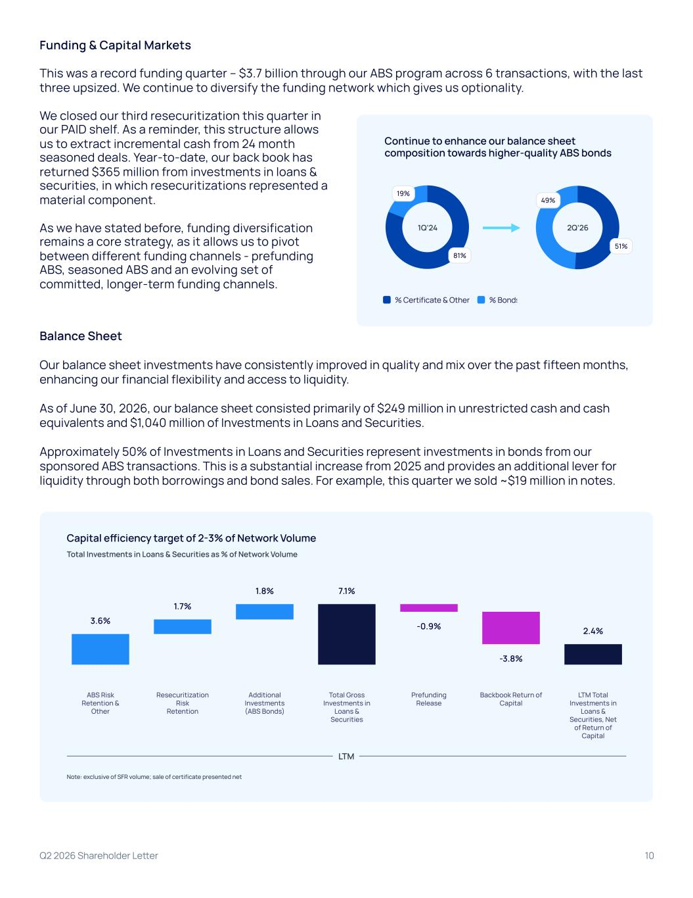
Funding & Capital Markets This was a record funding quarter – $3.7 billion through our ABS program across 6 transactions, with the last three upsized. We continue to diversify the funding network which gives us optionality. We closed our third resecuritization this quarter in our PAID shelf. As a reminder, this structure allows us to extract incremental cash from 24 month seasoned deals. Year-to-date, our back book has returned $365 million from investments in loans & securities, in which resecuritizations represented a material component. As we have stated before, funding diversification remains a core strategy, as it allows us to pivot between different funding channels - prefunding ABS, seasoned ABS and an evolving set of committed, longer-term funding channels. Balance Sheet Our balance sheet investments have consistently improved in quality and mix over the past fifteen months, enhancing our financial flexibility and access to liquidity. As of June 30, 2026, our balance sheet consisted primarily of $249 million in unrestricted cash and cash equivalents and $1,040 million of Investments in Loans and Securities. Approximately 50% of Investments in Loans and Securities represent investments in bonds from our sponsored ABS transactions. This is a substantial increase from 2025 and provides an additional lever for liquidity through both borrowings and bond sales. For example, this quarter we sold ~$19 million in notes. Capital efficiency target of 2-3% of Network Volume Total Investments in Loans & Securities as % of Network Volume Note: exclusive of SFR volume; sale of certificate presented net 3.6%‌ 1.7%‌ 1.8%‌ 7.1%‌ -0.9%‌ -3.8%‌ 2.4%‌ ABS Risk Retention & Other Resecuritization Risk Retention Additional Investments (ABS Bonds) Total Gross Investments in Loans & Securities Prefunding Release Backbook Return of Capital LTM Total Investments in Loans & Securities, Net of Return of Capital LTM Continue to enhance our balance sheet composition towards higher-quality ABS bonds 1​9%‌ 8​1%‌ 5​1%‌ 4​9%‌ % Certificate & Other % Bonds 1Q’24 2Q’26 Q2 2026 Shareholder Letter 10

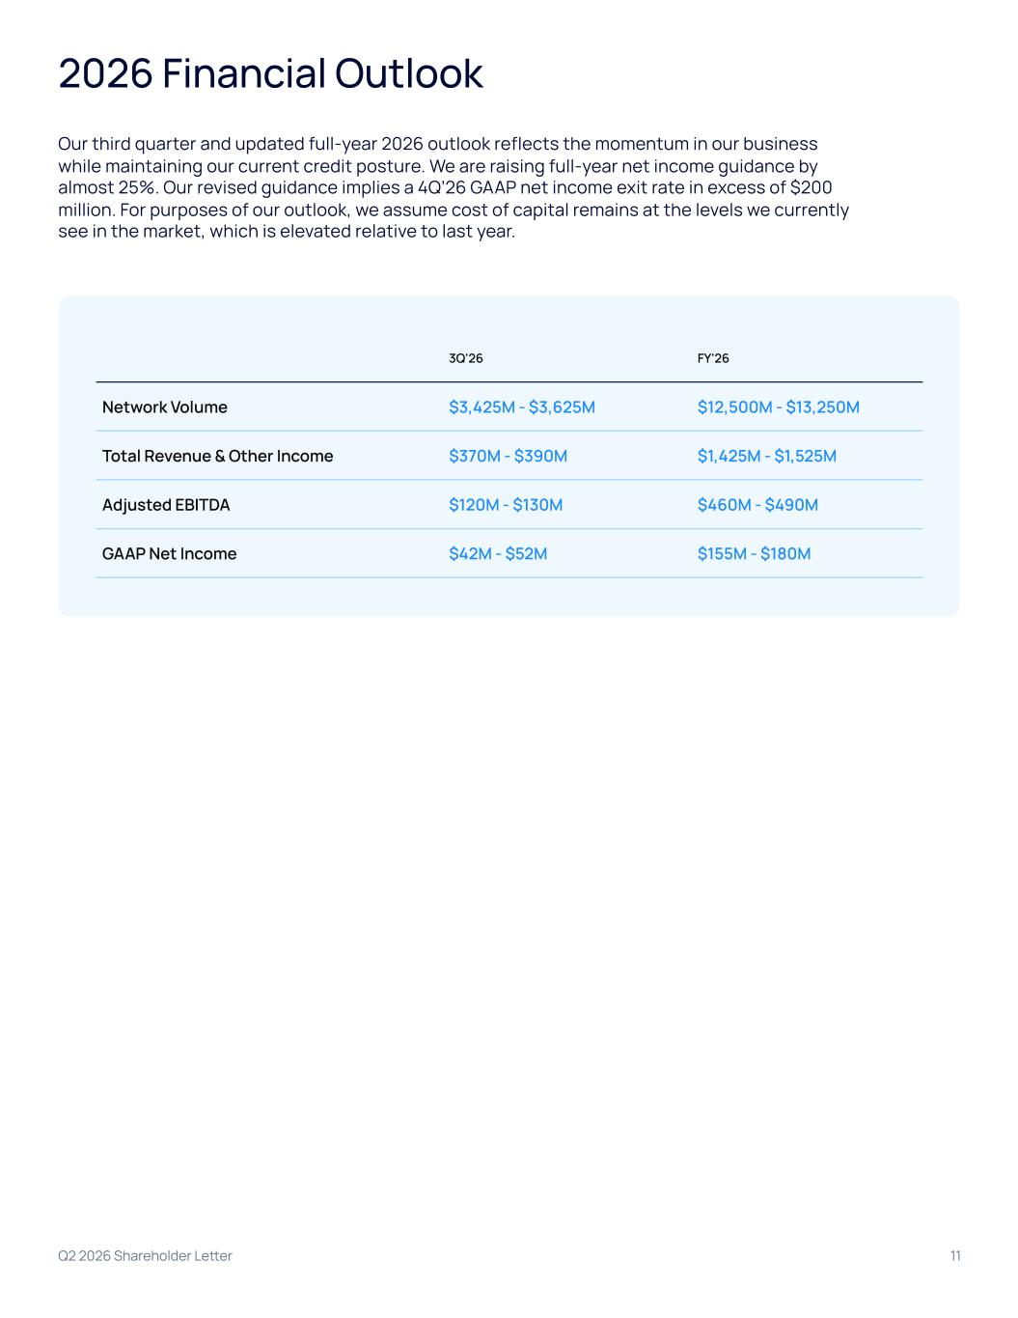
Q2 2026 Shareholder Letter 11 2026 Financial Outlook Our third quarter and updated full-year 2026 outlook reflects the momentum in our business while maintaining our current credit posture. We are raising full-year net income guidance by almost 25%. Our revised guidance implies a 4Q’26 GAAP net income exit rate in excess of $200 million. For purposes of our outlook, we assume cost of capital remains at the levels we currently see in the market, which is elevated relative to last year. 3Q'26 FY'26 Network Volume $3,425M - $3,625M $12,500M - $13,250M Total Revenue & Other Income $370M - $390M $1,425M - $1,525M Adjusted EBITDA $120M - $130M $460M - $490M GAAP Net Income $42M - $52M $155M - $180M

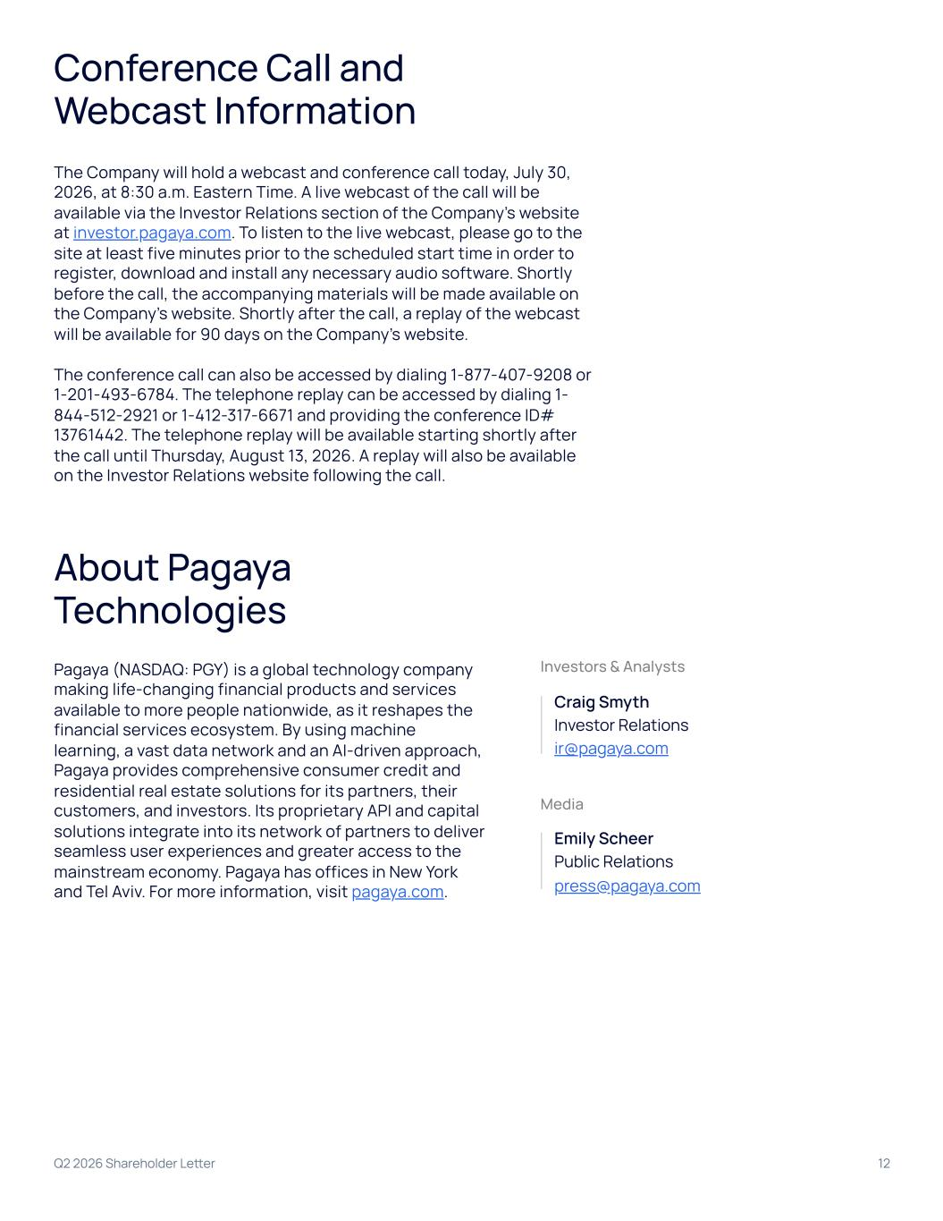
Q2 2026 Shareholder Letter 12 Conference Call and Webcast Information The Company will hold a webcast and conference call today, July 30, 2026, at 8:30 a.m. Eastern Time. A live webcast of the call will be available via the Investor Relations section of the Company’s website at investor.pagaya.com. To listen to the live webcast, please go to the site at least five minutes prior to the scheduled start time in order to register, download and install any necessary audio software. Shortly before the call, the accompanying materials will be made available on the Company’s website. Shortly after the call, a replay of the webcast will be available for 90 days on the Company’s website. The conference call can also be accessed by dialing 1-877-407-9208 or 1-201-493-6784. The telephone replay can be accessed by dialing 1- 844-512-2921 or 1-412-317-6671 and providing the conference ID# 13761442. The telephone replay will be available starting shortly after the call until Thursday, August 13, 2026. A replay will also be available on the Investor Relations website following the call. About Pagaya Technologies Pagaya (NASDAQ: PGY) is a global technology company making life-changing financial products and services available to more people nationwide, as it reshapes the financial services ecosystem. By using machine learning, a vast data network and an AI-driven approach, Pagaya provides comprehensive consumer credit and residential real estate solutions for its partners, their customers, and investors. Its proprietary API and capital solutions integrate into its network of partners to deliver seamless user experiences and greater access to the mainstream economy. Pagaya has offices in New York and Tel Aviv. For more information, visit pagaya.com. Investors & Analysts Craig Smyth Investor Relations ir@pagaya.com Media Emily Scheer Public Relations press@pagaya.com

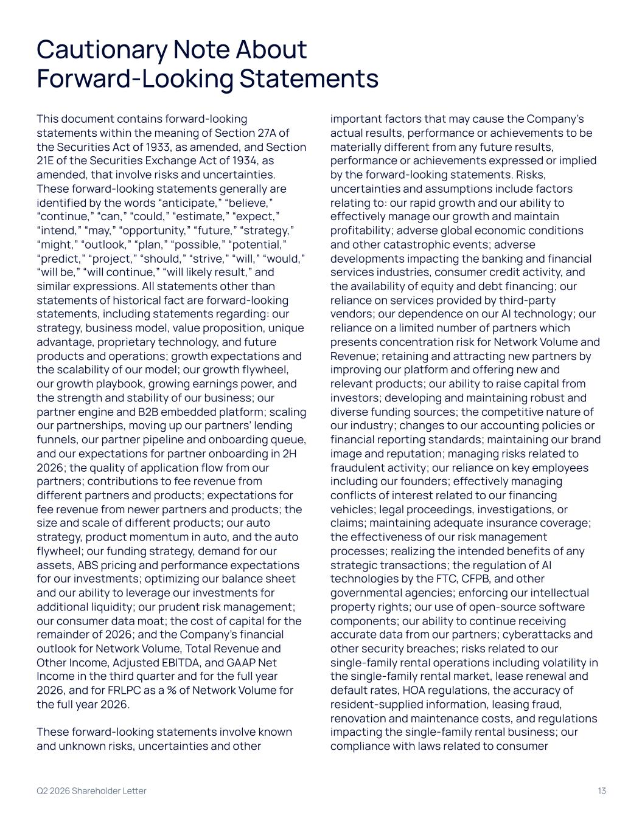
Q2 2026 Shareholder Letter 13 Cautionary Note About Forward-Looking Statements This document contains forward-looking statements within the meaning of Section 27A of the Securities Act of 1933, as amended, and Section 21E of the Securities Exchange Act of 1934, as amended, that involve risks and uncertainties. These forward-looking statements generally are identified by the words “anticipate,” “believe,” “continue,” “can,” “could,” “estimate,” “expect,” “intend,” “may,” “opportunity,” “future,” “strategy,” “might,” “outlook,” “plan,” “possible,” “potential,” “predict,” “project,” “should,” “strive,” “will,” “would,” “will be,” “will continue,” “will likely result,” and similar expressions. All statements other than statements of historical fact are forward-looking statements, including statements regarding: our strategy, business model, value proposition, unique advantage, proprietary technology, and future products and operations; growth expectations and the scalability of our model; our growth flywheel, our growth playbook, growing earnings power, and the strength and stability of our business; our partner engine and B2B embedded platform; scaling our partnerships, moving up our partners’ lending funnels, our partner pipeline and onboarding queue, and our expectations for partner onboarding in 2H 2026; the quality of application flow from our partners; contributions to fee revenue from different partners and products; expectations for fee revenue from newer partners and products; the size and scale of different products; our auto strategy, product momentum in auto, and the auto flywheel; our funding strategy, demand for our assets, ABS pricing and performance expectations for our investments; optimizing our balance sheet and our ability to leverage our investments for additional liquidity; our prudent risk management; our consumer data moat; the cost of capital for the remainder of 2026; and the Company’s financial outlook for Network Volume, Total Revenue and Other Income, Adjusted EBITDA, and GAAP Net Income in the third quarter and for the full year 2026, and for FRLPC as a % of Network Volume for the full year 2026. These forward-looking statements involve known and unknown risks, uncertainties and other important factors that may cause the Company’s actual results, performance or achievements to be materially different from any future results, performance or achievements expressed or implied by the forward-looking statements. Risks, uncertainties and assumptions include factors relating to: our rapid growth and our ability to effectively manage our growth and maintain profitability; adverse global economic conditions and other catastrophic events; adverse developments impacting the banking and financial services industries, consumer credit activity, and the availability of equity and debt financing; our reliance on services provided by third-party vendors; our dependence on our AI technology; our reliance on a limited number of partners which presents concentration risk for Network Volume and Revenue; retaining and attracting new partners by improving our platform and offering new and relevant products; our ability to raise capital from investors; developing and maintaining robust and diverse funding sources; the competitive nature of our industry; changes to our accounting policies or financial reporting standards; maintaining our brand image and reputation; managing risks related to fraudulent activity; our reliance on key employees including our founders; effectively managing conflicts of interest related to our financing vehicles; legal proceedings, investigations, or claims; maintaining adequate insurance coverage; the effectiveness of our risk management processes; realizing the intended benefits of any strategic transactions; the regulation of AI technologies by the FTC, CFPB, and other governmental agencies; enforcing our intellectual property rights; our use of open-source software components; our ability to continue receiving accurate data from our partners; cyberattacks and other security breaches; risks related to our single-family rental operations including volatility in the single-family rental market, lease renewal and default rates, HOA regulations, the accuracy of resident-supplied information, leasing fraud, renovation and maintenance costs, and regulations impacting the single-family rental business; our compliance with laws related to consumer

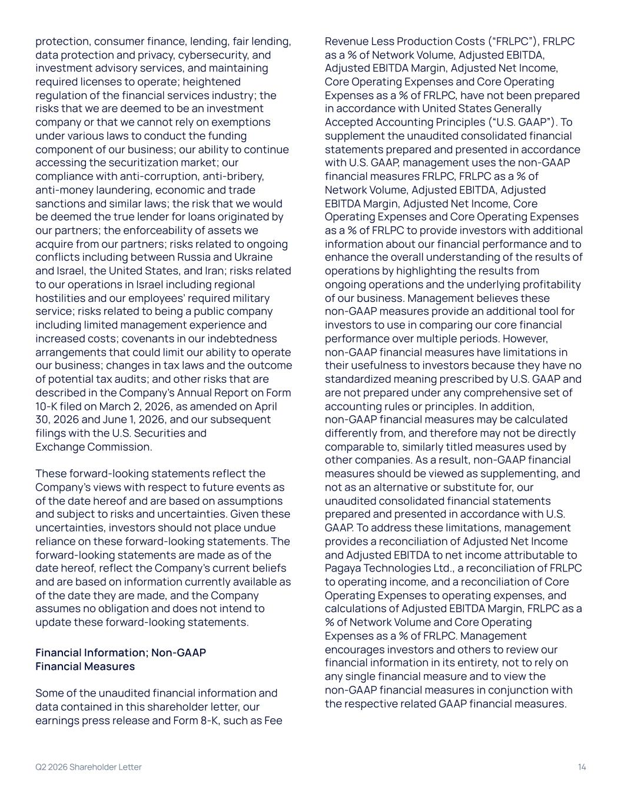
protection, consumer finance, lending, fair lending, data protection and privacy, cybersecurity, and investment advisory services, and maintaining required licenses to operate; heightened regulation of the financial services industry; the risks that we are deemed to be an investment company or that we cannot rely on exemptions under various laws to conduct the funding component of our business; our ability to continue accessing the securitization market; our compliance with anti-corruption, anti-bribery, anti-money laundering, economic and trade sanctions and similar laws; the risk that we would be deemed the true lender for loans originated by our partners; the enforceability of assets we acquire from our partners; risks related to ongoing conflicts including between Russia and Ukraine and Israel, the United States, and Iran; risks related to our operations in Israel including regional hostilities and our employees’ required military service; risks related to being a public company including limited management experience and increased costs; covenants in our indebtedness arrangements that could limit our ability to operate our business; changes in tax laws and the outcome of potential tax audits; and other risks that are described in the Company’s Annual Report on Form 10-K filed on March 2, 2026, as amended on April 30, 2026 and June 1, 2026, and our subsequent filings with the U.S. Securities and Exchange Commission. These forward-looking statements reflect the Company’s views with respect to future events as of the date hereof and are based on assumptions and subject to risks and uncertainties. Given these uncertainties, investors should not place undue reliance on these forward-looking statements. The forward-looking statements are made as of the date hereof, reflect the Company’s current beliefs and are based on information currently available as of the date they are made, and the Company assumes no obligation and does not intend to update these forward-looking statements. Financial Information; Non-GAAP Financial Measures Some of the unaudited financial information and data contained in this shareholder letter, our earnings press release and Form 8-K, such as Fee Revenue Less Production Costs (“FRLPC”), FRLPC as a % of Network Volume, Adjusted EBITDA, Adjusted EBITDA Margin, Adjusted Net Income, Core Operating Expenses and Core Operating Expenses as a % of FRLPC, have not been prepared in accordance with United States Generally Accepted Accounting Principles (“U.S. GAAP”). To supplement the unaudited consolidated financial statements prepared and presented in accordance with U.S. GAAP, management uses the non-GAAP financial measures FRLPC, FRLPC as a % of Network Volume, Adjusted EBITDA, Adjusted EBITDA Margin, Adjusted Net Income, Core Operating Expenses and Core Operating Expenses as a % of FRLPC to provide investors with additional information about our financial performance and to enhance the overall understanding of the results of operations by highlighting the results from ongoing operations and the underlying profitability of our business. Management believes these non-GAAP measures provide an additional tool for investors to use in comparing our core financial performance over multiple periods. However, non-GAAP financial measures have limitations in their usefulness to investors because they have no standardized meaning prescribed by U.S. GAAP and are not prepared under any comprehensive set of accounting rules or principles. In addition, non-GAAP financial measures may be calculated differently from, and therefore may not be directly comparable to, similarly titled measures used by other companies. As a result, non-GAAP financial measures should be viewed as supplementing, and not as an alternative or substitute for, our unaudited consolidated financial statements prepared and presented in accordance with U.S. GAAP. To address these limitations, management provides a reconciliation of Adjusted Net Income and Adjusted EBITDA to net income attributable to Pagaya Technologies Ltd., a reconciliation of FRLPC to operating income, and a reconciliation of Core Operating Expenses to operating expenses, and calculations of Adjusted EBITDA Margin, FRLPC as a % of Network Volume and Core Operating Expenses as a % of FRLPC. Management encourages investors and others to review our financial information in its entirety, not to rely on any single financial measure and to view the non-GAAP financial measures in conjunction with the respective related GAAP financial measures. Q2 2026 Shareholder Letter 14

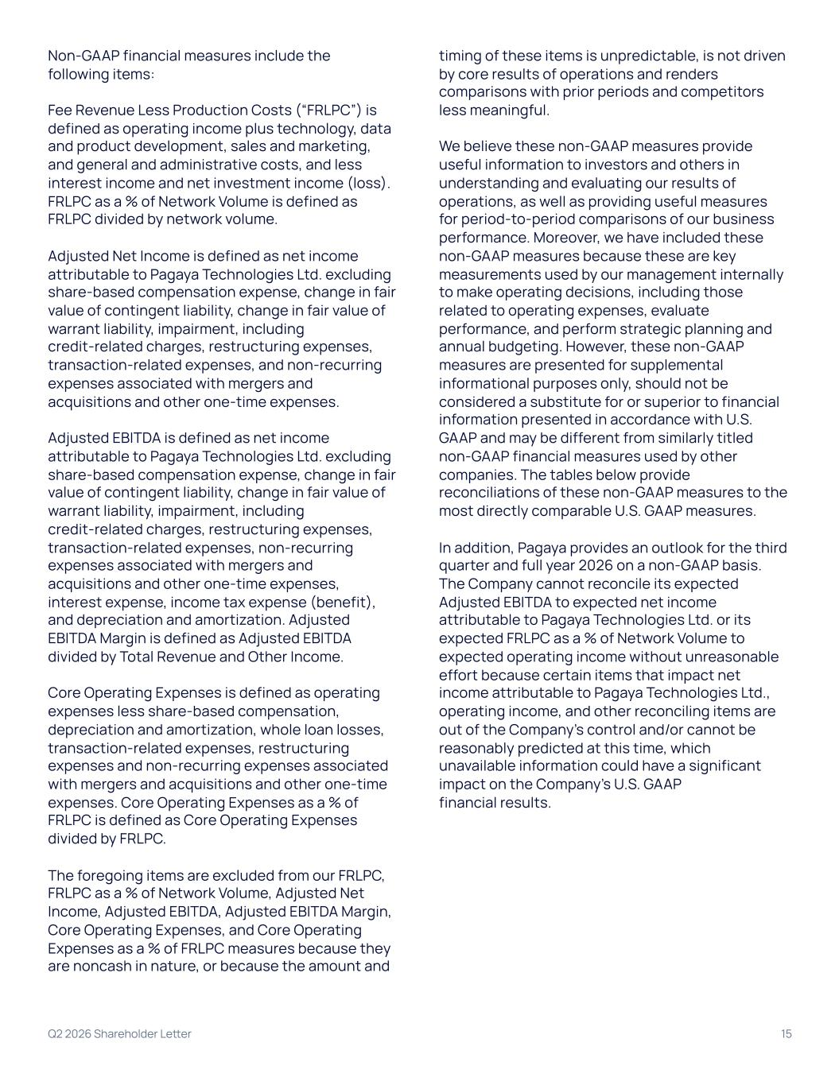
Non-GAAP financial measures include the following items: Fee Revenue Less Production Costs (“FRLPC”) is defined as operating income plus technology, data and product development, sales and marketing, and general and administrative costs, and less interest income and net investment income (loss). FRLPC as a % of Network Volume is defined as FRLPC divided by network volume. Adjusted Net Income is defined as net income attributable to Pagaya Technologies Ltd. excluding share-based compensation expense, change in fair value of contingent liability, change in fair value of warrant liability, impairment, including credit-related charges, restructuring expenses, transaction-related expenses, and non-recurring expenses associated with mergers and acquisitions and other one-time expenses. Adjusted EBITDA is defined as net income attributable to Pagaya Technologies Ltd. excluding share-based compensation expense, change in fair value of contingent liability, change in fair value of warrant liability, impairment, including credit-related charges, restructuring expenses, transaction-related expenses, non-recurring expenses associated with mergers and acquisitions and other one-time expenses, interest expense, income tax expense (benefit), and depreciation and amortization. Adjusted EBITDA Margin is defined as Adjusted EBITDA divided by Total Revenue and Other Income. Core Operating Expenses is defined as operating expenses less share-based compensation, depreciation and amortization, whole loan losses, transaction-related expenses, restructuring expenses and non-recurring expenses associated with mergers and acquisitions and other one-time expenses. Core Operating Expenses as a % of FRLPC is defined as Core Operating Expenses divided by FRLPC. The foregoing items are excluded from our FRLPC, FRLPC as a % of Network Volume, Adjusted Net Income, Adjusted EBITDA, Adjusted EBITDA Margin, Core Operating Expenses, and Core Operating Expenses as a % of FRLPC measures because they are noncash in nature, or because the amount and timing of these items is unpredictable, is not driven by core results of operations and renders comparisons with prior periods and competitors less meaningful. We believe these non-GAAP measures provide useful information to investors and others in understanding and evaluating our results of operations, as well as providing useful measures for period-to-period comparisons of our business performance. Moreover, we have included these non-GAAP measures because these are key measurements used by our management internally to make operating decisions, including those related to operating expenses, evaluate performance, and perform strategic planning and annual budgeting. However, these non-GAAP measures are presented for supplemental informational purposes only, should not be considered a substitute for or superior to financial information presented in accordance with U.S. GAAP and may be different from similarly titled non-GAAP financial measures used by other companies. The tables below provide reconciliations of these non-GAAP measures to the most directly comparable U.S. GAAP measures. In addition, Pagaya provides an outlook for the third quarter and full year 2026 on a non-GAAP basis. The Company cannot reconcile its expected Adjusted EBITDA to expected net income attributable to Pagaya Technologies Ltd. or its expected FRLPC as a % of Network Volume to expected operating income without unreasonable effort because certain items that impact net income attributable to Pagaya Technologies Ltd., operating income, and other reconciling items are out of the Company’s control and/or cannot be reasonably predicted at this time, which unavailable information could have a significant impact on the Company’s U.S. GAAP financial results. Q2 2026 Shareholder Letter 15

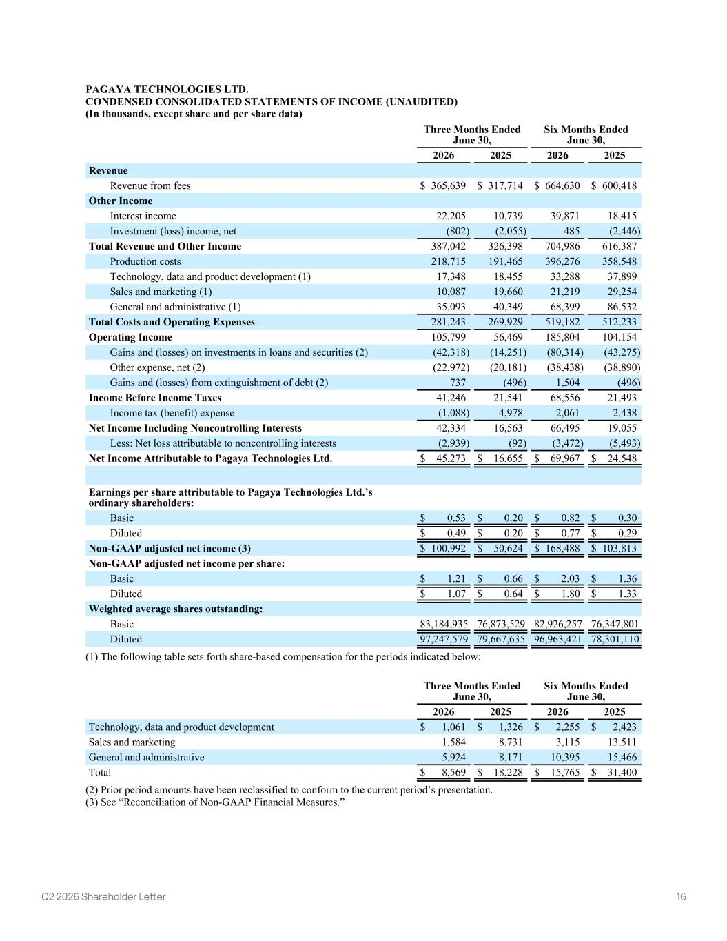
PAGAYA TECHNOLOGIES LTD. CONDENSED CONSOLIDATED STATEMENTS OF INCOME (UNAUDITED) (In thousands, except share and per share data) Three Months Ended June 30, Six Months Ended June 30, 2026 2025 2026 2025 Revenue Revenue from fees $ 365,639 $ 317,714 $ 664,630 $ 600,418 Other Income Interest income 22,205 10,739 39,871 18,415 Investment (loss) income, net (802) (2,055) 485 (2,446) Total Revenue and Other Income 387,042 326,398 704,986 616,387 Production costs 218,715 191,465 396,276 358,548 Technology, data and product development (1) 17,348 18,455 33,288 37,899 Sales and marketing (1) 10,087 19,660 21,219 29,254 General and administrative (1) 35,093 40,349 68,399 86,532 Total Costs and Operating Expenses 281,243 269,929 519,182 512,233 Operating Income 105,799 56,469 185,804 104,154 Gains and (losses) on investments in loans and securities (2) (42,318) (14,251) (80,314) (43,275) Other expense, net (2) (22,972) (20,181) (38,438) (38,890) Gains and (losses) from extinguishment of debt (2) 737 (496) 1,504 (496) Income Before Income Taxes 41,246 21,541 68,556 21,493 Income tax (benefit) expense (1,088) 4,978 2,061 2,438 Net Income Including Noncontrolling Interests 42,334 16,563 66,495 19,055 Less: Net loss attributable to noncontrolling interests (2,939) (92) (3,472) (5,493) Net Income Attributable to Pagaya Technologies Ltd. $ 45,273 $ 16,655 $ 69,967 $ 24,548 Earnings per share attributable to Pagaya Technologies Ltd.’s ordinary shareholders: Basic $ 0.53 $ 0.20 $ 0.82 $ 0.30 Diluted $ 0.49 $ 0.20 $ 0.77 $ 0.29 Non-GAAP adjusted net income (3) $ 100,992 $ 50,624 $ 168,488 $ 103,813 Non-GAAP adjusted net income per share: Basic $ 1.21 $ 0.66 $ 2.03 $ 1.36 Diluted $ 1.07 $ 0.64 $ 1.80 $ 1.33 Weighted average shares outstanding: Basic 83,184,935 76,873,529 82,926,257 76,347,801 Diluted 97,247,579 79,667,635 96,963,421 78,301,110 (1) The following table sets forth share-based compensation for the periods indicated below: Three Months Ended June 30, Six Months Ended June 30, 2026 2025 2026 2025 Technology, data and product development $ 1,061 $ 1,326 $ 2,255 $ 2,423 Sales and marketing 1,584 8,731 3,115 13,511 General and administrative 5,924 8,171 10,395 15,466 Total $ 8,569 $ 18,228 $ 15,765 $ 31,400 (2) Prior period amounts have been reclassified to conform to the current period’s presentation. (3) See “Reconciliation of Non-GAAP Financial Measures.” 1 Q2 2026 Shareholder Letter 16

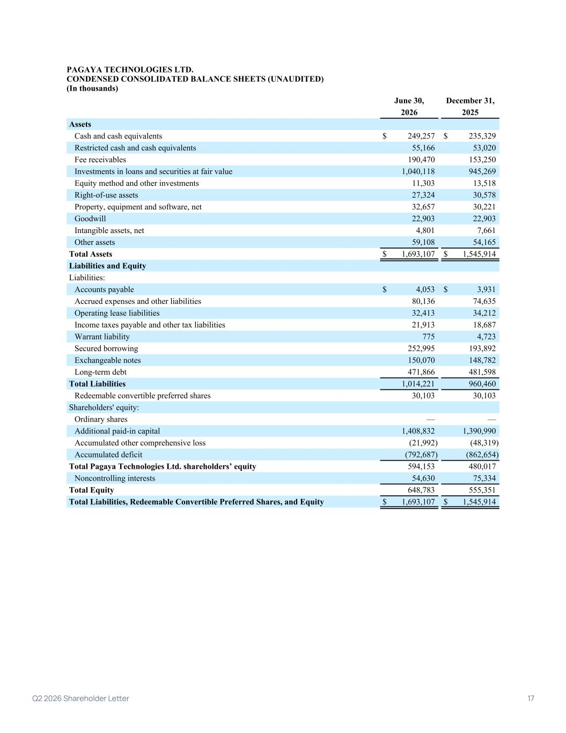
PAGAYA TECHNOLOGIES LTD. CONDENSED CONSOLIDATED BALANCE SHEETS (UNAUDITED) (In thousands) June 30, December 31, 2026 2025 Assets Cash and cash equivalents $ 249,257 $ 235,329 Restricted cash and cash equivalents 55,166 53,020 Fee receivables 190,470 153,250 Investments in loans and securities at fair value 1,040,118 945,269 Equity method and other investments 11,303 13,518 Right-of-use assets 27,324 30,578 Property, equipment and software, net 32,657 30,221 Goodwill 22,903 22,903 Intangible assets, net 4,801 7,661 Other assets 59,108 54,165 Total Assets $ 1,693,107 $ 1,545,914 Liabilities and Equity Liabilities: Accounts payable $ 4,053 $ 3,931 Accrued expenses and other liabilities 80,136 74,635 Operating lease liabilities 32,413 34,212 Income taxes payable and other tax liabilities 21,913 18,687 Warrant liability 775 4,723 Secured borrowing 252,995 193,892 Exchangeable notes 150,070 148,782 Long-term debt 471,866 481,598 Total Liabilities 1,014,221 960,460 Redeemable convertible preferred shares 30,103 30,103 Shareholders' equity: Ordinary shares — — Additional paid-in capital 1,408,832 1,390,990 Accumulated other comprehensive loss (21,992) (48,319) Accumulated deficit (792,687) (862,654) Total Pagaya Technologies Ltd. shareholders’ equity 594,153 480,017 Noncontrolling interests 54,630 75,334 Total Equity 648,783 555,351 Total Liabilities, Redeemable Convertible Preferred Shares, and Equity $ 1,693,107 $ 1,545,914 2 Q2 2026 Shareholder Letter 17

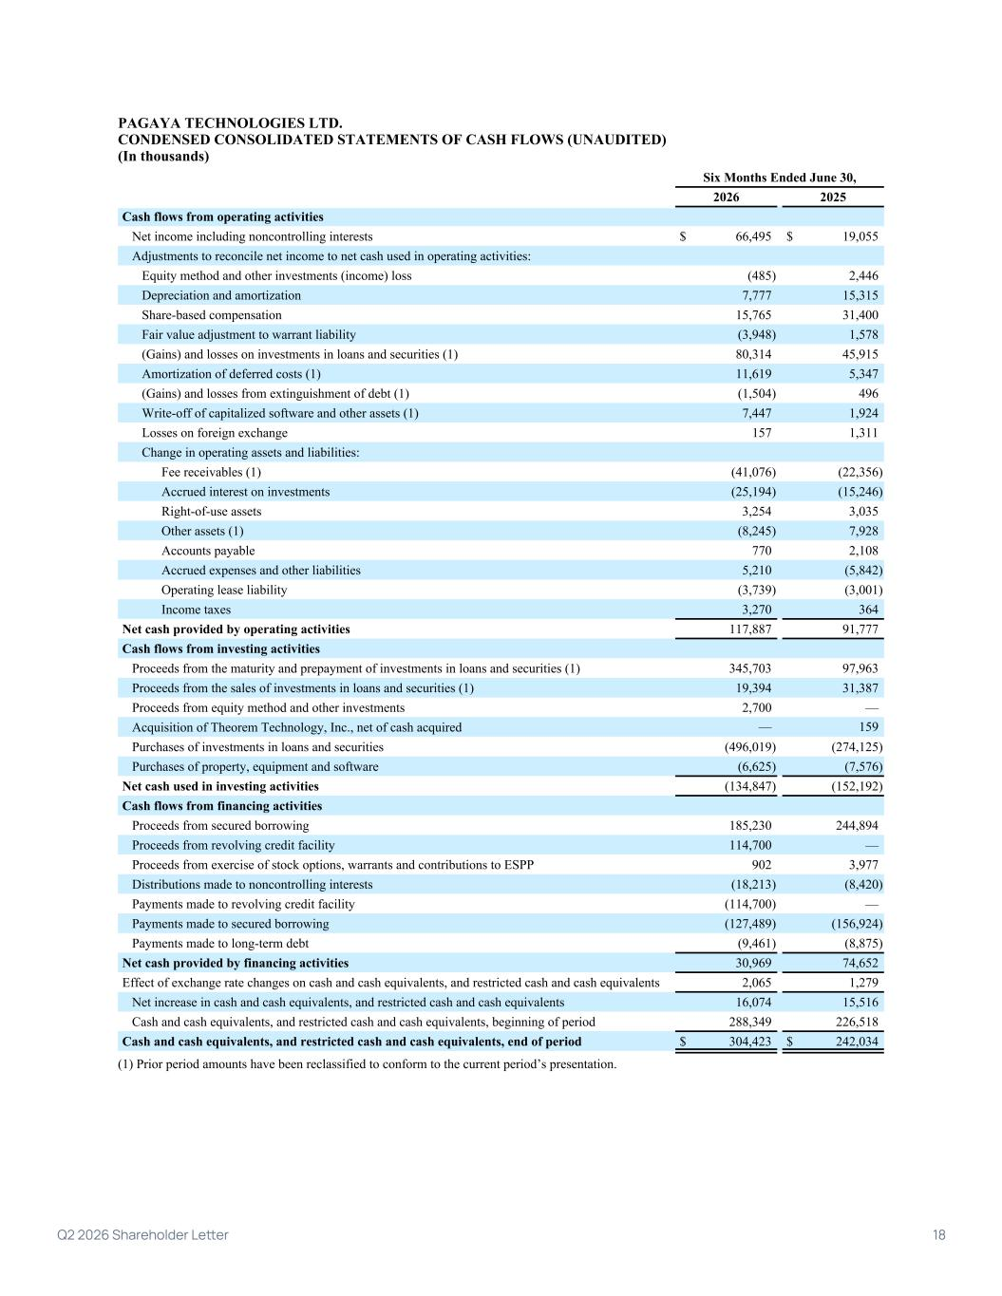
PAGAYA TECHNOLOGIES LTD. CONDENSED CONSOLIDATED STATEMENTS OF CASH FLOWS (UNAUDITED) (In thousands) Six Months Ended June 30, 2026 2025 Cash flows from operating activities Net income including noncontrolling interests $ 66,495 $ 19,055 Adjustments to reconcile net income to net cash used in operating activities: Equity method and other investments (income) loss (485) 2,446 Depreciation and amortization 7,777 15,315 Share-based compensation 15,765 31,400 Fair value adjustment to warrant liability (3,948) 1,578 (Gains) and losses on investments in loans and securities (1) 80,314 45,915 Amortization of deferred costs (1) 11,619 5,347 (Gains) and losses from extinguishment of debt (1) (1,504) 496 Write-off of capitalized software and other assets (1) 7,447 1,924 Losses on foreign exchange 157 1,311 Change in operating assets and liabilities: Fee receivables (1) (41,076) (22,356) Accrued interest on investments (25,194) (15,246) Right-of-use assets 3,254 3,035 Other assets (1) (8,245) 7,928 Accounts payable 770 2,108 Accrued expenses and other liabilities 5,210 (5,842) Operating lease liability (3,739) (3,001) Income taxes 3,270 364 Net cash provided by operating activities 117,887 91,777 Cash flows from investing activities Proceeds from the maturity and prepayment of investments in loans and securities (1) 345,703 97,963 Proceeds from the sales of investments in loans and securities (1) 19,394 31,387 Proceeds from equity method and other investments 2,700 — Acquisition of Theorem Technology, Inc., net of cash acquired — 159 Purchases of investments in loans and securities (496,019) (274,125) Purchases of property, equipment and software (6,625) (7,576) Net cash used in investing activities (134,847) (152,192) Cash flows from financing activities Proceeds from secured borrowing 185,230 244,894 Proceeds from revolving credit facility 114,700 — Proceeds from exercise of stock options, warrants and contributions to ESPP 902 3,977 Distributions made to noncontrolling interests (18,213) (8,420) Payments made to revolving credit facility (114,700) — Payments made to secured borrowing (127,489) (156,924) Payments made to long-term debt (9,461) (8,875) Net cash provided by financing activities 30,969 74,652 Effect of exchange rate changes on cash and cash equivalents, and restricted cash and cash equivalents 2,065 1,279 Net increase in cash and cash equivalents, and restricted cash and cash equivalents 16,074 15,516 Cash and cash equivalents, and restricted cash and cash equivalents, beginning of period 288,349 226,518 Cash and cash equivalents, and restricted cash and cash equivalents, end of period $ 304,423 $ 242,034 (1) Prior period amounts have been reclassified to conform to the current period’s presentation. 3 Q2 2026 Shareholder Letter 18

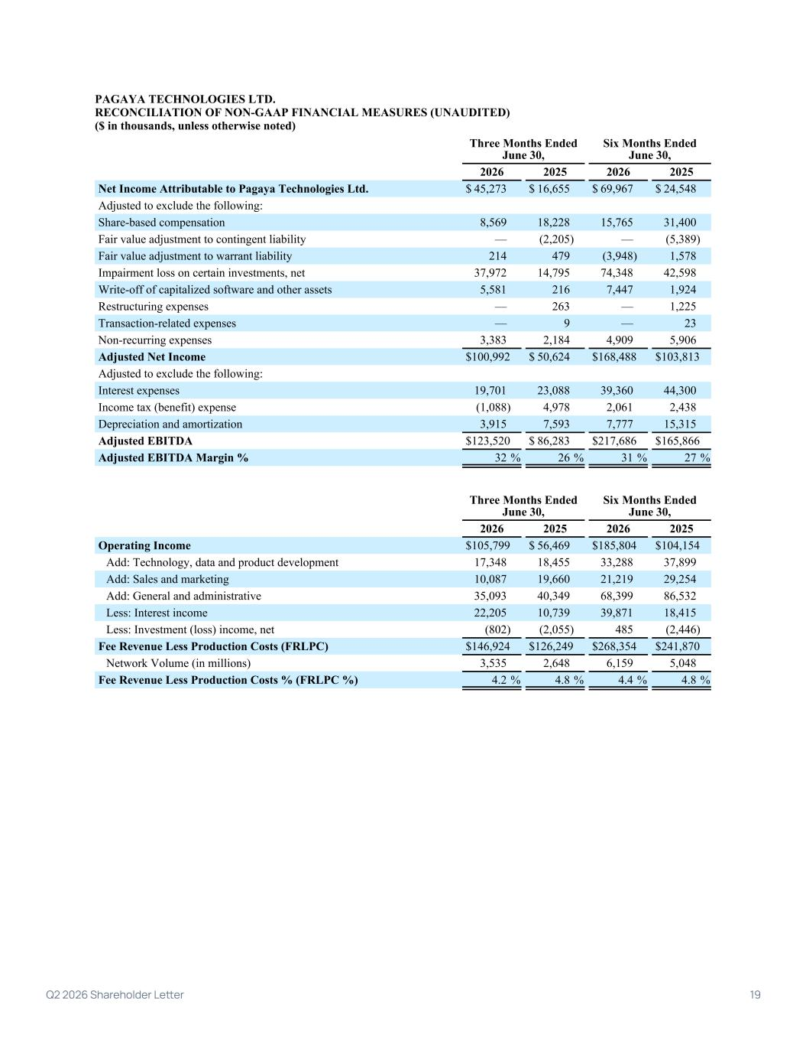
PAGAYA TECHNOLOGIES LTD. RECONCILIATION OF NON-GAAP FINANCIAL MEASURES (UNAUDITED) ($ in thousands, unless otherwise noted) Three Months Ended June 30, Six Months Ended June 30, 2026 2025 2026 2025 Net Income Attributable to Pagaya Technologies Ltd. $ 45,273 $ 16,655 $ 69,967 $ 24,548 Adjusted to exclude the following: Share-based compensation 8,569 18,228 15,765 31,400 Fair value adjustment to contingent liability — (2,205) — (5,389) Fair value adjustment to warrant liability 214 479 (3,948) 1,578 Impairment loss on certain investments, net 37,972 14,795 74,348 42,598 Write-off of capitalized software and other assets 5,581 216 7,447 1,924 Restructuring expenses — 263 — 1,225 Transaction-related expenses — 9 — 23 Non-recurring expenses 3,383 2,184 4,909 5,906 Adjusted Net Income $ 100,992 $ 50,624 $ 168,488 $ 103,813 Adjusted to exclude the following: Interest expenses 19,701 23,088 39,360 44,300 Income tax (benefit) expense (1,088) 4,978 2,061 2,438 Depreciation and amortization 3,915 7,593 7,777 15,315 Adjusted EBITDA $ 123,520 $ 86,283 $ 217,686 $ 165,866 Adjusted EBITDA Margin % 32 % 26 % 31 % 27 % Three Months Ended June 30, Six Months Ended June 30, 2026 2025 2026 2025 Operating Income $ 105,799 $ 56,469 $ 185,804 $ 104,154 Add: Technology, data and product development 17,348 18,455 33,288 37,899 Add: Sales and marketing 10,087 19,660 21,219 29,254 Add: General and administrative 35,093 40,349 68,399 86,532 Less: Interest income 22,205 10,739 39,871 18,415 Less: Investment (loss) income, net (802) (2,055) 485 (2,446) Fee Revenue Less Production Costs (FRLPC) $ 146,924 $ 126,249 $ 268,354 $ 241,870 Network Volume (in millions) 3,535 2,648 6,159 5,048 Fee Revenue Less Production Costs % (FRLPC %) 4.2 % 4.8 % 4.4 % 4.8 % 4 Q2 2026 Shareholder Letter 19

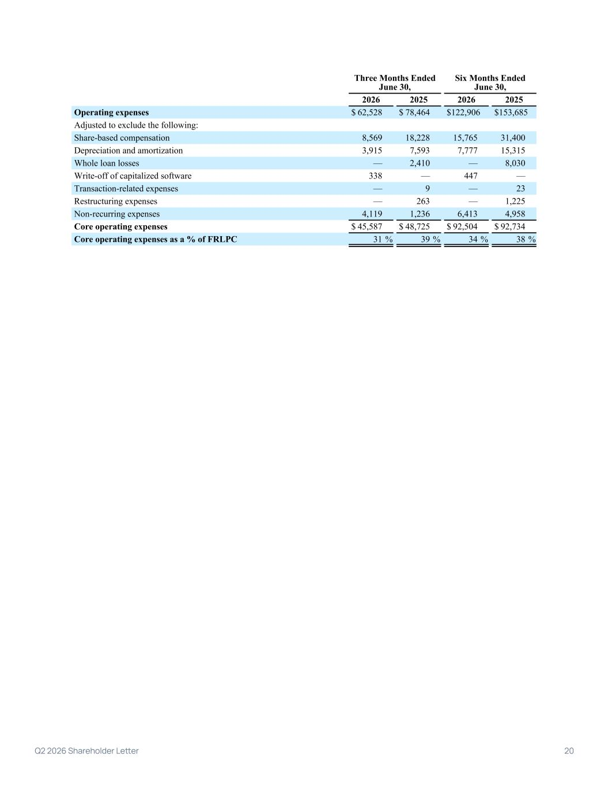
Three Months Ended June 30, Six Months Ended June 30, 2026 2025 2026 2025 Operating expenses $ 62,528 $ 78,464 $ 122,906 $ 153,685 Adjusted to exclude the following: Share-based compensation 8,569 18,228 15,765 31,400 Depreciation and amortization 3,915 7,593 7,777 15,315 Whole loan losses — 2,410 — 8,030 Write-off of capitalized software 338 — 447 — Transaction-related expenses — 9 — 23 Restructuring expenses — 263 — 1,225 Non-recurring expenses 4,119 1,236 6,413 4,958 Core operating expenses $ 45,587 $ 48,725 $ 92,504 $ 92,734 Core operating expenses as a % of FRLPC 31 % 39 % 34 % 38 % 5 Q2 2026 Shareholder Letter 20

