UNITED STATES
SECURITIES AND EXCHANGE COMMISSION
Washington, D.C. 20549

FORM 10-Q
☒ |  |  |  |  |  |  |  |  | QUARTERLY REPORT PURSUANT TO SECTION 13 OR 15(d) OF THE SECURITIES EXCHANGE ACT OF 1934
For the quarterly period ended June 30, 2026
OR
☐ |  |  |  |  |  |  |  |  | TRANSITION REPORT PURSUANT TO SECTION 13 OR 15(d) OF THE SECURITIES EXCHANGE ACT OF 1934
For the transition period from __________ to __________

Commission File Number: 001-41430

Pagaya Technologies Ltd.
(Exact name of registrant as specified in its charter)

Israel |  |  |  |  |  |  |  |  |  |  |  |  |  |  |  |  |  |  |  |  |  |  |  |  |  |  | 98-1704718
(State or other jurisdiction of incorporation or organization) |  |  |  |  |  |  |  |  |  |  |  |  |  |  |  |  |  |  |  |  |  |  |  |  |  |  | (I.R.S. Employer Identification No.)
335 Madison Ave, 16th Floor
New York, New York |  |  |  |  |  |  |  |  |  |  |  |  |  |  |  |  |  |  |  |  |  |  |  |  |  |  | 10017
(Address of principal executive offices) |  |  |  |  |  |  |  |  |  |  |  |  |  |  |  |  |  |  |  |  |  |  |  |  |  |  | (Zip Code)

(646) 710-7714
(Registrant's telephone number, including area code)

Securities registered pursuant to Section 12(b) of the Act:
Title of each class |  |  |  |  |  | Trading Symbol(s) |  |  |  |  |  | Name of each exchange on which registered
Class A Ordinary Shares, no par value |  |  |  |  |  | PGY |  |  |  |  |  | The NASDAQ Stock Market LLC
Warrants to purchase Class A Ordinary Shares |  |  |  |  |  | PGYWW |  |  |  |  |  | The NASDAQ Stock Market LLC
Indicate by check mark whether the registrant (1) has filed all reports required to be filed by Section 13 or 15(d) of the Securities Exchange Act of 1934 during the preceding 12 months (or for such shorter period that the registrant was required to file such reports), and (2) has been subject to such filing requirements for the past 90 days. Yes ☒ No ☐
Indicate by check mark whether the registrant has submitted electronically every Interactive Data File required to be submitted pursuant to Rule 405 of Regulation S-T (§232.405 of this chapter) during the preceding 12 months (or for such shorter period that the registrant was required to submit such files). Yes ☒ No ☐
Indicate by check mark whether the registrant is a large accelerated filer, an accelerated filer, a non-accelerated filer, a smaller reporting company, or an emerging growth company. See the definitions of “large accelerated filer,” “accelerated filer,” “smaller reporting company,” and “emerging growth company” in Rule 12b-2 of the Exchange Act.
Large accelerated filer |  |  | ☒ |  |  | Accelerated filer |  |  | ☐
Non-accelerated filer |  |  | ☐ |  |  | Smaller reporting company |  |  | ☐
 |  |  |  |  |  | Emerging growth company |  |  | ☐
If an emerging growth company, indicate by check mark if the registrant has elected not to use the extended transition period for complying with any new or revised financial accounting standards provided pursuant to Section 13(a) of the Exchange Act. ☐
Indicate by check mark whether the registrant is a shell company (as defined in Rule 12b-2 of the Exchange Act). Yes ☐ No ☒

As of July 29, 2026, the registrant had 72,137,266 Class A Ordinary Shares, no par value, outstanding; 11,288,577 Class B Ordinary Shares, no par value, outstanding; and 2,027,147 Series A Preferred Shares, no par value, outstanding.

Table of Contents
TABLE OF CONTENTS

 |  |  |  |  |  | Page
Part I - Financial Information |  |  |  |  |  | 1
Item 1. Financial Statements |  |  |  |  |  | 1
Condensed Consolidated Balance Sheets |  |  |  |  |  | 1
Condensed Consolidated Statements of Income |  |  |  |  |  | 2
Condensed Consolidated Statements of Comprehensive Income |  |  |  |  |  | 3
Condensed Consolidated Statements of Changes in Redeemable Convertible Preferred Shares and Equity |  |  |  |  |  | 4
Condensed Consolidated Statements of Cash Flows |  |  |  |  |  | 6
Notes to the Consolidated Financial Statements |  |  |  |  |  | 8
Item 2. Management’s Discussion and Analysis of Financial Condition and Results of Operations |  |  |  |  |  | 28
Item 3. Quantitative and Qualitative Disclosures About Market Risk |  |  |  |  |  | 47
Item 4. Controls and Procedures |  |  |  |  |  | 49
Part II - Other Information |  |  |  |  |  | 49
Item 1. Legal Proceedings |  |  |  |  |  | 49
Item 1A. Risk Factors |  |  |  |  |  | 50
Item 2. Unregistered Sales of Equity Securities and Use of Proceeds |  |  |  |  |  | 50
Item 3. Defaults Upon Senior Securities |  |  |  |  |  | 50
Item 4. Mine Safety Disclosures |  |  |  |  |  | 50
Item 5. Other Information |  |  |  |  |  | 50
Item 6. Exhibits |  |  |  |  |  | 50
Signatures |  |  |  |  |  | 52

i

Table of Contents
SPECIAL NOTE REGARDING FORWARD-LOOKING STATEMENTS

This Quarterly Report contains forward-looking statements that involve substantial risks and uncertainties. The Private Securities Litigation Reform Act of 1995 provides safe harbor protections for forward-looking statements in order to encourage companies to provide prospective information about their business. All statements other than statements of historical facts contained in this Quarterly Report are forward-looking statements. In some cases, you can identify forward-looking statements by words such as “estimate,” “plan,” “project,” “forecast,” “intend,” “expect,” “anticipate,” “believe,” “seek,” “strategy,” “future,” “opportunity,” “may,” “target,” “should,” “will,” “would,” “will be,” “will continue,” “will likely result,” or similar expressions that predict or indicate future events or trends or that are not statements of historical matters. Forward-looking statements include, without limitation, statements regarding: our expectations concerning the outlook for our business; our product suite; developing and scaling new asset types, products, and services; expanding our current Partner relationships; adding new Partners; increasing Network Volume; leveraging our data and AI capabilities; outperforming the broader market; improving our cost of capital; diversifying our funding network; delivering assets to meet our investors’ expectations; the impact of economic cycles on our financial performance and related metrics; evaluating operational and safety protocols; the importance of generating Network Volume, which is a key operating metric; making strategic investments to support our business plans, including in technology, data, and product development; pursuing diversified sources of financing; the sufficiency of our liquidity and capital resources to support our business operations; the Company’s capital efficiency strategies; and monitoring and upgrading our internal controls.

Forward-looking statements involve a number of risks, uncertainties and assumptions, and actual results or events may differ materially from those implied in those statements. Important factors that could cause such differences include, but are not limited to:

•our rapid growth and our ability to effectively manage our growth and maintain profitability;
•adverse global economic conditions and other catastrophic events;
•adverse developments impacting the banking and financial services industries, consumer credit activity, and the availability of equity and debt financing;
•our reliance on services provided by third-party vendors;
•our dependence on our AI technology;
•our reliance on a limited number of partners which presents concentration risk for Network Volume and Revenue;
•retaining and attracting new partners by improving our platform and offering new and relevant products;
•our ability to raise capital from investors;
•developing and maintaining robust and diverse funding sources;
•the competitive nature of our industry;
•changes to our accounting policies or financial reporting standards;
•maintaining our brand image and reputation;
•managing risks related to fraudulent activity;
•our reliance on key employees including our founders;
•effectively managing conflicts of interest related to our financing vehicles;
•legal proceedings, investigations, or claims;
•maintaining adequate insurance coverage;
•the effectiveness of our risk management processes;
•realizing the intended benefits of any strategic transactions;
•the regulation of AI technologies by the FTC, CFPB, and other governmental agencies;
•enforcing our intellectual property rights;
•our use of open-source software components;
•our ability to continue receiving accurate data from our partners;
•cyberattacks and other security breaches;
•risks related to our single-family rental operations including volatility in the single-family rental market, lease renewal and default rates, HOA regulations, the accuracy of resident-supplied information, leasing fraud, renovation and maintenance costs, and regulations impacting the single-family rental business;
ii

Table of Contents
•our compliance with laws related to consumer protection, consumer finance, lending, fair lending, data protection and privacy, cybersecurity, and investment advisory services, and maintaining required licenses to operate;
•heightened regulation of the financial services industry;
•the risks that we are deemed to be an investment company or that we cannot rely on exemptions under various laws to conduct the funding component of our business;
•our ability to continue accessing the securitization market;
•our compliance with anti-corruption, anti-bribery, anti-money laundering, economic and trade sanctions and similar laws;
•the risk that we would be deemed the true lender for loans originated by our partners;
•the enforceability of assets we acquire from our partners;
•risks related to ongoing conflicts including between Russia and Ukraine and Israel, the United States, and Iran;
•risks related to our operations in Israel including regional hostilities and our employees’ required military service;
•risks related to being a public company including limited management experience and increased costs;
•covenants in our indebtedness arrangements that could limit our ability to operate our business;
•changes in tax laws and the outcome of potential tax audits; and
•the other matters described in “Risk Factors” in our 2025 Annual Report on Form 10-K (defined below).

We caution you not to rely on forward-looking statements, which reflect current beliefs and are based on information currently available as of the date a forward-looking statement is made. Forward-looking statements set forth herein speak only as of the date of this Quarterly Report on Form 10-Q. We undertake no obligation to revise forward-looking statements to reflect future events, changes in circumstances or changes in beliefs except to the extent required by law. In the event that any forward-looking statement is updated, no inference should be made that we will make additional updates with respect to that statement, related matters, or any other forward-looking statements except to the extent required by law. Any corrections or revisions and other important assumptions and factors that could cause actual results to differ materially from forward-looking statements, including discussions of significant risk factors, may appear in our public filings with the SEC, which are or will be (as appropriate) accessible at www.sec.gov, and which you are advised to consult.

Market, ranking and industry data used throughout this Quarterly Report on Form 10-Q, including statements regarding market size and technology adoption rates, is based on the good faith estimates of our management, which in turn are based upon our management’s review of internal surveys, independent industry surveys and publications and other third-party research and publicly available information. This data involves a number of assumptions and limitations, and you are cautioned not to give undue weight to such estimates. While we are not aware of any misstatements regarding the industry data presented herein, its estimates involve risks and uncertainties and are subject to change based on various factors, including those discussed under “Risk Factors” in our Annual Report on Form 10-K filed on March 2, 2026, and amended on April 30, 2026 and June 1, 2026 (collectively, the “2025 Annual Report on Form 10-K”), and Item 2, “Management’s Discussion and Analysis of Financial Condition and Results of Operations” of this Quarterly Report on Form 10-Q.

iii

Table of Contents
PART I - Financial Information

Item 1. Financial Statements

PAGAYA TECHNOLOGIES LTD.
CONDENSED CONSOLIDATED BALANCE SHEETS (UNAUDITED)
(In thousands, except share amounts)
 |  |  | June 30, |  |  |  |  |  | December 31,
 |  |  | 2026 |  |  |  |  |  | 2025
Assets
Cash and cash equivalents |  |  | $ | 249,257 |  |  |  |  | $ | 235,329
Restricted cash and cash equivalents |  |  | 55,166 |  |  |  |  |  | 53,020
Fee receivables (1) |  |  | 190,470 |  |  |  |  |  | 153,250
Investments in loans and securities at fair value |  |  | 1,040,118 |  |  |  |  |  | 945,269
Equity method and other investments |  |  | 11,303 |  |  |  |  |  | 13,518
Right-of-use assets |  |  | 27,324 |  |  |  |  |  | 30,578
Property, equipment and software, net |  |  | 32,657 |  |  |  |  |  | 30,221
Goodwill |  |  | 22,903 |  |  |  |  |  | 22,903
Intangible assets, net |  |  | 4,801 |  |  |  |  |  | 7,661
Other assets (1) |  |  | 59,108 |  |  |  |  |  | 54,165
Total Assets |  |  | $ | 1,693,107 |  |  |  |  | $ | 1,545,914
Liabilities and Equity
Liabilities:
Accounts payable |  |  | $ | 4,053 |  |  |  |  | $ | 3,931
Accrued expenses and other liabilities |  |  | 80,136 |  |  |  |  |  | 74,635
Operating lease liabilities |  |  | 32,413 |  |  |  |  |  | 34,212
Income taxes payable and other tax liabilities |  |  | 21,913 |  |  |  |  |  | 18,687
Warrant liability |  |  | 775 |  |  |  |  |  | 4,723
Secured borrowing |  |  | 252,995 |  |  |  |  |  | 193,892
Exchangeable notes |  |  | 150,070 |  |  |  |  |  | 148,782
Long-term debt |  |  | 471,866 |  |  |  |  |  | 481,598
Total Liabilities |  |  | 1,014,221 |  |  |  |  |  | 960,460
Redeemable convertible preferred shares, no par value, 6,666,666 shares authorized, 2,027,147 shares issued and outstanding as of both June 30, 2026 and December 31, 2025; aggregate liquidation preference of $60,814 as of both June 30, 2026 and December 31, 2025. |  |  | 30,103 |  |  |  |  |  | 30,103
Shareholders' equity:
Class A ordinary shares, no par value, 666,666,666 shares authorized, 72,046,950 and 70,747,357 shares issued and outstanding as of June 30, 2026 and December 31, 2025, respectively. |  |  | — |  |  |  |  |  | —
Class B ordinary shares, no par value, 166,666,666 shares authorized, 11,288,577 shares issued and outstanding as of both June 30, 2026 and December 31, 2025. |  |  | — |  |  |  |  |  | —
Additional paid-in capital |  |  | 1,408,832 |  |  |  |  |  | 1,390,990
Accumulated other comprehensive loss |  |  | (21,992) |  |  |  |  |  | (48,319)
Accumulated deficit |  |  | (792,687) |  |  |  |  |  | (862,654)
Total Pagaya Technologies Ltd. shareholders’ equity |  |  | 594,153 |  |  |  |  |  | 480,017
Noncontrolling interests |  |  | 54,630 |  |  |  |  |  | 75,334
Total Equity |  |  | 648,783 |  |  |  |  |  | 555,351
Total Liabilities, Redeemable Convertible Preferred Shares, and Equity |  |  | $ | 1,693,107 |  |  |  |  | $ | 1,545,914
(1) Includes related-party fee receivables from ABS securitization trusts and investment funds totaling $124.3 million and $106.9 million and other related-party assets from ABS securitization trusts and investment funds of $46.9 million and $42.6 million, as of June 30, 2026 and December 31, 2025, respectively. Refer to Note 11, “Transactions with Related Parties,” for additional information regarding related-party transactions with ABS securitization trusts and investment funds.

The accompanying notes are an integral part of these condensed consolidated financial statements

1

Table of Contents
PAGAYA TECHNOLOGIES LTD.
CONDENSED CONSOLIDATED STATEMENTS OF INCOME (UNAUDITED)
(In thousands, except share and per share data)

 |  |  | Three Months Ended June 30, |  |  |  |  |  |  |  |  |  |  |  | Six Months Ended June 30,
 |  |  | 2026 |  |  |  |  |  | 2025 |  |  |  |  |  | 2026 |  |  |  |  |  | 2025
Revenue
Revenue from fees (1) |  |  | $ | 365,639 |  |  |  |  | $ | 317,714 |  |  |  |  | $ | 664,630 |  |  |  |  | $ | 600,418
Other Income
Interest income |  |  | 22,205 |  |  |  |  |  | 10,739 |  |  |  |  |  | 39,871 |  |  |  |  |  | 18,415
Investment (loss) income, net |  |  | (802) |  |  |  |  |  | (2,055) |  |  |  |  |  | 485 |  |  |  |  |  | (2,446)
Total Revenue and Other Income |  |  | 387,042 |  |  |  |  |  | 326,398 |  |  |  |  |  | 704,986 |  |  |  |  |  | 616,387
Production costs |  |  | 218,715 |  |  |  |  |  | 191,465 |  |  |  |  |  | 396,276 |  |  |  |  |  | 358,548
Technology, data and product development |  |  | 17,348 |  |  |  |  |  | 18,455 |  |  |  |  |  | 33,288 |  |  |  |  |  | 37,899
Sales and marketing |  |  | 10,087 |  |  |  |  |  | 19,660 |  |  |  |  |  | 21,219 |  |  |  |  |  | 29,254
General and administrative |  |  | 35,093 |  |  |  |  |  | 40,349 |  |  |  |  |  | 68,399 |  |  |  |  |  | 86,532
Total Costs and Operating Expenses |  |  | 281,243 |  |  |  |  |  | 269,929 |  |  |  |  |  | 519,182 |  |  |  |  |  | 512,233
Operating Income |  |  | 105,799 |  |  |  |  |  | 56,469 |  |  |  |  |  | 185,804 |  |  |  |  |  | 104,154
Gains and (losses) on investments in loans and securities (2) |  |  | (42,318) |  |  |  |  |  | (14,251) |  |  |  |  |  | (80,314) |  |  |  |  |  | (43,275)
Other expenses, net (2) |  |  | (22,972) |  |  |  |  |  | (20,181) |  |  |  |  |  | (38,438) |  |  |  |  |  | (38,890)
Gains and (losses) from extinguishment of debt (2) |  |  | 737 |  |  |  |  |  | (496) |  |  |  |  |  | 1,504 |  |  |  |  |  | (496)
Income Before Income Taxes |  |  | 41,246 |  |  |  |  |  | 21,541 |  |  |  |  |  | 68,556 |  |  |  |  |  | 21,493
Income tax (benefit) expense |  |  | (1,088) |  |  |  |  |  | 4,978 |  |  |  |  |  | 2,061 |  |  |  |  |  | 2,438
Net Income Including Noncontrolling Interests |  |  | 42,334 |  |  |  |  |  | 16,563 |  |  |  |  |  | 66,495 |  |  |  |  |  | 19,055
Less: Net loss attributable to noncontrolling interests |  |  | (2,939) |  |  |  |  |  | (92) |  |  |  |  |  | (3,472) |  |  |  |  |  | (5,493)
Net Income Attributable to Pagaya Technologies Ltd. |  |  | $ | 45,273 |  |  |  |  | $ | 16,655 |  |  |  |  | $ | 69,967 |  |  |  |  | $ | 24,548
Earnings per share attributable to Pagaya Technologies Ltd.’s
ordinary shareholders (Note 12):
Basic |  |  | $ | 0.53 |  |  |  |  | $ | 0.20 |  |  |  |  | $ | 0.82 |  |  |  |  | $ | 0.30
Diluted |  |  | $ | 0.49 |  |  |  |  | $ | 0.20 |  |  |  |  | $ | 0.77 |  |  |  |  | $ | 0.29
Weighted average shares outstanding:
Basic |  |  | 83,184,935 |  |  |  |  |  | 76,873,529 |  |  |  |  |  | 82,926,257 |  |  |  |  |  | 76,347,801
Diluted |  |  | 97,247,579 |  |  |  |  |  | 79,667,635 |  |  |  |  |  | 96,963,421 |  |  |  |  |  | 78,301,110
(1) Includes related-party revenues from ABS securitization trusts and investment funds totaling $231.4 million and $146.6 million for the three months ended June 30, 2026 and 2025, and $390.3 million and $314.5 million for the six months ended June 30, 2026 and 2025, respectively. Refer to Note 11, “Transactions with Related Parties,” for additional information regarding related-party transactions with ABS securitization trusts and investment funds.
(2) Prior period amounts have been reclassified to conform to the current period’s presentation.

The accompanying notes are an integral part of these condensed consolidated financial statements

2

Table of Contents
PAGAYA TECHNOLOGIES LTD.
CONDENSED CONSOLIDATED STATEMENTS OF COMPREHENSIVE INCOME (UNAUDITED)
(In thousands)

 |  |  | Three Months Ended June 30, |  |  |  |  |  |  |  |  |  |  |  | Six Months Ended June 30,
 |  |  | 2026 |  |  |  |  |  | 2025 |  |  |  |  |  | 2026 |  |  |  |  |  | 2025
Net Income Including Noncontrolling Interests |  |  | $ | 42,334 |  |  |  |  | $ | 16,563 |  |  |  |  | $ | 66,495 |  |  |  |  | $ | 19,055
Other Comprehensive Income:
Unrealized non-credit related adjustments to investment securities |  |  | 10,098 |  |  |  |  |  | (5,708) |  |  |  |  |  | 27,309 |  |  |  |  |  | (21,492)
Comprehensive Income (Loss) Including Noncontrolling Interests |  |  | 52,432 |  |  |  |  |  | 10,855 |  |  |  |  |  | 93,804 |  |  |  |  |  | (2,437)
Less: Comprehensive loss attributable to noncontrolling interests |  |  | (3,125) |  |  |  |  |  | (105) |  |  |  |  |  | (2,490) |  |  |  |  |  | (5,408)
Comprehensive Income Attributable to Pagaya Technologies Ltd. |  |  | $ | 55,557 |  |  |  |  | $ | 10,960 |  |  |  |  | $ | 96,294 |  |  |  |  | $ | 2,971

The accompanying notes are an integral part of these condensed consolidated financial statements

3

Table of Contents
PAGAYA TECHNOLOGIES LTD.
CONDENSED CONSOLIDATED STATEMENT OF CHANGES IN REDEEMABLE CONVERTIBLE PREFERRED SHARES AND EQUITY (UNAUDITED)
(In thousands, except share amounts)
 |  |  | Redeemable Convertible Preferred Shares |  |  |  |  |  |  |  |  |  |  |  |  |  |  | Ordinary Shares |  |  |  |  |  |  |  |  |  |  |  | Additional Paid-In Capital |  |  |  |  |  | Accumulated Other Comprehensive Loss |  |  |  |  |  | Accumulated Deficit |  |  |  |  |  | Total Pagaya Technologies Ltd. Shareholders’ Equity |  |  |  |  |  | Non-Controlling Interests |  |  |  |  |  | Total Equity
 |  |  | Shares |  |  |  |  |  | Amount |  |  |  |  |  |  |  |  | Shares |  |  |  |  |  | Amount
Balance – March 31, 2026 |  |  | 2,027,147 |  |  |  |  |  | $ | 30,103 |  |  |  |  |  |  |  | 82,775,444 |  |  |  |  |  | $ | — |  |  |  |  | $ | 1,399,545 |  |  |  |  | $ | (32,276) |  |  |  |  | $ | (837,960) |  |  |  |  | $ | 529,309 |  |  |  |  | $ | 69,843 |  |  |  |  | $ | 599,152
Issuance of ordinary shares upon exercise of share options |  |  | — |  |  |  |  |  | — |  |  |  |  |  |  |  |  | 27,047 |  |  |  |  |  | — |  |  |  |  |  | 100 |  |  |  |  |  | — |  |  |  |  |  | — |  |  |  |  |  | 100 |  |  |  |  |  | — |  |  |  |  |  | 100
Issuance of ordinary shares upon vesting of RSUs |  |  | — |  |  |  |  |  | — |  |  |  |  |  |  |  |  | 533,036 |  |  |  |  |  | — |  |  |  |  |  |  |  |  |  |  |  | — |  |  |  |  |  | — |  |  |  |  |  | — |  |  |  |  |  | — |  |  |  |  |  | —
Share-based compensation |  |  | — |  |  |  |  |  | — |  |  |  |  |  |  |  |  | — |  |  |  |  |  | — |  |  |  |  |  | 9,187 |  |  |  |  |  | — |  |  |  |  |  | — |  |  |  |  |  | 9,187 |  |  |  |  |  | — |  |  |  |  |  | 9,187
Return of capital to interests in consolidated VIEs |  |  | — |  |  |  |  |  | — |  |  |  |  |  |  |  |  | — |  |  |  |  |  | — |  |  |  |  |  | — |  |  |  |  |  | — |  |  |  |  |  | — |  |  |  |  |  | — |  |  |  |  |  | (12,088) |  |  |  |  |  | (12,088)
Other comprehensive income (loss) |  |  | — |  |  |  |  |  | — |  |  |  |  |  |  |  |  | — |  |  |  |  |  | — |  |  |  |  |  | — |  |  |  |  |  | 10,284 |  |  |  |  |  | — |  |  |  |  |  | 10,284 |  |  |  |  |  | (186) |  |  |  |  |  | 10,098
Net income (loss) |  |  | — |  |  |  |  |  | — |  |  |  |  |  |  |  |  | — |  |  |  |  |  | — |  |  |  |  |  | — |  |  |  |  |  |  |  |  |  |  |  | 45,273 |  |  |  |  |  | 45,273 |  |  |  |  |  | (2,939) |  |  |  |  |  | 42,334
Balance – June 30, 2026 |  |  | 2,027,147 |  |  |  |  |  | $ | 30,103 |  |  |  |  |  |  |  | 83,335,527 |  |  |  |  |  | $ | — |  |  |  |  | $ | 1,408,832 |  |  |  |  | $ | (21,992) |  |  |  |  | $ | (792,687) |  |  |  |  | $ | 594,153 |  |  |  |  | $ | 54,630 |  |  |  |  | $ | 648,783
Balance – December 31, 2025 |  |  | 2,027,147 |  |  |  |  |  | $ | 30,103 |  |  |  |  |  |  |  | 82,035,934 |  |  |  |  |  | $ | — |  |  |  |  | $ | 1,390,990 |  |  |  |  | $ | (48,319) |  |  |  |  | $ | (862,654) |  |  |  |  | $ | 480,017 |  |  |  |  | $ | 75,334 |  |  |  |  | $ | 555,351
Issuance of ordinary shares upon exercise of share options |  |  | — |  |  |  |  |  | — |  |  |  |  |  |  |  |  | 44,593 |  |  |  |  |  | — |  |  |  |  |  | 217 |  |  |  |  |  | — |  |  |  |  |  | — |  |  |  |  |  | 217 |  |  |  |  |  | — |  |  |  |  |  | 217
Issuance of ordinary shares upon vesting of RSUs |  |  | — |  |  |  |  |  | — |  |  |  |  |  |  |  |  | 1,188,186 |  |  |  |  |  | — |  |  |  |  |  | — |  |  |  |  |  | — |  |  |  |  |  | — |  |  |  |  |  | — |  |  |  |  |  | — |  |  |  |  |  | —
Issuance of ordinary shares upon purchase of shares under employee stock purchase plan |  |  | — |  |  |  |  |  | — |  |  |  |  |  |  |  |  | 66,814 |  |  |  |  |  | — |  |  |  |  |  | 685 |  |  |  |  |  | — |  |  |  |  |  | — |  |  |  |  |  | 685 |  |  |  |  |  | — |  |  |  |  |  | 685
Share-based compensation |  |  | — |  |  |  |  |  | — |  |  |  |  |  |  |  |  | — |  |  |  |  |  | — |  |  |  |  |  | 16,940 |  |  |  |  |  | — |  |  |  |  |  | — |  |  |  |  |  | 16,940 |  |  |  |  |  | — |  |  |  |  |  | 16,940
Return of capital to interests in consolidated VIEs |  |  | — |  |  |  |  |  | — |  |  |  |  |  |  |  |  | — |  |  |  |  |  | — |  |  |  |  |  | — |  |  |  |  |  | — |  |  |  |  |  | — |  |  |  |  |  | — |  |  |  |  |  | (18,214) |  |  |  |  |  | (18,214)
Other comprehensive income |  |  | — |  |  |  |  |  | — |  |  |  |  |  |  |  |  | — |  |  |  |  |  | — |  |  |  |  |  | — |  |  |  |  |  | 26,327 |  |  |  |  |  | — |  |  |  |  |  | 26,327 |  |  |  |  |  | 982 |  |  |  |  |  | 27,309
Net income (loss) |  |  | — |  |  |  |  |  | — |  |  |  |  |  |  |  |  | — |  |  |  |  |  | — |  |  |  |  |  | — |  |  |  |  |  | — |  |  |  |  |  | 69,967 |  |  |  |  |  | 69,967 |  |  |  |  |  | (3,472) |  |  |  |  |  | 66,495
Balance – June 30, 2026 |  |  | 2,027,147 |  |  |  |  |  | $ | 30,103 |  |  |  |  |  |  |  | 83,335,527 |  |  |  |  |  | $ | — |  |  |  |  | $ | 1,408,832 |  |  |  |  | $ | (21,992) |  |  |  |  | $ | (792,687) |  |  |  |  | $ | 594,153 |  |  |  |  | $ | 54,630 |  |  |  |  | $ | 648,783

4

Table of Contents
 |  |  | Redeemable Convertible Preferred Shares |  |  |  |  |  |  |  |  |  |  |  |  |  |  | Ordinary Shares |  |  |  |  |  |  |  |  |  |  |  | Additional Paid-In Capital |  |  |  |  |  | Accumulated Other Comprehensive Loss |  |  |  |  |  | Accumulated Deficit |  |  |  |  |  | Total Pagaya Technologies Ltd. Shareholders’ Equity |  |  |  |  |  | Non-Controlling Interests |  |  |  |  |  | Total Equity
 |  |  | Shares |  |  |  |  |  | Amount |  |  |  |  |  |  |  |  | Shares |  |  |  |  |  | Amount
Balance – March 31, 2025 |  |  | 5,000,000 |  |  |  |  |  | $ | 74,250 |  |  |  |  |  |  |  | 75,430,952 |  |  |  |  |  | $ | — |  |  |  |  | $ | 1,299,010 |  |  |  |  | $ | (27,370) |  |  |  |  | $ | (936,150) |  |  |  |  | $ | 335,490 |  |  |  |  | $ | 105,313 |  |  |  |  | $ | 440,803
Issuance of ordinary shares upon exercise of share options |  |  | — |  |  |  |  |  | — |  |  |  |  |  |  |  |  | 126,638 |  |  |  |  |  | — |  |  |  |  |  | 1,118 |  |  |  |  |  | — |  |  |  |  |  | — |  |  |  |  |  | 1,118 |  |  |  |  |  | — |  |  |  |  |  | 1,118
Issuance of ordinary shares upon vesting of RSUs |  |  | — |  |  |  |  |  | — |  |  |  |  |  |  |  |  | 604,379 |  |  |  |  |  | — |  |  |  |  |  | — |  |  |  |  |  | — |  |  |  |  |  | — |  |  |  |  |  | — |  |  |  |  |  | — |  |  |  |  |  | —
Share-based compensation |  |  | — |  |  |  |  |  | — |  |  |  |  |  |  |  |  | — |  |  |  |  |  | — |  |  |  |  |  | 19,184 |  |  |  |  |  | — |  |  |  |  |  | — |  |  |  |  |  | 19,184 |  |  |  |  |  | — |  |  |  |  |  | 19,184
Return of capital to interests in consolidated VIEs |  |  | — |  |  |  |  |  | — |  |  |  |  |  |  |  |  | — |  |  |  |  |  | — |  |  |  |  |  | — |  |  |  |  |  | — |  |  |  |  |  | — |  |  |  |  |  | — |  |  |  |  |  | (3,981) |  |  |  |  |  | (3,981)
Other comprehensive income (loss) |  |  | — |  |  |  |  |  | — |  |  |  |  |  |  |  |  | — |  |  |  |  |  | — |  |  |  |  |  | — |  |  |  |  |  | (5,695) |  |  |  |  |  | — |  |  |  |  |  | (5,695) |  |  |  |  |  | (13) |  |  |  |  |  | (5,708)
Net income (loss) |  |  | — |  |  |  |  |  | — |  |  |  |  |  |  |  |  | — |  |  |  |  |  | — |  |  |  |  |  | — |  |  |  |  |  | — |  |  |  |  |  | 16,655 |  |  |  |  |  | 16,655 |  |  |  |  |  | (92) |  |  |  |  |  | 16,563
Balance – June 30, 2025 |  |  | 5,000,000 |  |  |  |  |  | $ | 74,250 |  |  |  |  |  |  |  | 76,161,969 |  |  |  |  |  | $ | — |  |  |  |  | $ | 1,319,312 |  |  |  |  | $ | (33,065) |  |  |  |  | $ | (919,495) |  |  |  |  | $ | 366,752 |  |  |  |  | $ | 101,227 |  |  |  |  | $ | 467,979
Balance – December 31, 2024 |  |  | 5,000,000 |  |  |  |  |  | $ | 74,250 |  |  |  |  |  |  |  | 73,879,982 |  |  |  |  |  | $ | — |  |  |  |  | $ | 1,282,022 |  |  |  |  | $ | (11,488) |  |  |  |  | $ | (944,043) |  |  |  |  | $ | 326,491 |  |  |  |  | $ | 115,055 |  |  |  |  | $ | 441,546
Issuance of ordinary shares upon exercise of share options |  |  | — |  |  |  |  |  | — |  |  |  |  |  |  |  |  | 507,909 |  |  |  |  |  | — |  |  |  |  |  | 3,385 |  |  |  |  |  | — |  |  |  |  |  | — |  |  |  |  |  | 3,385 |  |  |  |  |  | — |  |  |  |  |  | 3,385
Issuance of ordinary shares upon vesting of RSUs |  |  | — |  |  |  |  |  | — |  |  |  |  |  |  |  |  | 1,718,202 |  |  |  |  |  | — |  |  |  |  |  | — |  |  |  |  |  | — |  |  |  |  |  | — |  |  |  |  |  | — |  |  |  |  |  | — |  |  |  |  |  | —
Issuance of ordinary shares upon employee stock purchase plan |  |  | — |  |  |  |  |  | — |  |  |  |  |  |  |  |  | 55,876 |  |  |  |  |  |  |  |  |  |  |  | 592 |  |  |  |  |  |  |  |  |  |  |  |  |  |  |  |  |  | 592 |  |  |  |  |  | — |  |  |  |  |  | 592
Share-based compensation |  |  | — |  |  |  |  |  | — |  |  |  |  |  |  |  |  | — |  |  |  |  |  | — |  |  |  |  |  | 33,313 |  |  |  |  |  | — |  |  |  |  |  | — |  |  |  |  |  | 33,313 |  |  |  |  |  | — |  |  |  |  |  | 33,313
Return of capital to interests in consolidated VIEs |  |  | — |  |  |  |  |  | — |  |  |  |  |  |  |  |  | — |  |  |  |  |  | — |  |  |  |  |  | — |  |  |  |  |  | — |  |  |  |  |  | — |  |  |  |  |  | — |  |  |  |  |  | (8,420) |  |  |  |  |  | (8,420)
Other comprehensive income (loss) |  |  | — |  |  |  |  |  | — |  |  |  |  |  |  |  |  | — |  |  |  |  |  | — |  |  |  |  |  | — |  |  |  |  |  | (21,577) |  |  |  |  |  | — |  |  |  |  |  | (21,577) |  |  |  |  |  | 85 |  |  |  |  |  | (21,492)
Net income (loss) |  |  | — |  |  |  |  |  | — |  |  |  |  |  |  |  |  | — |  |  |  |  |  | — |  |  |  |  |  | — |  |  |  |  |  | — |  |  |  |  |  | 24,548 |  |  |  |  |  | 24,548 |  |  |  |  |  | (5,493) |  |  |  |  |  | 19,055
Balance – June 30, 2025 |  |  | 5,000,000 |  |  |  |  |  | $ | 74,250 |  |  |  |  |  |  |  | 76,161,969 |  |  |  |  |  | $ | — |  |  |  |  | $ | 1,319,312 |  |  |  |  | $ | (33,065) |  |  |  |  | $ | (919,495) |  |  |  |  | $ | 366,752 |  |  |  |  | $ | 101,227 |  |  |  |  | $ | 467,979

The accompanying notes are an integral part of these condensed consolidated financial statements

5

Table of Contents
PAGAYA TECHNOLOGIES LTD.
CONDENSED CONSOLIDATED STATEMENTS OF CASH FLOWS (UNAUDITED)
(In thousands)
 |  |  | Six Months Ended June 30,
 |  |  | 2026 |  |  |  |  |  | 2025
Cash flows from operating activities
Net income including noncontrolling interests |  |  | $ | 66,495 |  |  |  |  | $ | 19,055
Adjustments to reconcile net income to net cash used in operating activities:
Equity method and other investments (income) loss |  |  | (485) |  |  |  |  |  | 2,446
Depreciation and amortization |  |  | 7,777 |  |  |  |  |  | 15,315
Share-based compensation |  |  | 15,765 |  |  |  |  |  | 31,400
Fair value adjustment to warrant liability |  |  | (3,948) |  |  |  |  |  | 1,578
(Gains) and losses on investments in loans and securities (1) |  |  | 80,314 |  |  |  |  |  | 45,915
Amortization of deferred costs (1) |  |  | 11,619 |  |  |  |  |  | 5,347
(Gains) and losses from extinguishment of debt (1) |  |  | (1,504) |  |  |  |  |  | 496
Write-off of capitalized software and other assets (1) |  |  | 7,447 |  |  |  |  |  | 1,924
Losses on foreign exchange |  |  | 157 |  |  |  |  |  | 1,311
Change in operating assets and liabilities:
Fee receivables (1) |  |  | (41,076) |  |  |  |  |  | (22,356)
Accrued interest on investments |  |  | (25,194) |  |  |  |  |  | (15,246)
Right-of-use assets |  |  | 3,254 |  |  |  |  |  | 3,035
Other assets (1) |  |  | (8,245) |  |  |  |  |  | 7,928
Accounts payable |  |  | 770 |  |  |  |  |  | 2,108
Accrued expenses and other liabilities |  |  | 5,210 |  |  |  |  |  | (5,842)
Operating lease liability |  |  | (3,739) |  |  |  |  |  | (3,001)
Income taxes |  |  | 3,270 |  |  |  |  |  | 364
Net cash provided by operating activities |  |  | 117,887 |  |  |  |  |  | 91,777
Cash flows from investing activities
Proceeds from the maturity and prepayment of investments in loans and securities (1) |  |  | 345,703 |  |  |  |  |  | 97,963
Proceeds from the sales of investments in loans and securities (1) |  |  | 19,394 |  |  |  |  |  | 31,387
Proceeds from equity method and other investments |  |  | 2,700 |  |  |  |  |  | —
Acquisition of Theorem Technology, Inc., net of cash acquired |  |  | — |  |  |  |  |  | 159
Purchases of investments in loans and securities |  |  | (496,019) |  |  |  |  |  | (274,125)
Purchases of property, equipment and software |  |  | (6,625) |  |  |  |  |  | (7,576)
Net cash used in investing activities |  |  | (134,847) |  |  |  |  |  | (152,192)
Cash flows from financing activities
Proceeds from secured borrowing |  |  | 185,230 |  |  |  |  |  | 244,894
Proceeds from revolving credit facility |  |  | 114,700 |  |  |  |  |  | —
Proceeds from exercise of stock options, warrants and contributions to ESPP |  |  | 902 |  |  |  |  |  | 3,977
Distributions made to noncontrolling interests |  |  | (18,213) |  |  |  |  |  | (8,420)
Payments made to revolving credit facility |  |  | (114,700) |  |  |  |  |  | —
Payments made to secured borrowing |  |  | (127,489) |  |  |  |  |  | (156,924)
Payments made to long-term debt |  |  | (9,461) |  |  |  |  |  | (8,875)
Net cash provided by financing activities |  |  | 30,969 |  |  |  |  |  | 74,652
Effect of exchange rate changes on cash and cash equivalents, and restricted cash and cash equivalents |  |  | 2,065 |  |  |  |  |  | 1,279
Net increase in cash and cash equivalents, and restricted cash and cash equivalents |  |  | 16,074 |  |  |  |  |  | 15,516
Cash and cash equivalents, and restricted cash and cash equivalents, beginning of period |  |  | 288,349 |  |  |  |  |  | 226,518
Cash and cash equivalents, and restricted cash and cash equivalents, end of period |  |  | $ | 304,423 |  |  |  |  | $ | 242,034
Reconciliation of cash and cash equivalents, and restricted cash and cash equivalents within the unaudited condensed consolidated balance sheet to the amounts shown in the statements of cash flow above:
Cash and cash equivalents |  |  | $ | 249,257 |  |  |  |  | $ | 182,986
Restricted cash and cash equivalents |  |  | 55,166 |  |  |  |  |  | 59,048
Total cash and cash equivalents, and restricted cash and cash equivalents |  |  | $ | 304,423 |  |  |  |  | $ | 242,034
6

Table of Contents
(1) Prior period amounts have been reclassified to conform to the current period’s presentation.

The accompanying notes are an integral part of these condensed consolidated financial statements

7

Table of Contents
NOTE 1 - BUSINESS DESCRIPTION

Pagaya Technologies Ltd. and its consolidated subsidiaries (together “we” “our” “Pagaya” or the “Company”) is a technology company that deploys sophisticated data science and proprietary AI technology to drive better results for financial services and other service providers, their customers, and asset investors. Service providers integrated with Pagaya’s network, which are referred to as “Partners,” range from high-growth financial technology companies to incumbent banks and financial institutions and auto finance providers. Partners have access to Pagaya’s network in order to assist with extending financial products to their customers, in turn helping those customers fulfill their financial needs and dreams. These assets originated by Partners with the assistance of Pagaya’s AI technology are eligible to be acquired by (i) investment funds managed or advised by Pagaya or one of its affiliates, (ii) asset backed securitization (“ABS”) vehicles sponsored or administered by Pagaya or one of its affiliates, (iii) special purpose vehicles established by third-party investors to facilitate the purchase of assets under forward flow agreements and (iv) other similar vehicles (“Financing Vehicles”).

Pagaya Technologies Ltd. was founded in 2016 and is organized under the laws of the State of Israel. Pagaya has its primary offices in the United States and Israel.

NOTE 2 - SUMMARY OF SIGNIFICANT ACCOUNTING POLICIES
Basis of Presentation and Principles of Consolidation

The accompanying unaudited condensed consolidated financial statements have been prepared in conformity with accounting principles generally accepted in the United States of America (“U.S. GAAP”) and include the accounts of the Company, its wholly-owned subsidiaries, and consolidated variable interest entities (“VIEs”) if any.

The accompanying unaudited condensed consolidated financial statements were derived from the audited consolidated financial statements, but do not include all of the disclosures, including certain notes required by GAAP on an annual reporting basis. Certain information and note disclosures normally included in the financial statements prepared in accordance with GAAP have been condensed or omitted pursuant to such rules and regulations. Therefore, these unaudited condensed consolidated financial statements should be read in conjunction with the audited consolidated financial statements and the related notes thereto as of and for the year ended December 31, 2025 included in the Company’s Annual Report on Form 10-K filed on March 2, 2026, and as amended on April 30, 2026 and June 1, 2026 (collectively, the “2025 Annual Report on Form 10-K”).

All intercompany accounts and transactions have been eliminated. The Company’s functional and reporting currency is the U.S. Dollar. In management’s opinion, the unaudited condensed consolidated financial statements have been prepared on the same basis as the annual consolidated financial statements, except as noted below, and reflect all adjustments, which include only normal recurring adjustments necessary for the fair presentation of the Company’s financial position as of June 30, 2026, the Company’s consolidated results of operations and equity for the three and six months ended June 30, 2026 and 2025, and the Company’s cash flows for the six months ended June 30, 2026 and 2025. The results for the three and six months ended June 30, 2026 are not necessarily indicative of the results to be expected for the full year ending December 31, 2026 or any other future interim or annual period.

Significant Accounting Estimates

During the first quarter of 2026, the Company completed an assessment of the useful life of its internally-developed software and adjusted the estimated useful life from an average of two years to an average of three years, effective on January 1, 2026. Refer to the Company’s accounting policies disclosed in Note 2, “Summary of Significant Accounting Policies,” in the 2025 Annual Report on Form 10-K.

Recent Accounting Pronouncements Not Yet Adopted

In November 2024, the FASB issued ASU 2024-03, “Income Statement - Reporting Comprehensive Income - Expense Disaggregation Disclosure (Subtopic 220-40), Disaggregation of Income Statement Expenses,” which requires disclosure of disaggregated information about certain expense captions presented in the consolidated statements of income as well as disclosure about selling expense. The effective date for this update was amended by ASU 2025-01, “Income Statement - Reporting Comprehensive Income - Expense Disaggregation Disclosures (Subtopic 220-40): Clarifying the Effective Date,” and is now effective for annual periods beginning after December 15, 2026, and interim reporting periods within annual reporting
8

Table of Contents
periods beginning after December 15, 2027. It could be applied either prospectively or retrospectively. The Company is currently evaluating the impact of these amendments on its consolidated financial statement disclosures.

In September 2025, the FASB issued ASU 2025-06, “Intangibles - Goodwill and Other - Internal-Use Software (Subtopic 350-40): Targeted Improvements to the Accounting for Internal-Use Software,” to modernize the accounting guidance for the costs to develop software for internal use. The standard applies to costs incurred to develop or obtain software for internal use. ASU 2025-06 amends the existing standard that refers to various stages of a software development project to align better with current software development methods, such as agile programming. Under the new standard, entities will commence capitalizing eligible costs when (i) management has authorized and committed to funding the software project, and (ii) it is probable that the project will be completed and the software will be used to perform the function intended. The new standard also supersedes the guidance related to costs incurred to develop a website. ASU 2025-06 guidance is effective for annual periods beginning after December 15, 2027. The guidance can be applied on a prospective basis, a modified basis for in-process projects or on a retrospective basis. The Company does not expect the adoption of these amendments to have a significant impact on its consolidated financial statements or related disclosures.

In November 2025, the FASB issued ASU 2025-08, “Financial Instruments - Credit Losses (Topic 326).” The amendments in this update expand the use of the gross-up approach to certain acquired loans beyond purchased financial assets with credit deterioration. The new guidance is effective for annual reporting periods beginning after December 15, 2026, with early adoption permitted. The amendments in this update must be adopted prospectively to loans that are acquired on or after the initial application date. The Company does not expect the adoption of these amendments to have a significant impact on its consolidated financial statements or related disclosures.

In December 2025, the FASB issued ASU 2025-10, “Government Grants (Topic 832): Accounting for Government Grants Received by Business Entities.” The update provides recognition, measurement, presentation, and disclosure requirements for government grants, including guidance for grants related to an asset and grants related to income. The amendments introduced two permitted approaches for asset-related grants: a deferred income approach or a cost accumulation approach. The guidance is effective for the Company beginning December 15, 2028, with early adoption permitted. The Company is currently evaluating the impact of these amendments on its consolidated financial statements or related disclosures.

In December 2025, the FASB issued ASU 2025-11, “Interim Reporting (Topic 270) Narrow-Scope Improvements,” which is intended to improve the navigability of the guidance in ASC 270, Interim Reporting, and clarify when it applies. Under the amendments, an entity is subject to ASC 270 if it provides interim financial statements and notes in accordance with GAAP. ASU 2025-11 also addresses the form and content of such financial statements, interim disclosures requirements, and establishes a principle under which an entity must disclose events since the end of the last annual reporting period that have a material impact on the entity. ASU 2025-11 is effective for interim reporting periods within annual reporting periods beginning after December 15, 2027, and early adoption is permitted. The Company does not expect the adoption of these amendments to have a significant impact on its consolidated financial statements or related disclosures.

NOTE 3 - REVENUE

Revenue from fees is comprised of Network AI fees and Contract fees. Network AI fees can be further broken down into two fee streams: AI integration fees and capital markets execution fees. AI integration fees are earned for the creation and delivery of assets that comprise Network Volume. The Company utilizes multiple funding channels to enable the purchase of network assets from Partners, such as asset backed securitizations, and forward flow arrangements. Capital markets execution fees are earned from the market pricing of ABS transactions, as well as upon the execution of forward flow transactions, while contract fees are administration and management fees, performance fees, and servicing fees. These fees are the result of agreements with customers and are recognized in accordance with FASB Accounting Standards Codification 606, “Revenue from Contracts with Customers” (“ASC 606”).
Revenue is recognized in accordance with ASC 606 with revenue recorded on a gross basis when the Company is a principal in the transaction with customers, and recorded on a net basis when the Company is acting as an agent on behalf of another. The Company generally recognizes revenue on a gross basis because the Company is primarily responsible for integrating the various services fulfilled by Partners and is ultimately responsible to the Financing Vehicles for the fulfillment of the related services. To the extent the Company does not meet the criteria for recognizing revenue on a gross basis, the Company records revenue on a net basis.

Network AI Fees
9

Table of Contents

Network AI fees, comprised of AI integration fees and capital markets execution fees, totaled $318.4 million and $285.9 million for the three months ended June 30, 2026 and 2025, respectively, and $585.4 million and $539.3 million for the six months ended June 30, 2026 and 2025, respectively. The Company recognizes Network AI fees primarily at a point in time when the related performance obligation is satisfied and the payment term is generally 30 days. From time to time the Company may provide certain incentives to a customer. When the Company determines that an incentive is consideration payable to a customer, which is not in exchange for distinct goods or services, the incentive is recorded as a reduction of revenue. Expenses to third parties for services that are integrated with the Company’s technology are recorded in the unaudited condensed consolidated statements of income as Production Costs.

Contract Fees

Contract fees include administration and management fees, performances fees, and servicing fees. Contract fees totaled $47.2 million and $31.8 million for the three months ended June 30, 2026 and 2025, respectively, and $79.3 million and $61.1 million for the six months ended June 30, 2026 and 2025, respectively. All of these fees are recognized over the service period for the Financing Vehicles managed or administered by the Company and the payment term is monthly as a fixed percentage of the entity’s assets. The Company includes variable consideration in the transaction price only to the extent that it is probable that a significant reversal in the amount of cumulative revenue recognized will not occur; to date, adjustments to these estimates have not resulted in a significant reversal of previously recognized revenue.

Performance fees are earned when certain Fund Financing Vehicles exceed contractual return thresholds. The Company recognizes these fees only to the extent that it is probable that a significant reversal of cumulative revenue will not occur. The Company initially estimates these fees based on a variety of factors including market conditions and expected loan performance. In the subsequent periods, the Company measures actual performance and adjusts our recognized revenue accordingly. Because of these adjustments, the Company may recognize additional revenue or reverse previously recognized revenue related to performance obligations satisfied in prior years. During the three and six months ended June 30, 2026, the Company recognized $0.1 million and $0.3 million, respectively, in performance fee revenue related to performance obligations satisfied in prior years. During the three and six months ended June 30, 2025, the Company recognized $0.2 million and $0.8 million, respectively, in performance fee revenue related to performance obligations satisfied in prior years.

Servicing fees for the Financing Vehicles, which primarily involve collecting payments and providing reporting on the loans within the securitization vehicles, are recognized over the service period and payment is received monthly from the Financing Vehicles. These duties have been considered to be agent responsibilities and do not include acting as a loan servicer. Accordingly, servicing fees are recorded on a net basis.

Total Revenue From Fees

The Company determines its contracts generally to not include a significant financing component since the Company's selling prices are not subjected to billing terms nor is its purpose to receive financing from its customers or to provide customers with financing. In addition, as a practical expedient, the Company does not adjust the transaction price for the effects of a significant financing component if, at contract inception, the period between payment and the transfer of services is expected to be one year or less.
Once revenue is recognized, it is recorded on the unaudited condensed consolidated balance sheets in fee receivables until the payment is received from the customer. The timing of the recognition depends on the type of service as described above.
 |  |  | Three Months Ended June 30, |  |  |  |  |  |  |  |  |  |  |  | Six Months Ended June 30,
 |  |  | 2026 |  |  |  |  |  | 2025 |  |  |  |  |  | 2026 |  |  |  |  |  | 2025
 |  |  | (in thousands)
Services transferred at a point in time |  |  | $ | 341,129 |  |  |  |  | $ | 298,604 |  |  |  |  | $ | 611,159 |  |  |  |  | $ | 561,722
Services transferred over time |  |  | 24,510 |  |  |  |  |  | 19,110 |  |  |  |  |  | 53,471 |  |  |  |  |  | 38,696
Total revenue from fees |  |  | $ | 365,639 |  |  |  |  | $ | 317,714 |  |  |  |  | $ | 664,630 |  |  |  |  | $ | 600,418
The timing of the revenue recognition may differ from the timing of payment from customers. A contract asset is the Company’s right to consideration in exchange for goods or services that the Company has transferred to a customer when that right is conditioned on something other than the passage of time. A right that is unconditional (only the passage of time until payment remains) is presented as a receivable, not a contract asset. A contract liability is the Company’s obligation to transfer goods or
10

Table of Contents
services to a customer for which the Company has received consideration from the customer. As of June 30, 2026 and December 31, 2025, contract assets from contracts with customers were $12.4 million and $13.0 million, respectively, which are included in other assets on the unaudited condensed consolidated balance sheets. Contract liabilities were $3.6 million and $8.0 million as of June 30, 2026 and December 31, 2025, respectively, which are included in accrued expenses and other liabilities on the unaudited condensed consolidated balance sheets.

Concentrations of Credit Risk and Significant Customers

Financial instruments, which potentially subject the Company to concentration of credit risk, consist primarily of cash and cash equivalents, restricted cash and cash equivalents and fees receivable. Cash and cash equivalents are principally maintained with major financial institutions, which management assesses to be of high credit quality. The Company has not experienced any losses on these deposits.

The Company’s fees receivable balances are predominantly with agreements with customers, and these are subject to normal credit risks which management believes to be not significant.

Significant customers are those which represent 10% or more of the Company’s total fee revenue for each respective period presented. Two ABS securitization trusts (which are related parties), represented greater than 10% of total fee revenue and totaled approximately 29% for three months ended June 30, 2026. No customer represented more than 10% of the Company’s total fee revenue for the six months ended June 30, 2026. Two customers, including one ABS securitization trust (which is a related party), individually represented greater than 10% of total fee revenue and collectively totaled approximately 23% for the three months ended June 30, 2025. No customer represented more than 10% of the Company’s total fee revenue for the six months ended June 30, 2025. Refer to Note 11, “Transactions with Related Parties,” for additional information regarding related party transactions.

NOTE 4 - INVESTMENTS

As of June 30, 2026 and December 31, 2025, our investments in loans and securities portfolio consisted of (i) Investments in Securities Available for Sale (“AFS securities”) under ASC 325-40 held at fair value with credit related changes recorded in earnings and non-credit related changes recorded in other comprehensive income; and (ii) investments in loans and securities held at fair value under the fair value option, with changes in fair value recorded in earnings. Below is a disaggregated presentation of our investments in loans and securities, including fair value adjustments, accrued interest income, and net of the allowance for credit losses, as applicable (in thousands):
 |  |  | Carrying Value
 |  |  | June 30, 2026 |  |  |  |  |  | December 31, 2025
Investments in securities, available for sale
Securitization notes, available for sale |  |  | $ | 494,087 |  |  |  |  | $ | 395,717
Securitization certificates, available for sale |  |  | 476,991 |  |  |  |  |  | 471,661
Total |  |  | 971,078 |  |  |  |  |  | 867,378
Investments in loans and securities, under the fair value option
Securitization notes |  |  | 10,420 |  |  |  |  |  | 12,473
Securitization certificates |  |  | 46,780 |  |  |  |  |  | 60,840
Loans |  |  | 11,840 |  |  |  |  |  | 4,578
Total |  |  | 69,040 |  |  |  |  |  | 77,891
Total investments in loans and securities (1) |  |  | $ | 1,040,118 |  |  |  |  | $ | 945,269
(1) $542.1 million and $504.3 million were held by the Company for regulatory risk retention purposes as of June 30, 2026 and December 31, 2025, respectively.

Investments in Securities, Available for Sale

The Company has determined that it is the primary beneficiary of certain VIEs that were established to purchase its investments in Pagaya sponsored ABS notes and certificates. The portion of these consolidated VIEs that the Company does not own is accounted for as a noncontrolling interest in the consolidated financial statements. Refer to Note 5, “Consolidation and Variable Interest Entities,” for additional information.
11

Table of Contents

The amortized cost, gross unrealized gains and losses, and fair value of AFS securities as of June 30, 2026 and December 31, 2025 were as follows (in thousands):
 |  |  | As of June 30, 2026
Investments in securities, available for sale(2): |  |  | Amortized  Cost |  |  |  |  |  | Gross  Unrealized  Gains (1) |  |  |  |  |  | Gross  Unrealized  Losses (1) |  |  |  |  |  | Allowance for Credit Losses |  |  |  |  |  | Fair Value
Securitization notes |  |  | $ | 486,235 |  |  |  |  | $ | 8,064 |  |  |  |  | $ | (212) |  |  |  |  | $ | — |  |  |  |  | $ | 494,087
Securitization certificates |  |  | 771,613 |  |  |  |  |  | 22,585 |  |  |  |  |  | (3,514) |  |  |  |  |  | (313,693) |  |  |  |  |  | 476,991
Total |  |  | $ | 1,257,848 |  |  |  |  | $ | 30,649 |  |  |  |  | $ | (3,726) |  |  |  |  | $ | (313,693) |  |  |  |  | $ | 971,078

 |  |  | As of December 31, 2025
Investments in securities, available for sale(2): |  |  | Amortized  Cost |  |  |  |  |  | Gross  Unrealized  Gains (1) |  |  |  |  |  | Gross  Unrealized  Losses (1) |  |  |  |  |  | Allowance for Credit Losses |  |  |  |  |  | Fair Value
Securitization notes |  |  | $ | 395,216 |  |  |  |  | $ | 970 |  |  |  |  | $ | (469) |  |  |  |  | $ | — |  |  |  |  | $ | 395,717
Securitization certificates |  |  | 874,170 |  |  |  |  |  | 6,489 |  |  |  |  |  | (23,120) |  |  |  |  |  | (385,878) |  |  |  |  |  | 471,661
Total |  |  | $ | 1,269,386 |  |  |  |  | $ | 7,459 |  |  |  |  | $ | (23,589) |  |  |  |  | $ | (385,878) |  |  |  |  | $ | 867,378
(1) The difference between accumulated other comprehensive income (“AOCI”) and gross unrealized gains and losses represents capitalized transaction costs which have been reclassified to OCI and are amortized to interest income over the average life of the investments.
(2) Includes accrued interest receivables of $41.1 million and $25.8 million as of June 30, 2026 and December 31, 2025, respectively.
The following tables set forth the fair value and gross unrealized losses on investments in AFS securities without an allowance for credit losses aggregated by investment category and length of time that individual securities had been in a continuous unrealized loss position, as of the dates indicated (in thousands):

 |  |  | As of June 30, 2026
 |  |  | Less than or equal to 1 year |  |  |  |  |  |  |  |  |  |  |  | Greater than 1 year |  |  |  |  |  |  |  |  |  |  |  | Total
Investments in securities, available for sale: |  |  | Fair Value |  |  |  |  |  | Unrealized Losses |  |  |  |  |  | Fair Value |  |  |  |  |  | Unrealized Losses |  |  |  |  |  | Fair Value |  |  |  |  |  | Unrealized Losses
Securitization notes |  |  | $ | 15,254 |  |  |  |  | $ | (108) |  |  |  |  | $ | 4,123 |  |  |  |  | $ | (104) |  |  |  |  | $ | 19,377 |  |  |  |  | $ | (212)

 |  |  | As of December 31, 2025
 |  |  | Less than or equal to 1 year |  |  |  |  |  |  |  |  |  |  |  | Greater than 1 year |  |  |  |  |  |  |  |  |  |  |  | Total
Investments in securities, available for sale: |  |  | Fair Value |  |  |  |  |  | Unrealized Losses |  |  |  |  |  | Fair Value |  |  |  |  |  | Unrealized Losses |  |  |  |  |  | Fair Value |  |  |  |  |  | Unrealized Losses
Securitization notes |  |  | $ | 36,797 |  |  |  |  | $ | (442) |  |  |  |  | $ | 5,504 |  |  |  |  | $ | (27) |  |  |  |  | $ | 42,301 |  |  |  |  | $ | (469)

The following tables set forth the amortized cost and fair value of investments in AFS securities by contractual maturities, as of the date indicated (in thousands):

12

Table of Contents
 |  |  | As of June 30, 2026
 |  |  | Within 1 year |  |  |  |  |  |  |  |  |  |  |  | Greater than 1 year, less than or equal to 5 years |  |  |  |  |  |  |  |  |  |  |  | Total
Investments in securities, available for sale (1): |  |  | Amortized Cost |  |  |  |  |  | Fair Value |  |  |  |  |  | Amortized Cost |  |  |  |  |  | Fair Value |  |  |  |  |  | Amortized Cost |  |  |  |  |  | Fair Value
Securitization notes |  |  | $ | 9,366 |  |  |  |  | $ | 9,468 |  |  |  |  | $ | 476,869 |  |  |  |  | $ | 484,619 |  |  |  |  | $ | 486,235 |  |  |  |  | $ | 494,087
Securitization certificates |  |  | 54,839 |  |  |  |  |  | 17,366 |  |  |  |  |  | 716,774 |  |  |  |  |  | 459,625 |  |  |  |  |  | 771,613 |  |  |  |  |  | 476,991
Total |  |  | $ | 64,205 |  |  |  |  | $ | 26,834 |  |  |  |  | $ | 1,193,643 |  |  |  |  | $ | 944,244 |  |  |  |  | $ | 1,257,848 |  |  |  |  | $ | 971,078

 |  |  | As of December 31, 2025
 |  |  | Within 1 year |  |  |  |  |  |  |  |  |  |  |  | Greater than 1 year, less than or equal to 5 years |  |  |  |  |  |  |  |  |  |  |  | Total
Investments in securities, available for sale (1): |  |  | Amortized Cost |  |  |  |  |  | Fair Value |  |  |  |  |  | Amortized Cost |  |  |  |  |  | Fair Value |  |  |  |  |  | Amortized Cost |  |  |  |  |  | Fair Value
Securitization notes |  |  | $ | 15,279 |  |  |  |  | $ | 15,602 |  |  |  |  | $ | 379,938 |  |  |  |  | $ | 380,115 |  |  |  |  | $ | 395,217 |  |  |  |  | $ | 395,717
Securitization certificates |  |  | 42,698 |  |  |  |  |  | 13,495 |  |  |  |  |  | 831,471 |  |  |  |  |  | 458,166 |  |  |  |  |  | 874,169 |  |  |  |  |  | 471,661
Total |  |  | $ | 57,977 |  |  |  |  | $ | 29,097 |  |  |  |  | $ | 1,211,409 |  |  |  |  | $ | 838,281 |  |  |  |  | $ | 1,269,386 |  |  |  |  | $ | 867,378
(1) Based on expected maturity date cash flows.

The following table sets forth gross proceeds and related investment gains and losses, as well as the allowance for credit losses of AFS securities, for the periods indicated (in thousands):
 |  |  | Three Months Ended June 30, |  |  |  |  |  |  |  |  |  |  |  | Six Months Ended June 30,
 |  |  | 2026 |  |  |  |  |  | 2025 |  |  |  |  |  | 2026 |  |  |  |  |  | 2025
Investments in securities, available for sale:
Proceeds from sales/maturities/prepayments |  |  | $ | 144,628 |  |  |  |  | $ | 70,539 |  |  |  |  | $ | 328,393 |  |  |  |  | $ | 128,418
Gross investment gains from sales/maturities/prepayments |  |  | $ | (45,266) |  |  |  |  | $ | (2,796) |  |  |  |  | $ | (123,202) |  |  |  |  | $ | (8,690)
Gross investment losses from sales/maturities/prepayments |  |  | $ | 60,553 |  |  |  |  | $ | — |  |  |  |  | $ | 146,257 |  |  |  |  | $ | —
Reductions (additions) to allowance for credit losses |  |  | $ | 22,448 |  |  |  |  | $ | (28,460) |  |  |  |  | $ | 72,185 |  |  |  |  | $ | 14,972

The following table sets forth the activity in the allowance for credit losses for investments in AFS securitization certificates, as of the dates indicated (in thousands):

 |  |  | Three Months Ended June 30, |  |  |  |  |  |  |  |  |  |  |  | Six Months Ended June 30,
Investments in securitization certificates, available for sale: |  |  | 2026 |  |  |  |  |  | 2025 |  |  |  |  |  | 2026 |  |  |  |  |  | 2025
Balance, beginning of period |  |  | $ | (336,141) |  |  |  |  | $ | (462,436) |  |  |  |  | $ | (385,878) |  |  |  |  | $ | (508,741)
Additions to allowance for credit losses on securities without a previous allowance |  |  | (8,255) |  |  |  |  |  | (22,594) |  |  |  |  |  | (8,957) |  |  |  |  |  | (46,120)
Reductions from sales/maturities/prepayments |  |  | 40,269 |  |  |  |  |  | — |  |  |  |  |  | 134,387 |  |  |  |  |  | 78,323
Additions to allowance for credit losses on securities with a previous allowance, net of reductions |  |  | (9,566) |  |  |  |  |  | (5,866) |  |  |  |  |  | (53,245) |  |  |  |  |  | (14,358)
Balance, end of period |  |  | $ | (313,693) |  |  |  |  | $ | (490,896) |  |  |  |  | $ | (313,693) |  |  |  |  | $ | (490,896)

Refer to Note 7, “Fair Value Measurement,” for additional information regarding the allowance for credit losses for investments.

Investments in loans and securities, under the fair value option

The fair value option may be elected on an instrument-by-instrument basis and is irrevocable unless a new election date occurs. If the fair value option is elected for an instrument, unrealized gains and losses for that instrument should be reported in earnings at each subsequent reporting date. We elected the fair value option to measure certain securities and all loans held by the company, as we believe that fair value best reflects the economic transaction of investing in certain securities and all loans. We determined the fair value of these securities and loans using a discounted cash flow methodology, while also considering market
13

Table of Contents
data as it became available. We record the initial fair value measurement and subsequent measurement changes in fair value in the period in which the changes occur within the gains and (losses) on investments in loans and securities in the unaudited condensed consolidated statements of income. We report the changes in fair value within (gains) and losses on investments in loans and securities in the unaudited condensed consolidated statements of cash flow.

The following table presents activities of investments in loans and securities for which we elected the fair value option (in thousands):
 |  |  | Three Months Ended June 30, |  |  |  |  |  |  |  |  |  |  |  | Six Months Ended June 30,
Investments in loans and securities under the fair value option |  |  | 2026 |  |  |  |  |  | 2025 |  |  |  |  |  | 2026 |  |  |  |  |  | 2025
Balance, beginning of period |  |  | $ | 80,105 |  |  |  |  | $ | — |  |  |  |  | $ | 77,891 |  |  |  |  | $ | —
Purchases |  |  | 7,766 |  |  |  |  |  | 21,026 |  |  |  |  |  | 16,047 |  |  |  |  |  | 21,026
Principal and interest payments |  |  | (33,235) |  |  |  |  |  | — |  |  |  |  |  | (55,405) |  |  |  |  |  | —
Gain on sale of investments in loans and securities |  |  | 3,191 |  |  |  |  |  | — |  |  |  |  |  | 13,560 |  |  |  |  |  | —
Accrued interest |  |  | 2,245 |  |  |  |  |  | — |  |  |  |  |  | 4,844 |  |  |  |  |  | —
Non-cash transactions |  |  | 1,556 |  |  |  |  |  | — |  |  |  |  |  | (94) |  |  |  |  |  | —
Change in fair value |  |  | 7,412 |  |  |  |  |  | 11,862 |  |  |  |  |  | 12,197 |  |  |  |  |  | 11,862
Balance, end of period |  |  | $ | 69,040 |  |  |  |  | $ | 32,888 |  |  |  |  | $ | 69,040 |  |  |  |  | $ | 32,888

Refer to Note 7, “Fair Value Measurement,” regarding the discounted cash methodology and the assumptions used for investments in loans and securities for which we elected the fair value option.

Equity Method and Other Investments
The following investments, including those accounted for under the equity method, are included within equity method and other investments in the unaudited condensed consolidated balance sheets as of June 30, 2026 and December 31, 2025 (in thousands):

 |  |  | Carrying Value
 |  |  | June 30, 2026 |  |  |  |  |  | December 31, 2025
Investments in Pagaya SmartResi F1 Fund, LP (1) |  |  | $ | 7,305 |  |  |  |  | $ | 8,324
Other (2) |  |  | 3,998 |  |  |  |  |  | 5,194
Total (3) |  |  | $ | 11,303 |  |  |  |  | $ | 13,518

(1) The Company owns approximately 5.4% and is the general partner of Pagaya SmartResi F1 Fund LP.
(2) Represents the Company’s proprietary investments.
(3) Income (loss) from these investments is included in investment (loss) income, net in the unaudited condensed consolidated statements of income.

NOTE 5 - CONSOLIDATION AND VARIABLE INTEREST ENTITIES
The Company has variable interests in asset-backed securitization vehicles that it sponsors. The Company consolidates VIEs when it is deemed to be the primary beneficiary. In order to be primary beneficiary, the Company must have a controlling financial interest in the VIE. This is determined by evaluating if the Company has both (1) the power to direct the activities of the VIE that most significantly impact the VIE’s economic performance, and (2) the obligation to absorb losses of the VIE that could potentially be significant to the VIE or the right to receive benefits from the VIE that could potentially be significant.
Consolidated VIEs
As of June 30, 2026 and December 31, 2025, the Company has determined that it is the primary beneficiary of Pagaya Structured Holdings LLC, Pagaya Structured Holdings II LLC, and Pagaya Structured Holding III LLC (collectively, the “Risk Retention Entities”). These entities were established by Pagaya to purchase investments in ABS notes and certificates issued by Pagaya-sponsored ABS entities. Pagaya owns a 20% interest in these entities, and the remaining 80% ownership shares are held by affiliate entities. As these entities are consolidated, we present 100% of the assets and liabilities on our consolidated balance sheets. The 80% ownership interest not owned by the Company in each of these consolidated VIEs is accounted for as a noncontrolling interest on the consolidated balance sheets. Any income or loss associated with the consolidated VIEs’ activities is
14

Table of Contents
reported within the corresponding line items of the consolidated statements of income, with the results of the 80% ownership interest not owned by the Company presented as net income (loss) attributable to noncontrolling interests.

As the sponsor of securitization transactions, the Company is subject to risk retention requirements and established the Risk Retention Entities to meet these requirements.

Below is a summary of assets and liabilities from the Company’s involvement with consolidated VIEs (i.e., the Risk Retention Entities) (in thousands):

 |  |  | Assets(1) |  |  |  |  |  | Liabilities |  |  |  |  |  | Net Assets
As of June 30, 2026 |  |  | $ | 67,582 |  |  |  |  | $ | — |  |  |  |  | $ | 67,582
As of December 31, 2025 |  |  | $ | 93,404 |  |  |  |  | $ | — |  |  |  |  | $ | 93,404
(1) Assets comprised of securitization notes and residual certificates to comply with risk retention requirements.

Unconsolidated VIEs
The Company determined that it is not the primary beneficiary of the trusts which hold the loans and issue securities associated with the securitization transactions the Company sponsors. These trusts include Pagaya AI Debt Trust (PAID) for personal loans, Research-Driven Pagaya Motor Asset Trust (RPM) for auto loans and Pagaya Point of Sale Holdings Trust (POSH) for point-of-sale loans. The Company does not have the power to direct or control the activities that most significantly affect the performance of the trusts, which were determined to be servicing loans in the ABS securitization trusts. Once the loans are purchased by the ABS securitization trusts, only the third-party loan servicers have direct engagement with the underlying borrowers and are responsible for loan collections, prepayments, disputes, modifications and settlements which are the activities that most significantly impact the VIEs’ economic performance.
The Company’s maximum exposure to loss from its involvement with unconsolidated VIEs represents the estimated loss that would be incurred under severe, hypothetical circumstances, for which the Company believes the possibility is remote, such as where the value of securitization notes and residual certificates the Company holds to comply with risk retention requirements declines to zero.
Below is a summary of the Company’s direct interest in (i.e., not held through the Risk Retention Entities) variable interests in nonconsolidated VIEs (in thousands):
 |  |  | Carrying Amount |  |  |  |  |  | Maximum Exposure to Loss |  |  |  |  |  | VIE Assets
As of June 30, 2026 |  |  | $ | 972,818 |  |  |  |  | $ | 972,818 |  |  |  |  | $ | 13,383,053
As of December 31, 2025 |  |  | $ | 847,290 |  |  |  |  | $ | 847,290 |  |  |  |  | $ | 13,070,284

From time to time, the Company may, but is not obligated to, purchase assets from the Financing Vehicles. Such repurchases occur at the Company’s discretion, subject to contractual requirements and limitations. Refer to Note 11, “Transactions with Related Parties,” for additional information.

NOTE 6 - BORROWINGS
The following table sets forth the Company’s outstanding borrowings as of the date indicated (in thousands):

 |  |  | June 30, 2026 |  |  |  |  |  | December 31, 2025
Secured borrowing |  |  | $ | 252,995 |  |  |  |  | $ | 193,892
Exchangeable notes |  |  | 150,070 |  |  |  |  |  | 148,782
Long-term debt |  |  | 471,866 |  |  |  |  |  | 481,598

The Company was in compliance with all covenants as of June 30, 2026 and December 31, 2025.

Secured Borrowing

15

Table of Contents
Secured borrowings are comprised of borrowings under risk retention master repurchase agreements and the Company’s receivable facilities. Interest expenses related to secured borrowings was $3.8 million and $6.2 million for the three months ended June 30, 2026 and 2025, respectively, and $7.2 million and $12.1 million for the six months ended June 30, 2026 and 2025, respectively.

Risk Retention Master Repurchase

In the normal course of business, the Company, through consolidated VIEs, enters into repurchase agreements to finance the Company’s risk retention balance in securitization notes and residual certificates retained from securitization transactions. Under these agreements, the Company sells its investment securities with an obligation to repurchase them in the future. These agreements generally contain contractual provisions allowing the counterparty the right to sell or repledge the collateral. As these agreements contain repurchase obligations, they are accounted for as secured borrowings with the sold investment retained on the unaudited condensed consolidated balance sheets. As of June 30, 2026 and December 31, 2025, the outstanding principal balance under the repurchase agreements was $160.8 million and $107.8 million, respectively, which is recorded within secured borrowing on the unaudited condensed consolidated balance sheets, with a weighted average interest rate of approximately 9% percent and 10% percent, respectively. The average remaining contractual maturities of the repurchase agreements were greater than 90 days as of both June 30, 2026 and December 31, 2025.

Receivables Facility

In April 2025, Pagaya Structured Products LLC, a wholly-owned subsidiary of the Company, entered into a Loan and Security Agreement (the “LSA Agreement”) with a certain lender. This agreement established a 24-month Capitalized Interest Amounts Facility (the “CIA Facility”) with a maximum principal amount of $24 million to finance eligible capitalized interest amounts related to sponsored securitization transactions. In March 2026, the maximum principal amount under the CIA Facility was increased to $30 million.

Additionally, in June 2025, Pagaya Structured Products LLC entered into a 30-month Accrued Loan Purchasing Fee Receivables Facility (the “ALPF Facility”) with a maximum principal amount of $65 million, to finance certain eligible fee receivables from sponsored securitization transactions. Borrowings under the CIA Facility bear interest at a rate per annum equal to the adjusted term SOFR (subject to a 1.00% floor) plus a margin of 4.00%, while borrowings under the ALPF Facility bear interest at a rate per annum equal to the adjusted term SOFR (subject to a 1.00% floor) plus a margin of 1.9%. As of June 30, 2026 and December 31, 2025, the combined outstanding principal balance under the CIA Facility and ALPF Facility was $93.5 million and $87.0 million, respectively, which is recorded within secured borrowing on the unaudited condensed consolidated balance sheets.

Exchangeable Notes

On October 1, 2024, the Company, through a wholly owned subsidiary of the Company, issued $160 million aggregate principal amount of its 6.125% Exchangeable Notes due 2029 (the “2029 Notes”). The issuance was in connection with a purchase agreement dated September 26, 2024, with certain initial purchasers. The 2029 Notes bear interest at a rate of 6.125% per annum, payable semiannually in arrears on April 1 and October 1 of each year, beginning April 1, 2025. The 2029 Notes will mature on October 1, 2029, unless they are repurchased, redeemed or exchanged prior to that date.

During the first quarter of 2026, the Sales Price Contingent Exchange Condition was met as the closing sale price of the Company’s Class A Ordinary Shares exceeded $18.19 (130% of the exchange price, $13.99) for the required period and, as a result, noteholders were entitled to exchange their 2029 Notes during the second quarter of 2026. During the second quarter of 2026, the Sales Price Contingent Exchange Condition was not met and, as a result, noteholders are not entitled to exchange their 2029 Notes during the third quarter of 2026. As of June 30, 2026, no holders had elected to exchange their 2029 Notes.

The Company accounted for the issuance of the 2029 Notes as a single liability at par as the conversion feature does not require bifurcation as a derivative under ASC 815 and the 2029 Notes were not issued at a substantial premium. Debt issuance costs consisting of underwriting fees and third-party offering costs, totaled $6.2 million. Original Issue Discount (“OID”) totaled $8.0 million. Both issuance costs and OID are amortized to interest expense using the effective interest method over the contractual term of the 2029 Notes. The Company recorded interest expense of $3.1 million and $6.2 million for the three and six months ended June 30, 2026, respectively, compared to $3.1 million and $6.1 million for the three and six months ended June 30, 2025, respectively. Interest expense included amortization of debt issuance costs of $0.7 million and $1.3 million for the three and six months ended June 30, 2026, respectively, and $0.6 million and $1.2 million for the three and six months ended June 30, 2025, respectively. The effective interest rate of the 2029 Notes is 8.5%.

Long-Term Debt
16

Table of Contents

Senior Notes

On July 28, 2025, the Company, through Pagaya US Holding Company LLC (“Pagaya US”), a wholly-owned subsidiary of the Company, completed the issuance of $500 million aggregate principal amount of Senior Unsecured Notes due 2030 (the “2030 Notes”). The 2030 Notes bear interest at a rate of 8.875% per annum, payable semi-annually in arrears on February 1 and August 1 of each year, beginning on February 1, 2026. The 2030 Notes will mature on August 1, 2030, unless earlier repurchased or redeemed.

At any time prior to August 1, 2027, Pagaya US may redeem the 2030 Notes, in whole or in part, at its option at a redemption price equal to 100% of the principal amount of the 2030 Notes plus a make-whole premium described in the indenture, plus accrued and unpaid interest, if any, to, but not including, the redemption date. On and after August 1, 2027, Pagaya US may redeem the 2030 Notes, in whole or in part, at the redemption prices set forth in the indenture.

The following table details the 2030 Notes as of June 30, 2026 and December 31, 2025 (in thousands):

 |  |  | June 30, 2026 |  |  |  |  |  | December 31, 2025
Principal amount |  |  | $ | 481,865 |  |  |  |  | $ | 493,085
Less: Unamortized issuance costs |  |  | (9,999) |  |  |  |  |  | (11,487)
Carrying amount |  |  | $ | 471,866 |  |  |  |  | $ | 481,598

The Company recorded interest expense of $11.4 million and $22.6 million, including $0.6 million and $1.2 million of amortization of debt issuance costs, for the three and six months ended June 30, 2026, respectively.

In February 2026, the Company repurchased $7.4 million of the outstanding 2030 Notes at a price equal to 87.3% of the principal amount. The Company paid total consideration of $6.5 million, excluding accrued interest, resulting in a $0.8 million gain on extinguishment of debt. This gain is net of the unamortized issuance costs and is recognized within gains and (losses) from extinguishment of debt on the unaudited condensed consolidated statements of income.

In May 2026, the Company repurchased $3.8 million of the outstanding 2030 Notes at a price equal to 78.5% of the principal amount. The Company paid total consideration of $3.0 million, excluding accrued interest, resulting in a $0.7 million gain on extinguishment of debt. This gain is net of the unamortized issuance costs and is recognized within gains and (losses) from extinguishment of debt on the unaudited condensed consolidated statements of income.

2025 Revolving Credit Facility

On October 1, 2025, the Company refinanced its revolving credit facility by way of terminating its prior credit agreement and entering into a new three-year revolving credit facility (the “2025 Revolving Credit Facility”) with a syndicate of financial institutions. The 2025 Revolving Credit Facility provides a committed borrowing capacity of $132 million. Borrowings under the 2025 Revolving Credit Facility bear interest at a rate per annum equal to, at the Company’s option, (i) a base rate (determined based on the prime rate and subject to 1.00% floor) plus a margin of 2.50% and (ii) an adjusted term SOFR (subject to 1.00% floor) plus a margin of 3.50%. A commitment fee accrues on any unused portion of the commitments under the 2025 Revolving Credit Facility at a rate per annum of 0.25% and is payable quarterly in arrears. The terms and conditions of the 2025 Revolving Credit Facility include customary covenants and restrictions.

As of June 30, 2026, the Company had no borrowings outstanding, following the full repayment of the outstanding balance during the second quarter of 2026, with $17.0 million in letters of credit issued. As a result, $115.0 million of borrowing capacity remained available under the 2025 Revolving Credit Facility as of June 30, 2026.

As of December 31, 2025, the Company had no borrowings outstanding, with $16.1 million in letters of credit issued. As a result, $115.9 million of borrowing capacity remained available under the 2025 Revolving Credit Facility as of December 31, 2025.

NOTE 7 - FAIR VALUE MEASUREMENT

FASB ASC 820, “Fair Value Measurements and Disclosures” (“ASC 820”), defines fair value, establishes a framework for measuring fair value under generally accepted accounting principles, and requires certain disclosures about fair value
17

Table of Contents
measurements. In general, fair values of financial instruments are based upon quoted market prices, when available. If such quoted market prices are not available, fair value is based upon a discounted cash flow model that uses, as inputs, observable market-based parameters to the greatest extent possible.

The Company determines the fair value of its financial instruments and conducts an ongoing assessment of the techniques used to ensure their appropriateness, consistent application and the reasonableness of the assumptions. In determining the fair value of each investment security and loan, the Company reviews performance characteristics of the underlying loan pool including origination vintage, borrower credit quality, and macroeconomic environment, among other factors. The Company determines the fair value for each investment security and loan by then estimating significant assumptions including discount rates, cumulative net loss rates, expected prepayment rates and consideration of any optional redemption features which are reviewed and approved by management.

The Company also engages a third-party valuation service provider to estimate a range of fair values for all significant investments in loans and securities. The Company reviews and validates its significant assumptions with reference to historical performance and expectations of future performance including: discount rate, cumulative net loss rates and prepayment rates. Finally, the Company reviews and validates that the fair value used for financial reporting falls within the range of fair value estimates by the third-party service provider for its significant investment in loans and securities.

Financial instruments are categorized in the fair value hierarchy based on the significance of unobservable inputs and assumptions in the overall fair value measurement. Financial instruments classified as Level 3 within the fair value hierarchy do not trade in an active market with readily observable prices. Accordingly, the Company uses significant unobservable inputs to measure the fair value of these assets. The Company has determined that its certificates, loans and certain subordinated notes meet the definition of Level 3 assets, as their fair value measurements are characterized by a lack of observable market data and a reliance on management's assumptions.

Financial Assets and Liabilities Recorded at Fair Value

The following tables present information about the Company’s assets and liabilities that are measured at fair value on a recurring basis as of June 30, 2026 and December 31, 2025, and indicates the fair value hierarchy of the valuation inputs the Company utilized to determine such fair values (in thousands):

 |  |  | June 30, 2026
 |  |  | Level 1 |  |  |  |  |  | Level 2 |  |  |  |  |  | Level 3 |  |  |  |  |  | Total
Assets:
Investments in loans and securities (Notes) |  |  | $ | — |  |  |  |  | $ | 153,400 |  |  |  |  | $ | 351,107 |  |  |  |  | $ | 504,507
Investments in loans and securities (Certificates) |  |  | — |  |  |  |  |  | — |  |  |  |  |  | 523,771 |  |  |  |  |  | 523,771
Investments in loans and securities (Loans) |  |  | — |  |  |  |  |  | — |  |  |  |  |  | 11,840 |  |  |  |  |  | 11,840
Liabilities:
Warrant liability |  |  | $ | 775 |  |  |  |  | $ | — |  |  |  |  | $ | — |  |  |  |  | $ | 775
Other liabilities (1) |  |  | — |  |  |  |  |  | — |  |  |  |  |  | 21,115 |  |  |  |  |  | 21,115

 |  |  | December 31, 2025
 |  |  | Level 1 |  |  |  |  |  | Level 2 |  |  |  |  |  | Level 3 |  |  |  |  |  | Total
Assets:
Investments in loans and securities (Notes) |  |  | $ | — |  |  |  |  | $ | 67,715 |  |  |  |  | $ | 340,475 |  |  |  |  | $ | 408,190
Investments in loans and securities (Certificates) |  |  | — |  |  |  |  |  | — |  |  |  |  |  | 532,501 |  |  |  |  |  | 532,501
Investments in loans and securities (Loans) |  |  | — |  |  |  |  |  | — |  |  |  |  |  | 4,578 |  |  |  |  |  | 4,578
Liabilities:
Warrant liability |  |  | $ | 4,723 |  |  |  |  | $ | — |  |  |  |  | $ | — |  |  |  |  | $ | 4,723
Other liabilities (1) |  |  | — |  |  |  |  |  | — |  |  |  |  |  | 13,112 |  |  |  |  |  | 13,112
(1) Included in “accrued expenses and other liabilities” on the unaudited condensed consolidated balance sheets. Refer to Note 9, “Commitment and Contingencies," for additional information.

Assets and Liabilities Measured at Fair Value on a Recurring Basis (Level 1)
18

Table of Contents

Warrant Liability (Level 1)

The following tables summarize the warrant liability activity for the three and six months ended June 30, 2026 and 2025 (in thousands):
 |  |  | Three Months Ended June 30,
 |  |  | 2026 |  |  |  |  |  | 2025
Balance, beginning of period |  |  | $ | 561 |  |  |  |  | $ | 1,992
Change in fair value |  |  | 214 |  |  |  |  |  | 479
Balance, end of period |  |  | $ | 775 |  |  |  |  | $ | 2,471

 |  |  | Six Months Ended June 30,
 |  |  | 2026 |  |  |  |  |  | 2025
Balance, beginning of period |  |  | $ | 4,723 |  |  |  |  | $ | 893
Change in fair value |  |  | (3,948) |  |  |  |  |  | 1,578
Balance, end of period |  |  | $ | 775 |  |  |  |  | $ | 2,471
Assets and Liabilities Measured at Fair Value on a Recurring Basis (Level 3)

Investments in Loans and Securities (Level 3)

As of June 30, 2026, investments in loans and securities categorized as Level 3 investments include loans and securities under the fair value option and securities classified as available for sale which are measured at fair value on a recurring basis. These assets are measured at fair value using a discounted cash flow model, and presented within investments in loans and securities on the unaudited condensed consolidated balance sheets.

AFS securities under ASC 325-40 are held at fair value. Credit related changes in fair value are recognized in earnings, while non-credit related changes are recorded in other comprehensive income. Separately, investments in loans and securities held at fair value under the fair value option are measured at fair value, with all changes in fair value recognized in earnings.

The following tables summarize the activity related to the fair value of the investments in loans and securities available for sale (Level 3 only) for the three and six months ended June 30, 2026 and 2025 (in thousands):

 |  |  | Three Months Ended June 30, |  |  |  |  |  |  |  |  |  |  |  | Six Months Ended June 30,
 |  |  | 2026 |  |  |  |  |  | 2025 |  |  |  |  |  | 2026 |  |  |  |  |  | 2025
Balance, beginning of period |  |  | $ | 861,853 |  |  |  |  | $ | 641,617 |  |  |  |  | $ | 877,554 |  |  |  |  | $ | 663,189
Transfer from Level 2 |  |  | (37,284) |  |  |  |  |  | — |  |  |  |  |  | (37,284) |  |  |  |  |  | —
Additions (1) |  |  | 210,081 |  |  |  |  |  | 182,259 |  |  |  |  |  | 368,204 |  |  |  |  |  | 248,978
Cash received |  |  | (148,922) |  |  |  |  |  | (60,706) |  |  |  |  |  | (300,906) |  |  |  |  |  | (108,016)
Gain on sale of Investments in loans and securities |  |  | 48,764 |  |  |  |  |  | 2,699 |  |  |  |  |  | 114,678 |  |  |  |  |  | 8,593
Loss on sale of Investments in loans and securities |  |  | (60,500) |  |  |  |  |  | — |  |  |  |  |  | (146,203) |  |  |  |  |  | —
Change in accrued interest on investments |  |  | 20,563 |  |  |  |  |  | 5,659 |  |  |  |  |  | 38,210 |  |  |  |  |  | 8,937
Non-cash transactions |  |  | 1,556 |  |  |  |  |  | — |  |  |  |  |  | (94) |  |  |  |  |  | —
Change in fair value (OCI) |  |  | 20,831 |  |  |  |  |  | (5,849) |  |  |  |  |  | 43,379 |  |  |  |  |  | (21,795)
Credit-related impairment loss, net of recoveries |  |  | (30,224) |  |  |  |  |  | (28,944) |  |  |  |  |  | (70,820) |  |  |  |  |  | (63,151)
Balance, end of period |  |  | $ | 886,718 |  |  |  |  | $ | 736,735 |  |  |  |  | $ | 886,718 |  |  |  |  | $ | 736,735
(1) Exclude capitalized transaction costs which have been reclassified to OCI and are amortized to interest income over the average life of the investments.

Significant unobservable inputs used for our Level 3 fair value measurement of the securities are the discount rate, net credit loss rate, prepayment rate and consideration of any optional redemption features in our investment securities. The discount rate reflects management’s estimate of the market-required return for similar financial instruments, to convert estimated future cash flows to a present value. The net credit loss rate is management’s estimate of potential loan losses, net of recoveries, from
19

Table of Contents
borrower defaults. The prepayment rate estimate is the proportion of principal received in advance of the contractual terms of the loan, which can impact the future interest cash flows of the investments and the investments expected duration. Because these inputs represent increased risk or accelerated capital return, they maintain an inverse relationship with valuation. Accordingly, an increase in the discount, credit risk, or prepayment rates, in isolation, would result in a lower fair value measurement.

The following tables present quantitative information about the significant unobservable inputs used for our Level 3 fair value measurement of the securities as of June 30, 2026 and December 31, 2025:

 |  |  |  |  |  | June 30, 2026 |  |  |  |  |  |  |  |  |  |  |  |  |  |  |  |  |  | December 31, 2025
Unobservable Input |  |  |  |  |  | Minimum |  |  |  |  |  | Maximum |  |  |  |  |  | Weighted Average |  |  |  |  |  | Minimum |  |  |  |  |  | Maximum |  |  |  |  |  | Weighted Average
Discount rate |  |  |  |  |  | 8.0 |  | % |  |  |  | 17.2 |  | % |  |  |  | 14.6 |  | % |  |  |  | 5.0 |  | % |  |  |  | 15.0 |  | % |  |  |  | 15.0 |  | %
Loss rate |  |  |  |  |  | 5.5 |  | % |  |  |  | 35.2 |  | % |  |  |  | 16.2 |  | % |  |  |  | 4.9 |  | % |  |  |  | 33.1 |  | % |  |  |  | 17.0 |  | %
Prepayment rate |  |  |  |  |  | 0.0 |  | % |  |  |  | 44.0 |  | % |  |  |  | 13.2 |  | % |  |  |  | 0.0 |  | % |  |  |  | 40.0 |  | % |  |  |  | 14.2 |  | %

Credit Support Liabilities (Level 3)

The Company entered into credit support agreements with certain strategic investors, which are accounted for as credit derivative liabilities at fair value under ASC 815, “Derivatives and Hedging.” These agreements, which are not designated as accounting hedges, obligate the Company to make payments to a limited number of investors if credit losses exceed predetermined thresholds, up to a specified maximum exposure. As of June 30, 2026 and December 31, 2025, the credit derivative liability amounted to $20.9 million and $12.9 million, which are recorded within accrued expenses and other liabilities on the unaudited condensed consolidated balance sheets.

The significant unobservable inputs used to estimate the fair value of the credit derivatives include probability weighted discount rates, which averaged 9.3% and 9.3%, loss rates, which averaged 19.6% and 19.1%, and prepayment rates, which averaged 13.3% and 12.8% as of June 30, 2026 and December 31, 2025, respectively. Refer to Note 9, “Commitment and Contingencies,” for additional information.

Financial Assets and Liabilities Not Recorded at Fair Value

The Company believes that the carrying amount of cash, cash equivalents and restricted cash, fee receivables, accounts payable and other current liabilities approximate their fair value due to the short-term maturities of these instruments.

The below tables contain information about assets that are not measured at fair value on a recurring basis as of June 30, 2026 and December 31, 2025 (in thousands):

 |  |  | June 30, 2026
 |  |  |  |  |  |  |  |  | Fair Value
 |  |  | Carrying  Value |  |  |  |  |  | Level 1 |  |  |  |  |  | Level 2 |  |  |  |  |  | Level 3 |  |  |  |  |  | Total
Assets:
Cash and cash equivalents, and restricted cash and cash equivalents |  |  | $ | 304,423 |  |  |  |  | $ | 304,423 |  |  |  |  | $ | — |  |  |  |  | $ | — |  |  |  |  | $ | 304,423
Fee receivables |  |  | 190,470 |  |  |  |  |  | — |  |  |  |  |  | 82,763 |  |  |  |  |  | 107,707 |  |  |  |  |  | 190,470
Liabilities:
Secured borrowing |  |  | $ | 252,995 |  |  |  |  | $ | — |  |  |  |  | $ | — |  |  |  |  | $ | 254,259 |  |  |  |  | $ | 254,259
Exchangeable notes |  |  | 150,070 |  |  |  |  |  | — |  |  |  |  |  | 253,451 |  |  |  |  |  | — |  |  |  |  |  | 253,451
Long-term debt |  |  | 471,866 |  |  |  |  |  | — |  |  |  |  |  | 413,647 |  |  |  |  |  | — |  |  |  |  |  | 413,647

20

Table of Contents
 |  |  | December 31, 2025
 |  |  |  |  |  |  |  |  | Fair Value
 |  |  | Carrying  Value |  |  |  |  |  | Level 1 |  |  |  |  |  | Level 2 |  |  |  |  |  | Level 3 |  |  |  |  |  | Total
Assets:
Cash and cash equivalents, and restricted cash and cash equivalents |  |  | $ | 288,349 |  |  |  |  | $ | 288,349 |  |  |  |  | $ | — |  |  |  |  | $ | — |  |  |  |  | $ | 288,349
Fee receivables |  |  | 153,250 |  |  |  |  |  | — |  |  |  |  |  | 69,864 |  |  |  |  |  | 83,386 |  |  |  |  |  | 153,250
Liabilities:
Secured borrowing |  |  | $ | 193,892 |  |  |  |  | $ | — |  |  |  |  | $ | — |  |  |  |  | $ | 191,983 |  |  |  |  | $ | 191,983
Exchangeable notes |  |  | 148,782 |  |  |  |  |  | — |  |  |  |  |  | 292,445 |  |  |  |  |  | — |  |  |  |  |  | 292,445
Long-term debt |  |  | 481,598 |  |  |  |  |  | — |  |  |  |  |  | 430,616 |  |  |  |  |  | — |  |  |  |  |  | 430,616

NOTE 8 - SHARE BASED COMPENSATION

Share Options

Granted share options generally expire at the earlier of termination of employment or ten years from the date of grant. Share options generally vest over four years of the employment commencement date or with 25% vesting on the twelve-month anniversary of the employment commencement date, and the remaining on a pro-rata basis each quarter over the next three years. Any options, which are forfeited or not exercised before expiration, become available for future grants.

The following table summarizes the Company’s share option activity during the six months ended June 30, 2026:

 |  |  | Number of Options |  |  |  |  |  | Weighted Average Exercise Price |  |  |  |  |  | Weighted Average  Remaining Contractual  Term (Years) |  |  |  |  |  | Aggregate  Intrinsic Value (000’s)
Balance, December 31, 2025 |  |  | 3,197,713 |  |  |  |  |  | $ | 6.7 |  |  |  |  | 5.7 |  |  |  |  |  | $ | 45,031
Granted |  |  | — |  |  |  |  |  | —
Exercised |  |  | (44,593) |  |  |  |  |  | 7.4
Forfeited |  |  | (31,042) |  |  |  |  |  | 23.5
Balance, June 30, 2026 |  |  | 3,122,078 |  |  |  |  |  | $ | 6.6 |  |  |  |  | 5.2 |  |  |  |  |  | $ | 36,349
Vested and exercisable, June 30, 2026 |  |  | 2,595,276 |  |  |  |  |  | $ | 4.9 |  |  |  |  | 4.6 |  |  |  |  |  | $ | 34,620

The aggregate intrinsic value of options exercised, and fair value of share options vested for the six months ended June 30, 2026 was $0.4 million and $1.4 million, respectively.

As of June 30, 2026, unrecognized compensation expense related to unvested share options was approximately $3.6 million, which is expected to be recognized over a remaining weighted-average vesting period of 1.3 years.

Restricted Stock Units (RSUs)

RSUs for new employees generally vest over two years of the employment commencement date with 50% vesting on the twelve-month anniversary of the employment commencement date, and the remaining on a pro-rata basis each quarter over the remaining twelve months. RSUs for existing employees are granted periodically and generally vest quarterly over 2 years. Unvested RSUs are forfeited at termination of employment. Any RSUs that are forfeited become available for future grants.

The following table summarizes the Company’s RSU activity during the six months ended June 30, 2026:
21

Table of Contents

 |  |  | Number of RSUs |  |  |  |  |  | Weighted Average Grant Date Fair Value Per Share
Unvested at December 31, 2025 |  |  | 2,150,173 |  |  |  |  |  | $ | 14.5
Granted |  |  | 2,421,411 |  |  |  |  |  | 12.1
Vested |  |  | (1,188,186) |  |  |  |  |  | 13.2
Forfeited |  |  | (278,782) |  |  |  |  |  | 13.2
Unvested at June 30, 2026 |  |  | 3,104,616 |  |  |  |  |  | $ | 13.3
As of June 30, 2026, unrecognized compensation expense related to RSUs was approximately $37.7 million, which is expected to be recognized over a remaining weighted-average period of 0.9 years.

Options to Restricted Shares

Options to restricted shares were granted to certain employees and directors during 2021.

The following table summarizes the Company’s options to restricted shares activity during the six months ended June 30, 2026:

 |  |  | Number of Options |  |  |  |  |  | Weighted Average Exercise Price |  |  |  |  |  | Weighted Average  Remaining Contractual  Term (Years) |  |  |  |  |  | Aggregate  Intrinsic Value (000’s)
Balance, December 31, 2025 |  |  | 19,884,985 |  |  |  |  |  | $ | 19.3 |  |  |  |  | 5.2 |  |  |  |  |  | $ | 30,967
Granted |  |  | — |  |  |  |  |  | —
Exercised |  |  | — |  |  |  |  |  | —
Forfeited |  |  | (1,691) |  |  |  |  |  | 40.1
Balance, June 30, 2026 |  |  | 19,883,294 |  |  |  |  |  | $ | 19.3 |  |  |  |  | 4.7 |  |  |  |  |  | $ | —
Vested and exercisable, June 30, 2026 |  |  | 16,577,977 |  |  |  |  |  | $ | 19.3 |  |  |  |  | 4.7 |  |  |  |  |  | $ | —

As of June 30, 2026, unrecognized compensation expense related to options to restricted shares was approximately $4.0 million, which is expected to be recognized over a remaining weighted-average period of 0.8 years.

Employee Stock Purchase Plan

The Employee Stock Purchase Plan (“ESPP”) allows eligible employees to purchase our Class A Ordinary Shares at a discounted price, normally through payroll deductions, subject to the terms of the ESPP and applicable law. During the six months ended June 30, 2026, 66,814 shares were issued under the ESPP. Compensation expense related to the ESPP was $0.2 million and $0.3 million for the three and six months ended June 30, 2026, respectively.

Share-Based Compensation Expense

The following table presents the components and classification of share-based compensation for the three and six months ended June 30, 2026 and 2025 (in thousands):

 |  |  | Three Months Ended June 30, |  |  |  |  |  |  |  |  |  |  |  | Six Months Ended June 30,
 |  |  | 2026 |  |  |  |  |  | 2025 |  |  |  |  |  | 2026 |  |  |  |  |  | 2025
Technology, data and product development |  |  | $ | 1,061 |  |  |  |  | $ | 1,326 |  |  |  |  | $ | 2,255 |  |  |  |  | $ | 2,423
Sales and marketing |  |  | 1,584 |  |  |  |  |  | 8,731 |  |  |  |  |  | 3,115 |  |  |  |  |  | 13,511
General and administrative |  |  | 5,924 |  |  |  |  |  | 8,171 |  |  |  |  |  | 10,395 |  |  |  |  |  | 15,466
Total |  |  | $ | 8,569 |  |  |  |  | $ | 18,228 |  |  |  |  | $ | 15,765 |  |  |  |  | $ | 31,400

22

Table of Contents
NOTE 9 - COMMITMENTS AND CONTINGENCIES

Legal Proceedings

From time to time, the Company is subject to legal proceedings and claims in the ordinary course of business. The results of such matters often cannot be predicted with certainty. In accordance with applicable accounting guidance, the Company establishes an accrued liability for legal proceeding and claims when those matters present loss contingencies which are both probable and reasonably estimable. All such liabilities arising from current legal matters, to the extent such matters existed, have been recorded in accrued expenses and other liabilities on the unaudited condensed consolidated balance sheets and these matters are not expected to have a material impact on the Company’s interim consolidated financial statements for the three and six months ended June 30, 2026.

Contractual Obligations and Commitments

From time to time, the Company enters into purchase commitments with our third-party cloud computing web services providers. As of June 30, 2026, the total remaining contractual obligations from these purchase commitments are approximately $8.8 million, of which $6.4 million is for the next 12 months. The Company may pay more than the minimum purchase commitment based on usage. Additionally, the Company has contractual obligations related to its lease for corporate office space. During the normal course of business, we enter into certain lease contracts with lease terms through 2032. As of June 30, 2026, the total remaining contractual obligations are approximately $39.5 million, of which $8.0 million is for the next 12 months.

For additional information regarding outstanding letters of credit issued in the ordinary course of business, refer to Note 6, “Borrowings,” for additional information.

Guarantees and Indemnifications

In the ordinary course of business, the Company may provide indemnifications or loss guarantees of varying scope and terms to customers and other third parties with respect to certain matters, including, but not limited to, losses arising out of breach of such agreements, services to be provided by the Company or from intellectual property infringement claims made by third parties. These indemnifications may survive termination of the underlying agreement and the maximum potential amount of future indemnification payments may not be subject to a cap.

For our forward flow agreements, loans purchased have a contractual performance requirement which is measured periodically over the life of the underlying loans. If the loan’s performance is below the contractual requirement, the counterparty may have first loss up until a contractual agreed limit. If the loans’ performance is below the counterparty’s first loss limit or if there is no first loss limit, then Pagaya would be required to make a payment to the counterparty such that the loans purchased would have achieved the contractual performance requirement. There is a contractual maximum loss for Pagaya’s loss protection with the counterparty taking full risk of loss beyond Pagaya’s loss protection. Our guarantee of contractual loss protection for the buyer meets the accounting definition of a derivative, and therefore we recognize, at inception and each reporting period, a liability for the fair value of the estimated loss protection payments, if any.

As of June 30, 2026, there have been no known events or circumstances that have resulted in a material indemnification liability and the Company did not incur material costs to defend lawsuits or settle claims related to these indemnifications. As of June 30, 2026, the unfunded maximum potential amount of undiscounted future payments the Company could be required to make under these guarantees totaled $141.3 million. Additionally, in accordance with the guarantee contracts, the Company is required to fund segregated cash balances to provide protection in the event the Company is not able to meet its contractual commitments. As of June 30, 2026, $48.1 million has been segregated and recognized within restricted cash and cash equivalents, of which $20.9 million has been accrued within accrued expenses and other liabilities on the unaudited condensed consolidated balance sheets in accordance with these contractual requirements.

23

Table of Contents
NOTE 10 - INCOME TAXES

Corporate Income Tax

Ordinary taxable income in Israel is subject to a corporate tax rate of 23%. The Company received approval from the Israeli Tax authorities on November 18, 2021 for Preferred Technological Enterprise (“PTE”) status which was implemented commencing 2020. The Company is currently in the process of obtaining a renewal of its PTE status.

Income from a PTE is generally subject to a 12% tax rate, unless a tax payer is subject to Pillar Two taxation. Following Israel’s adoption of the OECD Pillar Two framework and the introduction of a Qualified Domestic Minimum Top-Up Tax (“QDMTT”) in late 2025, the Company became subject to a minimum corporate tax rate of 15%, partially offset by a refundable R&D tax credit beginning in the first half of 2026.

Pillar Two Taxation

On October 8, 2021, the Organisation for Economic Co-operation and Development (“OECD”)/G20 inclusive framework (the “Inclusive Framework”) on Base Erosion and Profit Shifting published a statement updating and finalizing the key components of a two-pillar plan on global tax reform. The Inclusive Framework plan has now been agreed to by more than 140 OECD members. While many countries have adopted some or all aspects of these rules, some countries have not adopted any or all of them, and many interpretive questions remain that are expected to be addressed in future guidance.

Foreign Exchange Regulations in Israel

Under the Foreign Exchange Regulations, the Company calculates its tax liability in U.S. Dollars according to certain orders. The tax liability, as calculated in U.S. Dollars is translated into NIS according to the exchange rate as of December 31st of each year.

Non-Israeli subsidiaries are taxed according to the tax laws in their respective countries of residence.

The Company’s income tax expense (benefit) (in thousands) and effective tax rates for the three and six months ended June 30, 2026 and 2025 are as follows:

 |  |  | Three Months Ended June 30, |  |  |  |  |  |  |  |  |  |  |  | Six Months Ended June 30,
 |  |  | 2026 |  |  |  |  |  | 2025 |  |  |  |  |  | 2026 |  |  |  |  |  | 2025
Income before income taxes |  |  | $ | 41,246 |  |  |  |  | $ | 21,541 |  |  |  |  | $ | 68,556 |  |  |  |  | $ | 21,493
Income tax (benefit) expense |  |  | (1,088) |  |  |  |  |  | 4,978 |  |  |  |  |  | 2,061 |  |  |  |  |  | 2,438
Effective tax rate |  |  | NM |  |  |  |  |  | 23 |  | % |  |  |  | 3 |  | % |  |  |  | 11 |  | %
NM: Not Meaningful

The Company’s tax rate is affected by recurring items, such as tax rates in foreign jurisdictions and the relative amounts of income the Company earns in those jurisdictions. The difference between the effective tax rate and statutory tax rate in Israel is mainly related to a change in valuation allowances, tax expenses in the United States, and a change in uncertain tax positions. The change in the effective tax rate for the three and six months ended June 30, 2026, compared to the corresponding prior-year periods, was primarily attributable to net operating losses and changes in uncertain tax positions.

The Company regularly assesses the need for a valuation allowance against its deferred tax assets. In making that assessment, the Company considers both positive and negative evidence related to the likelihood of realization of the deferred tax assets to determine, based on the weight of available evidence, whether it is more likely than not that some or all of the deferred tax assets will not be realized.

The Company provides a full valuation allowance to offset certain deferred tax assets due to the uncertainty of realizing future tax benefits from its net operating loss carryforwards and other deferred tax assets.

Tax Assessments

The Company files income tax returns in various jurisdictions with varying statutes of limitation. As of June 30, 2026, the Company has received final tax assessments in Israel through 2020. As of June 30, 2026, the Company is currently subject to tax
24

Table of Contents
audits in Israel and federal and state tax audits in U.S. The tax audits are ongoing and to date, no material issues have been raised, and no adjustments have been proposed.

Legislative Updates

On March 31, 2026, the Law for the Encouragement and Incentivization of Research and Development (the “R&D Law”) was enacted. The R&D Law introduces a refundable tax credit regime for qualifying research and development expenditures incurred in Israel beginning in the 2026 tax year. Eligible companies may apply the credits against Israeli income taxes or the QDMTT, or alternatively receive a government grant. Refundable tax credits under the R&D Law are not within the scope of ASC 740 and are accounted for using a government-grant accounting model. The impact of the R&D Law was immaterial to the Company’s interim consolidated financial statements for the three and six months ended June 30, 2026.

NOTE 11 - TRANSACTIONS WITH RELATED PARTIES

In the ordinary course of business, the Company earns revenues and has outstanding receivable balances from the ABS securitization trusts and to a lesser extent investment funds when these entities purchase network assets. Both the ABS securitization trusts and investment funds are primarily funded with capital from third-party investors. The ABS securitization trusts purchase loans originated by our lending partners using our proprietary technology. Despite the fact that the ABS securitization trusts are primarily funded by third-party investors, these vehicles are considered related parties because Pagaya is the sponsor and administrative agent of the trusts. The investment funds invest in ABS securities as well as whole loans originated by our lending partners using our proprietary technology. Despite the fact that the investment funds are primarily funded by third-party investors, Pagaya is the registered investment advisor of the funds.

The Company has not entered into any transactions with directors, principal officers, their immediate families, and affiliated companies in which they are principal shareholders (commonly referred to as related parties).

As of June 30, 2026, the fee receivables from related parties are $124.3 million, which consist of $110.9 million from the ABS securitization trusts and $13.4 million from investment funds for which the Company is the registered investment advisor. As of December 31, 2025, the fee receivables from related parties are $106.9 million, which consists of $85.9 million from ABS securitization trusts and $21.0 million from investment funds.

As of June 30, 2026 and December 31, 2025, other assets include revolving facilities and other amounts due from related parties of $46.9 million and $42.6 million, respectively, all of which were attributable to the ABS securitization trusts and investment funds.

For the three months ended June 30, 2026, the total revenue from related parties is $231.4 million, which consists of $227.5 million from the ABS securitization trusts and $3.9 million from investment funds. For the six months ended June 30, 2026, the total revenue from related parties is $390.3 million, which consists of $382.0 million from the ABS securitization trusts and $8.3 million from investment funds. For the three months ended June 30, 2025, the total revenue from related parties is $146.6 million, which consists of $137.9 million from the ABS securitization trusts and $8.7 million from investment funds. For the six months ended June 30, 2025, the total revenue from related parties is $314.5 million, which consists of $297.0 million from the ABS securitization trusts and $17.5 million from investment funds.

During the three and six months ended June 30, 2026, the Company purchased approximately $7.8 million and $16.0 million of loan principal from the ABS securitization trusts. These repurchases resulted in a net loss of approximately $3.1 million for both the three and six months ended June 30, 2026. During the three and six months ended June 30, 2025, the Company purchased approximately $2.0 million and $5.8 million, respectively, of loan principal from the ABS securitization trusts and included a loss of approximately $1.9 million and $5.4 million, respectively.

NOTE 12 - EARNINGS PER SHARE

The following tables set forth the calculation of basic and diluted earnings per share attributable to ordinary shareholders for the three and six months ended June 30, 2026 and 2025 (in thousands, except share and per share data):

25

Table of Contents
 |  |  | Three Months Ended June 30, |  |  |  |  |  |  |  |  |  |  |  | Six Months Ended June 30,
 |  |  | 2026 |  |  |  |  |  | 2025 |  |  |  |  |  | 2026 |  |  |  |  |  | 2025
Basic EPS:
Numerator:
Net income attributable to Pagaya Technologies Ltd. |  |  | $ | 45,273 |  |  |  |  | $ | 16,655 |  |  |  |  | $ | 69,967 |  |  |  |  | $ | 24,548
Less: Undistributed earnings allocated to preferred shares |  |  | 1,077 |  |  |  |  |  | 1,017 |  |  |  |  |  | 1,670 |  |  |  |  |  | 1,509
Net income attributable to Pagaya Technologies Ltd. ordinary shareholders, basic |  |  | $ | 44,196 |  |  |  |  | $ | 15,638 |  |  |  |  | $ | 68,297 |  |  |  |  | $ | 23,039
Denominator:
Weighted average shares used for earnings per ordinary share, basic |  |  | 83,184,935 |  |  |  |  |  | 76,873,529 |  |  |  |  |  | 82,926,257 |  |  |  |  |  | 76,347,801
Earnings per share attributable to ordinary shareholders, basic |  |  | $ | 0.53 |  |  |  |  | $ | 0.20 |  |  |  |  | $ | 0.82 |  |  |  |  | $ | 0.30
Diluted EPS:
Numerator:
Net income attributable to Pagaya Technologies Ltd. ordinary shareholders, diluted |  |  | $ | 44,196 |  |  |  |  | $ | 15,638 |  |  |  |  | $ | 68,297 |  |  |  |  | $ | 23,039
Interest expense (add back) from exchangeable notes, net of tax (1) |  |  | 3,131 |  |  |  |  |  | — |  |  |  |  |  | 6,028 |  |  |  |  |  | —
Net income for diluted EPS |  |  | $ | 47,327 |  |  |  |  | $ | 15,638 |  |  |  |  | $ | 74,325 |  |  |  |  | $ | 23,039
Denominator:
Shares used in computation of basic earnings per share |  |  | 83,184,935 |  |  |  |  |  | 76,873,529 |  |  |  |  |  | 82,926,257 |  |  |  |  |  | 76,347,801
Assumed conversion of shares from exchangeable notes (1) |  |  | 11,434,704 |  |  |  |  |  | — |  |  |  |  |  | 11,434,704 |  |  |  |  |  | —
Ordinary share warrants |  |  | 785,284 |  |  |  |  |  | 785,289 |  |  |  |  |  | 785,385 |  |  |  |  |  | 785,062
Share options |  |  | 1,202,770 |  |  |  |  |  | 705,685 |  |  |  |  |  | 1,313,324 |  |  |  |  |  | 289,132
RSUs |  |  | 639,886 |  |  |  |  |  | 1,264,668 |  |  |  |  |  | 503,751 |  |  |  |  |  | 852,798
Employee stock purchase plan |  |  | — |  |  |  |  |  | 38,464 |  |  |  |  |  | — |  |  |  |  |  | 26,317
Weighted average shares used for earnings per ordinary share, diluted |  |  | 97,247,579 |  |  |  |  |  | 79,667,635 |  |  |  |  |  | 96,963,421 |  |  |  |  |  | 78,301,110
Earnings per share attributable to ordinary shareholders, diluted |  |  | $ | 0.49 |  |  |  |  | $ | 0.20 |  |  |  |  | $ | 0.77 |  |  |  |  | $ | 0.29
(1) The effect of interest expense and assumed conversion from exchangeable notes on the diluted EPS calculation for the three and six months ended June 30, 2025 would have been anti-dilutive and has been removed from the calculation.

EPS for Class B ordinary shares and EPS for preferred shares are not presented separately, as under the two-class method, the EPS for Class A, Class B and preferred shares are the same.

The following potentially dilutive outstanding securities as of June 30, 2026 and 2025 were excluded from the computation of diluted earnings per share because their effect would have been anti-dilutive for the periods:

 |  |  |  |  |  | June 30,
 |  |  |  |  |  | 2026 |  |  |  |  |  | 2025
Share options |  |  |  |  |  | 836,760 |  |  |  |  |  | 914,710
Options to restricted shares |  |  |  |  |  | 19,883,294 |  |  |  |  |  | 19,909,511
RSUs |  |  |  |  |  | 484,281 |  |  |  |  |  | 82,509
Ordinary share warrants |  |  |  |  |  | 1,229,166 |  |  |  |  |  | 1,229,166
Exchangeable notes |  |  |  |  |  | — |  |  |  |  |  | 11,434,704
Total |  |  |  |  |  | 22,433,501 |  |  |  |  |  | 33,570,600

NOTE 13 - SUBSEQUENT EVENTS

Receivables Facility Amendment

In July 2026, Pagaya Structured Products LLC, a wholly-owned subsidiary of the Company, entered into an Amendment to its Accrued Loan Purchasing Fee Receivables Facility (the “ALPF Facility”) with the lender, which increased the aggregate
26

Table of Contents
borrowing commitment from $65 million to $100 million. Pursuant to the amendment, the revolving period end date was extended from June 11, 2027, to July 16, 2028, and the scheduled maturity date was extended from December 11, 2027, to January 16, 2029. All other terms, including the interest rate, remained the same at the adjusted term SOFR (subject to a 1.00% floor) plus a margin of 1.9%.

27

Table of Contents
Item 2. Management’s Discussion and Analysis of Financial Condition and Results of Operations
You should read the following discussion and analysis of our financial condition and results of operations together with the unaudited condensed consolidated interim financial statements included in this Quarterly Report on Form 10-Q (this “Form 10-Q”) and our audited annual consolidated financial statements as of and for the year ended December 31, 2025, and the related notes included in our Annual Report on Form 10-K filed on March 2, 2026, and as amended on April 30, 2026 and June 1, 2026 (collectively, the “2025 Annual Report on Form 10-K”). Some of the information contained in this discussion and analysis, including information with respect to our plans and strategy for our business and related financing, includes forward-looking statements that involve risks and uncertainties. As a result of many factors, including those factors set forth in the “Risk Factors” section of the 2025 Annual Report on Form 10-K, our actual results could differ materially from the results described in or implied by the forward-looking statements contained in the following discussion and analysis. In this section “we,” “us,” “our” and “Pagaya” refer to Pagaya Technologies Ltd.

Company Overview
Pagaya’s mission is to deliver more financial opportunity to more people, more often. We believe our mission will be accomplished by becoming the trusted lending technology partner for the consumer finance ecosystem, with an expansive product suite (the fee-generating side of our business) fueled by effective and efficient capital and risk management (the capital efficiency side of our business). Both sides of our business working harmoniously to meet the complex needs of the leading financial institutions.
We are a product-focused technology company that deploys sophisticated data science and proprietary, AI-powered technology to enable better outcomes for financial institutions, their existing and potential customers, and institutional or sophisticated investors.
We have built, and we are continuing to scale, a leading AI and data network for the benefit of financial services and other service providers, their customers, and investors. Services providers integrated in our network, which we refer to as our ‘‘Partners,’’ range from high-growth financial technology companies to incumbent banks and financial institutions. We believe Partners benefit from our network to extend financial products to their customers, in turn helping those customers fulfill their financial needs. These assets originated by Partners with the assistance of Pagaya’s AI technology are eligible to be acquired by (i) investment funds managed or advised by Pagaya or one of its affiliates, (ii) asset backed securitization (“ABS”) vehicles sponsored or administered by Pagaya or one of its affiliates, (iii) special purpose vehicles established by third-party investors to facilitate the purchase of assets under forward flow agreements and (iv) other similar vehicles (“Financing Vehicles”).
In recent years, investments in digitization have improved the front-end delivery of financial products, upgrading customer experience and convenience. Notwithstanding these advances, we believe underlying approaches to the determination of creditworthiness for financial products are often outdated and overly manual. In our experience, providers of financial services tend to utilize a limited number of factors to make decisions, operate with siloed technology infrastructure and have data limited to their own experience. As a result, we believe financial services providers approve a smaller proportion of their application volume than is possible with the benefit of modern technology, such as our AI technology and data network.

At our core, we are a technology company that deploys data science and technology to drive better results across the financial ecosystem. We believe our solution drives a “win-win-win” for Partners, their customers and potential customers, and investors. First, by utilizing our network, Partners are able to approve more customer applications, which we believe drives superior revenue growth, enhanced brand affinity, opportunities to promote other financial products and decreased unit-level customer acquisition costs. Partners realize these benefits with limited incremental risk or funding requirements. Second, Partners’ customers benefit from enhanced and more convenient access to financial products. Third, investors benefit through gaining exposure to these assets originated by Partners with the assistance of our AI technology and acquired by the Financing Vehicles through our network.

Our Economic Model

Pagaya’s revenues are primarily derived from Network Volume. We define Network Volume as the gross dollar value of assets originated by our Partners with the assistance of our artificial intelligence (“AI”) technology1. We generate revenue from network AI fees, contract fees, interest income and investment income. Revenue from fees is comprised of network AI fees and contract fees. Network AI fees can be further broken down into two fee streams, including AI integration fees and capital markets
1 Our proprietary technology uses machine learning models as a subset of artificial intelligence that go through extensive testing, validation, and governance processes before they can be used or modified. The machine learning models are static and do not have the ability to self-correct, self-improve, and/or learn over time. Any change to the models requires human intervention, testing, validation, and governance approvals before a change can be made.
28

Table of Contents
execution fees. We primarily earn AI integration fees for the creation and delivery of the assets that comprise our Network Volume.

Capital markets execution and contract fees are primarily earned from investors. Multiple funding channels are utilized to enable the purchase of network assets from our Partners, such as asset backed securitizations and forward flow arrangements. Capital markets execution fees are primarily earned from the market pricing of ABS transactions, as well as upon the execution of forward flow transactions, while contract fees are management, performance and similar fees.
Additionally, we earn interest income from our investments in loans and securities, including risk retention holdings and additional investments we may make in our sponsored asset backed securitizations, and from our corporate cash balances. We earn investment income associated with our ownership interests in certain investment fund where Pagaya is the Registered Investment Advisor (“RIA”) and other proprietary investments.

We incur costs when Network Volume is acquired by the Financing Vehicles. These costs, which we refer to as ‘‘Production Costs,’’ compensate our Partners for acquiring and originating assets. Accordingly, the amount and growth of our Production Costs are highly correlated to Network Volume. An important operating metric to evaluate the success of our economic model, therefore, is FRLPC, or Fee Revenue Less Production Costs. FRLPC is a not calculated in accordance with generally accepted accounting principles in the U.S. (“GAAP”). See the section below entitled “Reconciliation of Non-GAAP Financial Measures” for a description and reconciliation of this measure to the most directly comparable GAAP measure.

Additionally, we have built what we believe to be a leading data science and AI organization that has enabled us to assist our Partners as they make decisions to extend credit to consumers. Excluding Production Costs, headcount, technology overhead and research and development expenses represent the most significant portion of our expenses.
Key Factors Affecting Our Performance
Expanded Usage of Our Network by Our Existing Partners
Our AI technology typically enables Partners to convert a larger proportion of their application volume into originated loans, enabling them to expand their ecosystem and generate incremental revenues. Our Partners have historically seen rapid scaling of origination volume on our network shortly after onboarding and the contribution of Pagaya’s network to Partners’ total origination volume tends to increase over time. Additionally, we continue to introduce and develop new asset types, products and services, enabling Partners to expand their relationship with Pagaya and further increase origination volumes.

Adoption of Our Network by New Partners
We devote significant time to, and have a team that focuses on, onboarding and managing Partners to our network. We believe that our success in adding new Partners to our network is driven by our distinctive value proposition: driving significant revenue uplift to our Partners at limited incremental cost or credit risk to the Partner. Our success adding new Partners has contributed to our overall Network Volume growth and driven our ability to rapidly scale new asset classes and products.
Continued Improvements to Our AI Technology
We believe our historical growth has been significantly influenced by improvements to our AI technology, which are in turn driven both by the deepening of our proprietary data network and the strengthening of our AI technology. As our existing Partners grow their usage of our network, new Partners join our network, and as we expand our network into new asset classes and products, the value of our data asset increases. Our technology improvements thus benefit from a flywheel effect that is characteristic of AI technology, in that improvements are derived from a continually increasing base of training data for our technology. We have found, and we expect to continue to experience, that more data leads to more efficient pricing and greater Network Volume. Since inception, we have evaluated more than $4.2 trillion in application volume.
In addition to the accumulation of data, we make improvements to our technology by leveraging the experience of our research and development specialists. Our research team is central to accelerating the sophistication of our AI technology and expanding into new markets and use cases. We are reliant on these experts’ success in making these improvements to our technology over time.
Availability and Pricing of Funding from Investors

29

Table of Contents
Regardless of market conditions, the availability and pricing of funding from investors is critical to our growth. We have diversified our investor network and will continue to seek to further diversify our investor base. For the six months ended June 30, 2026 and 2025, our top 5 investors collectively accounted for approximately 44% and 52%, respectively, of our total funding.

Performance of Assets Originated with the Assistance of Our Proprietary Technology
The availability of funding from investors is a function of demand for consumer credit, as well as the performance of such assets originated with the assistance of our AI technology and purchased by Financing Vehicles. Our AI technology and data-driven insights are designed to enable relative outperformance versus the broader market. We believe that investors in Financing Vehicles view our AI technology as an important component in delivering assets that meet their investment criteria.
Impact of Macroeconomic Cycles and Global and Regional Conditions

We expect economic cycles to affect our financial performance and related metrics. Macroeconomic conditions, including persistent inflation, elevated interest rates, supply chain constraints, geopolitical tensions, climate-related disruptions, and evolving global conflicts, may affect consumer demand for financial products, our Partners’ ability to generate and convert customer application volume, and the availability and cost of funding from investors through our Financing Vehicles.

Geopolitical instability persists in the Middle East and Eastern Europe. The ongoing conflict between Israel, the U.S., and Iran that erupted in February 2026 has resulted in volatility and disruption of global energy and financial markets, which has increased our cost of capital and may diminish investor appetite for risk assets. Management is actively monitoring the situation for systemic risks and will continue to evaluate our operational protocols as the security landscape evolves. Although these regional dynamics remain a source of uncertainty, to date we have not experienced material impacts on our business from this conflict. Prolonged hostilities or further escalation of this conflict could exacerbate disruptions to the global energy and financial markets, global inflationary pressures, and supply chain challenges, all of which could adversely affect consumer credit demand, investor appetite for risk assets, and our Network Volume.

Macroeconomic pressures, including sustained high interest rates and inflation, continue to shape our operating environment. Central banks, including the Federal Reserve, have maintained elevated rates into early 2026 to combat inflationary trends, increasing borrowing costs and potentially straining borrowers’ ability to service debt. This could lead to higher delinquencies, defaults, and charge-offs, reducing investor returns and dampening demand for assets generated on our platform. Inflation, though moderating from its 2022-2023 peak, remains above historical norms, driving up operating costs such as employee compensation, financing expenses, and technology investments. Meanwhile, the elevated risk-free rate environment has shifted investor preferences, with some favoring safer assets over consumer credit. While our ability to raise funding remains intact, the cost of capital has risen, necessitating adjustments in conversion ratios to meet investor return expectations. Adverse developments in the financial sector, such as regional bank stresses, liquidity concerns, or prolonged U.S. federal debt ceiling debates, could further complicate our operating landscape. Should these events escalate into systemic liquidity issues, they could impair our Partners’ and counterparties’ ability to meet obligations, disrupt funding flows, or destabilize financial markets, adversely affecting our performance. Similarly, ongoing trade tensions, particularly between the U.S. and China, and potential tariff escalations could introduce additional uncertainty. Economic downturns or prolonged uncertainty may pressure the performance of assets acquired by Financing Vehicles from our network.

Key Operating Metric
We collect and analyze operating and financial data of our business to assess our performance, formulate financial projections and make strategic decisions. In addition to total revenues, net operating income, other measures under U.S. GAAP, and certain non-GAAP financial measures (see the section below entitled “Reconciliation of Non-GAAP Financial Measures”), we consider Network Volume to be a key operating metric we use to evaluate our business. The following table sets forth our Network Volume for the three and six months ended June 30, 2026 and 2025:

 |  |  | Three Months Ended June 30, |  |  |  |  |  |  |  |  |  |  |  |  |  | Six Months Ended June 30,
 |  |  | 2026 |  |  |  |  |  | 2025 |  |  |  |  |  |  |  | 2026 |  |  |  |  |  | 2025
 |  |  | (in millions)
Network Volume |  |  | $ | 3,535 |  |  |  |  | $ | 2,648 |  |  |  |  |  |  | $ | 6,159 |  |  |  |  | $ | 5,048

30

Table of Contents
Network Volume
We believe that Network Volume metric is a helpful indicator for our overall scale and reach, as we generate revenue primarily on the basis of Network Volume. In addition, Network Volume directly influences Fee Revenue Less Production Cost (FRLPC), a key non-GAAP measure we use to assess operational efficiency. While maintaining a focus on profitable growth, which may result in a different targeted volume mix, we believe the growth in Network Volume highlights the scalability of our business, which, in turn, affects our operational leverage and profitability. Network Volume is primarily driven by our relationships with our Partners. We believe Network Volume has benefited from continuous improvements to our proprietary technology, enabling our network to more effectively identify assets for acquisition by the Financing Vehicles, thereby providing additional investment opportunities to investors. As a result, when viewed in combination with financial profitability metrics, the expansion of Network Volume provides insights into the effectiveness of our business strategies and the ability to leverage operational efficiencies across different asset classes. Network Volume is comprised of assets across several asset classes, including personal loans, auto loans, and point-of-sale receivables.

Components of Results of Operations
Revenue

We generate revenue from network AI fees, contract fees, interest income and investment income. Network AI fees and contract fees are presented together as Revenue from fees in the consolidated financial statements. Revenue from fees is recognized after applying the five-step model consistent with Financial Accounting Standards Board Accounting Standards Codification (“ASC”) 606, “Revenue from Contracts with Consumers” (“ASC 606”). Revenue from fees is inclusive of network AI fees and contract fees.
Network AI fees. Network AI fees can be further broken down into two fee streams: AI integration fees and capital markets execution fees. We earn AI integration fees for the creation and delivery of the assets that comprise our Network Volume. Multiple funding channels are used to enable the purchase of network assets from our Partners, such as ABS and forward flow arrangements. Capital markets execution fees are earned from the market pricing of ABS transactions, as well as upon the execution of forward flow transactions.
Contract fees. Contract fees primarily include administration and management fees, and performance fees. Administration and management fees are contracted upon the establishment of ABS trusts and investment funds. These fees are earned as the ABS trusts purchase loans and as the Company provides services to the ABS trusts and investment funds over their remaining lives. Performance fees are earned if certain Financing Vehicles exceed contractual return hurdles for investors and a significant reversal in the amount of cumulative revenue recognized is not expected to occur.
We also earn interest income from our investments in loans and securities, including risk retention holdings and additional investments we may make in our sponsored asset backed securitizations, and our corporate cash balances. We earn investment income associated with our ownership interests in certain investment funds where we are the RIA and other proprietary investments.
Costs and Operating Expenses
Costs and operating expenses consist of Production Costs, technology, data and product development expenses, sales and marketing expenses, and general and administrative expenses. Salaries and personnel-related costs, including benefits, bonuses, share-based compensation, and outsourcing comprise a significant component of several of these expense categories. A portion of our non-share-based compensation expense and, to a lesser extent, certain operating expenses (excluding Production Costs) are denominated in the new Israeli shekel (“NIS”), which could result in variability in our operating expenses which are presented in U.S. Dollars.
Production Costs
Production Costs are primarily comprised of expenses incurred when Network Volume is transferred from Partners into Financing Vehicles, as our Partners are responsible for marketing and customer interaction and facilitating additional application flow. Accordingly, the amount and growth of our Production Costs are highly correlated to Network Volume.

Technology, Data and Product Development
31

Table of Contents
Technology, data and product development expenses primarily comprise costs associated with the maintenance and ongoing development of our network and AI technology, including salaries and personnel-related costs, allocated overhead, and other development-related expenses. Technology, data and product development costs, net of amounts capitalized in accordance with U.S. GAAP, are expensed as incurred. Capitalized internal-use software is amortized on a straight-line method over the estimated useful life, which averages three years. We have invested and believe continued investments in technology, data and product development are important to achieving our strategic objectives.
Sales and Marketing
Sales and marketing expenses, related to Partner onboarding, development, and relationship management, as well as capital markets investor engagement and marketing, are comprised primarily of salaries and personnel-related costs, as well as the costs of certain professional services, and allocated overhead. Sales and marketing expenses are expensed as incurred. Sales and marketing expenses in absolute dollars may fluctuate from period to period based on the timing of our investments in our sales and marketing functions. These investments may vary in scope and scale over future periods depending on our pipeline of new Partners and strategic investors.
General and Administrative
General and administrative expenses primarily comprise salaries and personnel-related costs for our executives, finance, legal and other administrative functions, insurance costs, professional fees for external legal, accounting and other professional services and allocated overhead costs. General and administrative expenses are expensed as incurred.
Gains and (Losses) on Investments in Loans and Securities
Gains and (losses) on investments in loans and securities primarily reflects changes in fair value that management identifies as credit losses or reversals of previously recognized credit losses, including remeasurements of investments accounted for under the fair value option, and any gain or loss realized upon sale or termination of such instruments. As of the end of each reporting period, management reviews each available for sale security where the fair value is less than the amortized cost to determine whether any portion of the decline in fair value is due to a credit loss and/or whether or not we intend to sell or will be required to sell such security before recovery of its amortized cost basis. The portion of any recovery (or decline) in fair value which management identifies as a credit loss (or a reversal of previously recognized credit loss) is recognized as gain (or loss) on investments in loans and securities.
Other Expenses, Net
Other expenses, net primarily consists of interest expenses from borrowings, allowance for doubtful accounts, changes in the fair value of warrant liabilities, and other non-recurring items.

Gains and (Losses) from Extinguishment of Debt
Gains and (losses) from extinguishment of debt represents the difference between the reacquisition price and the net carrying amount of any retired debt. These amounts include gains from debt repurchases at a discount and losses related to early payment penalties and the write-off of unamortized deferred issuance costs and original issue discounts. Such amounts are recognized in the unaudited condensed consolidated statements of income upon the settlement of the underlying obligations.
Income Tax (Benefit) Expense
We account for taxes on income in accordance with ASC 740, “Income Taxes” (“ASC 740”). We are eligible for certain tax benefits in Israel as a Preferred Technological Enterprise (“PTE”), where income is generally subject to a 12% tax rate unless subject to Pillar Two taxation. Following Israel’s adoption of the OECD Pillar Two framework and the introduction of a Qualified Domestic Minimum Top-Up Tax (“QDMTT”) in late 2025, we became subject to a minimum corporate tax rate of 15%. Accordingly, as we generate taxable income in Israel, our effective tax rate is expected to be lower than the statutory corporate tax rate for Israeli companies of 23%, but subject to the 15% minimum corporate tax rate. Our taxable income generated in the United States or derived from other sources in Israel which is not eligible for tax benefits will be subject to the regular corporate tax rate in their respective tax jurisdictions.

Net Loss Attributable to Noncontrolling Interests
32

Table of Contents
Net loss attributable to noncontrolling interests in the unaudited condensed consolidated statements of income is a result of our investments in certain of our consolidated variable interest entities (‘‘VIEs’’) and consists of the portion of the net loss of these consolidated entities that is not attributable to us.

Results of Operations
The following table sets forth operating results for the periods indicated (in thousands, except share and per share data):

 |  |  | Three Months Ended June 30, |  |  |  |  |  |  |  |  |  |  |  | Six Months Ended June 30,
 |  |  | 2026 |  |  |  |  |  | 2025 |  |  |  |  |  | 2026 |  |  |  |  |  | 2025
Revenue
Revenue from fees |  |  | $ | 365,639 |  |  |  |  | $ | 317,714 |  |  |  |  | $ | 664,630 |  |  |  |  | $ | 600,418
Other Income
Interest income |  |  | 22,205 |  |  |  |  |  | 10,739 |  |  |  |  |  | 39,871 |  |  |  |  |  | 18,415
Investment (loss) income, net |  |  | (802) |  |  |  |  |  | (2,055) |  |  |  |  |  | 485 |  |  |  |  |  | (2,446)
Total Revenue and Other Income |  |  | 387,042 |  |  |  |  |  | 326,398 |  |  |  |  |  | 704,986 |  |  |  |  |  | 616,387
Production costs |  |  | 218,715 |  |  |  |  |  | 191,465 |  |  |  |  |  | 396,276 |  |  |  |  |  | 358,548
Technology, data and product development (2) |  |  | 17,348 |  |  |  |  |  | 18,455 |  |  |  |  |  | 33,288 |  |  |  |  |  | 37,899
Sales and marketing (2) |  |  | 10,087 |  |  |  |  |  | 19,660 |  |  |  |  |  | 21,219 |  |  |  |  |  | 29,254
General and administrative (2) |  |  | 35,093 |  |  |  |  |  | 40,349 |  |  |  |  |  | 68,399 |  |  |  |  |  | 86,532
Total Costs and Operating Expenses |  |  | 281,243 |  |  |  |  |  | 269,929 |  |  |  |  |  | 519,182 |  |  |  |  |  | 512,233
Operating Income |  |  | 105,799 |  |  |  |  |  | 56,469 |  |  |  |  |  | 185,804 |  |  |  |  |  | 104,154
Gains and (losses) on investments in loans and securities (1) |  |  | (42,318) |  |  |  |  |  | (14,251) |  |  |  |  |  | (80,314) |  |  |  |  |  | (43,275)
Other expenses, net (1) |  |  | (22,972) |  |  |  |  |  | (20,181) |  |  |  |  |  | (38,438) |  |  |  |  |  | (38,890)
Gains and (losses) from extinguishment of debt (1) |  |  | 737 |  |  |  |  |  | (496) |  |  |  |  |  | 1,504 |  |  |  |  |  | (496)
Income Before Income Taxes |  |  | 41,246 |  |  |  |  |  | 21,541 |  |  |  |  |  | 68,556 |  |  |  |  |  | 21,493
Income tax (benefit) expense |  |  | (1,088) |  |  |  |  |  | 4,978 |  |  |  |  |  | 2,061 |  |  |  |  |  | 2,438
Net Income Including Noncontrolling Interests |  |  | 42,334 |  |  |  |  |  | 16,563 |  |  |  |  |  | 66,495 |  |  |  |  |  | 19,055
Less: Net loss attributable to noncontrolling interests |  |  | (2,939) |  |  |  |  |  | (92) |  |  |  |  |  | (3,472) |  |  |  |  |  | (5,493)
Net Income Attributable to Pagaya Technologies Ltd. |  |  | $ | 45,273 |  |  |  |  | $ | 16,655 |  |  |  |  | $ | 69,967 |  |  |  |  | $ | 24,548
Earnings per share attributable to Pagaya Technologies Ltd.’s ordinary shareholders:
Basic |  |  | $ | 0.53 |  |  |  |  | $ | 0.20 |  |  |  |  | $ | 0.82 |  |  |  |  | $ | 0.30
Diluted |  |  | $ | 0.49 |  |  |  |  | $ | 0.20 |  |  |  |  | $ | 0.77 |  |  |  |  | $ | 0.29
Weighted average shares outstanding:
Basic |  |  | 83,184,935 |  |  |  |  |  | 76,873,529 |  |  |  |  |  | 82,926,257 |  |  |  |  |  | 76,347,801
Diluted |  |  | 97,247,579 |  |  |  |  |  | 79,667,635 |  |  |  |  |  | 96,963,421 |  |  |  |  |  | 78,301,110

(1) Prior period amounts have been reclassified to conform to the current period’s presentation.
(2) The following table sets forth share-based compensation for the periods indicated below (in thousands):

 |  |  | Three Months Ended June 30, |  |  |  |  |  |  |  |  |  |  |  | Six Months Ended June 30,
 |  |  | 2026 |  |  |  |  |  | 2025 |  |  |  |  |  | 2026 |  |  |  |  |  | 2025
Technology, data and product development |  |  | $ | 1,061 |  |  |  |  | $ | 1,326 |  |  |  |  | $ | 2,255 |  |  |  |  | $ | 2,423
Sales and marketing |  |  | 1,584 |  |  |  |  |  | 8,731 |  |  |  |  |  | 3,115 |  |  |  |  |  | 13,511
General and administrative |  |  | 5,924 |  |  |  |  |  | 8,171 |  |  |  |  |  | 10,395 |  |  |  |  |  | 15,466
Total share-based compensation in operating expenses |  |  | $ | 8,569 |  |  |  |  | $ | 18,228 |  |  |  |  | $ | 15,765 |  |  |  |  | $ | 31,400

Comparison of Three Months Ended June 30, 2026 and 2025
33

Table of Contents
Total Revenue and Other Income
 |  |  | Three Months Ended June 30,
 |  |  | 2026 |  |  |  |  |  | 2025 |  |  |  |  |  | Change |  |  |  |  |  | % Change
 |  |  | (in thousands, except percentages)
Revenue from fees |  |  | $ | 365,639 |  |  |  |  | $ | 317,714 |  |  |  |  | $ | 47,925 |  |  |  |  | 15 |  | %
Interest income |  |  | 22,205 |  |  |  |  |  | 10,739 |  |  |  |  |  | 11,466 |  |  |  |  |  | 107 |  | %
Investment (loss) income, net |  |  | (802) |  |  |  |  |  | (2,055) |  |  |  |  |  | 1,253 |  |  |  |  |  | 61 |  | %
Total Revenue and Other Income |  |  | $ | 387,042 |  |  |  |  | $ | 326,398 |  |  |  |  | $ | 60,644 |  |  |  |  | 19 |  | %
Total revenue and other income, increased by $60.6 million, or 19%, to $387.0 million for the three months ended June 30, 2026, compared to $326.4 million for the three months ended June 30, 2025. The increase was primarily driven by an increase in revenue from fees and interest income.

Revenue from fees for the three months ended June 30, 2026 increased by $47.9 million, or 15%, to $365.6 million, compared to $317.7 million for the three months ended June 30, 2025. The increase was primarily due to a $32.5 million increase in Network AI fees, comprised of AI integration fees and capital markets execution fees, to $318.4 million for the three months ended June 30, 2026 from $285.9 million for the three months ended June 30, 2025. The increase in Network AI fees was primarily driven by improved economics in AI integration fees earned from certain Partners, as well as growth in Network Volume, which increased by 33% to $3.5 billion for the three months ended June 30, 2026 from $2.6 billion for the three months ended June 30, 2025. Contract fees, comprised of administration and management fees, performances fees, and servicing fees, increased by $15.5 million to $47.2 million for the three months ended June 30, 2026 from $31.8 million for the three months ended June 30, 2025, reflecting an increase in the assets held by securitization vehicles driven by continued business growth.

Interest income for the three months ended June 30, 2026 increased by $11.5 million, or 107%, to $22.2 million compared to $10.7 million for the three months ended June 30, 2025. The increase in interest income was directly related to our investments in loans and securities, including risk retention holdings and related securities held in our consolidated VIEs, as well as certain risk retention holdings held directly by our consolidated subsidiaries. For further information, see “—Net Loss Attributable to Noncontrolling Interests.” The increase was primarily the result of a higher average balance in investments in loans and securities, as well as changes in the structure and composition of our asset portfolio toward a greater proportion of cash-yielding senior note tranches of our sponsored securitization transactions.

Investment loss for the three months ended June 30, 2026 decreased by $1.3 million to $0.8 million, compared to $2.1 million for the three months ended June 30, 2025, reflecting a less unfavorable impact from the change in valuation of certain proprietary investments.

Costs and Operating Expenses
 |  |  | Three Months Ended June 30,
 |  |  | 2026 |  |  |  |  |  | 2025
 |  |  | (in thousands)
Production costs |  |  | $ | 218,715 |  |  |  |  | $ | 191,465
Technology, data and product development |  |  | 17,348 |  |  |  |  |  | 18,455
Sales and marketing |  |  | 10,087 |  |  |  |  |  | 19,660
General and administrative |  |  | 35,093 |  |  |  |  |  | 40,349
Total Costs and Operating Expenses |  |  | $ | 281,243 |  |  |  |  | $ | 269,929

Production Costs
 |  |  | Three Months Ended June 30,
 |  |  | 2026 |  |  |  |  |  | 2025 |  |  |  |  |  | Change |  |  |  |  |  | % Change
 |  |  | (in thousands, except percentages)
Production costs |  |  | $ | 218,715 |  |  |  |  | $ | 191,465 |  |  |  |  | $ | 27,250 |  |  |  |  | 14 |  | %
Production costs for the three months ended June 30, 2026 increased by $27.3 million, or 14%, to $218.7 million, compared to $191.5 million for the three months ended June 30, 2025. The increase was due to growth in Network Volume, which increased by 33% to $3.5 billion for the three months ended June 30, 2026 from $2.6 billion for the three months ended June 30, 2025,
34

Table of Contents
attributable to continued business growth as well as shifts in the composition of the asset classes and products comprising our Network Volume.

Technology, Data and Product Development
 |  |  | Three Months Ended June 30,
 |  |  | 2026 |  |  |  |  |  | 2025 |  |  |  |  |  | Change |  |  |  |  |  | % Change
 |  |  | (in thousands, except percentages)
Technology, data and product development |  |  | $ | 17,348 |  |  |  |  | $ | 18,455 |  |  |  |  | $ | (1,107) |  |  |  |  | (6) |  | %

Technology, data and product development costs for the three months ended June 30, 2026 decreased by $1.1 million, or 6%, to $17.3 million, compared to $18.5 million for the three months ended June 30, 2025. The decrease was driven by a $3.3 million decrease in depreciation expenses, net of capitalization (as explained below). The reduction in depreciation expense was primarily due to an increase in the estimated useful life of internal-use software effective January 1, 2026. This decrease was partially offset by a $1.4 million increase in compensation expenses primarily driven by the appreciation of the Israeli Shekel against the U.S. Dollar.

During the three months ended June 30, 2026 and 2025, we capitalized $3.9 million and $4.0 million of software development costs, respectively. Depreciation expense was $2.6 million and $5.9 million during the three months ended June 30, 2026 and 2025, respectively.

Sales and Marketing
 |  |  | Three Months Ended June 30,
 |  |  | 2026 |  |  |  |  |  | 2025 |  |  |  |  |  | Change |  |  |  |  |  | % Change
 |  |  | (in thousands, except percentages)
Sales and marketing |  |  | $ | 10,087 |  |  |  |  | $ | 19,660 |  |  |  |  | $ | (9,573) |  |  |  |  | (49) |  | %

Sales and marketing costs for the three months ended June 30, 2026 decreased by $9.6 million, or 49%, to $10.1 million, compared to $19.7 million for the three months ended June 30, 2025. The decrease was primarily driven by a $10.1 million decrease in compensation expenses, including shared-based compensation, which was partially offset by a $0.3 million increase in amortization of intangible assets.

General and Administrative
 |  |  | Three Months Ended June 30,
 |  |  | 2026 |  |  |  |  |  | 2025 |  |  |  |  |  | Change |  |  |  |  |  | % Change
 |  |  | (in thousands, except percentages)
General and administrative |  |  | $ | 35,093 |  |  |  |  | $ | 40,349 |  |  |  |  | $ | (5,256) |  |  |  |  | (13) |  | %

General and administrative costs for the three months ended June 30, 2026 decreased by $5.3 million, or 13%, to $35.1 million, compared to $40.3 million for the three months ended June 30, 2025. Excluding the impact of one-time item of $2.4 million in the prior year period, general and administrative expenses decreased by $2.8 million due to a $2.2 million decrease in share-based compensation and a $0.4 million decrease in miscellaneous expenses.

Gains and (Losses) on Investments in Loans and Securities
 |  |  | Three Months Ended June 30,
 |  |  | 2026 |  |  |  |  |  | 2025 |  |  |  |  |  | Change |  |  |  |  |  | % Change
 |  |  | (in thousands, except percentages)
Gains and (losses) on investments in loans and securities |  |  | $ | (42,318) |  |  |  |  | $ | (14,251) |  |  |  |  | $ | (28,067) |  |  |  |  | (197) |  | %

Losses on investments in loans and securities for the three months ended June 30, 2026 increased by $28.1 million, or 197% to $42.3 million, compared to $14.3 million for the three months ended June 30, 2025. The increase was primarily driven by an increase in credit-related impairment losses on ABS securities. Of the credit-related impairment loss in the current period, $4.3 million is attributable to the noncontrolling interests in certain VIEs and accordingly does not impact net income attributable to Pagaya shareholders.
35

Table of Contents

Other Expense, Net
 |  |  | Three Months Ended June 30,
 |  |  | 2026 |  |  |  |  |  | 2025 |  |  |  |  |  | Change |  |  |  |  |  | % Change
 |  |  | (in thousands, except percentages)
Other expense, net |  |  | $ | (22,972) |  |  |  |  | $ | (20,181) |  |  |  |  | $ | (2,791) |  |  |  |  | (14) |  | %

Other expense, net for the three months ended June 30, 2026 increased by $2.8 million, or 14%, to $23.0 million, compared to $20.2 million for the three months ended June 30, 2025. The increase was primarily driven by a $3.5 million of a reserve against certain assets during the current period and the absence of a $2.2 million favorable adjustment on the contingent liability associated with the Theorem acquisition recorded in the prior year period. These increases were partially offset by lower interest expenses of $3.4 million.
Gains and (Losses) from Extinguishment of Debt
 |  |  | Three Months Ended June 30,
 |  |  | 2026 |  |  |  |  |  | 2025 |  |  |  |  |  | Change |  |  |  |  |  | % Change
 |  |  | (in thousands, except percentages)
Gains and (losses) from extinguishment of debt |  |  | $ | 737 |  |  |  |  | $ | (496) |  |  |  |  | $ | 1,233 |  |  |  |  | NM
NM: Not Meaningful

Gain from extinguishment of debt for the three months ended June 30, 2026 was $0.7 million, compared to a loss of $0.5 million for the three months ended June 30, 2025. The $0.7 million gain resulted from the repurchase of $3.8 million of the outstanding 2030 Notes at a price equal to 78.5% of the principal amount during the current period.

Income Tax (Benefit) Expense
 |  |  | Three Months Ended June 30,
 |  |  | 2026 |  |  |  |  |  | 2025 |  |  |  |  |  | Change |  |  |  |  |  | % Change
 |  |  | (in thousands, except percentages)
Income tax (benefit) expense |  |  | $ | (1,088) |  |  |  |  | $ | 4,978 |  |  |  |  | $ | (6,066) |  |  |  |  | NM

Income tax benefit for the three months ended June 30, 2026 was $1.1 million, compared to income tax expense of $5.0 million for the three months ended June 30, 2025. The change was primarily attributable to a favorable change in uncertain tax positions and the utilization of net operating loss carryforwards.
Net Loss Attributable to Noncontrolling Interests
 |  |  | Three Months Ended June 30,
 |  |  | 2026 |  |  |  |  |  | 2025 |  |  |  |  |  | Change |  |  |  |  |  | % Change
 |  |  | (in thousands, except percentages)
Net loss attributable to noncontrolling interests |  |  | $ | (2,939) |  |  |  |  | $ | (92) |  |  |  |  | $ | (2,847) |  |  |  |  | NM
Net loss attributable to noncontrolling interests for the three months ended June 30, 2026 increased by $2.8 million to $2.9 million, compared to $0.1 million for the three months ended June 30, 2025. The increase was driven by the net loss generated by our consolidated VIEs associated with investments in asset backed securitizations. This amount represented the net loss of the consolidated VIEs held by other investors in the VIEs for which we have no economic rights. This amount was primarily driven by $4.3 million of credit-related impairment losses in the current period. For further information regarding credit-related impairment losses, see “—Total Revenue and Other Income” and “—Gains and (Losses) on Investments in Loans and Securities.”

Comparison of Six Months Ended June 30, 2026 and 2025

Total Revenue and Other Income
36

Table of Contents
 |  |  | Six Months Ended June 30,
 |  |  | 2026 |  |  |  |  |  | 2025 |  |  |  |  |  | Change |  |  |  |  |  | % Change
 |  |  | (in thousands, except percentages)
Revenue from fees |  |  | $ | 664,630 |  |  |  |  | $ | 600,418 |  |  |  |  | $ | 64,212 |  |  |  |  | 11 |  | %
Interest income |  |  | 39,871 |  |  |  |  |  | 18,415 |  |  |  |  |  | 21,456 |  |  |  |  |  | 117 |  | %
Investment (loss) income, net |  |  | 485 |  |  |  |  |  | (2,446) |  |  |  |  |  | 2,930 |  |  |  |  |  | NM
Total Revenue and Other Income |  |  | $ | 704,986 |  |  |  |  | $ | 616,387 |  |  |  |  | $ | 88,599 |  |  |  |  | 14 |  | %
Total revenue and other income for the six months ended June 30, 2026 increased by $88.6 million, or 14%, to $705.0 million, compared to $616.4 million for the six months ended June 30, 2025. The increase was primarily driven by an increase in revenue from fees and interest income.
Revenue from fees for the six months ended June 30, 2026 increased by $64.2 million, or 11%, to $664.6 million, compared to $600.4 million for the six months ended June 30, 2025. The increase was primarily due to a $46.0 million increase in Network AI fees, comprised of AI integration fees and capital markets execution fees, to $585.4 million for the six months ended June 30, 2026 from $539.3 million for the six months ended June 30, 2025. The increase in Network AI fees was primarily driven by improved economics of AI integration fees earned from certain Partners, as well as the growth in Network Volume, which increased by 22% to $6.2 billion for the six months ended June 30, 2026 from $5.0 billion for the six months ended June 30, 2025. Contract fees, comprised of administration and management fees, performances fees, and servicing fees, increased by $18.2 million to $79.3 million for the six months ended June 30, 2026 from $61.1 million for the six months ended June 30, 2025, reflecting an increase in the assets held by securitization vehicles driven by continued business growth.
Interest income for the six months ended June 30, 2026 increased by $21.5 million, or 117%, to $39.9 million compared to $18.4 million for the six months ended June 30, 2025. The increase in interest income was directly related to our investments in loans and securities, including risk retention holdings and related securities held in our consolidated VIEs, as well as certain risk retention holdings held directly by our consolidated subsidiaries. For further information, see “—Net Loss Attributable to Noncontrolling Interests.” The increase was primarily the result of a higher average balance in investments in loans and securities, as well as changes in the structure and composition of our asset portfolio toward a greater proportion of cash-yielding senior note tranches of our sponsored securitization transactions.
Investment income for the six months ended June 30, 2026 was $0.5 million, compared to a loss of $2.4 million for the six months ended June 30, 2025, reflecting a favorable impact from the change in valuation of certain proprietary investments.

Costs and Operating Expenses
 |  |  | Six Months Ended June 30,
 |  |  | 2026 |  |  |  |  |  | 2025
 |  |  | (in thousands)
Production costs |  |  | $ | 396,276 |  |  |  |  | $ | 358,548
Technology, data and product development |  |  | 33,288 |  |  |  |  |  | 37,899
Sales and marketing |  |  | 21,219 |  |  |  |  |  | 29,254
General and administrative |  |  | 68,399 |  |  |  |  |  | 86,532
Total Costs and Operating Expenses |  |  | $ | 519,182 |  |  |  |  | $ | 512,233

Production Costs
 |  |  | Six Months Ended June 30,
 |  |  | 2026 |  |  |  |  |  | 2025 |  |  |  |  |  | Change |  |  |  |  |  | % Change
 |  |  | (in thousands, except percentages)
Production costs |  |  | $ | 396,276 |  |  |  |  | $ | 358,548 |  |  |  |  | $ | 37,728 |  |  |  |  | 11 |  | %
Production costs for the six months ended June 30, 2026 increased by $37.7 million, or 11%, to $396.3 million, compared to $358.5 million for the six months ended June 30, 2025. The increase was due to growth in the Network Volume, which increased by 22% to $6.2 billion for the six months ended June 30, 2026 from $5.0 billion for the six months ended June 30, 2025, attributable to continued business growth as well as shifts in the composition of the asset classes comprising our Network Volume.

37

Table of Contents
Technology, Data and Product Development
 |  |  | Six Months Ended June 30,
 |  |  | 2026 |  |  |  |  |  | 2025 |  |  |  |  |  | Change |  |  |  |  |  | % Change
 |  |  | (in thousands, except percentages)
Technology, data and product development |  |  | $ | 33,288 |  |  |  |  | $ | 37,899 |  |  |  |  | $ | (4,611) |  |  |  |  | (12) |  | %

Technology, data and product development costs for the six months ended June 30, 2026 decreased by $4.6 million, or 12%, to $33.3 million, compared to $37.9 million for the six months ended June 30, 2025. The decrease was driven by a $6.5 million decrease in depreciation expenses, net of capitalization (as explained below). The reduction in depreciation expense was primarily due to an increase in the estimated useful life of certain internal-use software effective January 1, 2026. This decrease was partially offset by a $2.0 million increase in compensation expenses primarily driven by the appreciation of the Israeli Shekel against the U.S. Dollar.

During the six months ended June 30, 2026 and 2025, we capitalized $7.5 million and $8.4 million of software development costs, respectively. Depreciation expense was $4.7 million and $12.2 million during the six months ended June 30, 2026 and 2025, respectively.

Sales and Marketing
 |  |  | Six Months Ended June 30,
 |  |  | 2026 |  |  |  |  |  | 2025 |  |  |  |  |  | Change |  |  |  |  |  | % Change
 |  |  | (in thousands, except percentages)
Sales and marketing |  |  | $ | 21,219 |  |  |  |  | $ | 29,254 |  |  |  |  | $ | (8,035) |  |  |  |  | (27) |  | %

Sales and marketing costs for the six months ended June 30, 2026 decreased by $8.0 million, or 27%, to $21.2 million, compared to $29.3 million for the six months ended June 30, 2025. The decrease was primarily driven by a $9.3 million decrease in compensation expenses, including shared-based compensation, which was partially offset by a $0.6 million increase in amortization of intangible assets.

General and Administrative
 |  |  | Six Months Ended June 30,
 |  |  | 2026 |  |  |  |  |  | 2025 |  |  |  |  |  | Change |  |  |  |  |  | % Change
 |  |  | (in thousands, except percentages)
General and administrative |  |  | $ | 68,399 |  |  |  |  | $ | 86,532 |  |  |  |  | $ | (18,133) |  |  |  |  | (21) |  | %

General and administrative costs for the six months ended June 30, 2026 decreased by $18.1 million, or 21%, to $68.4 million, compared to $86.5 million for the six months ended June 30, 2025. Excluding the impact of one-time item of $8.8 million in the prior year period, general and administrative expenses decreased by $9.3 million due to a $5.9 million decrease in compensation expenses, including share-based compensation, and a $2.5 million decrease in miscellaneous expenses.

Gains and (Losses) on Investments in Loans and Securities
 |  |  | Six Months Ended June 30,
 |  |  | 2026 |  |  |  |  |  | 2025 |  |  |  |  |  | Change |  |  |  |  |  | % Change
 |  |  | (in thousands, except percentages)
Gains and (losses) on investments in loans and securities |  |  | $ | (80,314) |  |  |  |  | $ | (43,275) |  |  |  |  | $ | (37,039) |  |  |  |  | (86) |  | %
Losses on investments in loans and securities for the six months ended June 30, 2026 increased by $37.0 million, or 86%, to $80.3 million, compared to $43.3 million for the six months ended June 30, 2025. The increase was primarily driven by an increase in credit-related impairment losses on ABS securities. Of the credit-related impairment loss in the current period, $6.0 million is attributable to the noncontrolling interests in certain VIEs and accordingly does not impact net income attributable to Pagaya shareholders.

Other Expense, Net
38

Table of Contents
 |  |  | Six Months Ended June 30,
 |  |  | 2026 |  |  |  |  |  | 2025 |  |  |  |  |  | Change |  |  |  |  |  | % Change
 |  |  | (in thousands, except percentages)
Other expense, net |  |  | $ | (38,438) |  |  |  |  | $ | (38,890) |  |  |  |  | $ | 452 |  |  |  |  | 1 |  | %
Other expense, net for the six months ended June 30, 2026 remained relatively flat compared to the six months ended June 30, 2025. Favorable items included lower interest expenses of $4.9 million and a benefit of $1.2 million from foreign currency exchange adjustment. These items were offset by the absence of a $5.4 million favorable adjustment on the contingent liability associated with the Theorem acquisition recorded in the prior year period.
Gain and (Loss) From Extinguishment of Debt
 |  |  | Six Months Ended June 30,
 |  |  | 2026 |  |  |  |  |  | 2025 |  |  |  |  |  | Change |  |  |  |  |  | % Change
 |  |  | (in thousands, except percentages)
Gains and (losses) from extinguishment of debt |  |  | $ | 1,504 |  |  |  |  | $ | (496) |  |  |  |  | $ | 2,000 |  |  |  |  | NM
NM: Not Meaningful

Gain from extinguishment of debt for the six months ended June 30, 2026 was $1.5 million, compared to a loss of $0.5 million for the six months ended June 30, 2025. The $1.5 million gain resulted from the repurchase of $7.4 million and $3.8 million of the outstanding 2030 Notes at a price equal to 87.3% and 78.5% of the principal amount, respectively, during the current period.
Income Tax Expense
 |  |  | Six Months Ended June 30,
 |  |  | 2026 |  |  |  |  |  | 2025 |  |  |  |  |  | Change |  |  |  |  |  | % Change
 |  |  | (in thousands, except percentages)
Income tax expense |  |  | $ | 2,061 |  |  |  |  | $ | 2,438 |  |  |  |  | $ | (377) |  |  |  |  | (15) |  | %
Income tax expense for the six months ended June 30, 2026 decreased by $0.4 million, or 15%, to $2.1 million, compared to $2.4 million for the six months ended June 30, 2025. The decrease was primarily attributable to changes in uncertain tax positions and the utilization of net operating loss carryforwards.

Net Loss Attributable to Noncontrolling Interests
 |  |  | Six Months Ended June 30,
 |  |  | 2026 |  |  |  |  |  | 2025 |  |  |  |  |  | Change |  |  |  |  |  | % Change
 |  |  | (in thousands, except percentages)
Net loss attributable to noncontrolling interests |  |  | $ | (3,472) |  |  |  |  | $ | (5,493) |  |  |  |  | $ | 2,021 |  |  |  |  | 37 |  | %
Net loss attributable to noncontrolling interests for the six months ended June 30, 2026 decreased by $2.0 million, or 37%, to $3.5 million, compared to $5.5 million for the six months ended June 30, 2025. The decrease was driven by the net loss generated by our consolidated VIEs associated with our risk retention holdings, which represents the net loss of the consolidated VIEs held by other investors in the VIEs for which we have no economic rights. This amount was primarily driven by a $6.0 million of credit-related impairment loss on the risk retention holdings during the current period. For further information regarding credit-related impairment losses, see “—Total Revenue and Other Income” and “—Gains and (Losses) on Investments in Loans and Securities.”

Reconciliation of Non-GAAP Financial Measures
To supplement the unaudited condensed consolidated financial statements prepared and presented in accordance with U.S. GAAP, we use the non-GAAP financial measures such as Fee Revenue Less Production Costs (“FRLPC”), FRLPC as a % of Network Volume (“FRLPC %”), Adjusted Net Income, and Adjusted EBITDA to provide investors with additional information about our financial performance and to enhance the overall understanding of the results of operations by highlighting the results from ongoing operations and the underlying profitability of our business. We are presenting these non-GAAP financial measures because we believe they provide an additional tool for investors to use in comparing our core financial performance over multiple periods with the performance of other companies.
39

Table of Contents
However, non-GAAP financial measures have limitations in their usefulness to investors because they have no standardized meaning prescribed by U.S. GAAP and are not prepared under any comprehensive set of accounting rules or principles. In addition, non-GAAP financial measures may be calculated differently from, and therefore may not be directly comparable to, similarly titled measures used by other companies. As a result, non-GAAP financial measures should be viewed as supplementing, and not as an alternative or substitute for, the unaudited condensed consolidated financial statements prepared and presented in accordance with U.S. GAAP.
To address these limitations, we provide a reconciliation of FRLPC, FRLPC %, Adjusted Net Income, and Adjusted EBITDA to the most directly comparable U.S. GAAP measure. We encourage investors and others to review our financial information in its entirety, not to rely on any single financial measure and to view FRLPC, FRLPC %, Adjusted Net Income, and Adjusted EBITDA in conjunction with their respective related U.S. GAAP financial measures.

FRLPC, FRLPC %, Adjusted Net Income, and Adjusted EBITDA
FRLPC, FRLPC %, Adjusted Net Income, and Adjusted EBITDA for the three and six months ended June 30, 2026 and 2025 are summarized below ($ in thousands):

 |  |  | Three Months Ended June 30, |  |  |  |  |  |  |  |  |  |  |  | Six Months Ended June 30,
 |  |  | 2026 |  |  |  |  |  | 2025 |  |  |  |  |  | 2026 |  |  |  |  |  | 2025
Fee Revenue Less Production Cost (FRLPC) |  |  | $ | 146,924 |  |  |  |  | $ | 126,249 |  |  |  |  | $ | 268,354 |  |  |  |  | $ | 241,870
Fee Revenue Less Production Costs % (FRLPC %) |  |  | 4.2 |  | % |  |  |  | 4.8 |  | % |  |  |  | 4.4 |  | % |  |  |  | 4.8 |  | %
Adjusted Net Income |  |  | $ | 100,992 |  |  |  |  | $ | 50,624 |  |  |  |  | $ | 168,488 |  |  |  |  | $ | 103,813
Adjusted EBITDA |  |  | $ | 123,520 |  |  |  |  | $ | 86,283 |  |  |  |  | $ | 217,686 |  |  |  |  | $ | 165,866
FRLPC is defined as operating income plus technology, data and product development, sales and marketing, and general and administrative costs, and less interest income and net investment income (loss). We use FRLPC as part of our overall assessment of performance, including the preparation of our annual budget and quarterly forecasts, to evaluate the effectiveness of our business strategies, and to communicate with our Board of Directors concerning our financial performance. The Company is including a reconciliation between FRLPC and operating income, which we consider the most directly comparable GAAP financial measure. FRLPC is designed to assess operational efficiency by measuring fee revenue against production costs, excluding operating expenses not directly tied to revenue production, such as technology development, sales and marketing, and general and administrative costs. FRLPC is intended to highlight the scalability of our platform as Network Volume (the gross dollar amount of assets originated using our technology) increases, demonstrating our ability to efficiently generate fee revenue while managing production costs. FRLPC %, defined as FRLPC divided by Network Volume, further illustrates this efficiency, showing how effectively we convert Network Volume into fee revenue relative to production costs as our platform scales.

Adjusted Net Income is defined as net income (loss) attributable to Pagaya Technologies Ltd. excluding share-based compensation expense, change in fair value of contingent liability, change in fair value of warrant liability, impairment loss on certain investments, restructuring expenses, transaction-related expenses, and non-recurring expenses associated with mergers and acquisitions and other one-time expenses. Adjusted EBITDA is defined as net income (loss) attributable to Pagaya Technologies Ltd. excluding share-based compensation expense, change in fair value of contingent liability, change in fair value of warrant liability, impairment, including credit-related charges, restructuring expenses, transaction-related expenses, non-recurring expenses associated with mergers and acquisitions and other one-time expenses, interest expense, income tax expense (benefit), and depreciation and amortization. These items are excluded from our Adjusted Net Income and Adjusted EBITDA measures because they are noncash in nature, or because the amount and timing of these items is unpredictable, is not driven by core results of operations and renders comparisons with prior periods and competitors less meaningful.

We believe FRLPC, FRLPC %, Adjusted Net Income, and Adjusted EBITDA provide useful information to investors and others in understanding and evaluating our results of operations, as well as providing a useful measure for period-to-period comparisons of our business performance. Moreover, we have included FRLPC, FRLPC %, Adjusted Net Income, and Adjusted EBITDA in this report because these are key measurements used by our management internally to make operating decisions, including those related to operating expenses, evaluate performance, and perform strategic planning and annual budgeting. However, these non-GAAP financial measures are presented for supplemental informational purposes only, should not be considered a substitute for or superior to financial information presented in accordance with U.S. GAAP and may be different from similarly titled non-GAAP financial measures used by other companies.

40

Table of Contents
The following tables present reconciliations of FRLPC and FRLPC % to operating income, and Adjusted Net Income and Adjusted EBITDA to net income (loss) attributable to Pagaya Technologies Ltd., in each case the most directly comparable U.S. GAAP measure ($ in thousands, unless otherwise noted):

 |  |  | Three Months Ended June 30, |  |  |  |  |  |  |  |  |  |  |  | Six Months Ended June 30,
 |  |  | 2026 |  |  |  |  |  | 2025 |  |  |  |  |  | 2026 |  |  |  |  |  | 2025
Operating Income |  |  | $ | 105,799 |  |  |  |  | $ | 56,469 |  |  |  |  | $ | 185,804 |  |  |  |  | $ | 104,154
Add: Technology, data and product development |  |  | 17,348 |  |  |  |  |  | 18,455 |  |  |  |  |  | 33,288 |  |  |  |  |  | 37,899
Add: Sales and marketing |  |  | 10,087 |  |  |  |  |  | 19,660 |  |  |  |  |  | 21,219 |  |  |  |  |  | 29,254
Add: General and administrative |  |  | 35,093 |  |  |  |  |  | 40,349 |  |  |  |  |  | 68,399 |  |  |  |  |  | 86,532
Less: Interest income |  |  | 22,205 |  |  |  |  |  | 10,739 |  |  |  |  |  | 39,871 |  |  |  |  |  | 18,415
Less: Investment income (loss), net |  |  | (802) |  |  |  |  |  | (2,055) |  |  |  |  |  | 485 |  |  |  |  |  | (2,446)
Fee Revenue Less Production Costs (FRLPC) |  |  | $ | 146,924 |  |  |  |  | $ | 126,249 |  |  |  |  | $ | 268,354 |  |  |  |  | $ | 241,870
Network Volume (in millions) |  |  | $ | 3,535 |  |  |  |  | $ | 2,648 |  |  |  |  | $ | 6,159 |  |  |  |  | $ | 5,048
Fee Revenue Less Production Costs % (FRLPC %) |  |  | 4.2 |  | % |  |  |  | 4.8 |  | % |  |  |  | 4.4 |  | % |  |  |  | 4.8 |  | %

 |  |  | Three Months Ended June 30, |  |  |  |  |  |  |  |  |  |  |  | Six Months Ended June 30,
 |  |  | 2026 |  |  |  |  |  | 2025 |  |  |  |  |  | 2026 |  |  |  |  |  | 2025
Net Income Attributable to Pagaya Technologies Ltd. |  |  | $ | 45,273 |  |  |  |  | $ | 16,655 |  |  |  |  | $ | 69,967 |  |  |  |  | $ | 24,548
Adjusted to exclude the following:
Share-based compensation |  |  | 8,569 |  |  |  |  |  | 18,228 |  |  |  |  |  | 15,765 |  |  |  |  |  | 31,400
Fair value adjustment to contingent liability |  |  | — |  |  |  |  |  | (2,205) |  |  |  |  |  | — |  |  |  |  |  | (5,389)
Fair value adjustment to warrant liability |  |  | 214 |  |  |  |  |  | 479 |  |  |  |  |  | (3,948) |  |  |  |  |  | 1,578
Impairment loss on certain investments, net |  |  | 37,972 |  |  |  |  |  | 14,795 |  |  |  |  |  | 74,348 |  |  |  |  |  | 42,598
Write-off of capitalized software and other assets |  |  | 5,581 |  |  |  |  |  | 216 |  |  |  |  |  | 7,447 |  |  |  |  |  | 1,924
Restructuring expenses |  |  | — |  |  |  |  |  | 263 |  |  |  |  |  | — |  |  |  |  |  | 1,225
Transaction-related expenses |  |  | — |  |  |  |  |  | 9 |  |  |  |  |  | — |  |  |  |  |  | 23
Non-recurring expenses |  |  | 3,383 |  |  |  |  |  | 2,184 |  |  |  |  |  | 4,909 |  |  |  |  |  | 5,906
Adjusted Net Income |  |  | $ | 100,992 |  |  |  |  | $ | 50,624 |  |  |  |  | $ | 168,488 |  |  |  |  | $ | 103,813
Adjusted to exclude the following:
Interest expenses |  |  | 19,701 |  |  |  |  |  | 23,088 |  |  |  |  |  | 39,360 |  |  |  |  |  | 44,300
Income tax (benefit) expense |  |  | (1,088) |  |  |  |  |  | 4,978 |  |  |  |  |  | 2,061 |  |  |  |  |  | 2,438
Depreciation and amortization |  |  | 3,915 |  |  |  |  |  | 7,593 |  |  |  |  |  | 7,777 |  |  |  |  |  | 15,315
Adjusted EBITDA |  |  | $ | 123,520 |  |  |  |  | $ | 86,283 |  |  |  |  | $ | 217,686 |  |  |  |  | $ | 165,866

Liquidity and Capital Resources

As of June 30, 2026 and December 31, 2025, the principal sources of liquidity were cash and cash equivalents, and restricted cash and cash equivalents of $304.4 million and $288.3 million, respectively. We believe these sources will be sufficient to meet our current liquidity needs for the next twelve months, from the date of issuance of the unaudited condensed consolidated financial statements included in this Quarterly Report on Form 10-Q, and be sufficient to support our future cash needs, however, we can provide no assurance that our liquidity and capital resources will meet future funding requirements.

Our primary requirements for liquidity and capital resources are to purchase and finance risk retention requirements, invest in technology, data and product development, and to attract, recruit and retain a strong employee base, as well as to fund potential
41

Table of Contents
strategic transactions, including acquisitions, if any. We intend to continue to make strategic investments to support our business plans.

We do not have capital expenditure commitments as the vast majority of our capital expenditures relate to the capitalization of certain compensation and non-compensation expenditures used in the development and improvement of our proprietary technology.

There are numerous risks to the Company’s financial results, liquidity and capital raising, some of which may not be quantified in the Company’s current estimates. The principal factors that could impact liquidity and capital needs are a prolonged inability to adequately access funding in the capital markets or in bilateral agreements, including as a result of macroeconomic conditions such as rising interest rates and higher cost of capital, the timing and extent of spending to support development efforts, the expansion of sales and marketing activities, the introduction of new and enhanced products and the continuing market adoption of the Company’s network.

We expect to fund our operations with existing cash and cash equivalents, cash generated from operations, including cash flows from investments in loans and securities, and additional secured borrowing, including repurchase agreements. We may also raise additional capital, including through borrowings, as described in the section below titled “2025 Revolving Credit Facility,” or through the sale or issuance of equity or debt securities, as described below in the sections titled “Shelf Registration Statement” and “Senior Notes.” The ownership interest of our shareholders will be, or could be, diluted as a result of sales or issuances of equity or debt securities, and the terms of any such securities may include liquidation or other preferences that adversely affect the rights of our shareholders of Class A Ordinary Shares. We intend to support our liquidity and capital position by pursuing diversified sources of financing, including debt financing, secured borrowing, or equity financing. The rates, terms, covenants and availability of such additional financing are not guaranteed and will be dependent on not only macro-economic factors, but also on factors such as our results of our operations and the returns generated by loans originated with the assistance of our AI technology.

Additional debt financing, such as secured or unsecured borrowings, including repurchase agreements, credit facilities or corporate bonds, and equity financing, if available, may involve agreements that include covenants limiting or restricting our ability to take specific actions, such as incurring additional debt, making capital expenditures or declaring dividends.

In addition, we will receive the proceeds from any exercise of any public warrants in cash. Each public warrant that was issued and exchanged for each EJFA Private Placement Warrant in the merger of Rigel Merger Sub Inc., a Cayman Islands exempted company and a wholly-owned subsidiary of Pagaya, with and into EJF Acquisition Corp (“EJFA”), as contemplated by the EJFA Merger Agreement (“EJFA Merger”). EJFA Merger entitles the holder thereof to purchase one Class A Ordinary Share at a price of $138 per share (as adjusted for the 1-for-12 reverse share split). Following the 1-for-12 reverse share split effective March 2024, each warrant entitles holder to purchase 1/12 of a Class A Ordinary Share (or equivalently, 12 warrants are required to obtain 1 Class A Ordinary Share). The aggregate amount of proceeds could be up to $169.6 million if all such warrants are exercised for cash. We expect to use any such proceeds for general corporate and working capital purposes, which would increase our liquidity.

As of July 29, 2026, the price of our Class A Ordinary Shares was $16.19 per share. We believe the likelihood that warrant holders will exercise their public warrants that were issued in the EJFA Merger, and therefore the amount of cash proceeds that we would receive, is dependent upon the market price of Class A Ordinary Shares. If the market price for our Class A Ordinary Shares is less than $138 per share, we believe warrant holders will be unlikely to exercise on a cash basis their public warrants that were issued in the EJFA Merger. To the extent the public warrants are exercised by warrant holders, ownership interests of our shareholders will be diluted as a result of such issuances. Moreover, the resale of Class A Ordinary Shares issuable upon the exercise of such warrants, or the perception of such sales, may cause the market price of our Class A Ordinary Shares to decline and impact our ability to raise additional financing on favorable terms.

We may, in the future, enter into arrangements to acquire or invest in complementary businesses, products, and technologies. We may be required to seek additional equity or debt financing related to such acquisitions or investments. In the event that we pursue additional financing, we may not be able to raise such financing on terms acceptable to us or at all. Additionally, as a result of any of these actions, we may be subject to restrictions and covenants in the agreements governing these transactions that may place limitations on us and we may be required to pledge collateral as security. If we are unable to raise additional capital or generate cash flows necessary to expand operations and invest in continued innovation, we may not be able to compete successfully.

Securitizations
42

Table of Contents

In connection with asset-backed securitizations, we sponsor and establish securitization vehicles to purchase loans originated by our Partners. Securities issued from our asset-backed securitizations are senior or subordinated, based on the waterfall criteria of loan payments to each security class. The subordinated residual interests issued from these transactions are first to absorb credit losses in accordance with the waterfall criteria.

To comply with risk retention regulatory requirements, we retain at least 5% of the credit risk of the securities issued by securitization vehicles (“Risk Retention Holdings”). In addition to these mandatory holdings, we may hold other interests in our securitization vehicles (“Additional Investments”). Additional Investments consist of interests acquired on a discretionary basis, as well as interests previously classified as Risk Retention Holdings for which the regulatory holding requirements have expired. We may purchase these Additional Investments to facilitate the execution of specific securitization transactions, or for investment purposes where we believe the risk-adjusted return is attractive. We may also sell Additional Investments when we view the market opportunity as attractive.

The following table presents the carrying value (fair value) of our investments in loans and securities as of June 30, 2026 and December 31, 2025 distinguishing between our Risk Retention Holdings and Additional Investments (in thousands):

 |  |  |  |  |  | June 30, |  |  |  |  |  | December 31,
 |  |  |  |  |  | 2026 |  |  |  |  |  | 2025
Risk Retention Holdings
Notes |  |  |  |  |  | $ | 110,229 |  |  |  |  | $ | 99,640
Certificates |  |  |  |  |  | 431,841 |  |  |  |  |  | 404,618
Total Risk Retention Holdings |  |  |  |  |  | $ | 542,070 |  |  |  |  | $ | 504,258
Additional Investments
Notes |  |  |  |  |  | $ | 394,278 |  |  |  |  | $ | 308,551
Certificates |  |  |  |  |  | 91,930 |  |  |  |  |  | 127,882
Loans |  |  |  |  |  | 11,840 |  |  |  |  |  | 4,578
Total Additional Investments |  |  |  |  |  | $ | 498,048 |  |  |  |  | $ | 441,011
Total Investments in Loans and Securities |  |  |  |  |  | $ | 1,040,118 |  |  |  |  | $ | 945,269

As of June 30, 2026 and December 31, 2025, our total Risk Retention Holdings were $542.1 million and $504.3 million, and represented approximately 52% and 53% of total investments in loans and securities, respectively. As of June 30, 2026, our total Additional Investments were $498.0 million and $441.0 million, and represented approximately 48% and 47% of total investments in loans and securities, respectively. Total Additional Investments increased by $57.0 million as of June 30, 2026 compared to December 31, 2025.

In the ordinary course of business, we enter into certain financing arrangements to finance our investments in loans and securities, including both our Risk Retention Holdings and Additional Investments. From time to time, the Company makes cash deposits that serve to collateralize guarantees for related transactions, included in restricted cash and cash equivalents on the unaudited condensed consolidated balance sheets. For further information, refer to Note 4, “Investments,” and Note 6, “Borrowings,” to the unaudited condensed consolidated financial statements included in this Quarterly Report on Form 10-Q.
Shelf Registration Statement

On October 4, 2023, we filed a shelf registration statement on Form F-3 (the “Shelf Registration”) with the SEC that was declared effective on October 16, 2023. Under this Shelf Registration, we may, from time to time, offer and sell in one or more
43

Table of Contents
offerings Class A Ordinary Shares, various series of debt securities and/or warrants to purchase any of such securities, either individually or in combination with any of these securities, up to an aggregate amount of $500 million.

Cash Flows
The following table presents summarized consolidated cash flow information for the periods presented (in thousands):

 |  |  | Six Months Ended June 30,
 |  |  | 2026 |  |  |  |  |  | 2025
Net cash provided by operating activities |  |  | $ | 117,887 |  |  |  |  | $ | 91,777
Net cash used in investing activities |  |  | $ | (134,847) |  |  |  |  | $ | (152,192)
Net cash provided by financing activities |  |  | $ | 30,969 |  |  |  |  | $ | 74,652
Operating Activities

Our primary uses of cash in operating activities are for the ordinary course of business, with the primary use related to employee and personnel-related expenses. As of June 30, 2026, we had 493 employees (220 in the U.S. and 273 in Israel) compared to 524 employees (262 in the U.S. and 262 in Israel) on June 30, 2025.
For the six months ended June 30, 2026, net cash provided by operating activities increased by $26.1 million to $117.9 million, compared to $91.8 million for the six months ended June 30, 2025. This reflects net income including noncontrolling interests of $66.5 million, adjusted for non-cash charges of $117.1 million, and net cash outflows of $65.8 million from changes in our operating assets and liabilities.

Non-cash charges during six months ended June 30, 2026 primarily consisted of (1) impairment losses on investments in loans and securities, which increased by $34.4 million compared to the same period in 2025, primarily driven by changes in the fair value of investments in loans and securities as a result of fluctuations in key inputs to the discounted cash flow models used to determine fair value, partially offset by fair value option gains from ABS resecuritizations at lower interest rates during the current period, of which $6.0 million is not attributable to Pagaya, but rather attributable to the VIEs noncontrolling interests, (2) share-based compensation, which decreased by $15.6 million compared to the same period in 2025, (3) depreciation and amortization, which decreased by $7.5 million compared to the same period in 2025, primarily from capitalized software, and (4) fair value adjustment to warrant liability, which decreased by $5.5 million compared to the same period in 2025, driven by changes in the market price of our Class A Ordinary Shares.

For the six months ended June 30, 2026, net cash flows resulting from changes in operating assets and liabilities decreased by $32.7 million to net cash outflows of $65.8 million, compared to net cash outflows of $33.0 million for the six months ended June 30, 2025.
Investing Activities

Our primary uses of cash in investing activities are the purchase of Risk Retention Holdings and Additional Investments.

For the six months ended June 30, 2026, net cash used in investing activities decreased by $17.3 million to $134.8 million, compared to $152.2 million for the six months ended June 30, 2025, primarily driven by purchases of Risk Retention Holdings and Additional Investments. Purchases of Risk Retention Holdings and Additional Investments during the six months ended June 30, 2026 totaled $496.0 million, an increase of $221.9 million compared to the same period in 2025. This cash outflow was partially offset by proceeds received from existing Risk Retention Holdings and Additional Investments, which totaled $365.1 million during the six months ended June 30, 2026, an increase of $235.7 million compared to the same period in 2025.

Financing Activities

For the six months ended June 30, 2026, net cash provided by financing activities decreased by $43.7 million to $31.0 million, compared to $74.7 million for the six months ended June 30, 2025. The current period financing cash inflows were primarily comprised of $185.2 million of proceeds from secured borrowings and $114.7 million of proceeds drawn on the revolving credit facility, partially offset by $127.5 million of repayments on secured borrowings, $114.7 million of repayments on the revolving credit facility, $18.2 million of distributions to noncontrolling interests, and $9.5 million of repurchases of the 2030 Notes.
44

Table of Contents

The year-over-year decrease in financing cash flows was primarily driven by lower secured borrowing proceeds of $185.2 million in the current period compared to $244.9 million in the prior year period, as well as $9.5 million of 2030 Notes repurchases and $9.8 million of higher distributions to noncontrolling interests in the current period. These items were partially offset by a $29.4 million decrease in secured borrowing repayments, which declined from $156.9 million in the prior year period to $127.5 million in the current period.

Indebtedness

Borrowings as of June 30, 2026 primarily includes revolving credit facility, long-term debt, secured borrowings, and exchangeable notes. A detailed description of each of our borrowing arrangements is included in Note 6 Borrowing in the notes to the condensed consolidated financial statements.

2025 Revolving Credit Facility

On October 1, 2025, the Company refinanced its revolving credit facility by way of terminating its prior credit agreement and entering into a new three-year revolving credit facility (the “2025 Revolving Credit Facility”) with a syndicate of financial institutions. The 2025 Revolving Credit Facility provides a committed borrowing capacity of $132 million. Borrowings under the 2025 Revolving Credit Facility bear interest at a rate per annum equal to, at the Company’s option, (i) a base rate (determined based on the prime rate and subject to 1.00% floor) plus a margin of 2.50% and (ii) an adjusted term SOFR (subject to 1.00% floor) plus a margin of 3.50%. A commitment fee accrues on any unused portion of the commitments under the 2025 Revolving Credit Facility at a rate per annum of 0.25% and is payable quarterly in arrears. The terms and conditions of the 2025 Revolving Credit Facility include customary covenants and restrictions. As of June 30, 2026, the Company had $0.0 million in borrowings outstanding, which was repaid in full during the second quarter of 2026.

Senior Notes

On July 28, 2025, the Company, through Pagaya US Holding Company LLC (“Pagaya US”), a wholly-owned subsidiary of the Company, issued $500 million aggregate principal amount of 8.875% Senior Unsecured Notes due 2030 (the “2030 Notes”). The 2030 Notes will accrue interest at a rate of 8.875% per annum, payable semi-annually in arrears on February 1 and August 1 of each year, beginning on February 1, 2026. The 2030 Notes will mature on August 1, 2030, unless earlier repurchased or redeemed. The 2030 Notes will be fully and unconditionally guaranteed, on a senior unsecured basis, by the Company and each of the Company’s subsidiaries (other than Pagaya US) that was a guarantor under the prior credit agreement (collectively, the “Guarantors”). The 2030 Notes and the related note guarantees will be senior unsecured obligations of Pagaya US and the Guarantors.

In December 2025, the Company repurchased $6.9 million aggregate principal amount of the outstanding 2030 Notes at a price equal to 87.4% of the principal amount. The Company paid total consideration of $6.0 million, excluding accrued interest, resulting in a $0.7 million net gain on extinguishment of debt. This gain is net of the written-off carrying value, which included associated pro rata unamortized debt issuance costs, and is reported within “Gains and (losses) from extinguishment of debt” in the consolidated statements of operations included in the Annual Report on Form 10-K.

In February 2026, the Company repurchased $7.4 million aggregate principal amount of the outstanding 2030 Notes at a price equal to 87.3% of the principal amount. The Company paid total consideration of $6.5 million, excluding accrued interest. This transaction resulted in a $0.8 million gain on extinguishment of debt, which is net of the write-off associated unamortized debt issuance costs and the carrying value of the repurchased notes.

In May 2026, the Company repurchased $3.8 million of the outstanding 2030 Notes at a price equal to 78.5% of the principal amount. The Company paid total consideration of $3.0 million, excluding accrued interest, resulting in a $0.7 million net gain on extinguishment of debt. This gain is net of the written-off carrying value, which included associated pro rata unamortized debt issuance cost. Following the repurchase, the remaining aggregate principal amount of the 2030 Notes outstanding was $481.9 million.

As of June 30, 2026, after deducting $10.0 million in unamortized issuance costs, the net carrying amount of the 2030 Notes was $471.9 million, which is recorded within long-term debt on the unaudited condensed consolidated balance sheets.
45

Table of Contents

Receivables Facility

In April 2025, Pagaya Structured Products LLC, a wholly-owned subsidiary of the Company, entered into a Loan and Security Agreement (the “LSA Agreement”) with a certain lender. This agreement established a 24-month Capitalized Interest Amounts Facility (the “CIA Facility”) with a maximum principal amount of $24 million to finance eligible capitalized interest amounts related to sponsored securitization transactions. In March 2026, the maximum principal amount under the CIA Facility was increased to $30 million.

Additionally, in June 2025, Pagaya Structured Products LLC entered into a 30-month Accrued Loan Purchasing Fee Receivables Facility (the “ALPF Facility”) with a maximum principal amount of $65 million to finance certain eligible receivables from sponsored securitization transactions. Borrowings under the CIA Facility bear interest at a rate per annum equal to the adjusted term Secured Overnight Financing Rate (“SOFR”) (subject to a 1.00% floor) plus a margin of 4.00%, while borrowings under the ALPF Facility bear interest at a rate per annum equal to the adjusted term SOFR (subject to a 1.00% floor) plus a margin of 1.9%. As of June 30, 2026 and December 31, 2025, the combined outstanding principal balance under the CIA Facility and ALPF Facility was $93.5 million and $87.0 million respectively, which is recorded within secured borrowing on the unaudited condensed consolidated balance sheets.

In July 2026, Pagaya Structured Products LLC, a wholly-owned subsidiary of the Company, entered into an Amendment to its the ALPF Facility with the lender, which increased the aggregate borrowing commitment from $65 million to $100 million. Pursuant to the amendment, the revolving period end date was extended from June 11, 2027, to July 16, 2028, and the scheduled maturity date was extended from December 11, 2027, to January 16, 2029. All other terms, including the interest rate, remained the same at the adjusted term SOFR (subject to a 1.00% floor) plus a margin of 1.9%.

Exchangeable Notes

On October 1, 2024, Pagaya US issued $160 million in aggregate principal amount of 6.125% exchangeable notes due 2029 (the “2029 Notes”). The issuance was in connection with a purchase agreement dated September 26, 2024, with certain initial purchasers.

The 2029 Notes bear interest at a rate of 6.125% per annum, payable semiannually in arrears on April 1 and October 1 of each year, beginning April 1, 2025, and mature on October 1, 2029, unless earlier repurchased, redeemed, or exchanged. The 2029 Notes are exchangeable for cash, Class A Ordinary Shares of the Company, or a combination of both, at the Company’s discretion, subject to certain conditions.

For further information, see Note 6 to our unaudited condensed consolidated financial statements included elsewhere in this Quarterly Report.

Contractual Obligations, Commitments and Contingencies
From time to time, the Company enters into purchase commitments with our third-party cloud computing web services providers. As of June 30, 2026, the total remaining contractual obligations from these purchase commitments are approximately $8.8 million, of which $6.4 million is for the next 12 months. The Company may pay more than the minimum purchase commitment based on usage. Additionally, the Company has contractual obligations related to its lease for corporate office space. During the normal course of business, we enter into certain lease contracts with lease terms through 2032. As of June 30, 2026, the total remaining contractual obligations are approximately $39.5 million, of which $8.0 million is for the next 12 months. Refer to Note 9, “Commitments and Contingencies,” to our unaudited condensed consolidated financial statements included in this Quarterly Report on Form 10-Q for details regarding when these obligations are due.
In the ordinary course of business, the Company may provide indemnifications or loss guarantees of varying scope and terms to customers and other third parties with respect to certain matters, including, but not limited to, losses arising out of breach of such agreements, services to be provided by the Company or from intellectual property infringement claims made by third parties. These indemnifications may survive termination of the underlying agreement and the maximum potential amount of future indemnification payments may not be subject to a cap.

For our forward flow agreements, loans purchased have a contractual performance requirement which is measured periodically over the life of the underlying loans. If the loan’s performance is below the contractual requirement, the counterparty may have first loss up until a contractual agreed limit. If the loans’ performance is below the counterparty’s first loss limit or if there is no first loss limit, then Pagaya would be required to make a payment to the counterparty such that the loans purchased would have
46

Table of Contents
achieved the contractual performance requirement. There is a contractual maximum loss for Pagaya’s loss protection with the counterparty taking full risk of loss beyond Pagaya’s loss protection. Our guarantee of contractual loss protection for the buyer meets the accounting definition of a derivative, and therefore we recognize, at inception and each reporting period, a liability for the fair value of the estimated loss protection payments, if any.

As of June 30, 2026, there have been no known events or circumstances that have resulted in a material indemnification liability and the Company did not incur material costs to defend lawsuits or settle claims related to these indemnifications. For certain contracts meeting the definition of a guarantee or a derivative, the guarantor must recognize, at inception, a liability for the fair value of the obligation undertaken in issuing the guarantee. In addition, the guarantor must disclose the maximum potential amount of future payments that the guarantor could be required to make under the guarantee, if there were a default by the guaranteed parties. The determination of the maximum potential future payments is based on the notional amount of the guarantees without consideration of possible recoveries under recourse provisions or from collateral held or pledged. As of June 30, 2026, the unfunded maximum potential amount of undiscounted future payments the Company could be required to make under these guarantees totaled $141.3 million. Additionally, in accordance with the guarantee contracts, the Company is required to fund segregated cash balances to provide protection in the event the Company is not able to meet its contractual commitments. As of June 30, 2026, $48.1 million has been segregated and recognized within restricted cash on the unaudited condensed consolidated balance sheet in accordance with these contractual requirements.
For a discussion of our long-term debt obligations and operating lease obligations as of June 30, 2026, refer to Note 6, “Borrowings,” to our unaudited condensed consolidated financial statements included in this Quarterly Report on Form 10-Q and Note 14, “Leases,” to the consolidated financial statements included in the 2025 Annual Report on Form 10-K for additional information.
Off-Balance Sheet Arrangements
In the ordinary course of business, we engage in activities with unconsolidated VIEs, including our sponsored securitization vehicles, which we contractually administer. To comply with risk retention regulatory requirements, we retain at least 5% of the credit risk of the securities issued by sponsored securitization vehicles. From time to time, we may, but are not obligated to, purchase assets from the Financing Vehicles. Such purchases could expose us to loss. For additional information, refer to Note 5, “Consolidation and Variable Interest Entities,” to the unaudited condensed consolidated financial statements included in this Quarterly Report on Form 10-Q.

Critical Accounting Policies and Estimates

Our significant accounting policies and their effect on our financial condition and results of operations are more fully described in our audited consolidated financial statements included in the 2025 Annual Report on Form 10-K. Management has reassessed the critical accounting policies and estimates as disclosed in Note 2, “Summary of Significant Accounting Policies,” to the audited consolidated financial statements included in the 2025 Annual Report on Form 10-K and determined that there were no significant changes in our critical accounting policies and estimates during the three months ended June 30, 2026.

Item 3. QUANTITATIVE AND QUALITATIVE DISCLOSURES ABOUT MARKET RISK

We are exposed to market risks in the ordinary course of our business. Market risk represents the risk of loss that may impact our financial position due to adverse changes in market prices. Our market risk exposure primarily relates to fluctuations in credit risk. We are exposed to market risk directly through investments in loans and securities held on our unaudited condensed consolidated balance sheets and access to the securitization markets.

Credit Risk

Credit risk refers to the risk of loss arising from individual borrower default due to inability or unwillingness to meet their financial obligations. The performance of certain financial instruments, including investments in loans, securitization notes and residual certificates on our unaudited condensed consolidated balance sheets, is dependent on the credit performance. To manage this risk, we monitor borrower payment performance and utilize our proprietary, AI-powered technology to evaluate individual loans in a manner that we believe is reflective of the credit risk.

The fair values of these loans, securitization notes, and residual certificates are estimated based on a discounted cash flow model which involves the use of significant unobservable inputs and assumptions, the most significant of which is expected credit losses. Accordingly, these instruments are sensitive to changes in credit risk. As of June 30, 2026 and December 31, 2025, we were exposed to credit risk on $1,040 million and $945 million, respectively, of investments in loans and securities held on our
47

Table of Contents
unaudited condensed consolidated balance sheets, with $986 million and $871 million, respectively, representing net exposure exclusive of non-controlling interests. We monitor our portfolio risk through internal monitoring as well as competitor and market assessments, reviewing macro-economic trends, and associated stress testing. Loans and related risk retention securities are monitored throughout the entire lifecycle. This risk monitoring framework provides timely and actionable feedback on managing credit risk exposures.

The following table summarizes the potential effect that changes in estimates would have on the fair value of our investments in loans and securities as of June 30, 2026 given a hypothetical change in significant unobservable inputs (in millions):

 |  |  | Change in Fair Value
Basis point change scenario |  |  | June 30, 2026
Credit loss rate increase of 100 basis points |  |  | $ | (117.0)
Credit loss rate decrease of 100 basis points |  |  | $ | 133.1

These scenarios illustrate a hypothetical, instantaneous shift in the value of our investments in loans and securities and do not represent management's performance expectations. As of June 30, 2026, our portfolio is comprised of 49% ABS securitization notes and 50% ABS residual certificates. Of the current portfolio of investments, 29% was originated in 2026, 36% in 2025, 20% in 2024 and 15% in 2023 and prior. We would normally expect more seasoned vintages and more senior investments to be less impacted by changes in credit loss rates. To manage this risk, management integrates these sensitivities into our continuous portfolio monitoring and stress-testing framework, ensuring our operations and capital structure remains resilient to such fluctuations.

We are also exposed to credit risk in the event of non-performance by the financial institutions holding our cash or providing access to our credit line. We maintain our cash deposits in highly-rated financial institutions. In the United States, the majority of our cash deposits are held at federally insured accounts. We manage this risk by maintaining our cash deposits at well-established, well-capitalized financial institutions and diversifying our counterparties.

Discount Rate Risk

The discount rate risk refers to the risk of loss of future earnings, values or future cash flows that may result from changes in market discount rates. The fair values of loans, securitization notes, and residual certificates are estimated based on a discounted cash flow model, where the discount rate represents an estimate of the required rate of return by market participants. The changes in the discount rates reflect the expected returns of similar financial instruments available in the market and can be caused by changes in the interest rates.

The following table summarizes the potential effect that changes in estimates would have on the fair value of our investments in loans and securities as of June 30, 2026 given a hypothetical change in significant unobservable inputs (in millions):

 |  |  | Change in Fair Value
Basis point change scenario |  |  | June 30, 2026
Discount rate increase of 100 basis points |  |  | $ | (8.5)
Discount rate decrease of 100 basis points |  |  | $ | 8.8

These scenarios illustrate potential market shifts rather than internal forecasts. While changes in market discount rates, reflecting the required rate of return for market participants—can influence the estimated fair value of our loans and securitization notes and residual certificates, management incorporates these hypothetical fluctuations into our proactive capital allocation and deal execution strategies. This modeling ensures we maintain operational stability and consistent access to funding across varying market conditions.

Interest Rate Risk

The interest rates charged on the loans originated by Partners are subject to change by the platform sellers, originators, and/or servicers. Higher interest rates could negatively impact collections on the underlying loans, leading to increased delinquencies, defaults, and our borrowers’ bankruptcies, all of which could have a substantial adverse effect on our business. This would also impact future loans and securitizations.

48

Table of Contents
Additionally, we maintain certain financing sources with varying degrees of interest rate sensitivities, including floating-rate interest payments on Pagaya’s credit facilities. Accordingly, trends in the prevailing interest rate environment can influence interest expense and payments and adversely affect our results of our operations. For additional information, see “Item 2. Liquidity and Capital Resources”.

We also rely on securitization transactions, with notes of those transactions typically bearing a fixed coupon. For future securitization issuances, higher interest rates could affect overall deal economics as well as the returns we would generate on our related risk retention investments and discretionary investments.

Foreign Exchange Risk

Foreign currency exchange rates do not pose a material market risk exposure. However, given the compensation and non-compensation expenses denominated in NIS, our inability or failure to manage foreign exchange risk could adversely affect our results of operations.

Item 4. CONTROLS AND PROCEDURES

Evaluation of Disclosure Controls and Procedures

We maintain disclosure controls and procedures (as that term is defined in Rules 13a-15(e) and 15d-15(e) under the Securities Exchange Act of 1934, as amended (the “Exchange Act”)) that are designed to ensure that information required to be disclosed in the Company’s reports under the Exchange Act is recorded, processed, summarized and reported within the time periods specified in the SEC’s rules and forms and that such information is accumulated and communicated to our management, including our Chief Executive Officer and Chief Financial Officer, as appropriate, to allow timely decisions regarding required disclosures. Any controls and procedures, no matter how well designed and operated, can provide only reasonable assurance of achieving the desired control objectives. Our management, with the participation of our Chief Executive Officer and Chief Financial Officer, has evaluated the effectiveness of the design and operation of our disclosure controls and procedures as of June 30, 2026. Based upon that evaluation, our Chief Executive Officer and Chief Financial Officer concluded that, as of June 30, 2026, our disclosure controls and procedures were effective to accomplish their objectives at the reasonable assurance level.

Changes in Internal Control over Financial Reporting

There were no changes in our internal control over financial reporting (as such term is defined in Rules 13a-15(f) and 15d-15(f) under the Exchange Act) that occurred during the quarter ended June 30, 2026 that have materially affected, or are reasonably likely to materially affect, our internal control over financial reporting.

Inherent Limitations on Effectiveness of Internal Control

The effectiveness of any system of internal control over financial reporting is subject to inherent limitations, including the exercise of judgment in designing, implementing, operating, and evaluating the controls and procedures, and the inability to eliminate misconduct completely. Accordingly, any system of internal control over financial reporting, no matter how well designed and operated, can only provide reasonable, not absolute assurance that its objectives will be met. In addition, projections of any evaluation of effectiveness to future periods are subject to the risk that controls may become inadequate because of changes in conditions, or that the degree of compliance with the policies or procedures may deteriorate. We intend to continue to monitor and upgrade our internal controls as necessary or appropriate for our business but such improvements will be subject to the same inherent limitations outlined in this section.

PART II - Other Information

Item 1. Legal Proceedings

Please refer to Note 9, “Commitments and Contingencies,” to the unaudited condensed consolidated financial statements included in this Quarterly Report on Form 10-Q.

From time to time, we may be subject to legal proceedings and claims in the ordinary course of business. We are not presently a party to any such other legal proceedings that, if determined adversely to us, would individually or taken together have a material adverse effect on our business, results of operations, financial condition, or cash flows. The results of any current or future litigation cannot be predicted with certainty, and regardless of the outcome, litigation can have an adverse impact on us because of defense and settlement costs, diversion of management resources, and other factors.
49

Table of Contents

Item 1A. Risk Factors

The risks described under Item 1A, “Risk Factors,” in the 2025 Annual Report on Form 10-K could materially and adversely affect our business, financial condition, results of operations, cash flows, future prospects, and the trading price of our Class A Ordinary Shares. The risks and uncertainties described therein are not the only ones we face. Additional risks and uncertainties that we are unaware of or that we currently deem immaterial may also become important factors that adversely affect our business.

You should carefully read and consider such risks, together with all of the other information in the 2025 Annual Report on Form 10-K, in this Quarterly Report on Form 10-Q (including the disclosures in Item 2, “Management’s Discussion and Analysis of Financial Condition and Results of Operations,” and in our unaudited condensed consolidated financial statements and the related notes thereto), and in the other documents that we file with the SEC.

There have been no material changes from the risk factors previously disclosed under Item 1A, “Risk Factors,” in the 2025 Annual Report on Form 10-K.

Item 2. Unregistered Sales of Equity Securities and Use of Proceeds

None

Item 3. Defaults Upon Senior Securities

None

Item 4. Mine Safety Disclosures

Not applicable.

Item 5. Other Information

Director and Officer Trading Plans or other Arrangements

Our directors and officers (as defined in Exchange Act Rule 16a-1(f)) may from time to time enter into plans or other arrangements for the purchase or sale of our shares that are intended to satisfy the affirmative defense conditions of Rule 10b5-1(c) or may represent a non-Rule 10b5-1 trading arrangement under the Exchange Act. During the quarter ended June 30, 2026, two officers or directors entered into a new 10b5-1 trading arrangement, and one officer or director terminated a prior 10b5-1 trading arrangement.

On June 2, 2026, Gal Krubiner, a director and the Company’s Chief Executive Officer, terminated his prior 10b5-1 Plan, dated March 25, 2026, with an end date of July 25, 2026, to sell a maximum aggregate of 350,000 shares. No sales occurred under the prior plan. On June 5, 2026, Mr. Krubiner entered into a new 10b5-1 plan with an end date of December 31, 2026, to sell up to a maximum aggregate of 350,000 shares.

On June 25, 2026, Avi Zeevi, a director, adopted a new 10b5-1 plan with an end date of December 31, 2026, to sell up to a maximum aggregate of 180,398 shares. The 10b5-1 plan also covers the sale of up to a maximum aggregate of 206,126 shares held by entities affiliated with Mr. Zeevi.

Item 6. Exhibits

Exhibit  Number |  |  |  |  |  | Description
3.1 |  |  |  |  |  | Articles of Association of Pagaya Technologies Ltd., as amended and restated on December 11, 2024 (incorporated by reference to Exhibit 3.1 of Pagaya Technologies Ltd. Current Report on Form 8-K filed with the SEC on December 12, 2024)
10.1* † |  |  |  |  |  | Employment Agreement between Jonathan Dobres and Pagaya Technologies US LLC
50

Table of Contents
31.1* |  |  |  |  |  | Certificate of Chief Executive Officer pursuant to Securities Exchange Act Rules 13a-14(a) and 15d-14(a) as adopted pursuant to §302 of the Sarbanes-Oxley Act of 2002
31.2* |  |  |  |  |  | Certificate of Chief Financial Officer pursuant to Securities Exchange Act Rules 13a-14(a) and 15d-14(a) as adopted pursuant to §302 of the Sarbanes-Oxley Act of 2002
32.1* |  |  |  |  |  | Certificate of Chief Executive Officer pursuant to 18 U.S.C. §1350, as adopted pursuant to §906 of the Sarbanes-Oxley Act of 2002
32.2* |  |  |  |  |  | Certificate of Chief Financial Officer pursuant to 18 U.S.C. §1350, as adopted pursuant to §906 of the Sarbanes-Oxley Act of 2002
101.INS |  |  |  |  |  | Inline XBRL Instance Document
101.SCH |  |  |  |  |  | Inline XBRL Taxonomy Extension Schema Document
101.CAL |  |  |  |  |  | Inline XBRL Taxonomy Extension Calculation Linkbase Document
101.DEF |  |  |  |  |  | Inline XBRL Taxonomy Extension Definition Linkbase Document
101.LAB |  |  |  |  |  | Inline XBRL Taxonomy Extension Label Linkbase Document
101.PRE |  |  |  |  |  | Inline XBRL Taxonomy Extension Presentation Linkbase Document
104 |  |  |  |  |  | Cover Page Interactive Data File (formatted as Inline XBRL and contained in Exhibit 101)

* Filed herewith
† Indicates a management contract or compensatory plan

51

Table of Contents
SIGNATURES

Pursuant to the requirements of the Securities Exchange Act of 1934, as amended, the registrant has duly caused this report to be signed on its behalf by the undersigned thereunto duly authorized.

 |  |  |  |  |  | PAGAYA TECHNOLOGIES LTD.
Date: July 30, 2026 |  |  | By: |  |  | /s/ Gal Krubiner
 |  |  | Name: |  |  | Gal Krubiner
 |  |  | Title: |  |  | Chief Executive Officer
Date: July 30, 2026 |  |  | By: |  |  | /s/ Jonathan Dobres
 |  |  | Name: |  |  | Jonathan Dobres
 |  |  | Title: |  |  | Chief Financial Officer
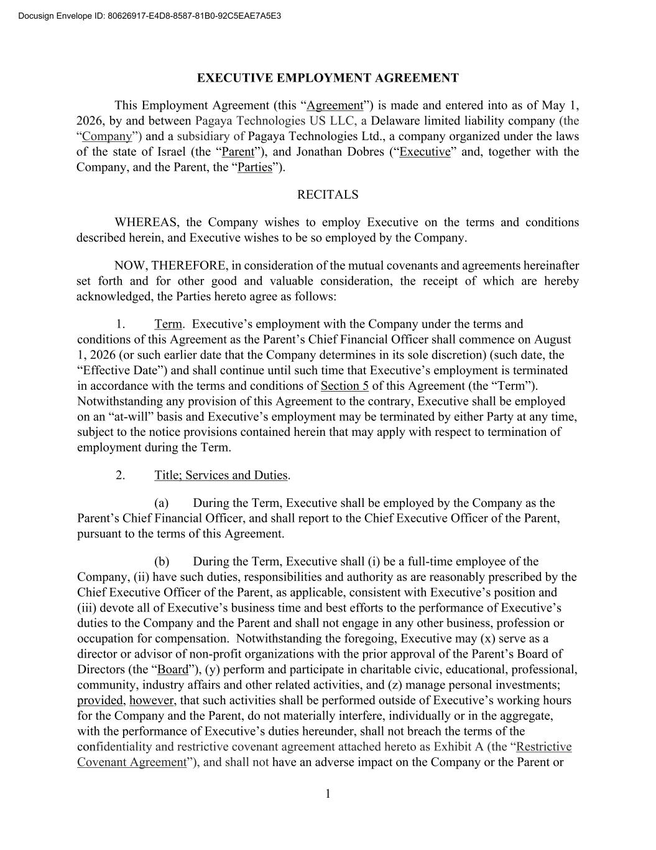
52
1 EXECUTIVE EMPLOYMENT AGREEMENT This Employment Agreement (this “Agreement”) is made and entered into as of May 1, 2026, by and between Pagaya Technologies US LLC, a Delaware limited liability company (the “Company”) and a subsidiary of Pagaya Technologies Ltd., a company organized under the laws of the state of Israel (the “Parent”), and Jonathan Dobres (“Executive” and, together with the Company, and the Parent, the “Parties”). RECITALS WHEREAS, the Company wishes to employ Executive on the terms and conditions described herein, and Executive wishes to be so employed by the Company. NOW, THEREFORE, in consideration of the mutual covenants and agreements hereinafter set forth and for other good and valuable consideration, the receipt of which are hereby acknowledged, the Parties hereto agree as follows: 1. Term. Executive’s employment with the Company under the terms and conditions of this Agreement as the Parent’s Chief Financial Officer shall commence on August 1, 2026 (or such earlier date that the Company determines in its sole discretion) (such date, the “Effective Date”) and shall continue until such time that Executive’s employment is terminated in accordance with the terms and conditions of Section 5 of this Agreement (the “Term”). Notwithstanding any provision of this Agreement to the contrary, Executive shall be employed on an “at-will” basis and Executive’s employment may be terminated by either Party at any time, subject to the notice provisions contained herein that may apply with respect to termination of employment during the Term. 2. Title; Services and Duties. (a) During the Term, Executive shall be employed by the Company as the Parent’s Chief Financial Officer, and shall report to the Chief Executive Officer of the Parent, pursuant to the terms of this Agreement. (b) During the Term, Executive shall (i) be a full-time employee of the Company, (ii) have such duties, responsibilities and authority as are reasonably prescribed by the Chief Executive Officer of the Parent, as applicable, consistent with Executive’s position and (iii) devote all of Executive’s business time and best efforts to the performance of Executive’s duties to the Company and the Parent and shall not engage in any other business, profession or occupation for compensation. Notwithstanding the foregoing, Executive may (x) serve as a director or advisor of non-profit organizations with the prior approval of the Parent’s Board of Directors (the “Board”), (y) perform and participate in charitable civic, educational, professional, community, industry affairs and other related activities, and (z) manage personal investments; provided, however, that such activities shall be performed outside of Executive’s working hours for the Company and the Parent, do not materially interfere, individually or in the aggregate, with the performance of Executive’s duties hereunder, shall not breach the terms of the confidentiality and restrictive covenant agreement attached hereto as Exhibit A (the “Restrictive Covenant Agreement”), and shall not have an adverse impact on the Company or the Parent or Docusign Envelope ID: 80626917-E4D8-8587-81B0-92C5EAE7A5E3

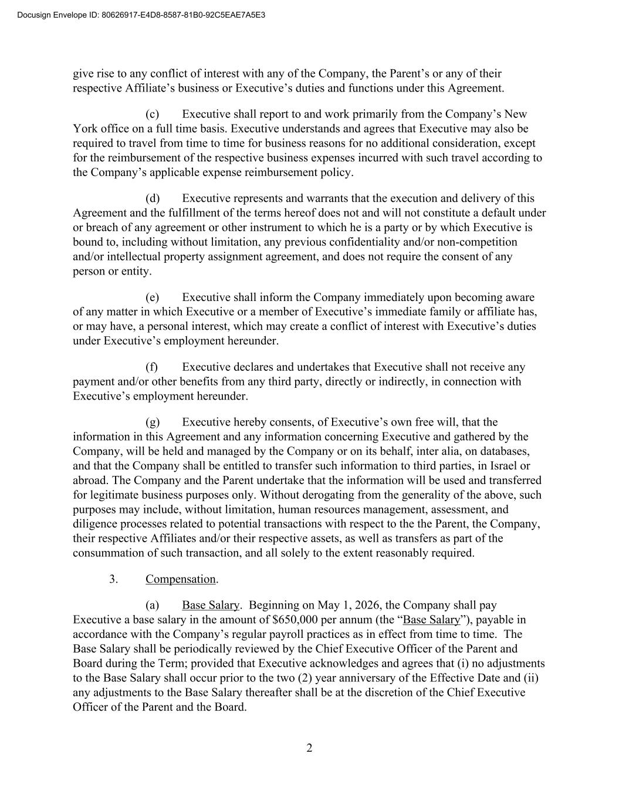
2 give rise to any conflict of interest with any of the Company, the Parent’s or any of their respective Affiliate’s business or Executive’s duties and functions under this Agreement. (c) Executive shall report to and work primarily from the Company’s New York office on a full time basis. Executive understands and agrees that Executive may also be required to travel from time to time for business reasons for no additional consideration, except for the reimbursement of the respective business expenses incurred with such travel according to the Company’s applicable expense reimbursement policy. (d) Executive represents and warrants that the execution and delivery of this Agreement and the fulfillment of the terms hereof does not and will not constitute a default under or breach of any agreement or other instrument to which he is a party or by which Executive is bound to, including without limitation, any previous confidentiality and/or non-competition and/or intellectual property assignment agreement, and does not require the consent of any person or entity. (e) Executive shall inform the Company immediately upon becoming aware of any matter in which Executive or a member of Executive’s immediate family or affiliate has, or may have, a personal interest, which may create a conflict of interest with Executive’s duties under Executive’s employment hereunder. (f) Executive declares and undertakes that Executive shall not receive any payment and/or other benefits from any third party, directly or indirectly, in connection with Executive’s employment hereunder. (g) Executive hereby consents, of Executive’s own free will, that the information in this Agreement and any information concerning Executive and gathered by the Company, will be held and managed by the Company or on its behalf, inter alia, on databases, and that the Company shall be entitled to transfer such information to third parties, in Israel or abroad. The Company and the Parent undertake that the information will be used and transferred for legitimate business purposes only. Without derogating from the generality of the above, such purposes may include, without limitation, human resources management, assessment, and diligence processes related to potential transactions with respect to the the Parent, the Company, their respective Affiliates and/or their respective assets, as well as transfers as part of the consummation of such transaction, and all solely to the extent reasonably required. 3. Compensation. (a) Base Salary. Beginning on May 1, 2026, the Company shall pay Executive a base salary in the amount of $650,000 per annum (the “Base Salary”), payable in accordance with the Company’s regular payroll practices as in effect from time to time. The Base Salary shall be periodically reviewed by the Chief Executive Officer of the Parent and Board during the Term; provided that Executive acknowledges and agrees that (i) no adjustments to the Base Salary shall occur prior to the two (2) year anniversary of the Effective Date and (ii) any adjustments to the Base Salary thereafter shall be at the discretion of the Chief Executive Officer of the Parent and the Board. Docusign Envelope ID: 80626917-E4D8-8587-81B0-92C5EAE7A5E3


3 (b) Bonus. (i) Executive shall be eligible to receive a performance based cash bonus in the target amount of $850,000 for the 2026 calendar year, subject to the Executive and the Company’s performance and as recommended by the Chief Executive Officer of the Parent and approved by the Board (the “2026 Performance Bonus”). The first payment installment of the 2026 Performance Bonus shall be in the amount of $350,000 and paid in cash as soon as practicable following the Effective Date as part of the normal monthly payroll cycle. The remaining portion of the 2026 Performance Bonus shall be paid in cash in the first quarter of 2027 following the Company’s compensation review cycle as part of the normal monthly payroll.. Notwithstanding the foregoing or anything to the contrary contained in this Agreement, if, prior to the eighteen (18) month anniversary of the Effective Date, Executive’s employment is terminated by the Company for Cause, or Executive resigns Executive’s employment other than for Good Reason, Executive shall be required to repay to the Company in cash the entire amount of the 2026 Performance Bonus. (ii) Beginning with the Company’s compensation review cycle that will take place in the first quarter of 2028, Executive shall be eligible to receive a performance based cash bonus for the previous calendar year in the target amount of $850,000, subject to Executive’s and the Company’s performance, and as recommended by the Chief Executive Officer of the Parent and approved by the Board. Any bonus amount referred to in this clause (ii) that becomes payable to Executive shall be paid to Executive in cash as part of the Company’s compensation review cycle. (iii) All performance bonuses (including the 2026 Performance Bonus and any subsequent performance bonus) shall be subject to the Executive and the Company’s performance and as recommended by the Chief Executive Officer of the Parent and approved by the Board. The actual amount of any performance bonus shall be at the discretion of the Chief Executive Officer of the Parent and the Board. (iv) Any performance bonus that becomes payable to Executive under this Section 3(b) shall only be payable provided Executive is an active employee of the Company, and has not given or received notice of termination or resignation of employment as of the date on which such payment is made or is not under investigation for conduct that may constitute Cause for termination . (c) Equity. (i) Subject to the approval of the Board, Executive shall be granted the following awards of restricted stock units of the Parent each, a “RSU Grant”): (A) as soon as practicable following the Effective Date, a RSU Grant with a value of $500,000 (B) as part of the Company’s compensation review cycle occurring in the first quarter of 2027, , a a RSU Grant with a value of $500,000 and (C) as part of the Company’s compensation review cycle occurring in the first quarter of 2028, a RSU Grant with a value of $1,000,000. The conversion of the dollar value of each RSU Grant to a specific number of shares of the Parent shall be determined by the Board, the Parent’s Compensation Committee and/or the Parent’s Chief Executive Officer, as appropriate, in each case, in their sole discretion. Each RSU Grant will vest in equal quarterly amounts Docusign Envelope ID: 80626917-E4D8-8587-81B0-92C5EAE7A5E3

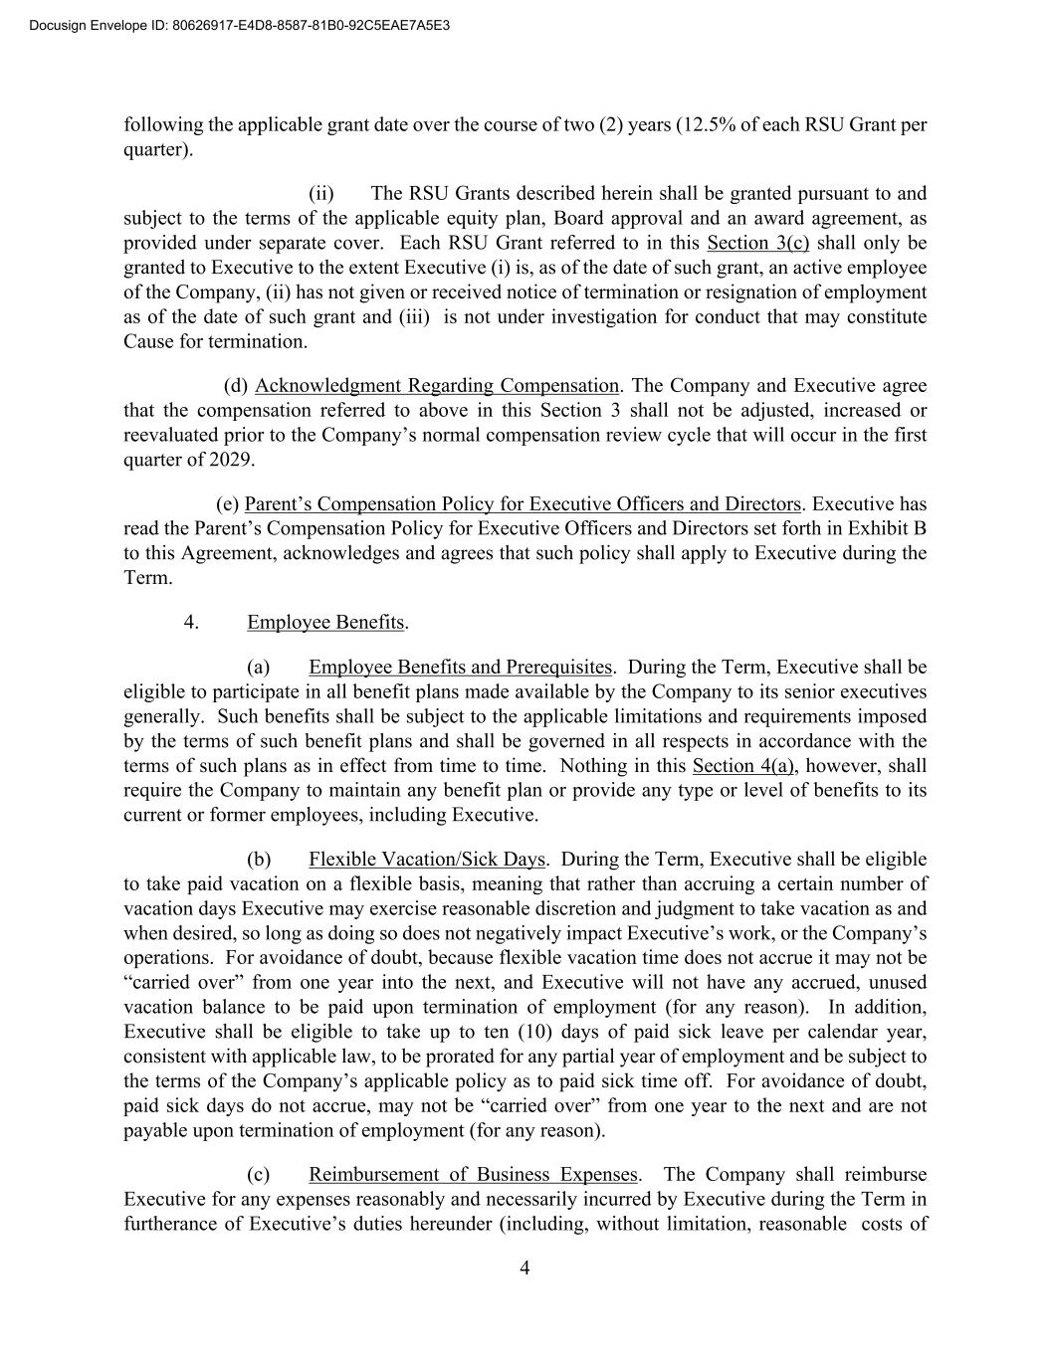
4 following the applicable grant date over the course of two (2) years (12.5% of each RSU Grant per quarter). (ii) The RSU Grants described herein shall be granted pursuant to and subject to the terms of the applicable equity plan, Board approval and an award agreement, as provided under separate cover. Each RSU Grant referred to in this Section 3(c) shall only be granted to Executive to the extent Executive (i) is, as of the date of such grant, an active employee of the Company, (ii) has not given or received notice of termination or resignation of employment as of the date of such grant and (iii) is not under investigation for conduct that may constitute Cause for termination. (d) Acknowledgment Regarding Compensation. The Company and Executive agree that the compensation referred to above in this Section 3 shall not be adjusted, increased or reevaluated prior to the Company’s normal compensation review cycle that will occur in the first quarter of 2029. (e) Parent’s Compensation Policy for Executive Officers and Directors. Executive has read the Parent’s Compensation Policy for Executive Officers and Directors set forth in Exhibit B to this Agreement, acknowledges and agrees that such policy shall apply to Executive during the Term. 4. Employee Benefits. (a) Employee Benefits and Prerequisites. During the Term, Executive shall be eligible to participate in all benefit plans made available by the Company to its senior executives generally. Such benefits shall be subject to the applicable limitations and requirements imposed by the terms of such benefit plans and shall be governed in all respects in accordance with the terms of such plans as in effect from time to time. Nothing in this Section 4(a), however, shall require the Company to maintain any benefit plan or provide any type or level of benefits to its current or former employees, including Executive. (b) Flexible Vacation/Sick Days. During the Term, Executive shall be eligible to take paid vacation on a flexible basis, meaning that rather than accruing a certain number of vacation days Executive may exercise reasonable discretion and judgment to take vacation as and when desired, so long as doing so does not negatively impact Executive’s work, or the Company’s operations. For avoidance of doubt, because flexible vacation time does not accrue it may not be “carried over” from one year into the next, and Executive will not have any accrued, unused vacation balance to be paid upon termination of employment (for any reason). In addition, Executive shall be eligible to take up to ten (10) days of paid sick leave per calendar year, consistent with applicable law, to be prorated for any partial year of employment and be subject to the terms of the Company’s applicable policy as to paid sick time off. For avoidance of doubt, paid sick days do not accrue, may not be “carried over” from one year to the next and are not payable upon termination of employment (for any reason). (c) Reimbursement of Business Expenses. The Company shall reimburse Executive for any expenses reasonably and necessarily incurred by Executive during the Term in furtherance of Executive’s duties hereunder (including, without limitation, reasonable costs of Docusign Envelope ID: 80626917-E4D8-8587-81B0-92C5EAE7A5E3

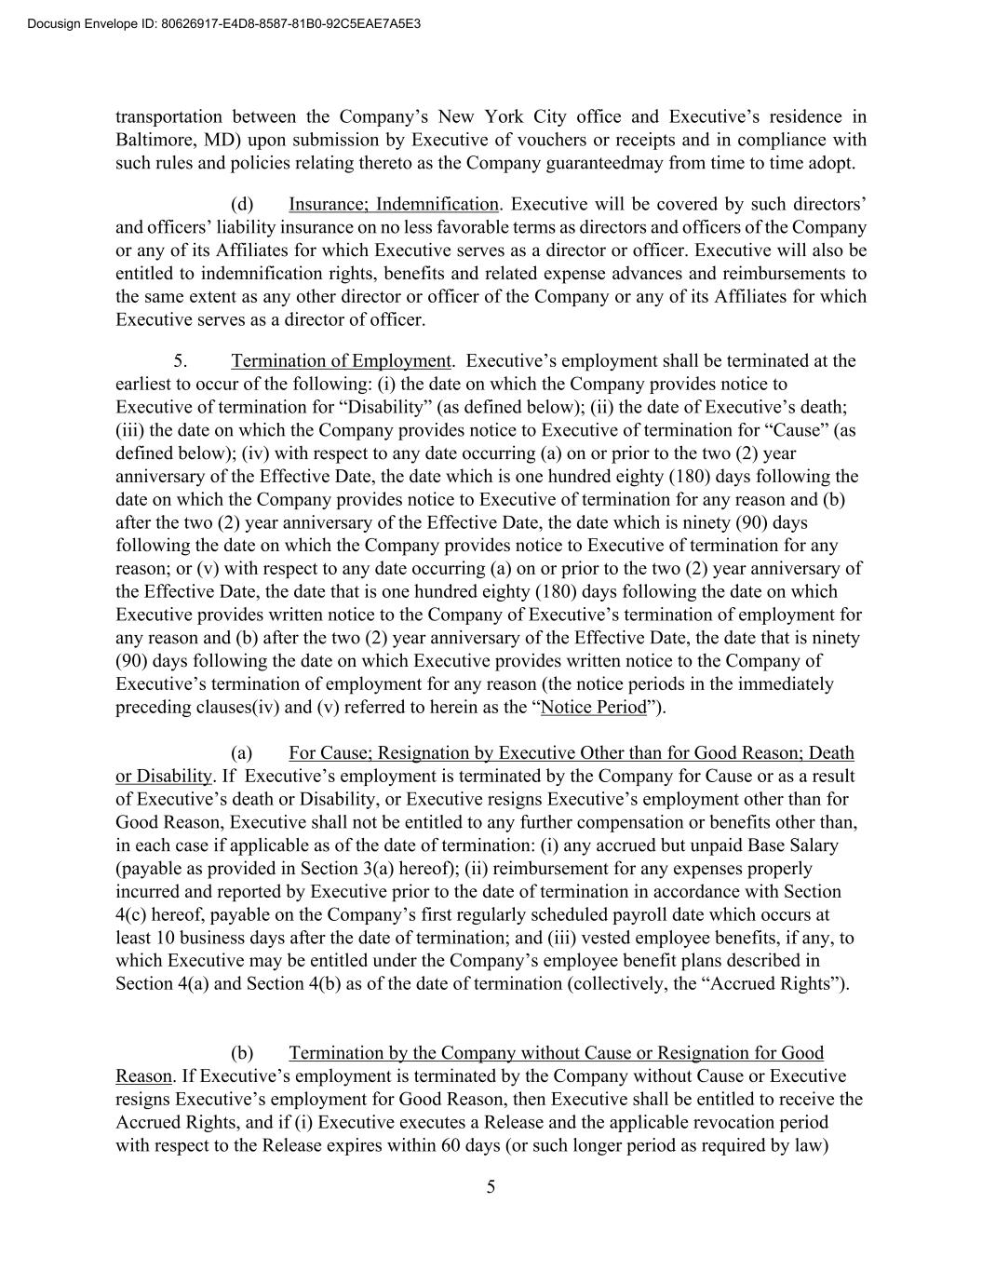
5 transportation between the Company’s New York City office and Executive’s residence in Baltimore, MD) upon submission by Executive of vouchers or receipts and in compliance with such rules and policies relating thereto as the Company guaranteedmay from time to time adopt. (d) Insurance; Indemnification. Executive will be covered by such directors’ and officers’ liability insurance on no less favorable terms as directors and officers of the Company or any of its Affiliates for which Executive serves as a director or officer. Executive will also be entitled to indemnification rights, benefits and related expense advances and reimbursements to the same extent as any other director or officer of the Company or any of its Affiliates for which Executive serves as a director of officer. 5. Termination of Employment. Executive’s employment shall be terminated at the earliest to occur of the following: (i) the date on which the Company provides notice to Executive of termination for “Disability” (as defined below); (ii) the date of Executive’s death; (iii) the date on which the Company provides notice to Executive of termination for “Cause” (as defined below); (iv) with respect to any date occurring (a) on or prior to the two (2) year anniversary of the Effective Date, the date which is one hundred eighty (180) days following the date on which the Company provides notice to Executive of termination for any reason and (b) after the two (2) year anniversary of the Effective Date, the date which is ninety (90) days following the date on which the Company provides notice to Executive of termination for any reason; or (v) with respect to any date occurring (a) on or prior to the two (2) year anniversary of the Effective Date, the date that is one hundred eighty (180) days following the date on which Executive provides written notice to the Company of Executive’s termination of employment for any reason and (b) after the two (2) year anniversary of the Effective Date, the date that is ninety (90) days following the date on which Executive provides written notice to the Company of Executive’s termination of employment for any reason (the notice periods in the immediately preceding clauses(iv) and (v) referred to herein as the “Notice Period”). (a) For Cause; Resignation by Executive Other than for Good Reason; Death or Disability. If Executive’s employment is terminated by the Company for Cause or as a result of Executive’s death or Disability, or Executive resigns Executive’s employment other than for Good Reason, Executive shall not be entitled to any further compensation or benefits other than, in each case if applicable as of the date of termination: (i) any accrued but unpaid Base Salary (payable as provided in Section 3(a) hereof); (ii) reimbursement for any expenses properly incurred and reported by Executive prior to the date of termination in accordance with Section 4(c) hereof, payable on the Company’s first regularly scheduled payroll date which occurs at least 10 business days after the date of termination; and (iii) vested employee benefits, if any, to which Executive may be entitled under the Company’s employee benefit plans described in Section 4(a) and Section 4(b) as of the date of termination (collectively, the “Accrued Rights”). (b) Termination by the Company without Cause or Resignation for Good Reason. If Executive’s employment is terminated by the Company without Cause or Executive resigns Executive’s employment for Good Reason, then Executive shall be entitled to receive the Accrued Rights, and if (i) Executive executes a Release and the applicable revocation period with respect to the Release expires within 60 days (or such longer period as required by law) Docusign Envelope ID: 80626917-E4D8-8587-81B0-92C5EAE7A5E3

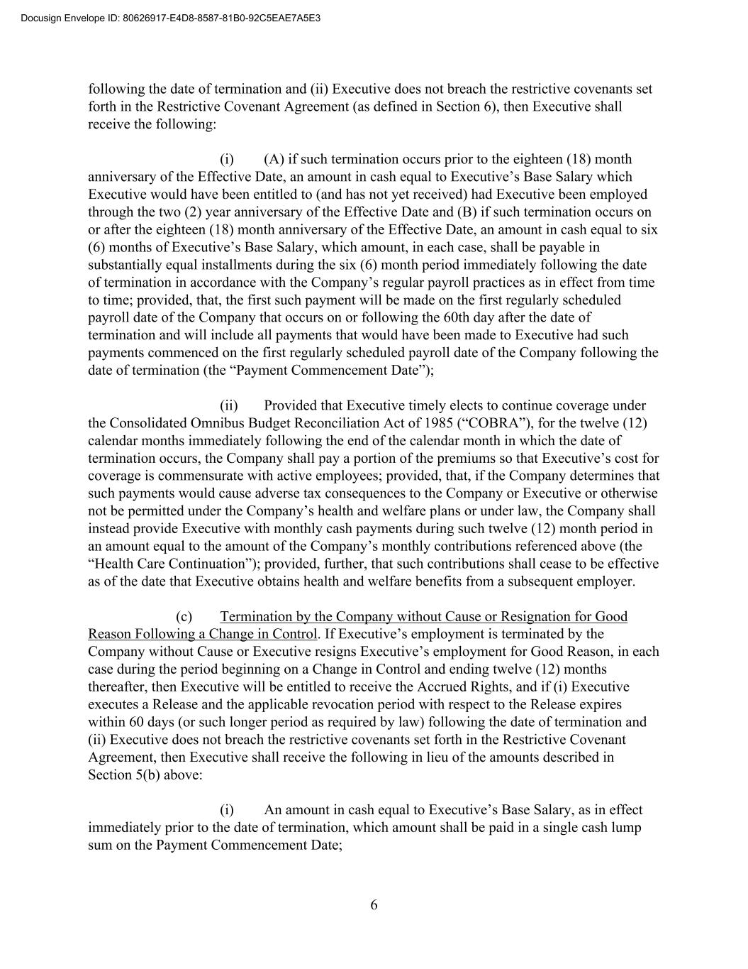
6 following the date of termination and (ii) Executive does not breach the restrictive covenants set forth in the Restrictive Covenant Agreement (as defined in Section 6), then Executive shall receive the following: (i) (A) if such termination occurs prior to the eighteen (18) month anniversary of the Effective Date, an amount in cash equal to Executive’s Base Salary which Executive would have been entitled to (and has not yet received) had Executive been employed through the two (2) year anniversary of the Effective Date and (B) if such termination occurs on or after the eighteen (18) month anniversary of the Effective Date, an amount in cash equal to six (6) months of Executive’s Base Salary, which amount, in each case, shall be payable in substantially equal installments during the six (6) month period immediately following the date of termination in accordance with the Company’s regular payroll practices as in effect from time to time; provided, that, the first such payment will be made on the first regularly scheduled payroll date of the Company that occurs on or following the 60th day after the date of termination and will include all payments that would have been made to Executive had such payments commenced on the first regularly scheduled payroll date of the Company following the date of termination (the “Payment Commencement Date”); (ii) Provided that Executive timely elects to continue coverage under the Consolidated Omnibus Budget Reconciliation Act of 1985 (“COBRA”), for the twelve (12) calendar months immediately following the end of the calendar month in which the date of termination occurs, the Company shall pay a portion of the premiums so that Executive’s cost for coverage is commensurate with active employees; provided, that, if the Company determines that such payments would cause adverse tax consequences to the Company or Executive or otherwise not be permitted under the Company’s health and welfare plans or under law, the Company shall instead provide Executive with monthly cash payments during such twelve (12) month period in an amount equal to the amount of the Company’s monthly contributions referenced above (the “Health Care Continuation”); provided, further, that such contributions shall cease to be effective as of the date that Executive obtains health and welfare benefits from a subsequent employer. (c) Termination by the Company without Cause or Resignation for Good Reason Following a Change in Control. If Executive’s employment is terminated by the Company without Cause or Executive resigns Executive’s employment for Good Reason, in each case during the period beginning on a Change in Control and ending twelve (12) months thereafter, then Executive will be entitled to receive the Accrued Rights, and if (i) Executive executes a Release and the applicable revocation period with respect to the Release expires within 60 days (or such longer period as required by law) following the date of termination and (ii) Executive does not breach the restrictive covenants set forth in the Restrictive Covenant Agreement, then Executive shall receive the following in lieu of the amounts described in Section 5(b) above: (i) An amount in cash equal to Executive’s Base Salary, as in effect immediately prior to the date of termination, which amount shall be paid in a single cash lump sum on the Payment Commencement Date; Docusign Envelope ID: 80626917-E4D8-8587-81B0-92C5EAE7A5E3

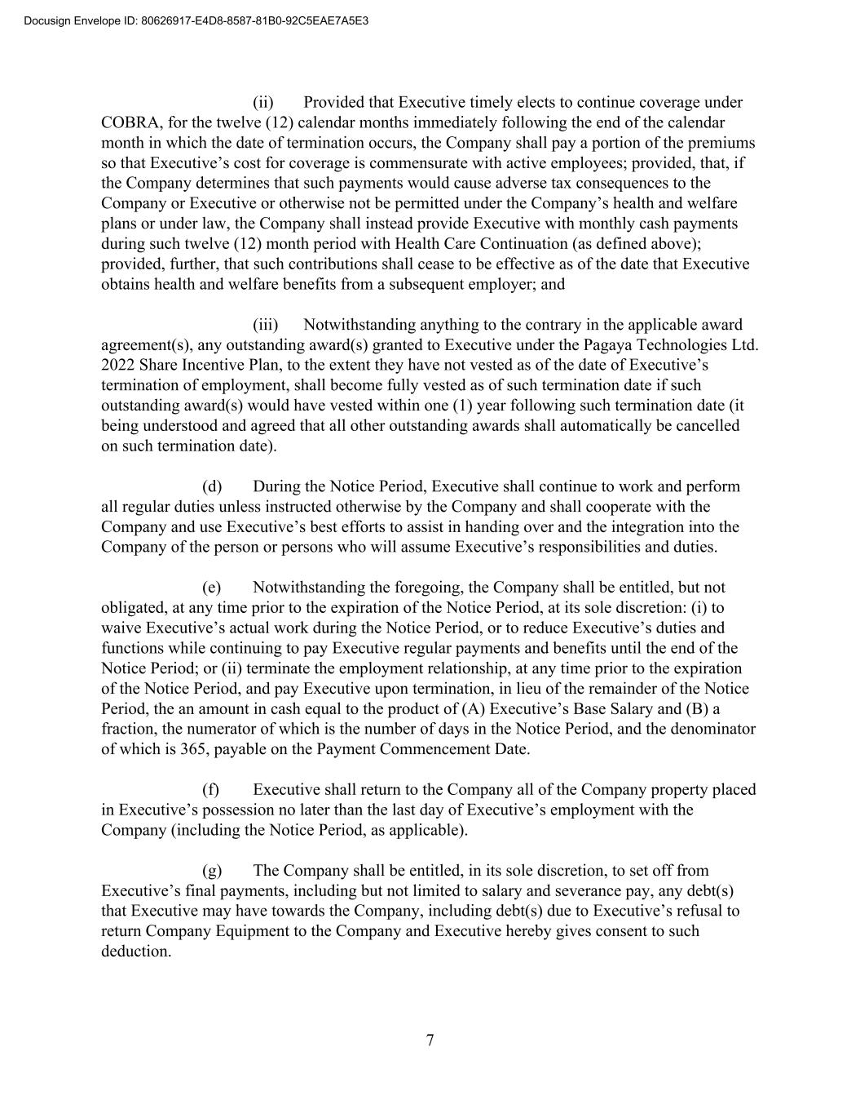
7 (ii) Provided that Executive timely elects to continue coverage under COBRA, for the twelve (12) calendar months immediately following the end of the calendar month in which the date of termination occurs, the Company shall pay a portion of the premiums so that Executive’s cost for coverage is commensurate with active employees; provided, that, if the Company determines that such payments would cause adverse tax consequences to the Company or Executive or otherwise not be permitted under the Company’s health and welfare plans or under law, the Company shall instead provide Executive with monthly cash payments during such twelve (12) month period with Health Care Continuation (as defined above); provided, further, that such contributions shall cease to be effective as of the date that Executive obtains health and welfare benefits from a subsequent employer; and (iii) Notwithstanding anything to the contrary in the applicable award agreement(s), any outstanding award(s) granted to Executive under the Pagaya Technologies Ltd. 2022 Share Incentive Plan, to the extent they have not vested as of the date of Executive’s termination of employment, shall become fully vested as of such termination date if such outstanding award(s) would have vested within one (1) year following such termination date (it being understood and agreed that all other outstanding awards shall automatically be cancelled on such termination date). (d) During the Notice Period, Executive shall continue to work and perform all regular duties unless instructed otherwise by the Company and shall cooperate with the Company and use Executive’s best efforts to assist in handing over and the integration into the Company of the person or persons who will assume Executive’s responsibilities and duties. (e) Notwithstanding the foregoing, the Company shall be entitled, but not obligated, at any time prior to the expiration of the Notice Period, at its sole discretion: (i) to waive Executive’s actual work during the Notice Period, or to reduce Executive’s duties and functions while continuing to pay Executive regular payments and benefits until the end of the Notice Period; or (ii) terminate the employment relationship, at any time prior to the expiration of the Notice Period, and pay Executive upon termination, in lieu of the remainder of the Notice Period, the an amount in cash equal to the product of (A) Executive’s Base Salary and (B) a fraction, the numerator of which is the number of days in the Notice Period, and the denominator of which is 365, payable on the Payment Commencement Date. (f) Executive shall return to the Company all of the Company property placed in Executive’s possession no later than the last day of Executive’s employment with the Company (including the Notice Period, as applicable). (g) The Company shall be entitled, in its sole discretion, to set off from Executive’s final payments, including but not limited to salary and severance pay, any debt(s) that Executive may have towards the Company, including debt(s) due to Executive’s refusal to return Company Equipment to the Company and Executive hereby gives consent to such deduction. Docusign Envelope ID: 80626917-E4D8-8587-81B0-92C5EAE7A5E3

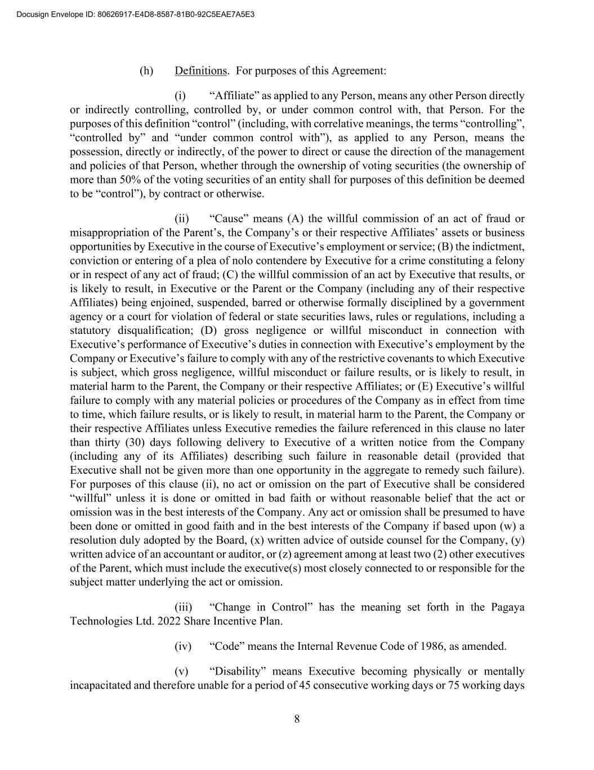
8 (h) Definitions. For purposes of this Agreement: (i) “Affiliate” as applied to any Person, means any other Person directly or indirectly controlling, controlled by, or under common control with, that Person. For the purposes of this definition “control” (including, with correlative meanings, the terms “controlling”, “controlled by” and “under common control with”), as applied to any Person, means the possession, directly or indirectly, of the power to direct or cause the direction of the management and policies of that Person, whether through the ownership of voting securities (the ownership of more than 50% of the voting securities of an entity shall for purposes of this definition be deemed to be “control”), by contract or otherwise. (ii) “Cause” means (A) the willful commission of an act of fraud or misappropriation of the Parent’s, the Company’s or their respective Affiliates’ assets or business opportunities by Executive in the course of Executive’s employment or service; (B) the indictment, conviction or entering of a plea of nolo contendere by Executive for a crime constituting a felony or in respect of any act of fraud; (C) the willful commission of an act by Executive that results, or is likely to result, in Executive or the Parent or the Company (including any of their respective Affiliates) being enjoined, suspended, barred or otherwise formally disciplined by a government agency or a court for violation of federal or state securities laws, rules or regulations, including a statutory disqualification; (D) gross negligence or willful misconduct in connection with Executive’s performance of Executive’s duties in connection with Executive’s employment by the Company or Executive’s failure to comply with any of the restrictive covenants to which Executive is subject, which gross negligence, willful misconduct or failure results, or is likely to result, in material harm to the Parent, the Company or their respective Affiliates; or (E) Executive’s willful failure to comply with any material policies or procedures of the Company as in effect from time to time, which failure results, or is likely to result, in material harm to the Parent, the Company or their respective Affiliates unless Executive remedies the failure referenced in this clause no later than thirty (30) days following delivery to Executive of a written notice from the Company (including any of its Affiliates) describing such failure in reasonable detail (provided that Executive shall not be given more than one opportunity in the aggregate to remedy such failure). For purposes of this clause (ii), no act or omission on the part of Executive shall be considered “willful” unless it is done or omitted in bad faith or without reasonable belief that the act or omission was in the best interests of the Company. Any act or omission shall be presumed to have been done or omitted in good faith and in the best interests of the Company if based upon (w) a resolution duly adopted by the Board, (x) written advice of outside counsel for the Company, (y) written advice of an accountant or auditor, or (z) agreement among at least two (2) other executives of the Parent, which must include the executive(s) most closely connected to or responsible for the subject matter underlying the act or omission. (iii) “Change in Control” has the meaning set forth in the Pagaya Technologies Ltd. 2022 Share Incentive Plan. (iv) “Code” means the Internal Revenue Code of 1986, as amended. (v) “Disability” means Executive becoming physically or mentally incapacitated and therefore unable for a period of 45 consecutive working days or 75 working days Docusign Envelope ID: 80626917-E4D8-8587-81B0-92C5EAE7A5E3

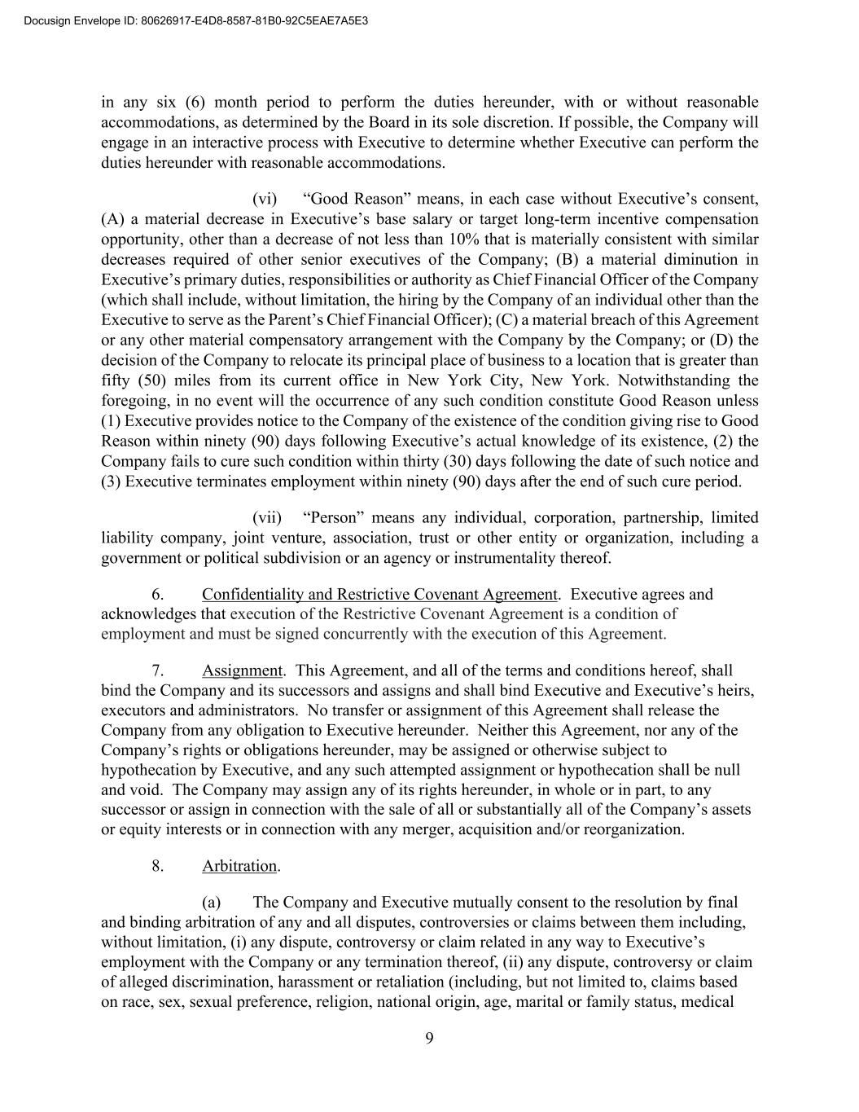
9 in any six (6) month period to perform the duties hereunder, with or without reasonable accommodations, as determined by the Board in its sole discretion. If possible, the Company will engage in an interactive process with Executive to determine whether Executive can perform the duties hereunder with reasonable accommodations. (vi) “Good Reason” means, in each case without Executive’s consent, (A) a material decrease in Executive’s base salary or target long-term incentive compensation opportunity, other than a decrease of not less than 10% that is materially consistent with similar decreases required of other senior executives of the Company; (B) a material diminution in Executive’s primary duties, responsibilities or authority as Chief Financial Officer of the Company (which shall include, without limitation, the hiring by the Company of an individual other than the Executive to serve as the Parent’s Chief Financial Officer); (C) a material breach of this Agreement or any other material compensatory arrangement with the Company by the Company; or (D) the decision of the Company to relocate its principal place of business to a location that is greater than fifty (50) miles from its current office in New York City, New York. Notwithstanding the foregoing, in no event will the occurrence of any such condition constitute Good Reason unless (1) Executive provides notice to the Company of the existence of the condition giving rise to Good Reason within ninety (90) days following Executive’s actual knowledge of its existence, (2) the Company fails to cure such condition within thirty (30) days following the date of such notice and (3) Executive terminates employment within ninety (90) days after the end of such cure period. (vii) “Person” means any individual, corporation, partnership, limited liability company, joint venture, association, trust or other entity or organization, including a government or political subdivision or an agency or instrumentality thereof. 6. Confidentiality and Restrictive Covenant Agreement. Executive agrees and acknowledges that execution of the Restrictive Covenant Agreement is a condition of employment and must be signed concurrently with the execution of this Agreement. 7. Assignment. This Agreement, and all of the terms and conditions hereof, shall bind the Company and its successors and assigns and shall bind Executive and Executive’s heirs, executors and administrators. No transfer or assignment of this Agreement shall release the Company from any obligation to Executive hereunder. Neither this Agreement, nor any of the Company’s rights or obligations hereunder, may be assigned or otherwise subject to hypothecation by Executive, and any such attempted assignment or hypothecation shall be null and void. The Company may assign any of its rights hereunder, in whole or in part, to any successor or assign in connection with the sale of all or substantially all of the Company’s assets or equity interests or in connection with any merger, acquisition and/or reorganization. 8. Arbitration. (a) The Company and Executive mutually consent to the resolution by final and binding arbitration of any and all disputes, controversies or claims between them including, without limitation, (i) any dispute, controversy or claim related in any way to Executive’s employment with the Company or any termination thereof, (ii) any dispute, controversy or claim of alleged discrimination, harassment or retaliation (including, but not limited to, claims based on race, sex, sexual preference, religion, national origin, age, marital or family status, medical Docusign Envelope ID: 80626917-E4D8-8587-81B0-92C5EAE7A5E3

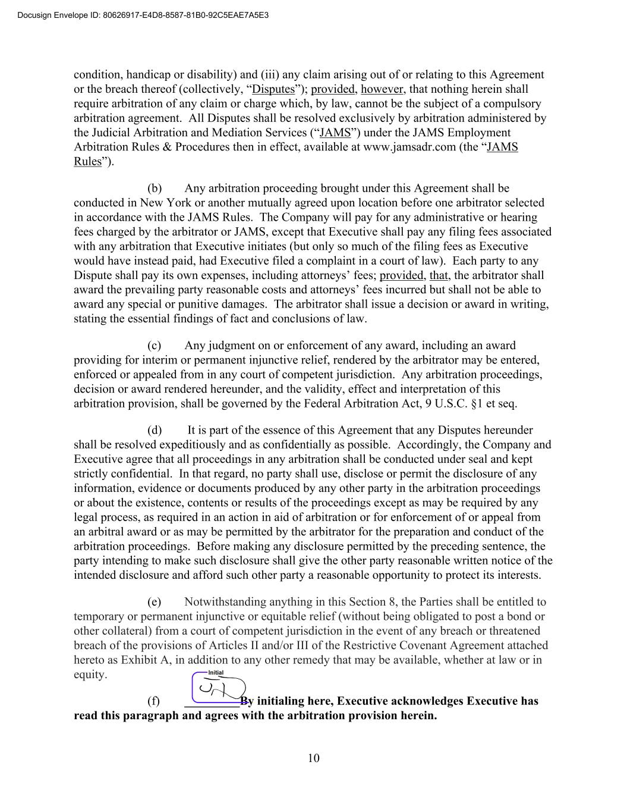
10 condition, handicap or disability) and (iii) any claim arising out of or relating to this Agreement or the breach thereof (collectively, “Disputes”); provided, however, that nothing herein shall require arbitration of any claim or charge which, by law, cannot be the subject of a compulsory arbitration agreement. All Disputes shall be resolved exclusively by arbitration administered by the Judicial Arbitration and Mediation Services (“JAMS”) under the JAMS Employment Arbitration Rules & Procedures then in effect, available at www.jamsadr.com (the “JAMS Rules”). (b) Any arbitration proceeding brought under this Agreement shall be conducted in New York or another mutually agreed upon location before one arbitrator selected in accordance with the JAMS Rules. The Company will pay for any administrative or hearing fees charged by the arbitrator or JAMS, except that Executive shall pay any filing fees associated with any arbitration that Executive initiates (but only so much of the filing fees as Executive would have instead paid, had Executive filed a complaint in a court of law). Each party to any Dispute shall pay its own expenses, including attorneys’ fees; provided, that, the arbitrator shall award the prevailing party reasonable costs and attorneys’ fees incurred but shall not be able to award any special or punitive damages. The arbitrator shall issue a decision or award in writing, stating the essential findings of fact and conclusions of law. (c) Any judgment on or enforcement of any award, including an award providing for interim or permanent injunctive relief, rendered by the arbitrator may be entered, enforced or appealed from in any court of competent jurisdiction. Any arbitration proceedings, decision or award rendered hereunder, and the validity, effect and interpretation of this arbitration provision, shall be governed by the Federal Arbitration Act, 9 U.S.C. §1 et seq. (d) It is part of the essence of this Agreement that any Disputes hereunder shall be resolved expeditiously and as confidentially as possible. Accordingly, the Company and Executive agree that all proceedings in any arbitration shall be conducted under seal and kept strictly confidential. In that regard, no party shall use, disclose or permit the disclosure of any information, evidence or documents produced by any other party in the arbitration proceedings or about the existence, contents or results of the proceedings except as may be required by any legal process, as required in an action in aid of arbitration or for enforcement of or appeal from an arbitral award or as may be permitted by the arbitrator for the preparation and conduct of the arbitration proceedings. Before making any disclosure permitted by the preceding sentence, the party intending to make such disclosure shall give the other party reasonable written notice of the intended disclosure and afford such other party a reasonable opportunity to protect its interests. (e) Notwithstanding anything in this Section 8, the Parties shall be entitled to temporary or permanent injunctive or equitable relief (without being obligated to post a bond or other collateral) from a court of competent jurisdiction in the event of any breach or threatened breach of the provisions of Articles II and/or III of the Restrictive Covenant Agreement attached hereto as Exhibit A, in addition to any other remedy that may be available, whether at law or in equity. (f) _________By initialing here, Executive acknowledges Executive has read this paragraph and agrees with the arbitration provision herein. Docusign Envelope ID: 80626917-E4D8-8587-81B0-92C5EAE7A5E3

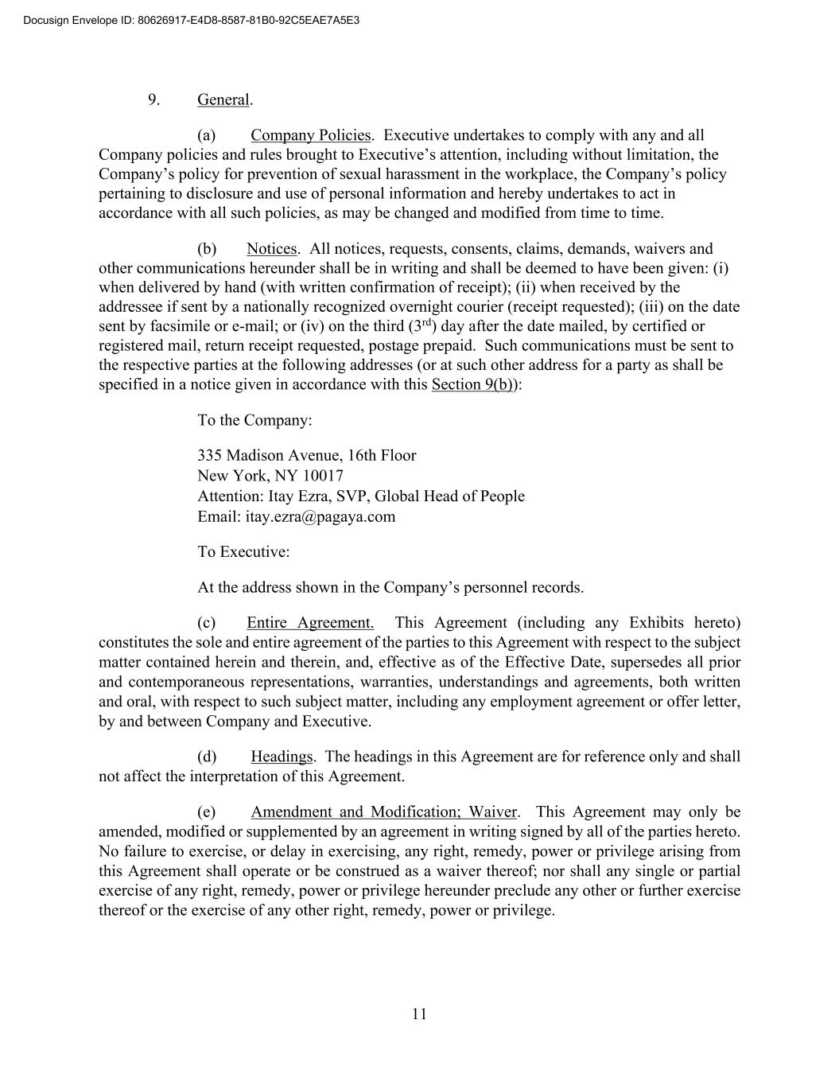
11 9. General. (a) Company Policies. Executive undertakes to comply with any and all Company policies and rules brought to Executive’s attention, including without limitation, the Company’s policy for prevention of sexual harassment in the workplace, the Company’s policy pertaining to disclosure and use of personal information and hereby undertakes to act in accordance with all such policies, as may be changed and modified from time to time. (b) Notices. All notices, requests, consents, claims, demands, waivers and other communications hereunder shall be in writing and shall be deemed to have been given: (i) when delivered by hand (with written confirmation of receipt); (ii) when received by the addressee if sent by a nationally recognized overnight courier (receipt requested); (iii) on the date sent by facsimile or e-mail; or (iv) on the third (3rd) day after the date mailed, by certified or registered mail, return receipt requested, postage prepaid. Such communications must be sent to the respective parties at the following addresses (or at such other address for a party as shall be specified in a notice given in accordance with this Section 9(b)): To the Company: 335 Madison Avenue, 16th Floor New York, NY 10017 Attention: Itay Ezra, SVP, Global Head of People Email: itay.ezra@pagaya.com To Executive: At the address shown in the Company’s personnel records. (c) Entire Agreement. This Agreement (including any Exhibits hereto) constitutes the sole and entire agreement of the parties to this Agreement with respect to the subject matter contained herein and therein, and, effective as of the Effective Date, supersedes all prior and contemporaneous representations, warranties, understandings and agreements, both written and oral, with respect to such subject matter, including any employment agreement or offer letter, by and between Company and Executive. (d) Headings. The headings in this Agreement are for reference only and shall not affect the interpretation of this Agreement. (e) Amendment and Modification; Waiver. This Agreement may only be amended, modified or supplemented by an agreement in writing signed by all of the parties hereto. No failure to exercise, or delay in exercising, any right, remedy, power or privilege arising from this Agreement shall operate or be construed as a waiver thereof; nor shall any single or partial exercise of any right, remedy, power or privilege hereunder preclude any other or further exercise thereof or the exercise of any other right, remedy, power or privilege. Docusign Envelope ID: 80626917-E4D8-8587-81B0-92C5EAE7A5E3

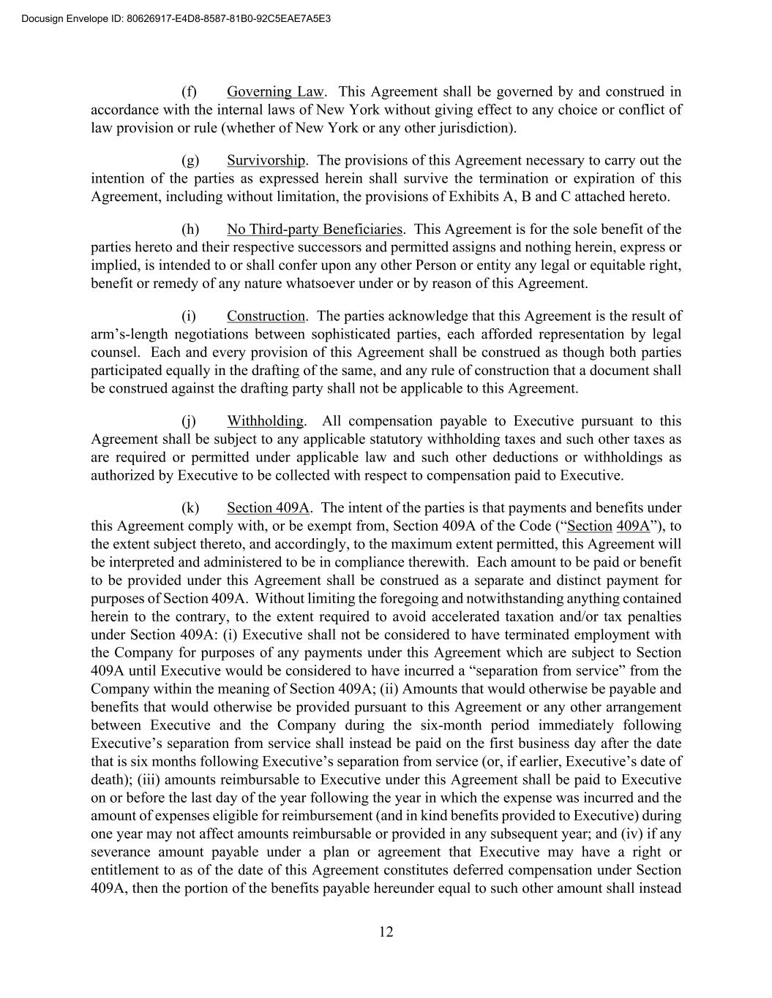
12 (f) Governing Law. This Agreement shall be governed by and construed in accordance with the internal laws of New York without giving effect to any choice or conflict of law provision or rule (whether of New York or any other jurisdiction). (g) Survivorship. The provisions of this Agreement necessary to carry out the intention of the parties as expressed herein shall survive the termination or expiration of this Agreement, including without limitation, the provisions of Exhibits A, B and C attached hereto. (h) No Third-party Beneficiaries. This Agreement is for the sole benefit of the parties hereto and their respective successors and permitted assigns and nothing herein, express or implied, is intended to or shall confer upon any other Person or entity any legal or equitable right, benefit or remedy of any nature whatsoever under or by reason of this Agreement. (i) Construction. The parties acknowledge that this Agreement is the result of arm’s-length negotiations between sophisticated parties, each afforded representation by legal counsel. Each and every provision of this Agreement shall be construed as though both parties participated equally in the drafting of the same, and any rule of construction that a document shall be construed against the drafting party shall not be applicable to this Agreement. (j) Withholding. All compensation payable to Executive pursuant to this Agreement shall be subject to any applicable statutory withholding taxes and such other taxes as are required or permitted under applicable law and such other deductions or withholdings as authorized by Executive to be collected with respect to compensation paid to Executive. (k) Section 409A. The intent of the parties is that payments and benefits under this Agreement comply with, or be exempt from, Section 409A of the Code (“Section 409A”), to the extent subject thereto, and accordingly, to the maximum extent permitted, this Agreement will be interpreted and administered to be in compliance therewith. Each amount to be paid or benefit to be provided under this Agreement shall be construed as a separate and distinct payment for purposes of Section 409A. Without limiting the foregoing and notwithstanding anything contained herein to the contrary, to the extent required to avoid accelerated taxation and/or tax penalties under Section 409A: (i) Executive shall not be considered to have terminated employment with the Company for purposes of any payments under this Agreement which are subject to Section 409A until Executive would be considered to have incurred a “separation from service” from the Company within the meaning of Section 409A; (ii) Amounts that would otherwise be payable and benefits that would otherwise be provided pursuant to this Agreement or any other arrangement between Executive and the Company during the six-month period immediately following Executive’s separation from service shall instead be paid on the first business day after the date that is six months following Executive’s separation from service (or, if earlier, Executive’s date of death); (iii) amounts reimbursable to Executive under this Agreement shall be paid to Executive on or before the last day of the year following the year in which the expense was incurred and the amount of expenses eligible for reimbursement (and in kind benefits provided to Executive) during one year may not affect amounts reimbursable or provided in any subsequent year; and (iv) if any severance amount payable under a plan or agreement that Executive may have a right or entitlement to as of the date of this Agreement constitutes deferred compensation under Section 409A, then the portion of the benefits payable hereunder equal to such other amount shall instead Docusign Envelope ID: 80626917-E4D8-8587-81B0-92C5EAE7A5E3

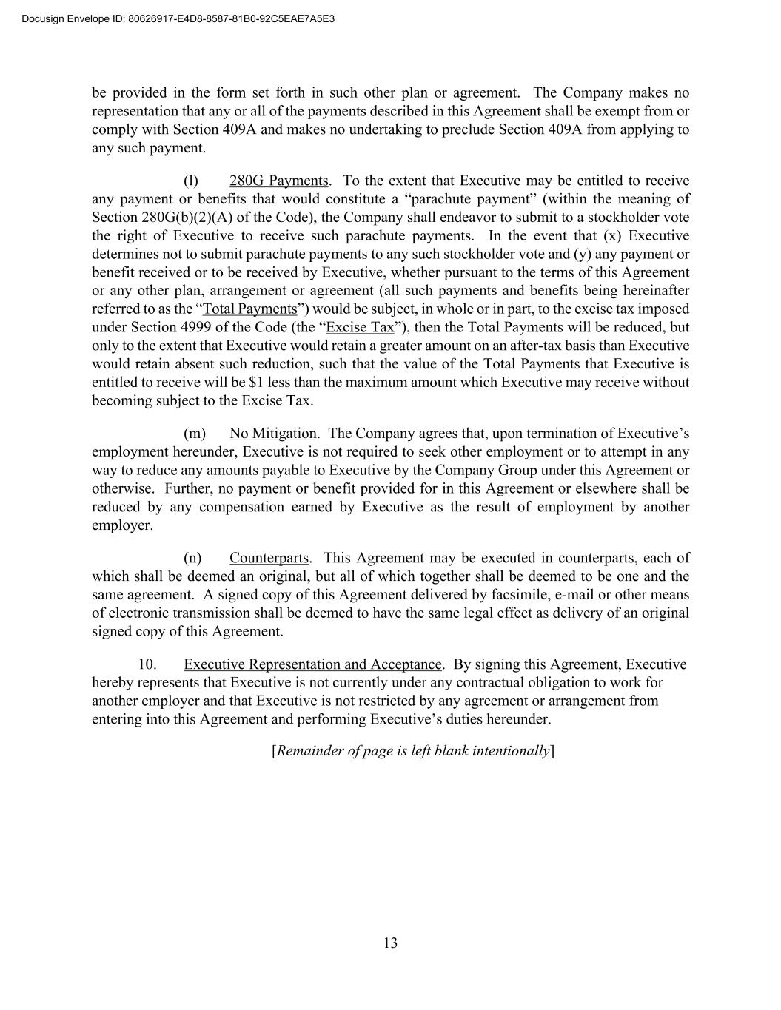
13 be provided in the form set forth in such other plan or agreement. The Company makes no representation that any or all of the payments described in this Agreement shall be exempt from or comply with Section 409A and makes no undertaking to preclude Section 409A from applying to any such payment. (l) 280G Payments. To the extent that Executive may be entitled to receive any payment or benefits that would constitute a “parachute payment” (within the meaning of Section 280G(b)(2)(A) of the Code), the Company shall endeavor to submit to a stockholder vote the right of Executive to receive such parachute payments. In the event that (x) Executive determines not to submit parachute payments to any such stockholder vote and (y) any payment or benefit received or to be received by Executive, whether pursuant to the terms of this Agreement or any other plan, arrangement or agreement (all such payments and benefits being hereinafter referred to as the “Total Payments”) would be subject, in whole or in part, to the excise tax imposed under Section 4999 of the Code (the “Excise Tax”), then the Total Payments will be reduced, but only to the extent that Executive would retain a greater amount on an after-tax basis than Executive would retain absent such reduction, such that the value of the Total Payments that Executive is entitled to receive will be $1 less than the maximum amount which Executive may receive without becoming subject to the Excise Tax. (m) No Mitigation. The Company agrees that, upon termination of Executive’s employment hereunder, Executive is not required to seek other employment or to attempt in any way to reduce any amounts payable to Executive by the Company Group under this Agreement or otherwise. Further, no payment or benefit provided for in this Agreement or elsewhere shall be reduced by any compensation earned by Executive as the result of employment by another employer. (n) Counterparts. This Agreement may be executed in counterparts, each of which shall be deemed an original, but all of which together shall be deemed to be one and the same agreement. A signed copy of this Agreement delivered by facsimile, e-mail or other means of electronic transmission shall be deemed to have the same legal effect as delivery of an original signed copy of this Agreement. 10. Executive Representation and Acceptance. By signing this Agreement, Executive hereby represents that Executive is not currently under any contractual obligation to work for another employer and that Executive is not restricted by any agreement or arrangement from entering into this Agreement and performing Executive’s duties hereunder. [Remainder of page is left blank intentionally] Docusign Envelope ID: 80626917-E4D8-8587-81B0-92C5EAE7A5E3


IN WITNESS WHEREOF AND INTENDING TO BE LEGALLY BOUND THEREBY, the parties hereto have executed and delivered this Agreement as of the year and date first above written. PAGAYA TECHNOLOGIES US LLC By: ________________________________ Name: Itay Ezra Title: SVP, Global Head of People By: ________________________________ Name: Jason Ban Title: Deputy General Counsel EXECUTIVE ___________________________________ _ Jonathan Dobres Docusign Envelope ID: 80626917-E4D8-8587-81B0-92C5EAE7A5E3


[SIGNATURE PAGE TO EXECUTIVE EMPLOYMENT AGREEMENT] Exhibit A Form Confidentiality and Restrictive Covenant Agreement Docusign Envelope ID: 80626917-E4D8-8587-81B0-92C5EAE7A5E3


Confidentiality and Restrictive Covenant Agreement This Confidentiality and Restrictive Covenant Agreement (“Agreement”), dated as of May 1, 2026 (the “Effective Date”), is entered into between Pagaya Technologies US LLC having a place of business at 335 Madison Avenue, Floor 16, New York, NY 10017 (“Employer”), and Jonathan Dobres (“Employee” or “You”). Employer and Employee shall collectively be referred to as the “Parties.” WHEREAS, Employer has engaged Employee as an employee pursuant to the terms of that certain employment agreement dated as of May 1, 2026. WHEREAS, as an inducement and as essential consideration for Employer to employ Employee, and as a condition for Employee’s employment or continued employment with Employer, and in exchange for other good and valuable consideration, the Parties desire to memorialize the terms and conditions of Employee’s confidentiality, non-competition, non- solicitation, and proprietary rights requirements with Employer under this Agreement as of the Effective Date. NOW, THEREFORE, in consideration of the mutual agreements set forth herein, Employer and Employee hereby agree as follows: ARTICLE I AT-WILL EMPLOYMENT Employer agrees to employ Employee, and Employee agrees to be employed, on an at-will basis, meaning that Employee’s employment may be terminated by Employer or Employee at any time, for any reason or no reason at all, with or without cause, and with or without notice. Employee acknowledges and agrees that, notwithstanding any representations to the contrary, altering the at-will nature of Employee’s employment relationship with Employer is unauthorized and invalid unless set forth in a written agreement executed by Employee and the Chief Executive Officer of Employer. ARTICLE II CONFIDENTIALITY, NON-COMPETITION, NON-SOLICITATION AND OTHER COVENANTS II.1. Confidentiality. During the course of employment, Employee will be provided with access to Confidential Information relating to Employer and/or its parents, subsidiaries and affiliates, its business, potential business, and the business and information of its clients and customers. “Confidential Information” includes all non-public information that relates to the actual or anticipated business or research and development of Employer and/or its parents, subsidiaries and affiliates, technical data, trade secrets, know-how, show-how, theories, technical, operating, financial, and other business information, whether or not reduced to writing or other medium and whether or not marked or labeled confidential, proprietary or the like, specifically including, but not limited to, product plans or other information regarding Docusign Envelope ID: 80626917-E4D8-8587-81B0-92C5EAE7A5E3

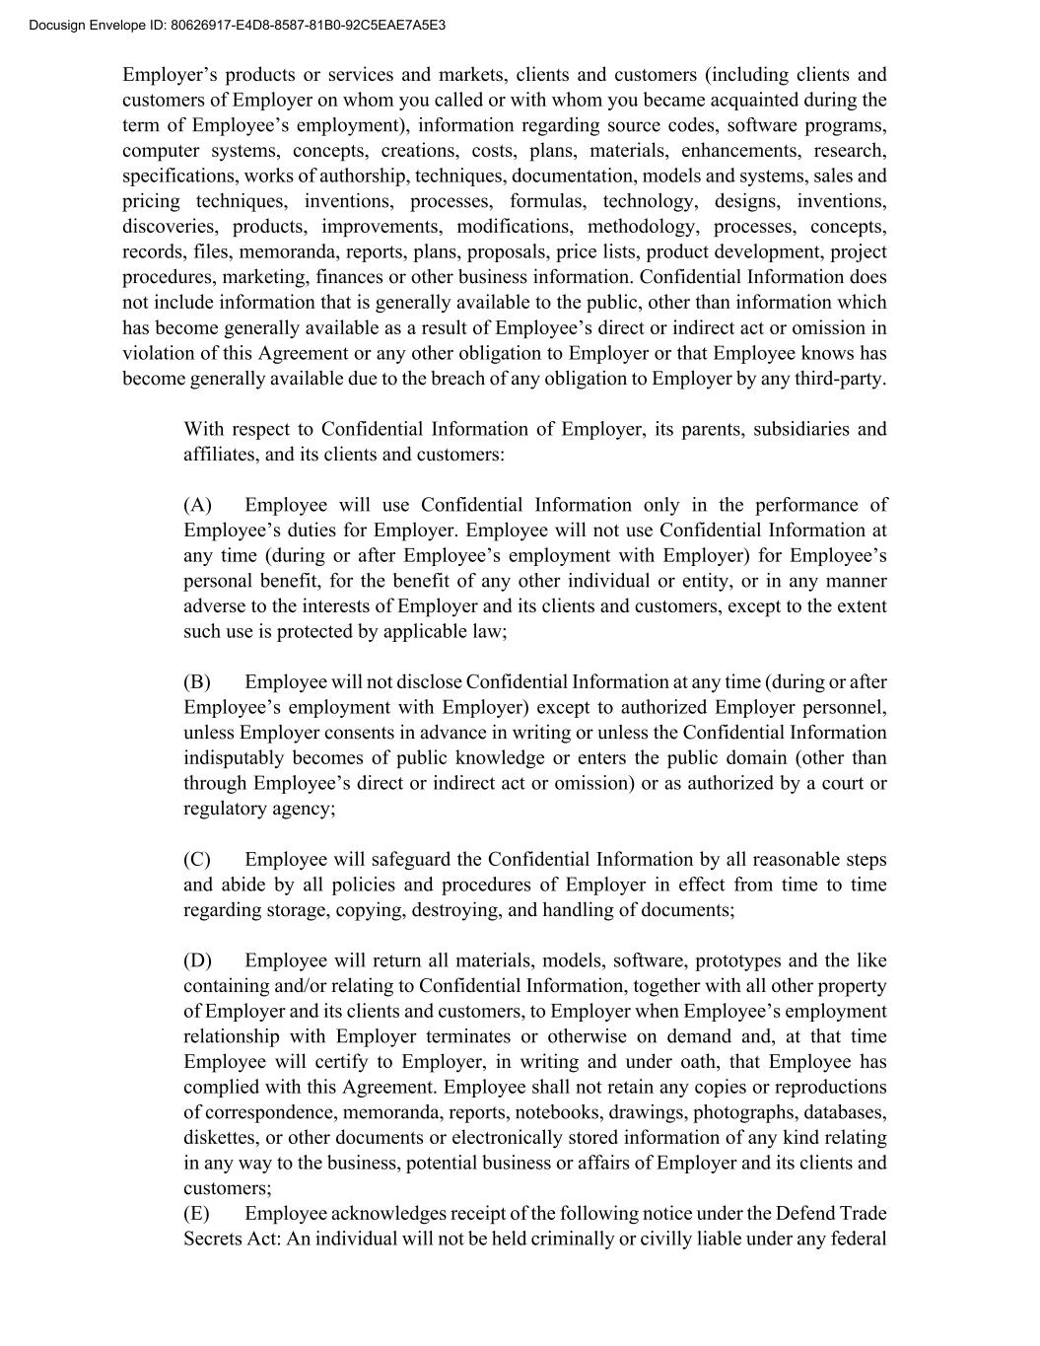
Employer’s products or services and markets, clients and customers (including clients and customers of Employer on whom you called or with whom you became acquainted during the term of Employee’s employment), information regarding source codes, software programs, computer systems, concepts, creations, costs, plans, materials, enhancements, research, specifications, works of authorship, techniques, documentation, models and systems, sales and pricing techniques, inventions, processes, formulas, technology, designs, inventions, discoveries, products, improvements, modifications, methodology, processes, concepts, records, files, memoranda, reports, plans, proposals, price lists, product development, project procedures, marketing, finances or other business information. Confidential Information does not include information that is generally available to the public, other than information which has become generally available as a result of Employee’s direct or indirect act or omission in violation of this Agreement or any other obligation to Employer or that Employee knows has become generally available due to the breach of any obligation to Employer by any third-party. With respect to Confidential Information of Employer, its parents, subsidiaries and affiliates, and its clients and customers: (A) Employee will use Confidential Information only in the performance of Employee’s duties for Employer. Employee will not use Confidential Information at any time (during or after Employee’s employment with Employer) for Employee’s personal benefit, for the benefit of any other individual or entity, or in any manner adverse to the interests of Employer and its clients and customers, except to the extent such use is protected by applicable law; (B) Employee will not disclose Confidential Information at any time (during or after Employee’s employment with Employer) except to authorized Employer personnel, unless Employer consents in advance in writing or unless the Confidential Information indisputably becomes of public knowledge or enters the public domain (other than through Employee’s direct or indirect act or omission) or as authorized by a court or regulatory agency; (C) Employee will safeguard the Confidential Information by all reasonable steps and abide by all policies and procedures of Employer in effect from time to time regarding storage, copying, destroying, and handling of documents; (D) Employee will return all materials, models, software, prototypes and the like containing and/or relating to Confidential Information, together with all other property of Employer and its clients and customers, to Employer when Employee’s employment relationship with Employer terminates or otherwise on demand and, at that time Employee will certify to Employer, in writing and under oath, that Employee has complied with this Agreement. Employee shall not retain any copies or reproductions of correspondence, memoranda, reports, notebooks, drawings, photographs, databases, diskettes, or other documents or electronically stored information of any kind relating in any way to the business, potential business or affairs of Employer and its clients and customers; (E) Employee acknowledges receipt of the following notice under the Defend Trade Secrets Act: An individual will not be held criminally or civilly liable under any federal Docusign Envelope ID: 80626917-E4D8-8587-81B0-92C5EAE7A5E3

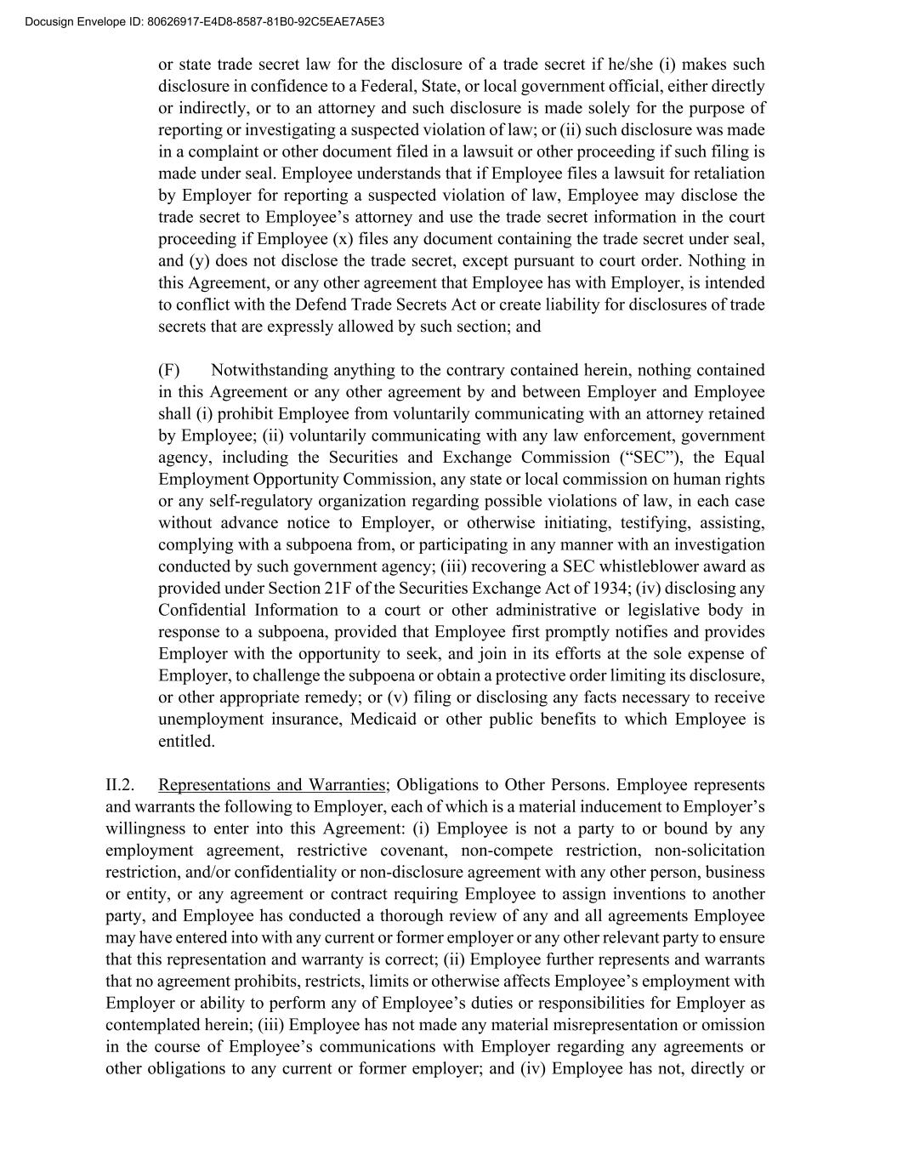
or state trade secret law for the disclosure of a trade secret if he/she (i) makes such disclosure in confidence to a Federal, State, or local government official, either directly or indirectly, or to an attorney and such disclosure is made solely for the purpose of reporting or investigating a suspected violation of law; or (ii) such disclosure was made in a complaint or other document filed in a lawsuit or other proceeding if such filing is made under seal. Employee understands that if Employee files a lawsuit for retaliation by Employer for reporting a suspected violation of law, Employee may disclose the trade secret to Employee’s attorney and use the trade secret information in the court proceeding if Employee (x) files any document containing the trade secret under seal, and (y) does not disclose the trade secret, except pursuant to court order. Nothing in this Agreement, or any other agreement that Employee has with Employer, is intended to conflict with the Defend Trade Secrets Act or create liability for disclosures of trade secrets that are expressly allowed by such section; and (F) Notwithstanding anything to the contrary contained herein, nothing contained in this Agreement or any other agreement by and between Employer and Employee shall (i) prohibit Employee from voluntarily communicating with an attorney retained by Employee; (ii) voluntarily communicating with any law enforcement, government agency, including the Securities and Exchange Commission (“SEC”), the Equal Employment Opportunity Commission, any state or local commission on human rights or any self-regulatory organization regarding possible violations of law, in each case without advance notice to Employer, or otherwise initiating, testifying, assisting, complying with a subpoena from, or participating in any manner with an investigation conducted by such government agency; (iii) recovering a SEC whistleblower award as provided under Section 21F of the Securities Exchange Act of 1934; (iv) disclosing any Confidential Information to a court or other administrative or legislative body in response to a subpoena, provided that Employee first promptly notifies and provides Employer with the opportunity to seek, and join in its efforts at the sole expense of Employer, to challenge the subpoena or obtain a protective order limiting its disclosure, or other appropriate remedy; or (v) filing or disclosing any facts necessary to receive unemployment insurance, Medicaid or other public benefits to which Employee is entitled. II.2. Representations and Warranties; Obligations to Other Persons. Employee represents and warrants the following to Employer, each of which is a material inducement to Employer’s willingness to enter into this Agreement: (i) Employee is not a party to or bound by any employment agreement, restrictive covenant, non-compete restriction, non-solicitation restriction, and/or confidentiality or non-disclosure agreement with any other person, business or entity, or any agreement or contract requiring Employee to assign inventions to another party, and Employee has conducted a thorough review of any and all agreements Employee may have entered into with any current or former employer or any other relevant party to ensure that this representation and warranty is correct; (ii) Employee further represents and warrants that no agreement prohibits, restricts, limits or otherwise affects Employee’s employment with Employer or ability to perform any of Employee’s duties or responsibilities for Employer as contemplated herein; (iii) Employee has not made any material misrepresentation or omission in the course of Employee’s communications with Employer regarding any agreements or other obligations to any current or former employer; and (iv) Employee has not, directly or Docusign Envelope ID: 80626917-E4D8-8587-81B0-92C5EAE7A5E3

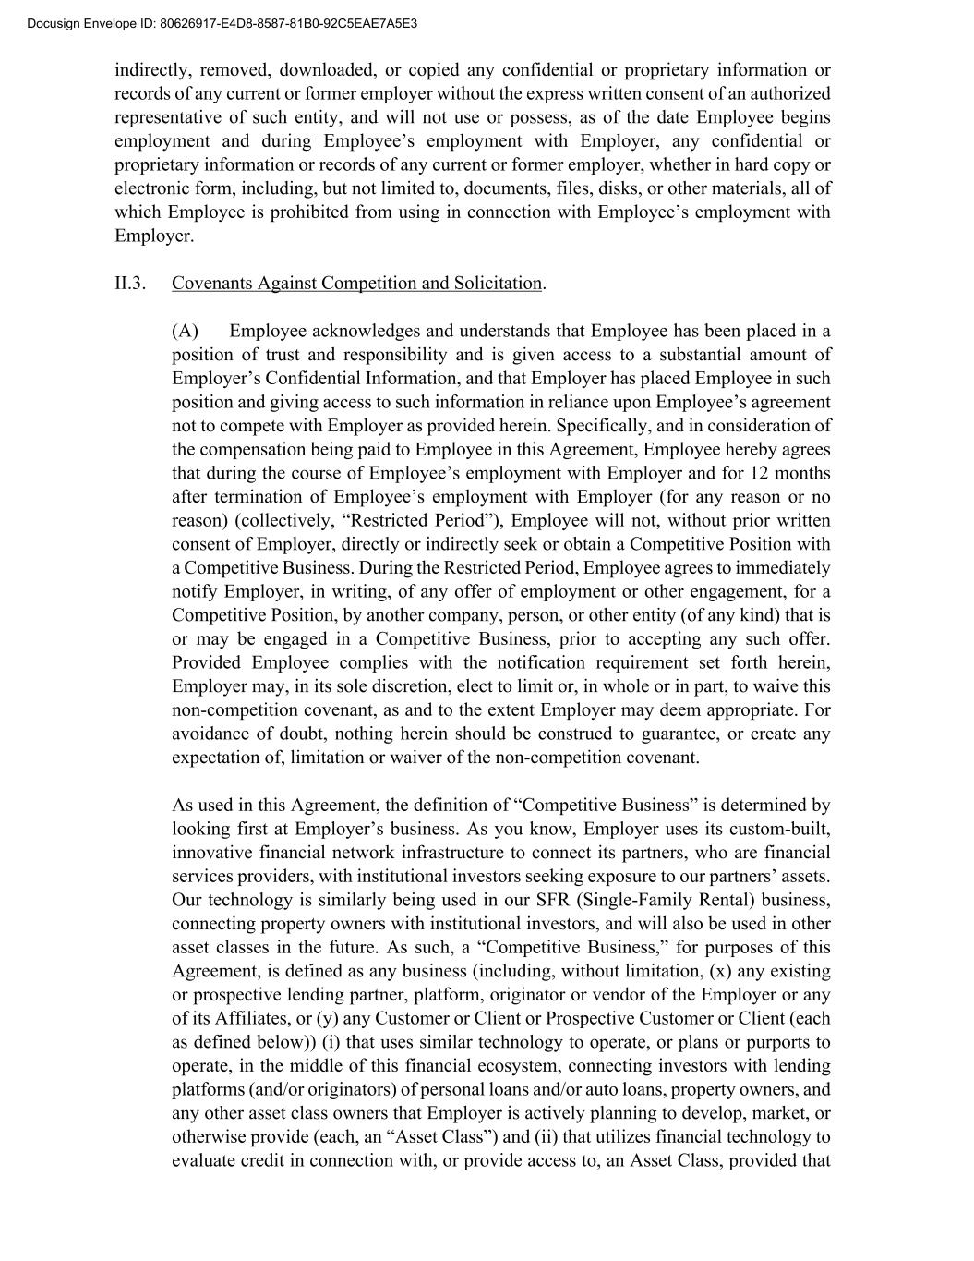
indirectly, removed, downloaded, or copied any confidential or proprietary information or records of any current or former employer without the express written consent of an authorized representative of such entity, and will not use or possess, as of the date Employee begins employment and during Employee’s employment with Employer, any confidential or proprietary information or records of any current or former employer, whether in hard copy or electronic form, including, but not limited to, documents, files, disks, or other materials, all of which Employee is prohibited from using in connection with Employee’s employment with Employer. II.3. Covenants Against Competition and Solicitation. (A) Employee acknowledges and understands that Employee has been placed in a position of trust and responsibility and is given access to a substantial amount of Employer’s Confidential Information, and that Employer has placed Employee in such position and giving access to such information in reliance upon Employee’s agreement not to compete with Employer as provided herein. Specifically, and in consideration of the compensation being paid to Employee in this Agreement, Employee hereby agrees that during the course of Employee’s employment with Employer and for 12 months after termination of Employee’s employment with Employer (for any reason or no reason) (collectively, “Restricted Period”), Employee will not, without prior written consent of Employer, directly or indirectly seek or obtain a Competitive Position with a Competitive Business. During the Restricted Period, Employee agrees to immediately notify Employer, in writing, of any offer of employment or other engagement, for a Competitive Position, by another company, person, or other entity (of any kind) that is or may be engaged in a Competitive Business, prior to accepting any such offer. Provided Employee complies with the notification requirement set forth herein, Employer may, in its sole discretion, elect to limit or, in whole or in part, to waive this non-competition covenant, as and to the extent Employer may deem appropriate. For avoidance of doubt, nothing herein should be construed to guarantee, or create any expectation of, limitation or waiver of the non-competition covenant. As used in this Agreement, the definition of “Competitive Business” is determined by looking first at Employer’s business. As you know, Employer uses its custom-built, innovative financial network infrastructure to connect its partners, who are financial services providers, with institutional investors seeking exposure to our partners’ assets. Our technology is similarly being used in our SFR (Single-Family Rental) business, connecting property owners with institutional investors, and will also be used in other asset classes in the future. As such, a “Competitive Business,” for purposes of this Agreement, is defined as any business (including, without limitation, (x) any existing or prospective lending partner, platform, originator or vendor of the Employer or any of its Affiliates, or (y) any Customer or Client or Prospective Customer or Client (each as defined below)) (i) that uses similar technology to operate, or plans or purports to operate, in the middle of this financial ecosystem, connecting investors with lending platforms (and/or originators) of personal loans and/or auto loans, property owners, and any other asset class owners that Employer is actively planning to develop, market, or otherwise provide (each, an “Asset Class”) and (ii) that utilizes financial technology to evaluate credit in connection with, or provide access to, an Asset Class, provided that Docusign Envelope ID: 80626917-E4D8-8587-81B0-92C5EAE7A5E3

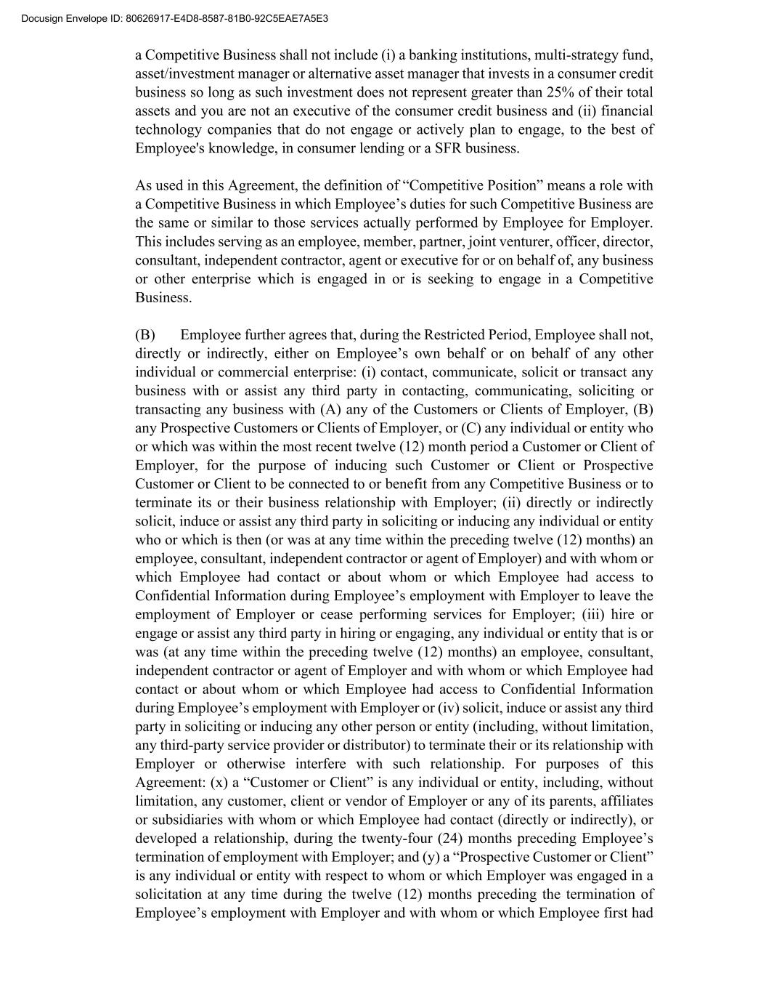
a Competitive Business shall not include (i) a banking institutions, multi-strategy fund, asset/investment manager or alternative asset manager that invests in a consumer credit business so long as such investment does not represent greater than 25% of their total assets and you are not an executive of the consumer credit business and (ii) financial technology companies that do not engage or actively plan to engage, to the best of Employee's knowledge, in consumer lending or a SFR business. As used in this Agreement, the definition of “Competitive Position” means a role with a Competitive Business in which Employee’s duties for such Competitive Business are the same or similar to those services actually performed by Employee for Employer. This includes serving as an employee, member, partner, joint venturer, officer, director, consultant, independent contractor, agent or executive for or on behalf of, any business or other enterprise which is engaged in or is seeking to engage in a Competitive Business. (B) Employee further agrees that, during the Restricted Period, Employee shall not, directly or indirectly, either on Employee’s own behalf or on behalf of any other individual or commercial enterprise: (i) contact, communicate, solicit or transact any business with or assist any third party in contacting, communicating, soliciting or transacting any business with (A) any of the Customers or Clients of Employer, (B) any Prospective Customers or Clients of Employer, or (C) any individual or entity who or which was within the most recent twelve (12) month period a Customer or Client of Employer, for the purpose of inducing such Customer or Client or Prospective Customer or Client to be connected to or benefit from any Competitive Business or to terminate its or their business relationship with Employer; (ii) directly or indirectly solicit, induce or assist any third party in soliciting or inducing any individual or entity who or which is then (or was at any time within the preceding twelve (12) months) an employee, consultant, independent contractor or agent of Employer) and with whom or which Employee had contact or about whom or which Employee had access to Confidential Information during Employee’s employment with Employer to leave the employment of Employer or cease performing services for Employer; (iii) hire or engage or assist any third party in hiring or engaging, any individual or entity that is or was (at any time within the preceding twelve (12) months) an employee, consultant, independent contractor or agent of Employer and with whom or which Employee had contact or about whom or which Employee had access to Confidential Information during Employee’s employment with Employer or (iv) solicit, induce or assist any third party in soliciting or inducing any other person or entity (including, without limitation, any third-party service provider or distributor) to terminate their or its relationship with Employer or otherwise interfere with such relationship. For purposes of this Agreement: (x) a “Customer or Client” is any individual or entity, including, without limitation, any customer, client or vendor of Employer or any of its parents, affiliates or subsidiaries with whom or which Employee had contact (directly or indirectly), or developed a relationship, during the twenty-four (24) months preceding Employee’s termination of employment with Employer; and (y) a “Prospective Customer or Client” is any individual or entity with respect to whom or which Employer was engaged in a solicitation at any time during the twelve (12) months preceding the termination of Employee’s employment with Employer and with whom or which Employee first had Docusign Envelope ID: 80626917-E4D8-8587-81B0-92C5EAE7A5E3

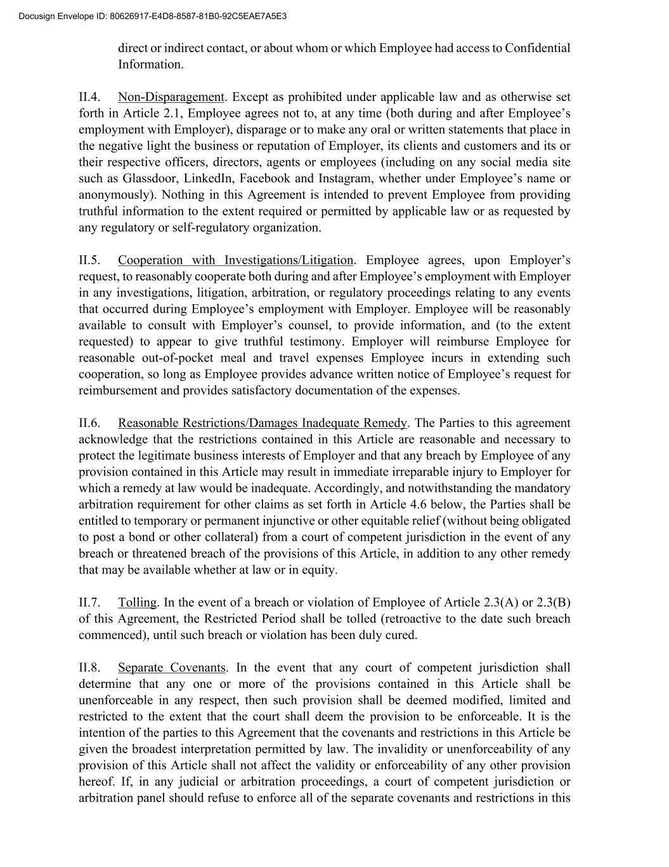
direct or indirect contact, or about whom or which Employee had access to Confidential Information. II.4. Non-Disparagement. Except as prohibited under applicable law and as otherwise set forth in Article 2.1, Employee agrees not to, at any time (both during and after Employee’s employment with Employer), disparage or to make any oral or written statements that place in the negative light the business or reputation of Employer, its clients and customers and its or their respective officers, directors, agents or employees (including on any social media site such as Glassdoor, LinkedIn, Facebook and Instagram, whether under Employee’s name or anonymously). Nothing in this Agreement is intended to prevent Employee from providing truthful information to the extent required or permitted by applicable law or as requested by any regulatory or self-regulatory organization. II.5. Cooperation with Investigations/Litigation. Employee agrees, upon Employer’s request, to reasonably cooperate both during and after Employee’s employment with Employer in any investigations, litigation, arbitration, or regulatory proceedings relating to any events that occurred during Employee’s employment with Employer. Employee will be reasonably available to consult with Employer’s counsel, to provide information, and (to the extent requested) to appear to give truthful testimony. Employer will reimburse Employee for reasonable out-of-pocket meal and travel expenses Employee incurs in extending such cooperation, so long as Employee provides advance written notice of Employee’s request for reimbursement and provides satisfactory documentation of the expenses. II.6. Reasonable Restrictions/Damages Inadequate Remedy. The Parties to this agreement acknowledge that the restrictions contained in this Article are reasonable and necessary to protect the legitimate business interests of Employer and that any breach by Employee of any provision contained in this Article may result in immediate irreparable injury to Employer for which a remedy at law would be inadequate. Accordingly, and notwithstanding the mandatory arbitration requirement for other claims as set forth in Article 4.6 below, the Parties shall be entitled to temporary or permanent injunctive or other equitable relief (without being obligated to post a bond or other collateral) from a court of competent jurisdiction in the event of any breach or threatened breach of the provisions of this Article, in addition to any other remedy that may be available whether at law or in equity. II.7. Tolling. In the event of a breach or violation of Employee of Article 2.3(A) or 2.3(B) of this Agreement, the Restricted Period shall be tolled (retroactive to the date such breach commenced), until such breach or violation has been duly cured. II.8. Separate Covenants. In the event that any court of competent jurisdiction shall determine that any one or more of the provisions contained in this Article shall be unenforceable in any respect, then such provision shall be deemed modified, limited and restricted to the extent that the court shall deem the provision to be enforceable. It is the intention of the parties to this Agreement that the covenants and restrictions in this Article be given the broadest interpretation permitted by law. The invalidity or unenforceability of any provision of this Article shall not affect the validity or enforceability of any other provision hereof. If, in any judicial or arbitration proceedings, a court of competent jurisdiction or arbitration panel should refuse to enforce all of the separate covenants and restrictions in this Docusign Envelope ID: 80626917-E4D8-8587-81B0-92C5EAE7A5E3

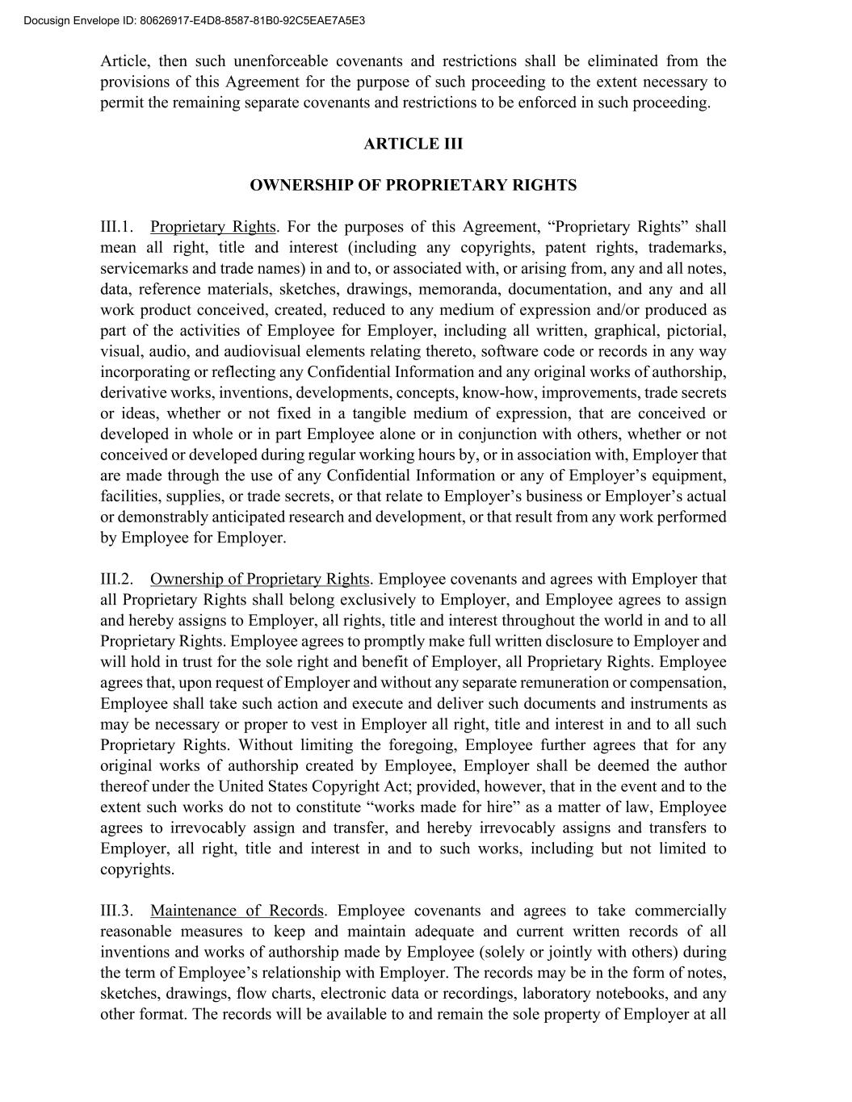
Article, then such unenforceable covenants and restrictions shall be eliminated from the provisions of this Agreement for the purpose of such proceeding to the extent necessary to permit the remaining separate covenants and restrictions to be enforced in such proceeding. ARTICLE III OWNERSHIP OF PROPRIETARY RIGHTS III.1. Proprietary Rights. For the purposes of this Agreement, “Proprietary Rights” shall mean all right, title and interest (including any copyrights, patent rights, trademarks, servicemarks and trade names) in and to, or associated with, or arising from, any and all notes, data, reference materials, sketches, drawings, memoranda, documentation, and any and all work product conceived, created, reduced to any medium of expression and/or produced as part of the activities of Employee for Employer, including all written, graphical, pictorial, visual, audio, and audiovisual elements relating thereto, software code or records in any way incorporating or reflecting any Confidential Information and any original works of authorship, derivative works, inventions, developments, concepts, know-how, improvements, trade secrets or ideas, whether or not fixed in a tangible medium of expression, that are conceived or developed in whole or in part Employee alone or in conjunction with others, whether or not conceived or developed during regular working hours by, or in association with, Employer that are made through the use of any Confidential Information or any of Employer’s equipment, facilities, supplies, or trade secrets, or that relate to Employer’s business or Employer’s actual or demonstrably anticipated research and development, or that result from any work performed by Employee for Employer. III.2. Ownership of Proprietary Rights. Employee covenants and agrees with Employer that all Proprietary Rights shall belong exclusively to Employer, and Employee agrees to assign and hereby assigns to Employer, all rights, title and interest throughout the world in and to all Proprietary Rights. Employee agrees to promptly make full written disclosure to Employer and will hold in trust for the sole right and benefit of Employer, all Proprietary Rights. Employee agrees that, upon request of Employer and without any separate remuneration or compensation, Employee shall take such action and execute and deliver such documents and instruments as may be necessary or proper to vest in Employer all right, title and interest in and to all such Proprietary Rights. Without limiting the foregoing, Employee further agrees that for any original works of authorship created by Employee, Employer shall be deemed the author thereof under the United States Copyright Act; provided, however, that in the event and to the extent such works do not to constitute “works made for hire” as a matter of law, Employee agrees to irrevocably assign and transfer, and hereby irrevocably assigns and transfers to Employer, all right, title and interest in and to such works, including but not limited to copyrights. III.3. Maintenance of Records. Employee covenants and agrees to take commercially reasonable measures to keep and maintain adequate and current written records of all inventions and works of authorship made by Employee (solely or jointly with others) during the term of Employee’s relationship with Employer. The records may be in the form of notes, sketches, drawings, flow charts, electronic data or recordings, laboratory notebooks, and any other format. The records will be available to and remain the sole property of Employer at all Docusign Envelope ID: 80626917-E4D8-8587-81B0-92C5EAE7A5E3

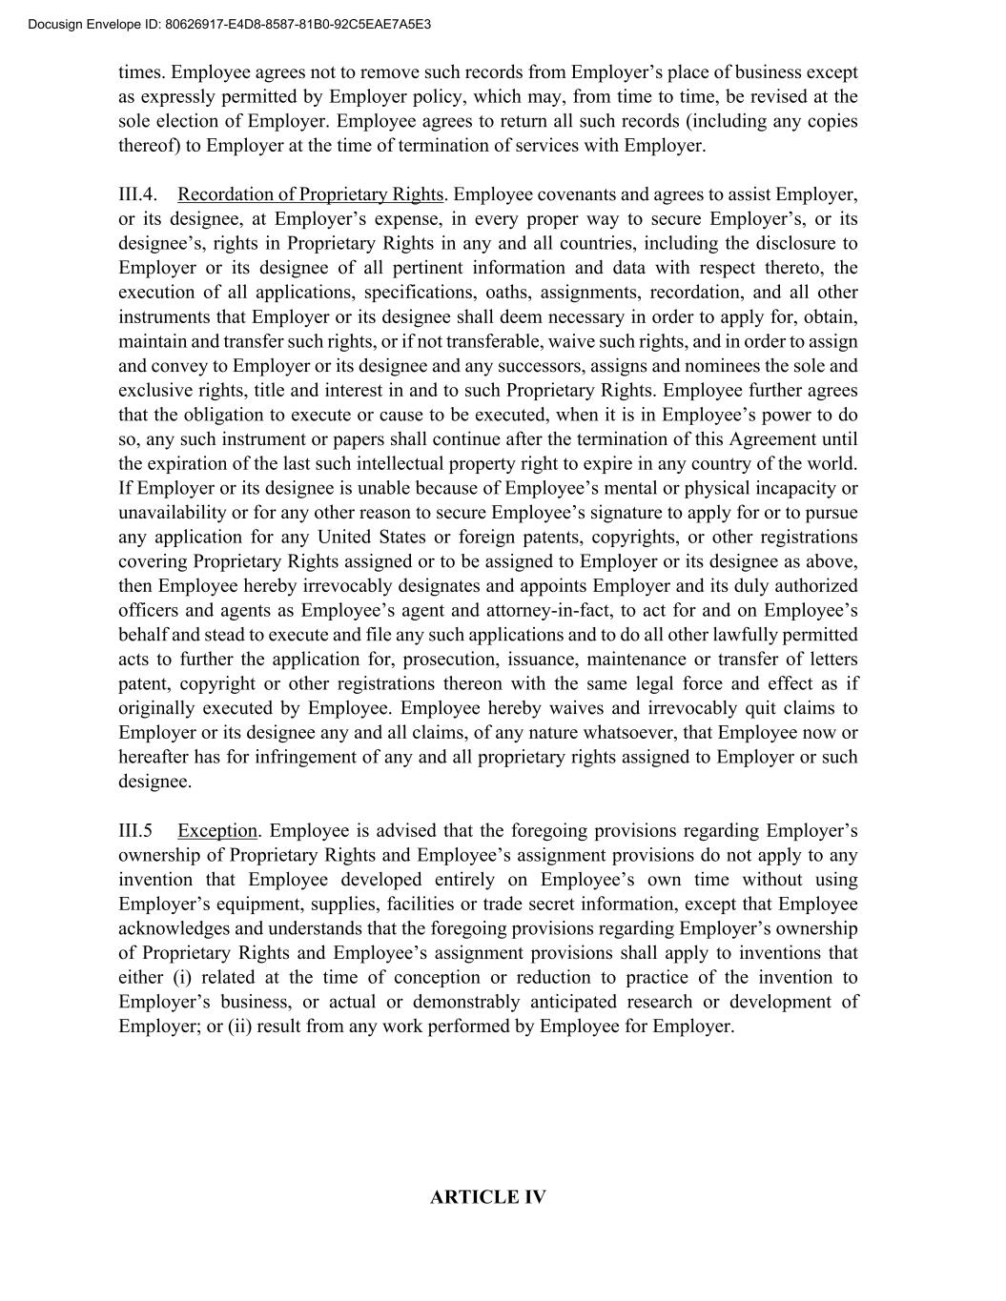
times. Employee agrees not to remove such records from Employer’s place of business except as expressly permitted by Employer policy, which may, from time to time, be revised at the sole election of Employer. Employee agrees to return all such records (including any copies thereof) to Employer at the time of termination of services with Employer. III.4. Recordation of Proprietary Rights. Employee covenants and agrees to assist Employer, or its designee, at Employer’s expense, in every proper way to secure Employer’s, or its designee’s, rights in Proprietary Rights in any and all countries, including the disclosure to Employer or its designee of all pertinent information and data with respect thereto, the execution of all applications, specifications, oaths, assignments, recordation, and all other instruments that Employer or its designee shall deem necessary in order to apply for, obtain, maintain and transfer such rights, or if not transferable, waive such rights, and in order to assign and convey to Employer or its designee and any successors, assigns and nominees the sole and exclusive rights, title and interest in and to such Proprietary Rights. Employee further agrees that the obligation to execute or cause to be executed, when it is in Employee’s power to do so, any such instrument or papers shall continue after the termination of this Agreement until the expiration of the last such intellectual property right to expire in any country of the world. If Employer or its designee is unable because of Employee’s mental or physical incapacity or unavailability or for any other reason to secure Employee’s signature to apply for or to pursue any application for any United States or foreign patents, copyrights, or other registrations covering Proprietary Rights assigned or to be assigned to Employer or its designee as above, then Employee hereby irrevocably designates and appoints Employer and its duly authorized officers and agents as Employee’s agent and attorney-in-fact, to act for and on Employee’s behalf and stead to execute and file any such applications and to do all other lawfully permitted acts to further the application for, prosecution, issuance, maintenance or transfer of letters patent, copyright or other registrations thereon with the same legal force and effect as if originally executed by Employee. Employee hereby waives and irrevocably quit claims to Employer or its designee any and all claims, of any nature whatsoever, that Employee now or hereafter has for infringement of any and all proprietary rights assigned to Employer or such designee. III.5 Exception. Employee is advised that the foregoing provisions regarding Employer’s ownership of Proprietary Rights and Employee’s assignment provisions do not apply to any invention that Employee developed entirely on Employee’s own time without using Employer’s equipment, supplies, facilities or trade secret information, except that Employee acknowledges and understands that the foregoing provisions regarding Employer’s ownership of Proprietary Rights and Employee’s assignment provisions shall apply to inventions that either (i) related at the time of conception or reduction to practice of the invention to Employer’s business, or actual or demonstrably anticipated research or development of Employer; or (ii) result from any work performed by Employee for Employer. ARTICLE IV Docusign Envelope ID: 80626917-E4D8-8587-81B0-92C5EAE7A5E3

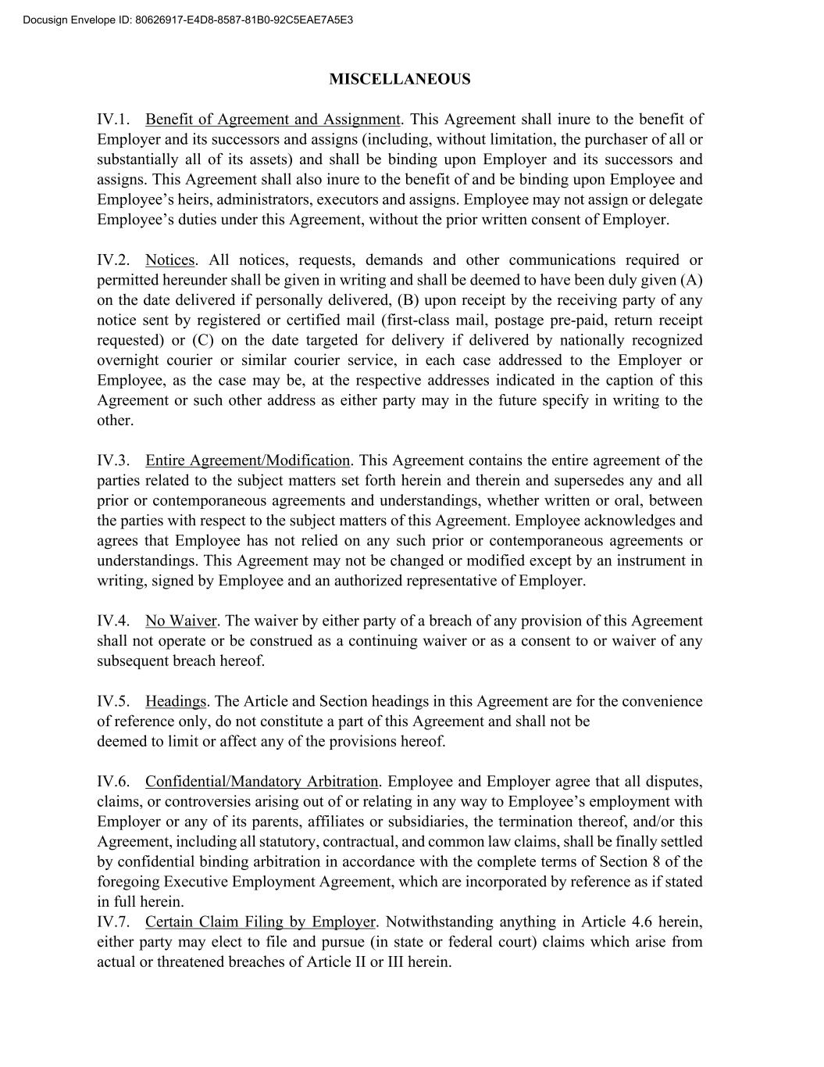
MISCELLANEOUS IV.1. Benefit of Agreement and Assignment. This Agreement shall inure to the benefit of Employer and its successors and assigns (including, without limitation, the purchaser of all or substantially all of its assets) and shall be binding upon Employer and its successors and assigns. This Agreement shall also inure to the benefit of and be binding upon Employee and Employee’s heirs, administrators, executors and assigns. Employee may not assign or delegate Employee’s duties under this Agreement, without the prior written consent of Employer. IV.2. Notices. All notices, requests, demands and other communications required or permitted hereunder shall be given in writing and shall be deemed to have been duly given (A) on the date delivered if personally delivered, (B) upon receipt by the receiving party of any notice sent by registered or certified mail (first-class mail, postage pre-paid, return receipt requested) or (C) on the date targeted for delivery if delivered by nationally recognized overnight courier or similar courier service, in each case addressed to the Employer or Employee, as the case may be, at the respective addresses indicated in the caption of this Agreement or such other address as either party may in the future specify in writing to the other. IV.3. Entire Agreement/Modification. This Agreement contains the entire agreement of the parties related to the subject matters set forth herein and therein and supersedes any and all prior or contemporaneous agreements and understandings, whether written or oral, between the parties with respect to the subject matters of this Agreement. Employee acknowledges and agrees that Employee has not relied on any such prior or contemporaneous agreements or understandings. This Agreement may not be changed or modified except by an instrument in writing, signed by Employee and an authorized representative of Employer. IV.4. No Waiver. The waiver by either party of a breach of any provision of this Agreement shall not operate or be construed as a continuing waiver or as a consent to or waiver of any subsequent breach hereof. IV.5. Headings. The Article and Section headings in this Agreement are for the convenience of reference only, do not constitute a part of this Agreement and shall not be deemed to limit or affect any of the provisions hereof. IV.6. Confidential/Mandatory Arbitration. Employee and Employer agree that all disputes, claims, or controversies arising out of or relating in any way to Employee’s employment with Employer or any of its parents, affiliates or subsidiaries, the termination thereof, and/or this Agreement, including all statutory, contractual, and common law claims, shall be finally settled by confidential binding arbitration in accordance with the complete terms of Section 8 of the foregoing Executive Employment Agreement, which are incorporated by reference as if stated in full herein. IV.7. Certain Claim Filing by Employer. Notwithstanding anything in Article 4.6 herein, either party may elect to file and pursue (in state or federal court) claims which arise from actual or threatened breaches of Article II or III herein. Docusign Envelope ID: 80626917-E4D8-8587-81B0-92C5EAE7A5E3

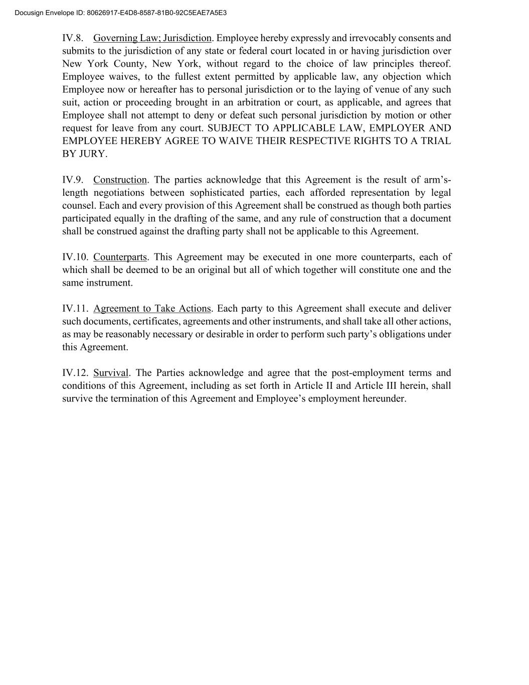
IV.8. Governing Law; Jurisdiction. Employee hereby expressly and irrevocably consents and submits to the jurisdiction of any state or federal court located in or having jurisdiction over New York County, New York, without regard to the choice of law principles thereof. Employee waives, to the fullest extent permitted by applicable law, any objection which Employee now or hereafter has to personal jurisdiction or to the laying of venue of any such suit, action or proceeding brought in an arbitration or court, as applicable, and agrees that Employee shall not attempt to deny or defeat such personal jurisdiction by motion or other request for leave from any court. SUBJECT TO APPLICABLE LAW, EMPLOYER AND EMPLOYEE HEREBY AGREE TO WAIVE THEIR RESPECTIVE RIGHTS TO A TRIAL BY JURY. IV.9. Construction. The parties acknowledge that this Agreement is the result of arm’s- length negotiations between sophisticated parties, each afforded representation by legal counsel. Each and every provision of this Agreement shall be construed as though both parties participated equally in the drafting of the same, and any rule of construction that a document shall be construed against the drafting party shall not be applicable to this Agreement. IV.10. Counterparts. This Agreement may be executed in one more counterparts, each of which shall be deemed to be an original but all of which together will constitute one and the same instrument. IV.11. Agreement to Take Actions. Each party to this Agreement shall execute and deliver such documents, certificates, agreements and other instruments, and shall take all other actions, as may be reasonably necessary or desirable in order to perform such party’s obligations under this Agreement. IV.12. Survival. The Parties acknowledge and agree that the post-employment terms and conditions of this Agreement, including as set forth in Article II and Article III herein, shall survive the termination of this Agreement and Employee’s employment hereunder. Docusign Envelope ID: 80626917-E4D8-8587-81B0-92C5EAE7A5E3


IN WITNESS WHEREOF, the Parties have executed this Agreement voluntarily and of their own free will and deed, after due time to review and consider it, and without any duress or coercion, as follows. PAGAYA TECHNOLOGIES US LLC By: ________________________________ Name: Itay Ezra Title: SVP, Global Head of People By: ________________________________ Name: Jason Ban Title: Deputy General Counsel EXECUTIVE ___________________________________ _ Jonathan Dobres Docusign Envelope ID: 80626917-E4D8-8587-81B0-92C5EAE7A5E3

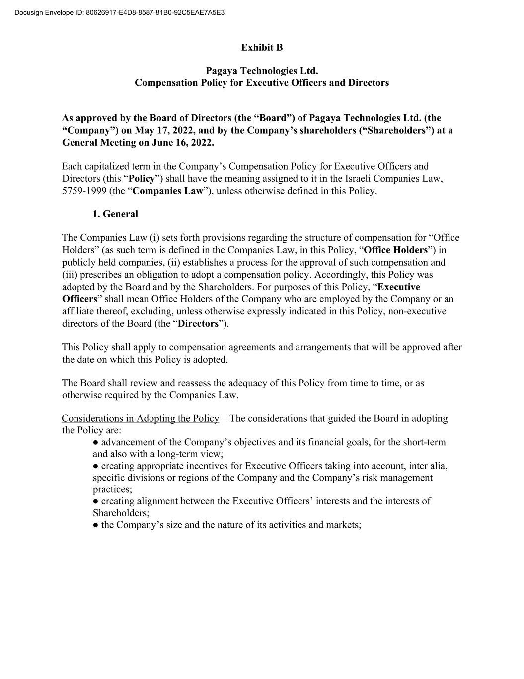
Exhibit B Pagaya Technologies Ltd. Compensation Policy for Executive Officers and Directors As approved by the Board of Directors (the “Board”) of Pagaya Technologies Ltd. (the “Company”) on May 17, 2022, and by the Company’s shareholders (“Shareholders”) at a General Meeting on June 16, 2022. Each capitalized term in the Company’s Compensation Policy for Executive Officers and Directors (this “Policy”) shall have the meaning assigned to it in the Israeli Companies Law, 5759-1999 (the “Companies Law”), unless otherwise defined in this Policy. 1. General The Companies Law (i) sets forth provisions regarding the structure of compensation for “Office Holders” (as such term is defined in the Companies Law, in this Policy, “Office Holders”) in publicly held companies, (ii) establishes a process for the approval of such compensation and (iii) prescribes an obligation to adopt a compensation policy. Accordingly, this Policy was adopted by the Board and by the Shareholders. For purposes of this Policy, “Executive Officers” shall mean Office Holders of the Company who are employed by the Company or an affiliate thereof, excluding, unless otherwise expressly indicated in this Policy, non-executive directors of the Board (the “Directors”). This Policy shall apply to compensation agreements and arrangements that will be approved after the date on which this Policy is adopted. The Board shall review and reassess the adequacy of this Policy from time to time, or as otherwise required by the Companies Law. Considerations in Adopting the Policy – The considerations that guided the Board in adopting the Policy are: ● advancement of the Company’s objectives and its financial goals, for the short-term and also with a long-term view; ● creating appropriate incentives for Executive Officers taking into account, inter alia, specific divisions or regions of the Company and the Company’s risk management practices; ● creating alignment between the Executive Officers’ interests and the interests of Shareholders; ● the Company’s size and the nature of its activities and markets; Docusign Envelope ID: 80626917-E4D8-8587-81B0-92C5EAE7A5E3

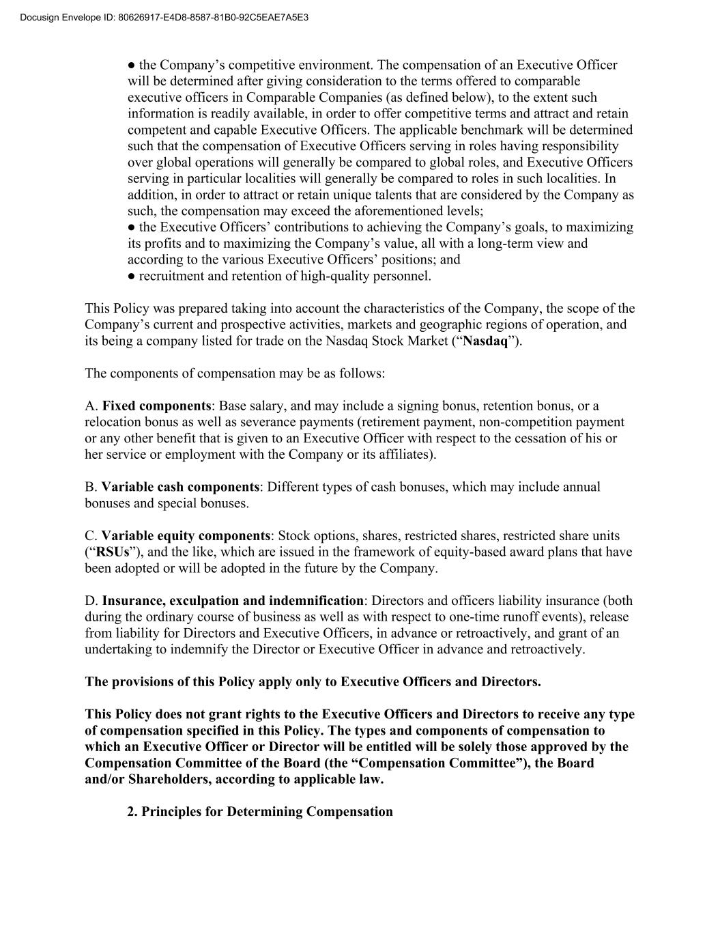
● the Company’s competitive environment. The compensation of an Executive Officer will be determined after giving consideration to the terms offered to comparable executive officers in Comparable Companies (as defined below), to the extent such information is readily available, in order to offer competitive terms and attract and retain competent and capable Executive Officers. The applicable benchmark will be determined such that the compensation of Executive Officers serving in roles having responsibility over global operations will generally be compared to global roles, and Executive Officers serving in particular localities will generally be compared to roles in such localities. In addition, in order to attract or retain unique talents that are considered by the Company as such, the compensation may exceed the aforementioned levels; ● the Executive Officers’ contributions to achieving the Company’s goals, to maximizing its profits and to maximizing the Company’s value, all with a long-term view and according to the various Executive Officers’ positions; and ● recruitment and retention of high-quality personnel. This Policy was prepared taking into account the characteristics of the Company, the scope of the Company’s current and prospective activities, markets and geographic regions of operation, and its being a company listed for trade on the Nasdaq Stock Market (“Nasdaq”). The components of compensation may be as follows: A. Fixed components: Base salary, and may include a signing bonus, retention bonus, or a relocation bonus as well as severance payments (retirement payment, non-competition payment or any other benefit that is given to an Executive Officer with respect to the cessation of his or her service or employment with the Company or its affiliates). B. Variable cash components: Different types of cash bonuses, which may include annual bonuses and special bonuses. C. Variable equity components: Stock options, shares, restricted shares, restricted share units (“RSUs”), and the like, which are issued in the framework of equity-based award plans that have been adopted or will be adopted in the future by the Company. D. Insurance, exculpation and indemnification: Directors and officers liability insurance (both during the ordinary course of business as well as with respect to one-time runoff events), release from liability for Directors and Executive Officers, in advance or retroactively, and grant of an undertaking to indemnify the Director or Executive Officer in advance and retroactively. The provisions of this Policy apply only to Executive Officers and Directors. This Policy does not grant rights to the Executive Officers and Directors to receive any type of compensation specified in this Policy. The types and components of compensation to which an Executive Officer or Director will be entitled will be solely those approved by the Compensation Committee of the Board (the “Compensation Committee”), the Board and/or Shareholders, according to applicable law. 2. Principles for Determining Compensation Docusign Envelope ID: 80626917-E4D8-8587-81B0-92C5EAE7A5E3

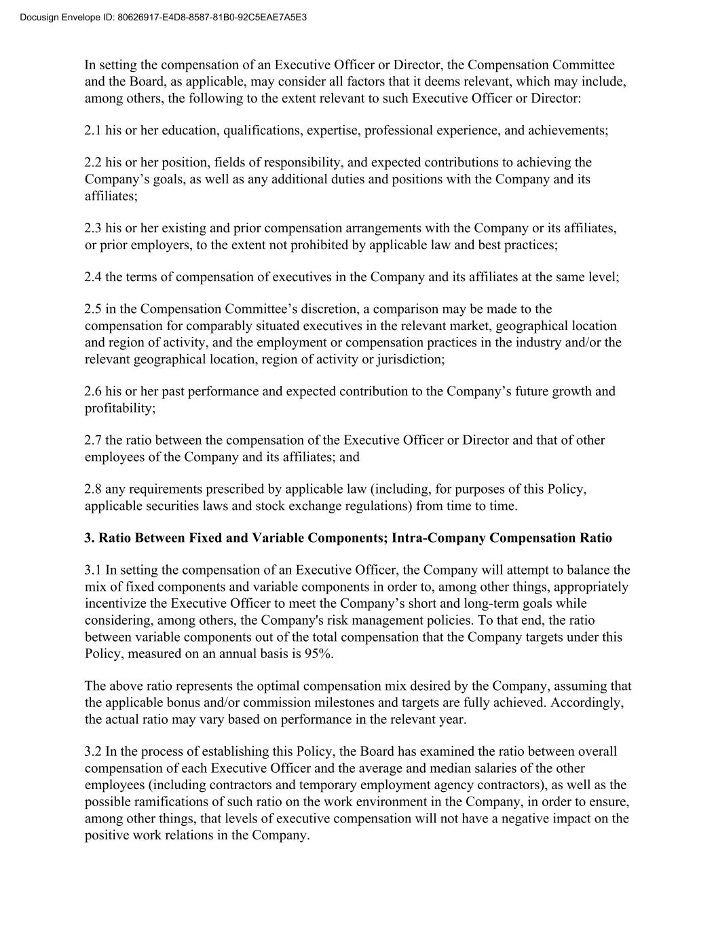
In setting the compensation of an Executive Officer or Director, the Compensation Committee and the Board, as applicable, may consider all factors that it deems relevant, which may include, among others, the following to the extent relevant to such Executive Officer or Director: 2.1 his or her education, qualifications, expertise, professional experience, and achievements; 2.2 his or her position, fields of responsibility, and expected contributions to achieving the Company’s goals, as well as any additional duties and positions with the Company and its affiliates; 2.3 his or her existing and prior compensation arrangements with the Company or its affiliates, or prior employers, to the extent not prohibited by applicable law and best practices; 2.4 the terms of compensation of executives in the Company and its affiliates at the same level; 2.5 in the Compensation Committee’s discretion, a comparison may be made to the compensation for comparably situated executives in the relevant market, geographical location and region of activity, and the employment or compensation practices in the industry and/or the relevant geographical location, region of activity or jurisdiction; 2.6 his or her past performance and expected contribution to the Company’s future growth and profitability; 2.7 the ratio between the compensation of the Executive Officer or Director and that of other employees of the Company and its affiliates; and 2.8 any requirements prescribed by applicable law (including, for purposes of this Policy, applicable securities laws and stock exchange regulations) from time to time. 3. Ratio Between Fixed and Variable Components; Intra-Company Compensation Ratio 3.1 In setting the compensation of an Executive Officer, the Company will attempt to balance the mix of fixed components and variable components in order to, among other things, appropriately incentivize the Executive Officer to meet the Company’s short and long-term goals while considering, among others, the Company's risk management policies. To that end, the ratio between variable components out of the total compensation that the Company targets under this Policy, measured on an annual basis is 95%. The above ratio represents the optimal compensation mix desired by the Company, assuming that the applicable bonus and/or commission milestones and targets are fully achieved. Accordingly, the actual ratio may vary based on performance in the relevant year. 3.2 In the process of establishing this Policy, the Board has examined the ratio between overall compensation of each Executive Officer and the average and median salaries of the other employees (including contractors and temporary employment agency contractors), as well as the possible ramifications of such ratio on the work environment in the Company, in order to ensure, among other things, that levels of executive compensation will not have a negative impact on the positive work relations in the Company. Docusign Envelope ID: 80626917-E4D8-8587-81B0-92C5EAE7A5E3

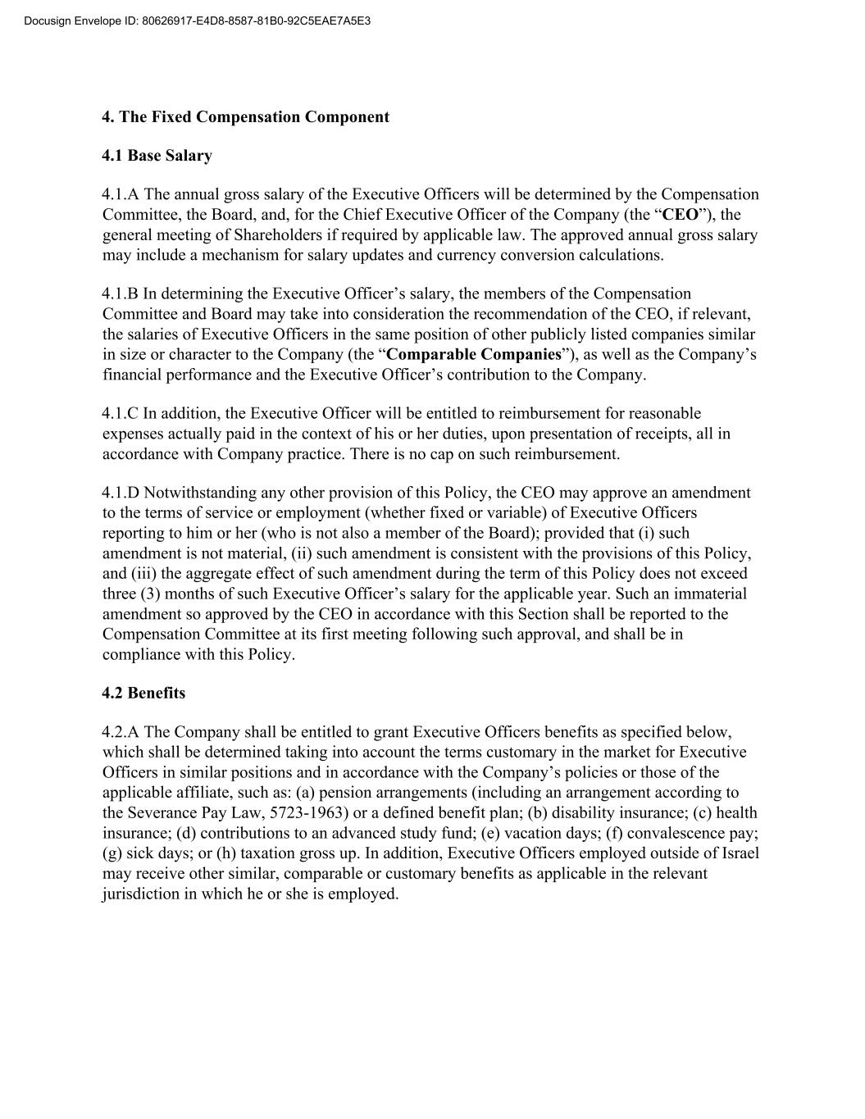
4. The Fixed Compensation Component 4.1 Base Salary 4.1.A The annual gross salary of the Executive Officers will be determined by the Compensation Committee, the Board, and, for the Chief Executive Officer of the Company (the “CEO”), the general meeting of Shareholders if required by applicable law. The approved annual gross salary may include a mechanism for salary updates and currency conversion calculations. 4.1.B In determining the Executive Officer’s salary, the members of the Compensation Committee and Board may take into consideration the recommendation of the CEO, if relevant, the salaries of Executive Officers in the same position of other publicly listed companies similar in size or character to the Company (the “Comparable Companies”), as well as the Company’s financial performance and the Executive Officer’s contribution to the Company. 4.1.C In addition, the Executive Officer will be entitled to reimbursement for reasonable expenses actually paid in the context of his or her duties, upon presentation of receipts, all in accordance with Company practice. There is no cap on such reimbursement. 4.1.D Notwithstanding any other provision of this Policy, the CEO may approve an amendment to the terms of service or employment (whether fixed or variable) of Executive Officers reporting to him or her (who is not also a member of the Board); provided that (i) such amendment is not material, (ii) such amendment is consistent with the provisions of this Policy, and (iii) the aggregate effect of such amendment during the term of this Policy does not exceed three (3) months of such Executive Officer’s salary for the applicable year. Such an immaterial amendment so approved by the CEO in accordance with this Section shall be reported to the Compensation Committee at its first meeting following such approval, and shall be in compliance with this Policy. 4.2 Benefits 4.2.A The Company shall be entitled to grant Executive Officers benefits as specified below, which shall be determined taking into account the terms customary in the market for Executive Officers in similar positions and in accordance with the Company’s policies or those of the applicable affiliate, such as: (a) pension arrangements (including an arrangement according to the Severance Pay Law, 5723-1963) or a defined benefit plan; (b) disability insurance; (c) health insurance; (d) contributions to an advanced study fund; (e) vacation days; (f) convalescence pay; (g) sick days; or (h) taxation gross up. In addition, Executive Officers employed outside of Israel may receive other similar, comparable or customary benefits as applicable in the relevant jurisdiction in which he or she is employed. Docusign Envelope ID: 80626917-E4D8-8587-81B0-92C5EAE7A5E3

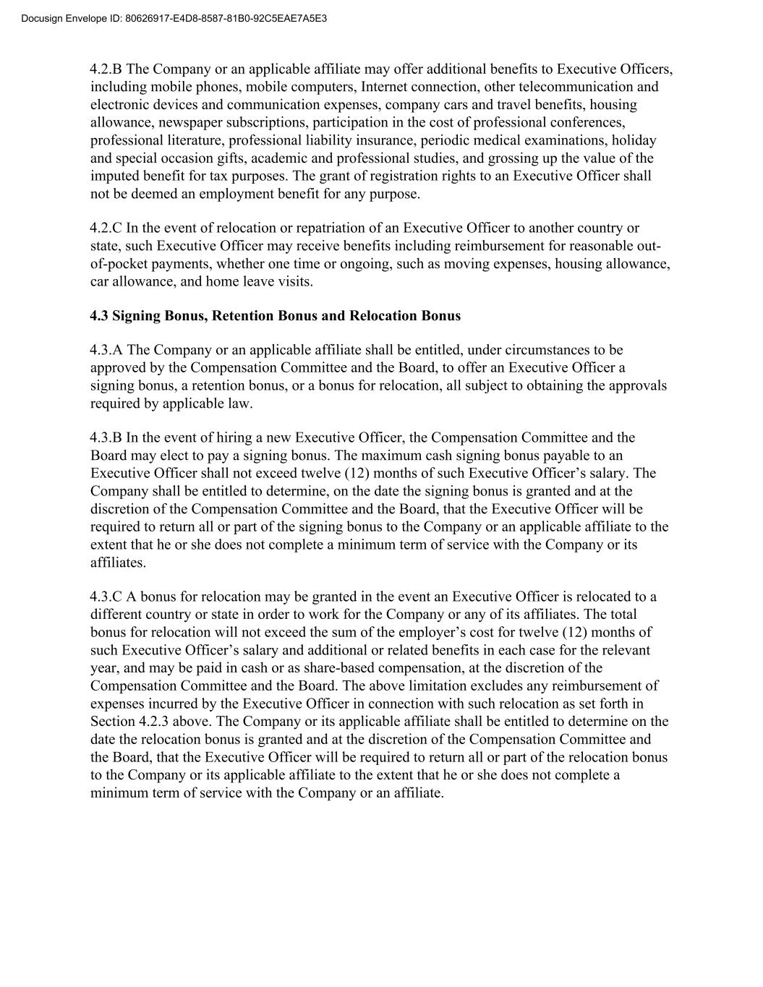
4.2.B The Company or an applicable affiliate may offer additional benefits to Executive Officers, including mobile phones, mobile computers, Internet connection, other telecommunication and electronic devices and communication expenses, company cars and travel benefits, housing allowance, newspaper subscriptions, participation in the cost of professional conferences, professional literature, professional liability insurance, periodic medical examinations, holiday and special occasion gifts, academic and professional studies, and grossing up the value of the imputed benefit for tax purposes. The grant of registration rights to an Executive Officer shall not be deemed an employment benefit for any purpose. 4.2.C In the event of relocation or repatriation of an Executive Officer to another country or state, such Executive Officer may receive benefits including reimbursement for reasonable out- of-pocket payments, whether one time or ongoing, such as moving expenses, housing allowance, car allowance, and home leave visits. 4.3 Signing Bonus, Retention Bonus and Relocation Bonus 4.3.A The Company or an applicable affiliate shall be entitled, under circumstances to be approved by the Compensation Committee and the Board, to offer an Executive Officer a signing bonus, a retention bonus, or a bonus for relocation, all subject to obtaining the approvals required by applicable law. 4.3.B In the event of hiring a new Executive Officer, the Compensation Committee and the Board may elect to pay a signing bonus. The maximum cash signing bonus payable to an Executive Officer shall not exceed twelve (12) months of such Executive Officer’s salary. The Company shall be entitled to determine, on the date the signing bonus is granted and at the discretion of the Compensation Committee and the Board, that the Executive Officer will be required to return all or part of the signing bonus to the Company or an applicable affiliate to the extent that he or she does not complete a minimum term of service with the Company or its affiliates. 4.3.C A bonus for relocation may be granted in the event an Executive Officer is relocated to a different country or state in order to work for the Company or any of its affiliates. The total bonus for relocation will not exceed the sum of the employer’s cost for twelve (12) months of such Executive Officer’s salary and additional or related benefits in each case for the relevant year, and may be paid in cash or as share-based compensation, at the discretion of the Compensation Committee and the Board. The above limitation excludes any reimbursement of expenses incurred by the Executive Officer in connection with such relocation as set forth in Section 4.2.3 above. The Company or its applicable affiliate shall be entitled to determine on the date the relocation bonus is granted and at the discretion of the Compensation Committee and the Board, that the Executive Officer will be required to return all or part of the relocation bonus to the Company or its applicable affiliate to the extent that he or she does not complete a minimum term of service with the Company or an affiliate. Docusign Envelope ID: 80626917-E4D8-8587-81B0-92C5EAE7A5E3

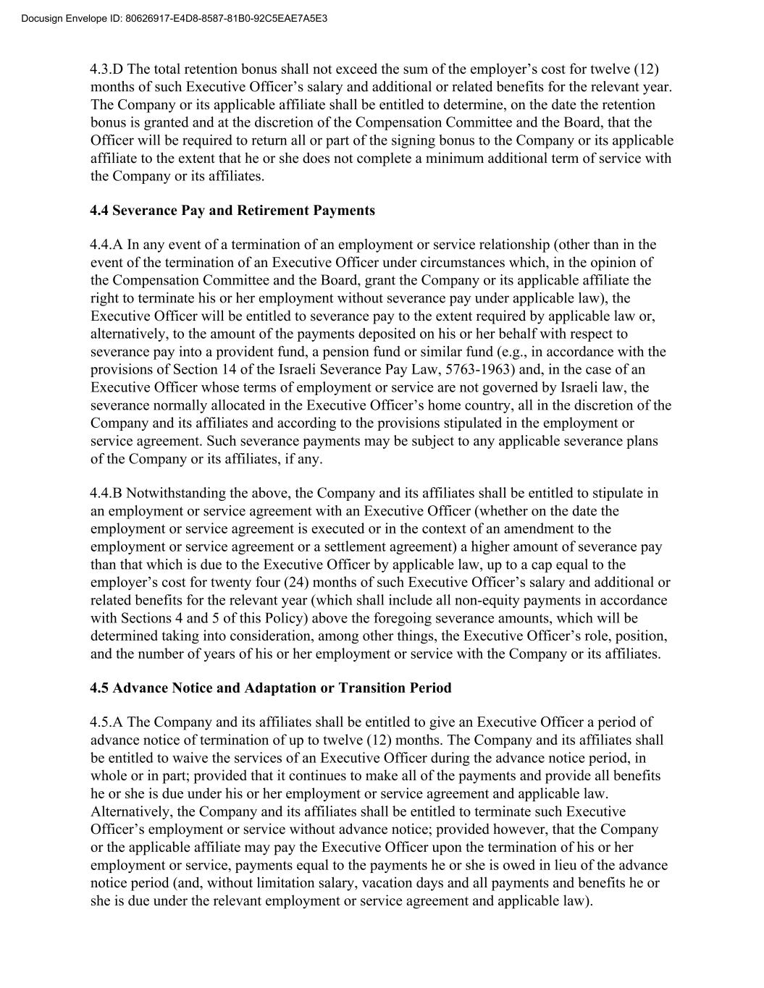
4.3.D The total retention bonus shall not exceed the sum of the employer’s cost for twelve (12) months of such Executive Officer’s salary and additional or related benefits for the relevant year. The Company or its applicable affiliate shall be entitled to determine, on the date the retention bonus is granted and at the discretion of the Compensation Committee and the Board, that the Officer will be required to return all or part of the signing bonus to the Company or its applicable affiliate to the extent that he or she does not complete a minimum additional term of service with the Company or its affiliates. 4.4 Severance Pay and Retirement Payments 4.4.A In any event of a termination of an employment or service relationship (other than in the event of the termination of an Executive Officer under circumstances which, in the opinion of the Compensation Committee and the Board, grant the Company or its applicable affiliate the right to terminate his or her employment without severance pay under applicable law), the Executive Officer will be entitled to severance pay to the extent required by applicable law or, alternatively, to the amount of the payments deposited on his or her behalf with respect to severance pay into a provident fund, a pension fund or similar fund (e.g., in accordance with the provisions of Section 14 of the Israeli Severance Pay Law, 5763-1963) and, in the case of an Executive Officer whose terms of employment or service are not governed by Israeli law, the severance normally allocated in the Executive Officer’s home country, all in the discretion of the Company and its affiliates and according to the provisions stipulated in the employment or service agreement. Such severance payments may be subject to any applicable severance plans of the Company or its affiliates, if any. 4.4.B Notwithstanding the above, the Company and its affiliates shall be entitled to stipulate in an employment or service agreement with an Executive Officer (whether on the date the employment or service agreement is executed or in the context of an amendment to the employment or service agreement or a settlement agreement) a higher amount of severance pay than that which is due to the Executive Officer by applicable law, up to a cap equal to the employer’s cost for twenty four (24) months of such Executive Officer’s salary and additional or related benefits for the relevant year (which shall include all non-equity payments in accordance with Sections 4 and 5 of this Policy) above the foregoing severance amounts, which will be determined taking into consideration, among other things, the Executive Officer’s role, position, and the number of years of his or her employment or service with the Company or its affiliates. 4.5 Advance Notice and Adaptation or Transition Period 4.5.A The Company and its affiliates shall be entitled to give an Executive Officer a period of advance notice of termination of up to twelve (12) months. The Company and its affiliates shall be entitled to waive the services of an Executive Officer during the advance notice period, in whole or in part; provided that it continues to make all of the payments and provide all benefits he or she is due under his or her employment or service agreement and applicable law. Alternatively, the Company and its affiliates shall be entitled to terminate such Executive Officer’s employment or service without advance notice; provided however, that the Company or the applicable affiliate may pay the Executive Officer upon the termination of his or her employment or service, payments equal to the payments he or she is owed in lieu of the advance notice period (and, without limitation salary, vacation days and all payments and benefits he or she is due under the relevant employment or service agreement and applicable law). Docusign Envelope ID: 80626917-E4D8-8587-81B0-92C5EAE7A5E3

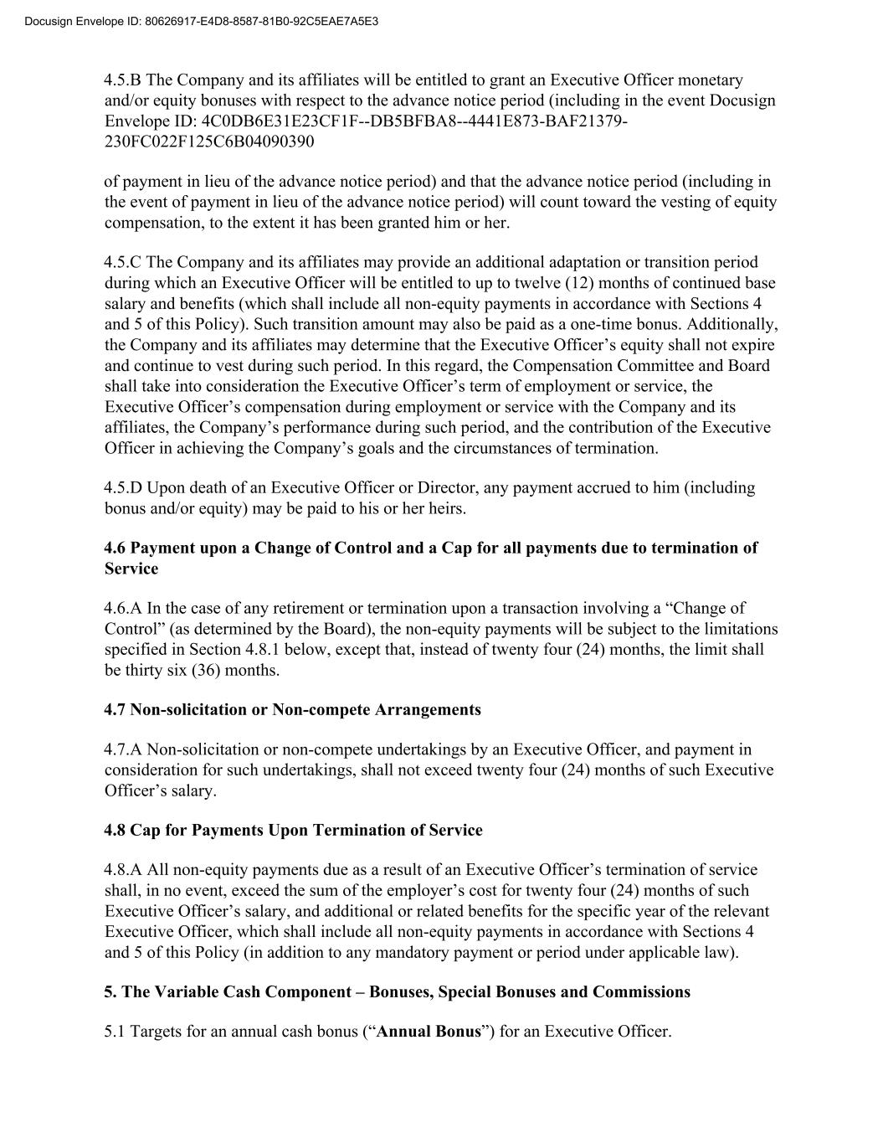
4.5.B The Company and its affiliates will be entitled to grant an Executive Officer monetary and/or equity bonuses with respect to the advance notice period (including in the event Docusign Envelope ID: 4C0DB6E31E23CF1F--DB5BFBA8--4441E873-BAF21379- 230FC022F125C6B04090390 of payment in lieu of the advance notice period) and that the advance notice period (including in the event of payment in lieu of the advance notice period) will count toward the vesting of equity compensation, to the extent it has been granted him or her. 4.5.C The Company and its affiliates may provide an additional adaptation or transition period during which an Executive Officer will be entitled to up to twelve (12) months of continued base salary and benefits (which shall include all non-equity payments in accordance with Sections 4 and 5 of this Policy). Such transition amount may also be paid as a one-time bonus. Additionally, the Company and its affiliates may determine that the Executive Officer’s equity shall not expire and continue to vest during such period. In this regard, the Compensation Committee and Board shall take into consideration the Executive Officer’s term of employment or service, the Executive Officer’s compensation during employment or service with the Company and its affiliates, the Company’s performance during such period, and the contribution of the Executive Officer in achieving the Company’s goals and the circumstances of termination. 4.5.D Upon death of an Executive Officer or Director, any payment accrued to him (including bonus and/or equity) may be paid to his or her heirs. 4.6 Payment upon a Change of Control and a Cap for all payments due to termination of Service 4.6.A In the case of any retirement or termination upon a transaction involving a “Change of Control” (as determined by the Board), the non-equity payments will be subject to the limitations specified in Section 4.8.1 below, except that, instead of twenty four (24) months, the limit shall be thirty six (36) months. 4.7 Non-solicitation or Non-compete Arrangements 4.7.A Non-solicitation or non-compete undertakings by an Executive Officer, and payment in consideration for such undertakings, shall not exceed twenty four (24) months of such Executive Officer’s salary. 4.8 Cap for Payments Upon Termination of Service 4.8.A All non-equity payments due as a result of an Executive Officer’s termination of service shall, in no event, exceed the sum of the employer’s cost for twenty four (24) months of such Executive Officer’s salary, and additional or related benefits for the specific year of the relevant Executive Officer, which shall include all non-equity payments in accordance with Sections 4 and 5 of this Policy (in addition to any mandatory payment or period under applicable law). 5. The Variable Cash Component – Bonuses, Special Bonuses and Commissions 5.1 Targets for an annual cash bonus (“Annual Bonus”) for an Executive Officer. Docusign Envelope ID: 80626917-E4D8-8587-81B0-92C5EAE7A5E3

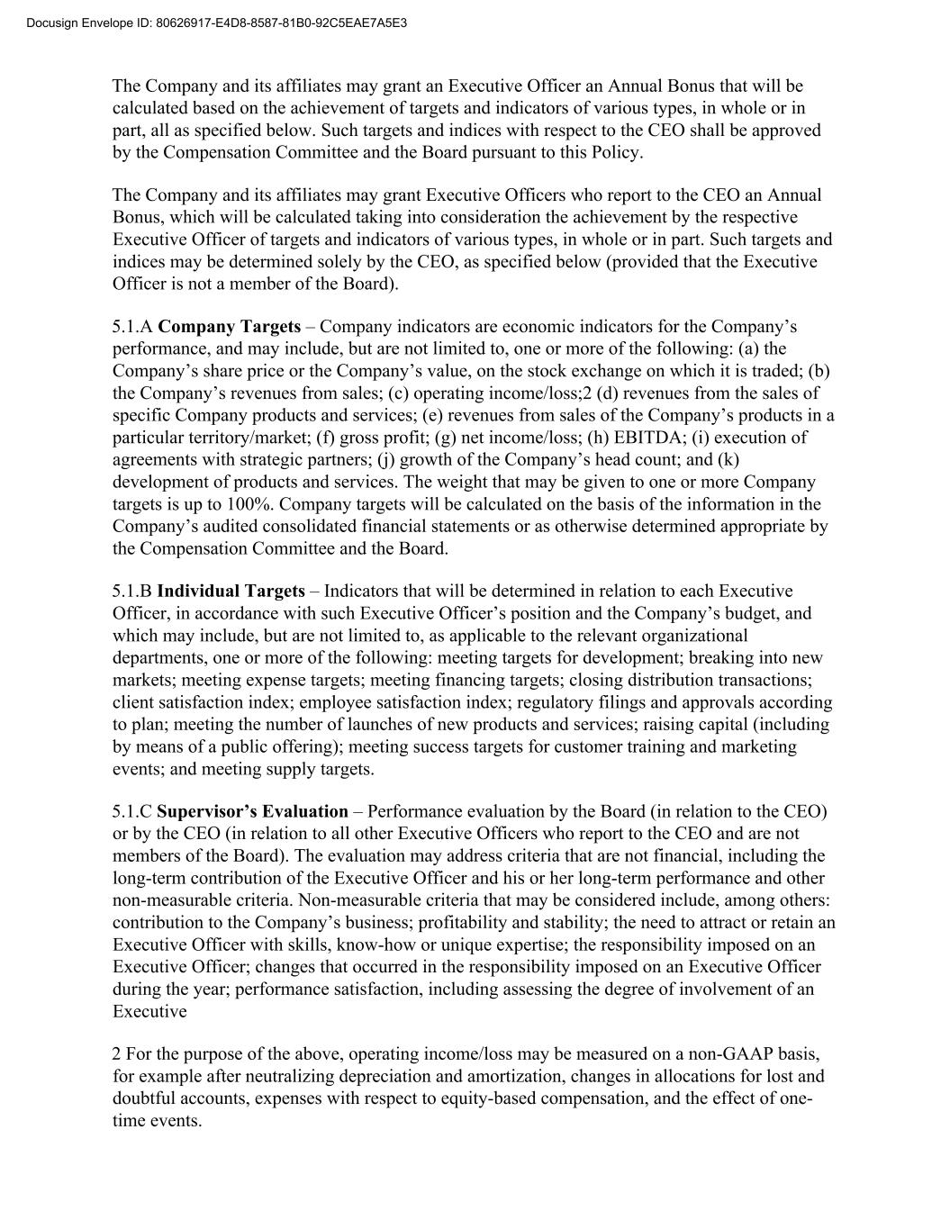
The Company and its affiliates may grant an Executive Officer an Annual Bonus that will be calculated based on the achievement of targets and indicators of various types, in whole or in part, all as specified below. Such targets and indices with respect to the CEO shall be approved by the Compensation Committee and the Board pursuant to this Policy. The Company and its affiliates may grant Executive Officers who report to the CEO an Annual Bonus, which will be calculated taking into consideration the achievement by the respective Executive Officer of targets and indicators of various types, in whole or in part. Such targets and indices may be determined solely by the CEO, as specified below (provided that the Executive Officer is not a member of the Board). 5.1.A Company Targets – Company indicators are economic indicators for the Company’s performance, and may include, but are not limited to, one or more of the following: (a) the Company’s share price or the Company’s value, on the stock exchange on which it is traded; (b) the Company’s revenues from sales; (c) operating income/loss;2 (d) revenues from the sales of specific Company products and services; (e) revenues from sales of the Company’s products in a particular territory/market; (f) gross profit; (g) net income/loss; (h) EBITDA; (i) execution of agreements with strategic partners; (j) growth of the Company’s head count; and (k) development of products and services. The weight that may be given to one or more Company targets is up to 100%. Company targets will be calculated on the basis of the information in the Company’s audited consolidated financial statements or as otherwise determined appropriate by the Compensation Committee and the Board. 5.1.B Individual Targets – Indicators that will be determined in relation to each Executive Officer, in accordance with such Executive Officer’s position and the Company’s budget, and which may include, but are not limited to, as applicable to the relevant organizational departments, one or more of the following: meeting targets for development; breaking into new markets; meeting expense targets; meeting financing targets; closing distribution transactions; client satisfaction index; employee satisfaction index; regulatory filings and approvals according to plan; meeting the number of launches of new products and services; raising capital (including by means of a public offering); meeting success targets for customer training and marketing events; and meeting supply targets. 5.1.C Supervisor’s Evaluation – Performance evaluation by the Board (in relation to the CEO) or by the CEO (in relation to all other Executive Officers who report to the CEO and are not members of the Board). The evaluation may address criteria that are not financial, including the long-term contribution of the Executive Officer and his or her long-term performance and other non-measurable criteria. Non-measurable criteria that may be considered include, among others: contribution to the Company’s business; profitability and stability; the need to attract or retain an Executive Officer with skills, know-how or unique expertise; the responsibility imposed on an Executive Officer; changes that occurred in the responsibility imposed on an Executive Officer during the year; performance satisfaction, including assessing the degree of involvement of an Executive 2 For the purpose of the above, operating income/loss may be measured on a non-GAAP basis, for example after neutralizing depreciation and amortization, changes in allocations for lost and doubtful accounts, expenses with respect to equity-based compensation, and the effect of one- time events. Docusign Envelope ID: 80626917-E4D8-8587-81B0-92C5EAE7A5E3

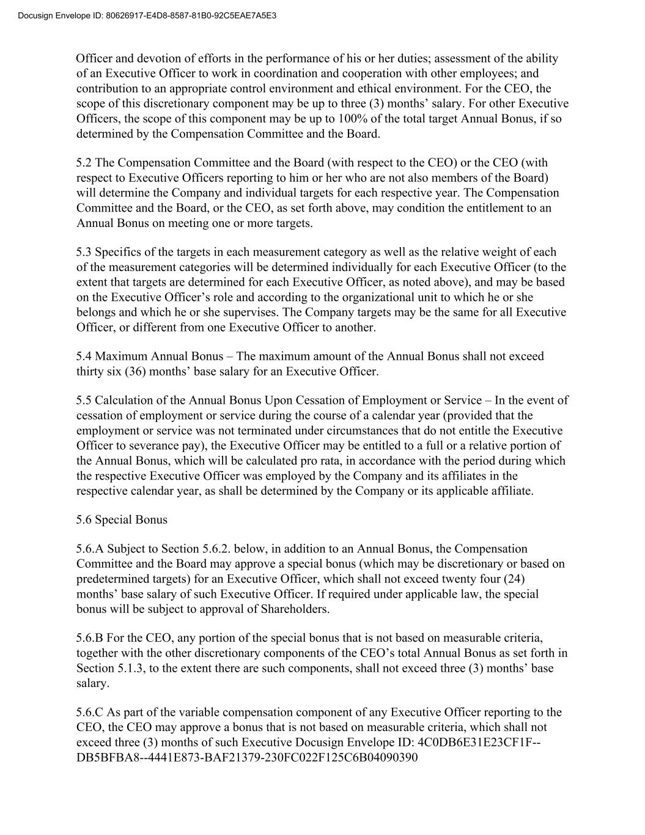
Officer and devotion of efforts in the performance of his or her duties; assessment of the ability of an Executive Officer to work in coordination and cooperation with other employees; and contribution to an appropriate control environment and ethical environment. For the CEO, the scope of this discretionary component may be up to three (3) months’ salary. For other Executive Officers, the scope of this component may be up to 100% of the total target Annual Bonus, if so determined by the Compensation Committee and the Board. 5.2 The Compensation Committee and the Board (with respect to the CEO) or the CEO (with respect to Executive Officers reporting to him or her who are not also members of the Board) will determine the Company and individual targets for each respective year. The Compensation Committee and the Board, or the CEO, as set forth above, may condition the entitlement to an Annual Bonus on meeting one or more targets. 5.3 Specifics of the targets in each measurement category as well as the relative weight of each of the measurement categories will be determined individually for each Executive Officer (to the extent that targets are determined for each Executive Officer, as noted above), and may be based on the Executive Officer’s role and according to the organizational unit to which he or she belongs and which he or she supervises. The Company targets may be the same for all Executive Officer, or different from one Executive Officer to another. 5.4 Maximum Annual Bonus – The maximum amount of the Annual Bonus shall not exceed thirty six (36) months’ base salary for an Executive Officer. 5.5 Calculation of the Annual Bonus Upon Cessation of Employment or Service – In the event of cessation of employment or service during the course of a calendar year (provided that the employment or service was not terminated under circumstances that do not entitle the Executive Officer to severance pay), the Executive Officer may be entitled to a full or a relative portion of the Annual Bonus, which will be calculated pro rata, in accordance with the period during which the respective Executive Officer was employed by the Company and its affiliates in the respective calendar year, as shall be determined by the Company or its applicable affiliate. 5.6 Special Bonus 5.6.A Subject to Section 5.6.2. below, in addition to an Annual Bonus, the Compensation Committee and the Board may approve a special bonus (which may be discretionary or based on predetermined targets) for an Executive Officer, which shall not exceed twenty four (24) months’ base salary of such Executive Officer. If required under applicable law, the special bonus will be subject to approval of Shareholders. 5.6.B For the CEO, any portion of the special bonus that is not based on measurable criteria, together with the other discretionary components of the CEO’s total Annual Bonus as set forth in Section 5.1.3, to the extent there are such components, shall not exceed three (3) months’ base salary. 5.6.C As part of the variable compensation component of any Executive Officer reporting to the CEO, the CEO may approve a bonus that is not based on measurable criteria, which shall not exceed three (3) months of such Executive Docusign Envelope ID: 4C0DB6E31E23CF1F-- DB5BFBA8--4441E873-BAF21379-230FC022F125C6B04090390 Docusign Envelope ID: 80626917-E4D8-8587-81B0-92C5EAE7A5E3

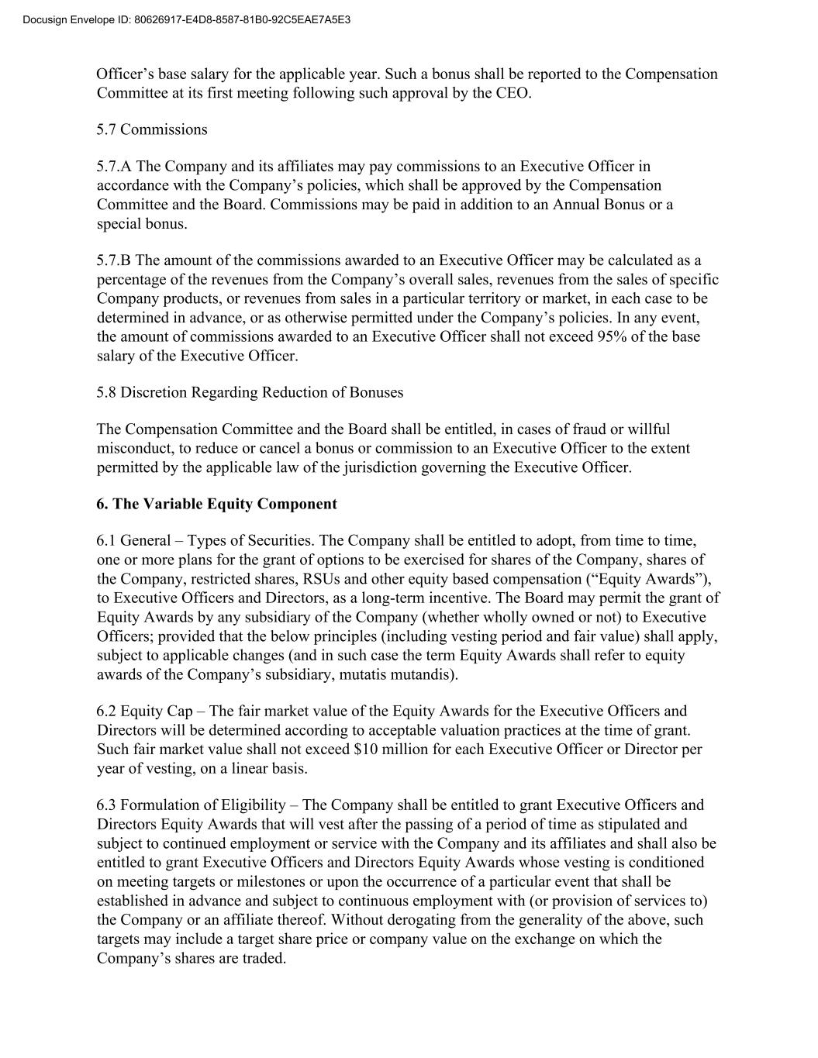
Officer’s base salary for the applicable year. Such a bonus shall be reported to the Compensation Committee at its first meeting following such approval by the CEO. 5.7 Commissions 5.7.A The Company and its affiliates may pay commissions to an Executive Officer in accordance with the Company’s policies, which shall be approved by the Compensation Committee and the Board. Commissions may be paid in addition to an Annual Bonus or a special bonus. 5.7.B The amount of the commissions awarded to an Executive Officer may be calculated as a percentage of the revenues from the Company’s overall sales, revenues from the sales of specific Company products, or revenues from sales in a particular territory or market, in each case to be determined in advance, or as otherwise permitted under the Company’s policies. In any event, the amount of commissions awarded to an Executive Officer shall not exceed 95% of the base salary of the Executive Officer. 5.8 Discretion Regarding Reduction of Bonuses The Compensation Committee and the Board shall be entitled, in cases of fraud or willful misconduct, to reduce or cancel a bonus or commission to an Executive Officer to the extent permitted by the applicable law of the jurisdiction governing the Executive Officer. 6. The Variable Equity Component 6.1 General – Types of Securities. The Company shall be entitled to adopt, from time to time, one or more plans for the grant of options to be exercised for shares of the Company, shares of the Company, restricted shares, RSUs and other equity based compensation (“Equity Awards”), to Executive Officers and Directors, as a long-term incentive. The Board may permit the grant of Equity Awards by any subsidiary of the Company (whether wholly owned or not) to Executive Officers; provided that the below principles (including vesting period and fair value) shall apply, subject to applicable changes (and in such case the term Equity Awards shall refer to equity awards of the Company’s subsidiary, mutatis mutandis). 6.2 Equity Cap – The fair market value of the Equity Awards for the Executive Officers and Directors will be determined according to acceptable valuation practices at the time of grant. Such fair market value shall not exceed $10 million for each Executive Officer or Director per year of vesting, on a linear basis. 6.3 Formulation of Eligibility – The Company shall be entitled to grant Executive Officers and Directors Equity Awards that will vest after the passing of a period of time as stipulated and subject to continued employment or service with the Company and its affiliates and shall also be entitled to grant Executive Officers and Directors Equity Awards whose vesting is conditioned on meeting targets or milestones or upon the occurrence of a particular event that shall be established in advance and subject to continuous employment with (or provision of services to) the Company or an affiliate thereof. Without derogating from the generality of the above, such targets may include a target share price or company value on the exchange on which the Company’s shares are traded. Docusign Envelope ID: 80626917-E4D8-8587-81B0-92C5EAE7A5E3

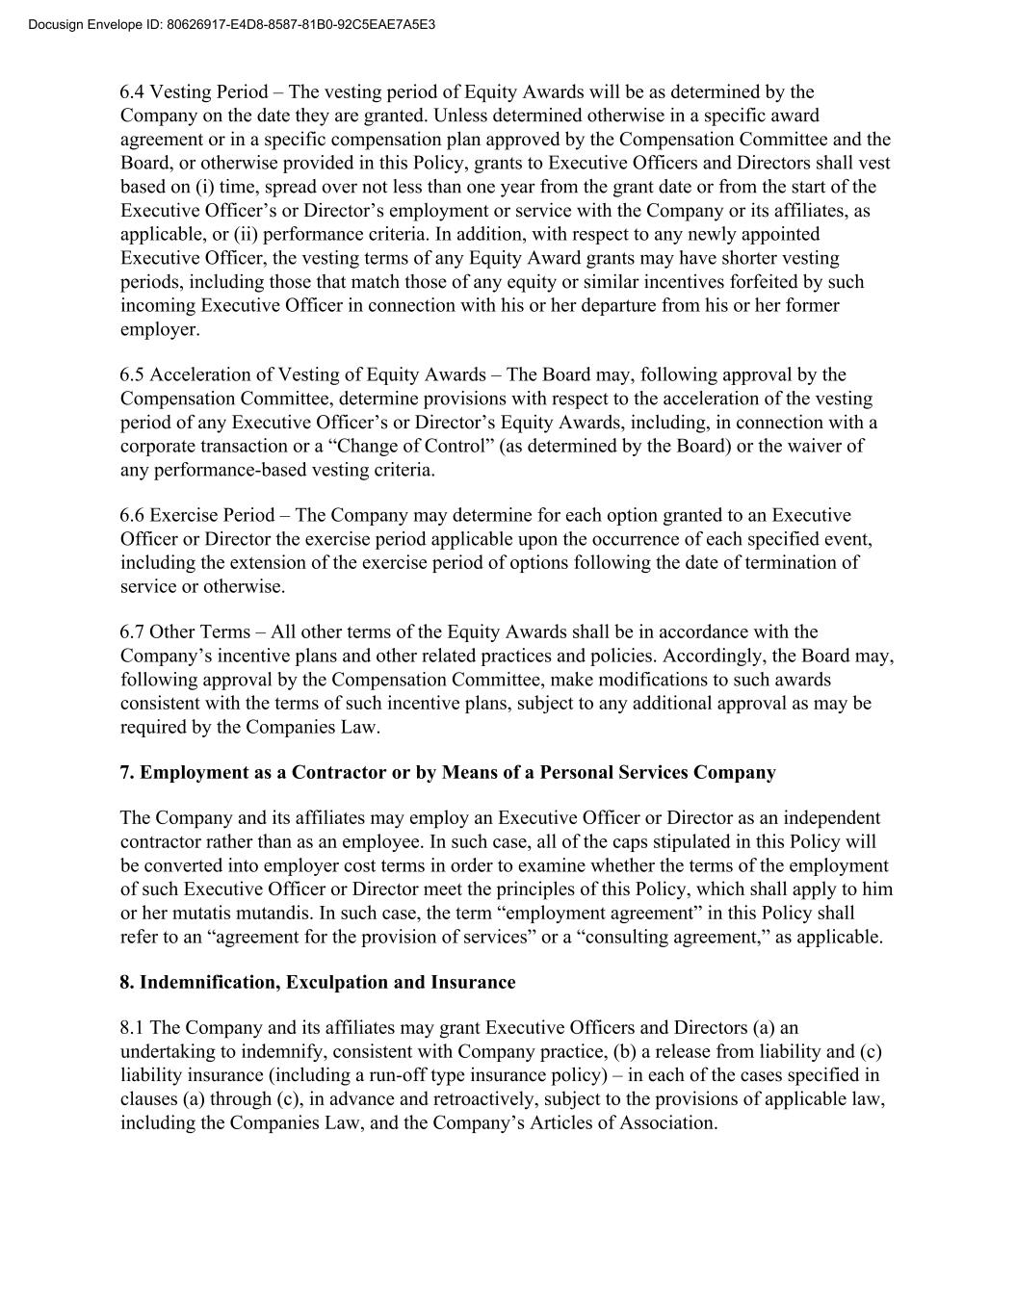
6.4 Vesting Period – The vesting period of Equity Awards will be as determined by the Company on the date they are granted. Unless determined otherwise in a specific award agreement or in a specific compensation plan approved by the Compensation Committee and the Board, or otherwise provided in this Policy, grants to Executive Officers and Directors shall vest based on (i) time, spread over not less than one year from the grant date or from the start of the Executive Officer’s or Director’s employment or service with the Company or its affiliates, as applicable, or (ii) performance criteria. In addition, with respect to any newly appointed Executive Officer, the vesting terms of any Equity Award grants may have shorter vesting periods, including those that match those of any equity or similar incentives forfeited by such incoming Executive Officer in connection with his or her departure from his or her former employer. 6.5 Acceleration of Vesting of Equity Awards – The Board may, following approval by the Compensation Committee, determine provisions with respect to the acceleration of the vesting period of any Executive Officer’s or Director’s Equity Awards, including, in connection with a corporate transaction or a “Change of Control” (as determined by the Board) or the waiver of any performance-based vesting criteria. 6.6 Exercise Period – The Company may determine for each option granted to an Executive Officer or Director the exercise period applicable upon the occurrence of each specified event, including the extension of the exercise period of options following the date of termination of service or otherwise. 6.7 Other Terms – All other terms of the Equity Awards shall be in accordance with the Company’s incentive plans and other related practices and policies. Accordingly, the Board may, following approval by the Compensation Committee, make modifications to such awards consistent with the terms of such incentive plans, subject to any additional approval as may be required by the Companies Law. 7. Employment as a Contractor or by Means of a Personal Services Company The Company and its affiliates may employ an Executive Officer or Director as an independent contractor rather than as an employee. In such case, all of the caps stipulated in this Policy will be converted into employer cost terms in order to examine whether the terms of the employment of such Executive Officer or Director meet the principles of this Policy, which shall apply to him or her mutatis mutandis. In such case, the term “employment agreement” in this Policy shall refer to an “agreement for the provision of services” or a “consulting agreement,” as applicable. 8. Indemnification, Exculpation and Insurance 8.1 The Company and its affiliates may grant Executive Officers and Directors (a) an undertaking to indemnify, consistent with Company practice, (b) a release from liability and (c) liability insurance (including a run-off type insurance policy) – in each of the cases specified in clauses (a) through (c), in advance and retroactively, subject to the provisions of applicable law, including the Companies Law, and the Company’s Articles of Association. Docusign Envelope ID: 80626917-E4D8-8587-81B0-92C5EAE7A5E3

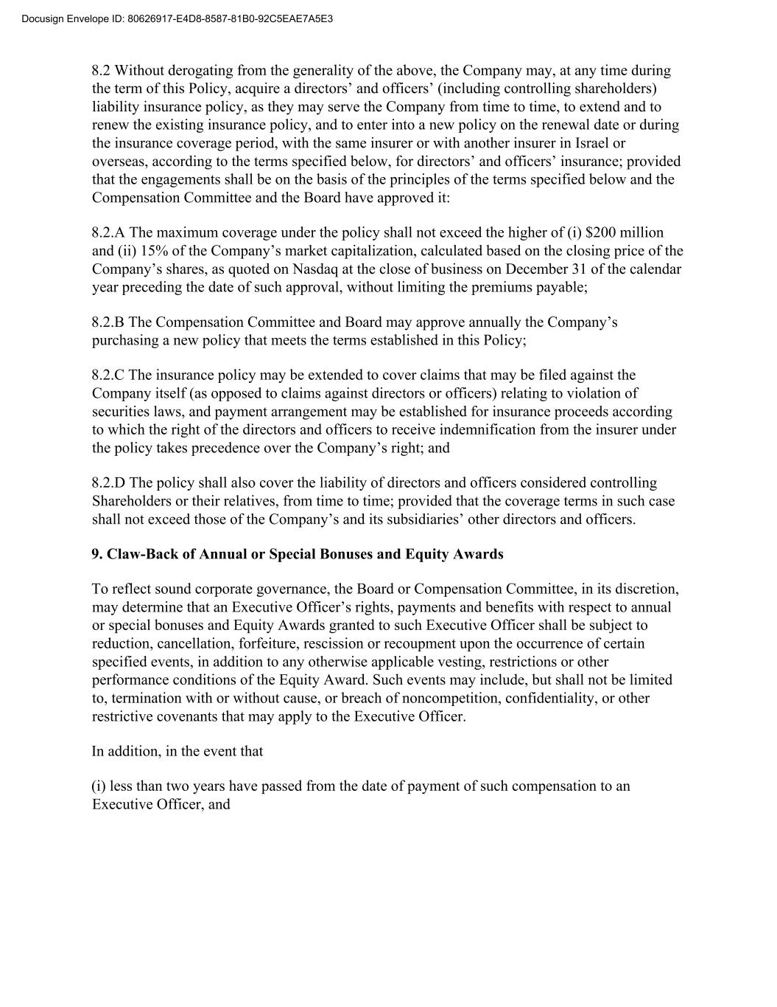
8.2 Without derogating from the generality of the above, the Company may, at any time during the term of this Policy, acquire a directors’ and officers’ (including controlling shareholders) liability insurance policy, as they may serve the Company from time to time, to extend and to renew the existing insurance policy, and to enter into a new policy on the renewal date or during the insurance coverage period, with the same insurer or with another insurer in Israel or overseas, according to the terms specified below, for directors’ and officers’ insurance; provided that the engagements shall be on the basis of the principles of the terms specified below and the Compensation Committee and the Board have approved it: 8.2.A The maximum coverage under the policy shall not exceed the higher of (i) $200 million and (ii) 15% of the Company’s market capitalization, calculated based on the closing price of the Company’s shares, as quoted on Nasdaq at the close of business on December 31 of the calendar year preceding the date of such approval, without limiting the premiums payable; 8.2.B The Compensation Committee and Board may approve annually the Company’s purchasing a new policy that meets the terms established in this Policy; 8.2.C The insurance policy may be extended to cover claims that may be filed against the Company itself (as opposed to claims against directors or officers) relating to violation of securities laws, and payment arrangement may be established for insurance proceeds according to which the right of the directors and officers to receive indemnification from the insurer under the policy takes precedence over the Company’s right; and 8.2.D The policy shall also cover the liability of directors and officers considered controlling Shareholders or their relatives, from time to time; provided that the coverage terms in such case shall not exceed those of the Company’s and its subsidiaries’ other directors and officers. 9. Claw-Back of Annual or Special Bonuses and Equity Awards To reflect sound corporate governance, the Board or Compensation Committee, in its discretion, may determine that an Executive Officer’s rights, payments and benefits with respect to annual or special bonuses and Equity Awards granted to such Executive Officer shall be subject to reduction, cancellation, forfeiture, rescission or recoupment upon the occurrence of certain specified events, in addition to any otherwise applicable vesting, restrictions or other performance conditions of the Equity Award. Such events may include, but shall not be limited to, termination with or without cause, or breach of noncompetition, confidentiality, or other restrictive covenants that may apply to the Executive Officer. In addition, in the event that (i) less than two years have passed from the date of payment of such compensation to an Executive Officer, and Docusign Envelope ID: 80626917-E4D8-8587-81B0-92C5EAE7A5E3

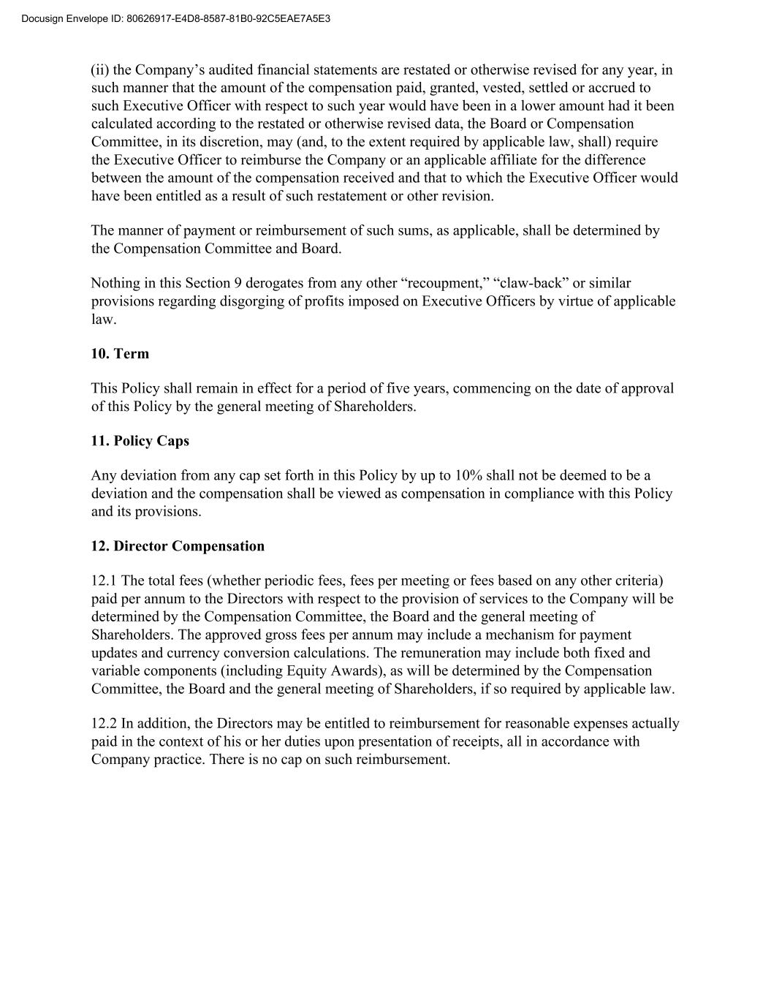
(ii) the Company’s audited financial statements are restated or otherwise revised for any year, in such manner that the amount of the compensation paid, granted, vested, settled or accrued to such Executive Officer with respect to such year would have been in a lower amount had it been calculated according to the restated or otherwise revised data, the Board or Compensation Committee, in its discretion, may (and, to the extent required by applicable law, shall) require the Executive Officer to reimburse the Company or an applicable affiliate for the difference between the amount of the compensation received and that to which the Executive Officer would have been entitled as a result of such restatement or other revision. The manner of payment or reimbursement of such sums, as applicable, shall be determined by the Compensation Committee and Board. Nothing in this Section 9 derogates from any other “recoupment,” “claw-back” or similar provisions regarding disgorging of profits imposed on Executive Officers by virtue of applicable law. 10. Term This Policy shall remain in effect for a period of five years, commencing on the date of approval of this Policy by the general meeting of Shareholders. 11. Policy Caps Any deviation from any cap set forth in this Policy by up to 10% shall not be deemed to be a deviation and the compensation shall be viewed as compensation in compliance with this Policy and its provisions. 12. Director Compensation 12.1 The total fees (whether periodic fees, fees per meeting or fees based on any other criteria) paid per annum to the Directors with respect to the provision of services to the Company will be determined by the Compensation Committee, the Board and the general meeting of Shareholders. The approved gross fees per annum may include a mechanism for payment updates and currency conversion calculations. The remuneration may include both fixed and variable components (including Equity Awards), as will be determined by the Compensation Committee, the Board and the general meeting of Shareholders, if so required by applicable law. 12.2 In addition, the Directors may be entitled to reimbursement for reasonable expenses actually paid in the context of his or her duties upon presentation of receipts, all in accordance with Company practice. There is no cap on such reimbursement. Docusign Envelope ID: 80626917-E4D8-8587-81B0-92C5EAE7A5E3

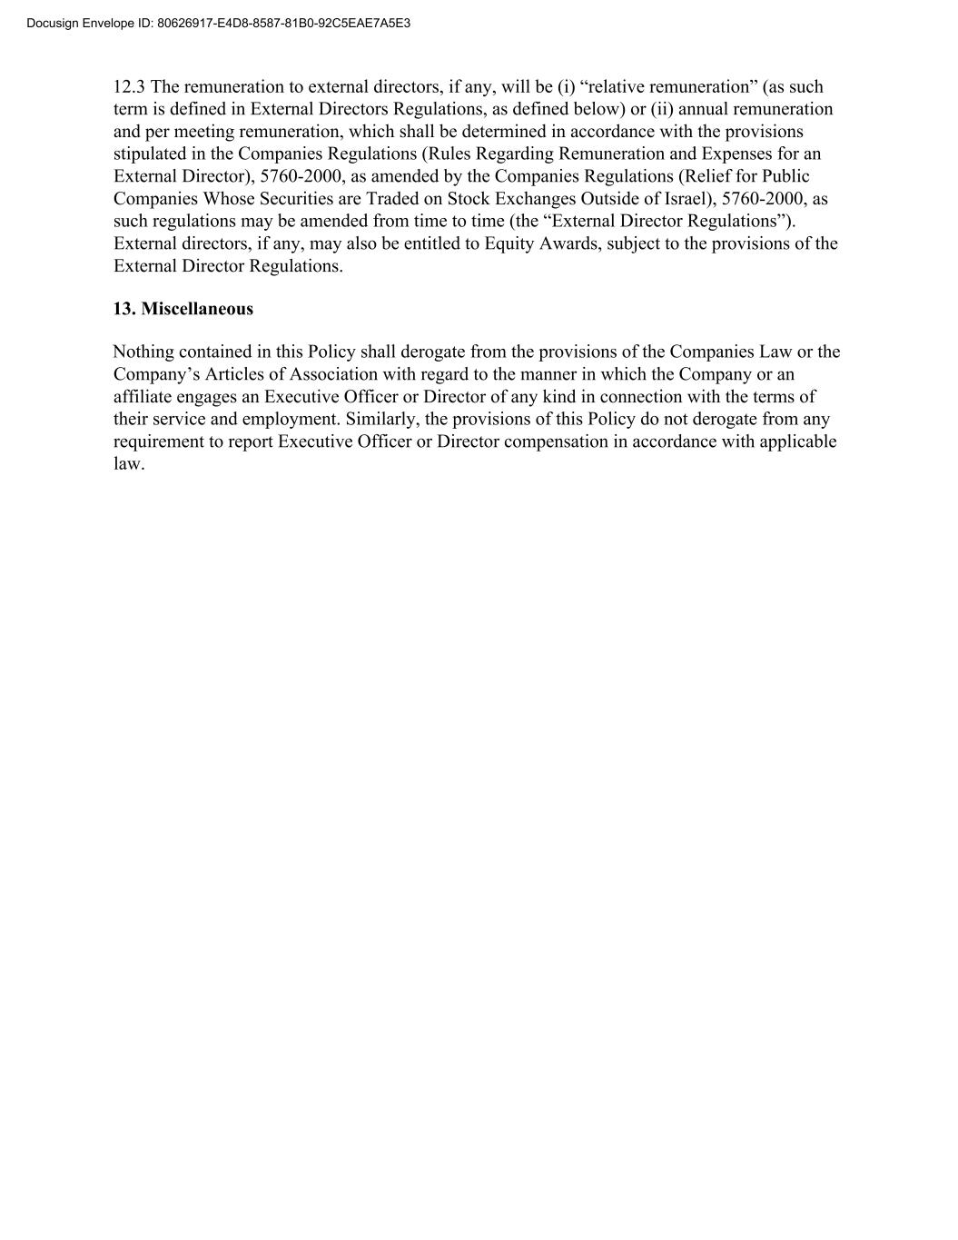
12.3 The remuneration to external directors, if any, will be (i) “relative remuneration” (as such term is defined in External Directors Regulations, as defined below) or (ii) annual remuneration and per meeting remuneration, which shall be determined in accordance with the provisions stipulated in the Companies Regulations (Rules Regarding Remuneration and Expenses for an External Director), 5760-2000, as amended by the Companies Regulations (Relief for Public Companies Whose Securities are Traded on Stock Exchanges Outside of Israel), 5760-2000, as such regulations may be amended from time to time (the “External Director Regulations”). External directors, if any, may also be entitled to Equity Awards, subject to the provisions of the External Director Regulations. 13. Miscellaneous Nothing contained in this Policy shall derogate from the provisions of the Companies Law or the Company’s Articles of Association with regard to the manner in which the Company or an affiliate engages an Executive Officer or Director of any kind in connection with the terms of their service and employment. Similarly, the provisions of this Policy do not derogate from any requirement to report Executive Officer or Director compensation in accordance with applicable law. Docusign Envelope ID: 80626917-E4D8-8587-81B0-92C5EAE7A5E3

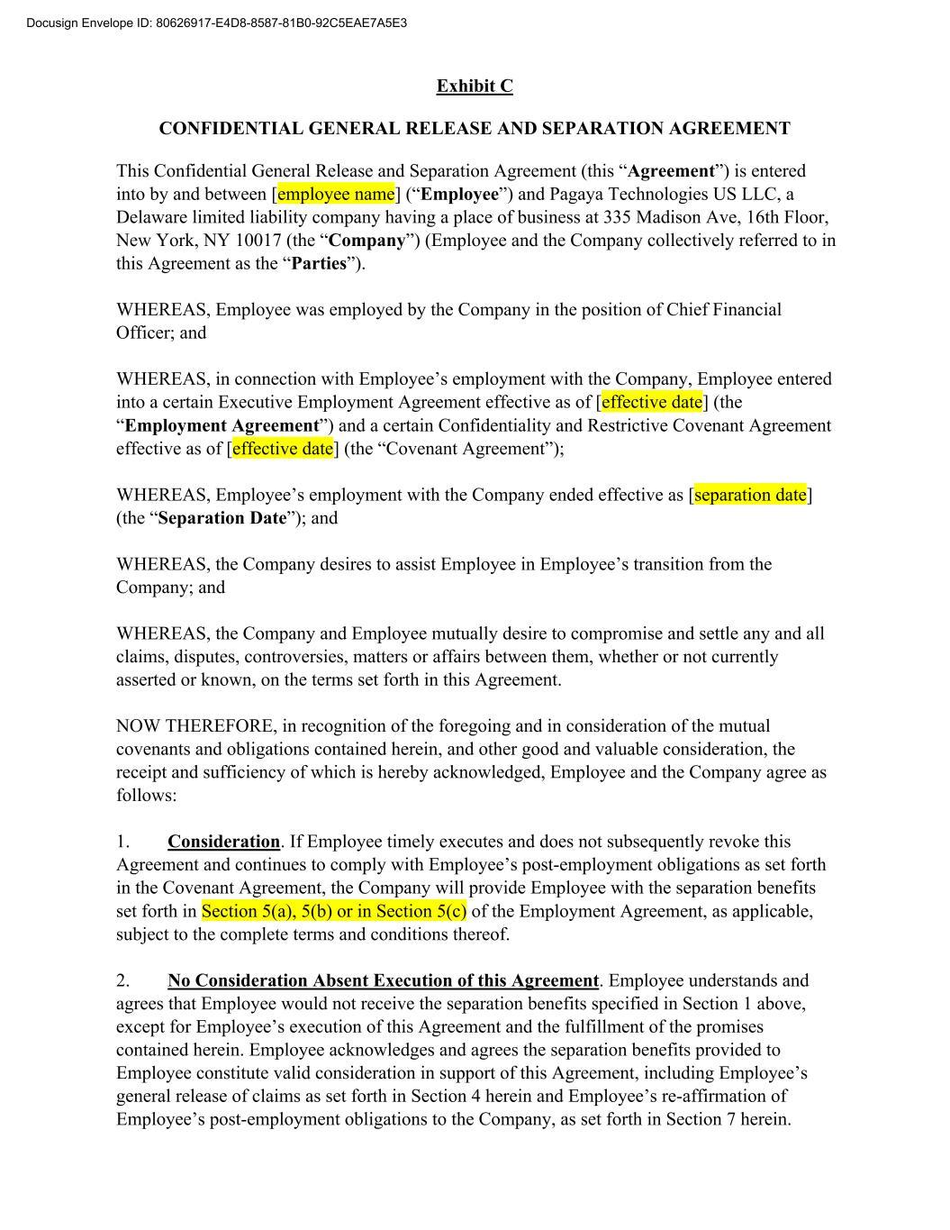
Exhibit C CONFIDENTIAL GENERAL RELEASE AND SEPARATION AGREEMENT This Confidential General Release and Separation Agreement (this “Agreement”) is entered into by and between [employee name] (“Employee”) and Pagaya Technologies US LLC, a Delaware limited liability company having a place of business at 335 Madison Ave, 16th Floor, New York, NY 10017 (the “Company”) (Employee and the Company collectively referred to in this Agreement as the “Parties”). WHEREAS, Employee was employed by the Company in the position of Chief Financial Officer; and WHEREAS, in connection with Employee’s employment with the Company, Employee entered into a certain Executive Employment Agreement effective as of [effective date] (the “Employment Agreement”) and a certain Confidentiality and Restrictive Covenant Agreement effective as of [effective date] (the “Covenant Agreement”); WHEREAS, Employee’s employment with the Company ended effective as [separation date] (the “Separation Date”); and WHEREAS, the Company desires to assist Employee in Employee’s transition from the Company; and WHEREAS, the Company and Employee mutually desire to compromise and settle any and all claims, disputes, controversies, matters or affairs between them, whether or not currently asserted or known, on the terms set forth in this Agreement. NOW THEREFORE, in recognition of the foregoing and in consideration of the mutual covenants and obligations contained herein, and other good and valuable consideration, the receipt and sufficiency of which is hereby acknowledged, Employee and the Company agree as follows: 1. Consideration. If Employee timely executes and does not subsequently revoke this Agreement and continues to comply with Employee’s post-employment obligations as set forth in the Covenant Agreement, the Company will provide Employee with the separation benefits set forth in Section 5(a), 5(b) or in Section 5(c) of the Employment Agreement, as applicable, subject to the complete terms and conditions thereof. 2. No Consideration Absent Execution of this Agreement. Employee understands and agrees that Employee would not receive the separation benefits specified in Section 1 above, except for Employee’s execution of this Agreement and the fulfillment of the promises contained herein. Employee acknowledges and agrees the separation benefits provided to Employee constitute valid consideration in support of this Agreement, including Employee’s general release of claims as set forth in Section 4 herein and Employee’s re-affirmation of Employee’s post-employment obligations to the Company, as set forth in Section 7 herein. Docusign Envelope ID: 80626917-E4D8-8587-81B0-92C5EAE7A5E3

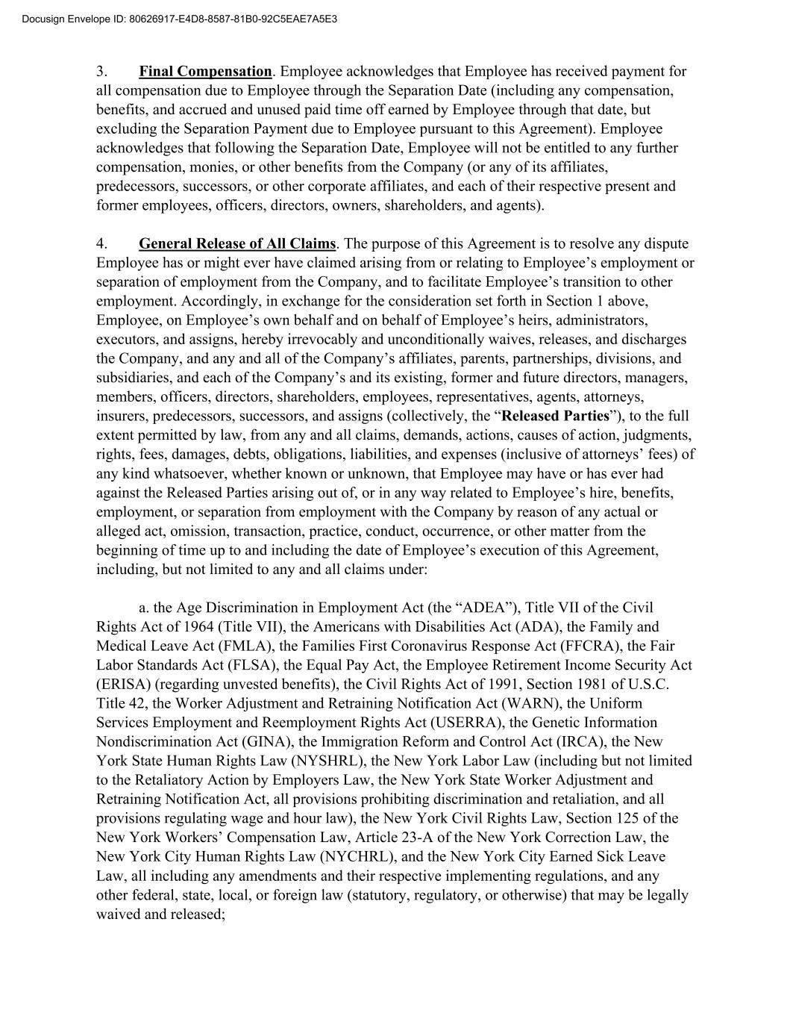
3. Final Compensation. Employee acknowledges that Employee has received payment for all compensation due to Employee through the Separation Date (including any compensation, benefits, and accrued and unused paid time off earned by Employee through that date, but excluding the Separation Payment due to Employee pursuant to this Agreement). Employee acknowledges that following the Separation Date, Employee will not be entitled to any further compensation, monies, or other benefits from the Company (or any of its affiliates, predecessors, successors, or other corporate affiliates, and each of their respective present and former employees, officers, directors, owners, shareholders, and agents). 4. General Release of All Claims. The purpose of this Agreement is to resolve any dispute Employee has or might ever have claimed arising from or relating to Employee’s employment or separation of employment from the Company, and to facilitate Employee’s transition to other employment. Accordingly, in exchange for the consideration set forth in Section 1 above, Employee, on Employee’s own behalf and on behalf of Employee’s heirs, administrators, executors, and assigns, hereby irrevocably and unconditionally waives, releases, and discharges the Company, and any and all of the Company’s affiliates, parents, partnerships, divisions, and subsidiaries, and each of the Company’s and its existing, former and future directors, managers, members, officers, directors, shareholders, employees, representatives, agents, attorneys, insurers, predecessors, successors, and assigns (collectively, the “Released Parties”), to the full extent permitted by law, from any and all claims, demands, actions, causes of action, judgments, rights, fees, damages, debts, obligations, liabilities, and expenses (inclusive of attorneys’ fees) of any kind whatsoever, whether known or unknown, that Employee may have or has ever had against the Released Parties arising out of, or in any way related to Employee’s hire, benefits, employment, or separation from employment with the Company by reason of any actual or alleged act, omission, transaction, practice, conduct, occurrence, or other matter from the beginning of time up to and including the date of Employee’s execution of this Agreement, including, but not limited to any and all claims under: a. the Age Discrimination in Employment Act (the “ADEA”), Title VII of the Civil Rights Act of 1964 (Title VII), the Americans with Disabilities Act (ADA), the Family and Medical Leave Act (FMLA), the Families First Coronavirus Response Act (FFCRA), the Fair Labor Standards Act (FLSA), the Equal Pay Act, the Employee Retirement Income Security Act (ERISA) (regarding unvested benefits), the Civil Rights Act of 1991, Section 1981 of U.S.C. Title 42, the Worker Adjustment and Retraining Notification Act (WARN), the Uniform Services Employment and Reemployment Rights Act (USERRA), the Genetic Information Nondiscrimination Act (GINA), the Immigration Reform and Control Act (IRCA), the New York State Human Rights Law (NYSHRL), the New York Labor Law (including but not limited to the Retaliatory Action by Employers Law, the New York State Worker Adjustment and Retraining Notification Act, all provisions prohibiting discrimination and retaliation, and all provisions regulating wage and hour law), the New York Civil Rights Law, Section 125 of the New York Workers’ Compensation Law, Article 23-A of the New York Correction Law, the New York City Human Rights Law (NYCHRL), and the New York City Earned Sick Leave Law, all including any amendments and their respective implementing regulations, and any other federal, state, local, or foreign law (statutory, regulatory, or otherwise) that may be legally waived and released; Docusign Envelope ID: 80626917-E4D8-8587-81B0-92C5EAE7A5E3

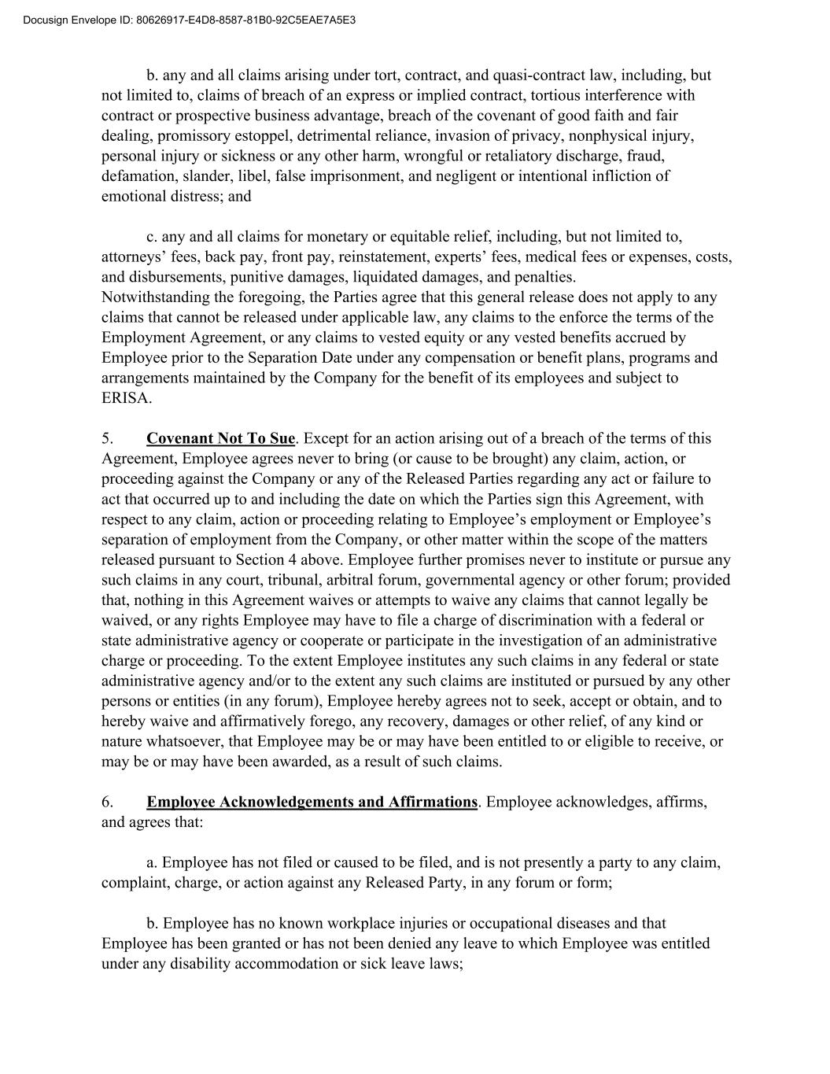
b. any and all claims arising under tort, contract, and quasi-contract law, including, but not limited to, claims of breach of an express or implied contract, tortious interference with contract or prospective business advantage, breach of the covenant of good faith and fair dealing, promissory estoppel, detrimental reliance, invasion of privacy, nonphysical injury, personal injury or sickness or any other harm, wrongful or retaliatory discharge, fraud, defamation, slander, libel, false imprisonment, and negligent or intentional infliction of emotional distress; and c. any and all claims for monetary or equitable relief, including, but not limited to, attorneys’ fees, back pay, front pay, reinstatement, experts’ fees, medical fees or expenses, costs, and disbursements, punitive damages, liquidated damages, and penalties. Notwithstanding the foregoing, the Parties agree that this general release does not apply to any claims that cannot be released under applicable law, any claims to the enforce the terms of the Employment Agreement, or any claims to vested equity or any vested benefits accrued by Employee prior to the Separation Date under any compensation or benefit plans, programs and arrangements maintained by the Company for the benefit of its employees and subject to ERISA. 5. Covenant Not To Sue. Except for an action arising out of a breach of the terms of this Agreement, Employee agrees never to bring (or cause to be brought) any claim, action, or proceeding against the Company or any of the Released Parties regarding any act or failure to act that occurred up to and including the date on which the Parties sign this Agreement, with respect to any claim, action or proceeding relating to Employee’s employment or Employee’s separation of employment from the Company, or other matter within the scope of the matters released pursuant to Section 4 above. Employee further promises never to institute or pursue any such claims in any court, tribunal, arbitral forum, governmental agency or other forum; provided that, nothing in this Agreement waives or attempts to waive any claims that cannot legally be waived, or any rights Employee may have to file a charge of discrimination with a federal or state administrative agency or cooperate or participate in the investigation of an administrative charge or proceeding. To the extent Employee institutes any such claims in any federal or state administrative agency and/or to the extent any such claims are instituted or pursued by any other persons or entities (in any forum), Employee hereby agrees not to seek, accept or obtain, and to hereby waive and affirmatively forego, any recovery, damages or other relief, of any kind or nature whatsoever, that Employee may be or may have been entitled to or eligible to receive, or may be or may have been awarded, as a result of such claims. 6. Employee Acknowledgements and Affirmations. Employee acknowledges, affirms, and agrees that: a. Employee has not filed or caused to be filed, and is not presently a party to any claim, complaint, charge, or action against any Released Party, in any forum or form; b. Employee has no known workplace injuries or occupational diseases and that Employee has been granted or has not been denied any leave to which Employee was entitled under any disability accommodation or sick leave laws; Docusign Envelope ID: 80626917-E4D8-8587-81B0-92C5EAE7A5E3

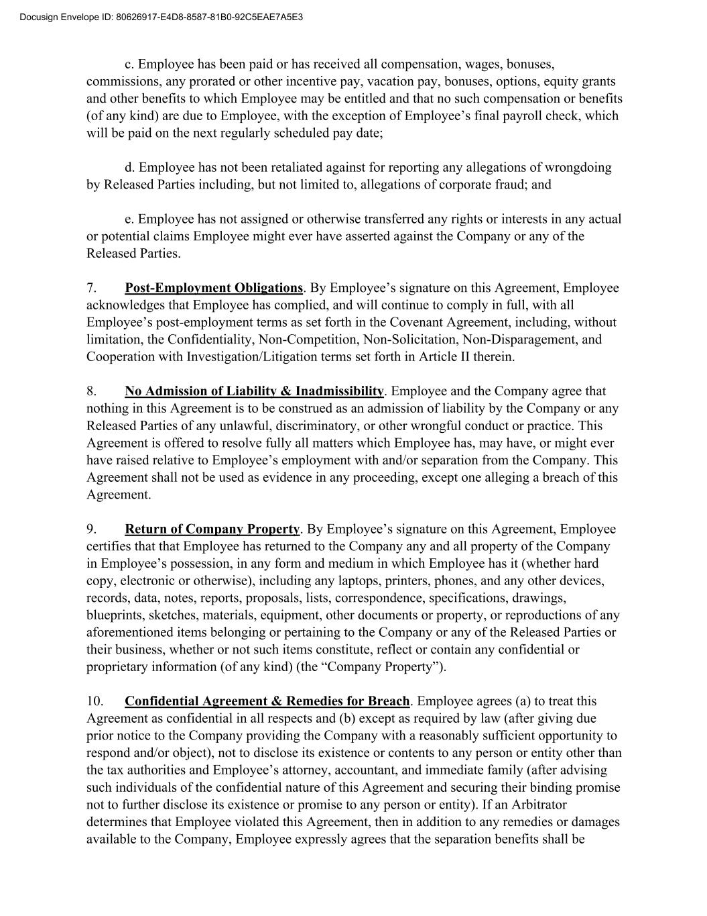
c. Employee has been paid or has received all compensation, wages, bonuses, commissions, any prorated or other incentive pay, vacation pay, bonuses, options, equity grants and other benefits to which Employee may be entitled and that no such compensation or benefits (of any kind) are due to Employee, with the exception of Employee’s final payroll check, which will be paid on the next regularly scheduled pay date; d. Employee has not been retaliated against for reporting any allegations of wrongdoing by Released Parties including, but not limited to, allegations of corporate fraud; and e. Employee has not assigned or otherwise transferred any rights or interests in any actual or potential claims Employee might ever have asserted against the Company or any of the Released Parties. 7. Post-Employment Obligations. By Employee’s signature on this Agreement, Employee acknowledges that Employee has complied, and will continue to comply in full, with all Employee’s post-employment terms as set forth in the Covenant Agreement, including, without limitation, the Confidentiality, Non-Competition, Non-Solicitation, Non-Disparagement, and Cooperation with Investigation/Litigation terms set forth in Article II therein. 8. No Admission of Liability & Inadmissibility. Employee and the Company agree that nothing in this Agreement is to be construed as an admission of liability by the Company or any Released Parties of any unlawful, discriminatory, or other wrongful conduct or practice. This Agreement is offered to resolve fully all matters which Employee has, may have, or might ever have raised relative to Employee’s employment with and/or separation from the Company. This Agreement shall not be used as evidence in any proceeding, except one alleging a breach of this Agreement. 9. Return of Company Property. By Employee’s signature on this Agreement, Employee certifies that that Employee has returned to the Company any and all property of the Company in Employee’s possession, in any form and medium in which Employee has it (whether hard copy, electronic or otherwise), including any laptops, printers, phones, and any other devices, records, data, notes, reports, proposals, lists, correspondence, specifications, drawings, blueprints, sketches, materials, equipment, other documents or property, or reproductions of any aforementioned items belonging or pertaining to the Company or any of the Released Parties or their business, whether or not such items constitute, reflect or contain any confidential or proprietary information (of any kind) (the “Company Property”). 10. Confidential Agreement & Remedies for Breach. Employee agrees (a) to treat this Agreement as confidential in all respects and (b) except as required by law (after giving due prior notice to the Company providing the Company with a reasonably sufficient opportunity to respond and/or object), not to disclose its existence or contents to any person or entity other than the tax authorities and Employee’s attorney, accountant, and immediate family (after advising such individuals of the confidential nature of this Agreement and securing their binding promise not to further disclose its existence or promise to any person or entity). If an Arbitrator determines that Employee violated this Agreement, then in addition to any remedies or damages available to the Company, Employee expressly agrees that the separation benefits shall be Docusign Envelope ID: 80626917-E4D8-8587-81B0-92C5EAE7A5E3

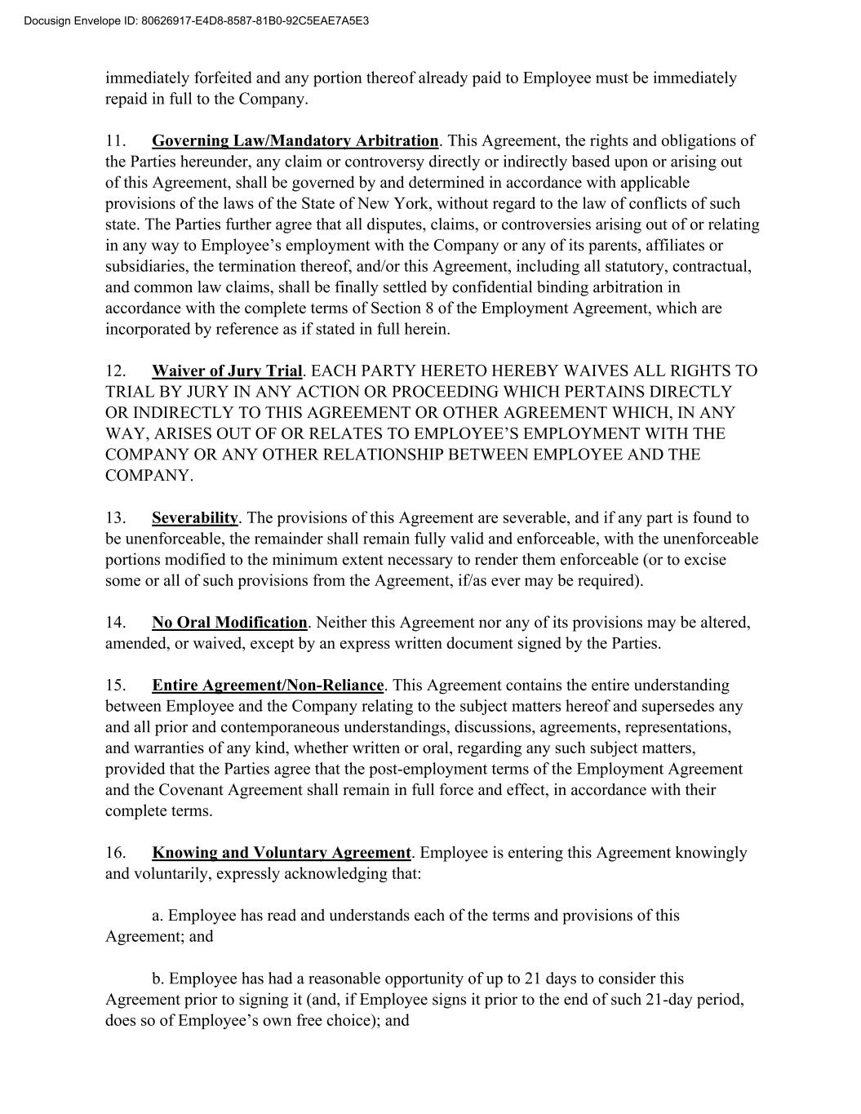
immediately forfeited and any portion thereof already paid to Employee must be immediately repaid in full to the Company. 11. Governing Law/Mandatory Arbitration. This Agreement, the rights and obligations of the Parties hereunder, any claim or controversy directly or indirectly based upon or arising out of this Agreement, shall be governed by and determined in accordance with applicable provisions of the laws of the State of New York, without regard to the law of conflicts of such state. The Parties further agree that all disputes, claims, or controversies arising out of or relating in any way to Employee’s employment with the Company or any of its parents, affiliates or subsidiaries, the termination thereof, and/or this Agreement, including all statutory, contractual, and common law claims, shall be finally settled by confidential binding arbitration in accordance with the complete terms of Section 8 of the Employment Agreement, which are incorporated by reference as if stated in full herein. 12. Waiver of Jury Trial. EACH PARTY HERETO HEREBY WAIVES ALL RIGHTS TO TRIAL BY JURY IN ANY ACTION OR PROCEEDING WHICH PERTAINS DIRECTLY OR INDIRECTLY TO THIS AGREEMENT OR OTHER AGREEMENT WHICH, IN ANY WAY, ARISES OUT OF OR RELATES TO EMPLOYEE’S EMPLOYMENT WITH THE COMPANY OR ANY OTHER RELATIONSHIP BETWEEN EMPLOYEE AND THE COMPANY. 13. Severability. The provisions of this Agreement are severable, and if any part is found to be unenforceable, the remainder shall remain fully valid and enforceable, with the unenforceable portions modified to the minimum extent necessary to render them enforceable (or to excise some or all of such provisions from the Agreement, if/as ever may be required). 14. No Oral Modification. Neither this Agreement nor any of its provisions may be altered, amended, or waived, except by an express written document signed by the Parties. 15. Entire Agreement/Non-Reliance. This Agreement contains the entire understanding between Employee and the Company relating to the subject matters hereof and supersedes any and all prior and contemporaneous understandings, discussions, agreements, representations, and warranties of any kind, whether written or oral, regarding any such subject matters, provided that the Parties agree that the post-employment terms of the Employment Agreement and the Covenant Agreement shall remain in full force and effect, in accordance with their complete terms. 16. Knowing and Voluntary Agreement. Employee is entering this Agreement knowingly and voluntarily, expressly acknowledging that: a. Employee has read and understands each of the terms and provisions of this Agreement; and b. Employee has had a reasonable opportunity of up to 21 days to consider this Agreement prior to signing it (and, if Employee signs it prior to the end of such 21-day period, does so of Employee’s own free choice); and Docusign Envelope ID: 80626917-E4D8-8587-81B0-92C5EAE7A5E3

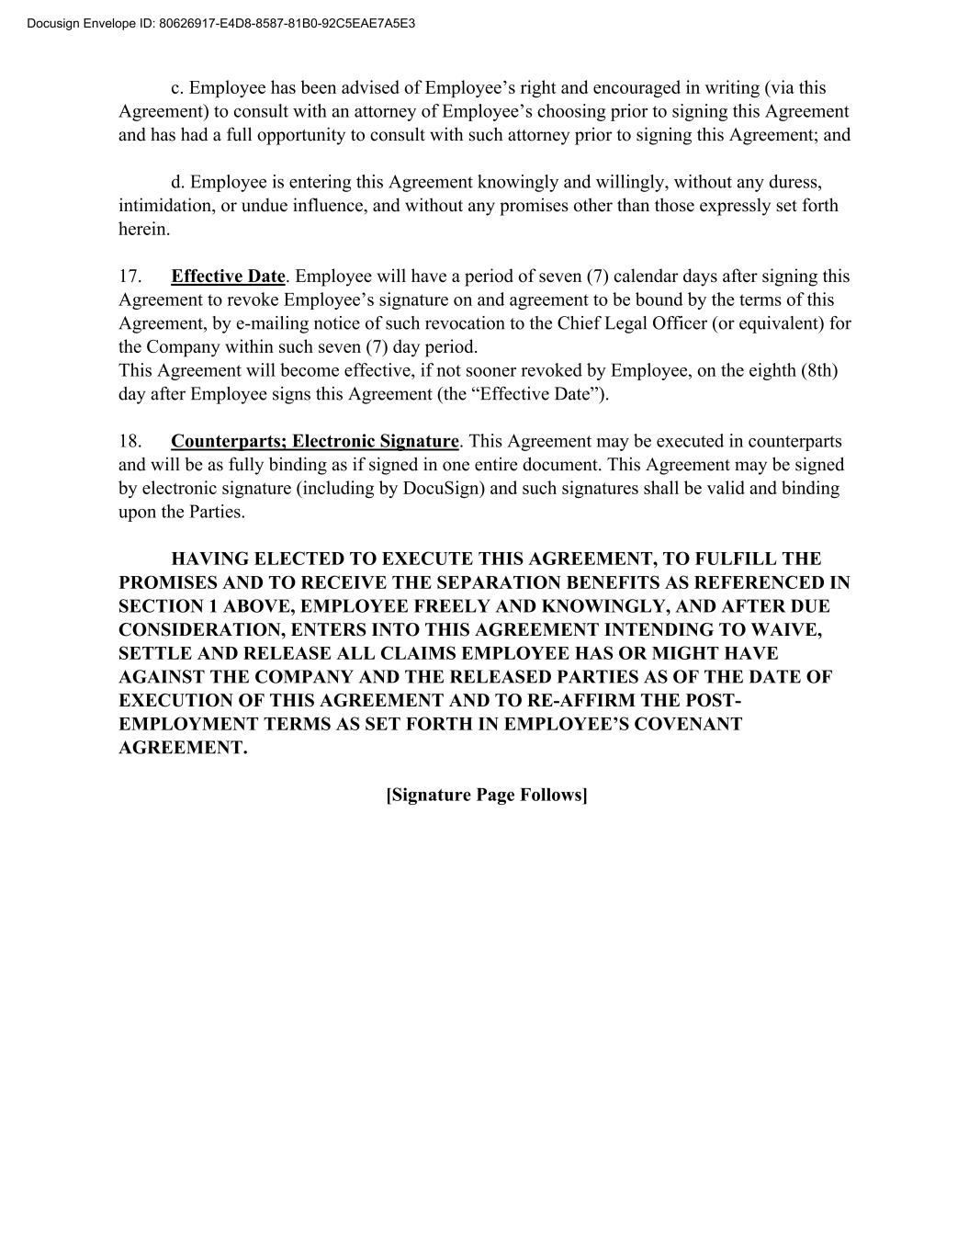
c. Employee has been advised of Employee’s right and encouraged in writing (via this Agreement) to consult with an attorney of Employee’s choosing prior to signing this Agreement and has had a full opportunity to consult with such attorney prior to signing this Agreement; and d. Employee is entering this Agreement knowingly and willingly, without any duress, intimidation, or undue influence, and without any promises other than those expressly set forth herein. 17. Effective Date. Employee will have a period of seven (7) calendar days after signing this Agreement to revoke Employee’s signature on and agreement to be bound by the terms of this Agreement, by e-mailing notice of such revocation to the Chief Legal Officer (or equivalent) for the Company within such seven (7) day period. This Agreement will become effective, if not sooner revoked by Employee, on the eighth (8th) day after Employee signs this Agreement (the “Effective Date”). 18. Counterparts; Electronic Signature. This Agreement may be executed in counterparts and will be as fully binding as if signed in one entire document. This Agreement may be signed by electronic signature (including by DocuSign) and such signatures shall be valid and binding upon the Parties. HAVING ELECTED TO EXECUTE THIS AGREEMENT, TO FULFILL THE PROMISES AND TO RECEIVE THE SEPARATION BENEFITS AS REFERENCED IN SECTION 1 ABOVE, EMPLOYEE FREELY AND KNOWINGLY, AND AFTER DUE CONSIDERATION, ENTERS INTO THIS AGREEMENT INTENDING TO WAIVE, SETTLE AND RELEASE ALL CLAIMS EMPLOYEE HAS OR MIGHT HAVE AGAINST THE COMPANY AND THE RELEASED PARTIES AS OF THE DATE OF EXECUTION OF THIS AGREEMENT AND TO RE-AFFIRM THE POST- EMPLOYMENT TERMS AS SET FORTH IN EMPLOYEE’S COVENANT AGREEMENT. [Signature Page Follows] Docusign Envelope ID: 80626917-E4D8-8587-81B0-92C5EAE7A5E3


IN WITNESS WHEREOF, the Parties have executed this Agreement voluntarily and of their own free will and deed, after due time to review and consider it, and without any duress or coercion, as follows. PAGAYA TECHNOLOGIES US LLC By: ________________________________ Name: Title: Date: ____________________ By: ________________________________ Name: Title: Date: ____________________ EMPLOYEE: Signature:_____________________________ Print Name: Date: ____________________ Docusign Envelope ID: 80626917-E4D8-8587-81B0-92C5EAE7A5E3

Exhibit 31.1

CERTIFICATION

I, Gal Krubiner, certify that:

1. I have reviewed this quarterly report on Form 10-Q of Pagaya Technologies Ltd.;

2. Based on my knowledge, this report does not contain any untrue statement of a material fact or omit to state a material fact necessary to make the statements made, in light of the circumstances under which such statements were made, not misleading with respect to the period covered by this report;

3. Based on my knowledge, the financial statements, and other financial information included in this report, fairly present in all material respects the financial condition, results of operations and cash flows of the company as of, and for, the periods presented in this report;

4. The company’s other certifying officer and I are responsible for establishing and maintaining disclosure controls and procedures (as defined in Exchange Act Rules 13a-15(e) and 15d-15(e)) and internal control over financial reporting (as defined in Exchange Act Rules 13a-15(f) and 15d-15(f)) for the company and have:

(a) Designed such disclosure controls and procedures, or caused such disclosure controls and procedures to be designed under our supervision, to ensure that material information relating to the company, including its consolidated subsidiaries, is made known to us by others within those entities, particularly during the period in which this report is being prepared;

(b) Designed such internal control over financial reporting, or caused such internal control over financial reporting to be designed under our supervision, to provide reasonable assurance regarding the reliability of financial reporting and the preparation of financial statements for external purposes in accordance with generally accepted accounting principles;

(c) Evaluated the effectiveness of the company’s disclosure controls and procedures and presented in this report our conclusions about the effectiveness of the disclosure controls and procedures, as of the end of the period covered by this report based on such evaluation; and

(d) Disclosed in this report any change in the company’s internal control over financial reporting that occurred during the period covered by the annual report that has materially affected, or is reasonably likely to materially affect, the company’s internal control over financial reporting; and

5. The company’s other certifying officer and I have disclosed, based on our most recent evaluation of internal control over financial reporting, to the company’s auditors and the audit committee of the company’s board of directors (or persons performing the equivalent functions):

(a) All significant deficiencies and material weaknesses in the design or operation of internal control over financial reporting which are reasonably likely to adversely affect the company’s ability to record, process, summarize and report financial information; and

(b) Any fraud, whether or not material, that involves management or other employees who have a significant role in the company’s internal control over financial reporting.

Date: July 30, 2026 |  |  | By: |  |  | /s/ Gal Krubiner
 |  |  |  |  |  | Gal Krubiner
 |  |  |  |  |  | Chief Executive Officer

Exhibit 31.2

CERTIFICATION

I, Jonathan Dobres, certify that:

1. I have reviewed this quarterly report on Form 10-Q of Pagaya Technologies Ltd.;

2. Based on my knowledge, this report does not contain any untrue statement of a material fact or omit to state a material fact necessary to make the statements made, in light of the circumstances under which such statements were made, not misleading with respect to the period covered by this report;

3. Based on my knowledge, the financial statements, and other financial information included in this report, fairly present in all material respects the financial condition, results of operations and cash flows of the company as of, and for, the periods presented in this report;

4. The company’s other certifying officer and I are responsible for establishing and maintaining disclosure controls and procedures (as defined in Exchange Act Rules 13a-15(e) and 15d-15(e)) and internal control over financial reporting (as defined in Exchange Act Rules 13a-15(f) and 15d-15(f)) for the company and have:

(a) Designed such disclosure controls and procedures, or caused such disclosure controls and procedures to be designed under our supervision, to ensure that material information relating to the company, including its consolidated subsidiaries, is made known to us by others within those entities, particularly during the period in which this report is being prepared;

(b) Designed such internal control over financial reporting, or caused such internal control over financial reporting to be designed under our supervision, to provide reasonable assurance regarding the reliability of financial reporting and the preparation of financial statements for external purposes in accordance with generally accepted accounting principles;

(c) Evaluated the effectiveness of the company’s disclosure controls and procedures and presented in this report our conclusions about the effectiveness of the disclosure controls and procedures, as of the end of the period covered by this report based on such evaluation; and

(d) Disclosed in this report any change in the company’s internal control over financial reporting that occurred during the period covered by the annual report that has materially affected, or is reasonably likely to materially affect, the company’s internal control over financial reporting; and

5. The company’s other certifying officer and I have disclosed, based on our most recent evaluation of internal control over financial reporting, to the company’s auditors and the audit committee of the company’s board of directors (or persons performing the equivalent functions):

(a) All significant deficiencies and material weaknesses in the design or operation of internal control over financial reporting which are reasonably likely to adversely affect the company’s ability to record, process, summarize and report financial information; and

(b) Any fraud, whether or not material, that involves management or other employees who have a significant role in the company’s internal control over financial reporting.

Date: July 30, 2026 |  |  | By: |  |  | /s/ Jonathan Dobres
 |  |  |  |  |  | Jonathan Dobres
 |  |  |  |  |  | Chief Financial Officer

Exhibit 32.1

CERTIFICATION

Pursuant to the requirement set forth in Rule 13a-14(b) of the Securities Exchange Act of 1934, as amended, (the “Exchange Act”) and Section 1350 of Chapter 63 of Title 18 of the United States Code (18 U.S.C. §1350), Gal Krubiner, Chief Executive Officer of Pagaya Technologies Ltd. (the “Company”), hereby certifies that, to the best of his knowledge:

1. The Company’s quarterly report on Form 10-Q for the quarter ended June 30, 2026, to which this Certification is attached as Exhibit 32.1 (the “Report”), fully complies with the requirements of Section 13(a) or Section 15(d) of the Exchange Act; and

2. The information contained in the Report fairly presents, in all material respects, the financial condition and results of operations of the Company.
Date: July 30, 2026 |  |  | By: |  |  | /s/ Gal Krubiner
 |  |  |  |  |  | Gal Krubiner
 |  |  |  |  |  | Chief Executive Officer
This certification accompanies the Form 10-Q to which it relates, is not deemed filed with the Securities and Exchange Commission and is not to be incorporated by reference into any filing of Pagaya Technologies Ltd. under the Securities Act of 1933, as amended, or the Exchange Act (whether made before or after the date of the Form 10-Q), irrespective of any general incorporation language contained in such filing.

Exhibit 32.2

CERTIFICATION

Pursuant to the requirement set forth in Rule 13a-14(b) of the Securities Exchange Act of 1934, as amended, (the “Exchange Act”) and Section 1350 of Chapter 63 of Title 18 of the United States Code (18 U.S.C. §1350), Jonathan Dobres, Chief Financial Officer of Pagaya Technologies Ltd. (the “Company”), hereby certifies that, to the best of his knowledge:

1. The Company’s quarterly report on Form 10-Q for the quarter ended June 30, 2026, to which this Certification is attached as Exhibit 32.2 (the “Report”), fully complies with the requirements of Section 13(a) or Section 15(d) of the Exchange Act; and

2. The information contained in the Report fairly presents, in all material respects, the financial condition and results of operations of the Company.
Date: July 30, 2026 |  |  | By: |  |  | /s/ Jonathan Dobres
 |  |  |  |  |  | Jonathan Dobres
 |  |  |  |  |  | Chief Financial Officer
This certification accompanies the Form 10-Q to which it relates, is not deemed filed with the Securities and Exchange Commission and is not to be incorporated by reference into any filing of Pagaya Technologies Ltd. under the Securities Act of 1933, as amended, or the Exchange Act (whether made before or after the date of the Form 10-Q), irrespective of any general incorporation language contained in such filing.

