UNITED STATES
SECURITIES AND EXCHANGE COMMISSION
Washington, D.C. 20549

FORM 6-K

REPORT OF FOREIGN PRIVATE ISSUER
PURSUANT TO SECTION 13A-16 OR 15D-16
UNDER THE SECURITIES EXCHANGE ACT OF 1934

For the month of August 2023

Commission File Number: 001-41430

Pagaya Technologies Ltd.
(Exact Name of Registrant as Specified in Its Charter)

Azrieli Sarona Bldg, 54th Floor
121 Derech Menachem Begin
Tel-Aviv 6701203, Israel
+972 (3) 715 0920
(Address of principal executive offices)

Indicate by check mark whether the registrant files or will file annual reports under cover of Form 20-F or Form 40-F.
Form 20-F ☒ Form 40-F ☐

Indicate by check mark if the registrant is submitting the Form 6-K in paper as permitted by Regulation S-T Rule 101(b)(1): ☐

Indicate by check mark if the registrant is submitting the Form 6-K in paper as permitted by Regulation S-T Rule 101(b)(7): ☐

CONTENTS

On August 10, 2023, Pagaya Technologies Ltd. (“Pagaya”) issued a press release titled “Pagaya Reports Second Quarter and First Half 2023 Results” and a Shareholder Letter. Copies of the press release and the Shareholder Letter are furnished as Exhibit 99.1 and Exhibit 99.2, respectively, to this Report of Foreign Private Issuer on Form 6-K (the “Report”).

The information in this Report, including Exhibit 99.1 and Exhibit 99.2 hereto, shall not be deemed to “filed” for purposes of Section 18 of the Securities Exchange Act of 1934, as amended (the “Exchange Act”), or otherwise subject to the liabilities of that section, nor shall such information be deemed incorporated by reference into any filing made by Pagaya under the Securities Act of 1933, as amended, or the Exchange Act, except as may be expressly set forth by specific reference in such filing.

CAUTIONARY NOTE ON FORWARD-LOOKING STATEMENTS

This Report contains forward-looking statements within the meaning of the Private Securities Litigation Reform Act of 1995. Words such as “may,” “will,” “expect,” “plan,” “anticipate,” “estimate,” “intend” and similar expressions (as well as other words or expressions referencing future events, conditions or circumstances) are intended to identify forward-looking statements. These forward-looking statements are based on Pagaya’s expectations and assumptions as of the date of this Report. Each of these forward-looking statements involves risks and uncertainties. Actual results may differ materially from those expressed or implied by these forward-looking statements. For a discussion of risk factors that may cause Pagaya’s actual results to differ from those expressed or implied in the forward-looking statements in this Report, you should refer to Pagaya’s filings with the U.S. Securities and Exchange Commission, including Pagaya’s most recent Form 20-F, particularly the section entitled “Risk Factors”. Except as required by law, Pagaya undertakes no obligation to publicly update any forward-looking statements, whether as a result of new information, future events or otherwise, except as required by law. You should, therefore, not rely on these forward-looking statements as representing Pagaya’s views as of any date subsequent to the date of this Report.

EXHIBIT INDEX

Exhibit No. |  |  |  |  |  | Description
99.1 |  |  |  |  |  | Press release, dated August 10, 2023, titled “Pagaya Reports Second Quarter and First Half 2023 Results”
99.2 |  |  |  |  |  | Shareholder Letter, dated August 10, 2023

SIGNATURES

Pursuant to the requirements of the Securities Exchange Act of 1934, the registrant has duly caused this report to be signed on its behalf by the undersigned, thereunto duly authorized.

 |  |  |  |  |  | PAGAYA TECHNOLOGIES LTD.
Date: August 10, 2023 |  |  | By: |  |  | /s/ Gal Krubiner
 |  |  | Name: |  |  | Gal Krubiner
 |  |  | Title: |  |  | Chief Executive Officer
 |  |  | By: |  |  | /s/ Michael Kurlander
 |  |  | Name: |  |  | Michael Kurlander
 |  |  | Title: |  |  | Chief Financial Officer



Pagaya Reports Second Quarter and First Half 2023 Results

Exceeded second quarter guidance on all metrics:
•Record Network Volume of $1.96 billion
•Total Revenue and Other Income grew 8% year-over-year to $195.6 million
•Adjusted EBITDA grew by 255% to $17.5 million

Raises outlook ranges for full-year 2023 Network Volume and Adjusted EBITDA

New York, NY and Tel Aviv, Israel – August 10, 2023 – Pagaya Technologies Ltd. (NASDAQ: PGY) (“Pagaya”, the “Company” or “we”), a global technology company delivering artificial intelligence infrastructure for the financial ecosystem, today announced financial results for the second quarter and the first half of 2023 and provided its third quarter 2023 and full-year 2023 outlook.

“We delivered another strong quarter while advancing our core mission to connect more people to financial opportunity,” said Gal Krubiner, co-founder and CEO of Pagaya Technologies. “Network volume reached a record-high as we continued to achieve consistent results for our lending partners and investors. We drove sustainable gains in profitability through increased monetization of our network and cost discipline. With continued momentum in our business, we are raising our network volume and adjusted EBITDA outlook for the year.”

Second Quarter 2023 Financial Highlights
All comparisons are made versus the same period in 2022 and on a year-over-year basis unless otherwise stated.

•Network volume grew to $1.96 billion (exceeding outlook of $1.8 billion to $1.9 billion), driven primarily by growth of the Company’s personal loan vertical and supported by new partners in auto and point-of-sale, partially offset by a continued low conversion rate of application volume across the portfolio.
•The Company raised $3.1 billion across seven asset-backed securitizations in the first half of the year and was once again the number one personal loan ABS issuer in the US by issuance size in the second quarter.
•Total revenue and other income increased 8% to $195.6 million (exceeding outlook of $180 million to $190 million), primarily due to higher revenue from fees, which grew by 14% and comprised approximately 95% of total revenue and other income.
•Revenue from fees less production costs (“FRLPC”) increased 12% to $65.1 million. FRLPC as a percentage of network volume (“FRLPC margin”) was 3.3%, in line with the Company’s target range of 3-4% of network volume.
•Adjusted EBITDA increased by 255% to $17.5 million (exceeding outlook of $5 million to $10 million), driven primarily by higher FRLPC and cost efficiencies.
•Adjusted net income of $0.9 million, which excludes share-based compensation expense, a change in fair value of warrant liability and non-recurring expenses.
1
•Net loss attributable to Pagaya shareholders of $31.3 million, from $175.3 million in the prior year, due to the continued improvement in operating results and a reduction in non-cash expenses such as share-based compensation expense.

Third Quarter 2023 Outlook

 |  |  | 3Q23
Network Volume |  |  | Expected to be between $1.9 billion and $2.0 billion
Total Revenue and Other Income |  |  | Expected to be between $190 million and $200 million
Adjusted EBITDA |  |  | Expected to be between $10 million and $20 million

Full-Year 2023 Outlook
The Company is raising its outlook for Network Volume and Adjusted EBITDA and maintaining its outlook for Total Revenue and Other Income:
 |  |  | FY23
Network Volume |  |  | Expected to be between $7.6 billion and $8.1 billion
Total Revenue and Other Income |  |  | Expected to be between $775 million and $825 million
Adjusted EBITDA |  |  | Expected to be between $40 million and $50 million

Webcast
The Company will hold a webcast and conference call today, August 10, 2023 at 5:00 p.m. Eastern Time. A live webcast of the call will be available via the Investor Relations section of the Company’s website at investor.pagaya.com. To listen to the live webcast, please go to the site at least five minutes prior to the scheduled start time in order to register, download and install any necessary audio software. Shortly before the call, the accompanying materials will be made available on the Company’s website. Shortly after the call, a replay of the webcast will be available for 90 days on the Company’s website.

The conference call can also be accessed by dialing 1-877-407-9208 or 1-201-493-6784. The telephone replay can be accessed by dialing 1-844-512-2921 or 1-412-317-6671 and providing the conference ID# 13739484. The telephone replay will be available starting shortly after the call until August 24, 2023. A replay will also be available on the Investor Relations website following the call.

About Pagaya Technologies
Pagaya (NASDAQ: PGY) is a global technology company making life-changing financial products and services available to more people nationwide. By using machine learning, a vast data network and a sophisticated AI-driven approach, Pagaya provides comprehensive consumer credit and residential real estate solutions for its partners, their customers, and investors. Its proprietary API and capital solutions integrate into its network of partners to deliver seamless user experiences and greater access to the mainstream economy. Pagaya has offices in New York and Tel Aviv. For more information, visit pagaya.com.

Cautionary Note About Forward-Looking Statements
This document contains forward-looking statements within the meaning of Section 27A of the Securities Act of 1933, as amended, and Section 21E of the Securities Exchange Act of 1934, as amended, that involve risks and uncertainties. These forward-looking statements generally are identified by the words “anticipate,” “believe,” “continue,” “can,” “could,” “estimate,” “expect,” “intend,” “may,” “opportunity,” “future,” “strategy,” “might,” “outlook,” “plan,” “possible,” “potential,” “predict,” “project,” “should,” “strive,” “will,” “would,” “will be,” “will continue,” “will likely result,” and similar expressions. All statements other than statements of historical fact are forward-looking statements, including statements regarding: the Company’s strategy and future operations, including the Company’s ability to continue to deliver consistent results for its lending partners and investors; the Company’s ability to continue to drive sustainable gains in profitability; the Company’s ability to achieve continued
2
momentum in its business; and the Company’s financial outlook for Network Volume, Total Revenue and Other Income and Adjusted EBITDA for the third quarter 2023 and full year 2023. These forward-looking statements involve known and unknown risks, uncertainties and other important factors that may cause the Company's actual results, performance or achievements to be materially different from any future results, performance or achievements expressed or implied by the forward-looking statements. Risks, uncertainties and assumptions include factors relating to: the Company's ability to attract new partners and to retain and grow its relationships with existing partners to support the underlying investment needs for its securitizations and funds products; the need to maintain a consistently high level of trust in its brand; the concentration of a large percentage of its investment revenue with a small number of partners and platforms; its ability to sustain its revenue growth rate or the growth rate of its related key operating metrics; its ability to improve, operate and implement its technology, its existing funding arrangements for the Company and its affiliates that may not be renewed or replaced or its existing funding sources that may be unwilling or unable to provide funding to it on terms acceptable to it, or at all; the performance of loans facilitated through its model; changes in market interest rates; its securitizations, warehouse credit facility agreements; the impact on its business of general economic conditions, including, but not limited to rising interest rates, inflation, supply chain disruptions, exchange rate fluctuations and labor shortages; the effect of and uncertainties related to the COVID-19 pandemic (including any government responses thereto); its ability to realize the potential benefits of past or future acquisitions; anticipated benefits and savings from our recently announced reduction in workforce; changes in the political, legal and regulatory framework for AI technology, machine learning, financial institutions and consumer protection; the ability to maintain the listing of our securities on Nasdaq; the financial performance of its partners, and fluctuations in the U.S. consumer credit and housing market; its ability to grow effectively through strategic alliances; seasonal fluctuations in our revenue as a result of consumer spending and saving patterns; pending and future litigation, regulatory actions and/or compliance issues including with respect to the merger with EJF Acquisition Corp.; and other risks that are described in and the Company’s Form 20-F filed on April 20, 2023 and subsequent filings with the U.S. Securities and Exchange Commission. These forward-looking statements reflect the Company's views with respect to future events as of the date hereof and are based on assumptions and subject to risks and uncertainties. Given these uncertainties, investors should not place undue reliance on these forward-looking statements. The forward-looking statements are made as of the date hereof, reflect the Company’s current beliefs and are based on information currently available as of the date they are made, and the Company assumes no obligation and does not intend to update these forward-looking statements.

Financial Information; Non-GAAP Financial Measures
Some of the unaudited financial information and data contained in this press release and Form 6-K, such as Fee Revenue Less Production Costs (“FRLPC”), FRLPC Margin, Adjusted EBITDA and Adjusted Net Income (Loss), have not been prepared in accordance with United States generally accepted accounting principles (“U.S. GAAP”). To supplement the unaudited consolidated financial statements prepared and presented in accordance with U.S. GAAP, management uses the non-GAAP financial measures FRLPC, FRLPC Margin, Adjusted Net Income (Loss) and Adjusted EBITDA to provide investors with additional information about our financial performance and to enhance the overall understanding of the results of operations by highlighting the results from ongoing operations and the underlying profitability of our business. Management believes these non-GAAP measures provide an additional tool for investors to use in comparing our core financial performance over multiple periods. However, non-GAAP financial measures have limitations in their usefulness to investors because they have no standardized meaning prescribed by U.S. GAAP and are not prepared under any comprehensive set of accounting rules or principles. In addition, non-GAAP financial measures may be calculated differently from, and therefore may not be directly comparable to, similarly titled measures used by other companies. As a result, non-GAAP financial measures should be viewed as supplementing, and not as an alternative or substitute for, our unaudited consolidated financial statements prepared and presented in accordance with U.S. GAAP. To address these limitations, management provides a reconciliation of Adjusted Net Income (Loss) and Adjusted EBITDA to net income (loss) attributable to Pagaya’s shareholders and a calculation of FRLPC and FRLPC Margin. Management encourages investors and others to review our financial information in its entirety, not to rely on any single financial measure and to view Adjusted Net Income (Loss) and Adjusted EBITDA in conjunction with its respective related GAAP financial measures.

Non-GAAP financial measures include the following items:

Fee Revenue Less Production Costs (“FRLPC”) is defined as revenue from fees less production costs. FRLPC margin is defined as FRLPC divided by Network Volume.

3
Adjusted Net Income (Loss) is defined as net income (loss) attributable to Pagaya Technologies Ltd.’s shareholders excluding share-based compensation expense, change in fair value of warrant liability, impairment, including credit-related charges, restructuring expenses, transaction-related expenses, and non-recurring expenses associated with mergers and acquisitions.

Adjusted EBITDA is defined as net income (loss) attributable to Pagaya Technologies Ltd.’s shareholders excluding share-based compensation expense, change in fair value of warrant liability, impairment, including credit-related charges, restructuring expenses, transaction-related expenses, non-recurring expenses associated with mergers and acquisitions, interest expense, depreciation expense, and provision for (benefit from) income taxes.

These items are excluded from our Adjusted Net Income (Loss) and Adjusted EBITDA measures because they are noncash in nature, or because the amount and timing of these items is unpredictable, is not driven by core results of operations and renders comparisons with prior periods and competitors less meaningful.

We believe Adjusted Net Income (Loss) and Adjusted EBITDA provide useful information to investors and others in understanding and evaluating our results of operations, as well as providing a useful measure for period-to-period comparisons of our business performance. Moreover, we have included Adjusted Net Income (Loss) and Adjusted EBITDA because these are key measurements used by our management internally to make operating decisions, including those related to operating expenses, evaluate performance, and perform strategic planning and annual budgeting. However, this non-GAAP financial information is presented for supplemental informational purposes only, should not be considered a substitute for or superior to financial information presented in accordance with U.S. GAAP and may be different from similarly titled non-GAAP financial measures used by other companies. The tables below provide reconciliations of Adjusted EBITDA to Net Loss Attributable to Pagaya Technologies Ltd., its most directly comparable U.S. GAAP amount.

In addition, Pagaya provides outlook for the third quarter and fiscal year 2023 on a non-GAAP basis. The Company cannot reconcile its expected Adjusted EBITDA to expected Net Loss Attributable to Pagaya under “Third Quarter 2023 Outlook” and “Full-Year 2023 Outlook” without unreasonable effort because certain items that impact net income (loss) and other reconciling items are out of the Company's control and/or cannot be reasonably predicted at this time, which unavailable information could have a significant impact on the Company’s U.S. GAAP financial results.

Investors & Analysts
Jency John
Head of Investor Relations
IR@pagaya.com

Media & Press
Emily Passer
Head of PR & External Communications
Press@pagaya.com

4
PAGAYA TECHNOLOGIES LTD.
CONSOLIDATED STATEMENTS OF OPERATIONS (UNAUDITED)
(In thousands, except share and per share data)
 |  |  | Three Months Ended June 30, |  |  |  |  |  |  |  |  |  |  |  | Six Months Ended June 30,
 |  |  | 2023 |  |  |  |  |  | 2022 |  |  |  |  |  | 2023 |  |  |  |  |  | 2022
Revenue
Revenue from fees |  |  | $ | 185,685 |  |  |  |  | $ | 163,302 |  |  |  |  | $ | 360,939 |  |  |  |  | $ | 321,627
Other Income
Interest income |  |  | 10,193 |  |  |  |  |  | 17,252 |  |  |  |  |  | 20,590 |  |  |  |  |  | 29,461
Investment income (loss) |  |  | (266) |  |  |  |  |  | 995 |  |  |  |  |  | 721 |  |  |  |  |  | 995
Total Revenue and Other Income |  |  | 195,612 |  |  |  |  |  | 181,549 |  |  |  |  |  | 382,250 |  |  |  |  |  | 352,083
Production costs |  |  | 120,613 |  |  |  |  |  | 104,980 |  |  |  |  |  | 245,670 |  |  |  |  |  | 197,260
Research and development (1) |  |  | 17,663 |  |  |  |  |  | 65,110 |  |  |  |  |  | 38,794 |  |  |  |  |  | 88,736
Sales and marketing (1) |  |  | 14,558 |  |  |  |  |  | 50,604 |  |  |  |  |  | 28,858 |  |  |  |  |  | 63,650
General and administrative (1) |  |  | 53,016 |  |  |  |  |  | 111,479 |  |  |  |  |  | 104,142 |  |  |  |  |  | 163,073
Total Costs and Operating Expenses |  |  | 205,850 |  |  |  |  |  | 332,173 |  |  |  |  |  | 417,464 |  |  |  |  |  | 512,719
Operating Loss |  |  | (10,238) |  |  |  |  |  | (150,624) |  |  |  |  |  | (35,214) |  |  |  |  |  | (160,636)
Other income (loss), net (2) |  |  | (16,895) |  |  |  |  |  | 6,300 |  |  |  |  |  | (83,875) |  |  |  |  |  | 6,613
Loss Before Income Taxes |  |  | (27,133) |  |  |  |  |  | (144,324) |  |  |  |  |  | (119,089) |  |  |  |  |  | (154,023)
Income tax expense (2) |  |  | 5,006 |  |  |  |  |  | 19,725 |  |  |  |  |  | 11,673 |  |  |  |  |  | 19,539
Net Loss Including Noncontrolling Interests |  |  | (32,139) |  |  |  |  |  | (164,049) |  |  |  |  |  | (130,762) |  |  |  |  |  | (173,562)
Less: Net income (loss) attributable to noncontrolling interests |  |  | (842) |  |  |  |  |  | 11,213 |  |  |  |  |  | (38,494) |  |  |  |  |  | 19,972
Net Loss Attributable to Pagaya Technologies Ltd. |  |  | $ | (31,297) |  |  |  |  | $ | (175,262) |  |  |  |  | $ | (92,268) |  |  |  |  | $ | (193,534)
Per share data:
Net loss attributable to Pagaya Technologies Ltd. shareholders |  |  | $ | (31,297) |  |  |  |  | $ | (175,262) |  |  |  |  | $ | (92,268) |  |  |  |  | $ | (193,534)
Less: Undistributed earnings allocated to participated securities |  |  | — |  |  |  |  |  | (5,531) |  |  |  |  |  | — |  |  |  |  |  | (12,205)
Net loss attributable to Pagaya Technologies Ltd. ordinary shareholders |  |  | $ | (31,297) |  |  |  |  | $ | (180,793) |  |  |  |  | $ | (92,268) |  |  |  |  | $ | (205,739)
Net loss per share:
Basic and Diluted (3) |  |  | $ | (0.04) |  |  |  |  | $ | (0.71) |  |  |  |  | $ | (0.13) |  |  |  |  | $ | (0.89)
Non-GAAP adjusted net income (loss) (4) |  |  | $ | 886 |  |  |  |  | $ | (18,648) |  |  |  |  | $ | (10,129) |  |  |  |  | $ | (14,542)
Non-GAAP adjusted net income (loss) per share:
Basic (3) |  |  | $ | 0.00 |  |  |  |  | $ | (0.07) |  |  |  |  | $ | (0.01) |  |  |  |  | $ | (0.06)
Diluted (3) |  |  | $ | 0.00 |  |  |  |  | $ | (0.07) |  |  |  |  | $ | (0.01) |  |  |  |  | $ | (0.06)
Weighted average shares outstanding (Class A and Class B):
Basic (3) |  |  | 715,317,456 |  |  |  |  |  | 255,474,778 |  |  |  |  |  | 712,643,696 |  |  |  |  |  | 230,180,474
Diluted (3) |  |  | 723,971,957 |  |  |  |  |  | 480,217,835 |  |  |  |  |  | 721,268,385 |  |  |  |  |  | 465,379,968

(1) The following table sets forth share-based compensation for the periods indicated below:
 |  |  | Three Months Ended June 30, |  |  |  |  |  |  |  |  |  |  |  | Six Months Ended June 30,
 |  |  | 2023 |  |  |  |  |  | 2022 |  |  |  |  |  | 2023 |  |  |  |  |  | 2022
Research and development |  |  | $ | 2,990 |  |  |  |  | $ | 54,383 |  |  |  |  | $ | 5,448 |  |  |  |  | $ | 60,243
Selling and marketing |  |  | 4,756 |  |  |  |  |  | 35,998 |  |  |  |  |  | 7,510 |  |  |  |  |  | 38,889
General and administrative |  |  | 12,462 |  |  |  |  |  | 55,689 |  |  |  |  |  | 23,617 |  |  |  |  |  | 63,573
Total |  |  | $ | 20,208 |  |  |  |  | $ | 146,070 |  |  |  |  | $ | 36,575 |  |  |  |  | $ | 162,705
(2) Amounts for the three and six months ended June 30, 2022 include certain adjustments for the second quarter of 2022 relating to deferred tax assets and warrant liability, which were not originally recorded as of and for the three and six months ended June 30, 2022.

(3) Prior period amounts have been retroactively adjusted to reflect the 1:186.9 stock split effected on June 22, 2022.

(4) See “Reconciliation of Non-GAAP Financial Measures.”

5
PAGAYA TECHNOLOGIES LTD.
CONSOLIDATED STATEMENTS OF FINANCIAL POSITION
(In thousands)
 |  |  | June 30, 2023 |  |  |  |  |  | December 31, 2022
Assets |  |  | (Unaudited) |  |  |  |  |  | (Audited)
Current assets:
Cash and cash equivalents |  |  | $ | 304,047 |  |  |  |  | $ | 309,793
Restricted cash |  |  | 22,540 |  |  |  |  |  | 22,539
Fees and other receivables |  |  | 68,034 |  |  |  |  |  | 59,219
Investments in loans and securities |  |  | 2,141 |  |  |  |  |  | 1,007
Prepaid expenses and other current assets |  |  | 24,619 |  |  |  |  |  | 27,258
Total current assets |  |  | 421,381 |  |  |  |  |  | 419,816
Restricted cash |  |  | 4,781 |  |  |  |  |  | 4,744
Fees and other receivables |  |  | 37,505 |  |  |  |  |  | 38,774
Investments in loans and securities |  |  | 588,314 |  |  |  |  |  | 462,969
Equity method and other investments |  |  | 26,615 |  |  |  |  |  | 25,894
Right-of-use assets |  |  | 56,748 |  |  |  |  |  | 61,077
Property and equipment, net |  |  | 38,028 |  |  |  |  |  | 31,663
Goodwill |  |  | 9,782 |  |  |  |  |  | —
Intangible assets |  |  | 3,826 |  |  |  |  |  | —
Prepaid expenses and other assets |  |  | 104 |  |  |  |  |  | 142
Total non-current assets |  |  | 765,703 |  |  |  |  |  | 625,263
Total Assets |  |  | $ | 1,187,084 |  |  |  |  | $ | 1,045,079
Liabilities and Shareholders’ Equity
Current liabilities:
Accounts payable |  |  | $ | 3,789 |  |  |  |  | $ | 1,739
Accrued expenses and other liabilities |  |  | 28,402 |  |  |  |  |  | 49,496
Operating lease liability - current |  |  | 7,169 |  |  |  |  |  | 8,530
Secured borrowing - current |  |  | 66,113 |  |  |  |  |  | 61,829
Income taxes payable - current |  |  | 6,239 |  |  |  |  |  | 6,424
Total current liabilities |  |  | 111,712 |  |  |  |  |  | 128,018
Non-current liabilities:
Warrant liability |  |  | 3,835 |  |  |  |  |  | 1,400
Revolving credit facility |  |  | 90,000 |  |  |  |  |  | 15,000
Secured borrowing - non-current |  |  | 150,467 |  |  |  |  |  | 77,802
Operating lease liability - non-current |  |  | 43,921 |  |  |  |  |  | 49,097
Income taxes payable - non-current |  |  | 9,206 |  |  |  |  |  | 7,771
Deferred tax liabilities, net - non-current |  |  | 570 |  |  |  |  |  | 568
Total non-current liabilities |  |  | 297,999 |  |  |  |  |  | 151,638
Total liabilities |  |  | 409,711 |  |  |  |  |  | 279,656
Redeemable convertible preferred shares |  |  | 74,250 |  |  |  |  |  | —
Shareholders’ equity:
Additional paid-in capital |  |  | 1,027,687 |  |  |  |  |  | 968,432
Accumulated other comprehensive income (loss) |  |  | 1,963 |  |  |  |  |  | (713)
Accumulated deficit |  |  | (506,467) |  |  |  |  |  | (414,199)
Total Pagaya Technologies Ltd. shareholders’ equity |  |  | 523,183 |  |  |  |  |  | 553,520
Noncontrolling interests |  |  | 179,940 |  |  |  |  |  | 211,903
Total shareholders’ equity |  |  | 703,123 |  |  |  |  |  | 765,423
Total Liabilities, Redeemable Convertible Preferred Shares, and Shareholders’ Equity |  |  | $ | 1,187,084 |  |  |  |  | $ | 1,045,079

6
PAGAYA TECHNOLOGIES LTD.
CONSOLIDATED STATEMENTS OF CASH FLOWS (UNAUDITED)
(In thousands)
 |  |  | Six Months Ended June 30,
 |  |  | 2023 |  |  |  |  |  | 2022
Cash flows from operating activities
Net loss including noncontrolling interests |  |  | $ | (130,762) |  |  |  |  | $ | (173,562)
Adjustments to reconcile net income (loss) to net cash used in operating activities:
Equity method income (loss) |  |  | (721) |  |  |  |  |  | (995)
Depreciation and amortization |  |  | 7,984 |  |  |  |  |  | 1,148
Share-based compensation |  |  | 36,575 |  |  |  |  |  | 162,705
Fair value adjustment to warrant liability |  |  | 2,435 |  |  |  |  |  | (6,409)
Impairment loss on available-for-sale debt securities |  |  | 78,327 |  |  |  |  |  | —
Write-off of capitalized software |  |  | 1,630 |  |  |  |  |  | —
Gain on foreign exchange |  |  | (94) |  |  |  |  |  | —
Change in operating assets and liabilities:
Fees and other receivables |  |  | (7,602) |  |  |  |  |  | (14,697)
Deferred tax assets, net |  |  | — |  |  |  |  |  | 732
Deferred tax liabilities, net |  |  | 2 |  |  |  |  |  | —
Prepaid expenses and other assets |  |  | 4,587 |  |  |  |  |  | (1,813)
Right-of-use assets |  |  | 4,619 |  |  |  |  |  | 727
Accounts payable |  |  | 2,083 |  |  |  |  |  | (8,658)
Accrued expenses and other liabilities |  |  | (21,395) |  |  |  |  |  | 5,963
Operating lease liability |  |  | (4,455) |  |  |  |  |  | (4,190)
Income tax payable |  |  | 1,274 |  |  |  |  |  | 13,409
Net cash used in operating activities |  |  | (25,513) |  |  |  |  |  | (25,640)
Cash flows from investing activities
Proceeds from the sale/maturity/prepayment of:
Investments in loans and securities |  |  | 91,360 |  |  |  |  |  | 50,090
Short-term deposits |  |  | — |  |  |  |  |  | 5,020
Equity method and other investments |  |  | — |  |  |  |  |  | 453
Cash and restricted cash acquired from Darwin Homes, Inc. |  |  | 1,608 |  |  |  |  |  | —
Payments for the purchase of:
Investments in loans and securities |  |  | (273,339) |  |  |  |  |  | (154,247)
Property and equipment |  |  | (10,496) |  |  |  |  |  | (1,657)
Equity method and other investments |  |  | — |  |  |  |  |  | (3,700)
Net cash used in investing activities |  |  | (190,867) |  |  |  |  |  | (104,041)
Cash flows from financing activities
Proceeds from sale of ordinary shares in connection with the Business Combination and PIPE Investment, net of issuance costs |  |  | — |  |  |  |  |  | 291,872
Proceeds from secured borrowing |  |  | 192,420 |  |  |  |  |  | 94,094
Proceeds received from noncontrolling interests |  |  | 15,293 |  |  |  |  |  | 29,522
Proceeds from revolving credit facility |  |  | 100,000 |  |  |  |  |  | 26,000
Proceeds from exercise of stock options |  |  | 1,430 |  |  |  |  |  | 446
Distributions made to noncontrolling interests |  |  | (28,913) |  |  |  |  |  | (53,361)
Payments made to revolving credit facility |  |  | (25,000) |  |  |  |  |  | (26,000)
Payments made to secured borrowing |  |  | (115,471) |  |  |  |  |  | (7,719)
Settlement of share-based compensation in satisfaction of tax withholding requirements |  |  | (650) |  |  |  |  |  | —
Proceeds from issuance of redeemable convertible preferred shares, net of issuance costs |  |  | 74,250 |  |  |  |  |  | —
Net cash provided by financing activities |  |  | 213,359 |  |  |  |  |  | 354,854
Effect of exchange rate changes on cash, cash equivalents and restricted cash |  |  | (2,687) |  |  |  |  |  | —
Net increase (decrease) in cash, cash equivalents and restricted cash |  |  | (5,708) |  |  |  |  |  | 225,173
Cash, cash equivalents and restricted cash, beginning of period |  |  | 337,076 |  |  |  |  |  | 204,575
Cash, cash equivalents and restricted cash, end of period |  |  | $ | 331,368 |  |  |  |  | $ | 429,748

7
PAGAYA TECHNOLOGIES LTD.
RECONCILIATION OF NON-GAAP FINANCIAL MEASURES (UNAUDITED)
($ in thousands, unless otherwise noted)

 |  |  | Three Months Ended June 30, |  |  |  |  |  |  |  |  |  |  |  | Six Months Ended June 30,
 |  |  | 2023 |  |  |  |  |  | 2022 |  |  |  |  |  | 2023 |  |  |  |  |  | 2022
Net Loss Attributable to Pagaya Technologies Ltd. |  |  | $ | (31,297) |  |  |  |  | $ | (175,262) |  |  |  |  | $ | (92,268) |  |  |  |  | $ | (193,534)
Adjusted to exclude the following:
Share-based compensation |  |  | 20,208 |  |  |  |  |  | 146,070 |  |  |  |  |  | 36,575 |  |  |  |  |  | 162,705
Fair value adjustment to warrant liability |  |  | 2,625 |  |  |  |  |  | (6,878) |  |  |  |  |  | 2,435 |  |  |  |  |  | (6,409)
Impairment loss on certain investments |  |  | 4,236 |  |  |  |  |  | — |  |  |  |  |  | 30,648 |  |  |  |  |  | —
Write-off of capitalized software |  |  | 106 |  |  |  |  |  | — |  |  |  |  |  | 1,630 |  |  |  |  |  | —
Restructuring expenses |  |  | 1,146 |  |  |  |  |  | — |  |  |  |  |  | 4,966 |  |  |  |  |  | —
Transaction-related expenses |  |  | 2,025 |  |  |  |  |  | — |  |  |  |  |  | 2,025 |  |  |  |  |  | —
Non-recurring expenses |  |  | 1,837 |  |  |  |  |  | 17,422 |  |  |  |  |  | 3,860 |  |  |  |  |  | 22,696
Adjusted Net Income (Loss) |  |  | $ | 886 |  |  |  |  | $ | (18,648) |  |  |  |  | $ | (10,129) |  |  |  |  | $ | (14,542)
Adjusted to exclude the following:
Interest expenses |  |  | 7,134 |  |  |  |  |  | 3,177 |  |  |  |  |  | 10,014 |  |  |  |  |  | 3,177
Provision for income tax |  |  | 5,006 |  |  |  |  |  | 19,725 |  |  |  |  |  | 11,673 |  |  |  |  |  | 19,539
Depreciation and amortization |  |  | 4,468 |  |  |  |  |  | 671 |  |  |  |  |  | 7,984 |  |  |  |  |  | 1,148
Adjusted EBITDA |  |  | $ | 17,494 |  |  |  |  | $ | 4,925 |  |  |  |  | $ | 19,542 |  |  |  |  | $ | 9,322

 |  |  | Three Months Ended June 30, |  |  |  |  |  |  |  |  |  |  |  | Six Months Ended June 30,
 |  |  | 2023 |  |  |  |  |  | 2022 |  |  |  |  |  | 2023 |  |  |  |  |  | 2022
Fee Revenue Less Production Costs (FRLPC):
Revenue from fees |  |  | $ | 185,685 |  |  |  |  | $ | 163,302 |  |  |  |  | $ | 360,939 |  |  |  |  | $ | 321,627
Production costs |  |  | 120,613 |  |  |  |  |  | 104,980 |  |  |  |  |  | 245,670 |  |  |  |  |  | 197,260
Fee Revenue Less Production Costs (FRLPC) |  |  | $ | 65,072 |  |  |  |  | $ | 58,322 |  |  |  |  | $ | 115,269 |  |  |  |  | $ | 124,367
Fee Revenue Less Production Costs Margin (FRLPC Margin):
Fee Revenue Less Production Costs (FRLPC) |  |  | $ | 65,072 |  |  |  |  | $ | 58,322 |  |  |  |  | $ | 115,269 |  |  |  |  | $ | 124,367
Network Volume (in millions) |  |  | 1,957 |  |  |  |  |  | 1,947 |  |  |  |  |  | 3,807 |  |  |  |  |  | 3,597
Fee Revenue Less Production Costs Margin (FRLPC Margin) |  |  | 3.3 |  | % |  |  |  | 3.0 |  | % |  |  |  | 3.0 |  | % |  |  |  | 3.5 |  | %

8
Letter to Shareholders PAGAYA TECHNOLOGIES LTD. August 10, 2023 Q2 2023 Q1 2023 Q3 2023 Q4 2023


The technology-enabled lending network connecting more people with financial opportunity Douglas Timmerman President, Dealer Financial Services Niclas Neglen Chief Financial Officer “ We just celebrated the one-year anniversary of our successful partnership. We look forward to continuing our relationship.” “ Integrating Pagaya into our systems has been a smooth process, they’ve been flexible and responsive to our needs as a fast-growing business in the U.S. We see them as a strategic growth partner for Klarna, helping us continue to deliver a seamless experience for our consumers.” Liew Tzu Mi Chief Investment Officer, Fixed Income & Multi Asset “ At GIC, the adoption of cutting-edge technologies like AI are important to the efficient deployment and diversification of our long-term capital. Pagaya is a key partner to GIC in these efforts, and our extended funding partnership reflects our firm belief that they will continue driving value by successfully helping platforms create attractive assets.” Q2 2023 2

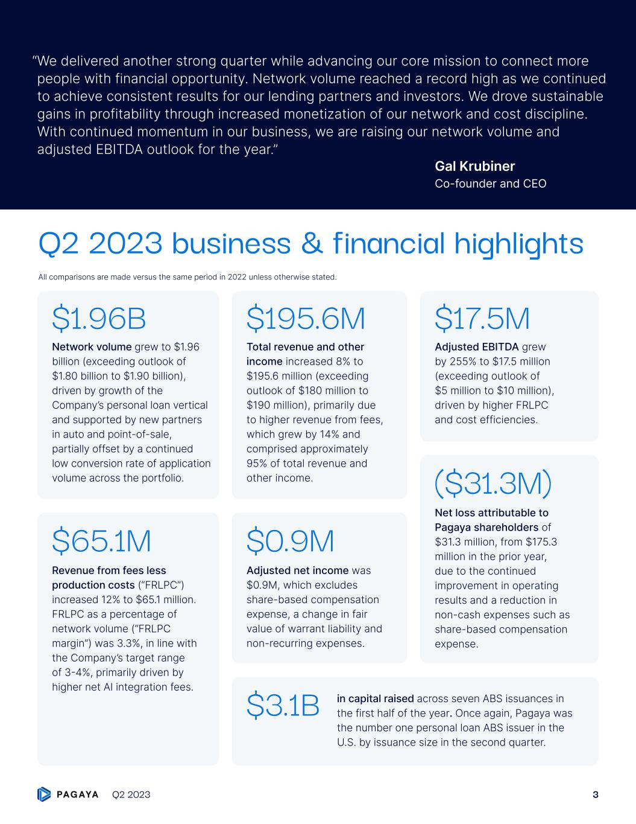
Total revenue and other income increased 8% to $195.6 million (exceeding outlook of $180 million to $190 million), primarily due to higher revenue from fees, which grew by 14% and comprised approximately 95% of total revenue and other income. $195.6M Network volume grew to $1.96 billion (exceeding outlook of $1.80 billion to $1.90 billion), driven by growth of the Company’s personal loan vertical and supported by new partners in auto and point-of-sale, partially offset by a continued low conversion rate of application volume across the portfolio. $1.96B Revenue from fees less production costs (“FRLPC”) increased 12% to $65.1 million. FRLPC as a percentage of network volume (“FRLPC margin”) was 3.3%, in line with the Company’s target range of 3-4%, primarily driven by higher net AI integration fees. $65.1M ($31.3M) Adjusted net income was $0.9M, which excludes share-based compensation expense, a change in fair value of warrant liability and non-recurring expenses. $0.9M Adjusted EBITDA grew by 255% to $17.5 million (exceeding outlook of $5 million to $10 million), driven by higher FRLPC and cost efficiencies. $17.5M in capital raised across seven ABS issuances in the first half of the year. Once again, Pagaya was the number one personal loan ABS issuer in the U.S. by issuance size in the second quarter. $3.1B Q2 2023 business & financial highlights “ We delivered another strong quarter while advancing our core mission to connect more people with financial opportunity. Network volume reached a record high as we continued to achieve consistent results for our lending partners and investors. We drove sustainable gains in profitability through increased monetization of our network and cost discipline. With continued momentum in our business, we are raising our network volume and adjusted EBITDA outlook for the year.” Gal Krubiner Co-founder and CEO All comparisons are made versus the same period in 2022 unless otherwise stated. Net loss attributable to Pagaya shareholders of $31.3 million, from $175.3 million in the prior year, due to the continued improvement in operating results and a reduction in non-cash expenses such as share-based compensation expense. Q2 2023 3

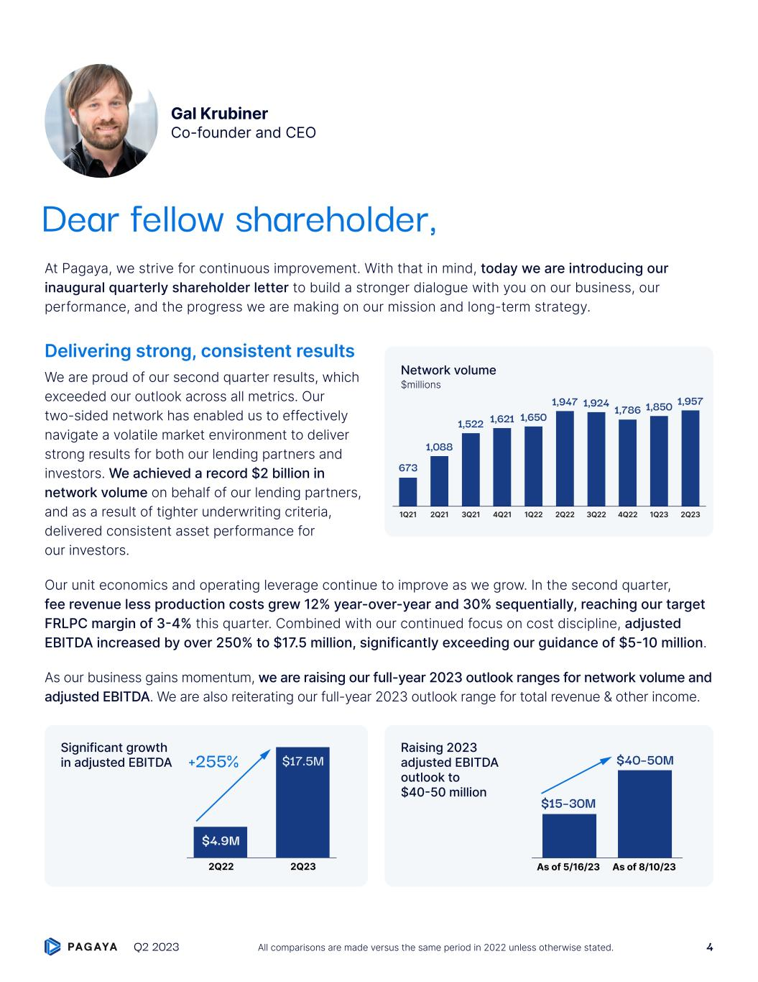
At Pagaya, we strive for continuous improvement. With that in mind, today we are introducing our inaugural quarterly shareholder letter to build a stronger dialogue with you on our business, our performance, and the progress we are making on our mission and long-term strategy. Delivering strong, consistent results We are proud of our second quarter results, which exceeded our outlook across all metrics. Our two-sided network has enabled us to effectively navigate a volatile market environment to deliver strong results for both our lending partners and investors. We achieved a record $2 billion in network volume on behalf of our lending partners, and as a result of tighter underwriting criteria, delivered consistent asset performance for our investors. Our unit economics and operating leverage continue to improve as we grow. In the second quarter, fee revenue less production costs grew 12% year-over-year and 30% sequentially, reaching our target FRLPC margin of 3-4% this quarter. Combined with our continued focus on cost discipline, adjusted EBITDA increased by over 250% to $17.5 million, significantly exceeding our guidance of $5-10 million. As our business gains momentum, we are raising our full-year 2023 outlook ranges for network volume and adjusted EBITDA. We are also reiterating our full-year 2023 outlook range for total revenue & other income. Gal Krubiner Co-founder and CEO $40–50M $15–30M As of 5/16/23 As of 8/10/23 Raising 2023 adjusted EBITDA outlook to $40-50 million Network volume $millions $17.5M+255% 2Q22 2Q23 $4.9M Significant growth in adjusted EBITDA Dear fellow shareholder, 1,947 1,6501,6211,522 1,088 673 1,924 1,786 1,850 1,957 2Q231Q21 2Q21 3Q21 4Q21 1Q22 2Q22 3Q22 4Q22 1Q23 Q2 2023 4All comparisons are made versus the same period in 2022 unless otherwise stated.

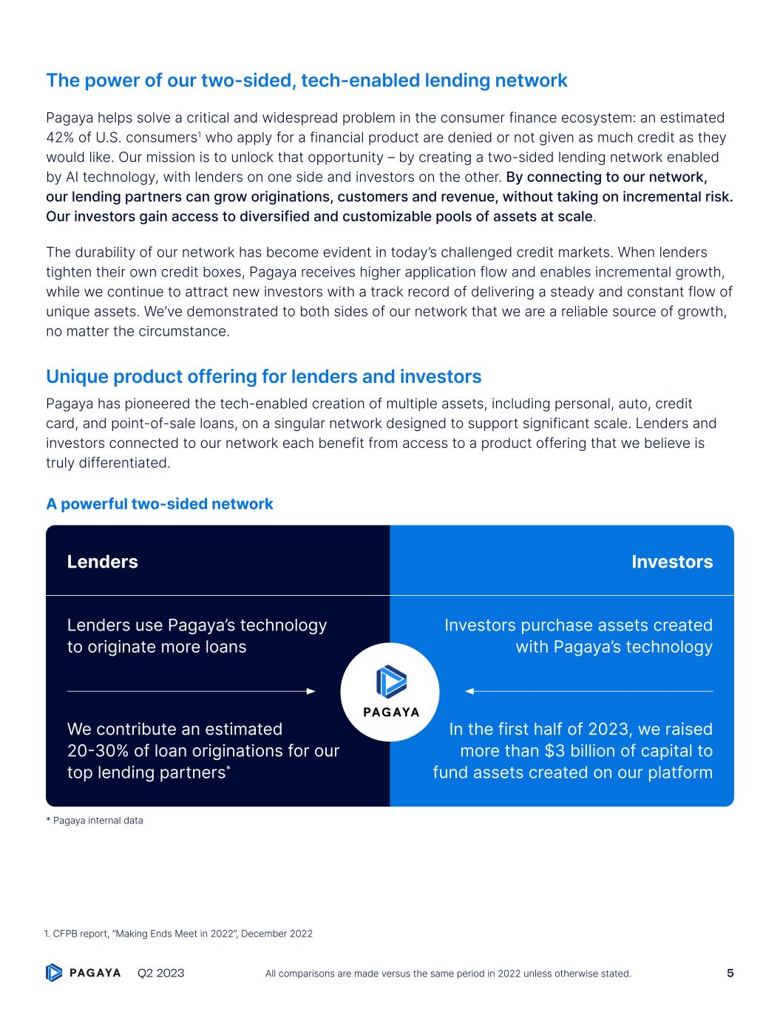
The power of our two-sided, tech-enabled lending network Pagaya helps solve a critical and widespread problem in the consumer finance ecosystem: an estimated 42% of U.S. consumers1 who apply for a financial product are denied or not given as much credit as they would like. Our mission is to unlock that opportunity – by creating a two-sided lending network enabled by AI technology, with lenders on one side and investors on the other. By connecting to our network, our lending partners can grow originations, customers and revenue, without taking on incremental risk. Our investors gain access to diversified and customizable pools of assets at scale. The durability of our network has become evident in today’s challenged credit markets. When lenders tighten their own credit boxes, Pagaya receives higher application flow and enables incremental growth, while we continue to attract new investors with a track record of delivering a steady and constant flow of unique assets. We’ve demonstrated to both sides of our network that we are a reliable source of growth, no matter the circumstance. Unique product offering for lenders and investors Pagaya has pioneered the tech-enabled creation of multiple assets, including personal, auto, credit card, and point-of-sale loans, on a singular network designed to support significant scale. Lenders and investors connected to our network each benefit from access to a product offering that we believe is truly differentiated. A powerful two-sided network Lenders use Pagaya’s technology to originate more loans Lenders Investors We contribute an estimated 20-30% of loan originations for our top lending partners* Investors purchase assets created with Pagaya’s technology In the first half of 2023, we raised more than $3 billion of capital to fund assets created on our platform * Pagaya internal data 1. CFPB report, “Making Ends Meet in 2022”, December 2022 Q2 2023 5All comparisons are made versus the same period in 2022 unless otherwise stated.

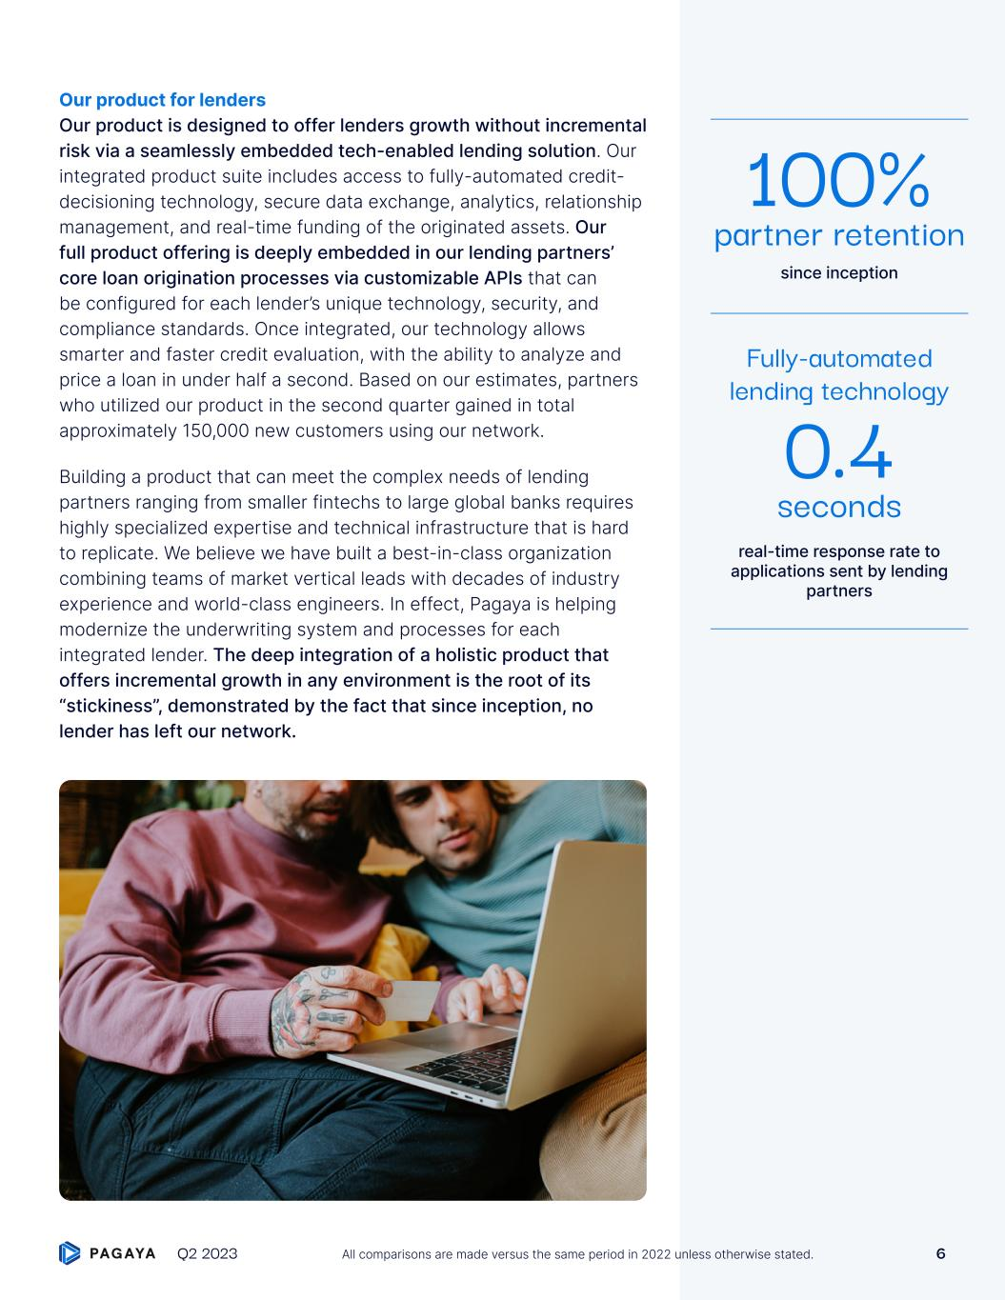
Our product for lenders Our product is designed to offer lenders growth without incremental risk via a seamlessly embedded tech-enabled lending solution. Our integrated product suite includes access to fully-automated credit- decisioning technology, secure data exchange, analytics, relationship management, and real-time funding of the originated assets. Our full product offering is deeply embedded in our lending partners’ core loan origination processes via customizable APIs that can be configured for each lender’s unique technology, security, and compliance standards. Once integrated, our technology allows smarter and faster credit evaluation, with the ability to analyze and price a loan in under half a second. Based on our estimates, partners who utilized our product in the second quarter gained in total approximately 150,000 new customers using our network. Building a product that can meet the complex needs of lending partners ranging from smaller fintechs to large global banks requires highly specialized expertise and technical infrastructure that is hard to replicate. We believe we have built a best-in-class organization combining teams of market vertical leads with decades of industry experience and world-class engineers. In effect, Pagaya is helping modernize the underwriting system and processes for each integrated lender. The deep integration of a holistic product that offers incremental growth in any environment is the root of its “stickiness”, demonstrated by the fact that since inception, no lender has left our network. since inception 100% partner retention real-time response rate to applications sent by lending partners Fully-automated lending technology 0.4 seconds Q2 2023 6All comparisons are made versus the same period in 2022 unless otherwise stated.

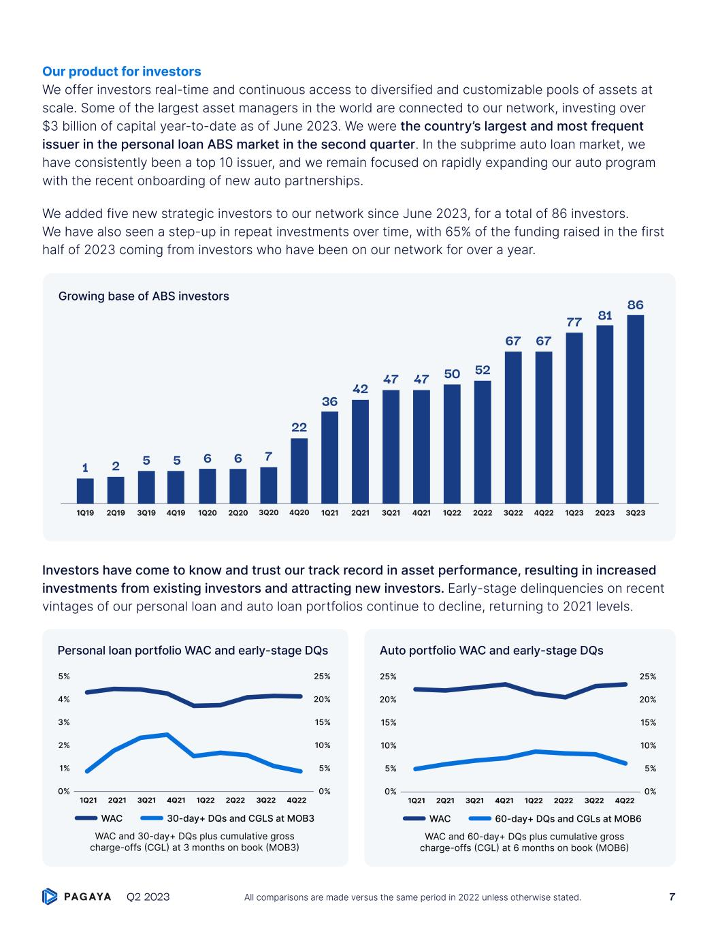
Our product for investors We offer investors real-time and continuous access to diversified and customizable pools of assets at scale. Some of the largest asset managers in the world are connected to our network, investing over $3 billion of capital year-to-date as of June 2023. We were the country’s largest and most frequent issuer in the personal loan ABS market in the second quarter. In the subprime auto loan market, we have consistently been a top 10 issuer, and we remain focused on rapidly expanding our auto program with the recent onboarding of new auto partnerships. We added five new strategic investors to our network since June 2023, for a total of 86 investors. We have also seen a step-up in repeat investments over time, with 65% of the funding raised in the first half of 2023 coming from investors who have been on our network for over a year. Investors have come to know and trust our track record in asset performance, resulting in increased investments from existing investors and attracting new investors. Early-stage delinquencies on recent vintages of our personal loan and auto loan portfolios continue to decline, returning to 2021 levels. 0% 1% 2% 3% 4% 5% 0% 5% 10% 15% 20% 25% WAC and 30-day+ DQs plus cumulative gross charge-offs (CGL) at 3 months on book (MOB3) WAC 30-day+ DQs and CGLS at MOB3 1Q21 2Q21 3Q21 4Q21 1Q22 2Q22 3Q22 4Q22 WAC 60-day+ DQs and CGLs at MOB6 1Q21 2Q21 3Q21 4Q21 1Q22 2Q22 3Q22 4Q22 0% 5% 10% 15% 20% 25% 0% 5% 10% 15% 20% 25% WAC and 60-day+ DQs plus cumulative gross charge-offs (CGL) at 6 months on book (MOB6) Auto portfolio WAC and early-stage DQsPersonal loan portfolio WAC and early-stage DQs Growing base of ABS investors 42 2Q21 86 3Q23 81 2Q23 77 1Q23 67 4Q22 67 3Q22 52 2Q22 50 1Q22 47 4Q21 47 3Q21 1 1Q19 2 2Q19 5 3Q19 5 4Q19 6 1Q20 6 2Q20 7 3Q20 22 4Q20 36 1Q21 Q2 2023 7All comparisons are made versus the same period in 2022 unless otherwise stated.


Our flywheel: the growing data advantage enabled by our network The strength of our network is rooted in what we believe are unrivaled data insights into the behavior of the U.S. consumer. The integration of 25+ lenders allows Pagaya to see more flow than traditional scoring models, enabling more timely and in-depth insights that inform our credit decisioning technology. Hundreds of millions of data points harvested from our proprietary flow and production, combined with access to all publicly available FCRA-compliant data, inform our AI models. Since inception, our network has evaluated approximately $1.5 trillion of loan applications. The wealth of data that is continuously being generated every day on our network drives our ability to continuously innovate, improve and expand: • We attract new lending partners and deepen current lending partner relationships by delivering incremental growth in originations and revenue; • Over time and with increasing scale, our performance continuously improves and expands our set of customized investment offerings, attracting more capital from both existing and new investors; • This, in turn, further strengthens our data advantage. sent to our network daily via API from our lending partners >100 million data points loan applications evaluated by our network since inception $1.5 trillion Q2 2023 8All comparisons are made versus the same period in 2022 unless otherwise stated.

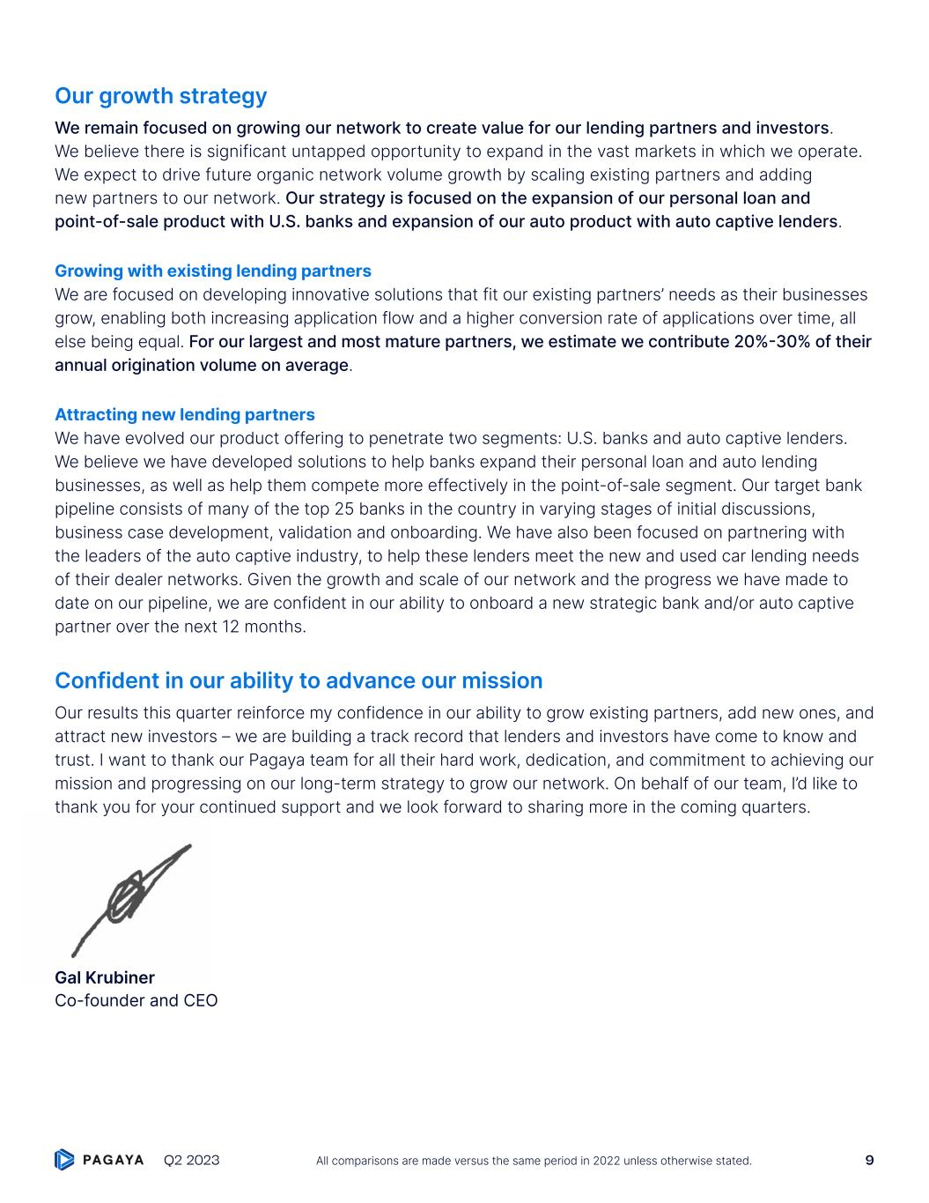
Our growth strategy We remain focused on growing our network to create value for our lending partners and investors. We believe there is significant untapped opportunity to expand in the vast markets in which we operate. We expect to drive future organic network volume growth by scaling existing partners and adding new partners to our network. Our strategy is focused on the expansion of our personal loan and point-of-sale product with U.S. banks and expansion of our auto product with auto captive lenders. Growing with existing lending partners We are focused on developing innovative solutions that fit our existing partners’ needs as their businesses grow, enabling both increasing application flow and a higher conversion rate of applications over time, all else being equal. For our largest and most mature partners, we estimate we contribute 20%-30% of their annual origination volume on average. Attracting new lending partners We have evolved our product offering to penetrate two segments: U.S. banks and auto captive lenders. We believe we have developed solutions to help banks expand their personal loan and auto lending businesses, as well as help them compete more effectively in the point-of-sale segment. Our target bank pipeline consists of many of the top 25 banks in the country in varying stages of initial discussions, business case development, validation and onboarding. We have also been focused on partnering with the leaders of the auto captive industry, to help these lenders meet the new and used car lending needs of their dealer networks. Given the growth and scale of our network and the progress we have made to date on our pipeline, we are confident in our ability to onboard a new strategic bank and/or auto captive partner over the next 12 months. Confident in our ability to advance our mission Our results this quarter reinforce my confidence in our ability to grow existing partners, add new ones, and attract new investors – we are building a track record that lenders and investors have come to know and trust. I want to thank our Pagaya team for all their hard work, dedication, and commitment to achieving our mission and progressing on our long-term strategy to grow our network. On behalf of our team, I’d like to thank you for your continued support and we look forward to sharing more in the coming quarters. Gal Krubiner Co-founder and CEO Q2 2023 9All comparisons are made versus the same period in 2022 unless otherwise stated.

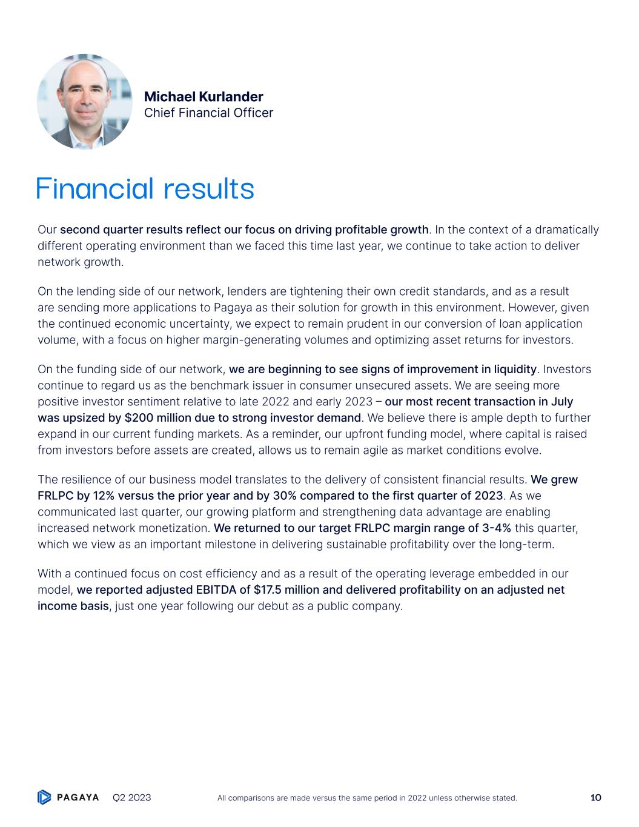
Our second quarter results reflect our focus on driving profitable growth. In the context of a dramatically different operating environment than we faced this time last year, we continue to take action to deliver network growth. On the lending side of our network, lenders are tightening their own credit standards, and as a result are sending more applications to Pagaya as their solution for growth in this environment. However, given the continued economic uncertainty, we expect to remain prudent in our conversion of loan application volume, with a focus on higher margin-generating volumes and optimizing asset returns for investors. On the funding side of our network, we are beginning to see signs of improvement in liquidity. Investors continue to regard us as the benchmark issuer in consumer unsecured assets. We are seeing more positive investor sentiment relative to late 2022 and early 2023 – our most recent transaction in July was upsized by $200 million due to strong investor demand. We believe there is ample depth to further expand in our current funding markets. As a reminder, our upfront funding model, where capital is raised from investors before assets are created, allows us to remain agile as market conditions evolve. The resilience of our business model translates to the delivery of consistent financial results. We grew FRLPC by 12% versus the prior year and by 30% compared to the first quarter of 2023. As we communicated last quarter, our growing platform and strengthening data advantage are enabling increased network monetization. We returned to our target FRLPC margin range of 3-4% this quarter, which we view as an important milestone in delivering sustainable profitability over the long-term. With a continued focus on cost efficiency and as a result of the operating leverage embedded in our model, we reported adjusted EBITDA of $17.5 million and delivered profitability on an adjusted net income basis, just one year following our debut as a public company. Michael Kurlander Chief Financial Officer Financial results Q2 2023 10All comparisons are made versus the same period in 2022 unless otherwise stated.

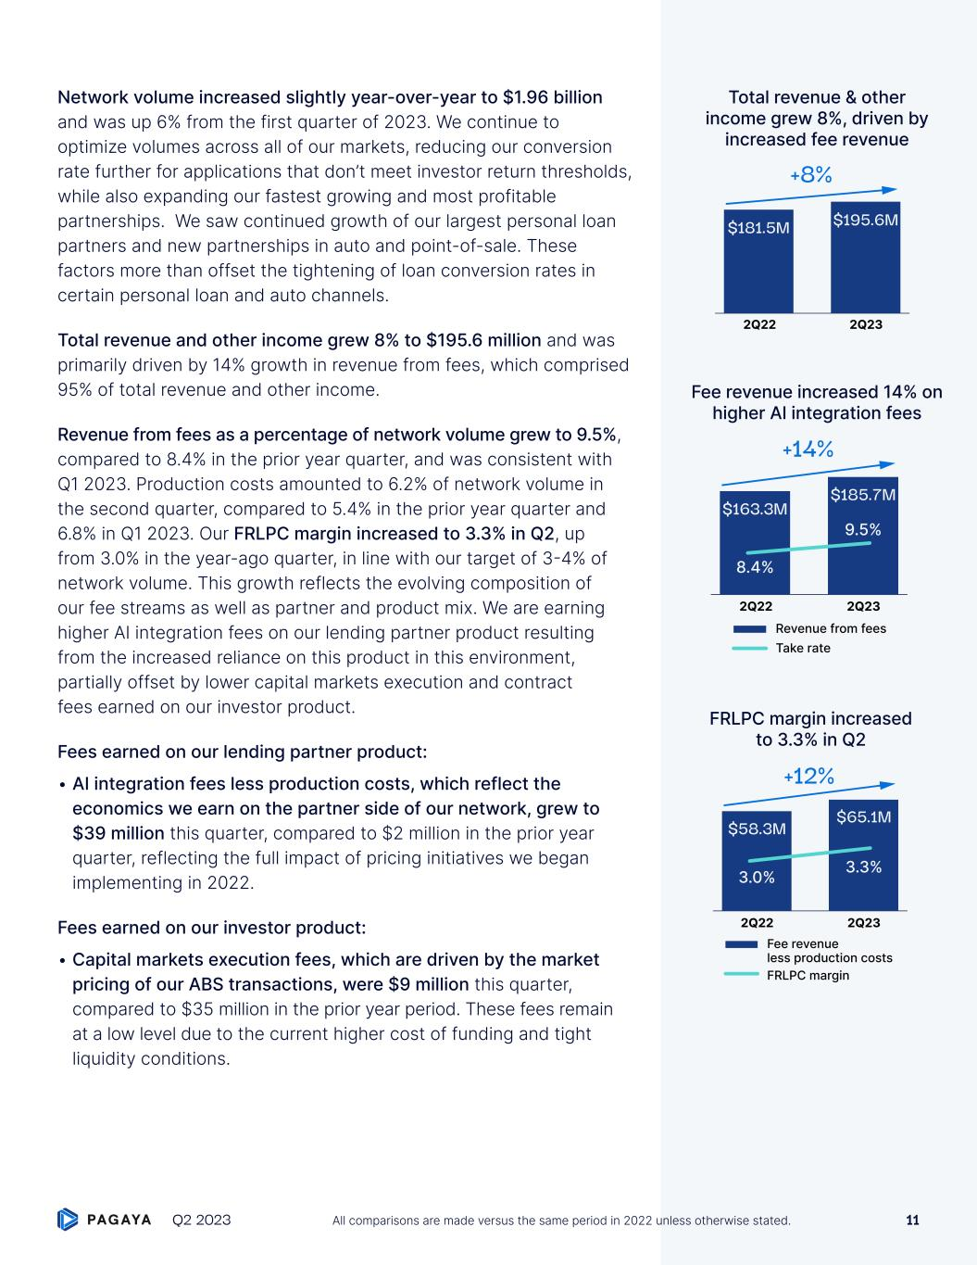
Network volume increased slightly year-over-year to $1.96 billion and was up 6% from the first quarter of 2023. We continue to optimize volumes across all of our markets, reducing our conversion rate further for applications that don’t meet investor return thresholds, while also expanding our fastest growing and most profitable partnerships. We saw continued growth of our largest personal loan partners and new partnerships in auto and point-of-sale. These factors more than offset the tightening of loan conversion rates in certain personal loan and auto channels. Total revenue and other income grew 8% to $195.6 million and was primarily driven by 14% growth in revenue from fees, which comprised 95% of total revenue and other income. Revenue from fees as a percentage of network volume grew to 9.5%, compared to 8.4% in the prior year quarter, and was consistent with Q1 2023. Production costs amounted to 6.2% of network volume in the second quarter, compared to 5.4% in the prior year quarter and 6.8% in Q1 2023. Our FRLPC margin increased to 3.3% in Q2, up from 3.0% in the year-ago quarter, in line with our target of 3-4% of network volume. This growth reflects the evolving composition of our fee streams as well as partner and product mix. We are earning higher AI integration fees on our lending partner product resulting from the increased reliance on this product in this environment, partially offset by lower capital markets execution and contract fees earned on our investor product. Fees earned on our lending partner product: • AI integration fees less production costs, which reflect the economics we earn on the partner side of our network, grew to $39 million this quarter, compared to $2 million in the prior year quarter, reflecting the full impact of pricing initiatives we began implementing in 2022. Fees earned on our investor product: • Capital markets execution fees, which are driven by the market pricing of our ABS transactions, were $9 million this quarter, compared to $35 million in the prior year period. These fees remain at a low level due to the current higher cost of funding and tight liquidity conditions. $163.3M $185.7M +14% 2Q22 2Q23 Revenue from fees Take rate 8.4% 9.5% Fee revenue increased 14% on higher AI integration fees Total revenue & other income grew 8%, driven by increased fee revenue $181.5M $195.6M +8% 2Q22 2Q23 2Q22 2Q23 $58.3M $65.1M 3.0% 3.3% +12% Fee revenue less production costs FRLPC margin FRLPC margin increased to 3.3% in Q2 Q2 2023 11All comparisons are made versus the same period in 2022 unless otherwise stated.

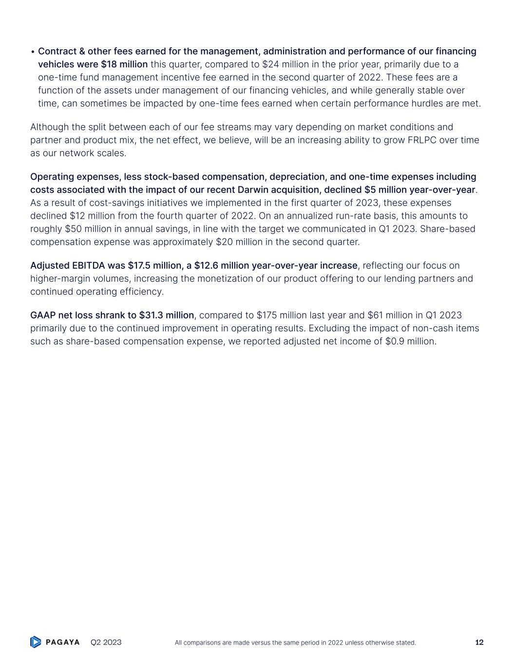
• Contract & other fees earned for the management, administration and performance of our financing vehicles were $18 million this quarter, compared to $24 million in the prior year, primarily due to a one-time fund management incentive fee earned in the second quarter of 2022. These fees are a function of the assets under management of our financing vehicles, and while generally stable over time, can sometimes be impacted by one-time fees earned when certain performance hurdles are met. Although the split between each of our fee streams may vary depending on market conditions and partner and product mix, the net effect, we believe, will be an increasing ability to grow FRLPC over time as our network scales. Operating expenses, less stock-based compensation, depreciation, and one-time expenses including costs associated with the impact of our recent Darwin acquisition, declined $5 million year-over-year. As a result of cost-savings initiatives we implemented in the first quarter of 2023, these expenses declined $12 million from the fourth quarter of 2022. On an annualized run-rate basis, this amounts to roughly $50 million in annual savings, in line with the target we communicated in Q1 2023. Share-based compensation expense was approximately $20 million in the second quarter. Adjusted EBITDA was $17.5 million, a $12.6 million year-over-year increase, reflecting our focus on higher-margin volumes, increasing the monetization of our product offering to our lending partners and continued operating efficiency. GAAP net loss shrank to $31.3 million, compared to $175 million last year and $61 million in Q1 2023 primarily due to the continued improvement in operating results. Excluding the impact of non-cash items such as share-based compensation expense, we reported adjusted net income of $0.9 million. Q2 2023 12All comparisons are made versus the same period in 2022 unless otherwise stated.

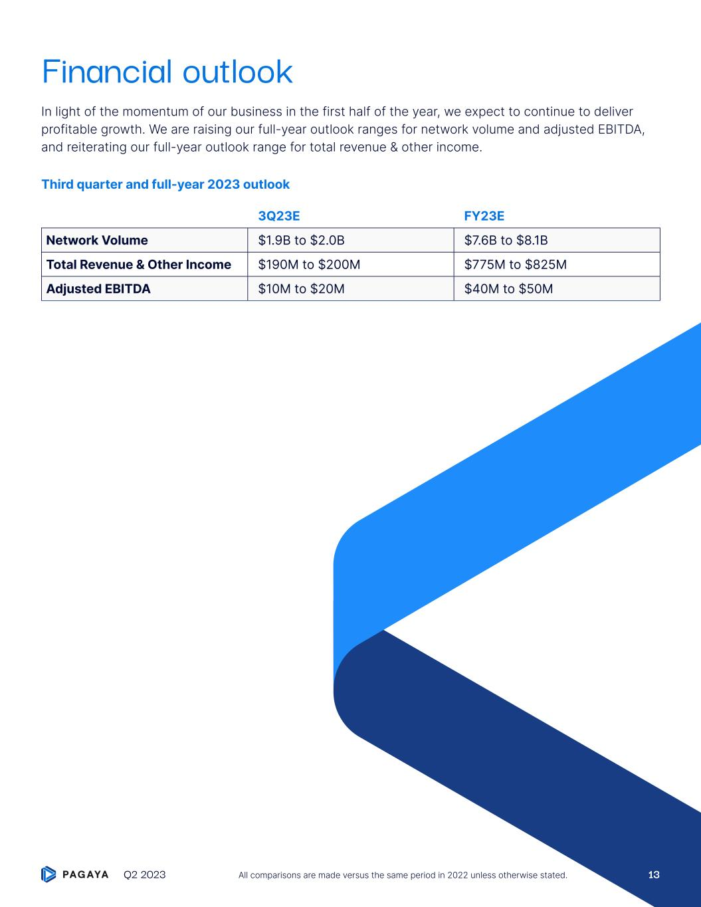
Financial outlook In light of the momentum of our business in the first half of the year, we expect to continue to deliver profitable growth. We are raising our full-year outlook ranges for network volume and adjusted EBITDA, and reiterating our full-year outlook range for total revenue & other income. Third quarter and full-year 2023 outlook 3Q23E FY23E Network Volume $1.9B to $2.0B $7.6B to $8.1B Total Revenue & Other Income $190M to $200M $775M to $825M Adjusted EBITDA $10M to $20M $40M to $50M Q2 2023 All comparisons are made versus the same period in 2022 unless otherwise stated. 13

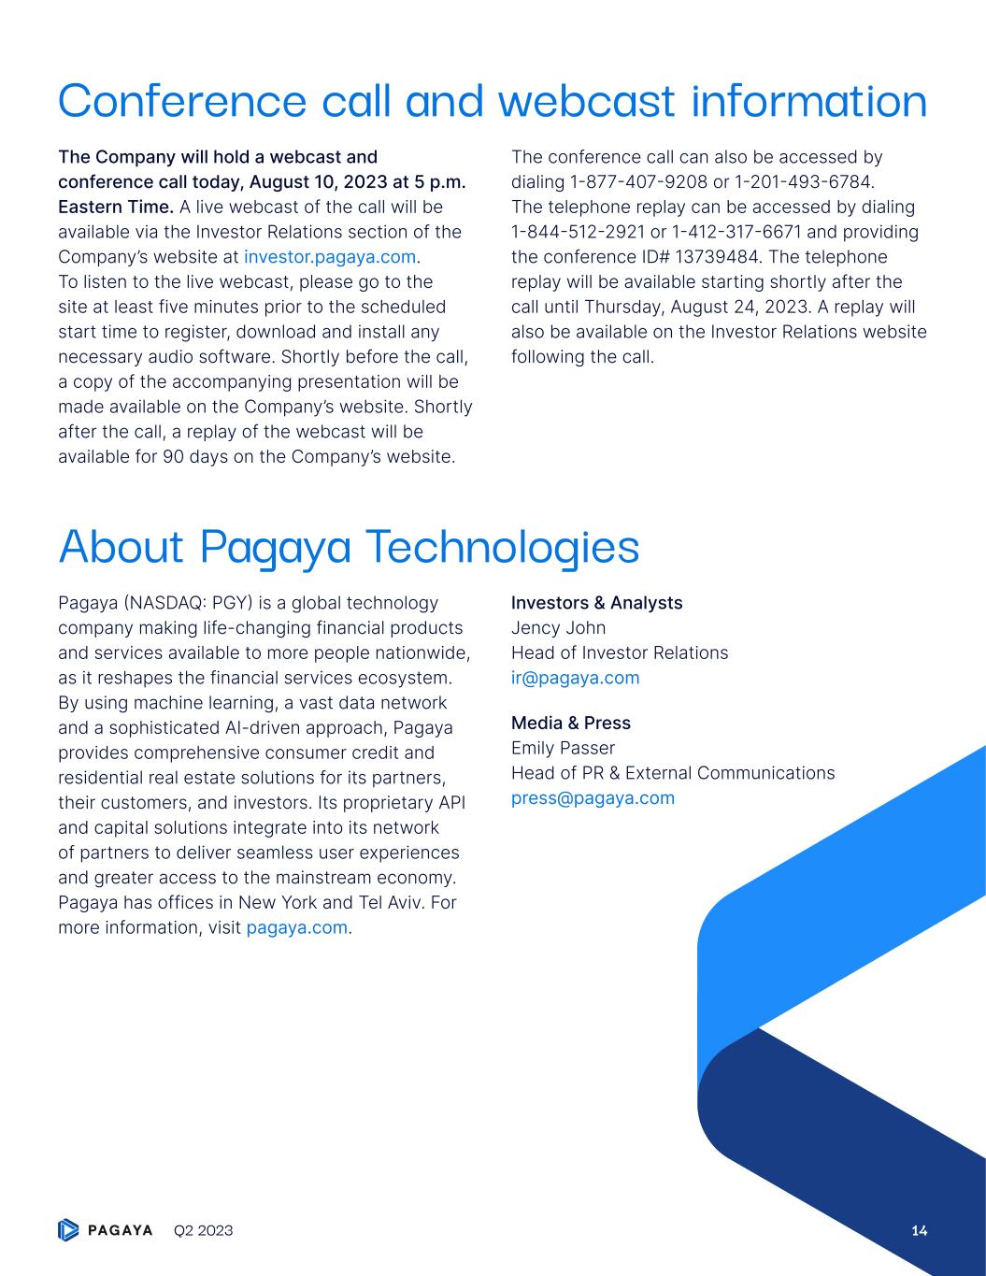
Conference call and webcast information The Company will hold a webcast and conference call today, August 10, 2023 at 5 p.m. Eastern Time. A live webcast of the call will be available via the Investor Relations section of the Company’s website at investor.pagaya.com. To listen to the live webcast, please go to the site at least five minutes prior to the scheduled start time to register, download and install any necessary audio software. Shortly before the call, a copy of the accompanying presentation will be made available on the Company’s website. Shortly after the call, a replay of the webcast will be available for 90 days on the Company’s website. The conference call can also be accessed by dialing 1-877-407-9208 or 1-201-493-6784. The telephone replay can be accessed by dialing 1-844-512-2921 or 1-412-317-6671 and providing the conference ID# 13739484. The telephone replay will be available starting shortly after the call until Thursday, August 24, 2023. A replay will also be available on the Investor Relations website following the call. About Pagaya Technologies Pagaya (NASDAQ: PGY) is a global technology company making life-changing financial products and services available to more people nationwide, as it reshapes the financial services ecosystem. By using machine learning, a vast data network and a sophisticated AI-driven approach, Pagaya provides comprehensive consumer credit and residential real estate solutions for its partners, their customers, and investors. Its proprietary API and capital solutions integrate into its network of partners to deliver seamless user experiences and greater access to the mainstream economy. Pagaya has offices in New York and Tel Aviv. For more information, visit pagaya.com. Investors & Analysts Jency John Head of Investor Relations ir@pagaya.com Media & Press Emily Passer Head of PR & External Communications press@pagaya.com Q2 2023 14

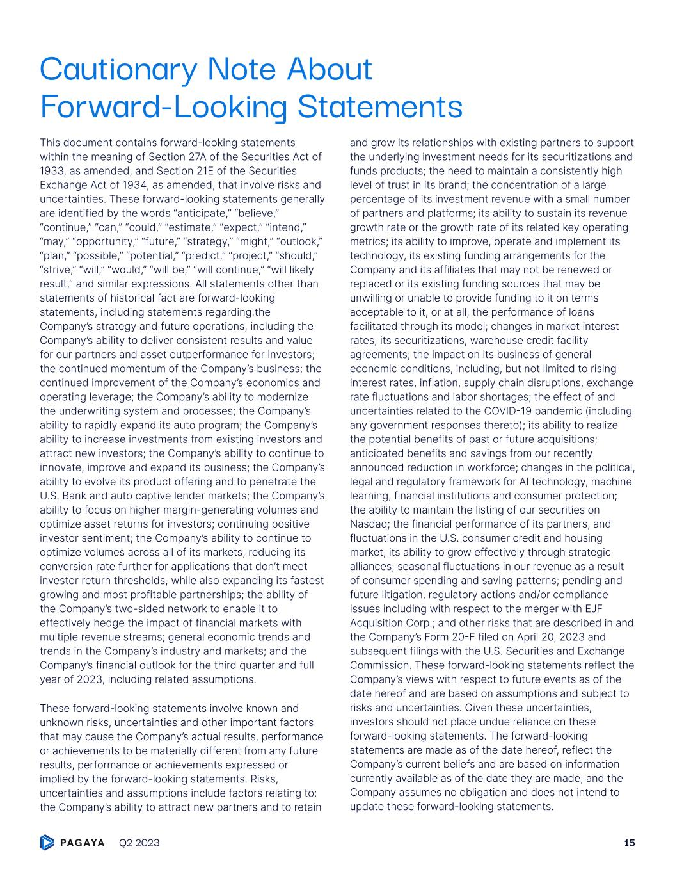
Cautionary Note About Forward-Looking Statements This document contains forward-looking statements within the meaning of Section 27A of the Securities Act of 1933, as amended, and Section 21E of the Securities Exchange Act of 1934, as amended, that involve risks and uncertainties. These forward-looking statements generally are identified by the words “anticipate,” “believe,” “continue,” “can,” “could,” “estimate,” “expect,” “intend,” “may,” “opportunity,” “future,” “strategy,” “might,” “outlook,” “plan,” “possible,” “potential,” “predict,” “project,” “should,” “strive,” “will,” “would,” “will be,” “will continue,” “will likely result,” and similar expressions. All statements other than statements of historical fact are forward-looking statements, including statements regarding:the Company’s strategy and future operations, including the Company’s ability to deliver consistent results and value for our partners and asset outperformance for investors; the continued momentum of the Company’s business; the continued improvement of the Company’s economics and operating leverage; the Company’s ability to modernize the underwriting system and processes; the Company’s ability to rapidly expand its auto program; the Company’s ability to increase investments from existing investors and attract new investors; the Company’s ability to continue to innovate, improve and expand its business; the Company’s ability to evolve its product offering and to penetrate the U.S. Bank and auto captive lender markets; the Company’s ability to focus on higher margin-generating volumes and optimize asset returns for investors; continuing positive investor sentiment; the Company’s ability to continue to optimize volumes across all of its markets, reducing its conversion rate further for applications that don’t meet investor return thresholds, while also expanding its fastest growing and most profitable partnerships; the ability of the Company’s two-sided network to enable it to effectively hedge the impact of financial markets with multiple revenue streams; general economic trends and trends in the Company’s industry and markets; and the Company’s financial outlook for the third quarter and full year of 2023, including related assumptions. These forward-looking statements involve known and unknown risks, uncertainties and other important factors that may cause the Company’s actual results, performance or achievements to be materially different from any future results, performance or achievements expressed or implied by the forward-looking statements. Risks, uncertainties and assumptions include factors relating to: the Company’s ability to attract new partners and to retain and grow its relationships with existing partners to support the underlying investment needs for its securitizations and funds products; the need to maintain a consistently high level of trust in its brand; the concentration of a large percentage of its investment revenue with a small number of partners and platforms; its ability to sustain its revenue growth rate or the growth rate of its related key operating metrics; its ability to improve, operate and implement its technology, its existing funding arrangements for the Company and its affiliates that may not be renewed or replaced or its existing funding sources that may be unwilling or unable to provide funding to it on terms acceptable to it, or at all; the performance of loans facilitated through its model; changes in market interest rates; its securitizations, warehouse credit facility agreements; the impact on its business of general economic conditions, including, but not limited to rising interest rates, inflation, supply chain disruptions, exchange rate fluctuations and labor shortages; the effect of and uncertainties related to the COVID-19 pandemic (including any government responses thereto); its ability to realize the potential benefits of past or future acquisitions; anticipated benefits and savings from our recently announced reduction in workforce; changes in the political, legal and regulatory framework for AI technology, machine learning, financial institutions and consumer protection; the ability to maintain the listing of our securities on Nasdaq; the financial performance of its partners, and fluctuations in the U.S. consumer credit and housing market; its ability to grow effectively through strategic alliances; seasonal fluctuations in our revenue as a result of consumer spending and saving patterns; pending and future litigation, regulatory actions and/or compliance issues including with respect to the merger with EJF Acquisition Corp.; and other risks that are described in and the Company’s Form 20-F filed on April 20, 2023 and subsequent filings with the U.S. Securities and Exchange Commission. These forward-looking statements reflect the Company’s views with respect to future events as of the date hereof and are based on assumptions and subject to risks and uncertainties. Given these uncertainties, investors should not place undue reliance on these forward-looking statements. The forward-looking statements are made as of the date hereof, reflect the Company’s current beliefs and are based on information currently available as of the date they are made, and the Company assumes no obligation and does not intend to update these forward-looking statements. Q2 2023 15

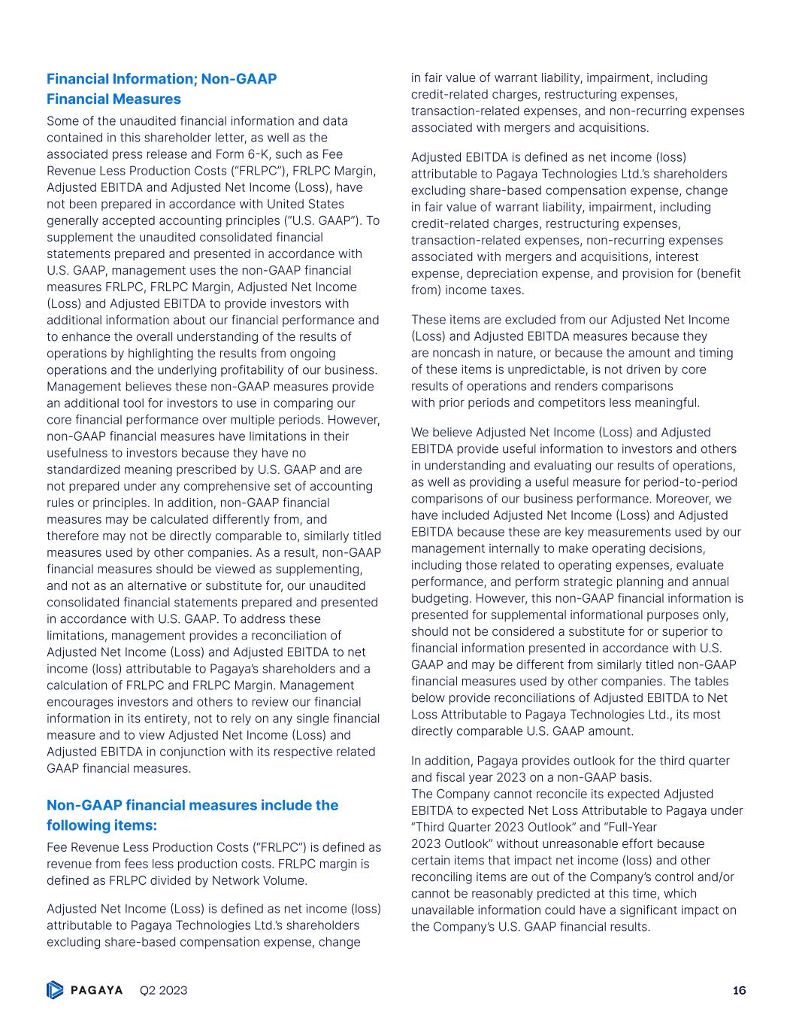
Financial Information; Non-GAAP Financial Measures Some of the unaudited financial information and data contained in this shareholder letter, as well as the associated press release and Form 6-K, such as Fee Revenue Less Production Costs (“FRLPC”), FRLPC Margin, Adjusted EBITDA and Adjusted Net Income (Loss), have not been prepared in accordance with United States generally accepted accounting principles (“U.S. GAAP”). To supplement the unaudited consolidated financial statements prepared and presented in accordance with U.S. GAAP, management uses the non-GAAP financial measures FRLPC, FRLPC Margin, Adjusted Net Income (Loss) and Adjusted EBITDA to provide investors with additional information about our financial performance and to enhance the overall understanding of the results of operations by highlighting the results from ongoing operations and the underlying profitability of our business. Management believes these non-GAAP measures provide an additional tool for investors to use in comparing our core financial performance over multiple periods. However, non-GAAP financial measures have limitations in their usefulness to investors because they have no standardized meaning prescribed by U.S. GAAP and are not prepared under any comprehensive set of accounting rules or principles. In addition, non-GAAP financial measures may be calculated differently from, and therefore may not be directly comparable to, similarly titled measures used by other companies. As a result, non-GAAP financial measures should be viewed as supplementing, and not as an alternative or substitute for, our unaudited consolidated financial statements prepared and presented in accordance with U.S. GAAP. To address these limitations, management provides a reconciliation of Adjusted Net Income (Loss) and Adjusted EBITDA to net income (loss) attributable to Pagaya’s shareholders and a calculation of FRLPC and FRLPC Margin. Management encourages investors and others to review our financial information in its entirety, not to rely on any single financial measure and to view Adjusted Net Income (Loss) and Adjusted EBITDA in conjunction with its respective related GAAP financial measures. Non-GAAP financial measures include the following items: Fee Revenue Less Production Costs (“FRLPC”) is defined as revenue from fees less production costs. FRLPC margin is defined as FRLPC divided by Network Volume. Adjusted Net Income (Loss) is defined as net income (loss) attributable to Pagaya Technologies Ltd.’s shareholders excluding share-based compensation expense, change in fair value of warrant liability, impairment, including credit-related charges, restructuring expenses, transaction-related expenses, and non-recurring expenses associated with mergers and acquisitions. Adjusted EBITDA is defined as net income (loss) attributable to Pagaya Technologies Ltd.’s shareholders excluding share-based compensation expense, change in fair value of warrant liability, impairment, including credit-related charges, restructuring expenses, transaction-related expenses, non-recurring expenses associated with mergers and acquisitions, interest expense, depreciation expense, and provision for (benefit from) income taxes. These items are excluded from our Adjusted Net Income (Loss) and Adjusted EBITDA measures because they are noncash in nature, or because the amount and timing of these items is unpredictable, is not driven by core results of operations and renders comparisons with prior periods and competitors less meaningful. We believe Adjusted Net Income (Loss) and Adjusted EBITDA provide useful information to investors and others in understanding and evaluating our results of operations, as well as providing a useful measure for period-to-period comparisons of our business performance. Moreover, we have included Adjusted Net Income (Loss) and Adjusted EBITDA because these are key measurements used by our management internally to make operating decisions, including those related to operating expenses, evaluate performance, and perform strategic planning and annual budgeting. However, this non-GAAP financial information is presented for supplemental informational purposes only, should not be considered a substitute for or superior to financial information presented in accordance with U.S. GAAP and may be different from similarly titled non-GAAP financial measures used by other companies. The tables below provide reconciliations of Adjusted EBITDA to Net Loss Attributable to Pagaya Technologies Ltd., its most directly comparable U.S. GAAP amount. In addition, Pagaya provides outlook for the third quarter and fiscal year 2023 on a non-GAAP basis. The Company cannot reconcile its expected Adjusted EBITDA to expected Net Loss Attributable to Pagaya under “Third Quarter 2023 Outlook” and “Full-Year 2023 Outlook” without unreasonable effort because certain items that impact net income (loss) and other reconciling items are out of the Company’s control and/or cannot be reasonably predicted at this time, which unavailable information could have a significant impact on the Company’s U.S. GAAP financial results. Q2 2023 16

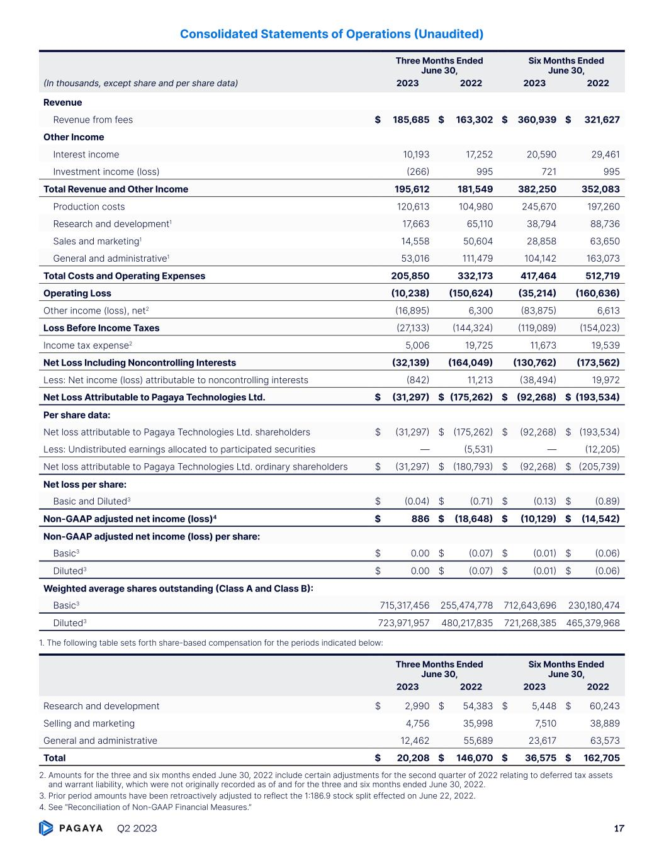
Consolidated Statements of Operations (Unaudited) Three Months Ended June 30, Six Months Ended June 30, (In thousands, except share and per share data) 2023 2022 2023 2022 Revenue Revenue from fees $ 185,685 $ 163,302 $ 360,939 $ 321,627 Other Income Interest income 10,193 17,252 20,590 29,461 Investment income (loss) (266) 995 721 995 Total Revenue and Other Income 195,612 181,549 382,250 352,083 Production costs 120,613 104,980 245,670 197,260 Research and development1 17,663 65,110 38,794 88,736 Sales and marketing1 14,558 50,604 28,858 63,650 General and administrative1 53,016 111,479 104,142 163,073 Total Costs and Operating Expenses 205,850 332,173 417,464 512,719 Operating Loss (10,238) (150,624) (35,214) (160,636) Other income (loss), net2 (16,895) 6,300 (83,875) 6,613 Loss Before Income Taxes (27,133) (144,324) (119,089) (154,023) Income tax expense2 5,006 19,725 11,673 19,539 Net Loss Including Noncontrolling Interests (32,139) (164,049) (130,762) (173,562) Less: Net income (loss) attributable to noncontrolling interests (842) 11,213 (38,494) 19,972 Net Loss Attributable to Pagaya Technologies Ltd. $ (31,297) $ (175,262) $ (92,268) $ (193,534) Per share data: Net loss attributable to Pagaya Technologies Ltd. shareholders $ (31,297) $ (175,262) $ (92,268) $ (193,534) Less: Undistributed earnings allocated to participated securities — (5,531) — (12,205) Net loss attributable to Pagaya Technologies Ltd. ordinary shareholders $ (31,297) $ (180,793) $ (92,268) $ (205,739) Net loss per share: Basic and Diluted3 $ (0.04) $ (0.71) $ (0.13) $ (0.89) Non-GAAP adjusted net income (loss)4 $ 886 $ (18,648) $ (10,129) $ (14,542) Non-GAAP adjusted net income (loss) per share: Basic3 $ 0.00 $ (0.07) $ (0.01) $ (0.06) Diluted3 $ 0.00 $ (0.07) $ (0.01) $ (0.06) Weighted average shares outstanding (Class A and Class B): Basic3 715,317,456 255,474,778 712,643,696 230,180,474 Diluted3 723,971,957 480,217,835 721,268,385 465,379,968 1. The following table sets forth share-based compensation for the periods indicated below: Three Months Ended June 30, Six Months Ended June 30, 2023 2022 2023 2022 Research and development $ 2,990 $ 54,383 $ 5,448 $ 60,243 Selling and marketing 4,756 35,998 7,510 38,889 General and administrative 12,462 55,689 23,617 63,573 Total $ 20,208 $ 146,070 $ 36,575 $ 162,705 2. Amounts for the three and six months ended June 30, 2022 include certain adjustments for the second quarter of 2022 relating to deferred tax assets and warrant liability, which were not originally recorded as of and for the three and six months ended June 30, 2022. 3. Prior period amounts have been retroactively adjusted to reflect the 1:186.9 stock split effected on June 22, 2022. 4. See “Reconciliation of Non-GAAP Financial Measures.” Q2 2023 17

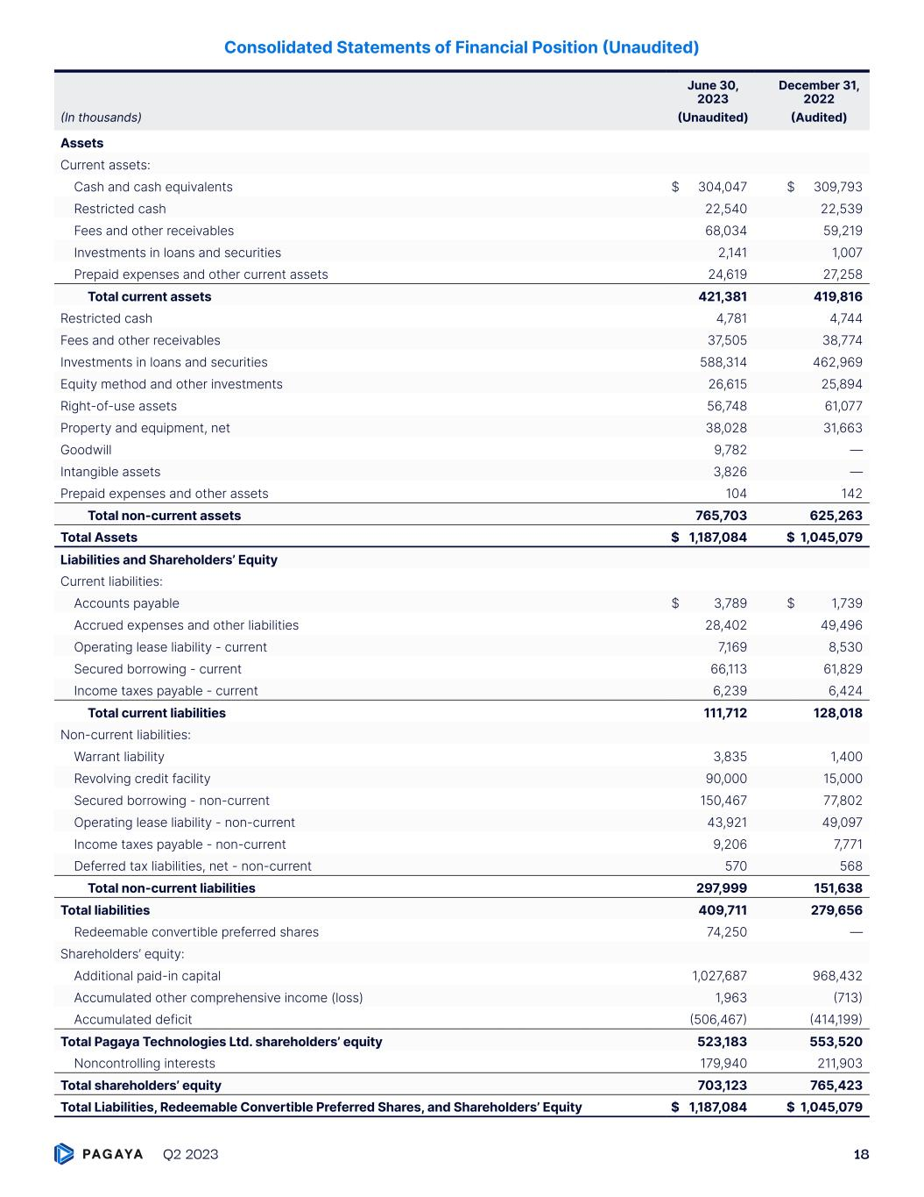
Consolidated Statements of Financial Position (Unaudited) June 30, 2023 December 31, 2022 (In thousands) (Unaudited) (Audited) Assets Current assets: Cash and cash equivalents $ 304,047 $ 309,793 Restricted cash 22,540 22,539 Fees and other receivables 68,034 59,219 Investments in loans and securities 2,141 1,007 Prepaid expenses and other current assets 24,619 27,258 Total current assets 421,381 419,816 Restricted cash 4,781 4,744 Fees and other receivables 37,505 38,774 Investments in loans and securities 588,314 462,969 Equity method and other investments 26,615 25,894 Right-of-use assets 56,748 61,077 Property and equipment, net 38,028 31,663 Goodwill 9,782 — Intangible assets 3,826 — Prepaid expenses and other assets 104 142 Total non-current assets 765,703 625,263 Total Assets $ 1,187,084 $ 1,045,079 Liabilities and Shareholders’ Equity Current liabilities: Accounts payable $ 3,789 $ 1,739 Accrued expenses and other liabilities 28,402 49,496 Operating lease liability - current 7,169 8,530 Secured borrowing - current 66,113 61,829 Income taxes payable - current 6,239 6,424 Total current liabilities 111,712 128,018 Non-current liabilities: Warrant liability 3,835 1,400 Revolving credit facility 90,000 15,000 Secured borrowing - non-current 150,467 77,802 Operating lease liability - non-current 43,921 49,097 Income taxes payable - non-current 9,206 7,771 Deferred tax liabilities, net - non-current 570 568 Total non-current liabilities 297,999 151,638 Total liabilities 409,711 279,656 Redeemable convertible preferred shares 74,250 — Shareholders’ equity: Additional paid-in capital 1,027,687 968,432 Accumulated other comprehensive income (loss) 1,963 (713) Accumulated deficit (506,467) (414,199) Total Pagaya Technologies Ltd. shareholders’ equity 523,183 553,520 Noncontrolling interests 179,940 211,903 Total shareholders’ equity 703,123 765,423 Total Liabilities, Redeemable Convertible Preferred Shares, and Shareholders’ Equity $ 1,187,084 $ 1,045,079 Q2 2023 18

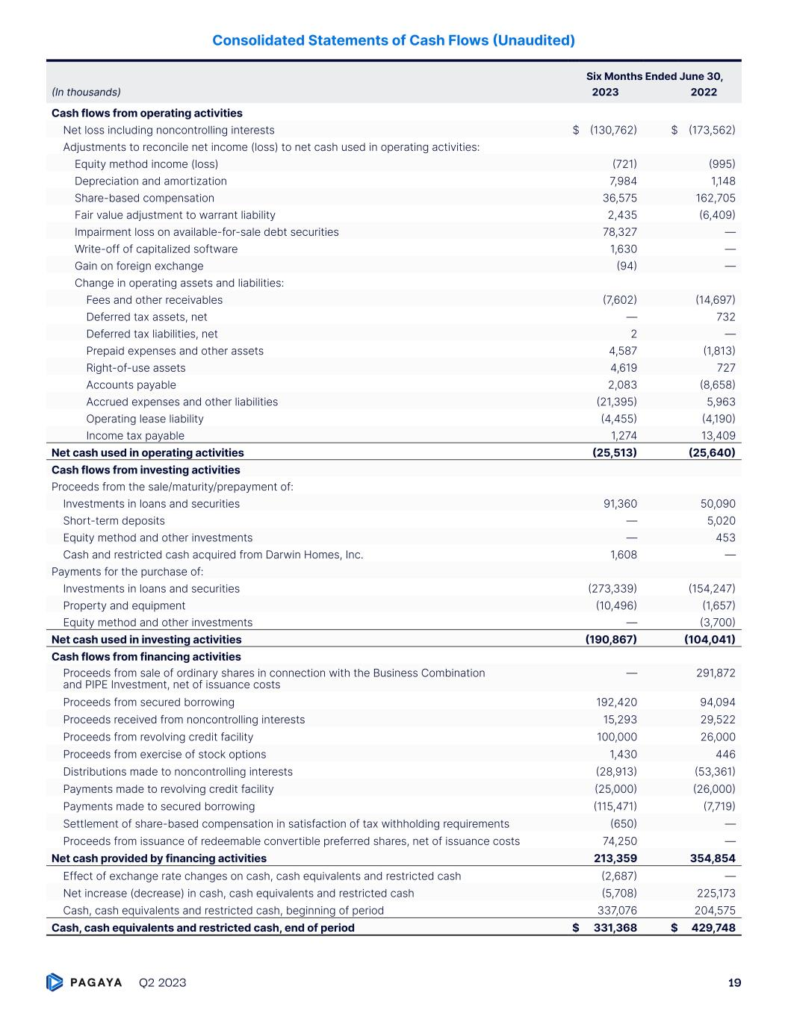
Consolidated Statements of Cash Flows (Unaudited) Six Months Ended June 30, (In thousands) 2023 2022 Cash flows from operating activities Net loss including noncontrolling interests $ (130,762) $ (173,562) Adjustments to reconcile net income (loss) to net cash used in operating activities: Equity method income (loss) (721) (995) Depreciation and amortization 7,984 1,148 Share-based compensation 36,575 162,705 Fair value adjustment to warrant liability 2,435 (6,409) Impairment loss on available-for-sale debt securities 78,327 — Write-off of capitalized software 1,630 — Gain on foreign exchange (94) — Change in operating assets and liabilities: Fees and other receivables (7,602) (14,697) Deferred tax assets, net — 732 Deferred tax liabilities, net 2 — Prepaid expenses and other assets 4,587 (1,813) Right-of-use assets 4,619 727 Accounts payable 2,083 (8,658) Accrued expenses and other liabilities (21,395) 5,963 Operating lease liability (4,455) (4,190) Income tax payable 1,274 13,409 Net cash used in operating activities (25,513) (25,640) Cash flows from investing activities Proceeds from the sale/maturity/prepayment of: Investments in loans and securities 91,360 50,090 Short-term deposits — 5,020 Equity method and other investments — 453 Cash and restricted cash acquired from Darwin Homes, Inc. 1,608 — Payments for the purchase of: Investments in loans and securities (273,339) (154,247) Property and equipment (10,496) (1,657) Equity method and other investments — (3,700) Net cash used in investing activities (190,867) (104,041) Cash flows from financing activities Proceeds from sale of ordinary shares in connection with the Business Combination and PIPE Investment, net of issuance costs — 291,872 Proceeds from secured borrowing 192,420 94,094 Proceeds received from noncontrolling interests 15,293 29,522 Proceeds from revolving credit facility 100,000 26,000 Proceeds from exercise of stock options 1,430 446 Distributions made to noncontrolling interests (28,913) (53,361) Payments made to revolving credit facility (25,000) (26,000) Payments made to secured borrowing (115,471) (7,719) Settlement of share-based compensation in satisfaction of tax withholding requirements (650) — Proceeds from issuance of redeemable convertible preferred shares, net of issuance costs 74,250 — Net cash provided by financing activities 213,359 354,854 Effect of exchange rate changes on cash, cash equivalents and restricted cash (2,687) — Net increase (decrease) in cash, cash equivalents and restricted cash (5,708) 225,173 Cash, cash equivalents and restricted cash, beginning of period 337,076 204,575 Cash, cash equivalents and restricted cash, end of period $ 331,368 $ 429,748 Q2 2023 19

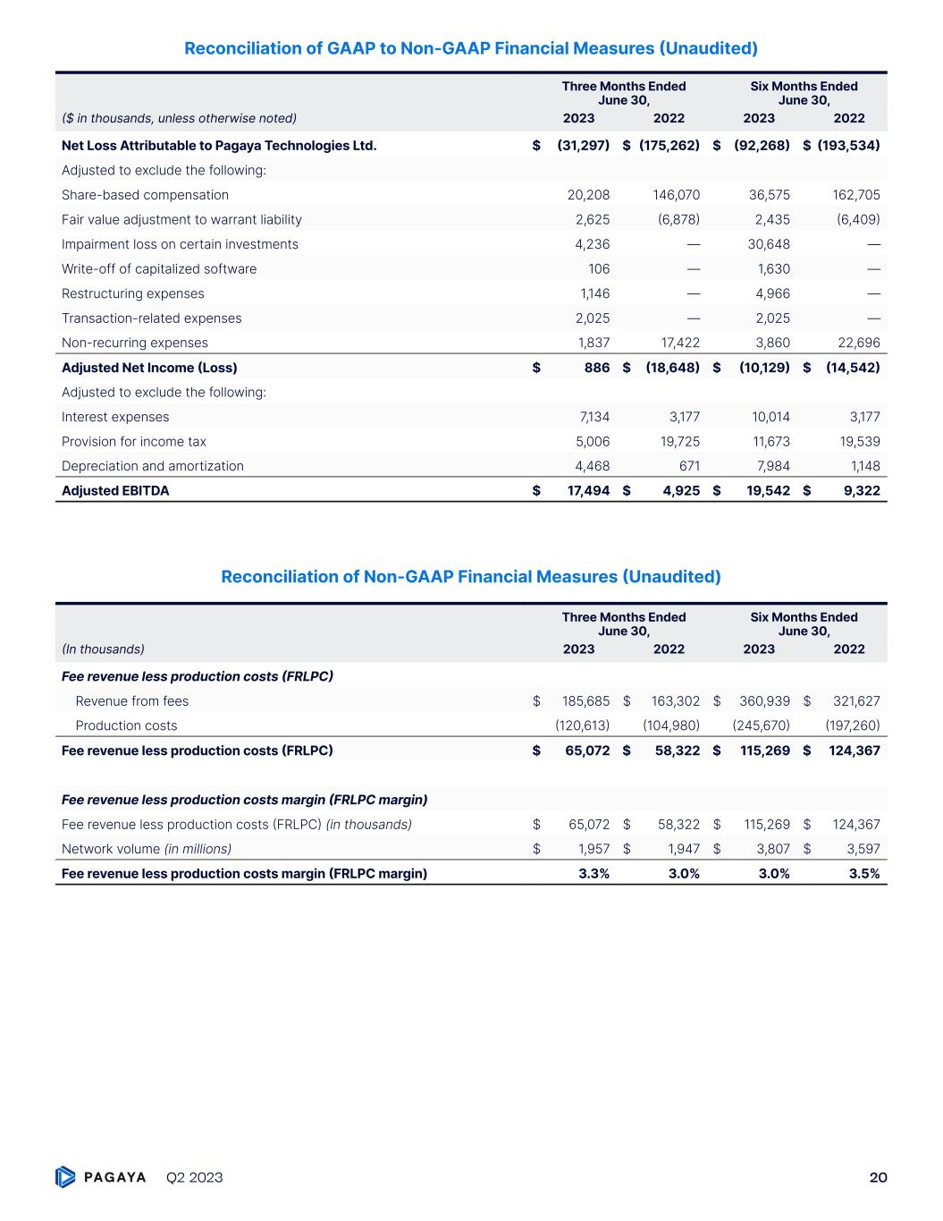
Reconciliation of GAAP to Non-GAAP Financial Measures (Unaudited) Three Months Ended June 30, Six Months Ended June 30, ($ in thousands, unless otherwise noted) 2023 2022 2023 2022 Net Loss Attributable to Pagaya Technologies Ltd. $ (31,297) $ (175,262) $ (92,268) $ (193,534) Adjusted to exclude the following: Share-based compensation 20,208 146,070 36,575 162,705 Fair value adjustment to warrant liability 2,625 (6,878) 2,435 (6,409) Impairment loss on certain investments 4,236 — 30,648 — Write-off of capitalized software 106 — 1,630 — Restructuring expenses 1,146 — 4,966 — Transaction-related expenses 2,025 — 2,025 — Non-recurring expenses 1,837 17,422 3,860 22,696 Adjusted Net Income (Loss) $ 886 $ (18,648) $ (10,129) $ (14,542) Adjusted to exclude the following: Interest expenses 7,134 3,177 10,014 3,177 Provision for income tax 5,006 19,725 11,673 19,539 Depreciation and amortization 4,468 671 7,984 1,148 Adjusted EBITDA $ 17,494 $ 4,925 $ 19,542 $ 9,322 Reconciliation of Non-GAAP Financial Measures (Unaudited) Three Months Ended June 30, Six Months Ended June 30, (In thousands) 2023 2022 2023 2022 Fee revenue less production costs (FRLPC) Revenue from fees $ 185,685 $ 163,302 $ 360,939 $ 321,627 Production costs (120,613) (104,980) (245,670) (197,260) Fee revenue less production costs (FRLPC) $ 65,072 $ 58,322 $ 115,269 $ 124,367 Fee revenue less production costs margin (FRLPC margin) Fee revenue less production costs (FRLPC) (in thousands) $ 65,072 $ 58,322 $ 115,269 $ 124,367 Network volume (in millions) $ 1,957 $ 1,947 $ 3,807 $ 3,597 Fee revenue less production costs margin (FRLPC margin) 3.3% 3.0% 3.0% 3.5% Q2 2023 20



