UNITED STATES

SECURITIES AND EXCHANGE COMMISSION

Washington, D.C. 20549

FORM 6-K

REPORT OF FOREIGN PRIVATE ISSUER

PURSUANT TO SECTION 13A-16 OR 15D-16

UNDER THE SECURITIES EXCHANGE ACT OF 1934

For the month of November 2023

Commission File Number: 001-41430

Pagaya Technologies Ltd.

(Exact Name of Registrant as Specified in Its Charter)

Azrieli Sarona Bldg, 54th Floor

121 Derech Menachem Begin

Tel-Aviv 6701203, Israel

+972 (3) 715 0920

(Address of principal executive offices)

Indicate by check mark whether the registrant files or will file annual reports under cover of Form 20-F or Form 40-F.

Form 20-F ☒ Form 40-F ☐

Indicate by check mark if the registrant is submitting the Form 6-K in paper as permitted by Regulation S-T Rule 101(b)(1): ☐

Indicate by check mark if the registrant is submitting the Form 6-K in paper as permitted by Regulation S-T Rule 101(b)(7): ☐

CONTENTS

Q3 Results

On November 2, 2023, Pagaya Technologies Ltd. (“Pagaya”) issued a press release titled “Pagaya Reports Third Quarter 2023 Results,” in which Pagaya reported its results of operations for the quarter and nine months ended September 30, 2023, and a Shareholder Letter. Copies of the press release and the Shareholder Letter are furnished as Exhibit 99.1 and Exhibit 99.2, respectively, to this Report of Foreign Private Issuer on Form 6-K (the “Report”) and shall not be deemed to “filed” for purposes of Section 18 of the Securities Exchange Act of 1934, as amended (the “Exchange Act”), or otherwise subject to the liabilities of that section, nor shall such information be deemed incorporated by reference into any filing made by Pagaya under the Securities Act of 1933, as amended, or the Exchange Act, except as may be expressly set forth by specific reference in such filing.

Pagaya’s Unaudited Condensed Consolidated Interim Financial Statements for the Three Months and Nine Months Ended September 30, 2023 included as Exhibit 99.3 of this Report, and Management’s Discussion and Analysis of Financial Condition and Results of Operations for the Three Months and Nine Months Ended September 30, 2023 and Risk Factors included as Exhibit 99.4 of this Report, shall be deemed to be incorporated by reference into Pagaya’s Registration Statement on Form S-8 (File No. 333-274540), Form S-8 (File No. 333-265739), Registration Statement on Form F-3 (File No. 333-266228), Registration Statement on Form F-3 (File No. 333-266930), Registration Statement on Form F-3 (File No. 333-271343) and Registration Statement on Form F-3 (File No. 333-274862), and any related prospectuses, as such registration statements and prospectuses may be amended from time to time, and to be a part thereof from the date on which this Report is furnished, to the extent not superseded by information subsequently filed or furnished (to the extent Pagaya expressly states that it incorporates such furnished information by reference) by Pagaya under the Securities Act of 1933, as amended, or the Securities Exchange Act of 1934, as amended.

This Report and exhibits contain forward-looking statements within the meaning of the Private Securities Litigation Reform Act of 1995. Words such as “may,” “will,” “expect,” “plan,” “anticipate,” “estimate,” “intend” and similar expressions (as well as other words or expressions referencing future events, conditions or circumstances) are intended to identify forward-looking statements. These forward-looking statements are based on Pagaya’s expectations and assumptions as of the date of this Report. Each of these forward-looking statements involves risks and uncertainties. Actual results may differ materially from those expressed or implied by these forward-looking statements. For a discussion of risk factors that may cause Pagaya’s actual results to differ from those expressed or implied in the forward-looking statements in this Report, you should refer to Pagaya’s filings with the U.S. Securities and Exchange Commission, including Pagaya’s most recent Form 20-F, particularly the section entitled “Risk Factors”. Except as required by law, Pagaya undertakes no obligation to publicly update any forward-looking statements, whether as a result of new information, future events or otherwise, except as required by law. You should, therefore, not rely on these forward-looking statements as representing Pagaya’s views as of any date subsequent to the date of this Report.

Changes to the Company’s Board of Directors

Mr. Juan Pujadas, who was elected to Pagaya’s shareholders to the board of directors (the “Board”) on September 13, 2023, has resigned from the Board effective as of November 1, 2023. Mr. Pujadas, age 61, advised that his resignation is due to personal reasons and not a result of any disagreement with the Company on any matter related to the operations or practices of the Company. The information under this heading “Changes to the Company’s Board of Directors” shall be deemed to be incorporated by reference into Pagaya’s Registration Statement on Form S-8 (File No. 333-274540), Form S-8 (File No. 333-265739), Registration Statement on Form F-3 (File No. 333-266228), Registration Statement on Form F-3 (File No. 333-266930), Registration Statement on Form F-3 (File No. 333-271343) and Registration Statement on Form F-3 (File No. 333-274862), and any related prospectuses, as such registration statements and prospectuses may be amended from time to time, and to be a part thereof from the date on which this Report is furnished, to the extent not superseded by information subsequently filed or furnished (to the extent Pagaya expressly states that it incorporates such furnished information by reference) by Pagaya under the Securities Act of 1933, as amended, or the Securities Exchange Act of 1934, as amended.

 |  |  |  | EXHIBIT INDEX
 | Exhibit No. |  |  | Description
 | 99.1 |  |  | Press release, dated November 2, 2023, titled “Pagaya Reports Third Quarter 2023 Results”
 | 99.2 |  |  | Shareholder Letter, dated November 2, 2023
 | 99.3 |  |  | Unaudited Condensed Consolidated Interim Financial Statements for the Three and Nine Months Ended September 30, 2023
 | 99.4 |  |  | Management’s Discussion and Analysis of Financial Condition and Results of Operations for the Three and Nine Months Ended September 30, 2023 and Risk Factors

SIGNATURES

Pursuant to the requirements of the Securities Exchange Act of 1934, the registrant has duly caused this report to be signed on its behalf by the undersigned, thereunto duly authorized.

 |  | PAGAYA TECHNOLOGIES LTD.
Date: November 2, 2023 | By: | /s/ Gal Krubiner
 | Name: | Gal Krubiner
 | Title: | Chief Executive Officer
 | By: | /s/ Michael Kurlander
 | Name: | Michael Kurlander
 | Title: | Chief Financial Officer


Pagaya Reports Third Quarter and Nine Months Ended 2023 Results

Exceeded third quarter guidance on all metrics:

- Record Network Volume of $2.1 billion

- Record Total Revenue and Other Income of $211.8 million

- Record Adjusted EBITDA of $28.3 million

- Announced new partner integrations, including a top 5 bank in the U.S. by total assets and a top 4 OEM auto captive by U.S. vehicle sales

Raises outlook for full-year 2023 Network Volume, Total Revenue and Other Income and Adjusted EBITDA

New York, NY and Tel Aviv, Israel – November 2, 2023 – Pagaya Technologies Ltd. (NASDAQ: PGY) (“Pagaya”, the “Company” or “we”), a global technology company delivering artificial intelligence infrastructure for the financial ecosystem, today announced financial results for the third quarter and nine months ended September 30, 2023 and raised its outlook for Network Volume, Total Revenue and Other Income and Adjusted EBITDA.

“Our third quarter performance once again underscored the strength of our two-sided network. We exceeded our outlook across all metrics and achieved record network volume, revenue and adjusted EBITDA,” said Gal Krubiner, co-founder and CEO of Pagaya Technologies. “The strong momentum in our business and the integration of our product by new transformational partnerships are driving a step-change in our journey to transform the consumer finance ecosystem.”

Third Quarter 2023 Financial Highlights

All comparisons are made versus the same period in 2022 and on a year-over-year basis unless otherwise stated.

- Record network volume of $2.1 billion (exceeding outlook of $1.9 billion to $2.0 billion), grew by 10%, driven primarily by continued growth of the Company’s largest strategic partners in its personal loan product and the ramp-up of newer partnerships.
- The Company raised $4.9 billion across eleven asset-backed securitizations (“ABS”) in the nine months ended September 30, 2023 and was once again the number one personal loan ABS issuer in the US by issuance size in the third quarter.
- Record total revenue and other income of $211.8 million (exceeding outlook of $190 million to $200 million), increased 4%, driven primarily by 9% growth in revenue from fees.

- Revenue from fees less production costs (“FRLPC”) increased 29% to $72.7 million. FRLPC as a percentage of network volume (“FRLPC margin”) improved 50 basis points to 3.4%.

- Record adjusted EBITDA of $28.3 million (exceeding outlook of $10 million to $20 million). This is an increase of $33 million compared to the prior year period, benefiting from the growth in FRLPC and operating leverage as the business scales. The Company also generated positive quarterly GAAP operating income for the first time as a public company.

1

- Adjusted net income of $14.3 million, which excludes the impact of non-cash items such as share-based compensation expense, representing the second consecutive quarter of positive adjusted net income.
- Net loss attributable to Pagaya shareholders of $21.8 million, compared to $74.8 million in the prior year period, due primarily to the continued improvement in operating results and lower non-cash expenses such as share-based compensation expense.

Full-Year 2023 Outlook

The Company is raising its outlook for Network Volume, Total Revenue and Other Income and Adjusted EBITDA:

FY23

Network Volume

Expected to be between $8.0 billion and $8.2 billion

Total Revenue and Other Income

Expected to be between $800 million and $825 million

Adjusted EBITDA

Expected to be between $65 million and $75 million

Webcast

The Company will hold a webcast and conference call today, November 2, 2023 at 8:30 a.m. Eastern Time. A live webcast of the call will be available via the Investor Relations section of the Company’s website at investor.pagaya.com. To listen to the live webcast, please go to the site at least five minutes prior to the scheduled start time in order to register, download and install any necessary audio software. Shortly before the call, the accompanying materials will be made available on the Company’s website. Shortly after the call, a replay of the webcast will be available for 90 days on the Company’s website.

The conference call can also be accessed by dialing 1-855-327-6837 or 1-631-891-4304. The telephone replay can be accessed by dialing 1-844-512-2921 or 1-412-317-6671 and providing the conference ID# 10022646. The telephone replay will be available starting shortly after the call until Thursday, November 16, 2023. A replay will also be available on the Investor Relations website following the call.

About Pagaya Technologies

Pagaya (NASDAQ: PGY) is a global technology company making life-changing financial products and services available to more people nationwide. By using machine learning, a vast data network and a sophisticated AI-driven approach, Pagaya provides comprehensive consumer credit and residential real estate solutions for its partners, their customers, and investors. Its proprietary API and capital solutions integrate into its network of partners to deliver seamless user experiences and greater access to the mainstream economy. Pagaya has offices in New York and Tel Aviv. For more information, visit pagaya.com.

Cautionary Note About Forward-Looking Statements

This document contains forward-looking statements within the meaning of Section 27A of the Securities Act of 1933, as amended, and Section 21E of the Securities Exchange Act of 1934, as amended, that involve risks and uncertainties. These forward-looking statements generally are identified by the words “anticipate,” “believe,” “continue,” “can,” “could,” “estimate,” “expect,” “intend,” “may,” “opportunity,” “future,” “strategy,” “might,” “outlook,” “plan,” “possible,” “potential,” “predict,” “project,” “should,” “strive,” “will,” “would,” “will be,” “will continue,” “will likely result,” and similar expressions. All statements other than statements of historical fact are forward-looking statements, including statements regarding: The Company’s strategy and future operations, including the Company’s ability to continue to deliver consistent results for its lending partners and investors; the Company’s ability to continue to drive sustainable gains in profitability; the Company’s ability to achieve continued momentum in its business; and the Company’s financial outlook for Network Volume, Total Revenue and Other Income and Adjusted EBITDA for the full year 2023. These forward-looking statements involve known and unknown risks, uncertainties and other important factors that may cause the Company's actual results, performance or achievements to be materially different from any future results, performance or achievements expressed or implied by the forward-looking statements. Risks, uncertainties and assumptions include factors relating to: the Company's ability to attract new partners and to retain and grow its relationships with existing partners to support the underlying investment needs for its securitizations and funds products; the need to maintain a consistently high

2

level of trust in its brand; the concentration of a large percentage of its investment revenue with a small number of partners and platforms; its ability to sustain its revenue growth rate or the growth rate of its related key operating metrics; its ability to improve, operate and implement its technology, its existing funding arrangements for the Company and its affiliates that may not be renewed or replaced or its existing funding sources that may be unwilling or unable to provide funding to it on terms acceptable to it, or at all; the performance of loans facilitated through its model; changes in market interest rates; its securitizations, warehouse credit facility agreements; the impact on its business of general economic conditions, including, but not limited to rising interest rates, inflation, supply chain disruptions, exchange rate fluctuations and labor shortages; the effect of and uncertainties related to public health crises such as the COVID-19 pandemic (including any government responses thereto); geopolitical conflicts such as the war in Israel; its ability to realize the potential benefits of past or future acquisitions; anticipated benefits and savings from our recently announced reduction in workforce; changes in the political, legal and regulatory framework for AI technology, machine learning, financial institutions and consumer protection; the ability to maintain the listing of our securities on Nasdaq; the financial performance of its partners, and fluctuations in the U.S. consumer credit and housing market; its ability to grow effectively through strategic alliances; seasonal fluctuations in our revenue as a result of consumer spending and saving patterns; pending and future litigation, regulatory actions and/or compliance issues including with respect to the merger with EJF Acquisition Corp.; and other risks that are described in and the Company’s Form 20-F filed on April 20, 2023 and subsequent filings with the U.S. Securities and Exchange Commission, including the Company’s Report of Foreign Private Issuer on Form 6-K filed or to be filed on November 2, 2023. These forward-looking statements reflect the Company's views with respect to future events as of the date hereof and are based on assumptions and subject to risks and uncertainties. Given these uncertainties, investors should not place undue reliance on these forward-looking statements. The forward-looking statements are made as of the date hereof, reflect the Company’s current beliefs and are based on information currently available as of the date they are made, and the Company assumes no obligation and does not intend to update these forward-looking statements.

Financial Information; Non-GAAP Financial Measures

Some of the unaudited financial information and data contained in this press release and Form 6-K, such as Fee Revenue Less Production Costs (“FRLPC”), FRLPC Margin, Adjusted EBITDA and Adjusted Net Income (Loss), have not been prepared in accordance with United States generally accepted accounting principles (“U.S. GAAP”). To supplement the unaudited consolidated financial statements prepared and presented in accordance with U.S. GAAP, management uses the non-GAAP financial measures FRLPC, FRLPC Margin, Adjusted Net Income (Loss) and Adjusted EBITDA to provide investors with additional information about our financial performance and to enhance the overall understanding of the results of operations by highlighting the results from ongoing operations and the underlying profitability of our business. Management believes these non-GAAP measures provide an additional tool for investors to use in comparing our core financial performance over multiple periods. However, non-GAAP financial measures have limitations in their usefulness to investors because they have no standardized meaning prescribed by U.S. GAAP and are not prepared under any comprehensive set of accounting rules or principles. In addition, non-GAAP financial measures may be calculated differently from, and therefore may not be directly comparable to, similarly titled measures used by other companies. As a result, non-GAAP financial measures should be viewed as supplementing, and not as an alternative or substitute for, our unaudited consolidated financial statements prepared and presented in accordance with U.S. GAAP. To address these limitations, management provides a reconciliation of Adjusted Net Income (Loss) and Adjusted EBITDA to net income (loss) attributable to Pagaya’s shareholders and a calculation of FRLPC and FRLPC Margin. Management encourages investors and others to review our financial information in its entirety, not to rely on any single financial measure and to view Adjusted Net Income (Loss) and Adjusted EBITDA in conjunction with its respective related GAAP financial measures.

Non-GAAP financial measures include the following items:

Fee Revenue Less Production Costs (“FRLPC”) is defined as revenue from fees less production costs. FRLPC Margin is defined as FRLPC divided by Network Volume.

Adjusted Net Income (Loss) is defined as net income (loss) attributable to Pagaya Technologies Ltd.’s shareholders excluding share-based compensation expense, change in fair value of warrant liability, impairment, including credit-

3

related charges, restructuring expenses, transaction-related expenses, and non-recurring expenses associated with mergers and acquisitions.

Adjusted EBITDA is defined as net income (loss) attributable to Pagaya Technologies Ltd.’s shareholders excluding share-based compensation expense, change in fair value of warrant liability, impairment, including credit-related charges, restructuring expenses, transaction-related expenses, non-recurring expenses associated with mergers and acquisitions, interest expense, depreciation expense, and income tax expense (benefit).

These items are excluded from our Adjusted Net Income (Loss) and Adjusted EBITDA measures because they are noncash in nature, or because the amount and timing of these items is unpredictable, is not driven by core results of operations and renders comparisons with prior periods and competitors less meaningful.

We believe FRLPC, FRLPC Margin, Adjusted Net Income (Loss) and Adjusted EBITDA provide useful information to investors and others in understanding and evaluating our results of operations, as well as providing a useful measure for period-to-period comparisons of our business performance. Moreover, we have included FRLPC, FRLPC Margin, Adjusted Net Income (Loss) and Adjusted EBITDA because these are key measurements used by our management internally to make operating decisions, including those related to operating expenses, evaluate performance, and perform strategic planning and annual budgeting. However, this non-GAAP financial information is presented for supplemental informational purposes only, should not be considered a substitute for or superior to financial information presented in accordance with U.S. GAAP and may be different from similarly titled non-GAAP financial measures used by other companies. The tables below provide reconciliations of Adjusted EBITDA to Net Loss Attributable to Pagaya Technologies Ltd., its most directly comparable U.S. GAAP amount.

In addition, Pagaya provides outlook for the fiscal year 2023 on a non-GAAP basis. The Company cannot reconcile its expected Adjusted EBITDA to expected Net Loss Attributable to Pagaya under “Full-Year 2023 Outlook” without unreasonable effort because certain items that impact net income (loss) and other reconciling items are out of the Company's control and/or cannot be reasonably predicted at this time, which unavailable information could have a significant impact on the Company’s U.S. GAAP financial results.

Investors & Analysts

Jency John

Head of Investor Relations

IR@pagaya.com

Media & Press

Emily Passer

Head of PR & External Communications

Press@pagaya.com

4

PAGAYA TECHNOLOGIES LTD.

CONSOLIDATED STATEMENTS OF OPERATIONS (UNAUDITED)
(In thousands, except share and per share data)

 |  | Three Months Ended September 30, |  |  |  |  |  | Nine Months Ended September 30,
 |  | 2023 |  |  | 2022 |  |  | 2023 |  |  | 2022
Revenue
Revenue from fees | $ | 201,447 |  | $ | 185,614 |  | $ | 562,386 |  | $ | 507,241
Other Income
Interest income |  | 10,375 |  |  | 13,666 |  |  | 30,965 |  |  | 43,127
Investment income (loss) |  | (65) |  |  | 4,675 |  |  | 656 |  |  | 5,670
Total Revenue and Other Income |  | 211,757 |  |  | 203,955 |  |  | 594,007 |  |  | 556,038
Production costs |  | 128,792 |  |  | 129,115 |  |  | 374,462 |  |  | 326,375
Research and development (1) |  | 18,039 |  |  | 38,643 |  |  | 56,833 |  |  | 127,379
Sales and marketing (1) |  | 11,339 |  |  | 26,579 |  |  | 40,197 |  |  | 90,229
General and administrative (1) |  | 53,425 |  |  | 73,790 |  |  | 157,567 |  |  | 236,863
Total Costs and Operating Expenses |  | 211,595 |  |  | 268,127 |  |  | 629,059 |  |  | 780,846
Operating Income (Loss) |  | 162 |  |  | (64,172) |  |  | (35,052) |  |  | (224,808)
Other income (loss), net |  | (47,260) |  |  | 3,233 |  |  | (131,135) |  |  | 9,846
Loss Before Income Taxes |  | (47,098) |  |  | (60,939) |  |  | (166,187) |  |  | (214,962)
Income tax expense (benefit) |  | (1,158) |  |  | 6,065 |  |  | 10,515 |  |  | 25,604
Net Loss Including Noncontrolling Interests |  | (45,940) |  |  | (67,004) |  |  | (176,702) |  |  | (240,566)
Less: Net income (loss) attributable to noncontrolling interests |  | (24,188) |  |  | 7,785 |  |  | (62,682) |  |  | 27,757
Net Loss Attributable to Pagaya Technologies Ltd. | $ | (21,752) |  | $ | (74,789) |  | $ | (114,020) |  | $ | (268,323)
Per share data:
Net loss attributable to Pagaya Technologies Ltd. shareholders | $ | (21,752) |  | $ | (74,789) |  | $ | (114,020) |  | $ | (268,323)
Less: Undistributed earnings allocated to participated securities |  | — |  |  | — |  |  | — |  |  | (12,205)
Net loss attributable to Pagaya Technologies Ltd. ordinary shareholders | $ | (21,752) |  | $ | (74,789) |  | $ | (114,020) |  | $ | (280,528)
Net loss per share:
Basic and Diluted (2) | $ | (0.03) |  | $ | (0.11) |  | $ | (0.16) |  | $ | (0.73)
Non-GAAP adjusted net income (loss) (3) | $ | 14,296 |  | $ | (14,440) |  | $ | 4,167 |  | $ | (28,981)
Non-GAAP adjusted net income (loss) per share:
Basic (2) | $ | 0.02 |  | $ | (0.02) |  | $ | 0.01 |  | $ | (0.08)
Diluted (2) | $ | 0.02 |  | $ | (0.02) |  | $ | 0.01 |  | $ | (0.08)
Weighted average shares outstanding (Class A and Class B):
Basic (2) |  | 728,563,796 |  |  | 679,431,901 |  |  | 715,411,921 |  |  | 381,831,895
Diluted (2) |  | 796,392,671 |  |  | 964,179,889 |  |  | 738,147,927 |  |  | 666,968,467
(1) The following table sets forth share-based compensation for the periods indicated below:
 |  | Three Months Ended September 30, |  |  |  |  |  | Nine Months Ended September 30,
 |  | 2023 |  |  | 2022 |  |  | 2023 |  |  | 2022
Research and development | $ | 3,467 |  | $ | 16,208 |  | $ | 8,915 |  | $ | 71,687
Selling and marketing |  | 3,469 |  |  | 15,645 |  |  | 10,979 |  |  | 54,534
General and administrative |  | 13,801 |  |  | 28,449 |  |  | 37,418 |  |  | 92,022
Total | $ | 20,737 |  | $ | 60,302 |  | $ | 57,312 |  | $ | 218,243

- Prior period amounts have been retroactively adjusted to reflect the 1:186.9 stock split effected on June 22, 2022.

- See “Reconciliation of Non-GAAP Financial Measures.”

5

PAGAYA TECHNOLOGIES LTD.

CONSOLIDATED STATEMENTS OF FINANCIAL POSITION
(In thousands)

 |  | September 30, 2023 |  |  | December 31, 2022
Assets |  | (Unaudited) |  |  | (Audited)
Current assets:
Cash and cash equivalents | $ | 252,578 |  | $ | 309,793
Restricted cash |  | 26,280 |  |  | 22,539
Fees and other receivables |  | 67,460 |  |  | 59,219
Investments in loans and securities |  | 249 |  |  | 1,007
Prepaid expenses and other current assets |  | 27,353 |  |  | 27,258
Income tax receivable |  | 4,073 |  |  | —
Total current assets |  | 377,993 |  |  | 419,816
Restricted cash |  | 5,320 |  |  | 4,744
Fees and other receivables |  | 35,393 |  |  | 38,774
Investments in loans and securities |  | 665,405 |  |  | 462,969
Equity method and other investments |  | 26,550 |  |  | 25,894
Right-of-use assets |  | 54,587 |  |  | 61,077
Property and equipment, net |  | 40,680 |  |  | 31,663
Goodwill |  | 10,945 |  |  | —
Intangible assets |  | 3,189 |  |  | —
Prepaid expenses and other assets |  | 145 |  |  | 142
Total non-current assets |  | 842,214 |  |  | 625,263
Total Assets | $ | 1,220,207 |  | $ | 1,045,079
Liabilities and Shareholders’ Equity
Current liabilities:
Accounts payable | $ | 1,299 |  | $ | 1,739
Accrued expenses and other liabilities |  | 29,332 |  |  | 49,496
Operating lease liability - current |  | 6,213 |  |  | 8,530
Secured borrowing - current |  | 44,193 |  |  | 61,829
Income taxes payable - current |  | 591 |  |  | 6,424
Total current liabilities |  | 81,628 |  |  | 128,018
Non-current liabilities:
Warrant liability |  | 5,163 |  |  | 1,400
Revolving credit facility |  | 100,000 |  |  | 15,000
Secured borrowing - non-current |  | 227,356 |  |  | 77,802
Operating lease liability - non-current |  | 41,116 |  |  | 49,097
Income taxes payable - non-current |  | 18,261 |  |  | 7,771
Deferred tax liabilities, net - non-current |  | 581 |  |  | 568
Total non-current liabilities |  | 392,477 |  |  | 151,638
Total Liabilities |  | 474,105 |  |  | 279,656
Redeemable convertible preferred shares |  | 74,250 |  |  | —
Shareholders’ equity:
Additional paid-in capital |  | 1,060,166 |  |  | 968,432
Accumulated other comprehensive income (loss) |  | 3,985 |  |  | (713)
Accumulated deficit |  | (528,219) |  |  | (414,199)
Total Pagaya Technologies Ltd. shareholders’ equity |  | 535,932 |  |  | 553,520
Noncontrolling interests |  | 135,920 |  |  | 211,903
Total shareholders’ equity |  | 671,852 |  |  | 765,423
Total Liabilities, Redeemable Convertible Preferred Shares, and Shareholders’ Equity | $ | 1,220,207 |  | $ | 1,045,079

6

PAGAYA TECHNOLOGIES LTD.

CONSOLIDATED STATEMENTS OF CASH FLOWS (UNAUDITED)
(In thousands)

 | Nine Months Ended September 30,
 | 2023 |  |  | 2022
Cash flows from operating activities
Net loss including noncontrolling interests | $ | (176,702) |  | $ | (240,566)
Adjustments to reconcile net income (loss) to net cash used in operating activities:
Equity method income (loss) |  | (655) |  |  | (5,670)
Depreciation and amortization |  | 13,161 |  |  | 4,077
Share-based compensation |  | 57,312 |  |  | 223,007
Fair value adjustment to warrant liability |  | 3,763 |  |  | (9,408)
Issuance of ordinary shares related to commitment shares |  | — |  |  | 1,000
Impairment loss on available-for-sale debt securities |  | 115,644 |  |  | 10,706
Write-off of capitalized software |  | 1,935 |  |  | —
Tax benefit related to release of valuation allowance |  | (1,162) |  |  | —
Gain on foreign exchange |  | (302) |  |  | —
Change in operating assets and liabilities:
Fees and other receivables |  | (7,666) |  |  | (31,832)
Deferred tax assets, net |  | — |  |  | (2,820)
Deferred tax liabilities, net |  | 13 |  |  | —
Prepaid expenses and other assets |  | 1,812 |  |  | (18,530)
Right-of-use assets |  | 6,435 |  |  | 2,322
Accounts payable |  | (374) |  |  | (9,097)
Accrued expenses and other liabilities |  | (16,682) |  |  | 23,250
Operating lease liability |  | (6,433) |  |  | (6,204)
Income tax receivable / payable |  | 529 |  |  | 21,885
Net cash used in operating activities |  | (9,372) |  |  | (37,880)
Cash flows from investing activities
Proceeds from the sale/maturity/prepayment of:
Investments in loans and securities |  | 134,101 |  |  | 88,538
Short-term deposits |  | — |  |  | 5,020
Equity method and other investments |  | — |  |  | 453
Cash and restricted cash acquired from Darwin Homes, Inc. |  | 1,608 |  |  | —
Payments for the purchase of:
Investments in loans and securities |  | (436,242) |  |  | (261,806)
Property and equipment |  | (15,555) |  |  | (18,266)
Equity method and other investments |  | — |  |  | (5,749)
Net cash used in investing activities |  | (316,088) |  |  | (191,810)
Cash flows from financing activities
Proceeds from sale of ordinary shares in connection with the Business Combination and PIPE Investment, net of issuance costs |  | — |  |  | 291,872
Proceeds from secured borrowing |  | 314,276 |  |  | 94,094
Proceeds received from noncontrolling interests |  | 19,235 |  |  | 92,988
Proceeds from revolving credit facility |  | 110,000 |  |  | 26,000
Proceeds from exercise of stock options |  | 2,538 |  |  | 1,480
Distributions made to noncontrolling interests |  | (39,321) |  |  | (70,255)
Payments made to revolving credit facility |  | (25,000) |  |  | (26,000)
Payments made to secured borrowing |  | (182,358) |  |  | (18,245)
Settlement of share-based compensation in satisfaction of tax withholding requirements |  | (650) |  |  | —
Proceeds from issuance of ordinary shares from the Equity Financing Purchase Agreement |  | 3,793 |  |  | —
Proceeds from issuance of redeemable convertible preferred shares, net of issuance costs |  | 74,250 |  |  | —
Net cash provided by financing activities |  | 276,763 |  |  | 391,934
Effect of exchange rate changes on cash, cash equivalents and restricted cash |  | (4,201) |  |  | —
Net increase (decrease) in cash, cash equivalents and restricted cash |  | (52,898) |  |  | 162,244
Cash, cash equivalents and restricted cash, beginning of period |  | 337,076 |  |  | 204,575
Cash, cash equivalents and restricted cash, end of period | $ | 284,178 |  | $ | 366,819

7

PAGAYA TECHNOLOGIES LTD.

RECONCILIATION OF NON-GAAP FINANCIAL MEASURES (UNAUDITED)
($ in thousands, unless otherwise noted)

 | Three Months Ended September 30, |  |  |  |  |  |  | Nine Months Ended September 30,
 | 2023 |  |  |  | 2022 |  |  | 2023 |  |  | 2022
Net Loss Attributable to Pagaya Technologies Ltd. | $ | (21,752) |  | $ | (74,789) |  | $ | (114,020) |  | $ | (268,323)
Adjusted to exclude the following:
Share-based compensation |  | 20,737 |  |  | 60,302 |  |  | 57,312 |  |  | 223,007
Fair value adjustment to warrant liability |  | 1,328 |  |  | (3,000) |  |  | 3,763 |  |  | (9,408)
Impairment loss on certain investments |  | 9,130 |  |  | — |  |  | 39,778 |  |  | —
Write-off of capitalized software |  | 305 |  |  | — |  |  | 1,935 |  |  | —
Restructuring expenses |  | 484 |  |  | — |  |  | 5,450 |  |  | —
Transaction-related expenses |  | 2,472 |  |  | — |  |  | 4,497 |  |  | —
Non-recurring expenses |  | 1,592 |  |  | 3,047 |  |  | 5,452 |  |  | 25,743
Adjusted Net Income (Loss) | $ | 14,296 |  | $ | (14,440) |  | $ | 4,167 |  | $ | (28,981)
Adjusted to exclude the following:
Interest expenses |  | 9,918 |  |  | 243 |  |  | 19,932 |  |  | 3,420
Income tax expense (benefit) |  | (1,158) |  |  | 6,065 |  |  | 10,515 |  |  | 25,604
Depreciation and amortization |  | 5,205 |  |  | 2,929 |  |  | 13,189 |  |  | 4,077
Adjusted EBITDA | $ | 28,261 |  | $ | (5,203) |  | $ | 47,803 |  | $ | 4,120

 |  | Three Months Ended September 30, |  |  |  |  |  | Nine Months Ended September 30,
 |  | 2023 |  |  | 2022 |  |  | 2023 |  |  | 2022
Fee Revenue Less Production Costs (FRLPC):
Revenue from fees | $ | 201,447 |  | $ | 185,614 |  | $ | 562,386 |  | $ | 507,241
Production costs |  | 128,792 |  |  | 129,115 |  |  | 374,462 |  |  | 326,375
Fee Revenue Less Production Costs (FRLPC) | $ | 72,655 |  | $ | 56,499 |  | $ | 187,924 |  | $ | 180,866
Fee Revenue Less Production Costs Margin (FRLPC Margin):
Fee Revenue Less Production Costs (FRLPC) | $ | 72,655 |  | $ | 56,499 |  | $ | 187,924 |  | $ | 180,866
Network Volume (in millions) |  | 2,112 |  |  | 1,924 |  |  | 5,919 |  |  | 5,521
Fee Revenue Less Production Costs Margin (FRLPC Margin) |  | 3.4 % |  |  | 2.9 % |  |  | 3.2 % |  |  | 3.3 %

8

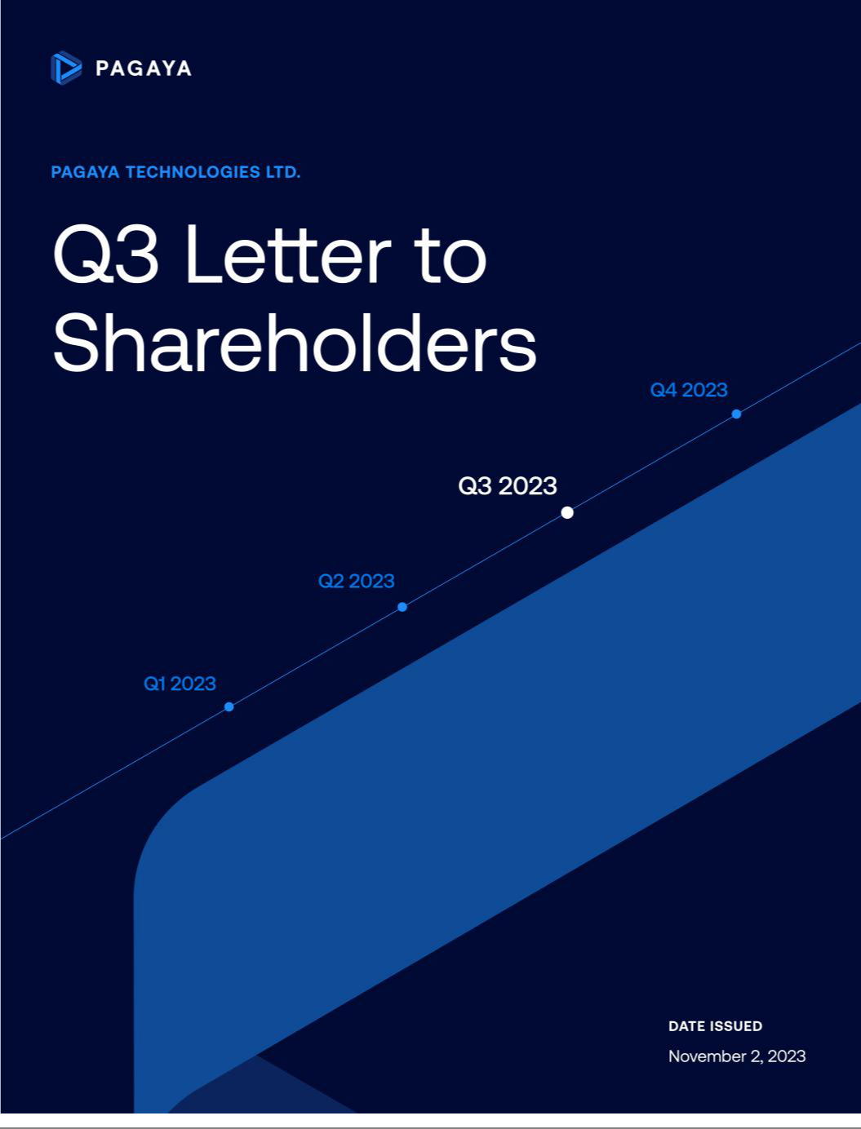

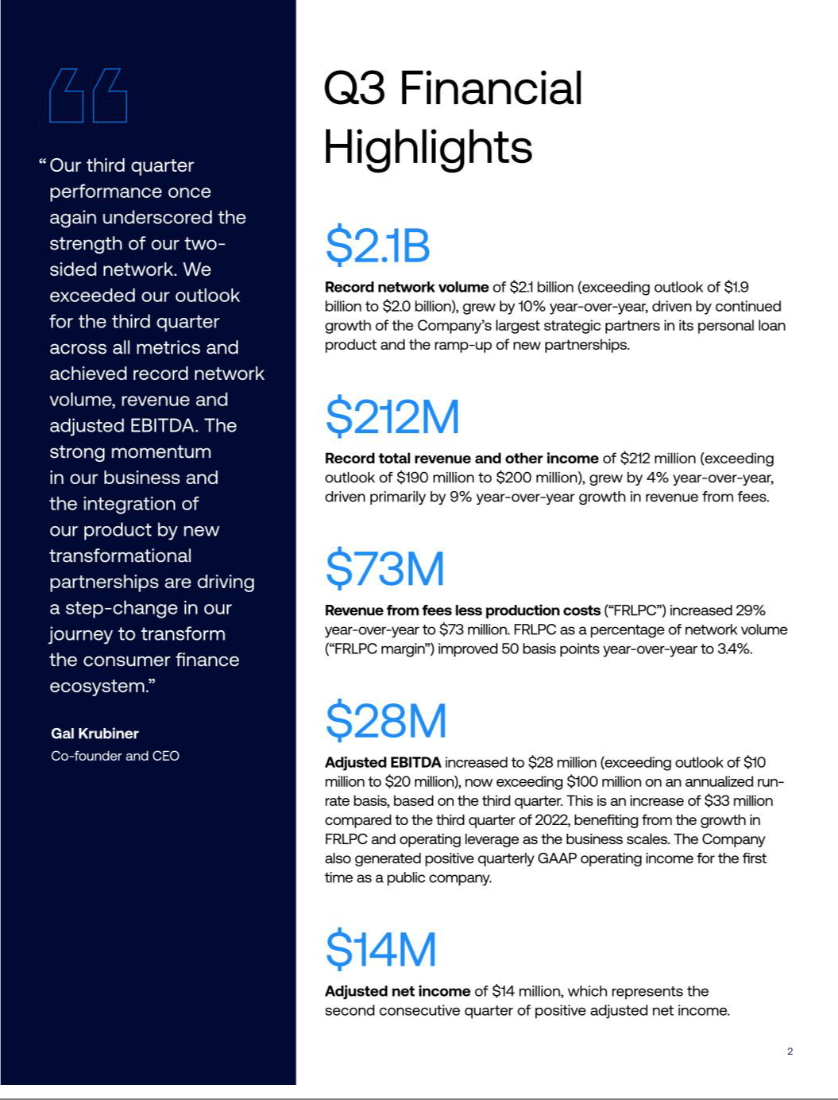

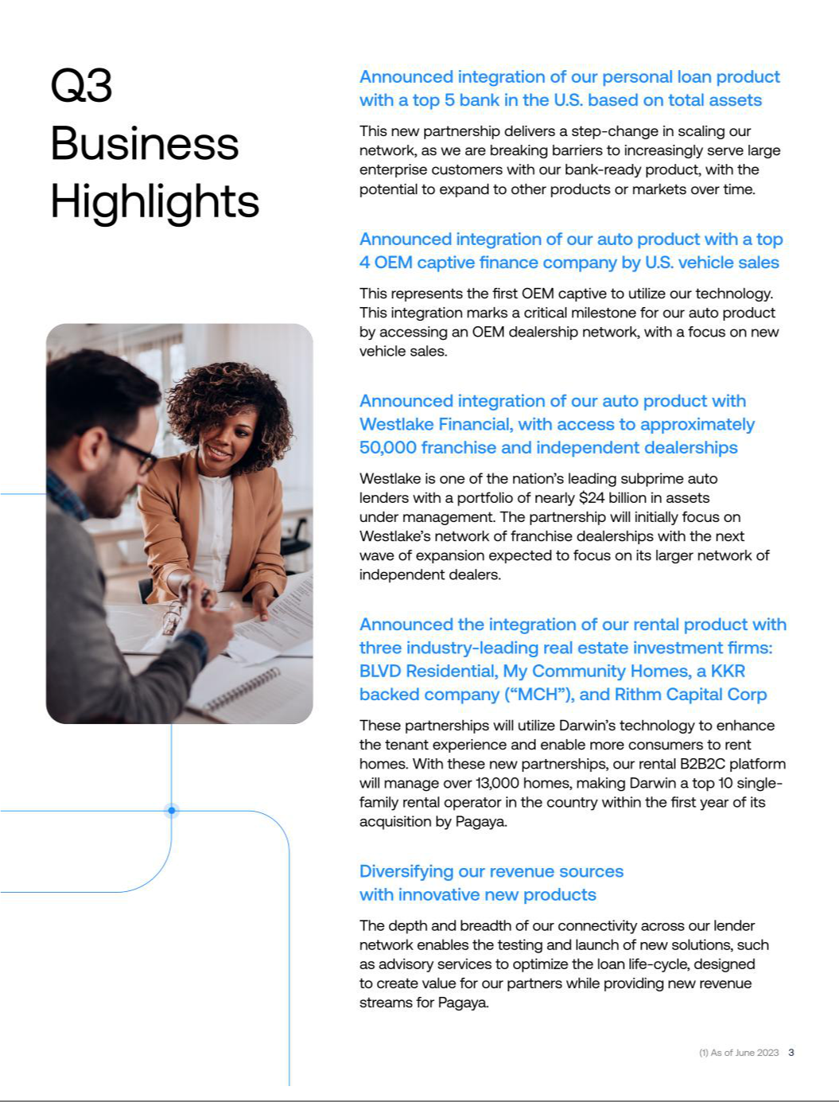

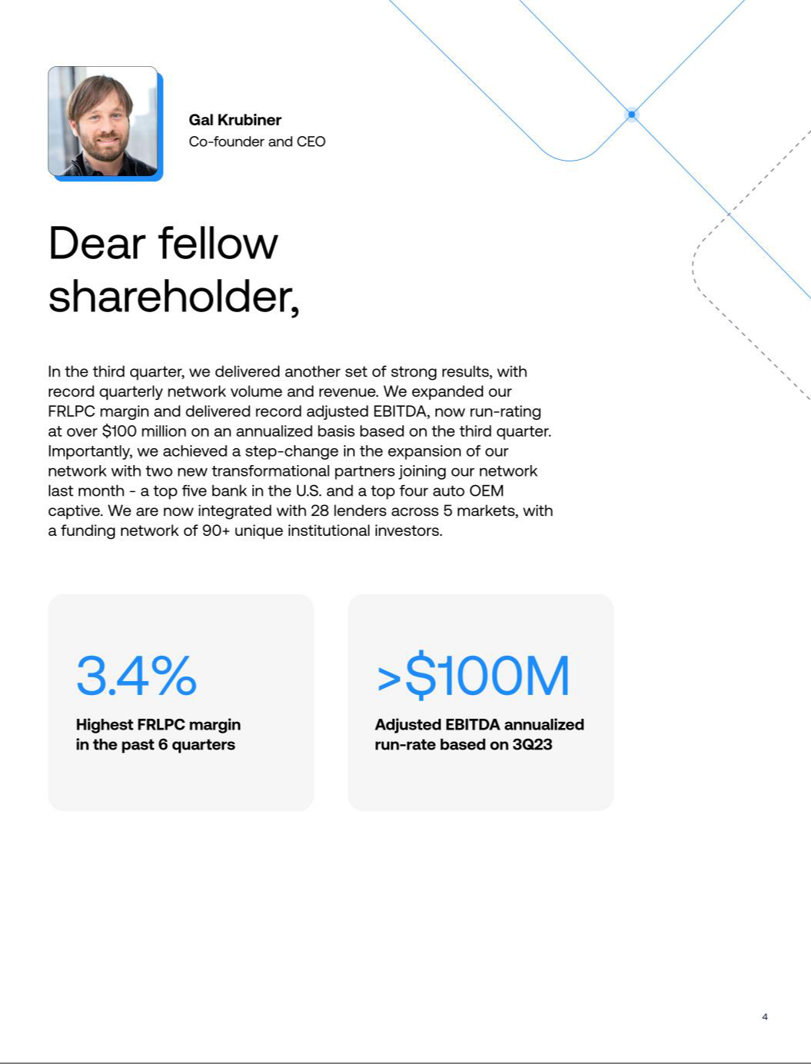

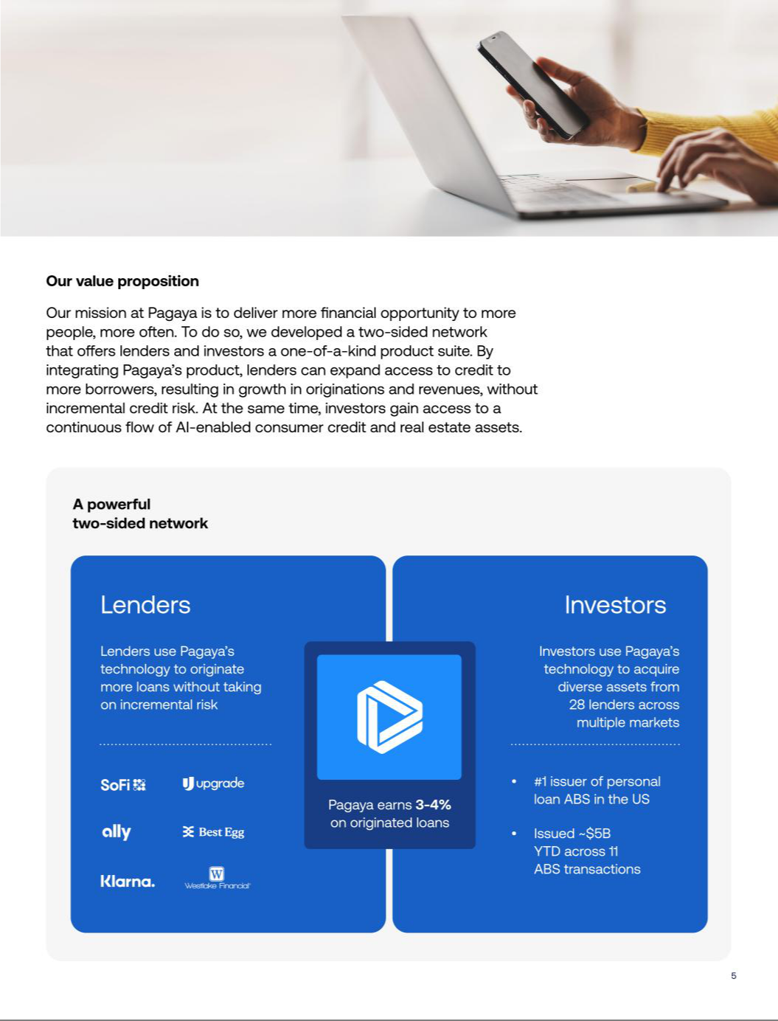

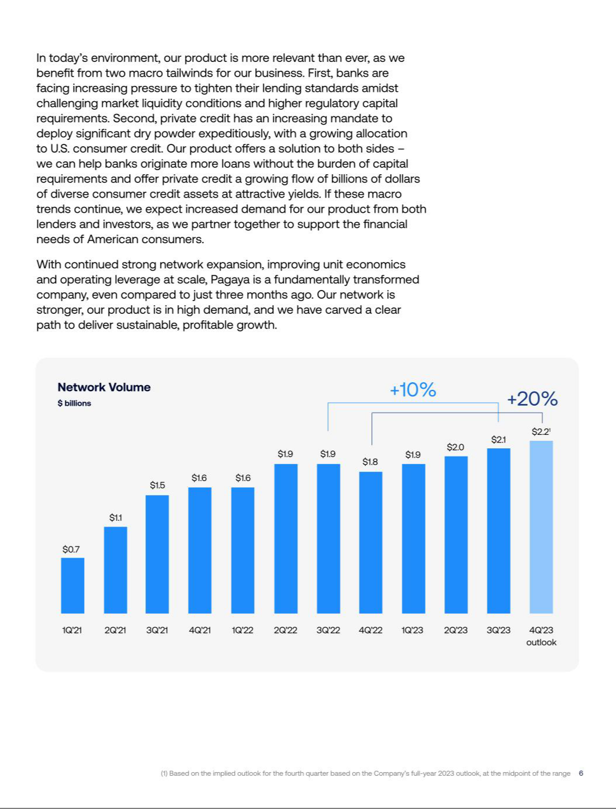

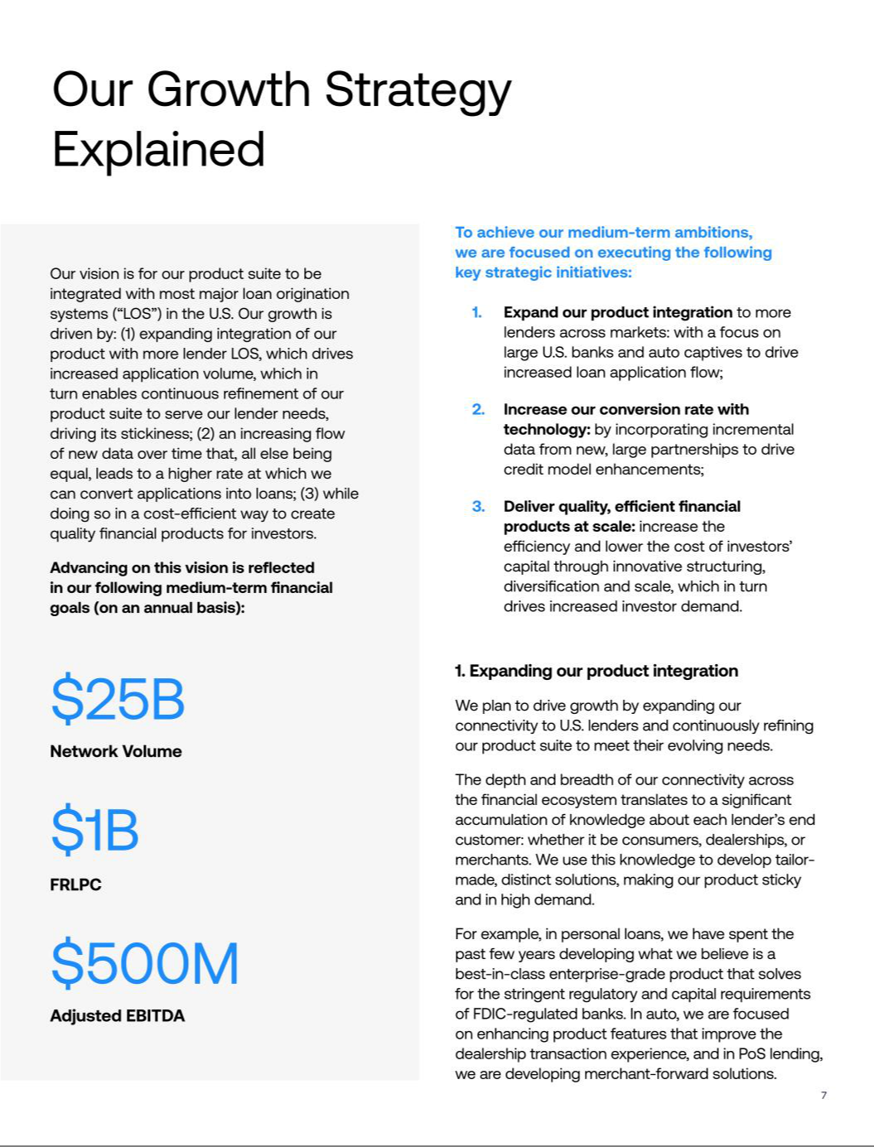



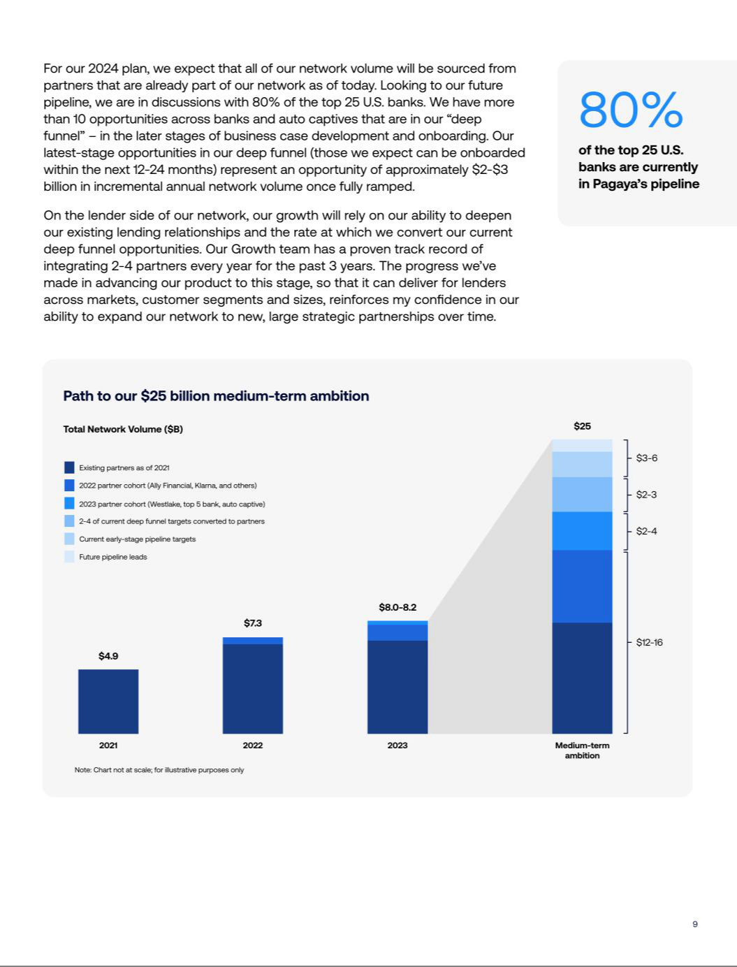

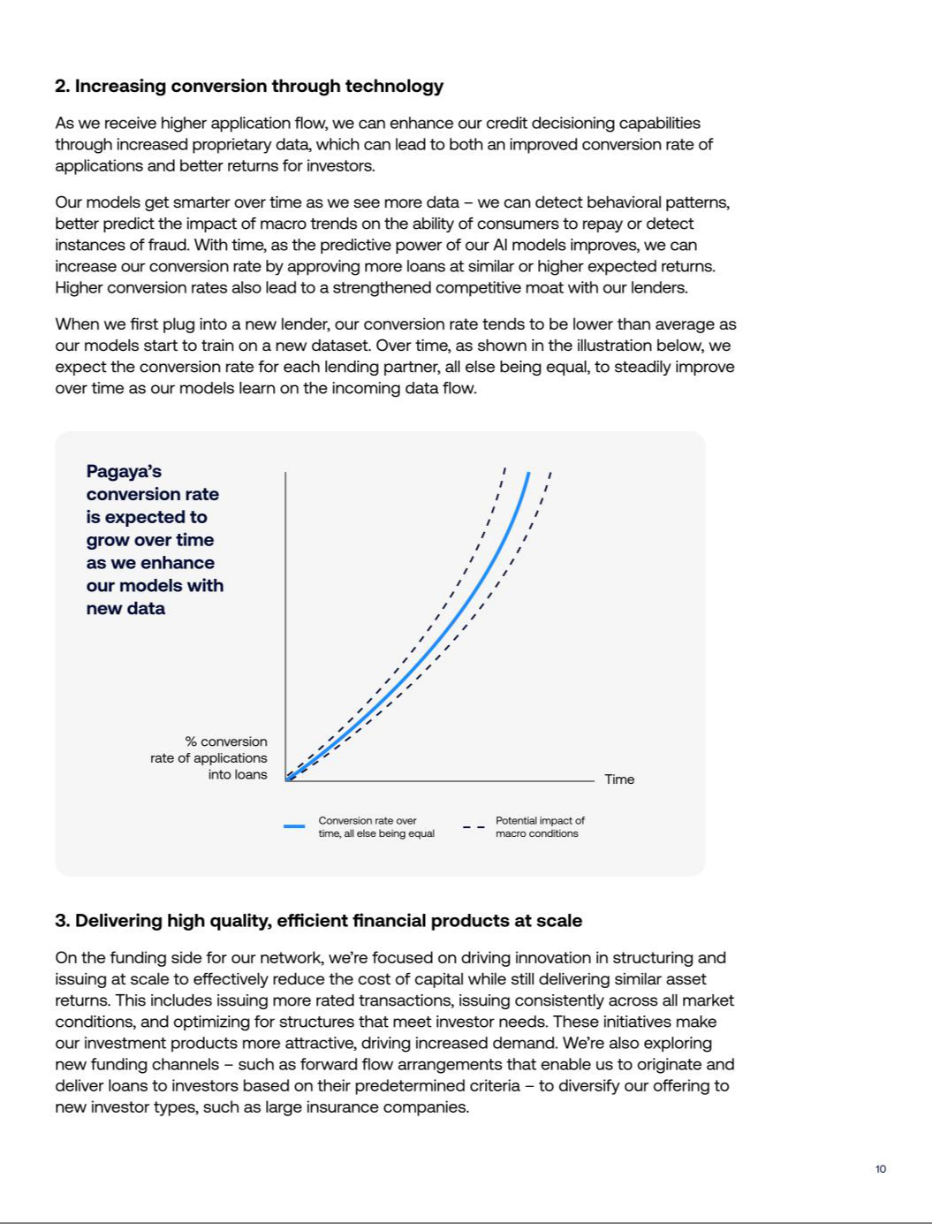

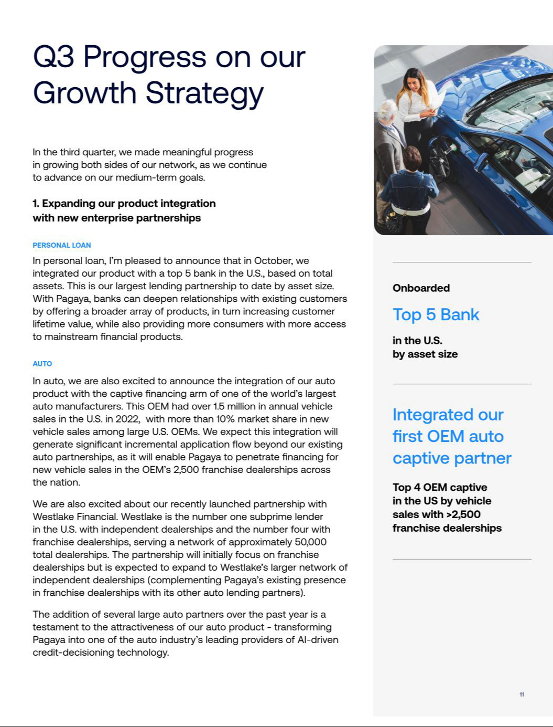

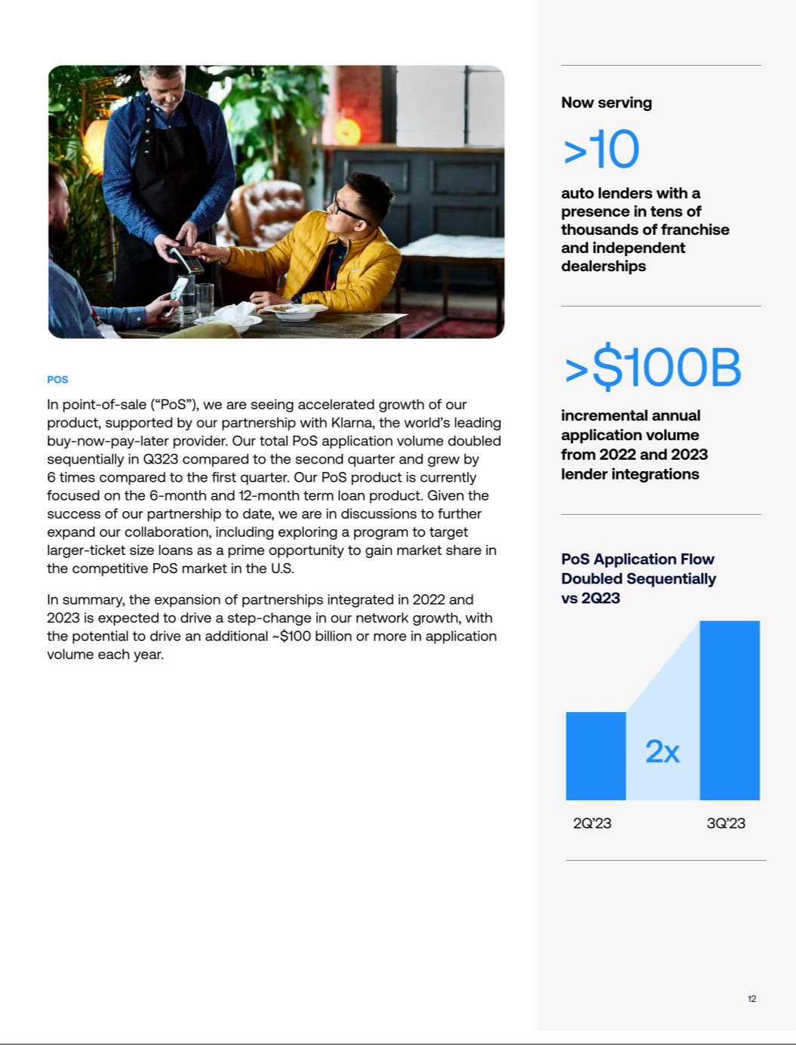

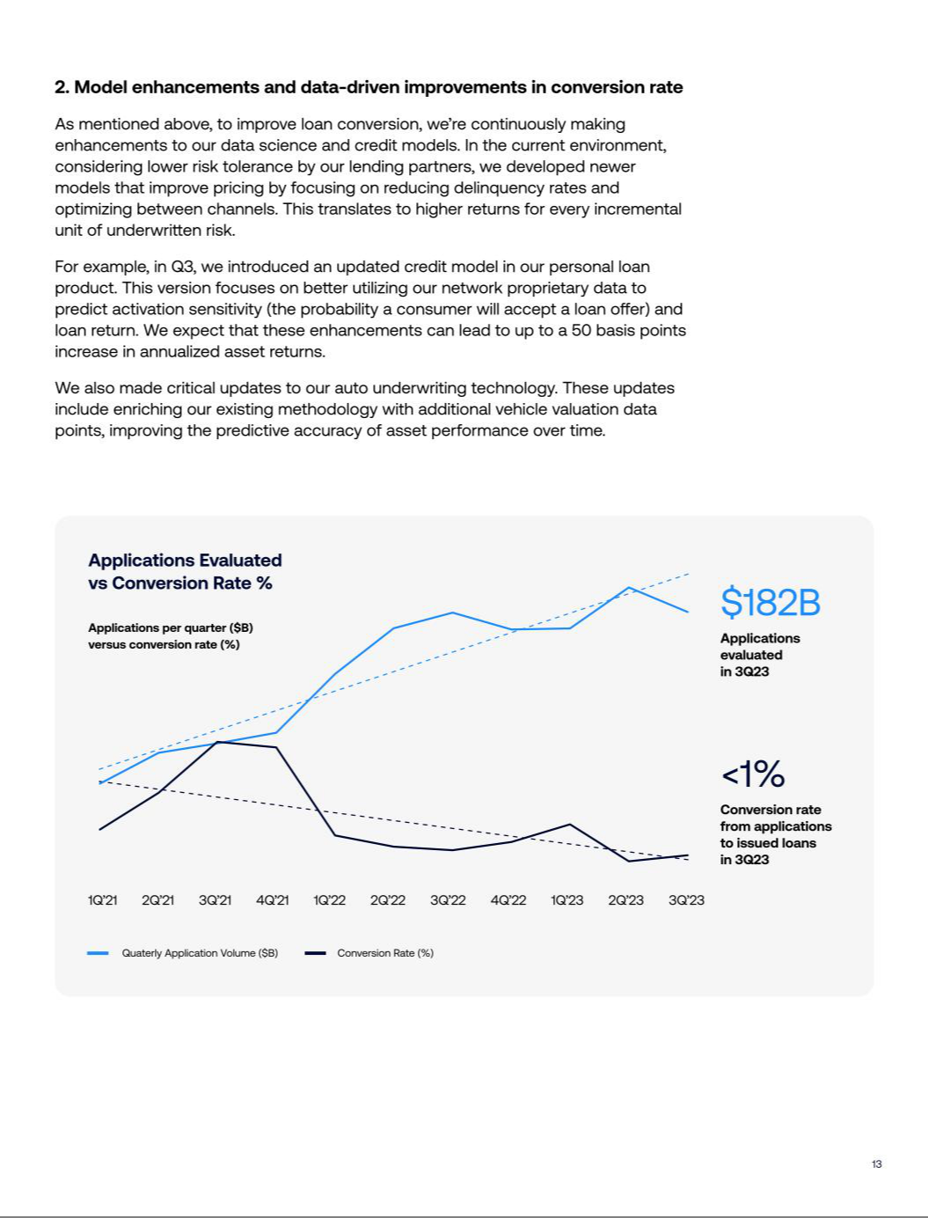

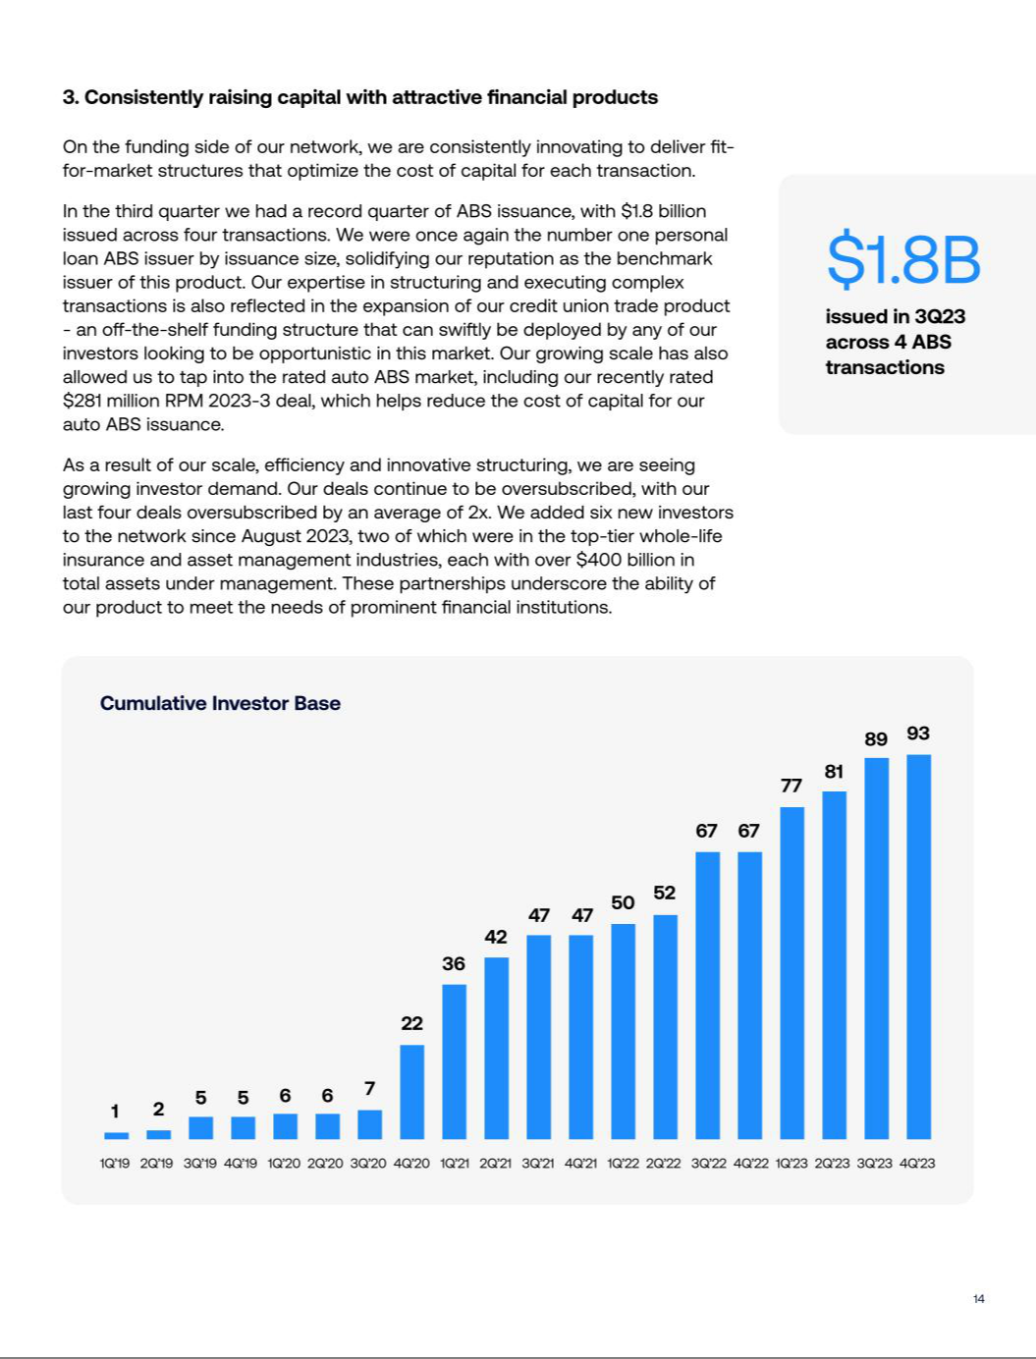

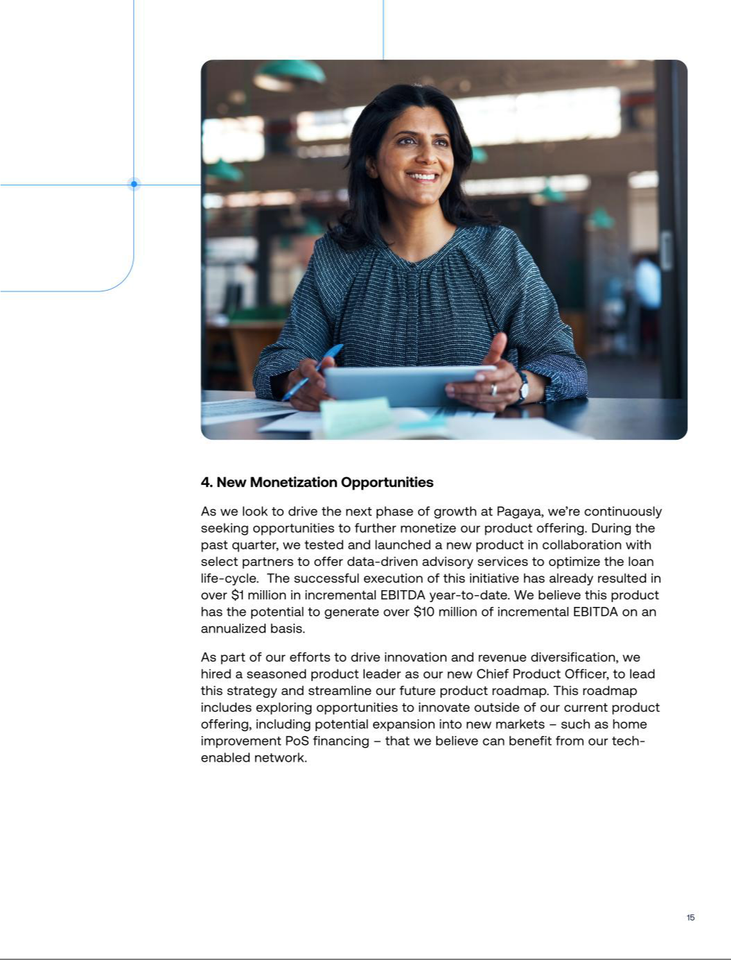



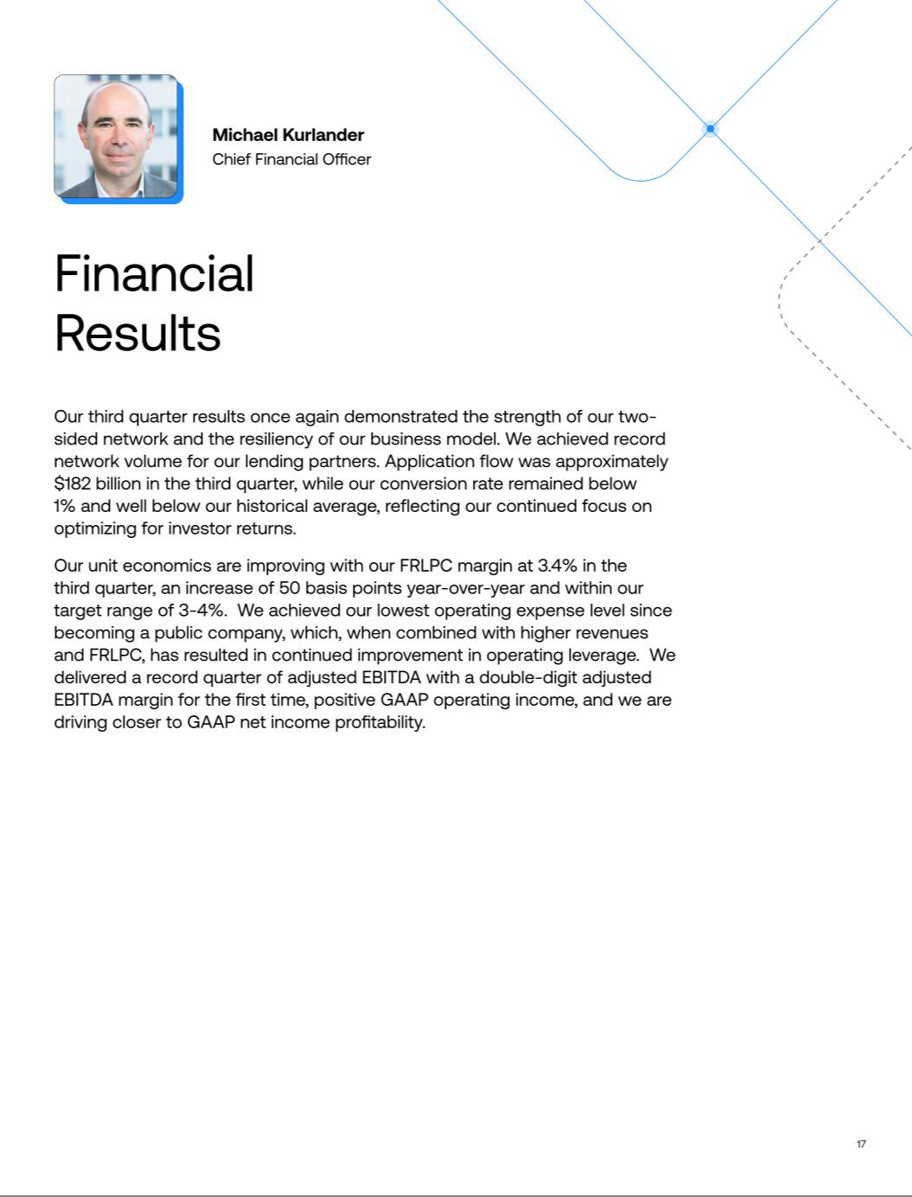

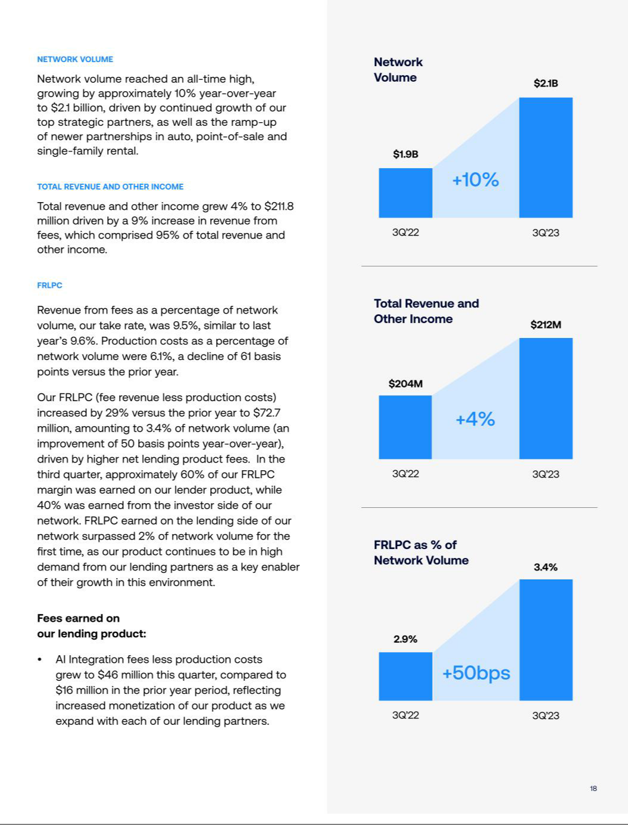

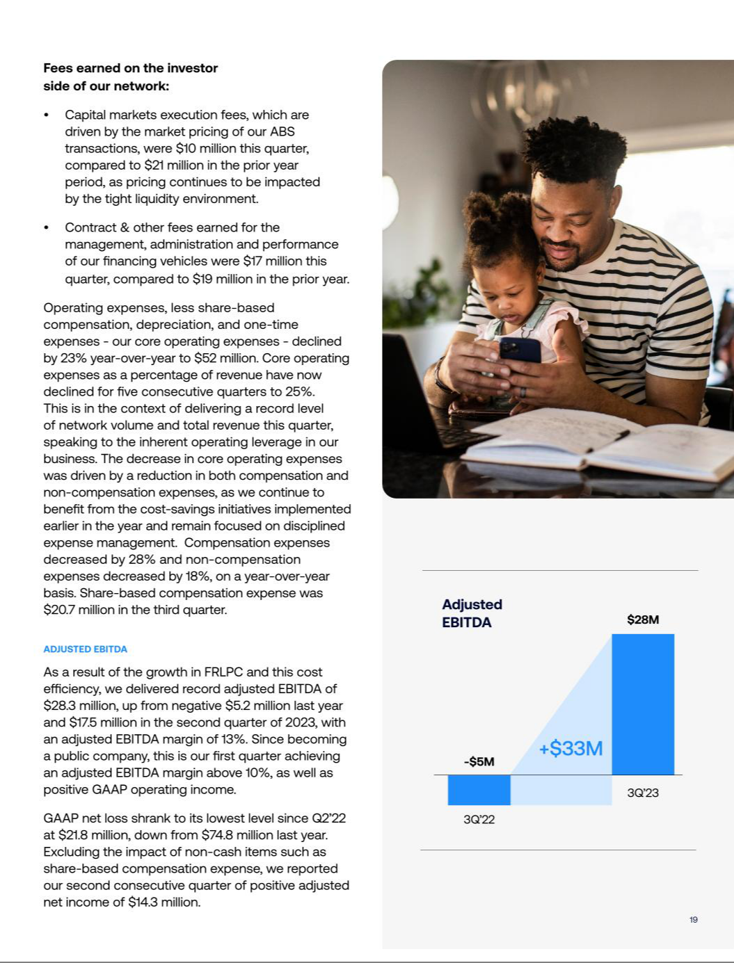

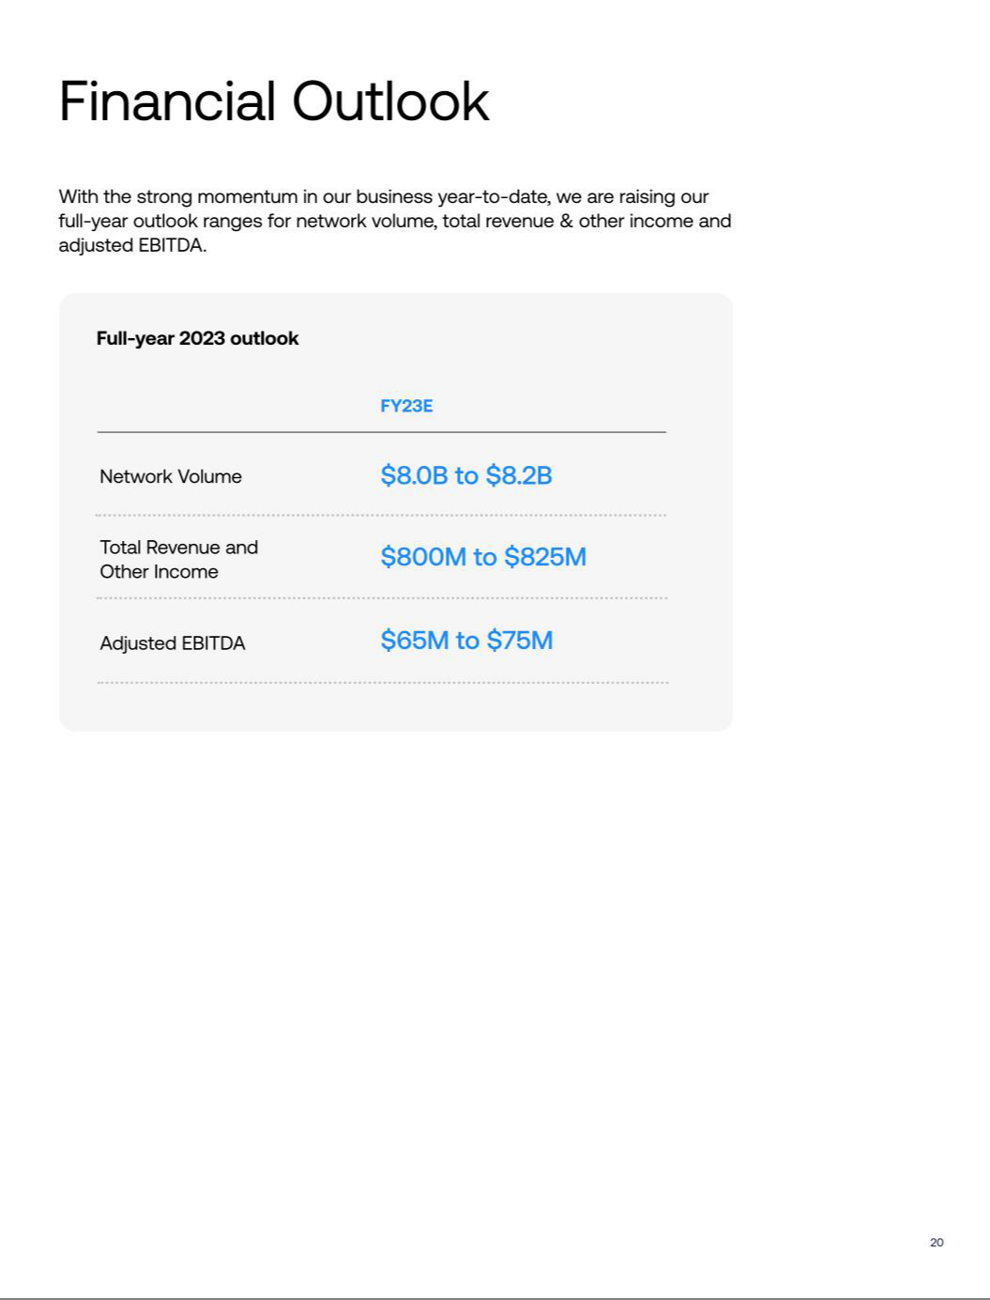

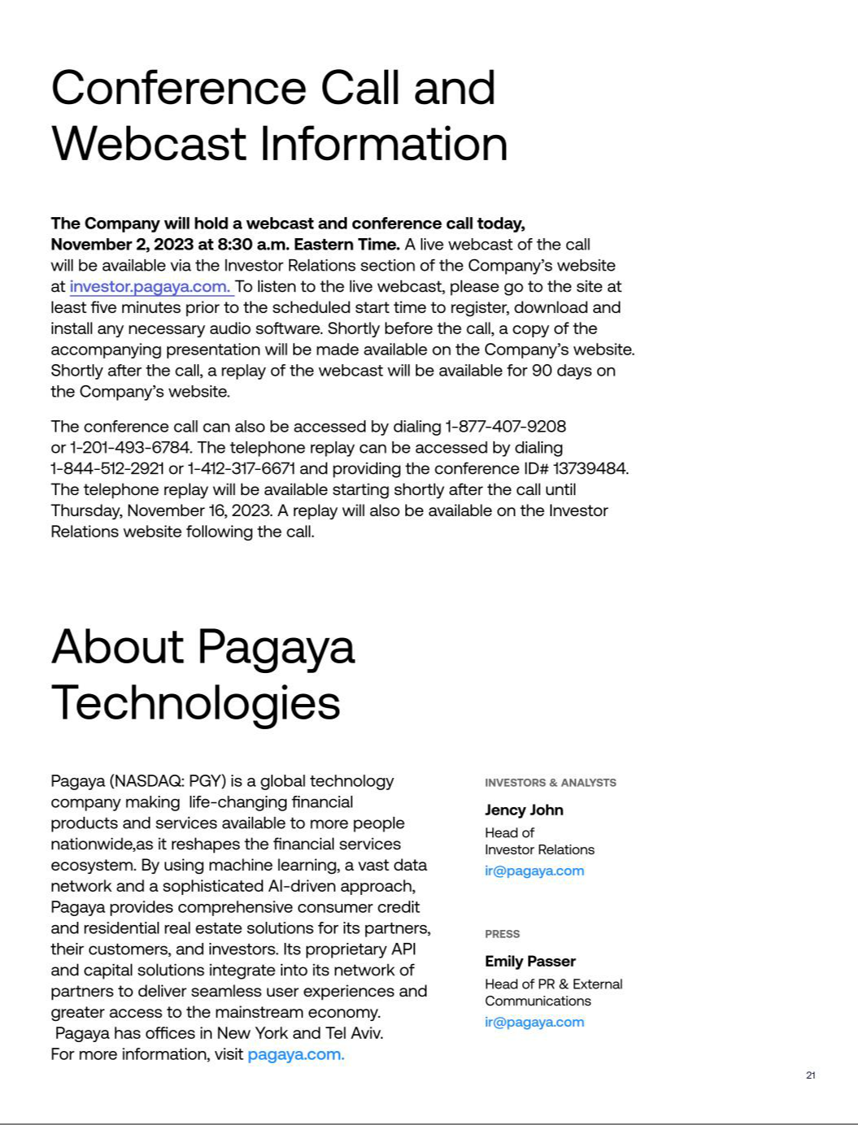

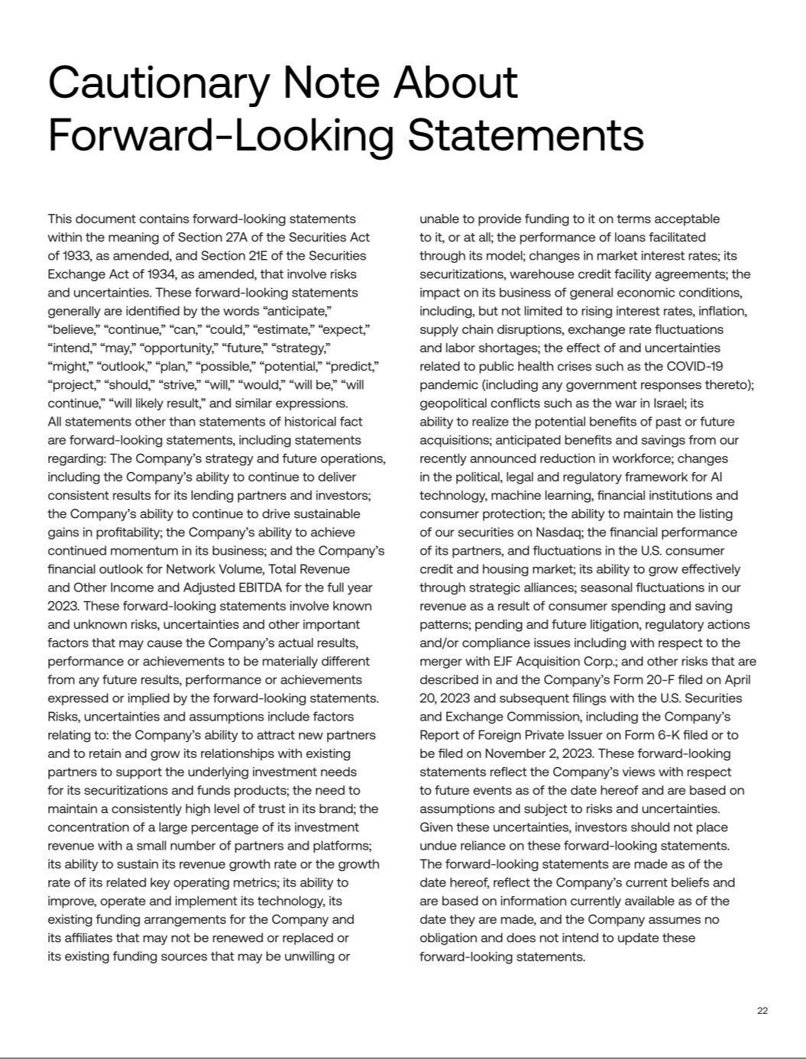

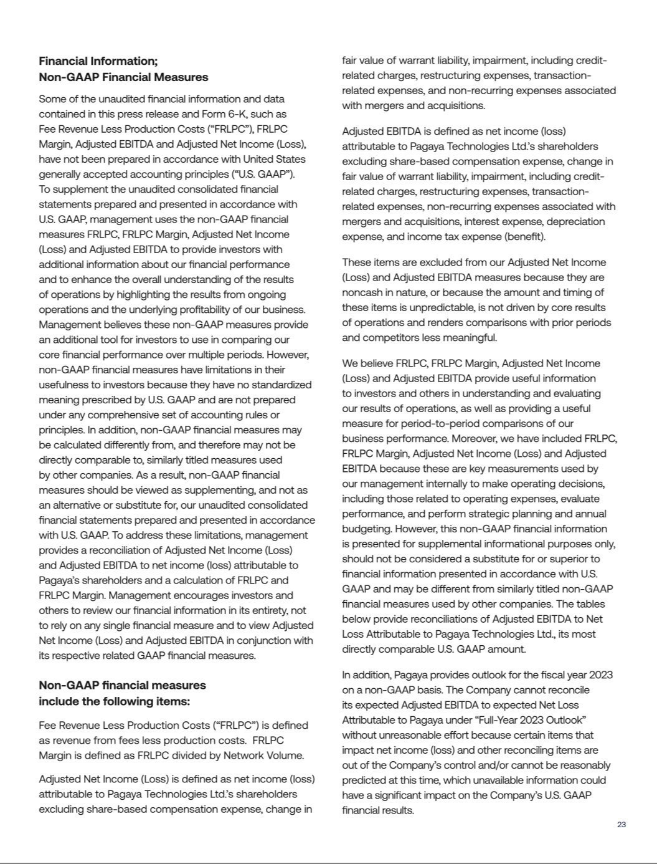

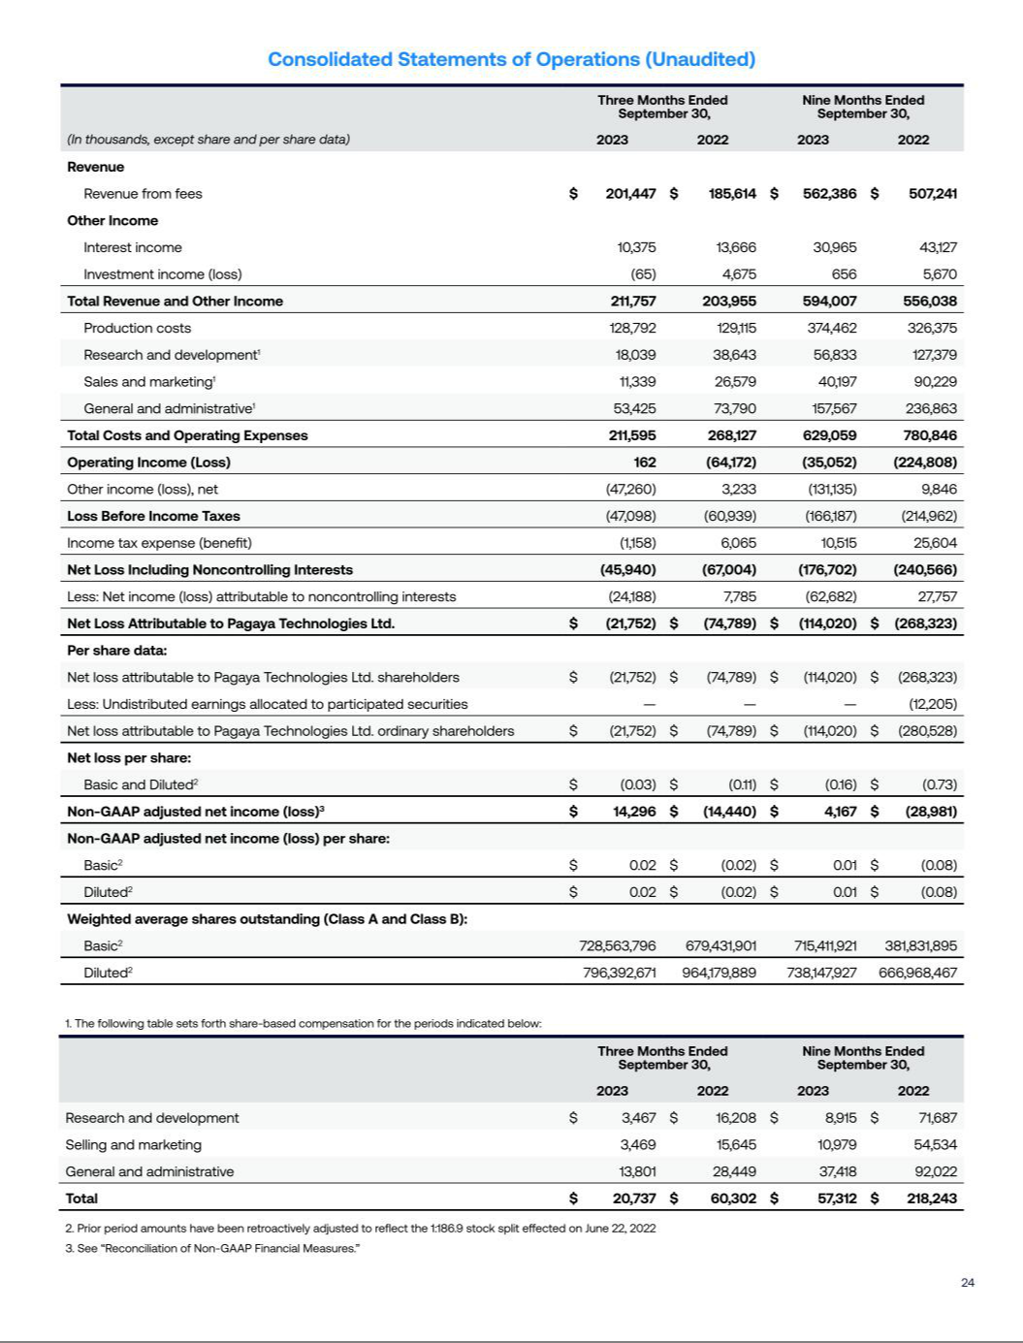

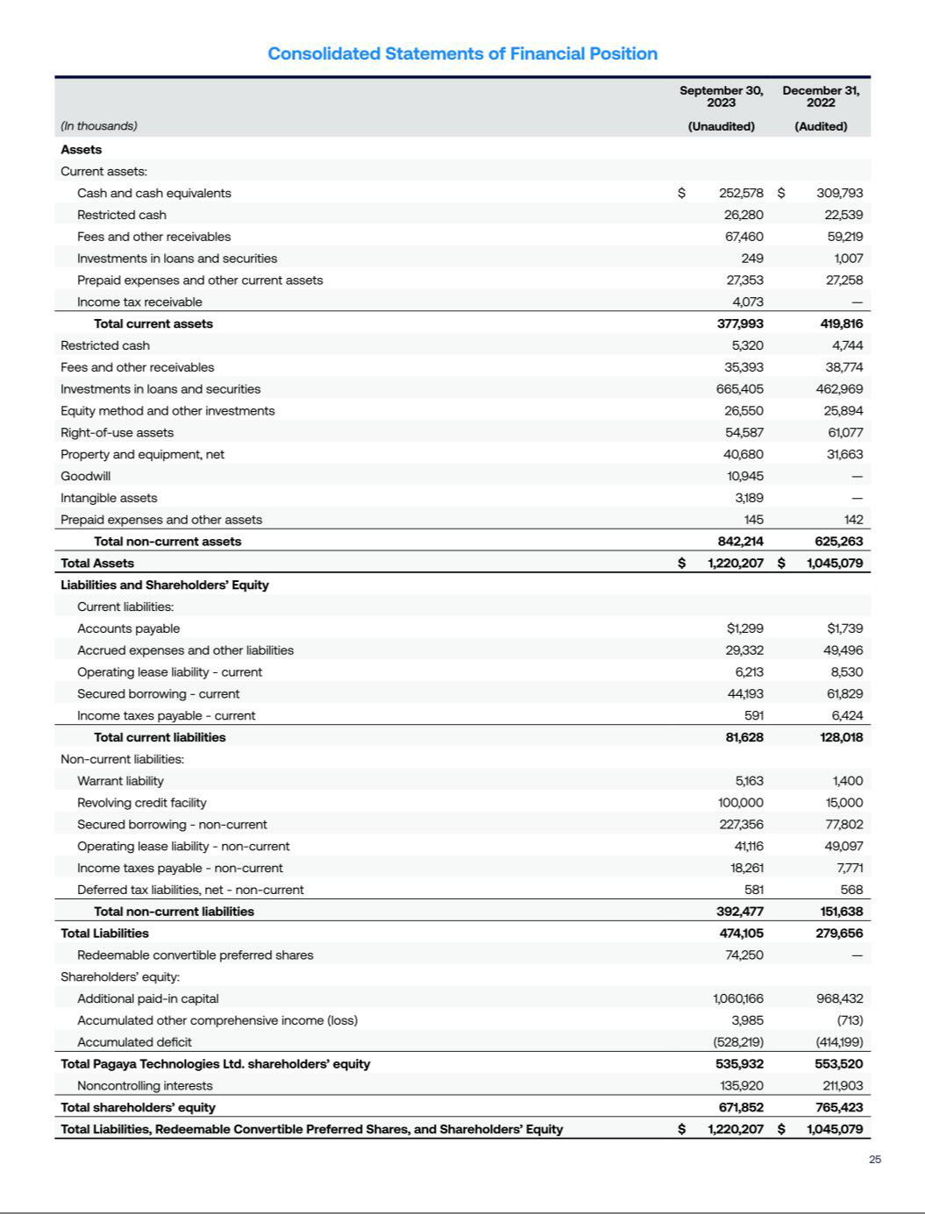

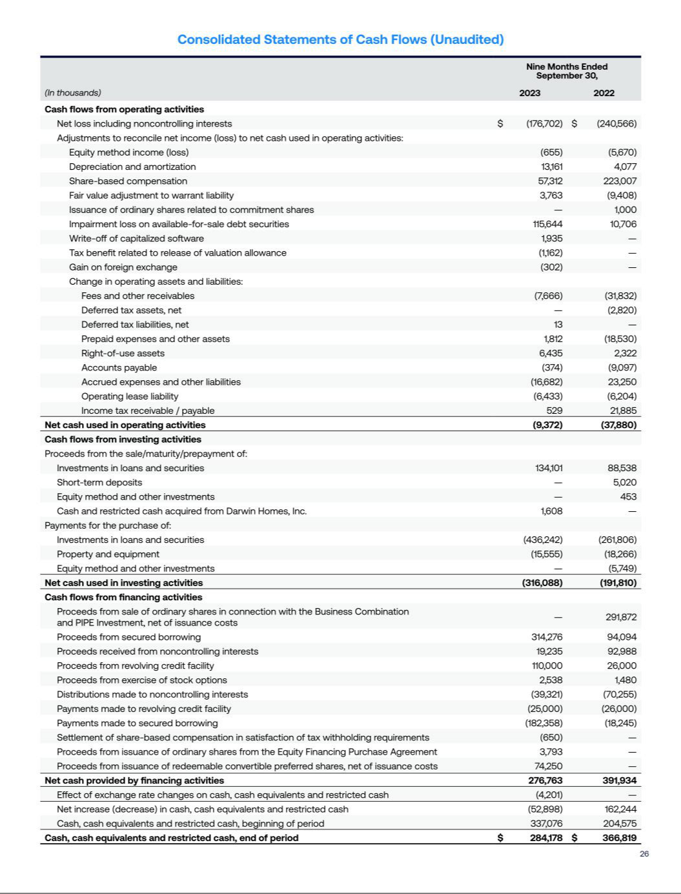

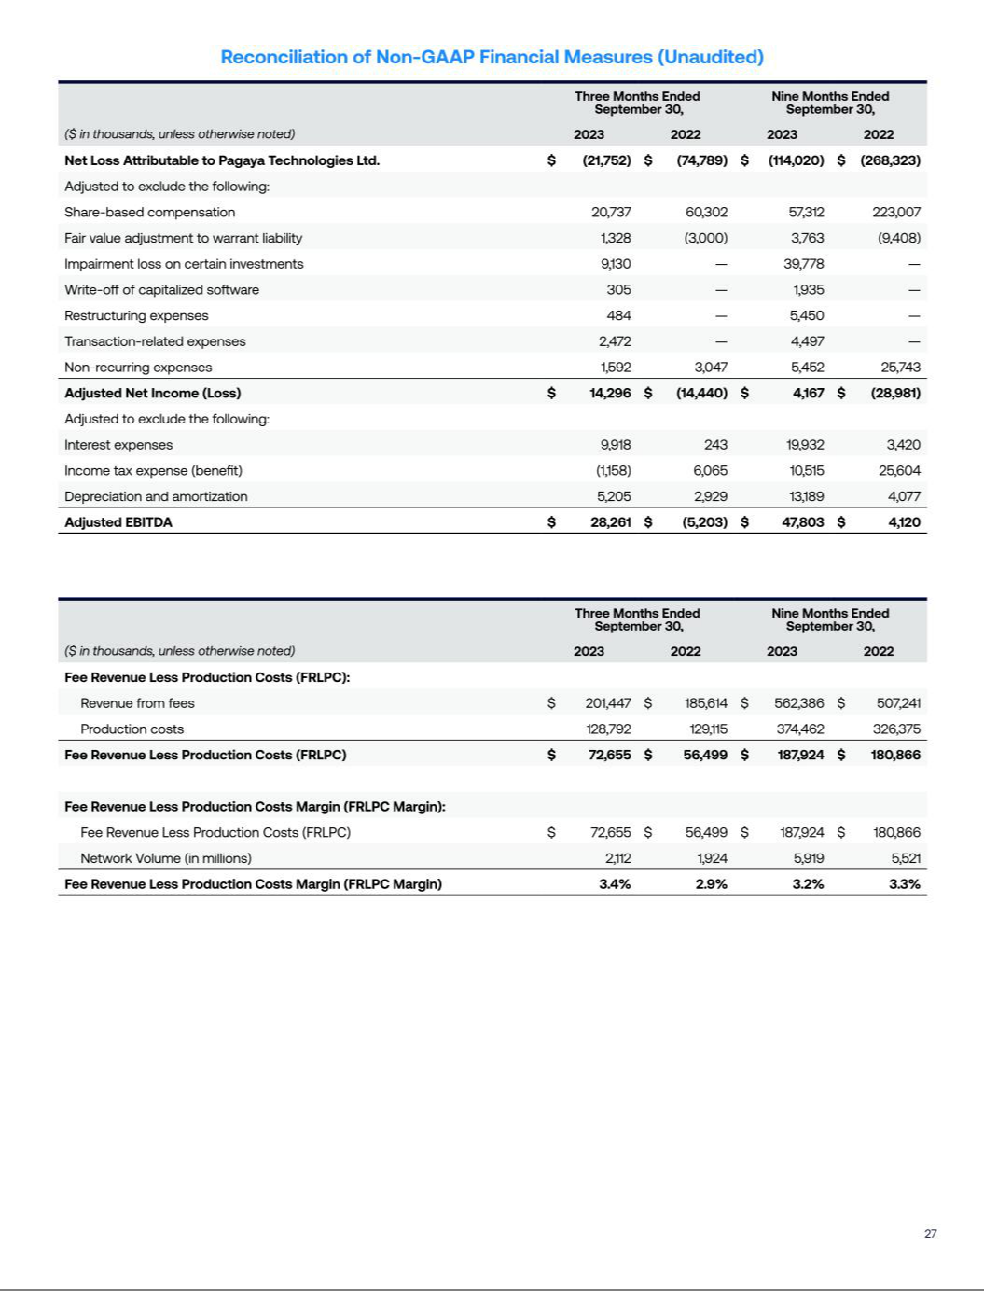

PAGAYA TECHNOLOGIES LTD.

CONDENSED CONSOLIDATED INTERIM STATEMENTS OF FINANCIAL POSITION
AS OF SEPTEMBER 30, 2023 AND DECEMBER 31, 2022 (In thousands)

 |  | September 30, |  |  | December 31,
 |  | 2023 |  |  | 2022
Assets |  | (Unaudited) |  |  | (Audited)
Current assets:
Cash and cash equivalents | $ | 252,578 |  | $ | 309,793
Restricted cash |  | 26,280 |  |  | 22,539
Fees and other receivables (including related party receivables of $50,934 and $49,427 as of September 30, 2023 and December 31, 2022, respectively) |  | 67,460 |  |  | 59,219
Investments in loans and securities |  | 249 |  |  | 1,007
Prepaid expenses and other current assets (including related party assets of $18,395 and $18,783 as of September 30, 2023 and December 31, 2022, respectively) |  | 27,353 |  |  | 27,258
Income tax receivable |  | 4,073 |  |  | —
Total current assets |  | 377,993 |  |  | 419,816
Restricted cash |  | 5,320 |  |  | 4,744
Fees and other receivables (including related party receivables of $34,980 and $38,332 as of September 30, 2023 and December 31, 2022, respectively) |  | 35,393 |  |  | 38,774
Investments in loans and securities |  | 665,405 |  |  | 462,969
Equity method and other investments |  | 26,550 |  |  | 25,894
Right-of-use assets |  | 54,587 |  |  | 61,077
Property and equipment, net |  | 40,680 |  |  | 31,663
Goodwill |  | 10,945 |  |  | —
Intangible assets |  | 3,189 |  |  | —
Prepaid expenses and other assets |  | 145 |  |  | 142
Total non-current assets |  | 842,214 |  |  | 625,263
Total Assets | $ | 1,220,207 |  | $ | 1,045,079
Liabilities and Shareholders’ Equity
Current liabilities:
Accounts payable | $ | 1,299 |  | $ | 1,739
Accrued expenses and other liabilities (including related party liabilities of $668 and $636 as of September 30, 2023 and December 31, 2022, respectively) |  | 29,332 |  |  | 49,496
Operating lease liability - current |  | 6,213 |  |  | 8,530
Secured borrowing - current |  | 44,193 |  |  | 61,829
Income taxes payable - current |  | 591 |  |  | 6,424
Total current liabilities |  | 81,628 |  |  | 128,018
Non-current liabilities:
Warrant liability |  | 5,163 |  |  | 1,400
Revolving credit facility |  | 100,000 |  |  | 15,000
Secured borrowing - non-current |  | 227,356 |  |  | 77,802
Operating lease liability - non-current |  | 41,116 |  |  | 49,097
Income taxes payable - non-current |  | 18,261 |  |  | 7,771
Deferred tax liabilities, net - non-current |  | 581 |  |  | 568
Total non-current liabilities |  | 392,477 |  |  | 151,638
Total Liabilities |  | 474,105 |  |  | 279,656
Redeemable convertible preferred shares, no par value, 80,000,000 shares authorized, 60,000,000 shares issued and outstanding as of September 30, 2023; aggregate liquidation preference of $150,000 as of
September 30, 2023. |  | 74,250 |  |  | —
Shareholders’ equity:
Class A ordinary shares, no par value, 8,000,000,000 shares authorized, 561,622,225 and 508,377,199 shares issued and outstanding as of September 30, 2023 and December 31, 2022, respectively. |  | — |  |  | —
Class B ordinary shares, no par value, 2,000,000,000 shares authorized, 151,827,730 and 174,934,392 shares issued and outstanding as of September 30, 2023 and December 31, 2022, respectively. |  | — |  |  | —
Additional paid-in capital |  | 1,060,166 |  |  | 968,432
Accumulated other comprehensive income (loss) |  | 3,985 |  |  | (713)
Accumulated deficit |  | (528,219) |  |  | (414,199)
Total Pagaya Technologies Ltd. shareholders’ equity |  | 535,932 |  |  | 553,520
Noncontrolling interests |  | 135,920 |  |  | 211,903
Total shareholders’ equity |  | 671,852 |  |  | 765,423
Total Liabilities, Redeemable Convertible Preferred Shares, and Shareholders’ Equity | $ | 1,220,207 |  | $ | 1,045,079

1

PAGAYA TECHNOLOGIES LTD.

UNAUDITED CONDENSED CONSOLIDATED INTERIM STATEMENTS OF OPERATIONS
FOR THREE AND NINE MONTHS ENDED SEPTEMBER 30, 2023 AND 2022
(In thousands, except share and per share data)

 |  | Three Months Ended September 30, |  |  |  |  |  | Nine Months Ended September 30,
 |  | 2023 |  |  | 2022 |  |  | 2023 |  |  | 2022
Revenue
Revenue from fees (including related party revenues of $157,590 and $171,300 for the three months ended
September 30, 2023 and 2022, respectively, and $459,581 and $492,300 for the nine months ended September 30, | $ | 201,447 |  | $ | 185,614 |  | $ | 562,386 |  | $ | 507,241
2023 and 2022) | $ | 201,447 |  | $ | 185,614 |  | $ | 562,386 |  | $ | 507,241
Other Income
Interest income |  | 10,375 |  |  | 13,666 |  |  | 30,965 |  |  | 43,127
Investment income (loss) (1) |  | (65) |  |  | 4,675 |  |  | 656 |  |  | 5,670
Total Revenue and Other Income |  | 211,757 |  |  | 203,955 |  |  | 594,007 |  |  | 556,038
Production costs |  | 128,792 |  |  | 129,115 |  |  | 374,462 |  |  | 326,375
Research and development |  | 18,039 |  |  | 38,643 |  |  | 56,833 |  |  | 127,379
Sales and marketing |  | 11,339 |  |  | 26,579 |  |  | 40,197 |  |  | 90,229
General and administrative |  | 53,425 |  |  | 73,790 |  |  | 157,567 |  |  | 236,863
Total Costs and Operating Expenses |  | 211,595 |  |  | 268,127 |  |  | 629,059 |  |  | 780,846
Operating Income (Loss) |  | 162 |  |  | (64,172) |  |  | (35,052) |  |  | (224,808)
Other income (loss), net |  | (47,260) |  |  | 3,233 |  |  | (131,135) |  |  | 9,846
Loss Before Income Taxes |  | (47,098) |  |  | (60,939) |  |  | (166,187) |  |  | (214,962)
Income tax expense (benefit) |  | (1,158) |  |  | 6,065 |  |  | 10,515 |  |  | 25,604
Net Loss Including Noncontrolling Interests |  | (45,940) |  |  | (67,004) |  |  | (176,702) |  |  | (240,566)
Less: Net income (loss) attributable to noncontrolling interests |  | (24,188) |  |  | 7,785 |  |  | (62,682) |  |  | 27,757
Net Loss Attributable to Pagaya Technologies Ltd. | $ | (21,752) |  | $ | (74,789) |  | $ | (114,020) |  | $ | (268,323)
Per share data:
Net loss attributable to Pagaya Technologies Ltd. shareholders | $ | (21,752) |  | $ | (74,789) |  | $ | (114,020) |  | $ | (268,323)
Less: Undistributed earnings allocated to participated securities |  | — |  |  | — |  |  | — |  |  | (12,205)
Net loss attributable to Pagaya Technologies Ltd. ordinary shareholders | $ | (21,752) |  | $ | (74,789) |  | $ | (114,020) |  | $ | (280,528)
Net loss per share attributable to Pagaya Technologies Ltd.:
Basic and Diluted (2) | $ | (0.03) |  | $ | (0.11) |  | $ | (0.16) |  | $ | (0.73)
Weighted average shares outstanding:
Basic and Diluted (2) |  | 728,563,796 |  |  | 679,431,901 |  |  | 715,411,921 |  |  | 381,831,895

(1) Includes income from proprietary investments.

(2) Prior period amounts have been retroactively adjusted to reflect the 1:186.9 stock split effected on June 22, 2022.

2

PAGAYA TECHNOLOGIES LTD.

UNAUDITED CONDENSED CONSOLIDATED INTERIM STATEMENTS OF COMPREHENSIVE INCOME (LOSS)
FOR THREE AND NINE MONTHS ENDED SEPTEMBER 30, 2023 AND 2022
(In thousands)

 | Three Months Ended September 30, |  |  |  |  |  |  | Nine Months Ended September 30,
 | 2023 |  |  |  | 2022 |  |  | 2023 |  |  | 2022
Net Loss Including Noncontrolling Interests | $ | (45,940) |  | $ | (67,004) |  | $ | (176,702) |  | $ | (240,566)
Other Comprehensive Income:
Unrealized gain on securities available for sale, net |  | 5,084 |  |  | — |  |  | 27,911 |  |  | —
Comprehensive Loss Including Noncontrolling Interests | $ | (40,856) |  | $ | (67,004) |  | $ | (148,791) |  | $ | (240,566)
Less: Comprehensive income (loss) attributable to noncontrolling interests |  | (21,126) |  |  | 7,785 |  |  | (39,469) |  |  | 27,757
Comprehensive Loss Attributable to Pagaya Technologies Ltd. | $ | (19,730) |  | $ | (74,789) |  | $ | (109,322) |  | $ | (268,323)

3

PAGAYA TECHNOLOGIES LTD.

UNAUDITED CONDENSED CONSOLIDATED INTERIM STATEMENTS OF CHANGES IN REDEEMABLE CONVERTIBLE PREFERRED SHARES AND SHAREHOLDERS’ EQUITY FOR THREE AND NINE MONTHS ENDED SEPTEMBER 30, 2023 AND 2022

(In thousands, except share amounts)

 | Redeemable Convertible |  |  |  |  | Ordinary Shares |  |  |  |  |  |  |  |  |  |  |  |  |  |  | Total Pagaya
 |  |  |  |  |  |  |  |  |  |  |  |  |  |  | Accumulated Other |  | Retained Earnings |  |  |  | Technologies Ltd.
 | Preferred Shares |  |  |  |  | (Class A and Class B)
 |  |  |  |  |  |  |  |  |  |  |  | Additional |  |  | Comprehensive |  |  | (Accumulated |  | Shareholders’ Equity |  |  | Non-Controlling |  |  | Total Shareholders’
 | Shares(1) |  |  | Amount |  | Shares(1) |  | Amount |  |  | Paid-In Capital |  |  |  | Income (Loss) |  |  | Deficit) |  |  | (Deficit) |  |  | Interests |  |  | Equity
Balance – June 30, 2023 | 60,000,000 |  | $ | 74,250 |  | 708,909,068 |  | $ | — |  | $ | 1,027,687 |  | $ | 1,963 |  | $ | (506,467) |  | $ | 523,183 |  | $ | 179,940 |  | $ | 703,123
Issuance of ordinary shares upon exercise of |  |  |  |  |  | 2,075,050 |  |  | — |  |  | 1,108 |  |  |  |  |  |  |  |  | 1,108 |  |  |  |  |  | 1,108
share options |  |  |  |  |  | 2,075,050 |  |  |  |  |  | 1,108 |  |  |  |  |  |  |  |  | 1,108 |  |  |  |  |  | 1,108
Issuance of ordinary shares upon vesting of |  |  |  |  |  | 602,816 |  |  | — |  |  |  |  |  |  |  |  |  |  |  | — |  |  |  |  |  | —
RSUs |  |  |  |  |  | 602,816 |  |  |  |  |  |  |  |  |  |  |  |  |  |  |  |  |  |  |  |  | —
Issuance of ordinary shares in connection with |  |  |  |  |  | 128,182 |  |  |  |  |  | — |  |  |  |  |  |  |  |  | — |  |  |  |  |  | —
the acquisition of Darwin Homes, Inc. |  |  |  |  |  | 128,182 |  |  |  |  |  |  |  |  |  |  |  |  |  |  |  |  |  |  |  |  | —
Issuance of ordinary shares from the Equity |  |  |  |  |  | 1,734,839 |  |  |  |  |  | 3,793 |  |  |  |  |  |  |  |  | 3,793 |  |  |  |  |  | 3,793
Financing Purchase Agreement |  |  |  |  |  | 1,734,839 |  |  |  |  |  | 3,793 |  |  |  |  |  |  |  |  | 3,793 |  |  |  |  |  | 3,793
Share-based compensation |  |  |  |  |  |  |  |  |  |  |  | 23,177 |  |  |  |  |  |  |  |  | 23,177 |  |  |  |  |  | 23,177
Reversal of issuance costs associated with the |  |  |  |  |  |  |  |  |  |  |  | 4,401 |  |  |  |  |  |  |  |  | 4,401 |  |  |  |  |  | 4,401
Business Combination and PIPE Investment |  |  |  |  |  |  |  |  |  |  |  | 4,401 |  |  |  |  |  |  |  |  | 4,401 |  |  |  |  |  | 4,401
Contributions of interests in consolidated VIEs |  |  |  |  |  |  |  |  |  |  |  |  |  |  |  |  |  |  |  |  | — |  |  | 3,942 |  |  | 3,942
Return of capital to interests in consolidated |  |  |  |  |  |  |  |  |  |  |  |  |  |  |  |  |  |  |  |  | — |  |  | (26,836) |  |  | (26,836)
VIEs |  |  |  |  |  |  |  |  |  |  |  |  |  |  |  |  |  |  |  |  |  |  |  | (26,836) |  |  | (26,836)
Other comprehensive income (loss) |  |  |  |  |  |  |  |  |  |  |  |  |  |  | 2,022 |  |  |  |  |  | 2,022 |  |  | 3,062 |  |  | 5,084
Net income (loss) |  |  |  |  |  |  |  |  |  |  |  |  |  |  |  |  |  | (21,752) |  |  | (21,752) |  |  | (24,188) |  |  | (45,940)
Balance – September 30, 2023 | 60,000,000 |  | $ | 74,250 |  | 713,449,955 |  | $ | — |  | $ | 1,060,166 |  | $ | 3,985 |  | $ | (528,219) |  | $ | 535,932 |  | $ | 135,920 |  | $ | 671,852

4

 | Redeemable Convertible |  |  |  |  | Ordinary Shares |  |  |  |  |  |  |  |  |  |  |  |  |  |  | Total Pagaya
 |  |  |  |  |  |  |  |  |  |  |  |  |  |  | Accumulated Other |  | Retained Earnings |  |  |  | Technologies Ltd.
 | Preferred Shares |  |  |  |  | (Class A and Class B)
 |  |  |  |  |  |  |  |  |  |  |  | Additional |  |  | Comprehensive |  |  | (Accumulated |  | Shareholders’ Equity |  |  | Non-Controlling |  |  | Total Shareholders’
 | Shares(1) |  |  | Amount |  | Shares(1) |  | Amount |  |  | Paid-In Capital |  |  |  | Income (Loss) |  |  | Deficit) |  |  | (Deficit) |  |  | Interests |  |  | Equity
Balance – December 31, 2022 | — |  | $ | — |  | 683,311,591 |  | $ | — |  | $ | 968,432 |  | $ | (713) |  | $ | (414,199) |  | $ | 553,520 |  | $ | 211,903 |  | $ | 765,423
Issuance of ordinary shares upon exercise of |  |  |  |  |  | 195,655 |  |  | — |  |  |  |  |  |  |  |  |  |  |  | — |  |  |  |  |  | —
warrants |  |  |  |  |  | 195,655 |  |  |  |  |  |  |  |  |  |  |  |  |  |  |  |  |  |  |  |  | —
Issuance of ordinary shares upon exercise of |  |  |  |  |  | 6,464,223 |  |  | — |  |  | 2,538 |  |  |  |  |  |  |  |  | 2,538 |  |  |  |  |  | 2,538
share options |  |  |  |  |  | 6,464,223 |  |  |  |  |  | 2,538 |  |  |  |  |  |  |  |  | 2,538 |  |  |  |  |  | 2,538
Issuance of ordinary shares upon vesting of |  |  |  |  |  | 3,433,719 |  |  | — |  |  |  |  |  |  |  |  |  |  |  | — |  |  |  |  |  | —
RSUs |  |  |  |  |  | 3,433,719 |  |  |  |  |  |  |  |  |  |  |  |  |  |  |  |  |  |  |  |  | —
Issuance of preferred shares, net of issuance | 60,000,000 |  |  | 74,250 |  | — |  |  |  |  |  | — |  |  |  |  |  |  |  |  | — |  |  |  |  |  | —
costs of $750 | 60,000,000 |  |  | 74,250 |  |  |  |  |  |  |  |  |  |  |  |  |  |  |  |  |  |  |  |  |  |  | —
Share-based compensation |  |  |  |  |  |  |  |  |  |  |  | 62,868 |  |  |  |  |  |  |  |  | 62,868 |  |  |  |  |  | 62,868
Reversal of issuance costs associated with the |  |  |  |  |  |  |  |  |  |  |  | 4,401 |  |  |  |  |  |  |  |  | 4,401 |  |  |  |  |  | 4,401
Business Combination and PIPE Investment |  |  |  |  |  |  |  |  |  |  |  | 4,401 |  |  |  |  |  |  |  |  | 4,401 |  |  |  |  |  | 4,401
Issuance of ordinary shares in connection with |  |  |  |  |  | 18,309,928 |  |  | — |  |  | 18,134 |  |  |  |  |  |  |  |  | 18,134 |  |  |  |  |  | 18,134
the acquisition of Darwin Homes, Inc. |  |  |  |  |  | 18,309,928 |  |  |  |  |  | 18,134 |  |  |  |  |  |  |  |  | 18,134 |  |  |  |  |  | 18,134
Issuance of ordinary shares from the Equity |  |  |  |  |  | 1,734,839 |  |  |  |  |  | 3,793 |  |  |  |  |  |  |  |  | 3,793 |  |  |  |  |  | 3,793
Financing Purchase Agreement |  |  |  |  |  | 1,734,839 |  |  |  |  |  | 3,793 |  |  |  |  |  |  |  |  | 3,793 |  |  |  |  |  | 3,793
Reclassification of warrants |  |  |  |  |  |  |  |  |  |  |  | — |  |  |  |  |  |  |  |  | — |  |  |  |  |  | —
Reclassification of investments |  |  |  |  |  |  |  |  |  |  |  |  |  |  | (1,881) |  |  |  |  |  | (1,881) |  |  | 18,341 |  |  | 16,460
Contributions of interests in consolidated VIEs |  |  |  |  |  |  |  |  |  |  |  |  |  |  |  |  |  |  |  |  | — |  |  | 19,235 |  |  | 19,235
Return of capital to interests in consolidated |  |  |  |  |  |  |  |  |  |  |  |  |  |  |  |  |  |  |  |  | — |  |  | (55,749) |  |  | (55,749)
VIEs |  |  |  |  |  |  |  |  |  |  |  |  |  |  |  |  |  |  |  |  |  |  |  | (55,749) |  |  | (55,749)
Other comprehensive income (loss) |  |  |  |  |  |  |  |  |  |  |  |  |  |  | 6,579 |  |  |  |  |  | 6,579 |  |  | 4,872 |  |  | 11,451
Net income (loss) |  |  |  |  |  |  |  |  |  |  |  |  |  |  |  |  |  | (114,020) |  |  | (114,020) |  |  | (62,682) |  |  | (176,702)
Balance – September 30, 2023 | 60,000,000 |  | $ | 74,250 |  | 713,449,955 |  | $ | — |  | $ | 1,060,166 |  | $ | 3,985 |  | $ | (528,219) |  | $ | 535,932 |  | $ | 135,920 |  | $ | 671,852

5

 | Redeemable Convertible |  |  |  |  |  |  |  |  |  |  |  |  |  |  |  |  |  |  |  |  |  | Total Pagaya
 |  |  |  |  |  |  |  |  |  |  |  |  |  |  |  |  | Accumulated Other |  | Retained Earnings |  |  |  | Technologies Ltd. |  |  | Non-
 | Preferred Shares |  |  |  |  |  |  | Ordinary Shares
 |  |  |  |  |  |  |  |  |  |  |  |  |  | Additional |  |  | Comprehensive |  |  | (Accumulated |  | Shareholders’ Equity |  |  |  | Controlling |  | Total Shareholders’
 | Shares(1) |  |  | Amount |  |  |  | Shares(1) |  | Amount |  |  | Paid-In Capital |  |  |  | Income (Loss) |  |  | Deficit) |  |  | (Deficit) |  |  | Interests |  |  | Equity
Balance – June 30, 2022 |  |  |  |  |  |  |  | 653,914,375 |  | $ | — |  | $ | 878,255 |  | $ | — |  | $ | (305,412) |  | $ | 572,843 |  | $ | 172,193 |  | $ | 745,036
Issuance of ordinary shares upon exercise of |  |  |  |  |  |  |  | 21,170,017 |  |  |  |  |  |  |  |  |  |  |  |  |  |  | — |  |  |  |  |  | —
warrants |  |  |  |  |  |  |  | 21,170,017 |  |  |  |  |  |  |  |  |  |  |  |  |  |  |  |  |  |  |  |  | —
Issuance of ordinary shares upon exercise of share |  |  |  |  |  |  |  | 5,573,732 |  |  |  |  |  | 1,034 |  |  |  |  |  |  |  |  | 1,034 |  |  |  |  |  | 1,034
options |  |  |  |  |  |  |  | 5,573,732 |  |  |  |  |  | 1,034 |  |  |  |  |  |  |  |  | 1,034 |  |  |  |  |  | 1,034
Issuance of ordinary shares upon vesting of RSUs |  |  |  |  |  |  |  | 91,655 |  |  |  |  |  |  |  |  |  |  |  |  |  |  | — |  |  |  |  |  | —
Issuance of ordinary shares related to commitment |  |  |  |  |  |  |  | 46,536 |  |  |  |  |  | 1,000 |  |  |  |  |  |  |  |  | 1,000 |  |  |  |  |  | 1,000
shares |  |  |  |  |  |  |  | 46,536 |  |  |  |  |  | 1,000 |  |  |  |  |  |  |  |  | 1,000 |  |  |  |  |  | 1,000
Share-based compensation |  |  |  |  |  |  |  |  |  |  |  |  |  | 67,092 |  |  |  |  |  |  |  |  | 67,092 |  |  |  |  |  | 67,092
Contributions of interests in consolidated VIEs |  |  |  |  |  |  |  |  |  |  |  |  |  |  |  |  |  |  |  |  |  |  | — |  |  | 63,466 |  |  | 63,466
Return of capital to interests in consolidated VIEs |  |  |  |  |  |  |  |  |  |  |  |  |  |  |  |  |  |  |  |  |  |  | — |  |  | (16,894) |  |  | (16,894)
Net income (loss) |  |  |  |  |  |  |  |  |  |  |  |  |  |  |  |  |  |  |  | (74,789) |  |  | (74,789) |  |  | 7,785 |  |  | (67,004)
Balance – September 30, 2022 |  | — $ |  |  | — |  |  | 680,796,315 |  | $ | — |  | $ | 947,381 |  | $ | — |  | $ | (380,201) |  | $ | 567,180 |  | $ | 226,550 |  | $ | 793,730

6

 | Redeemable Convertible |  |  |  |  |  |  |  |  |  |  |  |  |  |  |  |  |  |  |  | Total Pagaya
 |  |  |  |  |  |  |  |  |  |  |  |  |  |  | Accumulated Other |  | Retained Earnings |  |  |  | Technologies Ltd. |  |  | Non-
 | Preferred Shares |  |  |  |  | Ordinary Shares
 |  |  |  |  |  |  |  |  |  |  |  | Additional |  |  | Comprehensive |  |  | (Accumulated |  | Shareholders’ Equity |  |  |  | Controlling |  | Total Shareholders’
 | Shares(1) |  |  | Amount |  | Shares(1) |  | Amount |  |  | Paid-In Capital |  |  |  | Income (Loss) |  |  | Deficit) |  |  | (Deficit) |  |  | Interests |  |  | Equity
Balance – December 31, 2021 | 406,399,029 |  | $ | 307,047 |  | 194,345,791 |  | $ | — |  | $ | 113,170 |  | $ | — |  | $ | (111,878) |  | $ | 1,292 |  | $ | 176,060 |  | $ | 177,352
Issuance of ordinary shares upon exercise of |  |  |  |  |  | 21,170,017 |  |  |  |  |  |  |  |  |  |  |  |  |  |  | — |  |  |  |  |  | —
warrants |  |  |  |  |  | 21,170,017 |  |  |  |  |  |  |  |  |  |  |  |  |  |  |  |  |  |  |  |  | —
Issuance of ordinary shares upon exercise of share |  |  |  |  |  | 15,606,239 |  |  |  |  |  | 1,480 |  |  |  |  |  |  |  |  | 1,480 |  |  |  |  |  | 1,480
options |  |  |  |  |  | 15,606,239 |  |  |  |  |  | 1,480 |  |  |  |  |  |  |  |  | 1,480 |  |  |  |  |  | 1,480
Issuance of ordinary shares upon vesting of RSUs |  |  |  |  |  | 96,326 |  |  |  |  |  |  |  |  |  |  |  |  |  |  | — |  |  |  |  |  | —
Issuance of ordinary shares related to |  |  |  |  |  | 46,536 |  |  |  |  |  | 1,000 |  |  |  |  |  |  |  |  | 1,000 |  |  |  |  |  | 1,000
commitment shares |  |  |  |  |  | 46,536 |  |  |  |  |  | 1,000 |  |  |  |  |  |  |  |  | 1,000 |  |  |  |  |  | 1,000
Issuance of ordinary shares in connection with the
Business Combination and PIPE Investment, net | (406,399,029) |  |  | (307,047) |  | 449,531,406 |  |  |  |  |  | 581,359 |  |  |  |  |  |  |  |  | 581,359 |  |  |  |  |  | 581,359
of issuance costs of $57,400 | (406,399,029) |  |  | (307,047) |  | 449,531,406 |  |  |  |  |  | 581,359 |  |  |  |  |  |  |  |  | 581,359 |  |  |  |  |  | 581,359
Share-based compensation |  |  |  |  |  |  |  |  |  |  |  | 229,797 |  |  |  |  |  |  |  |  | 229,797 |  |  |  |  |  | 229,797
Reclassification of warrants |  |  |  |  |  |  |  |  |  |  |  | 20,575 |  |  |  |  |  |  |  |  | 20,575 |  |  |  |  |  | 20,575
Contributions of interests in consolidated VIEs |  |  |  |  |  |  |  |  |  |  |  |  |  |  |  |  |  |  |  |  | — |  |  | 92,988 |  |  | 92,988
Return of capital to interests in consolidated VIEs |  |  |  |  |  |  |  |  |  |  |  |  |  |  |  |  |  |  |  |  | — |  |  | (70,255) |  |  | (70,255)
Net income (loss) |  |  |  |  |  |  |  |  |  |  |  |  |  |  |  |  |  | (268,323) |  |  | (268,323) |  |  | 27,757 |  |  | (240,566)
Balance – September 30, 2022 | — |  | $ | — |  | 680,796,315 |  | $ | — |  | $ | 947,381 |  | $ | — |  | $ | (380,201) |  | $ | 567,180 |  | $ | 226,550 |  | $ | 793,730

- Prior period amounts have been retroactively adjusted to reflect the 1:186.9 stock split effected on June 22, 2022.

7

PAGAYA TECHNOLOGIES LTD.

UNAUDITED CONDENSED CONSOLIDATED INTERIM STATEMENTS OF CASH FLOWS

FOR NINE MONTHS ENDED SEPTEMBER 30, 2023 AND 2022 (In thousands)

 | Nine Months Ended September 30,
 | 2023 |  |  | 2022
Cash flows from operating activities
Net loss including noncontrolling interests | $ | (176,702) |  | $ | (240,566)
Adjustments to reconcile net income (loss) to net cash used in operating activities:
Equity method income (loss) |  | (655) |  |  | (5,670)
Depreciation and amortization |  | 13,161 |  |  | 4,077
Share-based compensation |  | 57,312 |  |  | 223,007
Fair value adjustment to warrant liability |  | 3,763 |  |  | (9,408)
Write-off of capitalized software |  | 1,935 |  |  | —
Issuance of ordinary shares related to commitment shares |  | — |  |  | 1,000
Impairment loss on available-for-sale debt securities |  | 115,644 |  |  | 10,706
Tax benefit related to release of valuation allowance |  | (1,162) |  |  | —
Gain on foreign exchange |  | (302) |  |  | —
Change in operating assets and liabilities:
Fees and other receivables |  | (7,666) |  |  | (31,832)
Deferred tax assets, net |  | — |  |  | (2,820)
Deferred tax liabilities, net |  | 13 |  |  | —
Prepaid expenses and other assets |  | 1,812 |  |  | (18,530)
Right-of-use assets |  | 6,435 |  |  | 2,322
Accounts payable |  | (374) |  |  | (9,097)
Accrued expenses and other liabilities |  | (16,682) |  |  | 23,250
Operating lease liability |  | (6,433) |  |  | (6,204)
Income tax receivable / payable |  | 529 |  |  | 21,885
Net cash used in operating activities |  | (9,372) |  |  | (37,880)
Cash flows from investing activities
Proceeds from the sale/maturity/prepayment of:
Investments in loans and securities |  | 134,101 |  |  | 88,538
Short-term deposits |  | — |  |  | 5,020
Equity method and other investments |  | — |  |  | 453
Cash and restricted cash acquired from Darwin Homes, Inc. |  | 1,608 |  |  | —
Payments for the purchase of:
Investments in loans and securities |  | (436,242) |  |  | (261,806)
Property and equipment |  | (15,555) |  |  | (18,266)
Equity method and other investments |  | — |  |  | (5,749)
Net cash used in investing activities |  | (316,088) |  |  | (191,810)
Cash flows from financing activities
Proceeds from sale of ordinary shares in connection with the Business Combination and PIPE Investment, net of issuance costs |  | — |  |  | 291,872
Proceeds from secured borrowing |  | 314,276 |  |  | 94,094
Proceeds received from noncontrolling interests |  | 19,235 |  |  | 92,988
Proceeds from revolving credit facility |  | 110,000 |  |  | 26,000
Proceeds from exercise of stock options |  | 2,538 |  |  | 1,480
Distributions made to noncontrolling interests |  | (39,321) |  |  | (70,255)
Payments made to revolving credit facility |  | (25,000) |  |  | (26,000)
Payments made to secured borrowing |  | (182,358) |  |  | (18,245)
Settlement of share-based compensation in satisfaction of tax withholding requirements |  | (650) |  |  | —
Proceeds from issuance of ordinary shares from the Equity Financing Purchase Agreement |  | 3,793 |  |  | —
Proceeds from issuance of redeemable convertible preferred shares, net of issuance costs |  | 74,250 |  |  | —
Net cash provided by financing activities |  | 276,763 |  |  | 391,934
Effect of exchange rate changes on cash, cash equivalents and restricted cash |  | (4,201) |  |  | —
Net increase (decrease) in cash, cash equivalents and restricted cash |  | (52,898) |  |  | 162,244
Cash, cash equivalents and restricted cash, beginning of period |  | 337,076 |  |  | 204,575
Cash, cash equivalents and restricted cash, end of period | $ | 284,178 |  | $ | 366,819

8

Reconciliation of cash, cash equivalents, and restricted cash within the consolidated statements of financial position to the amounts shown in the statements of cash flow above:
Cash and cash equivalents | $ | 252,578 |  | $ | 327,896
Restricted cash - current |  | 26,280 |  |  | 34,161
Restricted cash - non-current |  | 5,320 |  |  | 4,762
Total cash, cash equivalents, and restricted cash | $ | 284,178 |  | $ | 366,819

9

PAGAYA’S MANAGEMENT’S DISCUSSION AND ANALYSIS OF

FINANCIAL CONDITION AND RESULTS OF OPERATIONS

You should read the following discussion and analysis of our financial condition and results of operations together with the unaudited condensed consolidated interim financial statements as of and for the three and nine months ended September 30, 2023 and 2022 included as Exhibit 99.3 to the Report of Foreign Private Issuer on Form 6-K furnished with the Securities and Exchange Commission (the “SEC”) on November 2, 2023 (the “Report”) and the historical audited annual consolidated financial statements as of and for the years ended December 31, 2022 and 2021, and the related notes included in our Annual Report on Form 20-F filed with the SEC on April 20, 2023 (“our Annual Report on Form 20-F”). Some of the information contained in this discussion and analysis, including information with respect to our plans and strategy for our business and related financing, includes forward-looking statements that involve risks and uncertainties. As a result of many factors, including those factors set forth in the “Risk Factors” section of our Annual Report on Form 20-F and our Reports of Foreign Private Issuer on Form 6-K furnished with the SEC and the “Risk Factors” section set forth below in this Exhibit 99.4, our actual results could differ materially from the results described in or implied by the forward-looking statements contained in the following discussion and analysis. In this section “we,” “us,” “our” and “Pagaya” refer to Pagaya Technologies Ltd.

Company Overview

Pagaya makes life-changing financial products and services available to more people.

We have built, and we are continuing to scale, a leading AI and data network for the benefit of financial services and other service providers, their customers, and investors. Services providers integrated in our network, which we refer to as our ‘‘Partners,’’ range from high-growth financial technology companies to incumbent banks and financial institutions. We believe Partners benefit from our network to extend financial products to their customers, in turn helping those customers fulfill their financial needs. These assets originated by Partners with the assistance of Pagaya’s AI technology are eligible to be acquired by Financing Vehicles: (i) funds managed or advised by Pagaya or one of its affiliates, (ii) securitization vehicles sponsored or administered by Pagaya or one of its affiliates and (iii) other similar vehicles (“Financing Vehicles”).

In recent years, investments in digitization have improved the front-end delivery of financial products, upgrading customer experience and convenience. Notwithstanding these advances, we believe underlying approaches to the determination of creditworthiness for financial products are often outdated and overly manual. In our experience, providers of financial services tend to utilize a limited number of factors to make decisions, operate with siloed technology infrastructure and have data limited to their own experience. As a result, we believe financial services providers approve a smaller proportion of their application volume than is possible with the benefit of modern technology, such as our AI technology and data network.

At our core, we are a technology company that deploys sophisticated data science, machine learning and AI technology to drive better results across the financial ecosystem. We believe our solution drives a “win-win-win” for Partners, their customers and potential customers, and investors. First, by utilizing our network, Partners receive direct benefits from our network by approving more customer applications, which we believe drives superior revenue growth, enhanced brand affinity, opportunities to promote other financial products and decreased unit-level customer acquisition costs. Partners realize these benefits with limited incremental risk or funding requirements. Second, Partners’ customers benefit from enhanced and more convenient access to financial products. Third, investors benefit through gaining exposure to these assets originated by Partners with the assistance of our AI technology and acquired by the Financing Vehicles through our network.

Recent Developments

Acquisition of Darwin Homes, Inc.

On January 5, 2023, we consummated an acquisition pursuant to the certain Merger Agreement (the “Darwin Merger Agreement”), dated as of November 15, 2022, by and among Pagaya, Darwin Homes, Inc., a Delaware corporation (“Darwin”), DH Merger Sub Inc., a Delaware corporation and a direct, wholly owned subsidiary of Pagaya (“Darwin Merger Sub”), and Shareholder Representative Services LLC, a Colorado limited liability
company, acting solely in its capacity as the representative, agent and attorney-in-fact of the stockholders of Darwin. On January 5, 2023, the following transactions occurred pursuant to the terms and conditions of the

Darwin Merger Agreement:

- at the effective time of the merger (the “Darwin Effective Time”), Darwin Merger Sub merged with and into Darwin (the “Darwin Merger”), with Darwin continuing as the surviving company after the Darwin Merger (“Darwin Surviving

1

Company”), and, as a result of the Darwin Merger, the Darwin Surviving Company became a direct, wholly owned subsidiary of Pagaya; and

- at the Darwin Effective Time, preferred shares of Darwin’s capital stock (“Darwin Shares”) issued and outstanding prior to the Darwin Effective Time (other than any Darwin Shares that were (i) subject to options or warrants, (ii) held in Darwin’s treasury or owned by Pagaya, Darwin Merger Sub or Darwin immediately prior to the Darwin Effective Time or (iii) held by the equityholders of Darwin (the “Darwin Equityholders”) who perfected and did not withdraw a demand for appraisal rights pursuant to the applicable provisions of Delaware General Corporation Law), were cancelled and automatically converted into the right to receive Pagaya’s Class A Ordinary Shares, no par value (the “Class A Ordinary Shares”) such that, following the Darwin Effective Time, Pagaya issued approximately 18.2 million Class A Ordinary Shares and may issue an additional approximately 180,000 Class A Ordinary Shares to the Darwin Equityholders.

Reduction in Workforce

On January 18, 2023, we announced a reduction in workforce of approximately 20% of employees across our Israel and U.S. offices, as compared to our headcount as of December 31, 2022. This reduction in workforce is expected to enable us to streamline our operations in the current market environment to achieve our near-to-medium term growth priorities. The affected employees were notified on or before January 17, 2023, and all actions associated with the reduction were substantially completed in the first quarter of 2023.

We expect that this reduction in workforce will result in approximately $30 million of annualized cost savings. We incurred a severance-related charge of approximately $4 million, consisting primarily of one-time separation payments, in the first quarter of 2023. We may also incur other charges, costs or cash expenditures not currently contemplated due to events that may occur as a result of, or associated with, the reduction in
workforce. See “Item 3.D.—Risk Factors—Our recent reduction in workforce, announced on January 18, 2023, may not result in anticipated savings or operational efficiencies, could result in total costs and expenses that are greater than expected, and could disrupt our business” in our Annual Report on Form 20-F.

Amended Letter Agreement

Pursuant to the Letter Agreement, dated June 1, 2020, we agreed to provide Radiance Star Pte. Ltd. (“Radiance”), an affiliate of GIC Private Limited, the right to purchase up to a certain amount of qualified securities in certain offerings by us and to provide Radiance with notice of any fund offerings or securitization offerings. On March 19, 2023, we and Radiance agreed to extend the term of this letter agreement by three years (the “Amended Letter Agreement”) to June 1, 2028 on the same terms and amount, including the issuance of 2,640,000 warrants to purchase the Class A Ordinary Shares at an exercise price of $0.01 that vest annually if certain investment thresholds by Radiance are met. There were no other material changes to the existing terms of the letter agreement.

Series A Preferred Share Purchase Agreement

On April 14, 2023 we entered into a Preferred Share Purchase Agreement (the “Purchase Agreement”) with Oak HC/FT Partners V, L.P., Oak HC/FT Partners V-A, L.P. and Oak HC/FT Partners V-B, L.P (together, the “Investor”) pursuant to which we agreed, subject to Shareholder Approval (as defined below), to issue and sell to the Investor an aggregate of 60,000,000 Series A Preferred Shares, no par value (the “Series A Preferred Shares”), at a price of $1.25 per share (subject to applicable adjustment as provided in the A&R Articles) (as defined below), for an aggregate purchase price of $75 million (the “Transaction”). Subject to shareholder approval of certain Amended and Restated Articles of Association of Pagaya (the “A&R Articles”), the Series A Preferred Shares will have the rights and preferences set forth in the A&R Articles. Pursuant to the A&R Articles, there are 80,000,000 authorized Series A Preferred Shares and we may issue and sell the balance of the authorized but unissued Series A Preferred Shares from time to time in the future.

The Investor is affiliated with Oak HC/FT Partners II, L.P. (“Oak”), an entity that holds approximately 12% of the Class A Ordinary Shares and approximately 3% of the voting power of Pagaya as of the date of the Purchase Agreement. Mr. Dan Petrozzo, a member of our board of directors (“Pagaya Board”) and the Audit Committee of the Pagaya Board, is a partner at Oak. Following their review of applicable considerations pursuant to our policies and applicable Israeli law, the disinterested members of the Audit Committee and of the Pagaya Board approved the Purchase Agreement and the exhibits, schedules and ancillary documents thereto, and the Pagaya Board recommended to our shareholders to adopt the A&R Articles and approve the Transaction and the matters contemplated thereby. As required by the Purchase Agreement and Israeli law, a meeting of shareholders was held on May 24, 2023 and the transaction was completed the following day.

2

In connection with the execution of the Purchase Agreement, Gal Krubiner, Avital Pardo and Yahav Yulzari, our three founders, entered into a voting agreement (the “Voting Agreement”) with the Company, pursuant to which the founders agreed to vote at a meeting of the shareholders (i) in favor of (a) the adoption of the A&R Articles and (b) any other matter reasonably necessary to the consummation of the Transaction and considered and voted upon by our shareholders, and (ii) against any action, proposal, transaction or agreement that could reasonably be expected to impede, interfere with, delay, discourage, adversely affect or inhibit the timely consummation of the Transaction.

The foregoing does not purport to be a complete description of the rights and obligations of the parties to the Purchase Agreement and is qualified in its entirety by reference to the Purchase Agreement, a copy of which is attached as Exhibit 4.17 to our Annual Report on Form 20-F. The foregoing description of the terms pertaining to the Series A Preferred Shares is not complete and is qualified in its entirety by reference to the A&R Articles, a copy of which is attached as an exhibit to the Purchase Agreement. The foregoing description of the Voting Agreement is not complete and is qualified in its entirety by reference to the Voting Agreement, a copy of which is attached as Exhibit 4.18 to our Annual Report on Form 20-F. Also, see the Form 6-K filed with the SEC on April 20, 2023.

Evolving War in Israel

On October 7, 2023, a terrorist organization primarily based in the Gaza Strip launched a series of attacks on Israel, including in areas where our employees and independent contractors are located. As a result of such attack, on October 8, 2023, Israel officially declared war. Israel’s military response has included, among other things, calling on a large number of army reservists, including approximately 15% of Pagaya employees based in Israel as of the date of this Report.

While the Company’s business operations have not been materially impacted due to this evolving conflict as of the date of this Report, our business, financial condition, results of operations and prospects may be adversely affected due to the ongoing nature of this conflict. Pagaya’s technology infrastructure, including its data, cloud and platform, are located in the United States, with backup systems in place. As a two-sided lending network, Pagaya has experienced no disruption as of the date of this Report, either from its lending partners or investors.

See the section entitled “Risk Factors” included in our Annual Report on Form 20-F, any updates in our Reports of Foreign Private Issuer on Form 6-K, and the section entitled “Risk Factors” set forth below in this Exhibit 99.4 to the Report.

Emerging Growth Company Status

We qualify as an “emerging growth company,” as defined in Section 2(a) of the Securities Act of 1933, as amended (the “Securities Act”), as modified by the Jumpstart Our Business Startups Act of 2012 (the “JOBS Act”). As such, we are eligible to take advantage of certain exemptions from various reporting requirements that are applicable to other public companies that are not “emerging growth companies,” including, but not limited to, not being required to comply with the auditor attestation requirements of Section 404 of the Sarbanes-Oxley Act of 2002 (the “Sarbanes-Oxley Act”), reduced disclosure obligations regarding executive compensation in our periodic reports and proxy statements, and exemptions from the requirements of holding a non-binding advisory vote on executive compensation and shareholder approval of any golden parachute payments not previously approved. If some investors find our securities less attractive as a result, there may be a less active trading market for our securities and the prices of our securities may be more volatile.

Further, Section 102(b)(1) of the JOBS Act exempts emerging growth companies from being required to comply with new or revised financial accounting standards until private companies (that is, those that have not had a Securities Act registration statement declared effective or do not have a class of securities registered under the Securities Exchange Act of 1934, as amended (the “Exchange Act”)) are required to comply with the new or revised financial accounting standards. The JOBS Act provides that a company can elect to opt out of the extended transition period and comply with the requirements that apply to non-emerging growth companies but any such election to opt out is irrevocable. We have elected not to opt out of such extended transition period, which means that when a standard is issued or revised and it has different application dates for public or private companies, we, as an emerging growth company, can adopt the new or revised standard at the time private companies adopt the new or revised standard. This may make comparison of our financial statements with certain other public companies difficult or impossible because of the potential differences in accounting standards used.

We will remain an emerging growth company until the earlier of: (i) the last day of the fiscal year (a) following the fifth anniversary of June 22, 2022, (b) in which we have an annual total gross revenue of at least $1.235 billion, or (c) in which we are deemed to be a large accelerated filer, which means the market value of our ordinary equity that is held by non-affiliates exceeds $700 million as of the last business day of the second fiscal quarter of such fiscal year; and (ii) the date on which we have issued more than $1 billion in non-convertible debt securities during the prior three-year period. References herein to “emerging growth company” have the meaning associated with it in the JOBS Act.

3

Foreign Private Issuer Exemptions

We report as a “foreign private issuer” under U.S. Securities and Exchange Commission rules. Consequently, we are subject to the reporting requirements under the Exchange Act applicable to foreign private issuers. As a result, we are not required to file our annual report on Form 20-F until 120 days after the end of each fiscal year and we will furnish reports on Form 6-K to the SEC regarding certain information required to be publicly disclosed by us in Israel or that is distributed or required to be distributed by us to our shareholders. Based on our foreign private issuer status, we will not be required to (i) file periodic reports and financial statements with the SEC as frequently or as promptly as a U.S. company whose securities are registered under the Exchange Act, (ii) comply with Regulation FD, which addresses certain restrictions on the selective disclosure of material information or (iii) comply with SEC rules relating to proxy solicitation in connection with shareholder meetings and presentation of shareholder proposals. In addition, among other matters, based on our foreign private issuer status, our officers, directors and principal shareholders will be exempt from the reporting and “short-swing” profit recovery provisions of Section 16 of the Exchange Act and the rules under the Exchange Act with respect to their purchases and sales of the Ordinary Shares.

Our Economic Model

Pagaya’s revenues are primarily derived from Network Volume. We define Network Volume as the gross dollar value of assets originated by our Partners¹ with the assistance of our artificial intelligence (“AI”) technology² and, with respect to single family residential real estate operations, the gross dollar value of services, which may include the value of newly onboarded properties onto our Darwin platform. We generate revenue from network AI fees, contract fees, interest income and investment income. Revenue from fees is comprised of network AI fees and contract fees. Network AI fees can be further broken down into two fee streams: AI integration fees and capital markets execution fees.

We primarily earn AI integration fees for the creation and delivery of the assets that comprise our Network Volume.

Capital markets execution and contract fees are primarily earned from investors. Multiple funding channels are utilized to enable the purchase of network assets from our Partners, such as asset backed securitizations (“ABS”). Capital markets execution fees are primarily earned from the market pricing of ABS transactions while contract fees are management, performance and similar fees.

Additionally, we earn interest income from our risk retention holdings and our corporate cash balances and investment income associated with our ownership interests in certain Financing Vehicles and other proprietary investments.

We incur costs when Network Volume is acquired by the Financing Vehicles. These costs, which we refer to as ‘‘Production Costs,’’ compensate our Partners for acquiring and originating assets. Accordingly, the amount and growth of our Production Costs are highly correlated to Network Volume.

Additionally, we have built what we believe to be a leading data science and AI organization that has enabled us to assist our Partners as they make decisions to extend credit to consumers or for the identification and purchase, or property management, of single-family residential properties. Headcount, technology overhead and research and development expenses represent the significant portion of our expenses outside of Production Costs.

Key Factors Affecting Our Performance

Expanded Usage of Our Network by Our Existing Partners

Our AI technology enables certain Partners to convert a larger proportion of their application volume into originated loans, enabling them to expand their ecosystem and generate incremental revenues. Our Partners have historically seen rapid scaling of origination volume on our network shortly after onboarding and the contribution of Pagaya’s network to Partners’ total origination volume tends to increase over time.

- “Partners” refers to financial institutions including, among others, banks, peer-to-peer lending networks, online marketplaces, non-bank finance companies, fintechs, financing intermediaries, consumer product companies, brokers, agents and credit unions that have entered into arrangements to utilize Pagaya’s AI technology and network to assist them in creating and originating credit and other assets that may be acquired by a Financing Vehicle.

- Our proprietary technology uses machine learning models as a subset of artificial intelligence that go through extensive testing, validation, and governance processes before they can be used or modified. The machine learning models are static and do not have the ability to self-correct, self-improve, and/or learn over time. Any change to the models requires human intervention, testing, validation, and governance approvals before a change can be made.

4

Adoption of Our Network by Partners

We devote significant time to, and have a team that focuses on, onboarding and managing Partners to our network. We believe that our success in adding new Partners to our network is driven by our distinctive value proposition: driving significant revenue uplift to our Partners at limited incremental cost or credit risk to the Partner. Our success adding new Partners has contributed to our overall Network Volume growth and driven our ability to rapidly scale new asset classes. In 2022, we onboarded six new Partners, including Klarna and Ally Financial. Approximately $800 million of Network Volume was generated by new Partners and channels on our network in the first nine months of 2023.

Continued Improvements to Our AI Technology

We believe our historical growth has been significantly influenced by improvements to our AI technology, which are in turn driven both by the deepening of our proprietary data network and the strengthening of our AI technology. As our existing Partners grow their usage of our network, new Partners join our network, and as we expand our network into new asset classes, the value of our data asset increases. Our technology improvements thus benefit from a flywheel effect that is characteristic of AI technology, in that improvements are derived from a continually increasing base of training data for our technology. We have found, and we expect to continue to experience, that more data leads to more efficient pricing and greater Network Volume. Since inception, we have evaluated more than $1.5 trillion in application volume.

In addition to the accumulation of data, we make improvements to our technology by leveraging the experience of our research and development specialists. Our research team is central to accelerating the sophistication of our AI technology and expanding into new markets and use cases. We are reliant on these experts’ success in making these improvements to our technology over time.

Availability and Pricing of Funding from Investors

In a sustained high interest rate environment, the availability and pricing of funding from investors is critical to our growth, as Financing Vehicles only acquire an asset if funding is available for that specific asset. We continue to seek to diversify funding channels and counterparties as our business grows. Since the beginning of 2019, we have raised more than $18 billion from investors, but the availability of funding is not guaranteed and is subject to market conditions.

Performance of Assets Originated with the Assistance of Our AI Technology

The availability of funding from investors is a function of demand for consumer credit and residential real estate assets, as well as the performance of such assets originated with the assistance of our AI technology and purchased by Financing Vehicles. Our AI technology and data-driven insights are designed to enable relative outperformance versus the broader market. We believe that investors in Financing Vehicles view our AI technology as an important component in delivering assets that meet their investment criteria. To the extent that assets acquired by the Financing Vehicles underperform investors’ expectations, the availability of funding may be adversely affected. See “Item 3.D.—Risk Factors—Risks Related to the Operations of Our Business” section in our Annual Report on Form 20-F, any updates included in our Reports of Foreign Private Issuer on Form 6-K, and the section entitled “Risk Factors” set forth below in this Exhibit 99.4 to the Report.

Impact of Macroeconomic Cycles and Global and Regional Conditions

We expect economic cycles to affect our financial performance and related metrics. Macroeconomic conditions, including, but not limited to the evolving conflict in Israel, rising interest rates, inflation, supply chain disruptions, labor shortages, bank failures, U.S. deficit concerns, and the Russian invasion of Ukraine, may impact consumer demand for financial products, our Partners’ ability to generate and convert customer application volume, as well as the availability of funding from our investors through the Financing Vehicles. On October 7, 2023, a terrorist organization primarily based in the Gaza Strip launched a series of attacks on Israel, igniting a war with Israel. The conflict is rapidly evolving and developing, and the intensity and duration of the current war and any escalation is difficult to predict, as are its economic impacts on the Company’s business and operations and on regional and global political and economic conditions in general. Although the Company’s business operations have not been materially impacted due to this evolving conflict as of the date of this Report, our business, financial condition, results of operations and prospects may be adversely affected due to the ongoing nature of this conflict. The recent rise in inflation and corresponding rapid rise in interest rates may increase financing costs and adversely impact the ability of borrowers to service their debt, which could lead to deterioration of the credit performance of loans and impact investor returns, and therefore may result in lower demand from investors for assets generated on our platform and lead to constraints on our ability to fund new Network Volume. In addition, rising inflation may create an escalation in our operating costs, including employee compensation, financing costs, and general corporate expenses, which could reduce our cash flow and operating income. As of the date of this report, we have not experienced material impacts to our business performance from inflationary pressure. Higher interest rates often lead to higher payment obligations, which may reduce the ability of borrowers to remain current on their obligations and

5

therefore, lead to increased delinquencies, defaults, customer bankruptcies, charge-offs, and decreasing recoveries. Any impact to investor returns may lead to an adverse impact on our earnings. The increased risk-free rate of return may impact investor demand for risk assets such as consumer credit, which may constrain our ability to raise new funding for Network Volume. While our ability to raise new funding has not been materially impacted, the cost of capital has increased due to the higher interest rate environment which has led to a reduction in conversion ratio to meet investor return hurdles, more than offset by an increase in application volume to our network from our Partners, resulting in net growth in Network Volume this year. We continue to closely monitor the invasion of Ukraine by Russia in February 2022 and its global impacts. While the outcome remains highly uncertain, we do not believe the ongoing Russia-Ukraine conflict will have a material impact on our business and results of operation. However, if the Russia-Ukraine conflict continues or worsens, leading to greater global economic disruptions and uncertainty, our business and results of operations could be materially impacted. Adverse developments that affect financial institutions, transactional counterparties or other third parties, such as bank failures and protracted U.S. federal debt ceiling negotiations, or concerns or speculation about any similar events or risks, could lead to credit downgrades and market-wide liquidity problems, which in turn may cause Partners and their customers and other third parties to become unable to meet their obligations under various types of financial arrangements as well as general disruptions or instability in the financial markets, which may adversely affect our business. A prolonged economic downturn may also adversely affect the performance of assets that Financing Vehicles acquire from our network. At the same time, such events, including the COVID-19 pandemic or the inflationary environment, provide key data that we can utilize to improve our AI technology, and they may also help to validate the outcomes our network drives for both Partners and investors. For a further discussion of uncertainties and other factors that could impact our operating results, see “Item 3.D.—Risk Factors” section in our Annual Report on Form 20-F, any updates included in our Reports of Foreign Private Issuer on Form 6-K, and the section entitled “Risk Factors” set forth below in this Exhibit 99.4 to the Report.

Key Operating Metrics

We collect and analyze operating and financial data of our business to assess our performance, formulate financial projections and make strategic decisions. In addition to total revenues, net operating income (loss), other measures under U.S. GAAP, and certain non-GAAP financial measures (see discussion and reconciliation herein titled “Reconciliation of Non-GAAP Financial Measures.”) The following table sets forth a key operating metric we use to evaluate our business.

 | Three Months Ended September 30, |  |  |  |  |  | Nine Months Ended September 30,
 | 2023 |  |  | 2022 | % Change |  | 2023 |  | 2022 | % Change
 |  |  |  |  | ($ in millions)
Network Volume | $ | 2,112 | $ | 1,924 | 9.8 % $ |  | 5,919 | $ | 5,521 | 7.2%

Network Volume

We believe the Network Volume metric to be a suitable proxy for our overall scale and reach, as we generate revenue primarily on the basis of Network Volume. Network Volume is primarily driven by our relationships with our Partners, and we believe that this has benefited from continuous improvements to our AI technology, enabling our network to more effectively identify assets for acquisition by the Financing Vehicles, thereby providing additional investment opportunities to investors. Network Volume is comprised of assets across several asset classes, including personal loans, auto loans, residential real estate, credit card receivables and point of sale receivables.

Components of Results of Operations

Revenue

We generate revenue from network AI fees, contract fees, interest income and investment income. Network AI fees and contract fees are presented together as Revenue from fees in the consolidated financial statements. Revenue from fees is recognized after applying the five-step model consistent with Financial Accounting Standards Board Accounting Standards Codification (“ASC”) 606, “Revenue from Contracts with Consumers” (“ASC 606”).

Network AI fees. Network AI fees can be further broken down into two fee streams: AI integration fees and capital markets execution fees. We earn AI integration fees for the creation and delivery of the assets that comprise our Network Volume. Multiple funding channels are used to enable the purchase of network assets from our Partners, such as ABS. Capital markets execution fees are earned from the market pricing of ABS transactions.

6

Contract fees. Contract fees primarily include administration and management fees, and performance fees. Administration and management fees are contracted upon the establishment of Financing Vehicles and are earned and collected over their remaining lives. Performance fees are earned when certain Financing Vehicles exceed contractual return hurdles and a significant reversal in the amount of cumulative revenue recognized is not expected to occur.

We also earn interest income from our risk retention holdings and cash balances and investment income associated with our ownership interests in certain Financing Vehicles and other proprietary investments.

Costs and Operating Expenses

Costs and operating expenses consist of Production Costs, research and development expenses, sales and marketing expenses, and general and administrative expenses. Salaries and personnel-related costs, including benefits, bonuses, share-based compensation, and outsourcing comprise a significant component of several of these expense categories. A portion of our non-share-based compensation expense and, to a lesser extent, certain operating expenses (excluding Production Costs) are denominated in the new Israeli shekel (“NIS”), which could result in variability in our operating expenses which are presented in U.S. Dollars.

Production Costs

Production Costs are primarily comprised of expenses incurred when Network Volume is transferred from Partners into Financing Vehicles, as our Partners are responsible for marketing and customer interaction and facilitating the flow of additional application flow. Accordingly, the amount and growth of our Production Costs are highly correlated to Network Volume. Additionally, but to a lesser extent, Production Costs also include expenses incurred to renovate single family residential real estate.

Research and Development

Research and development expenses primarily comprise costs associated with the maintenance and ongoing development of our network and AI technology, including personnel, allocated costs, and other development-related expenses. Research and development costs are expensed as incurred and net of amounts capitalized in accordance with US GAAP. We have invested and believe continued investments in research and development are important to achieving our strategic objectives.

Sales and Marketing

Sales and marketing expenses, related to Partner onboarding, development, and relationship management, as well as capital markets investor engagement and marketing, are comprised primarily of salaries and personnel-related costs, as well as the costs of certain professional services, and allocated overhead. Sales and marketing expenses are expensed as incurred. Sales and marketing expenses in absolute dollars may fluctuate from period to period based on the timing of our investments in our sales and marketing functions. These investments may vary in scope and scale over future periods depending on our pipeline of new Partners and strategic investors.

General and Administrative

General and administrative expenses primarily comprise personnel-related costs for our executives, finance, legal and other administrative functions, insurance costs, professional fees for external legal, accounting and other professional services and allocated overhead costs. General and administrative expenses are expensed as incurred.

Other Income (loss), net

Other Income (loss), net primarily consists of changes in the fair value of warrant liabilities and other non-recurring items, including a credit-related impairment losses on investments in loans and securities.

Income Tax Expense

We account for taxes on income in accordance with ASC 740, “Income Taxes” (“ASC 740”). We are eligible for certain tax benefits in Israel under the Law for the Encouragement of Capital Investments or the Investment Law at a reduced tax rate of 12%. Accordingly, as we generate taxable income in Israel, our effective tax rate is expected to be lower than the standard corporate tax rate for Israeli companies, which is 23%. Our taxable income generated in the United States or derived from other sources in Israel which is not eligible for tax benefits will be subject to the regular corporate tax rate in their respective tax jurisdictions.

7

Net Income Attributable to Noncontrolling Interests

Net income attributable to noncontrolling interests in our consolidated statements of operations is a result of our investments in certain of our consolidated variable interest entities (‘‘VIEs’’) and consists of the portion of the net income of these consolidated entities that is not attributable to us.

8

Results of Operations
The following table sets forth operating results for the periods indicated (in thousands, except share and per share data):
 |  | Three Months Ended September 30, |  |  |  |  |  | Nine Months Ended September 30,
 |  | 2023 |  |  | 2022 |  |  | 2023 |  |  | 2022
Revenue
Revenue from fees | $ | 201,447 |  | $ | 185,614 |  | $ | 562,386 |  | $ | 507,241
Other Income
Interest income |  | 10,375 |  |  | 13,666 |  |  | 30,965 |  |  | 43,127
Investment income (loss) |  | (65) |  |  | 4,675 |  |  | 656 |  |  | 5,670
Total Revenue and Other Income |  | 211,757 |  |  | 203,955 |  |  | 594,007 |  |  | 556,038
Production costs |  | 128,792 |  |  | 129,115 |  |  | 374,462 |  |  | 326,375
Research and development (1) |  | 18,039 |  |  | 38,643 |  |  | 56,833 |  |  | 127,379
Sales and marketing (1) |  | 11,339 |  |  | 26,579 |  |  | 40,197 |  |  | 90,229
General and administrative (1) |  | 53,425 |  |  | 73,790 |  |  | 157,567 |  |  | 236,863
Total Costs and Operating Expenses |  | 211,595 |  |  | 268,127 |  |  | 629,059 |  |  | 780,846
Operating Income (Loss) |  | 162 |  |  | (64,172) |  |  | (35,052) |  |  | (224,808)
Other income (loss), net |  | (47,260) |  |  | 3,233 |  |  | (131,135) |  |  | 9,846
Loss Before Income Taxes |  | (47,098) |  |  | (60,939) |  |  | (166,187) |  |  | (214,962)
Income tax expense (benefit) |  | (1,158) |  |  | 6,065 |  |  | 10,515 |  |  | 25,604
Net Loss |  | (45,940) |  |  | (67,004) |  |  | (176,702) |  |  | (240,566)
Less: Net income (loss) attributable to noncontrolling interests |  | (24,188) |  |  | 7,785 |  |  | (62,682) |  |  | 27,757
Net Loss Attributable to Pagaya Technologies Ltd. | $ | (21,752) |  | $ | (74,789) |  | $ | (114,020) |  | $ | (268,323)
Per share data:
Net loss attributable to Pagaya Technologies Ltd. shareholders | $ | (21,752) |  | $ | (74,789) |  | $ | (114,020) |  | $ | (268,323)
Less: Undistributed earnings allocated to participated securities |  | — |  |  | — |  |  | — |  |  | (12,205)
Net loss attributable to Pagaya Technologies Ltd. ordinary shareholders | $ | (21,752) |  | $ | (74,789) |  | $ | (114,020) |  | $ | (280,528)
Net loss per share attributable to Pagaya Technologies Ltd.:
Basic and Diluted (2) | $ | (0.03) |  | $ | (0.11) |  | $ | (0.16) |  | $ | (0.73)
Non-GAAP adjusted net income (loss) (3) | $ | 14,296 |  | $ | (14,440) |  | $ | 4,167 |  | $ | (28,981)
Non-GAAP adjusted net income (loss) per share:
Basic (2) | $ | 0.02 |  | $ | (0.02) |  | $ | 0.01 |  | $ | (0.08)
Diluted (2) | $ | 0.02 |  | $ | (0.02) |  | $ | 0.01 |  | $ | (0.08)
Weighted average shares outstanding (Class A and Class B):
Basic (2) |  | 728,563,796 |  |  | 679,431,901 |  |  | 715,411,921 |  |  | 381,831,895
Diluted (2) |  | 796,392,671 |  |  | 964,179,889 |  |  | 738,147,927 |  |  | 666,968,467
(1) The following table sets forth share-based compensation for the periods indicated below (in thousands):
 |  | Three Months Ended September 30, |  |  |  |  |  | Nine Months Ended September 30,
 |  | 2023 |  |  | 2022 |  |  | 2023 |  |  | 2022
Research and development | $ | 3,467 |  | $ | 16,208 |  | $ | 8,915 |  | $ | 71,687
Sales and marketing |  | 3,469 |  |  | 15,645 |  |  | 10,979 |  |  | 54,534
General and administrative |  | 13,801 |  |  | 28,449 |  |  | 37,418 |  |  | 92,022
Total share-based compensation in operating expenses | $ | 20,737 |  | $ | 60,302 |  | $ | 57,312 |  | $ | 218,243

9

Share-based compensation for the three and nine months ended September 30, 2022 included compensation of $45.6 million and $171.2 million, respectively, related to the vesting of certain performance-based options, which was included in research and development, sales and marking, and general and administrative expenses.

- Prior period amounts have been retroactively adjusted to reflect the 1:186.9 stock split effected on June 22, 2022.

- See “Reconciliation of Non-GAAP Financial Measures.”

Comparison of Three Months Ended September 30, 2023 and 2022
Total Revenue and Other Income
 | Three Months Ended September 30,
 | 2023 |  |  |  | 2022 |  |  | Change |  | % Change
 |  |  |  |  |  |  |  | (in thousands, except percentages)
Revenue from fees | $ | 201,447 |  | $ | 185,614 |  | $ | 15,833 |  | 9 %
Interest income |  | 10,375 |  |  | 13,666 |  |  | (3,291) |  | (24)%
Investment income (loss) |  | (65) |  |  | 4,675 |  |  | (4,740) |  | (101)%
Total Revenue and Other Income | $ | 211,757 |  | $ | 203,955 |  | $ | 7,802 |  | 4 %

Total revenue and other income, increased by $7.8 million, or 4%, to $211.8 million for the three months ended September 30, 2023 from $204.0 million for the three months ended September 30, 2022. The increase was primarily driven by an increase in revenue from fees, partially offset by decreases in interest income and investment income.

Revenue from fees increased by $15.8 million, or 9%, to $201.4 million for the three months ended September 30, 2023 from $185.6 million for the three months ended September 30, 2022. The increase was primarily due to a $17.7 million increase in Network AI fees, comprised of AI integration fees and capital markets execution fees, from $166.3 million for the three months ended September 30, 2022 to $184.0 million for the three months ended September 30, 2023. The increase in Network AI fees was primarily driven by a favorable impact from AI integration fees earned from contractual fee arrangements with certain Partners which did not exist during three months ended September 30, 2022, coupled with the growth in Network Volume, which increased by 9.8% from $1.9 billion for the three months ended September 30, 2022 to $2.1 billion for the three months ended September 30, 2023. These increases were partially offset by a decrease in capital markets execution fees earned from our ABS transactions affected by tighter economic environment during the three months ended September 30, 2023. Contract fees, comprised of administration and management fees, performances fees, and servicing fees, decreased by $1.9 million from $19.3 million for the three months ended September 30, 2022 to $17.4 million for the three months ended September 30, 2023, reflecting a decline in net asset values of the assets held by certain Financing Vehicles driven by higher interest rates and widening credit spreads.

Interest income decreased by $3.3 million, or 24%, to $10.4 million for the three months ended September 30, 2023 from $13.7 million for the three months ended September 30, 2022. The decrease in interest income was directly related to our risk retention holdings and related securities held in our consolidated VIEs as well as certain risk retention holdings held directly by our consolidated subsidiaries. For further information, see “—Net Income (Loss) Attributable to Noncontrolling Interests.” The decrease in interest income was primarily the result of changes in structure and composition of asset portfolio, partially offset by higher interest income on our cash balances.

Investment income (loss) decreased from an income of $4.7 million for the three months ended September 30, 2022 to a loss of $0.1 million for the three months ended September 30, 2023, reflecting an unfavorable impact from the change in valuation of certain proprietary investments.

Costs and Operating Expenses

10

 |  |  |  |  |  | Three Months Ended September 30,
 |  |  |  |  |  | 2023 |  |  | 2022
 |  |  |  |  |  |  | (in thousands)
Production costs |  |  |  | $ |  |  | 128,792 |  | $ | 129,115
Research and development |  |  |  |  |  |  | 18,039 |  |  | 38,643
Sales and marketing |  |  |  |  |  |  | 11,339 |  |  | 26,579
General and administrative |  |  |  |  |  |  | 53,425 |  |  | 73,790
Total Costs and Operating Expenses |  |  |  | $ |  |  | 211,595 |  | $ | 268,127
Production Costs
 |  | Three Months Ended September 30,
 |  | 2023 |  | 2022 |  | Change |  |  | % Change
 |  |  |  | (in thousands, except percentages)
Production costs | $ | 128,792 | $ | 129,115 |  | $ | (323) |  |  | 0 %

Production costs decreased by $0.3 million, or 0%, to $128.8 million for the three months ended September 30, 2023 from $129.1 million for the three months ended September 30, 2022. This decrease was primarily due to the composition of the asset classes that make up Network Volume, as well as new Partners joining our network, partially offset by increases in Network Volume.

Research and Development
 |  | Three Months Ended September 30,
 |  | 2023 |  | 2022 |  | Change | % Change
 |  |  |  | (in thousands, except percentages)
Research and development | $ | 18,039 | $ | 38,643 | $ | (20,604) | (53)%

Research and development costs in the three months ended September 30, 2023 decreased $20.6 million, or 53%, compared to the same period in 2022. Excluding Darwin’s contribution of $1.4 million for the 2023 period, research and development costs decreased $22.0 million for the three months ended September 30, 2023, primarily driven by a $20.9 million decrease in compensation expenses, including a $12.8 million decrease in share-based compensation due to the absence of the acceleration of vesting of certain performance awards which occurred during the three months ended September 30, 2022 and decreased headcount in the 2023 period. Also contributing to the decrease was a $3.5 million decrease in expenses related to server and professional services, partially offset by a $2.4 million increase in overhead allocation and other miscellaneous costs.

Sales and Marketing
 |  | Three Months Ended September 30,
 |  | 2023 |  | 2022 |  | Change | % Change
 |  |  |  | (in thousands, except percentages)
Sales and marketing | $ | 11,339 | $ | 26,579 | $ | (15,240) | (57)%

Sales and marketing costs in the three months ended September 30, 2023 decreased $15.2 million, or 57%, compared to the same period in 2022. The decrease was primarily attributable to a $13.6 million decrease in compensation expenses, including a $12.2 million decrease in share-based compensation due to the absence of the acceleration of vesting of certain performance awards which occurred during the three months ended September 30, 2022 and decreased headcount in the 2023 period. Also contributing to the decrease was a $1.6 million decrease in expenses related to marketing.

General and Administrative
 |  | Three Months Ended September 30,
 |  | 2023 |  | 2022 |  | Change | % Change
 |  |  |  | (in thousands, except percentages)
General and administrative | $ | 53,425 | $ | 73,790 | $ | (20,365) | (28)%

11

General and administrative costs in the three months ended September 30, 2023 decreased $20.4 million, or 28%, compared to the same period in 2022. Excluding Darwin’s contribution of $5.4 million for the 2023 period, general and administrative costs decreased $25.8 million for the three months ended September 30, 2023, primarily driven by a $17.0 million decrease in compensation expenses, including a $15.0 million decrease in share-based compensation due to the absence of the acceleration of vesting of certain performance awards which occurred during the three months ended September 30, 2022 and decreased headcount in the 2023 period. Also contributing to the decrease was a $8.7 million decrease in expenses related to the public company readiness, legal and other professional services.

Other Income (Loss), net
 |  | Three Months Ended September 30,
 |  | 2023 |  | 2022 |  | Change | % Change
 |  |  |  | (in thousands, except percentages)
Other income (loss), net | $ | (47,260) | $ | 3,233 | $ | (50,493) | (1562)%

Other income (loss), net decreased from income of $3.2 million for the three months ended September 30, 2022 to a loss of $47.3 million for the three months ended September 30, 2023. The decrease was due to a $37.0 million credit-related impairment loss on certain investments during the three months ended September 30, 2023 driven by changes in the fair value of investments in loans and securities as a result of fluctuations in key inputs to the discounted cash flow models used to determine fair value. We are not exposed economically to a significant portion of these fair value changes as certain investments are held within consolidated VIEs. For further information, see “—Net Income (Loss) Attributable to Noncontrolling Interests.” Also contributing to the decrease were higher interest expenses of $9.7 million due to higher interest rates and increased borrowings to support business growth, and a $4.3 million unfavorable impact from the changes in fair value remeasurement of warrants.

Income Tax Expense (Benefit)
 |  | Three Months Ended September 30,
 |  | 2023 |  | 2022 |  | Change | % Change
 |  |  |  | (in thousands, except percentages)
Income tax expense (benefit) | $ | (1,158) | $ | 6,065 | $ | (7,223) | (119)%

Income tax expense in the three months ended September 30, 2023 decreased $7.2 million compared to the same period in 2022. The decrease was primarily driven by tax benefit related to release of valuation allowance, as well as geographical mix of taxable net income.

Net Income (Loss) Attributable to Noncontrolling Interests
 |  | Three Months Ended September 30,
 |  | 2023 |  | 2022 |  | Change | % Change
 |  |  |  | (in thousands, except percentages)
Net income (loss) attributable to noncontrolling interests | $ | (24,188) | $ | 7,785 | $ | (31,973) | (411)%

Net Income (loss) attributable to noncontrolling interests in the three months ended September 30, 2023 decreased $32.0 million compared to the same period in 2022. The decrease was driven by the net loss generated by our consolidated VIEs associated with our risk retention holdings. This amount represented the net income (loss) of the consolidated VIEs to which we had no economic right and was the result of interest income of $3.7 million generated from risk retention holdings offset by the credit-related impairment loss of $27.9 million on the same risk retention holdings. For further information, see “—Total Revenue and Other Income” and “— Other Income (Loss), net.”

Comparison of Nine Months Ended September 30, 2023 and 2022

Total Revenue and Other Income

12

 | Nine Months Ended September 30,
 | 2023 |  |  | 2022 |  |  |  | Change |  | % Change
 |  |  |  |  |  |  |  | (in thousands, except percentages)
Revenue from fees | $ | 562,386 |  | $ | 507,241 |  | $ | 55,145 |  | 11 %
Interest income |  | 30,965 |  |  | 43,127 |  |  | (12,162) |  | (28)%
Investment income |  | 656 |  |  | 5,670 |  |  | (5,014) |  | (88)%
Total Revenue and Other Income | $ | 594,007 |  | $ | 556,038 |  | $ | 37,969 |  | 7 %

Total revenue and other income, increased by $38.0 million, or 7%, to $594.0 million for the nine months ended September 30, 2023 from $556.0 million for the nine months ended September 30, 2022. The increase was primarily driven by an increase in revenue from fees, partially offset by decreases in interest income and investment income.

Revenue from fees increased by $55.1 million, or 11%, to $562.4 million for the nine months ended September 30, 2023 from $507.2 million for the nine months ended September 30, 2022. The increase was primarily due to a $59.0 million increase in Network AI fees, comprised of AI integration fees and capital markets execution fees, from $446.5 million for the nine months ended September 30, 2022 to $505.5 million for the nine months ended September 30, 2023. The increase in Network AI fees was primarily driven by a favorable impact from AI integration fees earned from contractual fee arrangements with certain Partners which did not exist during nine months ended September 30, 2022, coupled with the growth in Network Volume, which increased by 7% from $5.5 billion for the nine months ended September 30, 2022 to $5.9 billion for the nine months ended September 30, 2023. These increases were partially offset by a decrease in capital markets execution fees earned from our ABS transactions affected by tighter economic environment during the nine months ended September 30, 2023. Contract fees, comprised of administration and management fees, performances fees, and servicing fees, decreased by $3.8 million from $60.7 million for the nine months ended September 30, 2022 to $56.9 million for the nine months ended September 30, 2023, reflecting a decline in net asset values of the assets held by certain Financing Vehicles driven by higher interest rates and widening credit spreads.

Interest income decreased by $12.2 million, or 28%, to $31.0 million for the nine months ended September 30, 2023 from $43.1 million for the nine months ended September 30, 2022. The decrease in interest income was directly related to our risk retention holdings and related securities held in our consolidated VIEs as well as certain risk retention holdings held directly by our consolidated subsidiaries. For further information, see “—Net Income (Loss) Attributable to Noncontrolling Interests.” The decrease in interest income was primarily the result of changes in structure and composition of asset portfolio, partially offset by higher interest income on our cash balances.

Investment income decreased by $5.0 million to $0.7 million for the nine months ended September 30, 2023 from $5.7 million for nine months ended September 30, 2022, reflecting a less favorable impact from the change in valuation of certain proprietary investments.

Costs and Operating Expenses
 |  |  |  |  |  | Nine Months Ended September 30,
 |  |  |  |  | 2023 |  |  |  | 2022
 |  |  |  |  |  |  | (in thousands)
Production costs |  |  |  |  | $ |  | 374,462 |  | $ | 326,375
Research and development |  |  |  |  |  |  | 56,833 |  |  | 127,379
Sales and marketing |  |  |  |  |  |  | 40,197 |  |  | 90,229
General and administrative |  |  |  |  |  |  | 157,567 |  |  | 236,863
Total Costs and Operating Expenses |  |  |  |  | $ |  | 629,059 |  | $ | 780,846
Production Costs
 | Nine Months Ended September 30,
 | 2023 |  | 2022 |  |  | Change |  |  | % Change
 |  |  |  |  |  | (in thousands, except percentages)
Production costs | $ | 374,462 | $ | 326,375 | $ |  | 48,087 |  |  | 15 %

13

Production costs increased by $48.1 million, or 15%, to $374.5 million for the nine months ended September 30, 2023 from $326.4 million for the nine months ended September 30, 2022. This increase was primarily due to increases in Network Volume and the composition of the asset classes that make up our Network Volume, as well as new Partners joining our network.

Research and Development
 |  | Nine Months Ended September 30,
 |  | 2023 |  | 2022 |  | Change | % Change
 |  |  |  | (in thousands, except percentages)
Research and development | $ | 56,833 | $ | 127,379 | $ | (70,546) | (55)%

Research and development costs in the nine months ended September 30, 2023 decreased $70.5 million, or 55%, compared to the same period in 2022. Excluding Darwin’s contribution of $3.2 million for the 2023 period, research and development costs decreased $73.8 million for the nine months ended September 30, 2023, primarily driven by a $76.4 million decrease in compensation expenses, including a $63.0 million decrease in share-based compensation due to the absence of the acceleration of vesting of certain performance awards which occurred during the nine months ended September 30, 2022 and a decreased headcount in the 2023 period. Also contributing to the decrease was a $6.9 million decrease in expenses related to server and professional services, partially offset by a $9.6 million increase in overhead allocation and other miscellaneous costs.

Sales and Marketing
 |  | Nine Months Ended September 30,
 |  | 2023 |  | 2022 |  | Change | % Change
 |  |  |  | (in thousands, except percentages)
Sales and marketing | $ | 40,197 | $ | 90,229 | $ | (50,032) | (55)%

Sales and marketing costs in the nine months ended September 30, 2023 decreased by $50.0 million, or 55%, compared to the same period in 2022. This decrease was primarily due to a $47.7 million decrease in compensation expenses, including a $43.6 million decrease in share-based compensation due to the absence of the acceleration of vesting of certain performance awards which occurred during the nine months ended September 30, 2022 and a decreased headcount in the 2023 period. Also contributing to the decrease was a $2.3 million decrease in expenses related to marketing.

General and Administrative
 |  | Nine Months Ended September 30,
 |  | 2023 |  | 2022 |  | Change | % Change
 |  |  |  | (in thousands, except percentages)
General and administrative | $ | 157,567 | $ | 236,863 | $ | (79,296) | (33)%

General and administrative costs in the nine months ended September 30, 2023 decreased by $79.3 million, or 33%, compared to the same period in 2022. Excluding Darwin’s contribution of $18.5 million for the 2023 period, general and administrative costs decreased $97.8 million for the nine months ended September 30, 2023, primarily driven by a $59.0 million decrease in compensation expenses, including a $57.6 million decrease in share-based compensation due to the absence of the acceleration of vesting of certain performance awards which occurred during the nine months ended September 30, 2022 and a decreased headcount in the 2023 period. Also contributing to the decrease was a $39.3 million decrease in expenses related to the public company readiness, legal and other business-related professional services.

Other Income (Loss), net
 |  | Nine Months Ended September 30,
 |  | 2023 |  | 2022 |  | Change | % Change
 |  |  |  | (in thousands, except percentages)
Other income (loss), net | $ | (131,135) | $ | 9,846 | $ | (140,981) | (1432)%

Other income (loss), net changed from income of $9.8 million for the nine months ended September 30, 2022 to a loss of $131.1 million for the nine months ended September 30, 2023. The decrease was due to a $111.3 million credit-related impairment loss on certain investments during the nine months ended September 30, 2023 driven by changes in the fair value of investments in loans and securities as a result of fluctuations in key inputs to the discounted cash flow models used to determine

14

fair value. We are not exposed economically to a significant portion of these fair value changes as certain investments are held within consolidated VIEs. For further information, please see “—Net Income (Loss) Attributable to Noncontrolling Interests.” Also contributing to the decrease were higher interest expenses of $16.5 million due to higher interest rates and increased borrowings to support business growth, and a $13.2 million unfavorable impact from the changes in fair value remeasurement of warrants.

Income Tax Expense
 |  | Nine Months Ended September 30,
 |  | 2023 |  | 2022 |  | Change | % Change
 |  |  |  | (in thousands, except percentages)
Income tax expense | $ | 10,515 | $ | 25,604 | $ | (15,089) | (59)%

Income tax expense decreased by $15.1 million, or 59%, to $10.5 million for the nine months ended September 30, 2023 from $25.6 million for the nine months ended September 30, 2022. The decrease was primarily driven by geographical mix of taxable net income.

Net Income Attributable to Noncontrolling Interests
 |  | Nine Months Ended September 30,
 |  | 2023 |  | 2022 |  | Change | % Change
 |  |  |  | (in thousands, except percentages)
Net income (loss) attributable to noncontrolling interests | $ | (62,682) | $ | 27,757 | $ | (90,439) | (326)%

Net Income (loss) attributable to noncontrolling interests in the nine months ended September 30, 2023 decreased by $90.4 million, or 326%, compared to the same period in 2022. The decrease was driven by the net loss generated by our consolidated VIEs associated with our risk retention holdings. This amount represented the net income (loss) of the consolidated VIEs to which we had no economic right and was the result of interest income of $12.2 million generated from risk retention holdings offset by the credit-related impairment loss of $74.9 million on the same risk retention holdings. For further information, see “—Total Revenue and Other Income” and “—Other Income (Loss), net.”

Reconciliation of Non-GAAP Financial Measures

To supplement our consolidated financial statements prepared and presented in accordance with U.S. GAAP, we use the non-GAAP financial measures Adjusted Net Income (Loss) and Adjusted EBITDA to provide investors with additional information about our financial performance and to enhance the overall understanding of the results of operations by highlighting the results from ongoing operations and the underlying profitability of our business. Management believes these non-GAAP financial measures provide an additional tool for investors to use in comparing our core financial performance over multiple periods.

However, non-GAAP financial measures have limitations in their usefulness to investors because they have no standardized meaning prescribed by U.S. GAAP and are not prepared under any comprehensive set of accounting rules or principles. In addition, non-GAAP financial measures may be calculated differently from, and therefore may not be directly comparable to, similarly titled measures used by other companies. As a result, non-GAAP financial measures should be viewed as supplementing, and not as an alternative or substitute for, our consolidated financial statements prepared and presented in accordance with U.S. GAAP.

To address these limitations, we provide a reconciliation of Adjusted Net Income (Loss) and Adjusted EBITDA to net income (loss) attributable to Pagaya’s shareholders. We encourage investors and others to review our financial information in its entirety, not to rely on any single financial measure and to view Adjusted Net Income (Loss) and Adjusted EBITDA in conjunction with their respective related U.S. GAAP financial measures.

Adjusted Net Income (Loss) and Adjusted EBITDA

Adjusted Net Income (Loss) and Adjusted EBITDA for the three and nine months ended September 30, 2023 and 2022 are summarized below (in thousands):

15

 | Three Months Ended September 30, |  |  |  |  |  |  | Nine Months Ended September 30,
 | 2023 |  |  |  | 2022 |  |  | 2023 |  |  | 2022
Adjusted Net Income (Loss) | $ | 14,296 |  | $ | (14,440) |  | $ | 4,167 |  | $ | (28,981)
Adjusted EBITDA | $ | 28,261 |  | $ | (5,203) |  | $ | 47,803 |  | $ | 4,120

Adjusted Net Income (Loss) is defined as net income (loss) attributable to our shareholders excluding share-based compensation expense, change in fair value of warrant liability, impairment, including credit-related charges, restructuring expenses, transaction-related expenses, and non-recurring expenses associated with mergers and acquisitions. Adjusted EBITDA is defined as net income (loss) attributable to our shareholders excluding share-based compensation expense, change in fair value of warrant liability, impairment, including credit-related charges, restructuring expenses, transaction-related expenses, non-recurring expenses associated with mergers and acquisitions, interest expense, depreciation expense, and provision (and benefit from) for income taxes.

These items are excluded from our Adjusted Net Income (Loss) and Adjusted EBITDA measures because they are noncash in nature, or because the amount and timing of these items is unpredictable, is not driven by core results of operations and renders comparisons with prior periods and competitors less meaningful.

We believe Adjusted Net Income (Loss) and Adjusted EBITDA provide useful information to investors and others in understanding and evaluating our results of operations, as well as providing a useful measure for period-to-period comparisons of our business performance. Moreover, we have included Adjusted Net Income (Loss) and Adjusted EBITDA in this report because these are key measurements used by our management internally to make operating decisions, including those related to operating expenses, evaluate performance, and perform strategic planning and annual budgeting. However, this non-GAAP financial information is presented for supplemental informational purposes only, should not be considered a substitute for or superior to financial information presented in accordance with U.S. GAAP and may be different from similarly titled non-GAAP financial measures used by other companies.

The following table presents a reconciliation of net income (loss) attributable to Pagaya shareholders, the most directly comparable U.S. GAAP measure, to Adjusted Net Income (Loss) and Adjusted EBITDA (in thousands):

 | Three Months Ended September 30, |  |  |  |  |  |  | Nine Months Ended September 30,
 | 2023 |  |  |  | 2022 |  |  | 2023 |  |  | 2022
Net Loss Attributable to Pagaya Technologies Ltd. | $ | (21,752) |  | $ | (74,789) |  | $ | (114,020) |  | $ | (268,323)
Adjusted to exclude the following:
Share-based compensation |  | 20,737 |  |  | 60,302 |  |  | 57,312 |  |  | 223,007
Fair value adjustment to warrant liability |  | 1,328 |  |  | (3,000) |  |  | 3,763 |  |  | (9,408)
Impairment loss on certain investments |  | 9,130 |  |  | — |  |  | 39,778 |  |  | —
Write-off of capitalized software |  | 305 |  |  | — |  |  | 1,935 |  |  | —
Restructuring expenses |  | 484 |  |  | — |  |  | 5,450 |  |  | —
Transaction-related expenses |  | 2,472 |  |  | — |  |  | 4,497 |  |  | —
Non-recurring expenses |  | 1,592 |  |  | 3,047 |  |  | 5,452 |  |  | 25,743
Adjusted Net Income (Loss) | $ | 14,296 |  | $ | (14,440) |  | $ | 4,167 |  | $ | (28,981)
Adjusted to exclude the following:
Interest expenses |  | 9,918 |  |  | 243 |  |  | 19,932 |  |  | 3,420
Income tax expense (benefit) |  | (1,158) |  |  | 6,065 |  |  | 10,515 |  |  | 25,604
Depreciation and amortization |  | 5,205 |  |  | 2,929 |  |  | 13,189 |  |  | 4,077
Adjusted EBITDA | $ | 28,261 |  | $ | (5,203) |  | $ | 47,803 |  | $ | 4,120

Liquidity and Capital Resources

As of September 30, 2023 and December 31, 2022, the principal sources of liquidity were cash, cash equivalents and restricted cash of $284.2 million and $337.1 million, respectively. As of September 30, 2023, shareholders’ equity related to Pagaya was approximately $535.9 million.

16

Our primary requirements for liquidity and capital resources are to finance risk retention requirements and related securities, invest in research and development and to attract, recruit and retain a strong employee base, as well as to fund potential strategic transactions, including acquisitions. We intend to continue to make strategic investments to support our business plans.

We believe that our existing cash and cash equivalents will be sufficient to meet our working capital and capital expenditure requirements for at least the next 12 months. This estimate is based on our current business plan and expectations and assumptions in light of current macroeconomic conditions. We have based these estimates on assumptions that may prove to be wrong and could use our available capital resources sooner than we currently expect, and future capital requirements and the adequacy of available funds will depend on many factors, including those described below as well as in “Item 3.D.—Risk Factors” in our Annual Report on Form 20-F, any updates included in our Reports of Foreign Private Issuer on Form 6-K, and the section entitled “Risk Factors” set forth below in this Exhibit 99.4 to the Report.

There are numerous risks to our financial results, liquidity and capital raising, some of which may not be quantified in our current estimates. The principal factors that could impact liquidity and capital needs are a prolonged inability to adequately access funding in the capital markets or in bilateral agreements, including as a result of macroeconomic conditions such as rising interest rates and higher cost of capital, the timing and extent of spending to support development efforts, the expansion of sales and marketing activities, the introduction of new and enhanced products and the continuing market adoption of our network.

We expect to finance our cash needs and fund our operations through existing cash and cash equivalents. We also have the ability to raise additional capital, including through borrowings under the Revolving Credit Facility pursuant to which we can borrow up to an additional $50 million (see further description of the Revolving Credit Facility below in the section titled “Credit Facility”) or through the sale or issuance of equity or debt securities, as described below in the sections titled “The Committed Equity Financing” and “Shelf Registration Statement,” as well as the issuance of up to an additional 20 million Series A Preferred Shares. The ownership interest of our shareholders will be, or could be, diluted as a result of sales or issuances of equity or debt securities, and the terms of any such securities may include liquidation or other preferences that adversely affect the rights of our shareholders of Class A Ordinary Shares. We intend to support our liquidity and capital position by pursuing diversified sources of funding, including debt financing, equity financing, or new securitization vehicles, to provide committed liquidity in case of prolonged market uncertainty.

Additional debt financing, such as secured or unsecured borrowings, credit facilities or corporate bonds, and equity financing, if available, may involve agreements that include covenants limiting or restricting our ability to take specific actions, such as incurring additional debt, making capital expenditures or declaring dividends. Our future capital requirements and the adequacy of available funds will depend on many factors, including those set forth in “Item 3.D.—Risk Factors” in our Annual Report on Form 20-F, any updates included in our Reports of Foreign Private Issuer on Form 6-K, and the section entitled “Risk Factors” set forth below in this Exhibit 99.4 to the Report.

In addition, we will receive the proceeds from any exercise of any public warrants and private placement warrants in cash. Each public warrant and each private placement warrant that was issued and exchanged for each private placement warrants of EJFA entitling the holder to purchase one Class A ordinary share of EJFA per warrant (the “EJFA Private Placement Warrant”) in the EJFA Merger entitles the holder thereof to purchase one Class A Ordinary Share at a price of $11.50 per share. The aggregate amount of proceeds could be up to $169.6 million if all such warrants are exercised for cash. We expect to use any such proceeds for general corporate and working capital purposes, which would increase our liquidity, but do not need such proceeds to fund our operations.

As of [November 1, 2023], the price of our Class A Ordinary Shares was [$x.xx] per share. We believe the likelihood that warrant holders will exercise their public warrants and private placement warrants that were issued and exchanged for EJFA Private Placement Warrants in the EJFA Merger, and therefore the amount of cash proceeds that we would receive, is dependent upon the market price of Class A Ordinary Shares. If the market price for our Class A Ordinary Shares is less than $11.50 per share, we believe warrant holders will be unlikely to exercise on a cash basis their public warrants and private placement warrants that were issued and exchanged for EJFA Private Placement Warrants in the EJFA Merger. To the extent the public warrants and private placement warrants are exercised by warrant holders, ownership interest of our shareholders will be diluted as a result of such issuances. Moreover, the resale of Class A Ordinary Shares issuable upon the exercise of such warrants, or the perception of such sales, may cause the market price of our Class A Ordinary Shares to decline and impact our ability to raise additional financing on favorable terms. See “Item 3.D.—Risk Factors—We may need to raise additional funds in the future, including, but not limited to, through equity,

debt, or convertible debt financings, to support business growth, and those funds may be unavailable on acceptable terms, or at all. As a result, we may be unable to meet our future capital requirements, which could limit our ability to grow and jeopardize our ability to continue our business” and “Item 3.D.—Risk Factors—Risks Related to Ownership of our Class A Ordinary Shares and Warrants” in our Annual Report on Form 20-F.

17

We may, in the future, enter into arrangements to acquire or invest in complementary businesses, products, and technologies. We may be required to seek additional equity or debt financing related to such acquisitions or investments. In the event that we pursue additional financing, we may not be able to raise such financing on terms acceptable to us or at all. Additionally, as a result of any of these actions, we may be subject to restrictions and covenants in the agreements governing these transactions that may place limitations on us and we may be required to pledge collateral as security. If we are unable to raise additional capital or generate cash flows necessary to expand operations and invest in continued innovation, we may not be able to compete successfully, which would harm our business, operations and financial condition. It is also possible that the actual outcome of one or more of our plans could be materially different than expected or that one or more of the significant judgments or estimates could prove to be materially incorrect.

The Committed Equity Financing

On August 17, 2022, we entered into an Ordinary Shares Purchase Agreement (the “Equity Financing Purchase Agreement”) and a registration rights agreement (the “Equity Financing Registration Rights Agreement”) with B. Riley Principal Capital II, LLC (“B. Riley Principal Capital II”). Pursuant to the Equity Financing Purchase Agreement, we have the right to sell to B. Riley Principal Capital II up to $300 million of our Class A Ordinary Shares, subject to certain limitations and conditions set forth in the Equity Financing Purchase Agreement, from time to time during the 24-month term of the Equity Financing Purchase Agreement. Sales of our Class A Ordinary Shares pursuant to the Equity Financing Purchase Agreement, and the timing of any sales, are solely at our option, and we are under no obligation to sell any securities to B. Riley Principal Capital II under the Equity Financing Purchase Agreement. For any such sales, we must timely deliver a written purchase notice to B. Riley Principal Capital II pursuant to the Equity Financial Purchase Agreement on a trading day (each a “Purchase Date”) and the following conditions must be met: (i) the closing sale price of our Class A Ordinary Shares on the trading day immediately prior to the Purchase Date is not less than the threshold price of $1.00 (subject to adjustment as set forth in the Equity Financing Purchase Agreement) and (ii) all of our Class A Ordinary Shares subject to all prior purchases under the Equity Financing Purchase Agreement and all prior intraday purchases effected by us under the Equity Financing Purchase Agreement have been received by B. Riley Principal Capital II prior to the time we deliver such notice to B. Riley Principal Capital II.

The per share purchase price for the shares of Class A Ordinary Shares that we elect to sell to B. Riley Principal Capital II pursuant to the Equity Financing Purchase Agreement, if any, will be determined by reference to the VWAP as defined within the Equity Financing Purchase Agreement, less a fixed 3% discount the VWAP for such Purchase Valuation Period (as defined in the Equity Financing Purchase Agreement). We cannot issue to B. Riley Principal Capital II more than 40,139,607 shares of Class A Ordinary Shares, which number of shares is approximately 9% of outstanding Class A Ordinary Shares immediately prior to the execution of the Equity Financing Purchase Agreement.

The net proceeds under the Equity Financing Purchase Agreement to us will depend on the frequency and prices at which we sell shares of our stock to B. Riley Principal Capital II.

As consideration for B. Riley Principal Capital II’s commitment to purchase shares of Class A Ordinary Shares at our direction upon the terms and subject to the conditions set forth in the Equity Financing Purchase Agreement, upon execution of the Equity Financing Purchase Agreement, we issued 46,536 shares of Class A Ordinary Shares to B. Riley Principal Capital II. Expense of $1 million related to these shares was recognized within other income (loss), net in our consolidated statements of operations for the year ended December 31, 2022. During the three months ended September 30, 2023, 1,734,839 shares were issued under the Equity Financing Purchase Agreement for net proceeds of of $3.8 million.

The Equity Financing Purchase Agreement and the Equity Financing Registration Rights Agreement contain customary representations, warranties, conditions and indemnification obligations of the parties. Copies of the agreements have been filed as exhibits to our Annual Report on Form 20-F.

Series A Preferred Share Purchase Agreement

On April 14, 2023, we entered into a securities purchase agreement with Oak HC/FT Partners V, L.P., Oak HC/FT Partners V-A, L.P. and Oak HC/FT Partners V-B, L.P to purchase 60 million Series A Preferred Shares for an aggregate purchase price of $75 million. On May 25, 2023, we completed the transaction. In connection with the transaction, shareholders approved the A&R Articles, which provide the rights and preferences of the Series A Preferred Shares. Pursuant to the A&R Articles, there are 80 million authorized Series A Preferred Shares and we may issue and sell the balance of the authorized but unissued Series A Preferred Shares from time to time in the future. See the section titled “Series A Preferred Share Purchase Agreement” above for additional information.

Shelf Registration Statement

18

On October 4, 2023, we filed a shelf registration statement on Form F-3 (the “Shelf Registration”) with the SEC that was declared effective on October 16, 2023. Under this Shelf Registration, we may, from time to time, offer and sell in one or more offerings Class A ordinary shares, various series of debt securities and/or warrants to purchase any of such securities, either individually or in combination with any of these securities, up to $500 million.

Contractual Obligations, Commitments and Contingencies

During the normal course of business, we enter into certain lease contracts with lease terms through 2032. As of September 30, 2023, the total remaining contractual obligations are approximately $59.0 million.

In the ordinary course of business, the Company may provide indemnifications or loss guarantees of varying scope and terms to customers and other third parties with respect to certain matters, including, but not limited to, losses arising out of breach of such agreements, services to be provided by the Company or from intellectual property infringement claims made by third parties. These indemnifications may survive termination of the underlying agreement and the maximum potential amount of future indemnification payments may not be subject to a cap. As of September 30, 2023, there have been no known events or circumstances that have resulted in a material indemnification liability and the Company did not incur material costs to defend lawsuits or settle claims related to these indemnifications.

Cash Flow

The following table presents summarized consolidated cash flow information for the periods presented (in thousands):

 | Nine Months Ended September 30,
 | 2023 |  |  | 2022
Net cash used in operating activities | $ | (9,372) |  | $ | (37,880)
Net cash used in investing activities | $ | (316,088) |  | $ | (191,810)
Net cash provided by financing activities | $ | 276,763 |  | $ | 391,934

Operating Activities

Net cash used in operating activities during the nine months ended September 30, 2023 improved by $28.5 million, or 75%, compared to the same period in 2022, due to a $63.9 million decrease in net loss including noncontrolling interests, partially offset by a $34.0 million decrease in non-cash items and a $1.3 million decrease in operating assets and liabilities.

Investing Activities

Net cash used in investing activities during the nine months ended September 30, 2023 increased $124.3 million, or 65%, compared to the same period in 2022. The increase was due to a $128.9 million increase in the purchase of investments in loans and securities, net of proceeds received from existing investments, partially offset by a $2.7 million decrease in the purchase of property and equipment, which includes costs capitalized for the development of software.

Financing Activities

Net cash provided by financing activities during the nine months ended September 30, 2023 decreased $115.2 million, or 29%, compared to the same period in 2022. The decrease was primarily due to proceeds from the issuance of ordinary shares as part of the EJFA Merger and related PIPE investment during the prior period not recurring, and a decrease of $42.8 million in proceeds from noncontrolling interests, net of distributions. These decreases were partially offset by a $85.0 million increase in proceeds from revolving credit facility, net of repayments, $74.3 million of proceeds from the issuance of Series A Preferred Shares, a $56.1 million increase from secured borrowing, net of repayments, and $3.8 million of net proceeds from the issuance of ordinary shares from Equity Financing Purchase Agreement.

Indebtedness

Credit Facility

On September 2, 2022, we entered into that certain Senior Secured Revolving Credit Agreement (the “Credit Agreement”) by and among Pagaya, as the borrower, the lenders from time to time party thereto and Silicon Valley Bank (“SVB”) , as administrative

19

agent and collateral agent, which provides for a 3-year senior secured revolving credit facility (the “Revolving Credit Facility”) in an initial principal amount of $167.5 million, which includes a sub-limit for letters of credit in an initial aggregate principal amount of $50.0 million, of which up to a U.S. dollar equivalent of $20.0 million may be issued in NIS.

Proceeds of borrowings under the Revolving Credit Facility may be used to finance our ongoing working capital needs, permitted acquisitions or for general corporate purposes of us and our subsidiaries.

Borrowings under the Revolving Credit Facility bear interest at a rate per annum equal to either (i) a base rate (determined based on the prime rate and subject to a 1.00% floor) plus a margin of 1.75% or (ii) an adjusted term Secured Overnight Financing Rate (subject to a 0.00% floor) plus a margin of 2.75%. A commitment fee accrues on any unused portion of the commitments under the Revolving Credit Facility at a rate per annum of 0.25% and is payable quarterly in arrears. We may voluntarily prepay borrowings under the Revolving Credit Facility at any time and from time to time without premium or penalty, subject only to the payment of customary “breakage” costs. No amortization payments are required to be made in respect of borrowings under the Revolving Credit Facility.

Our obligations under the Credit Agreement are guaranteed by certain of our material, wholly-owned subsidiaries (collectively, the “Guarantors”) and are secured by a first priority lien on substantially all assets of us and the Guarantors, subject to certain customary exceptions.

The Credit Agreement contains customary negative covenants, which include, among other things, limitations on the ability of us and our consolidated subsidiaries to incur indebtedness, grant liens, engage in certain fundamental changes, make certain dispositions and investments, enter into sale and leaseback transactions and make restricted payments and other distributions. The Credit Agreement contains the following financial maintenance covenants, which will be tested on the last day of each fiscal quarter, commencing with the fiscal quarter ending September 30, 2022: (i) a minimum Consolidated Adjusted Quick Ratio (as defined in the Credit Agreement) of 1.25:1.00 and (ii) Consolidated Total Revenue (as defined in the Credit Agreement) not less than the amounts set forth in the Credit Agreement. The Credit Agreement also includes affirmative covenants customary for a credit facility of its type, including customary reporting covenants.

The Credit Agreement includes events of default related to, among other things, failure to pay amounts due under the Credit Agreement, breaches of representations, warranties or covenants, defaults under other material indebtedness, certain events of bankruptcy or insolvency, material judgment defaults and change of control, in each case, subject to customary cure periods where appropriate.

As of September 30, 2023, we had $100.0 million drawn, letters of credit issued in the amount of $17.5 million, and $50.0 million of remaining borrowing capacity available under the Revolving Credit Facility. As of September 30, 2023, we are in compliance with all covenants.

As of the date of this report, we are in discussions with SVB and the other lenders under the Revolving Credit Facility to amend the Credit Agreement and ancillary documents. This potential amendment is not anticipated to alter the facility amount, maturity, or participating lenders. The potential amendment is expected to be limited, in material respects, to (i) add Pagaya US Holdings Company LLC, a wholly-owned subsidiary of the Company, as a co-borrower, (ii) provide more flexibility to the Company and our consolidated subsidiaries to incur indebtedness, grant liens, and make certain investments; and (iii) change one of our financial maintenance covenants to use Adjusted EBITDA as the controlling metric, rather than Total Revenue.

In October 2022, we entered into a Loan and Security Agreement (the “LSA Agreement”) with certain lenders, which provides for a 3-year loan facility (the “Receivables Facility”) in a maximum principal amount of $22 million to finance certain eligible receivables purchased from sponsored securitization transactions. In June 2023, the Company amended the agreement and increased the maximum principal amount by $10 million to $32 million. Borrowings under the Receivables Facility bear interest at a rate per annum equal to the adjusted term Secured Overnight Financing Rate (subject to a 0.00% floor) plus a margin of 2.20%, and the balance is repaid using cash proceeds received from the receivables. As of September 30, 2023 and December 31, 2022, the outstanding principal balance under the Receivables Facility was $20.0 million and $15.0 million, respectively.

On March 10, 2023, SVB was closed by the California Department of Financial Protection and Innovation, and the Federal Deposit Insurance Corporation (“FDIC”) has been appointed as a receiver. On March 14, 2023, the FDIC announced that substantially all third-party contracts previously entered into by SVB, including the Credit Agreement, have been transferred to Silicon Valley Bridge Bank, National Association (“SVBBNA”) and that SVBBNA has assumed all obligations of SVB under those contracts.

20

Additionally, we held a total of approximately $15 million at SVB as of December 31, 2022, which represented approximately 5% of our cash and cash equivalents balance as of December 31, 2022. On March 14, 2023, our deposits with SVB were withdrawn and deposited in accounts at other banks where we hold our primary banking relationships.

In addition to being the administrative agent and collateral agent, SVB was the lead lender for the Revolving Credit Facility and Receivables Facility. With regard to our Revolving Credit Facility, we continue to have access and, on March 10, 2023, to ensure the facility was still operational, we submitted a draw request which was successfully funded on March 15, 2023. The Receivables Facility was unaffected.

We continue to believe that our existing cash and cash equivalents balance and cash flow from operations will be sufficient to meet our working capital, capital expenditures, and cash requirements from known contractual obligations for at least the next twelve months.

The foregoing descriptions of the Credit Agreement are qualified in their entirety by reference to the full and complete terms thereof, which are incorporated herein by reference to Exhibit 4.6 of our Annual Report on Form 20-F.

Securitizations

In connection with asset-backed securitizations, we sponsor and establish securitization vehicles to purchase loans originated by our Partners. Securities issued from our asset-backed securitizations are senior or subordinated, based on the waterfall criteria of loan payments to each security class. The subordinated residual interests issued from these transactions are first to absorb credit losses in accordance with the waterfall criteria. To comply with risk retention regulatory requirements, we retain at least 5% of the credit risk of the securities issued by securitization vehicles. In the ordinary course of our business, we enter into certain financing arrangements to finance our risk retention balance in certain notes and securities retained from securitization transactions. From time to time, the Company makes cash deposits that serve to collateralize guarantees for related transactions, included in restricted cash on the consolidated balance sheets. For further information, see Note 5 and Note 7 to the consolidated financial statements included in our Annual Report on Form 20-F.

Recent Accounting Pronouncements

See Note 2 to the consolidated financial statements included in our Annual Report on Form 20-F. The adoption of ASU No. 2016-13 (Topic 326), Financial Instruments-Credit Losses: Measurement of Credit Losses on

Financial Instruments and ASU No. 2020-06, Debt—Debt with Conversion and Other Options (Subtopic 470-20) and Derivatives and Hedging—Contracts in Entity’s Own Equity (Subtopic 815-40): Accounting for Convertible Instruments and Contracts in an Entity’s Own Equity did not have a material impact on the Company’s consolidated financial statements.

Critical Accounting Policies and Estimates

Our significant accounting policies and their effect on our financial condition and results of operations are more fully described in our audited consolidated financial statements included in our Annual Report on Form 20-F.

Quantitative and Qualitative Discussions of Market Risk

We are exposed to market risks in the ordinary course of our business, which primarily relate to fluctuations in credit risks, liquidity risks, and interest rates. We are exposed to market risk directly through investments in loans and securities held on our consolidated balance sheets and access to the securitization markets. As of September 30, 2023, there have been no material changes in our exposure to market risk from December 31, 2022, a description of which can be found in our Annual Report on Form 20-F. See “Item 3.D.—Risk Factors” in our Annual Report on Form 20-F, any updates included in our Reports of Foreign Private Issuer on Form 6-K, and the section entitled “Risk Factors” set forth below in this Exhibit 99.4 to this Report for a discussion of how difficult conditions in the financial markets and the economy generally may materially adversely affect our business and results of our operations.

Risk Factors

There have been no material changes to the risk factors included in our Annual Report on Form 20-F filed with the SEC on April 20, 2023 other than the following risk factors:

Conditions in Israel and relations between Israel and other countries could adversely affect our business, including current uncertainty and instability resulting from the war between Israel and a terrorist organization primarily based in the Gaza Strip.

21

We are incorporated under the laws of the State of Israel, and one of our major corporate offices and certain of our facilities are located in Israel. Accordingly, political, economic and military conditions in Israel and the surrounding region directly affect our business and operations and could materially and adversely affect our ability to continue to operate from Israel. Since the State of Israel was established in 1948, a number of armed conflicts have occurred between Israel and its Arab neighbors. Terrorism and violence within Israel or the outbreak of conflicts between Israel and its neighbors, including the Palestinians, Iran, and terrorist organizations operating in the region, may adversely affect our business, operations, or personnel. Most recently, on October 7, 2023, a terrorist organization primarily based in the Gaza Strip launched a series of attacks on Israel. As a result of such attack, on October 8, 2023, Israel officially declared a state of war. Although the current conflict in Israel has not materially impacted our business or operations as of the date of this Report, the conflict is rapidly evolving and developing and it is not possible to predict its long-term consequences, which could include further regional instability, geopolitical shifts and adverse effects on trade between Israel and its trading partners, macroeconomic conditions, security conditions and financial markets. In the weeks since the initial attack by the terrorist organization, hostilities along Israel’s northern border have accelerated, and this clash may escalate in the future into a greater regional conflict. Any escalation and expansion of this conflict could have a negative impact on both global and regional conditions and may adversely affect our business, financial condition and results of operations. Additionally, in the event that our facilities are damaged as a result of hostile action or hostilities otherwise disrupt the ongoing operation of our facilities, our ability to continue our operations could be materially adversely affected.

Our commercial insurance does not cover losses that may occur as a result of events associated with war and terrorism. Although the Israeli government currently covers the reinstatement value of property damage and certain direct and indirect damages that are caused by terrorist attacks or acts of war, such coverage would likely be limited, may not be applicable to our business (either due to the geographic location of our offices or the type of business that we operate) and may not reinstate our loss of revenue or economic losses more generally. Furthermore, we cannot assure you that this government coverage will be maintained or that it will sufficiently cover our potential damages, or whether such coverage would be timely provided. Any losses or damages incurred by us as a result of the current conflict in Israel, or any similar conflicts in the future, could have a material adverse effect on our business, financial condition and results of operations.

Further, in the past, the State of Israel and Israeli companies have been subjected to economic boycotts. Several countries still restrict doing business with Israel and Israeli companies, and additional countries may impose restrictions on doing business with Israel and Israeli companies as a result of hostilities in Israel or political instability in the region. These restrictive laws and policies, or significant downturn in the economic or financial condition of Israel, could materially and adversely affect our operations and product development, and could cause our sales to decrease.

A large concentration of our staff resides in Israel and many of our employees and independent contractors in Israel are required to perform military reserve duty, which may disrupt their work for us.

Many of our employees and independent contractors, including certain of our Founders and certain members of our management team, operate from our headquarters that are located in Tel-Aviv, Israel. In addition, a number of our officers, including our Founders, and directors are residents of Israel. Accordingly, political, economic and military conditions in Israel and the surrounding region may directly affect our business and operations.

In addition, many of our employees in Israel, including executive officers, may be called upon to perform several days of military reserve duty until they reach the age of 40 (and in some cases, depending on their military duties up to the age of 45 or even 49) and, in emergency circumstances, could be called to immediate and unlimited active duty (subject to approval by the Israeli government). Following the October 7, 2023 attacks by a terrorist organization primarily based in the Gaza Strip on Israel, approximately 15% of our employees based in Israel have been called in as reservists as of the date of this Report. It is possible that there will be additional military reserve duty call-ups in the future. Although our operations and business have not been materially impacted by these call-ups as of the date of this Report, our operations could be disrupted by such call-ups or additional call-ups, particularly if such call-ups include the call-up of members of our management, given the current shortage of talent in Israel due to the recent acceleration of activity in startups, especially in the technology space. Such disruption could materially and adversely affect our business, financial condition and results of operations.

We are heavily dependent on our AI technology. If we are unable to continue to improve our AI technology or if our AI technology does not operate or perform as we expect, contains errors or is otherwise ineffective, our network may improperly evaluate products, not be able to process the volume we have historically, and our growth prospects, business, financial condition and results of operations could be adversely affected.

Our ability to enable our Partners to increase the number and quality of loans or other assets that they originate with the assistance of our AI technology will depend in large part on our ability to effectively evaluate the creditworthiness and likelihood of default of our Partners’ customers and, based on that evaluation, help our Partners offer competitively-priced loans or other

22

assets as well as obtain higher approval rates. Further, our overall operating efficiency and margins will depend in large part on our AI technology’s ability to effectively evaluate the creditworthiness, likelihood of default and credit asset pricing for our Partners’ customers, which will affect our Partners’ business volume. In the ordinary course, we enter into contractual arrangements with our Partners with customary indemnification provisions (including for violation of law). Such indemnification provisions potentially assume regulatory liability and liability for claims by Partners or third parties if the AI technology contains errors or incorrectly evaluates Partners’ customers. We further assume liability as the investment manager, sponsor and/or administrator for the Financing Vehicles, including if the AI technology contains errors or incorrectly evaluates the
Partners’ customers underlying the assets purchased by the Financing Vehicles. Such liability may result in claims by asset investors or regulatory action. For more information, see the risk factors entitled “If we fail to comply with or facilitate compliance with, or our Partners fail to comply with the variety of federal, state and local laws to which we or they are subject, including those related to consumer protection, consumer finance, lending, fair lending, data protection, and investment advisory services, or if we or our Partners are found to be operating without having obtained necessary state or local licenses, it may result in regulatory action, litigation, or monetary payments or may otherwise negatively impact our reputation, business, and results of operations, and may prevent us from serving users in jurisdictions where those regulations apply,” “Risks Related to Our Legal and Regulatory Environment” and “Any legal proceedings, investigations or claims against us could be costly and time-consuming to defend and could harm our reputation regardless of the outcome. In addition, our business and operations could be negatively affected if they become subject to any securities litigation or shareholder activism, which could cause us to incur significant expense, hinder execution of business and growth strategy and impact our share price” included in the section entitled “Risk Factors” in our Annual Report on Form 20-F.

In addition, we utilize the data gathered from various sources in our automated credit analysis process. The data that we gather is evaluated and curated by our AI technology. The ongoing development, maintenance and operation of our AI technology is expensive and complex, and may involve unforeseen difficulties including material performance problems, and undetected defects or errors, for example, with new or existing capabilities incorporating AI. Our proprietary technology uses machine learning models as a subset of our AI, but those models are static and do not have the ability to self-correct, self-improve, and/or learn over time, and therefore any change to the models requires human intervention, testing, validation, and governance approvals. We may encounter technical obstacles, and it is possible that we may discover additional problems that prevent our AI technology from operating properly. If our AI technology fails to adequately predict the creditworthiness of Partners’ applicants or customers, or to properly place loans or other assets for acquisition by Financing Vehicles due to the design of our models or programming or other errors or failures, other characteristics of our AI or for any other reasons, or any of the other components of the automated credit analysis process fails, our Partners and asset investors may experience higher than forecasted loan and other losses that will in turn negatively impact the performance of the Financing Vehicles that acquire our Partners’ assets. Additionally, errors or inaccuracies in our AI technology could result in exposure to the credit risk of loans or other assets originated by Partners, whether it be exposure for us, Partners or asset investors, which may result in higher than expected losses or lower than desired returns of such loans or other assets.

As the political and regulatory framework for AI technology and machine learning evolves, our business, financial condition and results of operations may be adversely affected.

The political and regulatory framework for AI technology and machine learning is evolving and remains uncertain. It is possible that new laws and regulations will be adopted in the United States, or existing laws and regulations may be interpreted in new ways, that would affect the operation of our network and the way in which we use AI technology and machine learning, including with respect to lending laws, fair lending laws and model risk management guidance. In the last year, the U.S. Banking regulators and CFPB have increased its focus on financial institutions that rely on AI technology in their business and has sent requests for information to various companies to better understand the use of AI technology and machine learning by financial institutions. Further, the cost to comply with such laws or regulations could be significant and would increase our operating expenses, which could adversely affect our business, financial condition and results of operations. In addition, a number of U.S. lawmakers have stated that algorithmic underwriting technologies may result in disparate impact discrimination and urged consumer regulatory agencies to increase enforcement actions where necessary to ensure that consumer lending technology is not being used to discriminate or exacerbate existing biases. Our proprietary technology uses machine learning models as a subset of our AI, but those machine learning models are static and do not have the ability to self-correct, self-improve, and/or learn over time, and any change to the models requires human intervention, testing, validation, and governance approvals before a change can be made. Nevertheless, we face a risk that the use of machine learning in our models, or one or more variables in our model, could be deemed to have resulted in a “disparate impact” on protected groups. Such a result would require us to revise the loan decisioning model in a manner that might generate lower approval rates or higher credit losses.

Cautionary Notes Regarding Forward-Looking Statements

This document contains forward-looking statements within the meaning of Section 27A of the Securities Act and Section 21E of the Exchange Act. Forward-looking statements include, without limitation, our expectations concerning the outlook for our

23

business, productivity, plans and goals for future operational improvements and capital investments, operational performance, future market conditions or economic performance and developments in the capital and credit markets and expected future financial performance, as well as any information concerning possible or assumed future results of operations. All statements other than statements of historical facts contained in this document, including statements regarding our future financial position, business strategy and plans and objectives of management for future operations, are forward-looking statements. In some cases, you can identify forward-looking statements by words such as “estimate,” “plan,” “project,” “forecast,” “intend,” “expect,” “anticipate,” “believe,” “seek,” “strategy,” “future,” “opportunity,” “may,” “target,” “should,” “will,” “would,” “will be,” “will continue,” “will likely result,” or similar expressions, or negatives of those expressions, that predict or indicate future events or trends or that are not statements of historical matters.

Forward-looking statements involve a number of risks, uncertainties and assumptions, and actual results or events may differ materially from those implied in those statements. Important factors that could cause such differences include, but are not limited to:

- the ability to implement business plans and other expectations;

- the impact of the continuation of or changes in the short-term and long-term interest rate environment;

- difficult market or political conditions in which we compete;

- the availability and cost of capital for our network;
- our ability to develop and maintain a diverse and robust funding network;

- our uncertain future prospects and rate of growth due to our relatively limited operating history;

- the performance of our AI technology to meet return expectations of asset investors in Financing Vehicles;
- our ability to improve, operate and implement our AI technology, including as we expand into new asset classes;

- competition in attracting and onboarding new Partners and raising capital from asset investors through Financing Vehicles given the current limited number of Partners that account for a substantial portion of the total number of the financial products facilitated with the assistance of our AI technology;

- anticipated benefits and savings from our recently announced reduction in workforce;

- potential difficulties in retaining our current management team and other key employees and independent contractors, including highly-skilled technical experts;
- our estimates of our future financial performance;

- changes in the political, legal and regulatory framework for AI technology, machine learning; financial institutions and consumer protection;

- the impact of health epidemics, including the ongoing COVID-19 pandemic;

- our ability to realize the potential benefits of past or future acquisitions;

- conditions related to our operations in Israel;
- current uncertainty and instability resulting from the war between Israel and a terrorist organization primarily based in the Gaza Strip;

- risks related to data, security and privacy;

- changes to accounting principles and guidelines;

- our ability to develop and maintain effective internal controls;

- potential litigation or conflicts relating to the Company’s merger with EJF Acquisition Corporation;
- the ability to maintain the listing of our securities on Nasdaq;

- the price of our securities has been and may continue to be volatile;

- unexpected costs or expenses;

- future issuances, sales or resales of our Class A ordinary shares;

- an active public trading market for our Class A ordinary shares may not be sustained; and
- other risks and uncertainties set forth in our Annual Report on Form 20-F, our Reports of Foreign Private Issuer on Form 6-K or the section entitled in “Risk Factors” in this Exhibit 99.4 to the Report.

We caution you not to rely on forward-looking statements, which reflect current beliefs and are based on information currently available as of the date of the Report. We undertake no obligation to revise forward-looking statements to reflect future events, changes in circumstances or changes in beliefs except to the extent required by law. In the event that any forward-looking statement is updated, no inference should be made that we will make additional updates with respect to that statement, related matters, or any other forward-looking statements except to the extent required by law. We have identified some of the important factors that could cause future events to differ from our current expectations and they are described under the caption “Risk Factors,” including in our Annual Report on Form 20-F, any updates in our Reports of Foreign Private Issuer on Form 6-K, and the section entitled “Risk Factors” in this Exhibit 99.4 to the Report, all of which you should review carefully. Please consider our forward-looking statements in light of those risks as you read this document.

24

